Robotics and Automation in Horticulture: An Insight for Future Orchard Technologies
Savreet Khehra
Punjab Agricultural University,
Farm Advisory Service Centre, Tarn Taran
Punjab, India

ABSTRACT
Progress in horticulture is of great importance for the introduction of mechanical and robotic technologies in fruit tree production. The purpose of this chapter is to critically examine the possibilities and problems in managing orchard from the perspective of robotics and automation in the orchard from pre-harvest management to post-harvest techniques. Lack of labour and reliance on experienced orchardists are challenges in both privileged and under privileged countries. In addition, the high reliance on scarce seasonal labour and rapidly rising labour costs have led to a growing interest in the use of robots and automatic machinery in orchards, which is critical to the attribute of high standard fruit crops. The reason for failure of utilization of such crops for elevated trade is soaring initial and post harvest costs. The newly introduced orchard architecture enables the robotic platform to successfully perform the desired robotic management.
Keywords
Automation, orchard management, post- harvest, pre-harvest, robotics
- INTRODUCTION
Agriculture in India is still in the continuation stage due to the constant practice of traditional farming methods. Due to population growth and upcoming stern issues, automation in horticulture appears to be in high demand right now due to current (Smita, 2019). Automating horticultural production can solve the large-scale soil problems faced by orchards. Automation has not eliminated the need for human resources, but it has enabled key employees to work more efficiently and smarter, reducing the need for extra human resources during seasonal peaks. Robotics and automation procedures have unearthed many exercises in horticulture. The primary causes of the employment of robotic or automated machinery in orchard operations are a lack of labor availability and fast rising labor costs in the production of tree fruits. Both have diminished the general dependence on seasonal human labour keeping in mind recovering yield of premium fruits. Apart from the uniformity of traits, the protection during perharvest and postharvest phases is also the mandate of robotics and automation. The key robotic orchard handling procedures start after the setting up of the fruit plants. These comprise automated methods of tree pruning, fruit thinning, and chemical spraying, accurate harvesting, sorting, grading of mature fruits etc. Production automation is good news for producers of specialty crops and this will be beginning of progress The most significant of them are probably autonomous vehicles that can go alongside rows of fruit and nursery trees while carrying with them a large range of sensors that improve management effectiveness.

II. APPLICATIONS OF ROBOTICS AND AUTOMATION IN ORCHARD MANAGEMENT

- Soil Health Analysis: The first and foremost need of horticultural crops is soil health which is estimated in terms of moisture and nutrients. The heathy soils not only improve yields (Sennar, 2019), but also enhance fruit quality. For the recognition and computation of soil moisture and nutrients, algorithms and sensors are used in artificial intelligence and machine learning systems. Moreover, for predictive analysis of recommended fertilizer and irrigation doses, robots can also be used to compute soil nutrients (Baruha, 2019). Crops such as cashews are exhausting and require large amounts of nutrients and machine learning and robotics (Kamilaris and Prenafeta-Boldú, 2018) could potentially resolve such problems in these crops. To determine the soil health, soil sampling is of great importance. The most important initial step in any soil fertility management program for orchards is the effective soil sampling technique. If we talk about long term perspective, if the fertility management is ignored, soil deterioration can build up considerably resulting into a devastating problem. In general, soil sampling should reflect soil type and texture, drainage and slopes, cropping patterns, tillage, past fertilizer amendment programmes (Oliver, 2010). With the rapid increase in demand of soil sampling, the age old manual methods seems to be more time consuming and labour intensive. Or this option is robotic sampling; however often drilling is required particularly in areas with hard and uneven soil cover (Zhang et al., 2017). The result value is greatly affected by allocation of soil sampling indicators to the test site. For soil fertility analysis, grid sampling is usually considered best method for taking soil samples (Ferguson and Hergert, 2000 Robotic research, which has a potential for significant impact, is primarily concerned with mapping and sampling in terms of precision agriculture (Bechar & Vigneault, 2017). It is clear that sampling model creation is a crucial job so automation process has clear advantage. There is a great requirement for automation of entire soil sampling procedure so as to accomplish enhanced effectiveness and excellence (Krishna, 2016). Autoprobe, Falcon, Wintex, Magictec, Agriprobe, etc., are used for a variety of semi automated commercial solutions, which means that the sampling process is automated, but the sampler is transported with an ordinary vehicle, such as a ATV or tractor, while the human operator determines the trajectory. These solutions claimed to have about twice the probe speed in comparison with a human operator and manual process.

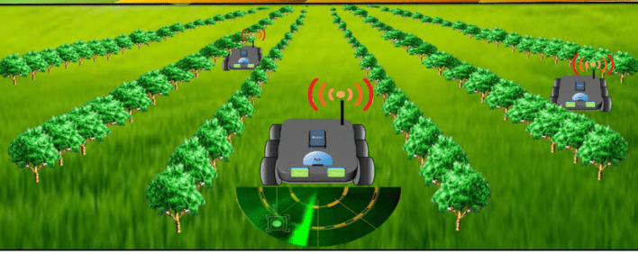

Figure 1: Automated soil test and health analysis

- Diagnosis of disease: Fruit crops are more susceptible to illness than other crops which directly influence not only yield but also quality, leading to inferior market prices (Singh et al. 2016). Due to inadequate awareness, farmers commonly spray all crops equally with pesticides and fungicides, increasing the cost of chemical use and waste. Machine learning can therefore build up algorithms that direct farmers to exactly where these chemicals are needed, further reducing input and disposal costs (Sennar, 2019). The nature of the disease can be identified by combining captured images with algorithms, thus better predicting how to battle it. This expertise can be widely used in vineyards for the detection of diseased grape leaves. The current development in machine learning and artificial intelligence (AI) has wide relevance in disease detection with the help of equipments such as robots sensors, drones and intelligent monitoring systems. In recent years in horticultural crops, computer image based assessment of plant stress, diagnostics and severity estimation of plant diseases has gained thrust. Network sensors for disease biomarkers, such as volatile organic compounds, shall be used in early detection and prediction of plant diseases and host pathogen interaction studies. Thus, unmanned aerial vehicles are employed for phenotyping orchards for accurate application of plant protection chemicals. Mobile field diagnostics are in high demand worldwide, especially at remote locations where laboratory diagnosis of diseases is difficult. AI's still in its childhood when it comes to detection of diseases. Integrating AI and augmented reality is the need of an hour to improve accuracy and automated remote diagnosis of plant diseases, as well as the protection of plants. It is clear that in the near future a self sufficient and disease free, ideal plant concept will be possible only with the help of plant robotics bio hybrids.

- Tree pruning: Schupp et al. (2017) documented that for various horticultural and economic reasons, to maintain stability amid vegetative and reproductive growth of the plant, cutting off branches is done. This process is known as pruning which involves limiting of plant size, manipulation of the canopy to ensure quality of fruits, size, yield, fruit set, etc. for next season. As the fruit trees are perennial plants, so pruning is a collective process, where the results of one year's pruning have an effect on plant size and production in subsequent years. Tree heading is required every year and is very labour intensive for which human labour needs to be replaced by machines due to seasonal deficit in terms of labour. The only solution is robotic pruning. However, mechanical pruning as understood up to now consists of tree form recognition, branch cutting along with pruning protocol execution and robotic routing. In order to estimate an item's shape with high accuracy, well-established computer vision techniques frequently use qualities that make an object easy to identify, like corners and edges, stable or predictable imaging surroundings, or object smoothness. Based on this technique still cuts are performed while trees are leafless and objects are thin. Then finally, data is collected outdoor and stored. However, these properties breach many hypothesis of recognized technology. On the basis of this, many latest techniques have been building up to identify treetops. Last but not least, photographs may typically only be shot from single angle of the tree at a time due to tree spacing and fixed trellis systems that limit optical access to the canopy. Numerous groups around the world have created the recognition algorithms needed for robotic cutting, but processing time continues to be a significant constraint for real-time applications. The data collection on two trees has been reported to have taken one hour by Medeiros et al., 2017. The data collection by Tabb and Medeiros, 2017 took 1.5 minutes for each tree, an average transit time of 8.65 minutes with a high performance computer used in the case of smaller trees. Over the next few years, autonomous pruning will need more research and development. Not even a single research project took any crossroad navigation for robots into account. Autonomous pruning will require further study and development in the future.

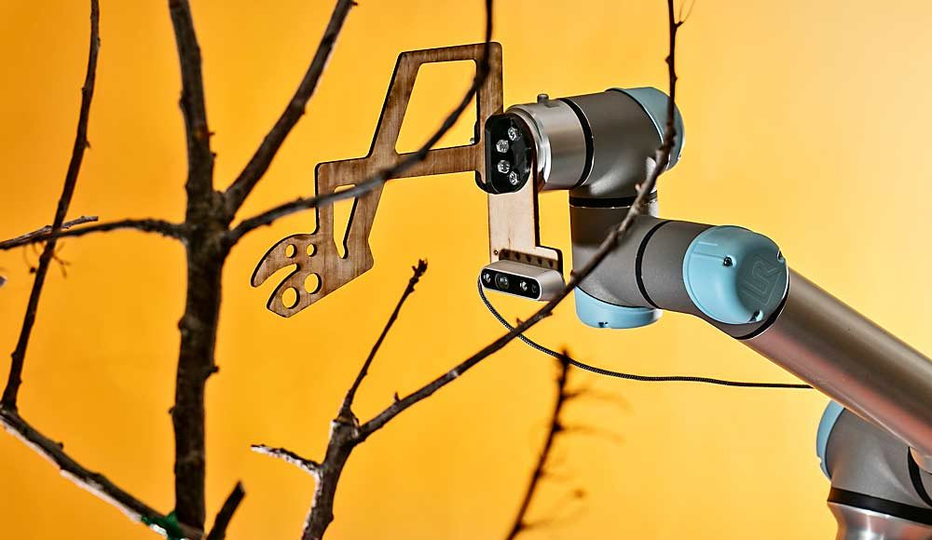

Figure 2: Robotic automated pruning

- Fruit thinning: Fruit trees generate a great deal more blossoms than are necessary for commercial cultivation, with optimal yields, fruit size, and fruit quality. By controlling the number of ripening fruits, flower thinning affects fruit dimension and attributes. Moreover, fruit thinning is mandatory to account for some fruit kinds' propensity to spin during crop rotation. Crops are currently thinned either chemically or manually. As part of crop load management, growers and crop advisors use flower number to programme chemical thinning treatments. Yoder et al., 2013 studied that for apples, two models used to predict thinning splash require bloom as input. The challenges for the introduction of robots and automated solutions in the fruit cultivation are presented by a relatively small size of target flowers as compared with that of the canopy. So far, the thinning of flowers has been dominated by robotic and automated thinning. This included an introduction to the elements such as increased autonomy of bulk removal systems like filament tape by developing thinning arms and end effects in robotic technology. In addition, it has been detecting color flowers or multiple spectral images as inputs to the precision estimate of flower in a model for thinning and 3D estimation of treetops and trees being thinned by robots. The knowledge of canopy structure and flower location is required for removal of flower with automated systems. Many efforts have been made to study the 3D reconstruction of tree crowns and flowers using the peach vertical V training system to strengthen the framework of the robotic decimation system. A method to detect simplified crown peaches using structured light in a laboratory setting was developed by Emery et al. (2010). Nielsen et al. 2012, using special stereo reconstruction technique combined with flash illumination and night operations to define peach tree location and map flower positions in a more realistic outdoor environment has used these techniques.

- Spraying operations: One of the most crucial field operations is the spraying of pesticides to fruit crops in order to protect plants from numerous pests and diseases as well as to provide them with the nutrients and other elements they require, such as plant growth regulators. In order for the input to be administered successfully and produce the desired effect, accurate chemical application is indispensable. This depends on 3Rs of spraying viz. spraying the right quantity, at the right spot and at the right time. The usage of chemicals has the potential to harm both the environment and human health. The following health and safety laws are thus applicable and ought to be taken into account. Therefore, precision spraying continues to be a crucial technology in the production of tree fruits. Robotic systems may be able to spray pesticides on orchards more precisely than ever thanks to fast improving processing power, sensor technology, and cutting-edge artificial intelligence methods like convolution neural networks (CNN) and deep learning. is displayed. 21-7 To attain the desired level of accuracy while spraying in orchards, both ground and aerial robots (such as spraying chemicals to specified places using UAS) can be used. Precision spraying is being researched for artificial (including mechanical) pollination of fruit crops in addition to pesticide treatments. To carefully and precisely distribute the proper amount of material to the target area within the canopy, a robotic spray system typically comprise of a spray control and a targeting system. The soil spray systems described so far do not have the ability to spray the input material specifically onto fruits or individual flowers. Several efforts are underway to develop robotic solutions for spraying tree canopies and specific parts of objects. Kang et al., 2012 evaluated a system aimed to apply herbicides to grape shoots growing at the base of the grape stem. The system included a camera that detected vine stems and shoots, and a series of nozzles that sprayed chemicals only on specific areas of the stem to control shoots insects. The system was tested on vines and it was evident that chemical savings of up to 92% were obtained as compared to conventional sprayer application of streak chemicals. A machine vision-based automated system that precisely sprays hormones on fruits and insecticides on leaves without affecting non-targeted areas was developed by Berenstein et al. (2010). Oberti et al. (2016) also developed a similar system for the managing powdery mildew in grapes. Various tests conducted in a greenhouse environment saved up to 35% chemical consumption achieving 85% to 100% accuracy in detecting diseased areas. To make these technologies reliable and extensively applicable to the target flower, fruit, and canopy areas where issues have been discovered, more studies and advances are required. The research and development activities have been focussed at robotics and sensor systems that enable the precise application of the required amount of chemical to target areas or crops, as well as those which are capable of detecting pests and identifying problems in a crop canopy.
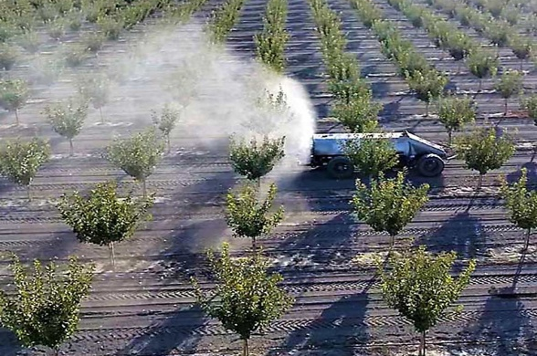

Figure 3: Autonomous spraying system for orchards

- Fruit harvesting: In fruit production, harvesting is a labor intensive and time sensitive process. Automated fruit harvesting is although still in its infancy, but many other orchard processes are already fully automated. Scientists (Rabatel et al., 1995, Harrel et al., 1989 and, Bazley, 2017) have used automation in apples, citrus fruits, cherries and kiwis but unfortunately, no commercial success has been achieved so far. With the latest expansion in artificial intelligence, computers and sensors, fruit picking with the help of robots has appeared as a practicable technology. The vision system for detecting and counting the target crop, the steering system in relation to reaching the target crop as well as the harvesting table carrying out the fruit removal from tree branches are generally included in robot orchard harvesting systems. An alternative method for automatic that is targeted shake-and-catch system for fruit harvesting is used in some countries. A more detailed work in fruit harvesting has been experimented by Bac et al. (2014), Gongal et al. (2015), Zhang et al. (2016) and Karkee et al. (2017). The critical step in robotic harvesting is to get closer to the fruit. The key concern is to decide the best way of moving a picking end effector into its aimed fruit and detaching it entirely from the tree. Zhang et al., 2017 and Chen et al., 2017) have successfully applied deep learning to solve various fruit recognition challenges. The primary action in automated harvesting is to identify the fruit and assess its 3D position within the tree canopy so that the end effector can reach the targeted fruit and separate it from the tree. With reference to detection of fruits and obstacles using different thresholding and classification methods, e.g. with the use of Bayesian classification systems and neural networks derived from individual features like shapes, sizes, colors, edges or textures, a broad research effort has been carried out (Silwal et al., 2014 and Tab et al., 2006). The main function of robotic tree fruit harvesting is to separate fruits from trees. In order to apply the required forces and movement of the fruit in order to release it from the tree, a pick end effector shall be used. The end effector technologies used in fruit picking are of wide range. The example of one such technique is to use a automatic end effector with human being like soft hands and fingers to harvest the fruit. Davidson et al., 2016 studied different such designs are used in motorized hands, containing different numbers of fingers and actuators to operate the fingers. Soft robotics materials can be used for mechanical hands and hydraulic actuation. (Shintake et al., 2018).

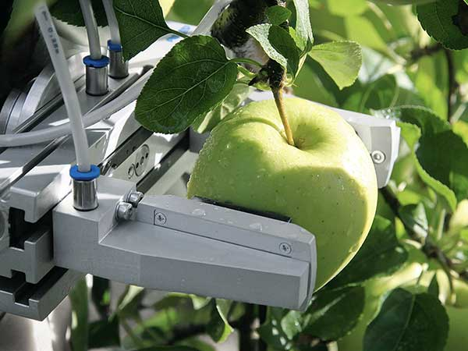

Figure 4. Robotic fruit harvesting in apple

- Sorting and grading of fruits: The development of robots capable of dealing with the inborn disparity in the produce being sorted and graded has begun to take place as a result of the actual processing of fresh horticultural produce and the reduction in the number of workers. A large quantity of harvested crops gets lost every year due to non availability of enough labour for sorting and grading procedures. Sarig et. al, 2000 reported that horticulture crops need new productive harvesting technologies. The first and foremost important step for postharvest technologies includes sorting and grading of harvested fruits. Leblanc and Vigneault, 2008 studied that the decrease of quality of any horticultural produce is generally directly proportional to the time a produce is exposed to any adverse condition. Hence, timely transportation of fruits from orchards to the market is of utmost importance. Further Vigneault, 2004 and De Castro et al, 2005 proved that any delay in the transportation of fruits will generates sooner or later serious effects on the final quality of the produce at the marketing end. Leblanc and Vigneault, 2008 documented that this may result in a significant loss of marketable value. The technology based on robotics and automated machine vision has increased many folds in terms of importance and potential in orchard management in recent years. To meet the high quality standards, grading and sorting are considered as the most crucial steps. The quality of fruits generally depends on factors including color, size and shape, however color and size are the most crucial ones for fruit grading and sorting. Fruit sorting depends mostly on its color, but because certain fruits have hues that are similar to one another, in such cases size can also be useful in finding solutions. Although fruit sorting and grading is one of the most crucial processes, it is mainly done manually, which is inefficient as it is prone to error caused by humans. Therefore, to omit human mistake and to make the process speedy to maintain uniformity, a computer vision based automatic system for grading and sorting need to be developed. The engineers offer a variety of solutions based on, automation and robotics to maintain the quality of horticultural produce based on their prior experience. The method of capturing the fruit image using camera is widely used for grading process wherein image is interpreted using various processing techniques. However, for sorting, image is taken in same way but size detection is based on binary image. Automatic techniques like color detection and edge detection are used these days where color detection is used to recognize the defected part with the threshold intensity but for finding out the boundaries of objects within images, ,the edge detection method is used. Such type of automatic fruit grading system saves time, effort and supply better accuracy than the manual sorting.

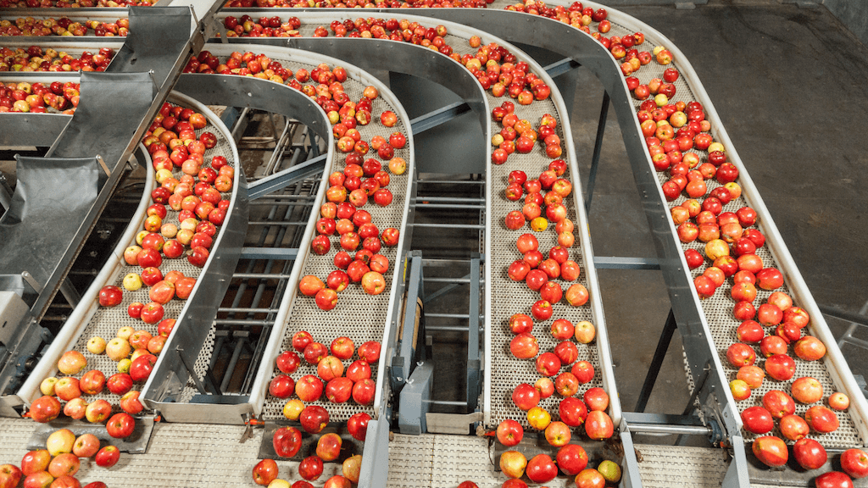

Figure 5 : Automated sorting and grading of fruits

III. CHALLENGES OF USING ROBOTICS AND AUTOMATION IN HORTICULTURE

The horticultural industry currently faces many challenges that affect crop yield and productivity. These variables prevent farmers from benefiting from the benefits of this industry, even though it is a highly profitable industry. The real-world problems that openly or ultimately improve the production of superior agricultural products can be solved by using automation technologies like as data analysis, artificial intelligence, block chain technology, and digital image processing. On the other hand, inappropriate use of synthetic chemicals in fruit and vegetable production causing environmental degradation will also be reduced using such techniques. Every new technology has to face various hurdles to reach its goal and same is the story of orchard robots. They need to recognize the trunk of a tree and to separately classify fruit, flowers and leaves along identifying the paths between the trees and must gain knowledge of the harvested area. To handle fragile fruits and berries which bruise easily, these robots have to be very specific and skilled. To move through mud, rough terrain, soil and sloping ground, they need to be sturdy. Even they have to recognize other obstacles like poles, stumps, rocks, wires and also people. There will be need to identify other robots without getting in their way for smooth functioning. Robots definitely have to be multifunctional so as to cover their economics. Some orchard operation such as fruit picking are confined to short duration that last for only a few months of the year. It is simply not gainful to use a high valued robot for such a small span. Moreover, it should be quick and specific to pollinate flowers, count buds, prune trees efficiently and pick the fruits without bruising so as to certify a realistic economic return. So these economic uses which pose a number of problems need to be worked out to make robotics and automation a successful venture in horticulture industry.

REFERENCES

- T. Bazley, Robotic hands gently snatch kiwifruit future. 2017, pp. 21-18
- C. W. Bac, E. J. Van Henten, J. Hemming, and Y. Edan, Harvesting Robots for High-value Crops: State-of-the-art Review and Challenges Ahead. Journal of Field Robotics. 2014, https://doi.org/10.1002/rob.21525,
- A. Baruha, Artificial Intelligence in Indian Agriculture – An Industry and Startup Overview, 2019.emerj.rj.com/ai-sector-overviews/artificial-intelligence-in-indian-agriculture-an-industry-and-startup-overview.
- K. Sennar, AI in Agriculture – Present Applications and Impact. Available, 2019. https://emerj. com/ai-sector-overviews/ai-agriculture-present-applications-impact/
- A. Kamilaris, and F. X. Prenafeta-Boldú, F. X. Deep learning in agriculture: A survey. Computers and electronics in agriculture 2018,147:70-90.
- H. Medeiros, D. Kim, J. Sun, H. Seshadri, S. A. Akbar, N. M. Elfiky and J. Park, Modeling Dormant Fruit Trees for Agricultural Automation. Journal of Field Robotics. 2017, https://doi.org/10.1002/rob.21679
- K. G. Emery, D. M. Faubion, C. S. Walsh, and Y. Tao, Development of 3-D range imaging system to scan peach branches for selective robotic blossom thinning. In American Society of Agricultural and Biological Engineers Annual International Meeting 2010, ASABE 2010.
- M., Nielsen, D. C. Slaughter and C. Gliever, Vision-based 3D peach tree reconstruction for automated blossom thinning. IEEE Transactions on Industrial Informatics. 2012, https://doi.org/10.1109/TII.2011.2166780
- M. Karkee, R. J. Davidson and A. Silwal, Mechanical Harvest and In-field Handling of Tree Fruit Crops. Automation in Tree Fruit Production: Principles and Practice, 2017, pp. 179.
- F. Kang, H. Wang, F. J. Pierce, Q. Zhang, and S. Wang, Sucker detection of grapevines for targeted spray using optical sensors. Transactions of the ASABE, 2012, 55(5), 2007-2014
- R. Berenstein, O. Shahar, Ben, A. Shapiro and Y. Edan, Grape clusters and foliage detection algorithms for autonomous selective vineyard sprayer. Intelligent Service Robotics. 2010, https://doi.org/10.1007/s11370-010-0078-z
- R. Oberti, M. Marchi, P. Tirelli, A. Calcante, M. Iriti, E. Tona and H. Ulbrich, Selective spraying of grapevines for disease control using a modular agricultural robot. Biosystems Engineering. 2016, https://doi.org/10.1016/j.biosystemseng.2015.12.004
- G. Rabatel, A. Bourely, F. Sevila, and F. Juste, Robotic Harvesting of Citrus: State-Of-Art and Development of the French Spanish EUREKA Project,1995.
- R. C. Harrell, D. C. Slaughter and P. D. Adsit , A Fruit-Tacking System for Robotic Harvesting, Machine Vision and Applications, 1989, 2: pp.69-80.
- A. Gongal, S. Amatya, M. Karkee, Q. Zhang, and K. Lewis, Sensors and systems for fruit detection and localization: A review. Computers and Electronics in Agriculture. 2015, https://doi.org/10.1016/j.compag.2015.05.021
- A. Singh, B. Ganapathysubramanian and A.K. Singh, Machine learning for high-throughput stress phenotyping in plants. Trends Plant Sci 2016; 21(2):110–124.
- C. Smita, Smart Irrigation Techniques for Water Resource Management, in Smart Farming Technologies for Sustainable Agricultural Development, C. P. Ramesh, G. Xiao-Zhi, R. Linesh, S. Sugam, and V. Sonali, Eds. Hershey, PA, USA: IGI Global, 2019, pp 196-219.
- J. R. Schupp, H. E. Winzeler, T. M. Kon, R. P. Marini, T. A. Baugher, L. F. Kime, and M. A. Schupp, A Method for Quantifying Whole-tree Pruning Severity in Mature Tall Spindle Apple Plantings. HortScience, 2017, 52(9): pp 1233–1240.
- A. Tabb and H. Medeiros, A robotic vision system to measure tree traits. In IEEE/RSJ International Conference on Intelligent Robots and Systems. 2017. https://doi.org/10.1109/ IROS.2017.8206497
- K. S. Yoder, G. M. Peck, L. D. Combs, R. E. Byers, and A. H. Smith, Using a pollen tube growth model to improve apple bloom thinning for organic production. In Acta Horticulturae. 2013. https://doi.org/10.17660/ActaHortic.2013.1001.23
- Z. Zhang, P. H. Heinemann, J. Liu, T. A. Baugher and J. R. Schupp, The development of mechanical apple harvesting technology: A review. Transactions of the ASABE, 2016, 59(5): pp 1165–1180.
- J. Zhang, L. He, M. Karkee, Q. Zhang, X. Zhang and Z. Gao, Branch Detection with Apple Trees Trained in Fruiting Wall Architecture using Stereo Vision and Regions-Convolutional Neural Network (R-CNN). In 2017 ASABE Annual International Meeting (p. 1). American Society of Agricultural and Biological Engineers, 2017.
- S. W. Chen, S. S. Shivakumar, S. Dcunha, J. Das, E. Okon, C. Qu and V. Kumar, Counting Apples and Oranges With Deep Learning: A Data-Driven Approach. IEEE Robotics and Automation Letters, 2017, https://doi.org/10.1109/LRA.2017.2651944
- A. Silwal, A. Gongal and M. Karkee, Identification of red apples in field environment with over the row machine vision system. Agricultural Engineering International: CIGR Journal, 2014.
- A. Tabb, D. Peterson and J. Park, Segmentation of Apple fruit from Video via Background Modeling. ASABE paper No. 063060. St. Joseph, Mich.: ASABE. 2006
- J. R. Davidson, A. Silwal, C. J. Hohimer, M. Karkee, C. Mo, and Q. Zhang, Proof-of-concept of a robotic apple harvester. In IEEE International Conference on Intelligent Robots and Systems, 2016, https://doi.org/10.1109/IROS.2016.7759119
- J. Shintake, V. Cacucciolo, D. Floreano and H. Shea, Soft Robotic Grippers. Advanced Materials, 1707035, 2018.
- Y. Sarig, J.F. Thompson and G.K. Brown, Alternatives to Immigrant Labor? The Status of Fruit and Vegetable Harvest Mechanization in the United States. 2000:(http://www.cis.org/articles /2000/back1200.html). Avail able online 2010/07/29.
- D.I. Leblanc and C. Vigneault Predicting quality changes of fresh fruits and vegetables during postharvest handling and distribution. Stewart Postharvest Review 2008, 4 (4): pp 1.1–1.3.
- C. Vigneault, Y. Gariépy, D. Roussel and B. Goyette, The effect of precooling delay on the quality of stored sweet corn. International Journal of Food, Agriculture and Environment 2004,2(2): pp 71–73.
- L.R. De Castro, C, Vigneault, M.T. Charles and L.A.B .Cortez, Effect of cooling delay and cold-chain breakage on Santa Clara tomato. International Journal of Food, Agriculture and Environment 2005, 3 (1): pp 49–54.
- A. Bechar and C. Vigneault, Agricultural robots for field operations. Part 2: Operations and systems. Biosystems Engineering 2017, pp. 153, 110, 12
- K.R. Krishna, Push Button Agriculture: Robotics, Drones, Satellite-Guided Soil and Crop Management. Apple Academic Press, Oakville, 2016, pp.470
- M.A. Oliver, Geostatical Applications for Precision Agriculture. Springer, London, 2010, pp.331
- R.B. Ferguson and G.W. Hergert, EC00-154: Soil Sampling for Precision Agriculture. In: Precision Agriculture. University of Nebraska-Lincoln, 2000. pp. 1 4.
- T. Zhang, W. Zhang, K. Wang, S. Gao, L. Hou, J. Ji and X. Ding, Drilling, sampling, and sample-handling system for China's asteroid exploration mission. Acta Astronautica, 2017 pp 137, 192 204,

