Effect of annealing on the structural and electrical parameters of sol-gel derived ZnO nanoparticles
N.KALAISELVI¹, K.U.MADHU²
¹ Department of Electronics, S.T.Hindu College, Nagercoil– 629002
² Department of Physics, S.T.Hindu College, Nagercoil– 629002,
(Affiliated to Manonmaniam Sundaranar University,Abhishekapatti, Tirunelveli)
Tamil Nadu, India.
Abstract
In this paper, we report the synthesis of ZnO nanoparticles prepared via. Sol-gel method. The prepared samples were annealed at 200⁰C and 800⁰C for 1hr. The influence of annealing temperature on the particle size and morphology was examined by X ray diffraction. Electrical parameters such as dielectric constant, dielectric loss factor and AC electrical conductivity with respect to frequency and temperature were measured and the results have been analysed. As the process is simple and low-cost, it has the potential to be produced on a large scale.
Key words: Sol-gel method, dielectric loss factor, dielctric constant, Electrical conductivity
Introduction
Zinc Oxide is a member of II-VI semiconducting compounds and occurs naturally as the mineral zincite. It is a hexagonal wurtzite type crystal exhibiting anisotropy. ZnO is a well-known n-type semiconductor and has got a wide band gap of 3.3 eV at 300 K [1-5]. It is transparent to the visible light [6]. It is also considered as a major candidate for UV and blue light-emitting devices such as blue LED and Lasers due to its large exciton binding energy [7, 8]. Although, several NPs are showing their effectiveness in different sectors of technology, zinc oxide (ZnO) NPs have gained much more importance in the recent years due to their attractive and outstanding properties such as high chemical stability, high photostability, high electrochemical coupling coefficient and a wide range of radiation absorption [9]. It exhibits piezoelectricity, meaning it can generate an electrical charge when subjected to mechanical stress. Additionally, ZnO has antibacterial and UV-protective properties, which make it useful in various industries such as cosmetics, healthcare, and textiles[10,11].Nowadays, ZnO NPs are predominantly used as antimicrobial agents, delivering systems vaccines and anti-cancer systems, photocatalyst, biosensors, energy generators and bio-imaging materials[12–15]. In addition to their fundamental importance in solid-state physics, the phonon properties of ZnO are also of practical significance. For example, they play a crucial role in determining the thermal conductivity and thermal transport properties of ZnO, which are important for applications such as thermoelectric devices and heat dissipation in electronic devices [16].
Experimental Detail
ZnO nanoparticles were prepared by sol-gel method. The reactants used for the synthesis of ZnO nanoparticles were zinc acetate (Zn (CH₃COO)₂ · 2H₂O)., sodium hydroxide (NaOH) and PVA was used for the preparation of ZnO nano particles. Distilled water was used as the solvent. In this process Zine acetate and NaOH were taken in the 1:3 molecular ratio and was dissolved in 100ml doubly distilled water then 2g of PVA is added to the modified Zinc acetate solution and the white precipitate was obtained. Annealing was carried out for the samples at 200⁰C, 800⁰C.The annealed samples were characterized structurally and electrically.
Characterization
The structural characteristics of pure and annealed samples were identified by the powder x-ray diffraction analysis. The AC electrical measurements such as dielectric constant, dielectric loss factor and electrical conductivity were carried out by the conventional parallel plate capacitor method using an Agilent 4284A of LCR meter at various temperatures for different frequencies.
Results & Discussion
Fig 1-3 shows the PXRD pattern of as prepared and annealed samples and the variation of structural morphology for different annealing temperature was analysed. However, to understand the ZnO phase evolution, calcinations was performed at 200°C and 800°C. The results revealed that ZnO thus formed is of hexagonal phase (JCPDS no. 36-1451 with P63 mc space group, a=3.249 Å, c=5.206 Å) The major peaks were indexed as (1 0 0), (0 0 2),(1 0 1), (1 0 2), (1 1 0),(1 0 3),(2 0 0 and (1 1 2). It is obvious that there is an improvement in the crystallinity of ZnO nanoparticles with the increase in the annealing temperature [17]. Table.1 shows the effect of annealing temperature on the crystallite size. When the annealing temperature is increased to 200°C, the minimum crystallite size of 26.66 is obtained. Further increase in the annealing temperature results in the increase of the crystallite to 31.96 nm. The colour of pure ZnO was white, at 800⁰C it turns to pale yellow. The yield percentage of various temperatures were calculated and given in the table 1.

Table1: Preparation time, Sample used , colour and yield percentage for the prepared samples
Sample | Reaction time (min) | Colour | Yield (%)
Pure ZnO | 60 | white | 30.34
Annealed 200ºC | 60 | white | 18.6
Annealed 800ºC | 60 | Pale yellow | 9.7

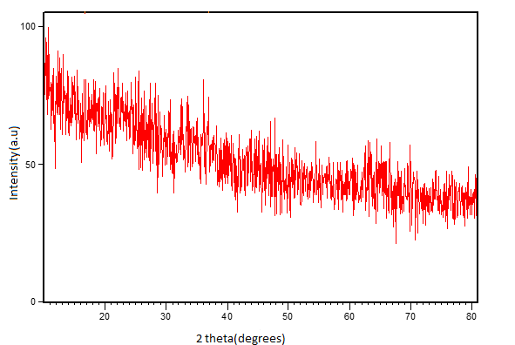
Fig 1: Un-annealed Zno nanoparticles
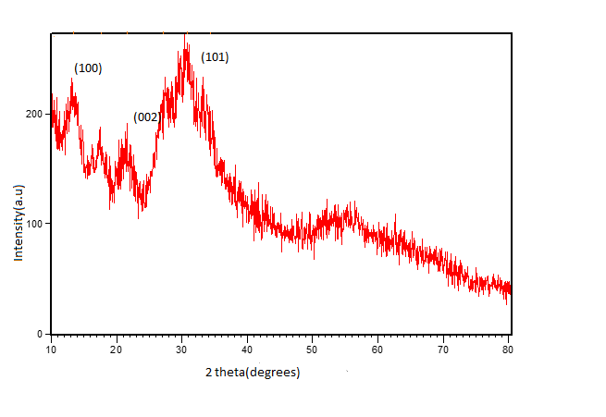
Fig2: 200⁰C annealed Zno nanoparticles
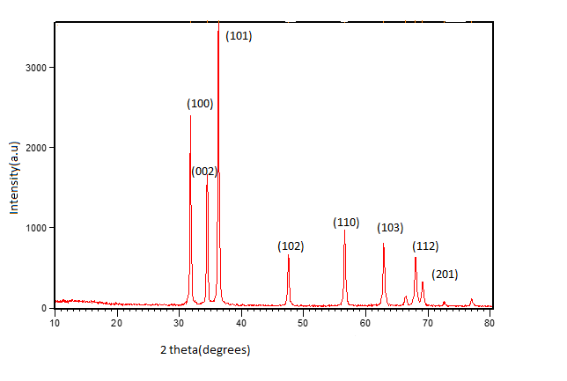
Fig3: 800⁰C annealed Zno nanoparticles
The dielectric and AC conductivity of the prepared samples were analyzed for the temperature range 40 - 150ºC for the range of frequency 100 Hz – 1 MHz using Two-probe method. Variation of dielectric constant for the as prepared and annealed samples with temperature for various frequencies are depicted in Figs. 4 - 6. From the Figure it was clear that for all frequencies, the dielectric constant increases with increasing temperature. This may be due to change in available number of free electrons in a material with increasing temperature in turn, changes the conductive part and hence the capacitive part[18]. In Fig7-9 at low frequencies the dielectric loss is high , Higher loss (tanδ) at lower frequency in dielectric may be attributed to DC conduction losses [19] Typically, the dielectric losses are attributed to the crystal structure and the imperfections in the crystal system such as impurities, micro-structural defects, grain boundaries, porosity, micro-cracks and random crystallite orientation.
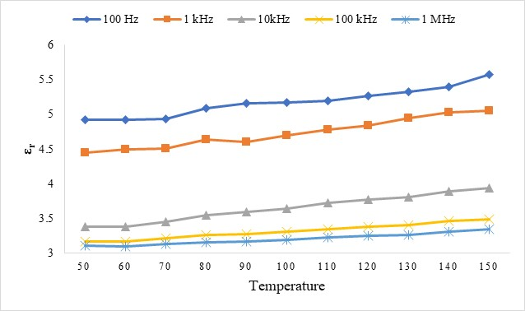
Fig 4:Dielectic Constant for Un-annealed ZnO

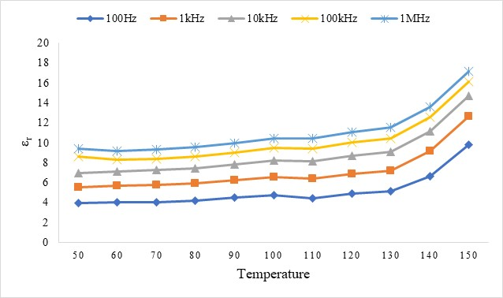
Fig 5:Dielectic Constant for ZnO annealed at 200ºC

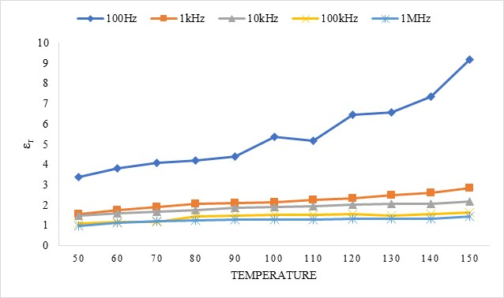
Fig 6:Dielectic Constant for ZnO annealed at 800ºC

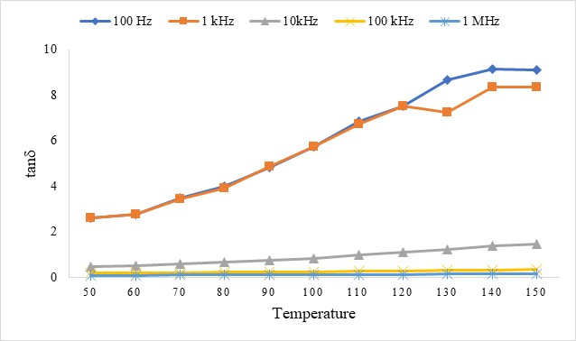
Fig 7:Dielectric loss for Un-annealed ZnO

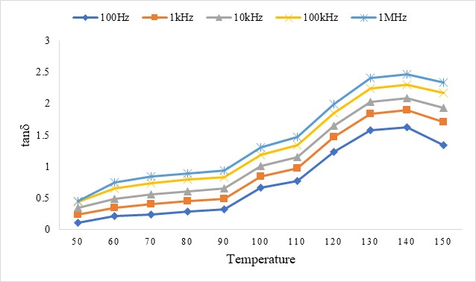
Fig 8:Dielectic loss for ZnO annealed at 200ºC

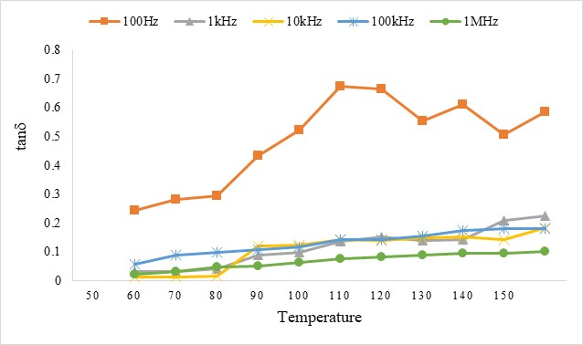
Fig 9:Dielectic loss for ZnO annealed at 800ºC

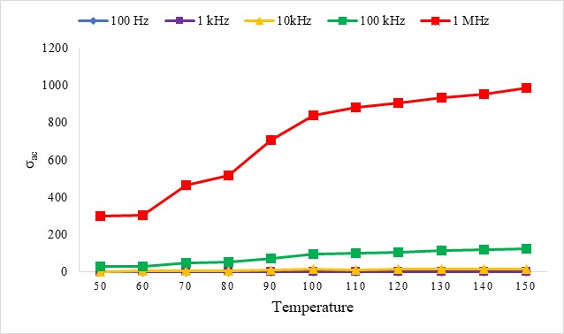
Fig 10: AC Conductivity for Un-annealed ZnO
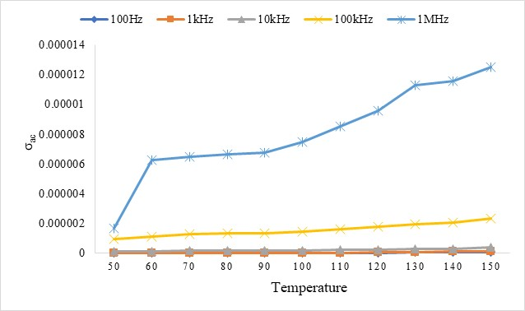
Fig 11: AC Conductivity for ZnO annealed at 200ºC
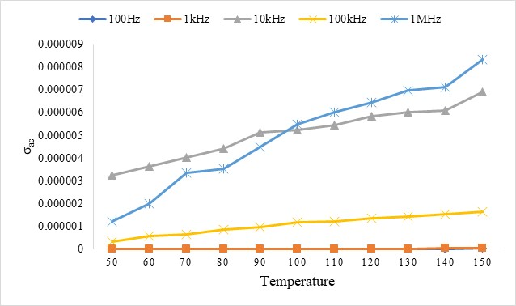
Fig 12:AC Conductivity for ZnO annealed at 800ºC
The plotted graph from Fig 10-12 demonstrates the frequency independent conductivity in the low frequency region, and frequency dependent conductivity in the mid and high frequency regions, respectively. In the low frequency region, nearly uniform value of conductivity represents the continuation of DC conductivity. In the mid and high frequency regions, conductivity increases monotonically with frequency and represents the AC conductivity following the frequency power law [20].

Conclusion
The ZnO nanoparticles were successfully synthesized through simple sol-gel method and annealed at 200⁰C and 800⁰C. The X-ray diffraction pattern confirmed the formation of ZnO with hexagonal structure. The heating technique also influences the size and shows that there is an improvement in the crystallinity of ZnO nanoparticles which leads to fine quantum confinement with the increase in annealing temperature. The electrical parameters are measured and the variations with respect to temperature and frequency was evidently analysed.
References
- Ozgur, Y.I. Alivov, C. Liu, A. Teke, M.A. Reshchikov, S. Dogan, V. Avrutin, S.J. Cho, H. Morkoc, J. Appl. Phys. 98, 41301 (2005).
- H. Tang, K. Prasad, R. Sanijines, P.E. Schmid, F. Levy, J. Appl. Phys. 75, 2042 (1994).
- G. Oskam, Z.S. Hu, R.L. Penn, N. Pesika, P.C. Searson, Phys. Rev. E 66, 11403 (2002).
- H.S. Bae, M.H. Yoon, J.H. Kim, S. Im, Appl. Phys. Lett. 83, 5313 (2003).
- K. Keis, A.Roos, Opt. Mater. 20, 35 (2002).
- D.R. Lide, Hand Book of Chemistry and Physics, 71st ed. (CRC, Boca Raton, FL: 1991)
- A. Ohtomo, M.Kawasaki, I. Ohkubo, H. Koinuma, T. Yasuda, Y. Segawa, Appl. Phy. Lett. 75, 980 (1999).
- Z.K. Tang, G.K.L. Wong, P. Yu, M. Kawasaki, A. Ohtomo, H. Koinuma, Y. Segawa, Appl. Phys. Lett. 72, 3270 (1998).
- Khan S A et al 2018 Green synthesis of ZnO and Cu-doped ZnO nanoparticles from leaf extracts of Abutilon indicum, Clerodendrum infortunatum, Clerodendrum inerme and investigation of their biological and photocatalytic activities Mater. Sci. Eng.C82 46–59
- Kairyte K, Kadys A and Luksiene Z 2013 Antibacterial and antifungal activity of photoactivated ZnO nanoparticles in suspension J. Photochem Photobiol B Biol. 128 78–84
- Kolodziejczak-Radzimska A and Jesionowski T 2014 Zinc oxide-from synthesis to application: a review Materials (Basel) 7 2833–81
- Reddy K M et al 2007 Selective toxicity of zinc oxide nanoparticles to prokaryotic and eukaryotic systems Appl. Phys. Lett. 90 10–13.
- Yan X and Xu G 2009 Effect of sintering atmosphere on the electrical and optical properties of(ZnO)1-x(MnO2)x NTCR ceramics Phys. B Condens Matter 404 2377–81
- S. Y. Myong, S. J. Baik, C. H. Lee, W. Y. Cho, and K. S. Lim, Jpn. J. Appl Phys., Part 236, L1078 (1997).
- [20] B. M. Ataev, A. M. Bagamadova, A. M. Djabrailov, V.V. Mamedoy. and R. A Rabadanov, Thin Solid Films 260, 19 (1995).
- C. G. Van de Walle, Phys. Rev. Lett. 85,1012 (2000).
- Rezq Naji Aljawfi a, Mohammad Jane Alam b , F. Rahman b , Shabbir Ahmad b , Aga
Shahee c Shalendra Kumar d, Arabian journal of chemistry, 13, 1, 2207-2218,2020
- Chun Yan et al, World.Appl.Sci., 14,1091-1094, 2011

Shukla, N, Pathak, HP, Rao, V & Dwived, DK, Chalcogenide Letters,
13, 4, 177-185, 2016.
- Liu, BH & Ding, J, J. Phys. Chem. B, 88, 04, 2006.

