Exploring the Versatility and Applications of Supramolecular Derivatives: Design, Synthesis, and Functionality
Bhargav Dave, Keyur Bhatt
Department of Chemistry, C.U. Shah University, Wadhwan-363001, Gujarat, India
Department of Chemistry, Ganpat University, Kherva-384012, Gujarat, India

Abstract
Supermolecular chemistry has become a dynamic field focused on understanding and exploiting non-covalent interactions to create functional and flexible systems. This summary explores the importance of supramolecular derivatives, a group of compounds that are the result of deliberate modification and manipulation of supramolecular assemblies.
Supermolecular derivatives exhibit a wide range of properties and applications due to the inherent flexibility of non-covalent interactions. These derivatives are formed by incorporating functional radicals into supramolecular frameworks, allowing for custom material design with specific properties. This summary highlights key aspects of supramolecular derivatives, including their structural diversity, synthesis strategies, and diverse applications. Structurally, supramolecular derivatives include a wide range of architectures such as host-guest complexes, coordination polymers, and self-assembled monolayers. Through the strategic placement of functional groups in these architectures, properties such as solubility, selectivity, and reactivity can be fine-tuned. This design flexibility presents opportunities in areas such as drug delivery, catalysis and materials science.

Keywords: Supramolecular Chemistry, Calixarene, Receptor, Interaction
Corresponding author: Keyur Bhatt (kdb01@guni.ac.in)

Introduction to Supramolecular Chemistry
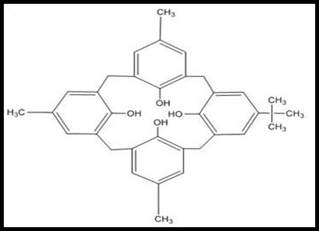
“Supramolecular Chemistry” is very well defined as “Chemistry beyond the Molecule” by Dr. Jean Marie Lehn who discovered the term “Supramolecule” and won the Nobel Prize in 1987 for his work in the area of “The Chemistry of Molecular Assemblies and of the Intermolecular Bond”. This definition may also be expressed as “Non-Molecular Chemistry” that is “Chemistry of Non-Covalent Bonds” (1–3). This May be also defined as a Chemistry of Non-Covalent interactions between a ‘Host’ and a ‘Guest’ molecule. Electron, Proton and other sub-atomic particles assemble to give an Atom. These atoms assemble to give various Molecules. Thousands of these molecules by self-assembling together to give Macromolecules. Polymers, Proteins, Steroids, Alkaloids and Supramolecules etc. belongs to the class of Macromolecules. The Development in Macromolecular chemistry led to the further development in supramolecular chemistry (4–6).

Figure 1.1 Para Functionalized Calix[4]arene

which is one of the fastest growing field in chemistry today. Supramolecules are resulted from the Intermolecular forces like Hydrogen bond, Dipole- Dipole Interaction, Ion-dipole Interaction, London force etc. between its components. This macromolecule exhibits a variety of properties like Molecular recognition, Self-assemblies, Self-replication, Self-organization and plays a very important role in the field of Biotechnology, Molecular engineering, Environmental Science, and having a great potential application in the field of Bio-medical chemistry, Nanotechnology, Chromatography, Electrochemistry, Catalysts and Molecular Sensors (7,8). Supramolecules are the macromolecules that provides a basic platform for the functionalization at its various sites (9).
It is Highly Challenging to do a Selective and Effective functionalization on a Multifunction macrocyclic unit because it requires a very efficient control in Chemo selectivity, Stereoselectivity and Regioselectivity. Molecular Scaffolds which are prepared by some easy chemical synthesis, Functionalization modification and designed recognition system makes Supramolecules as a very effective molecular receptors that is a ‘Host’ molecule. A variety of supramolecular organic receptors like Crown-ethers, Cryptands, Spherands, Calixarenes have been developed and synthesized that having a wide variety of application and further very fast growing in the area of research. Supramolecular organic materials have stunning application for Quantum Dot in bio-medicine and bio-informatics from artificial intelligence to the virtual reality. All these extensive applications in variety of field led to know the fact that Supramolecules are the future chemical building blocks (10–12).

2 Host-guest chemistry of Suparamolecules
‘Host-Guest’ term is first introduced by Cram in 1970. Host–guest chemistry of supramolecule is an interesting jawelstone that attracted various field of study like molecular engineering, biotechnology, Nanotechnology etc. In biological chemistry, supramolecules are the host structures like receptor, enzymes, genes, immune system antibodies etc, and the guests are the substracts, drug, antigen, inhibitors and co-factors etc. Macrocyclic supramolecules are having a very huge ring structure which is uncharged and contain a intrinsic hollow cavity in it which is responsible for the ‘Host’ behavior. Crown-ethers, Cyclodextrins, Fullerens, Cryptands, Calixarenes are the supramolecules comes under this category. Huge size Host molecules assists small size Guest molecules into their intrinsic cavity via certain non-covalent interaction leading to the formation of ‘Host-Guest’ complex(13,14). 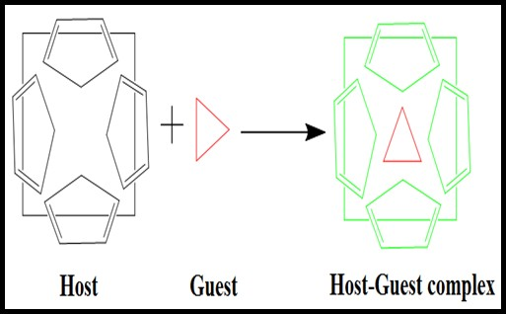
Figure 1.2 Host-Guest Complex

1.3 Calix[n]arene system
Supramolecules on the basis of their generation can be classified into three main classes. Cyclodextrins are the first generation supramolecule. Crown ethers, Cryptands, Spherands are the second generation supramolecules and Calixarenes are the third generation supramolecules. The term calixarene was first given by C. D. Gutsche in 1978 (15). The word calixarene is derived from the Greek word calix means vase or cone shape conformation. Calixarene family can be divided into two main categories
- Phenol- derived cyclooligomers e.g p-tertbutylcalix[n]arene system
- Resorcinol-derived cyclooligomers e.g. calix[4]resorcinarene
Due to cone shape conformation, there are two different zones can be distinguished in calixarene. The region of phenolic hydroxy group which also called ‘Lower Rim’ of the calixarene and the para position of phenol which also called ‘Upper Rim’ of the calixarene (16). There are lots of possibilities for chemical modification at both the lower rim and upper rim of the calixarene. In this way calixarene provides basic platforms for multi-functionality at both the rims separately. In calixarene, [n] use to denote the number of phenolic units in macrocycle (17,18). The size of the cavity of calixarene to assist the guest molecule can be changed by changing the value of [n] i.e the number of phenolic units to synthesize selective host molecule. Separate chemical modification can be done on both the rim. Modification on one ring for selective incorporation of specific ligating group and Modification on the other rim is to acquire desired solubility. Calixarenes as s ground for the multi-functionality and chemical modification emerged as a Third Generation Supramolecule having a variety of application in the different fields like Molecular devices, ion sensors, metal ion selectivity, molecular switches, molecular reorganization, chromatographic applications and in bio informatics etc (19–21).

1.4 The chemistry of Calix[4]pyrrole

1.4.1 Historical Development
Calix[4]pyrrole, a white crystalline solid material was firstly synthesized by Bayer in 1886. Bayer obtained calix[4]pyrrole by the condensation reaction of pyrrole with acetone in the presence of hydrochloric acid as acidic medium in a single step with high yield. Later by considering the work of bayer, Dennstedt and Zimmermann carried out the same reaction by using ‘Cholrzinc’ as an acid catalyst (22–25).
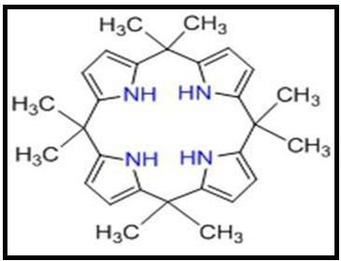
Figure 1.3 Calix[4]Pyrrole
In 1916, Chelintzev and Tronov proposed a cyclic tetrameric porphyrinogen structure. In 1955, Rothemund and Gage further improved the synthetic approach by using a methane sulphonic acid as an acid catalyst. Later on continues work has been carried out to study this class of compounds and the study mainly focused on the purified synthesis of these macrocycles and their meso- substituted derivatives (26). The synthetic procedure developed by Chelintzev et al. were very effectively modified by Brown et al. in 1970 and he got tetra- spirocyclohexylcalix[4]pyrrole in a adequate yield by the condensation reaction between pyrrole and cyclohexanone in the presence of an acid as a catalyst. Sessler and Co- workers in mid 90s investigated that as the calixpyrrole can act as a host molecule, the NH array which is present in the calixpyrrole has a very good binding properties towards the various anions and neutral subtracts which are guest species (27).
In 1990, Floriani and Co-workers by their considerable work on metalation and stimulate the synthetic chemistry of deprotonated calix[4]pyrrole. Sessler et al. first reported the synthesis of meso- octamethyle calix[4]pyrrole act as a host molecule due to its cone structure and have a extraordinary binding capabilities with different anions, cations and neutral guest species through the –NH group present in the pyrrole ring that acting as a multiple hydrogen bonding donor under different conditions (28,29). All these versatile properties of calix[4]pyrrole makes them a ground platform for the variety of further modification. Exhaustive investigation was carried out which leads to the development of the novel moiety having a diverse range of applications.

1.4.2 Chemistry and Mechanism of Calix[4]pyrrole
Calix[4]pyrrole formally known as “pyrrole-acetone” belonging to the class of neutral tetra-pyrrolic macrocycles. Calix[4]pyrrole also called as meso-octa-alkyle Porphyrinogens.
Porphyrinogens are generally obtained from nature and are colourless macrocycles consisting of four pyrrole ring attached to each other via α ( i.e pyrrolic 2 and 5 ) or meso position by sp³ hybridized carbon atom. Calix[4]pyrrole and porphyrin both products are the result of the condensation reaction between pyrrole and electrophile but are different from each other in such a way that in calix[4]pyrrole, an electrophile is acetone while that in porphyrin is generally aldehyde. On the basis of aromaticity, calix[4]pyrrole and porphyrin are different from each other i.e calix[4]pyrrole is non-aromatic system while porphyrin is aromatic system. Stable calix[4]pyrrole cannot be oxidized into their corresponding porphyrins as unstable porphyrinogen do.
Mechanism
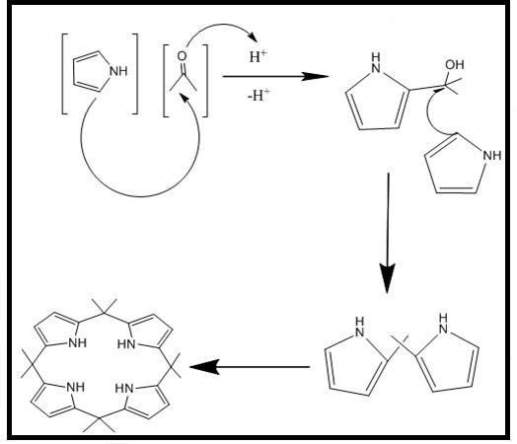
The formation of calix[4]pyrrole follow the mechanism of acid catalyzed condensation reaction. Calix[4]pyrrole is formed by electrophilic α-substitution of pyrrole by ketone in the presence of acid as a catalyst. Four pyrrole units are combines via acid catalyzed oligomerization and spontaneous non-template cyclization resulting in the formation of non-conjugated calix[4]pyrrole macrocycle. There are some quite easy methods for the synthesis of calix[4]pyrrole system but the product obtained is less due to the polymerization (30).

Figure 1.4 Synthetic scheme used in preparation of meso-octa methyl calix[4]pyrrole

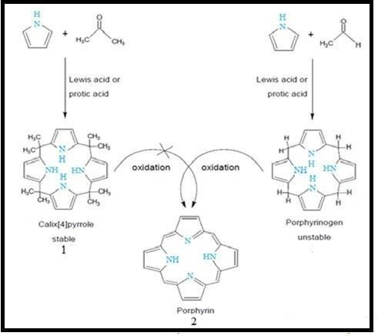

Figure 1.5 Schematic representation showing the different behavior of calix[4] pyrrole 1 and porphyrin 2 with respect to oxidation.

1.4.3 Different conformers of calix[4]pyrrole Macrocycle

Calix[4]pyrrole acquire the same conformation as the calix[4]arene system. There are mainly four types of conformations adopted by calix[4]pyrrole and these are cone, partial cone, 1,2-alternate and 1,3-alternate. As we know that energy and stability are having reciprocal relationship to each other. The conformer with less energy is more stable. The 1,3-alternate conformation is predicted and experimentally proved lowest energetic so 1,3-alternate conformer of calix[4]pyrrole is the highest stable form in which pyrrole rings are found to be up-down-up-down position alternatively. The studies of stability of conformers in gas phase and solution phase disclose the stability order 1,3-alternate > partial cone > 1,2-alternate > cone (31).
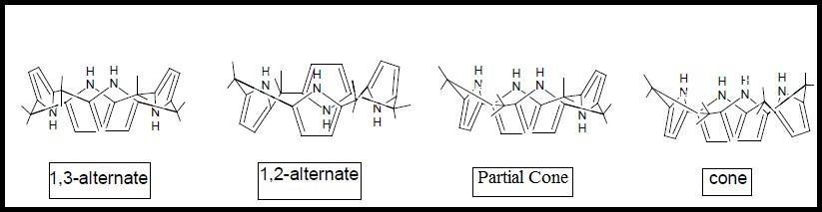
Figure 1.6 Different conformers of Calix[4]Pyrrole

1.4.4 Various Synthetic Techniques for calix[4]pyrrole Macrocycles
Calix[4]pyrrole is synthesized by using following four main techniques
[1+1] condensation (One pot) synthesis
[2+2] condensation
[3+1] condensation
The Number in the brackets denotes the number of pyrrolic ring that involved in the synthesis. There are also some Eco-friendly way to synthesize calix[4]pyrrole by using different types of catalyst. All above mentioned synthetic techniques are very much in use but [1+1] one pot condensation synthetic approach is most popular and more in use.
1.4.5a [1+1+1+1] condensation (One pot synthesis)
In One pot condensation, pyrroles and ketones having ratio 1:1 is allowed to react in the presence of acid as a catalyst like Hydrochloric acid, Trifluoracetic acid, Methane-sulfonic acid, Boron trifluoride and Diethyl etherate. The solvents in which the reaction is carried out are generally Methanol, Ethanol, Acetonitrile and Dichloro methane. In some reaction ketones act as both solvent as well as reactant in condensation with pyrrole. On the basis of types of ketones and pyrroles use in the one pot condensation reaction, this condensation can be classified into two main classes (a) Homogeneous condensation and (b) Mixed condensation.

1.4.5b [2+2] Condensation
Dipyrromethene units which obtained from the pyrrole are condensed with ketone in the presence of acid as a catalyst comes under the [2+2] condensation. This condensation technique is very important for the preparation of wide variety of calix[4]pyrrole molecules which otherwise cannot be synthesized by using [1+1] condensation method.

1.4.5c [3+1] Condensation
Tripyrrane or its derivatives are condensed with pyrrole or its derivatives in the presence of acid as a catalyst comes under the [3+1] condensation. The products obtained by this reaction are generally very poor because the tripyrrane and its derivatives which are used in this reaction are unstable in the presence of the acid catalyst. The fact is that no calix[4]pyrrole derivatives are prepared by using this condensation method.

1.5 State of art approach
Improved synthetic techniques to get high yield calixpyrrole macrocycle by using green environmental synthetic methods is of a great interest. It is very demanding to reduce the risk of hazardous pollution that caused by using the Homogeneous acid catalyst. The best synthetic method for making very high selective calixpyrrole derivatives with high yield and effectively low cost is Heterogeneous acid catalysis. Mesoporous materials like MSM- type alumina and silica acid catalyst which are effectively functionalized and having very good structure arrangement are very effective to get calixpyrrole in a high yield. Zeolite based sieves by using microwave irradiation method is also applied for the synthesis of calixpyrrole and its derivatives (32,33).

Modification in calix[4]pyrroles
The stability of pyrrolic N-H in calix[4]pyrrole to make a complex is not so good as well as very poor for analytical use. A functional modification at any of three sites on the calix[4]pyrrole namely the meso-position, bridge β-pyrrolic position(C-rim) and the N-rim helps in improving complexing abilities and akes it very good for analytical use. The number and type of substituent have a very great effect on the calix[4]pyrrole skeleton.
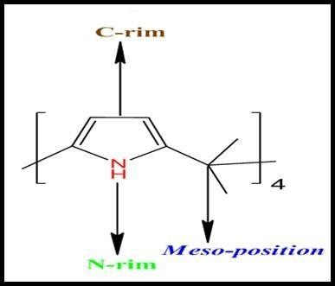
Figure 1.7 Sites for functionalization in calix[4]pyrrole

1.6.1 Functionalization at the β-position (C-rim)
C-rim modification that is β-position functionalization has been widely introduced by Sessler at el(Gale et al. 1997). β-mono functionalization’s and β-octa functionalization’s are the most popular C-rim functionalization because single dominant product is obtained. The functionalization at the β-position is a very important strategy because it will increase the anionic binding property of calix system but such kind of modification usually leads to the undesirable side effects like steric interactions with the groups like methyl on the meso carbon atoms leading to negative influence on the anion affinity and as a result destabilization and conformational changes. Therefore, it is more likely introduce small atoms such as oxygen, sulfur and halogen into the β-position. Extensively exploration on C- rim modification has not been carried out due to difficulty in separation of product as well as poor control on reaction.
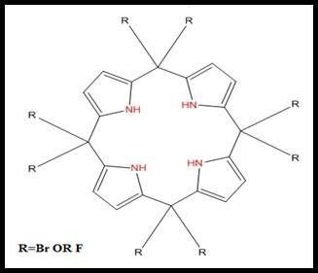
Gale et al. introduced the first - position adapted calix[4]pyrrole receptor with bromine in 1997. Anzenbacher, Jursková, and Sessler reported the second receptor modified with different halogen atoms such as fluorine in 2000. Binding studies revealed that receptors 3 and 4 have
Figure 1.8 C-rim substituted Calix(4)pyrrole
higher affinity for different anions than -unsubstituted calix[4]pyrrole due to an electronic effect caused by the attachment of substituent groups at the -pyrrolic positions (34).
A range of calix[4]pyrrole derivatives synthesized by Chauhan et al in 2009 via introducing an aryl-azo group at one β–position and chromogenic groups at two different β–positions (Figure 1.9). Binding property of synthesized calix[4]pyrrole derivatives were investigated with different anion. Investigation revealed that introduction of aryl-azo and the chromogenic groups in the structure of calix[4]pyrrole enhances binding properties of anion towards these receptors.

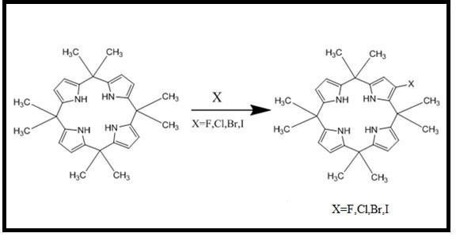
Figure 1.9 Functionalized Calix[4]pyrrole at ß-position

Miyaji et al. reported a series of mono-functionalized calix[4]pyrroles by adding halogens (F, Cl, Br) at one β–position (Figure 1.10).Affinity towards anion is regulated with the help of electron donating and withdrawing group present on β-rim.
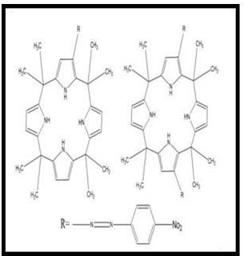
Figure 1.10 Mono halogenations of Calix[4]pyrrole

Kim et al. synthesized a new receptor containing a bicyclic pyrrole so- called a hydrofuran‐fused calix[4]pyrrole, (Figure 1.11). Findings conditional from NMR spectroscopy as well as isothermal titration calorimetry revealed that this modified system is able to form complexes with anion of halide and benzoate (as tetra-n-butylammonium salts) in CDCl₃ through hydrogen bonds formed by the NH functionality. In addition, this receptor solubilize CsF as ion pair in CDCl₃ more successfully than the parent unsubstituted calix[4]pyrrole. Additional donor atom i.e. oxygen of the furan ring attributes improvement in the solubility of CsF and Cs⁺ complexation process (35).
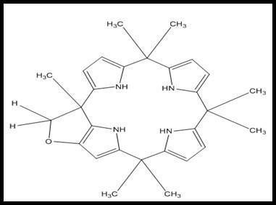

Figure 1.11 Hydrofuran‐fused calix[4]pyrrole

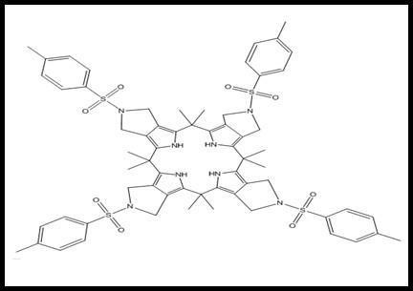
Calix[4]pyrrole was first synthesized by Kim et al with N-tosylpyrrolidine fused at -pyrrolic positions. (Figure 1.12). The receptor is capable of making a complex with as an ion pair of cesium halide in solution of chloroform due to binding of halide anion with the NH protons of pyrrole via hydrogen bonds and

Figure 1.12 Structure of N-tosylpyrrolidine fused into the β-pyrrolic positions
Cs+ cation with four tosyl groups via dipole-cation interactions in calix[4]pyrrole, according to ion binding studies using spectroscopy and isothermal titration calorimetry (35,36).

Saha et al. described an ion pair receptor known as calix[4]tetra hydrothiophenopyrrole, which was created by fusing calix[4]pyrrole and -pyrrolic position 2,5-dihydrothiophene in dry THF with 18-crown-6 and potassium tert-butoxide (Figure 1.13). A binding study in CDCl3 solution reveals that can form an ion-pair complex with CsF selectively via H-bonding and cation-interaction. This works well as a receptor for Hg+2 ions, forming stable complexes with both Hg2+cations in rigid 1, 3-alternate conformations.
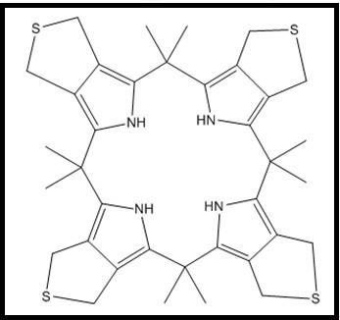

Figure 1.13 Functionalized calix[4]pyrroles at β-position

1.6.2 Modification of calix[4]pyrrole at the N-rim

Takata et al. reported the possibility of modifying the calix[4]pyrrole's N-rim. The reaction of meso-octaethyl calix[4]pyrrole, with methyl iodide and sodium hydride in the presence of 18-crown-6 in THF produced a variety of N-methylated calix[4]pyrroles (Figure 1.14). The various products were created by varying the concentration of methyl iodide. When the mono-N-methylated derivative product was used, one equivalent concentration of methyl iodide was obtained. The use of two equivalents of methyl iodide, on the other hand, results in the synthesis of poly-N- methylated derivatives (37).

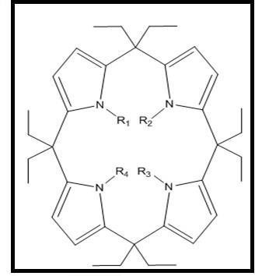
(R1= R2= R3= R4=H)
(R1=Me, R2= R3= R4=H)
(R1= R2= Me, R3= R4=H
(R1= R3= Me, R2= R4=H)
(R1= R2= R3= Me, R4=H)
(R1=R2= R3= R4= Me)

Figure 1.14 N-rim calix[4]pyrrole derivatives

1.6.3 Functionalization at meso (Bridge) Position

In the synthesis of calix[4]pyrrole derivatives, the most advantageous approach is to modify the bridge, i.e. the meso-position. The introduction of groups such as aryl or other rigid groups at the bridge position of calix[4]pyrroles alters the system's inherent ion selective property. In appropriate cases, preamble at secondary binding sites allows selective recognition of bound cationic, anionic, and neutral guests and has great potential as ditopic receptors.

Controlling the amount of ketone in the reaction mixture allows for the formation of mono, di, and tri functionalized derivatives. These derivatives are separated using chromatographic techniques. Sessler and colleagues used the above approach to create amine functionalized calixpyrroles. The precursor was synthesized to function as fluorescent calix[4]pyrrole anion sensors. Structures obtained by acid catalysis condensation of various ketones with pyrrole (Figure 1.15) (38).

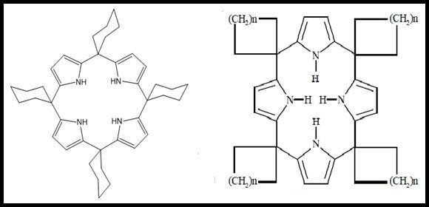

Figure 1.15 Meso-rim modified calix[4]pyrroles derivatives

Carboxyl-functionalized based calix[4]pyrrole were synthesized by condensation of ethyl acetobutyrate and pyrrole with cyclohexanone, which serves as an excellent example of meso-modification. The slow reactivity and proper -ketoester ratios result in a reasonably good yield of meso curved calixpyrrole (Figure 1.16).
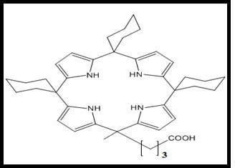
Figure 1.16 Carboxylic acid functionalized calix[4]pyrrole
Danil de Namor and Abbas studied the interaction of calix[4]pyrrole derivatives with metal cations in acetonitrile using various measurement techniques (conductance, calorimetry, potentiometry, and spectroscopy). The research reveals an interaction between the ligands and the Hg(II) ions. Thermodynamic complexation of Hg(II) ion (as perchlorate salt) and receptors in acetonitrile at 298.15 K indicates that replacing one or more pyrrole units from calix[4]pyrrole with thiophene rings has a strong influence on receptor binding ability (39).
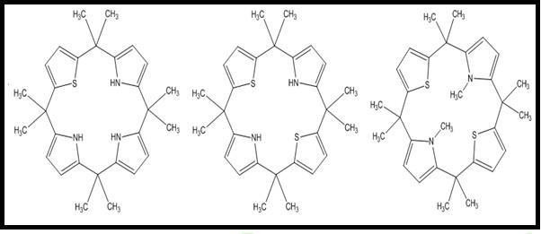

Figure 1.17 Calixthienopyrrole derivatives: Calix[3]thieno[1]pyrrole calix[2]thieno[2]pyrrole and N, N-dimethyl calix[2]thieno[1]pyrrole

El Gamouz studied the complexation process of calix[4]pyrrole where ligand meso-tetramethyl-tetrakis CPA, acted as a receptor for uni and bivalent metal cations (as perchlorate salts), lanthanides (as trifluoro methanesulfonate salts) as well as for anions as a salts of tetra-n-butylammonium in acetonitrile. The main significant chemical changes are seen in the N-H functionality of the pyrrolic rings as well as other proton sites, according to studies using different techniques such as 1H NMR, conductometric, and calorimetric techniques. The thermodynamic results revealed that CPA has the highest stability with Hg2+ when compared to the stabilities of the ligand with other ionic species in acetonitrile solution.

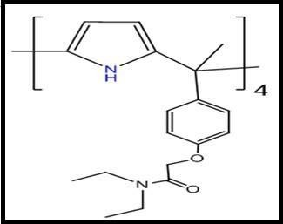

Figure 1.19 meso-tetramethyl-tetrakis-(4-N,Ndiethylacetamidephenoxymethyl) calix[4]pyrrole

Hemangini et al. created a substituted calix[4]pyrrole (HMCP) that senses F- ions and Cu⁺² ions selectively. In absorption spectroscopy, a red shift was observed upon the addition of Cu⁺² and F- ions, indicating the formation of a stable complex with HMCP. The charge-transfer interactions between HMCP with electron-deficient pyrrole rings and the electron-rich guest ions resulted in a significant red shift and colour change (40).
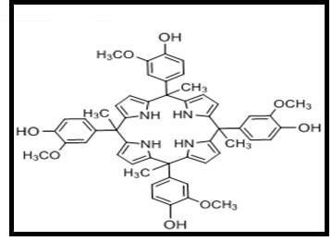

Figure 1.20 Tetra hydroxyl methoxy substituted calix[4]pyrrole

Conclusion
In essence, the world of supramolecular derivatives presents an intricate interplay between the fundamental principles of supramolecular chemistry and the innovative realm of molecular engineering. This abstract has unveiled the myriad structural permutations achievable through deliberate design, guided self-assembly, and strategic functionalization. By seamlessly integrating functional groups into these architectures, tailored properties are harnessed, fueling advancements across diverse applications.

References:

1. Steed JW, Turner DR, Wallace KJ. Core concepts in supramolecular chemistry and nanochemistry. John Wiley & Sons; 2007.
2. Steed JW, Atwood JL. Supramolecular chemistry. John Wiley & Sons; 2022.
3. Pedersen CJ. The discovery of crown ethers (Noble Lecture). Angewandte Chemie International Edition in English. 1988;27(8):1021–7.
4. Oshovsky G V, Reinhoudt DN, Verboom W. Supramolecular chemistry in water. Angewandte Chemie International Edition. 2007;46(14):2366–93.
5. Lehn JM. Supramolecular chemistry. Science (1979). 1993;260(5115):1762–3.
6. Huang F, Anslyn E V. Introduction: supramolecular chemistry. Vol. 115, Chemical reviews. ACS Publications; 2015. p. 6999–7000.
7. Parikh J, Bhatt K, Modi K, Patel N, Desai A, Kumar S, et al. A versatile enrichment of functionalized calixarene as a facile sensor for amino acids. Luminescence. 2022;37(3):370–90.
8. Patel N, Modi K, Bhatt K, Mohan B, Parikh J, Liska A, et al. Cyclotriveratrylene (CTV): Rise of an untapped supramolecular prodigy providing a new generation of sensors. J Mol Struct. 2023;1273:134330.
9. Moreno‐Alcántar G, Casini A. Bioinorganic supramolecular coordination complexes and their biomedical applications. FEBS Lett. 2023;597(1):191–202.
10. Isik A, Oguz M, Kocak A, Yilmaz M. Calixarenes: recent progress in supramolecular chemistry for application in cancer therapy. J Incl Phenom Macrocycl Chem. 2022 Jun 2;102(5–6):439–49.
11. Kumar R, Lee YO, Bhalla V, Kumar M, Kim JS. Recent developments of thiacalixarene based molecular motifs. Chem Soc Rev. 2014;43(13):4824.
12. Kumar R, Sharma A, Singh H, Suating P, Kim HS, Sunwoo K, et al. Revisiting Fluorescent Calixarenes: From Molecular Sensors to Smart Materials. Chem Rev. 2019 Aug 28;119(16):9657–721.
13. Evans NH, Beer PD. Advances in anion supramolecular chemistry: from recognition to chemical applications. Angewandte Chemie International Edition. 2014;53(44):11716–54.
14. Kolesnichenko I V, Anslyn E V. Practical applications of supramolecular chemistry. Chem Soc Rev. 2017;46(9):2385–90.
15. Gutsche CD, Dhawan B, No KH, Muthukrishnan R. Calixarenes. 4. The synthesis, characterization, and properties of the calixarenes from p-tert-butylphenol. J Am Chem Soc. 1981;103(13):3782–92.
16. Baklouti L, Harrowfield J, Pulpoka B, Vicens J. 1, 3-Alternate, the smart conformation of calix [4] arenes. Mini Rev Org Chem. 2006;3(4):355–84.
17. Cram DJ, Cram JM. Host-Guest Chemistry: Complexes between organic compounds simulate the substrate selectivity of enzymes. Science (1979). 1974;183(4127):803–9.
18. Nag R, Rao CP. Calixarene-mediated host–guest interactions leading to supramolecular assemblies: visualization by microscopy. Chemical Communications. 2022;58(41):6044–63.
19. Sayin S. Synthesis of New Quinoline-Conjugated Calixarene as a Fluorescent Sensor for Selective Determination of Cu2+ Ion. J Fluoresc. 2021 Jul 12;31(4):1143–51.
20. Desai V, Panchal M, Dey S, Panjwani F, Jain VK. Recent Advancements for the Recognization of Nitroaromatic Explosives Using Calixarene Based Fluorescent Probes. J Fluoresc. 2022 Jan 23;32(1):67–79.
21. Sharma VS, Vishwakarma VK, Shrivastav PS, Ammathnadu Sudhakar A, Sharma AS, Shah PA. Calixarene Functionalized Supramolecular Liquid Crystals and Their Diverse Applications. ACS Omega. 2022 Dec 20;7(50):45752–96.
22. Rather IA, Ali R, Ali A. Recent developments in calix[4]pyrrole (C4P)-based supramolecular functional systems. Organic Chemistry Frontiers. 2022;9(22):6416–40.
23. Gale PA, Sessler JL, Král V, Lynch V. Calix[4]pyrroles: Old Yet New Anion-Binding Agents. J Am Chem Soc. 1996 Jan 1;118(21):5140–1.
24. Chelintzev V V, Tronov B V. Process of condensation of pyrrole with acetone. Constitution of the resulting products. Zhurnal Russkago Fiziko-Khimicheskago Obshchestva. 1916;48:105–55.
25. Baeyer A. Ueber ein condensationsproduct von pyrrol mit aceton. Berichte der deutschen chemischen Gesellschaft. 1886;19(2):2184–5.
26. Chelintzev V V, Tronov B V. Process of condensation of pyrrole with acetone. Constitution of the resulting products. Zhurnal Russkago Fiziko-Khimicheskago Obshchestva. 1916;48:105–55.
27. Corwin AH, Chivvis AB, Storm CB. The Structure of Acetonepyrrole1. J Org Chem. 1964;29(12):3702–3.
28. Gale PA, Sessler JL, Allen WE, Tvermoes NA, Lynch V. Calix [4] pyrroles: C-rim substitution and tunability of anion binding strength. Chemical Communications. 1997;(7):665–6.
29. Escobar L, Sun Q, Ballester P. Aryl-Extended and Super Aryl-Extended Calix [4] pyrroles: Design, Synthesis, and Applications. Acc Chem Res. 2023;56(4):500–13.
30. Rather IA, Wagay SA, Hasnain MS, Ali R. New dimensions in calix[4]pyrrole: the land of opportunity in supramolecular chemistry. RSC Adv. 2019;9(66):38309–44.
31. Dhumale B, Bhatt KD, Patel N, Modi K. Reconnoitering the Dynamics-Calix [4] pyrrole: A heights in research and technology. Results Chem. 2023;100881.
32. Kasprowiak A, Rather IA, Ali R, Danjou PE. Revisiting β-dicyanovinyl substituted calix [4] pyrrole: Toward the chemodosimetric detection of hydrazine in solution. J Mol Struct. 2023;1287:135694.
33. Desai AL, Bhatt KD, Modi KM, Patel C, Pillai SG. Novel edifice calix [4] pyrrole derivatives as a potential sensor for the detection of analytes and in silico computational behaviour. Talanta Open. 2022;5:100115.
34. Parikh J, Bhatt K, Patel N, Modi K, Parmar N. Host-guest interaction of tryptophane with acid-functionalized calix[4]pyrrole: a fluorescence-based study. J Biomol Struct Dyn. 2023 Jun 28;1–8.
35. Kim SK, Yeon Y, Gross DE, Sessler JL. Hydrofuran ring-fused calix [4] pyrrole: synthesis and ion-binding studies. Supramol Chem. 2012;24(7):481–6.
36. Kim SK, Gross DE, Cho DG, Lynch VM, Sessler JL. N-Tosylpyrrolidine calix [4] pyrrole: Synthesis and ion binding studies. J Org Chem. 2011;76(4):1005–12.
37. Chen D, Luo D, He Y, Tian J, Yu Y, Wang H, et al. Calix [4] pyrrole-based azo-bridged porous organic polymer for bromine capture. J Am Chem Soc. 2022;144(37):16755–60.
38. Sessler JL, Anzenbacher Jr P, Jursikova K, Miyaji H, Genge JW, Tvermoes NA, et al. Functionalized calix [4] pyrroles. Pure and Applied Chemistry. 1998;70(12):2401–8.
39. Danil de Namor AF, Al Hakawati N. Anion Complexation by an Azocalix [4] arene Derivative and the Scope of Its Fluoride Complex Salt to Capture CO2 from the Air. Molecules. 2023;28(16):6029.
40. Bhatt KD, Shah HD, Panchal M. A switch‐off fluorescence probe towards Pb (II) and cu (II) ions based on a calix [4] pyrrole bearing amino‐quinoline group. Luminescence. 2017;32(8):1398–404.

