EXPERIMENTAL INVESTIGATION OF THE EFFECTIVENESS OF GLASS FIBER REINFORCED POLYMER (GFRP) RETROFITTING ON THE MECHANICAL PROPERTIES OF CONCRETE SPECIMEN
Pranav Dutta¹, Paras Yadav², Gurukiran B R³, Shaik M. Feroz⁴
Department of Civil Engineering
Jain (Deemed-to-be) University
Bangalore, India
pranavdutta27@gmail.com

ABSTRACT
Glass Fiber Reinforced Polymer (GFRP) has emerged as a promising retrofitting material for improving the performance and durability of concrete structures. In this study, the effectiveness of GFRP retrofitting for enhancing the mechanical properties of concrete structures was investigated. Concrete cubes and concrete cylinder were casted, followed by material testing and mix-design. Compressive strength test and Split tensile strength tests were performed on both normal concrete specimens and GFRP retrofitted concrete specimens at 7th and 28th day. The results revealed that the GFRP retrofitting significantly improved the split tensile strength of concrete specimens, with GFRP retrofitted concrete specimens exhibiting superior performance compared to normal concrete specimens. The high strength and stiffness properties of GFRP enhance the load-carrying capacity and ductility of retrofitted concrete structures, providing a robust solution for strengthening concrete structures. These findings offer valuable insights into the benefits of using GFRP for retrofitting concrete structures, with practical implications for enhancing structural performance and durability. The study’s outcomes provide a framework for evaluating the effectiveness of GFRP retrofitting and demonstrate its potential to improve the performance and durability of concrete structures, highlighting its potential as a sustainable and cost-effective solution for retrofitting and strengthening aging concrete structures.
Keywords: Glass-Fiber Reinforced Polymer, Retrofitting, Strengthening, Restoration, Concrete Specimens.
I. INTRODUCTION
Retrofitting has grown significantly in importance recently and is now utilized for many different things all around the world. It includes more than just fixing structural issues: it also includes enhancing technology systems, increasing energy efficiency, and implementing sustainable design ideas. To fulfill current needs and regulations, retrofitting old structures or infrastructure has emerged as a practical and environment-friendly solution. Retrofitting plays a critical role in encouraging sustainability, lowering carbon footprints, and maximizing resource utilization by repurposing and modernizing existing structures. This adaptable method is becoming more widely acknowledged as a crucial tactic for creating resilient, adaptive, and sustainable built environments.

I.I FIBER-REINFORCED POLYMER METHOD
The game-changing technique of Fiber Reinforced Polymer (FRP) retrofitting is revolutionizing the way we improve structures. FRP's high strength-to-weight ratio, durability, and corrosion resistance make it a lightweight and flexible alternative to traditional approaches. It guarantees a speedy simple installation process, minimizing interruption and lessening the effect on already-existing structures. FRP is a great option for modernizing buildings and bridges because of its resistance to environmental elements and capacity to improve aesthetics. Even if costs and impact resistance should be taken into account, the benefits of FRP retrofitting are apparent and include better performance, a longer lifespan, and a safer, more robust built environment. FRP has the potential to change the way retrofitting is done in the future by opening up fresh options for improved constructions.
I.II BACKGROUND OF GFRP
Glass fibers inserted in a polymer matrix make up the composite material known as GFRP (Glass Fiber Reinforced Polymer). It is lightweight, corrosion-resistant, and has great strength and stiffness. Construction firms employ GFRP to reinforce buildings, while the automotive, aerospace, and marine sectors utilize it to make lightweight parts. It offers durability in hostile settings and a strong-to-weight ratio.
I.III ADHESIVE REQUIREMENTS
To firmly connect FRP composites to concrete surfaces, superior adhesive resins are required. These resins, which include polyester, epoxy, and phenolic, work as adhesives to join other polymeric materials with ease. The most popular kind, epoxy resins, are created by mixing particular amounts of epoxy and hardener in accordance with the manufacturer’s guidelines.
II. OBJECTIVES & METHODOLOGY
II.I OBJECTIVES
- To compare the structural behavior and performance of GFRP retrofitted concrete specimens with normal concrete specimens under compression and tensile loading conditions.
- To evaluate the effectiveness of GFRP retrofitting in enhancing the mechanical properties of concrete structures through material testing and strength tests on retrofitted specimens.
II.II METHODOLOGY
At first, the collection of materials is done and the properties of the materials are characterized. As per the quality of materials, the mix design is done as per IS 10262:2009. After the mix design is done, casting of 12 concrete cubes of 100*100mm and 12 concrete cylinders of 100*200mm is done and is left for curing in the curing tank. Damage on concrete specimens is done followed by compressive test of concrete cube (3 normal concrete cube and 3 damaged GFRP retrofitted concrete cube) and split tensile strength test of cylinder (3 normal concrete cylinder and 3 damaged GFRP retrofitted concrete cylinder) is done at 7th day and same is repeated for 28th day too. Finally, normal concrete cubes and cylinders and self-damaged GFRP retrofitted concrete cubes and cylinders are compared as per the tests carried out.

II.III PROCESS
- Surface Preparation: Clean and roughen the concrete surface.
- Apply Epoxy Resin: Evenly apply epoxy resin on the concrete surface.
- Place GFRP Mat: Position and smooth out the GFRP mat on the resin-coated surface.
- Apply Epoxy Resin: Apply another layer of epoxy resin on top of the GFRP mat.
- Curing: Allow the epoxy resin to cure for the specified time (24-48 hours).
- Repeat Steps: Repeat the above steps until the desired GFRP layer thickness is achieved.
- Benefits: The use of GFRP and epoxy resin strengthens and repairs the concrete, enhancing durability and performance.

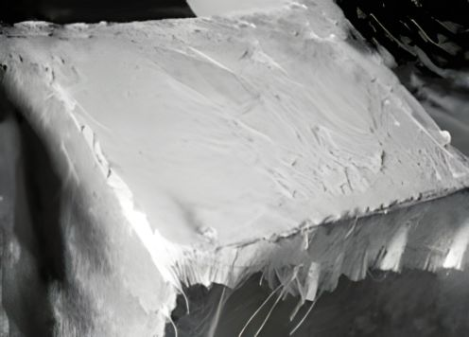
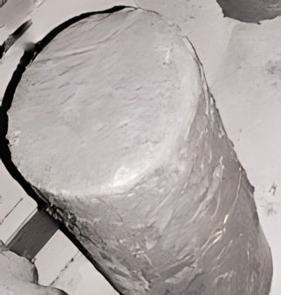

Fig a. GFRP retrofitted concrete cylinder Fig b. GFRP retrofitted concrete cube
III. MATERIAL PROPERTIES
III.I CEMENT
Ordinary Portland Cement (Birla) of Grade 53 was used for this research.
III.II AGGREGATES
M Sand is used as fine aggregates and 20mm down size of coarse aggregates is used.
III.III GLASS-FIBER REINFORCED POLYMER MAT (GFRP MAT)
Glass-Fiber Reinforced Polymer (GFRP) composite is a commonly used material for retrofitting works in Civil Engineering and is readily available in the market. One of the main advantages of using GFRP mat is its flexibility to be shaped according to the site conditions.
III.IV EPOXY RESIN
A thermosetting material called epoxy resin is utilized in many different fields as an adhesive or coating. It is made up of two parts resin and hardener which, when put together, undergo a chemical reaction to create a sturdy material. Epoxy resins cures at different rates depending on formulation, temperature, and humidity. Normally, it takes 24 to 48 hours to fully heal, however this time frame is flexible. The, manufacturers recommendations for correct mixing, application, and curing must be strictly adhered to.
IV. MIX-PROPORTION
- Cement- 413.33Kg
- Fine Aggregate- 656 Kg
- Coarse Aggregate- 1161 Kg
- Water to Cement ratio - 0.45
- Mix proportion by weight - 1:1.6:2.81

Table. I Mix Proportion
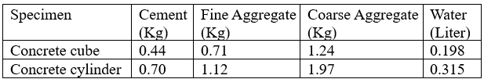
V. CASTING & CURING OF CONCRETE SAMPLES
After doing all the materials testing and mix-design, all the concrete samples were as per the mix design i.e., 1:1.6:2.81. Concrete cubes of 100mm*100mm*100mm and concrete cylinders of 100mm dia and 200mm height were casted as per the mix-design obtained from the test conducted. The materials used were obtained from the local market of Bangalore. The tap water available in the laboratory were used for mixing purpose. Total of 12 concrete cubes and 12 concrete cylinders i.e., 24 concrete samples were casted in the laboratory. After the completion of casting, the concrete samples were kept for curing in a curing tank. After 7th and 28th day, compressive strength test for concrete cubes & split tensile strength test with and without retrofitting were carried out respectively.
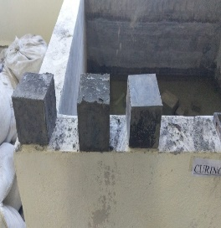
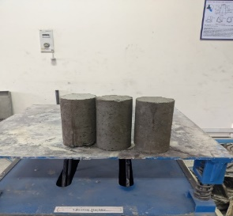

Fig b. Concrete Cylinder Fig c. Concrete Cube
V.I DAMAGING OF CONCRETE SAMPLES
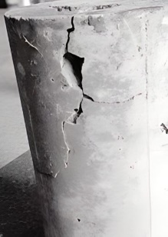
Concrete cubes and concrete cylinders are damaged using hammer. After damaging, it is retrofitted using GFRP and epoxy resin.
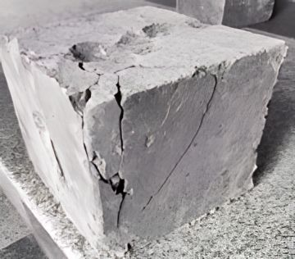

Fig d. Damaged Concrete Cylinder Fig e. Damaged Concrete Cube

VI. PROPERTIES OF CONCRETE
- FRESH PROPERTIES OF CONCRETE
- Workability of Concrete
A common test to assess the consistency or workability of freshly mixed concrete is the slump test. It gives an indication of the concrete mixtures water content, aggregate dispersion, and general quality. In this test, the cone is layered with concrete and tamped 25 times each time and the cone are then raised vertically. The figure below displays the slump test.
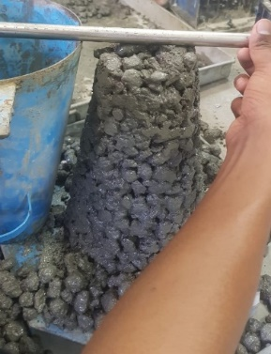

Fig f. Slump Test
- MECHANICAL PROPERTIES OF HARDENED CONCRETE
- Compressive strength of hardened concrete
The compressive strength test was carried out on cubical specimen of size 100mm in a compression testing machine of capacity 2000KN, as per IS 516:1959 specification. The setup of compression test is shown in fig.
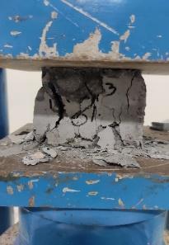

Fig g. Compression Test Setup
- Split Tensile Strength of Hardened Concrete
Split tensile test was carried out on a cylindrical specimen of size 100*200mm in a universal testing machine of capacity 2000KN, as per IS 516:1959 specification. The setup of split tensile test is shown below:

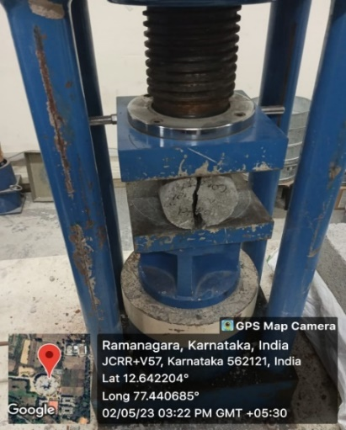

Fig h. Split Tensile Test Setup
VII. RESULT & DISCUSSION
Table II. Properties of Materials
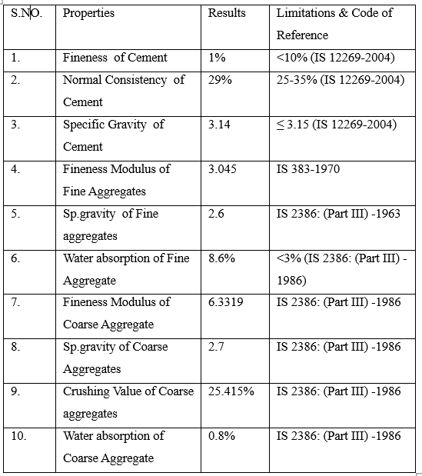
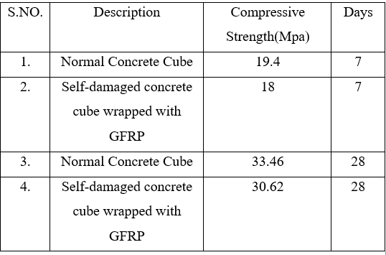
Table III. Compressive Strength Test

Table IV. Split Tensile Strength Test
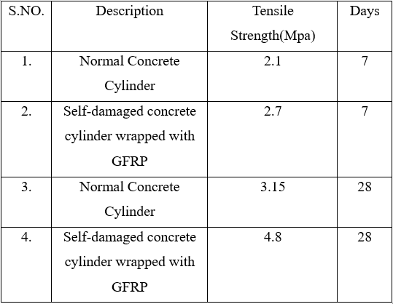

VII. CONCLUSION & FUTURE SCOPE
A study comparing retrofitted cylinders to non-retrofitted cylinders demonstrated that retrofitting concrete structures with GFRP greatly boosts their strength. This demonstrates the great potential of GFRP for strengthening and rebuilding ancient structures, boosting the economy, technology, and aesthetics of the construction sector. According to the study, GFRP laminates can be used for significant structural elements of contemporary buildings because of their stiffness, which reduces bond failure stresses. To evaluate the long-term performance of modified structures, particularly in extreme circumstances like earthquakes, more research is required. When compared to other fibers, GFRP is a more affordable option, and a cost-benefit analysis can evaluate whether it is suitable for certain applications. Investigating variables including the kind and amount of GFRP utilized, as well as surface preparation and bonding methods, might help to optimize the retrofitting procedure.
REFERENCES
- Siddika, A., Al Mamun, M. A., Alyousef, R., & Amran, Y. M. (2019). Strengthening of reinforced concrete beams by using fiber-reinforced polymer composites: A review. Journal of Building Engineering, 25, 100798.
- Sarker, P., Begum, M., & Nasrin, S. (2011). Fiber reinforced polymers for structural retrofitting: A review. J. Civ. Eng, 39(1), 49-57.
- Eppa Sahithi, Chitlapally Shiva Sai. (2021). Retrofitting Using Fiber Reinforce Polymers. A Review. International Research Journal of Engineering and Technology (IRJET)
- Ankit Dasgupta. (2018). Retrofitting of Concrete Structure with Fiber Reinforced Polymer. IJIRST –International Journal for Innovative Research in Science & Technology
- R. Nandhini, Dr. M. M. Saravanan, Karunya Grace.A. (2020). Retrofitting Of Concrete Structures Using Fiber-Reinforced Polymer (FRP): A Review. INTERNATIONAL JOURNAL OF SCIENTIFIC & TECHNOLOGY RESEARCH
- Aleesha Alexander & Nimesh Mohan. (2015). Retrofitting of Reinforced Concrete Beam with Glass Fiber Reinforced Polymer Strips and Sheet. International Journal of Engineering Research & Technology (IJERT)
- K. Mohandas & G. Elangovan. (2016). Retrofitting of reinforced concrete beam using different resins bonded GFRP laminates. International Journal of Advanced Engineering Technology
- Durgadevi, S., Karthikeyan, S., Lavanya, N., & Kavitha, C. (2021). A review on retrofitting of reinforced concrete elements using FRP. Materials Today: Proceedings, 45, 1050-1054

