Liar Domination on Hesitancy Fuzzy Graphs
S.SANGEETHA,S.VIJAYALAKSHMI,N.MALINI,A.KIRUTHIKA
DEPARTMENT OF MATHEMATICS
DHANALAKSHMI SRINIVASAN COLLEGE
OF ARTS AND SCIENCE FOR WOMEN (AUTONOMOUS)
(AFFILIATED TO BHARATHIDASAN UNIVERSITY)
PERAMBALUR
Email: sangeethasankar2016@gmail.com

Abstract
In some networks including computer network, communication network, transport network, social network etc., consider there is some intruder such as thief, fire in a place or fire in ventilation duct or possible processor fault in a computer network. A set S is said to be a liar dominating set if it can identify the location node x of an intruder when any one of the nodes which is closed neighborhood of x lie or wrongly identify the intruder’s location.
In this paper, we study some characterization of liar dominating set for hesitancy fuzzy graphs and also discuss some theorems and results with suitable examples.
Introduction
Assume that each vertex of a graph G is the probable location for an “intruder”, for instance, a thief or a saboteur, a fire in a facility or some imaginable processor fault in a computer network. A device at a vertex u could be expected to sense the intruder at any vertex in its closed neighbourhood N[ u] and to recognize at which vertex in N[ u] the intruder is positioned. Liar’s dominating sets can identify an intruder’s position even if the other device in the neighbourhood of the intruder vertex fails, that is, if device in the neighbourhood of the intruder vertex misidentifies the presence of other vertex in its closed neighbourhood as the intruder location. P.J. Slater [1] introduced liar’s dominating sets in graph theory. P.J. Slater [2] introduced Locating sets and it was carried forward by F. Harary and R.A. Melter[3] where they termed it as metric bases. D. Manuel Paul [4] premeditated on both locating-domination and liar domination in circulant networks to narrate the characterization of locating-dominating set and liar dominating set of circulant networks and sharp lower and upper bounds. .[6] A.Nagoorgani studied Fuzzy Independent dominating sets.[5][7] A.Nagoorgani studied double domination on intuitionistic fuzzy graphs.

Basic Definitions
Definition 1 : [7] An edge uv is said to be strong if ∞(u,v) = (u,v) and ∞(u,v) = (u,v), where ∞(u,v) is maximum weight of weakest arc and ∞(u,v) is minimum weight of weakest arc.
That is,
∞(,)= sup{^{k}(,)/k=1,2,…n}
∞(,)= inf{^{k}(,)/k=1,2,…n}

Definition 2 : [7] Open neighbourhood of a vertex u is defined as, N(u) = {v ∈ V (G)\(u,v) = µ(u,v)}
Definition 3 : [7] Closed neighbourhood of a vertex N[ u] is defined as, N[ u] = {u} ∪ {v ∈ V (G) : (u,v) = µ(u,v) }
Definition 4 : [7]The vertex u is said to be dominated by the vertex v if u ∈ N[ v] , where, N[ v] = {v} ∪ {u ∈ V,(u,v)is strong edge}.
Definition 5 : [7]Let G =< σ,µ > be a fuzzy graph on V . A set A ⊆ V is called a liar dominating or domination set if it satisfies the following conditions.
- Each vertex u ∈ V (G) is dominated by at least two vertices in A.
- Every pair of vertices u,v ∈ V (G) is dominated by at least three vertices in A.
Definition 6 : [7] An hesitency fuzzy graph (HFG) is of the form G = (V,E) where
- V = {u₁,u₂,u₃,...,u_{n}}such that α₁ : V → [0,1] and β₁ : V → [0,1] denote the degree of membership and non-membership of the vertex u_{i} ∈ V respectively and 0 ≤ ≤1, for every ∈ V (1 = 1,2,..n).
- E ⊂ V × V where : V × V → [0,1] and : V × V → [0,1] such that
And 0 for all
Definition 7 : [7] An hesitancy fuzzy graph G = (V,E) is called strong if
for all ∈ E.
Definition 8 : [7] An hesitancy fuzzy graph G = (V,E) is called complete if
for all ∈ V .
Definition 9:[7] Let G =(V,E) be an HFG. Then the cardinality of G is defined to be
=
Definition 10:[7]
Let G =(V,E) be an HFG. Then the vertex cardinality of G is defined to be
=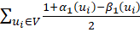, for all
Definition 11:[7]
Let G =(V,E) be an HFG. Then the edge cardinality of G is defined to be
=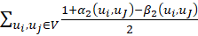, for all 1
Definition 12 : [7] A path in an hesitancy fuzzy graph G is a sequence of vertices and edges … such that either one of the following conditions is satisfied.
- 0 and = 0 for some i, j.
- = 0 and > 0 for some i, j.
- 0 and 0 for some i,j.
Definition 13 :[7] Let u be a vertex in hesitancy fuzzy graph. Then, N[u] = {u} ∪ {v : v ∈ V and (u,v) is strong edge in HFG } is called closed neighbourhood of the vertex u in G.
Definition 14 : [6]A vertex u is said to be a isolated vertex if N(u) = ∅. An isolated vertex u is dominated by itself.
Definition 15 : [6]We say that u dominates v if v ∈ N[u]. This implies that u dominates itself. Obviously, domination satisfies symmetric relation on V . That is, u dominates v iff v dominates u,∀u,v ∈ V .
If no edge is strong edge in HFG, then we can not form liar dominating set for hesitancy fuzzy graphs, since every node is single dominant node in this case.
Liar Domination for hesitancy Fuzzy Graphs:
Definition : A set I ⊆ V in a HFG is called a liar dominating set if I satisfies the following two conditions:
- every u ∈ v is dominated by minimum two nodes in HFG.
- every pair u,v ∈ V, is dominated by minimum three nodes in HFG.
Definition : A liar dominating set I in HFG is called a minimum liar dominating set, if there is no liar dominating set I⁰ such that |H⁰| < |H|.
Definition : The minimum fuzzy cardinality of liar dominating set I in HFG is called liar dominating number and is denoted by ω(HFG).
In Figure 1, ω(HFG) = {v₁,v₂,v₄} forms liar dominating set.
Definition : A liar dominating set H⁰ in HFG, is called a minimal liar dominating set if no proper subset of H⁰ is a liar dominating set.
Definition : A liar dominating set I in HFG is called a maximum liar dominating set if there is no liar dominating set I⁰ such that |H⁰| > |H|.
In Figure 2, {a,b,c,d,e,f} is maximum liar dominating set.
Theorem 1 : A liar dominating set I in HFG G =< V,E > is a minimal liar dominating set if for each p_{m} ∈ I,m = 1,2,...,i,...,j,...,n, then one of the following conditions hold.
- p_{i} (for some i) is a strong neighbour to only one vertex in I;
- There are nodes v ∈ V_{I} such that N(v) ∩ I = {p_{i},p_{j}},p_{i},p_{j} ∈ I.
Proof 1 : Let I be a minimal liar dominating set in HFG. Let p_{i} ∈ I. Then I − {p_{i}} is not a liar dominating set of G. This implies that there is some u ∈ V is not dominated by I − {p_{i}}.
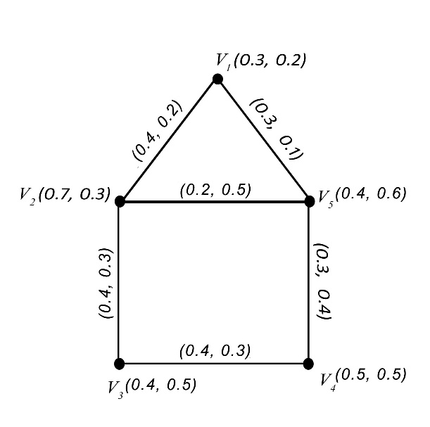
Figure 1:
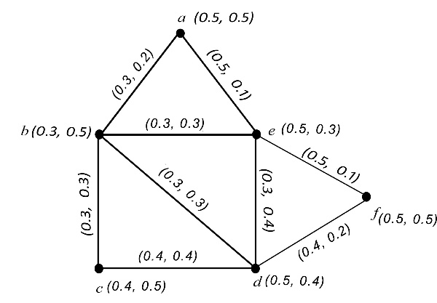
Figure 2:
If u = p_{i}, then p_{i} is strong neighbour to only one vertex in I. Since I is a liar domination set, if v 6= p_{i}, (i.e) v ∈ V −I, then there are two strong neighbours to v in I. That is, N(v)∩I = {p_{i},p_{j}} where p_{i},p_{j} ∈ I.
Conversely, Suppose the two conditions (i) & (ii) hold in HFG.
Suppose I is not a minimal liar dominating set. If v 6= p_{i} ∈ I, then there are two strong neighbours to v in I, then this is contradiction to (i).
Let v ∈ V − I, then each v is dominated by at least three vertices in I. Then Condition (ii) fails in this case.
Therefore I must be minimal liar dominating set in HFG.
Theorem (2)
If G is a hesitancy fuzzy graph without pendant vertices and nthen 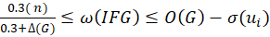, for some i.
Proof:
In an hesitancy fuzzy graph, pendant vertex v is a vertex in G such that N(v) = {u}, for some u
If G does not contain any pendant vertex, then all the vertices must be in a cycle. This implies that one can find a vertex namely for some i is dominated by at least two vertices in I. Obviously, u satisfies the second axiom of liar dominating set if D = V\
Thus,
Each node of G can dominate itself and other nodes.Therfore, lower bound for dominating number could be,
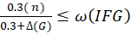, which proves the theorem.
Theorem (3):
+ 2 (O(G))
Proof:
Let HFG be an hesitancy fuzzy graph and be a complement of HFG.
From the above theorem,
(1)
But, may be an hesitancy fuzzy graph with pendant vertices.
(2)
From (1) and (2)
+ 2 (O(G))
Theorem (4):
(p-v)), where (u,v) is weakest arc and G has no pendant vertices.
Proof:
If G is hesitancy fuzzy graph without having pendant vertices, then every vertex has 2 neighbours. Since there is no pendant vertex in G, G must contain a fuzzy cycle. Then there is at least one node in G has two strong neighbours. Therefore, V(G) \u form a liar dominating set in G. Since (u,w) is weakest arc, is the least membership value.
Therefore,
(p-v)),
Conclusion
In this paper, we introduced the liar dominating set for hesitancy fuzzy graphs and also discussed some theorems and results with suitable examples.

References
- E. J Cockayne, P.M. Dreyer Jr., S.M. Hedetniemi, On Roman domination in graphs, Discrete Math. 278 (2004), 11–22.
- S.Sangeetha,PERFORMANCE ANALYSIS OF GAME THEORY FOR NETWORK SECURITY IN WSN,Sangeetha S, JOURNAL OF CRITICAL REVIEW
,2637-2642

- S Sangeetha,Fuzzy graph theory and coloring ,material today proceedings
- S.Sangeetha,Turkish Journal of Computer and Mathematics Education Vol.12 No.7 (2021),1171-1176
- S.Sangeetha,Basic concepts of fuzzy matrices,IJERT
- S.Sangeetha Application of RAM in Dual Hesitant Fuzzy Transportation Problem,journal of algebraic statistics
- S.Sangeetha ,Bipolar valued fuzzy B-ideals on B-Algebra, European Journal of Molecular & Clinical Medicine.

