Battery Energy Storage System (BESS) for Addressing Energy Transition in India
Ashish Kumar Sharmaª, Saurabh Motiwala^{b}, Ishan Purohitª
ªInternational Finance Corporation, World Bank Group, India
^{b}Indian Institute of Technology Bombay

1. Introduction
Being world’s third-biggest emitter of GHG’s India has targeted to reduce the emissions up to 45% of its GDP value of 2005 levels by the 2030. Since energy generation is one of the prime contributors of GHGs country also launched several missions and polices to reduce the fossil fuel-based electricity generation. Further, commitments have been made to reduce this share to 50% by 2030. In view of above commitments, commitments country has also targeted to install 500 GW renewable energy-based electricity capacity by 2030.
By end July 2023, total installed renewable energy capacity reached 130.86 GW followed by 71.11 GW solar, 43.94 GW wind,49.80 small etc. There has been significant emphasis and adoption of large-scale renewable energy options and shift in focus from standalone to hybrid solutions that provide firm (or even “round the clock (RTC)”) renewable energy.
Despite of rapid growth, ambitious targets the typical arguments against renewable based energy generation are predominantly related to (i) integration into the overall power system (grid), (ii) dispatchability, (iii) scheduling and forecasting, (iv) curtailment, clipping and must run status (NREL, 2016). Compared with the conventional power generation (coal, gas, hydro and nuclear fired technologies) the power output from renewables (without energy storage) is not being controllable and thus have such challenges. Moreover, in the present scenario, emphasis is given on reliability and dispatch ability by the consumer as well as seller of electricity market. The reason being energy markets in India are moving from a fixed tariffs to demand based tariffs. Also, power producers are getting higher prices for meeting peak energy demand of consumers. Another trend prevailing in Global as well as in Indian energy market is procurement and selling of renewable based electricity which is govern by polices as well as RPOs. In view of the above, power producers’ intended to providing high quality RE power as well whenever needed. However, the power output of renewable energy plants typically depends on intermittent resource (wind power density & solar insolation etc.) is again problematic for stability of electric grid due to continuous harmonics. Moreover, 500 GW of non-fossil fuel-based power would mean a substantial share in future total generation of energy in India. Such large share of intermittent sources will require reliable transmission infrastructure which again is a huge investment to ensure smart supply and demand management. Intermittent behaviours of renewable sources create un-stability and harmonics in the electricity grid due to reflection in voltage and power output and frequency responses which further affects the transmission and distribution systems of utility grid. Table 1 summarizes three key characteristics of renewable energy generation which affect the power grid. These characteristics itself are the major challenges to the green power producers whether technically of economically.
Table 1. Characteristics of renewable electricity generation and associated integration challenges³
Characteristic Impact |  | Integration Challenge
 |  | Energy Value & Curtailment | Capacity Value
Variability | RE output can vary  as underlying  resource fluctuates. | Supply/demand mismatch  coupled with generator  inflexibility leads to  curtailment. | RE may not be able to replace  conventional capacity during  periods of peak demand.
Uncertainty | Output cannot be  predicted with perfect  accuracy. | Part-load operation of thermal  plants for operating reserves  leads to curtailment. | Capacity needed for provision  of operating reserves.
Non  synchronous  generation | RE does not currently  help maintain system  frequency. | Part-load operation of thermal  plants for provision of  frequency response leads to  curtailment. | Capacity needed for provision  of frequency response.

This is an established fact that energy transition (RE targets, coal Phaseout, coal repurposing etc.) is impossible without intervention of energy storage technologies. Govt, of India has come out with energy storage requirements to execute its 500 GW non fossil fuels-based energy generation target by year 2023 in its revised national electricity plan. In view of the above, it is evident that storage of energy is highly necessitated for smoother integration of RE sources into the electricity grid. whether it is at generation, transmission, or distribution along with the grid ancillary services. The provision of energy storage technologies not even reduce peak demand but also enhance day-to-day reliability, and can also ensure power in case of interrupted generation. All these benefits of energy storage would reduce overall envisaged costs (consumer and utility) by consumer by easing load balance challenges.
2. Energy Storage Technologies
Energy storage technologies can be described under five classifications based on the working principle. These include, mechanical, electrochemical (or batteries), thermal, electrical, and hydrogen storage technologies. These technologies have different use case scenarios, capable of providing electricity with in fraction of seconds to hours. The suitable duration (long or short) of storage, scale of systems (in MW and MWh) and response time are technology dependent making it important to choose the appropriate technology as per the application requirements and constraints.
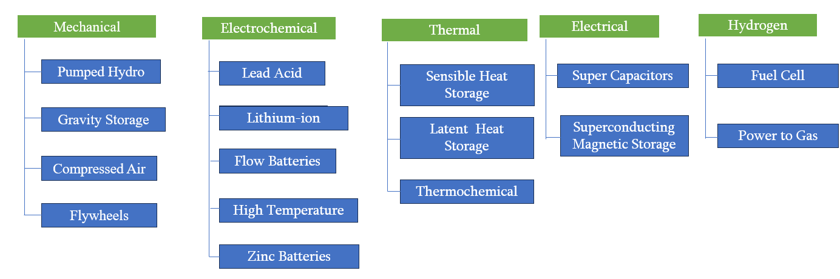
Figure 1. Classification of energy storage technologies
2.1 Mechanical Energy Storage
This is the energy storage by applying force to an appropriate medium to deliver acceleration, compression, or displacement (against gravity); the process can be reversed to recover the stored kinetic or potential energy. This energy storage works in complex systems that use heat, water or air with compressors, turbines, and other machinery.
2.1.1 Pumped Hydro Storage (PHS)
Pump hydro system stores potential energy of water at higher elevation. During off demand of energy water is pumped to the reservoir located at higher elevation and stored in the form of potential energy. During the peak or regular energy demand this stored water is guided to run the turbine and generate PHS systems usually store energy for long durations (8-24 hours).
2.1.2 Gravity Storage Technologies
Gravity based energy storage technologies bases systems works on the same principle of PHS i.e. storing potential energy for later use, Only difference in on place of liquid medium water, cement, rocks and bricks are used thus prevail the advantage of higher density (of these solids) and reduces the size of energy storage system. In addition, alike the PHS these system does not require specific geological features.
2.1.3 Compressed Air Energy Storage (CAES)
A CAES system stores compressed air underground or in high pressure vessels. During off or excess availability of energy demand electric pumps compressed the air at high pressure During peak or regular energy demand, this stored compressed air is guided towards the blade of a modified gas turbines to generate electricity.
2.1.4 Flywheel Energy Storage (FES)
Flywheels are also mechanical energy storage system those store rotational or kinetic form of energy in a heavy cylindrical rotating mass. Flywheel are manufactured with the materials those can sustain high centrifugal forces and velocities. These systems can absorb as well as deliver energy in very short span of time, thus suitable for high power applications.
2.2 Electrochemical Storage
Electrochemical storage technologies include systems are basically the battery energy storage systems (BESS), where energy is stored in the form of electrochemical reactions. These batteries are of different materials and chemical compositions to work such as lead-acid batteries, lithium-ion (Li-ion) batteries, sodium-sulfur batteries (NAS), flow batteries, Zn-air batteries, and supercapacitors. Based on the type and sub-technology these batteries can be well used for a short duration (few minutes) or long duration (8+ hours) applications. For stationary storage applications, two of the main parameters are the cycle life and the roundtrip energy efficiency (%) of the batteries.
2.3 Thermal Storage
Thermal energy storage system stores energy in the form of heat. Energy transfer takes place during heating and cooling process. Energy storage could be of sensible heat storge or latent heat storage.
2.3.1 Sensible Heat Storage
Energy is storage in the specific materials in a thermal gradient, which can be further utilized while its heating or cooling. One of the most well-known technologies of this type is molten salt storage, which is coupled with solar thermal power plants. During sun shine hour heat generated by the collector field is used to increase the temperatures of molten salts and stored in the insulated vessels. In the off-sunshine hours this stored heat is transferred to water which convert it into steam and finally steam is guided to the steam turbine to generate required electricity. There is no change in the phase of medium during heat energy storage and its release. Another important technology in this space is hot and chilled water storage. These are especially relevant where a large part of the electrical load is for space heating or cooling applications.
2.3.2 Latent Heat Storage
Latent heat storage is similar to sensible heat storage where energy is again stored through temperature gradient with in a material or substance, however, during this process this material undergoes a phase change (transition between solid and liquid) as it stores and releases energy. Examples of latent heat storage include ice stored for cooling applications, storage of saturated steam for industrial applications etc. During periods of excess energy and low demand (usually night-time), the liquid water is converted into ice and stored in large tanks. When the cooling load increases during the daytime and afternoon, the ice is melted to provide space cooling to the connected buildings.
2.3.3 Thermochemical Storage
The third category of thermal storage involves storing energy in reversible chemical reactions. Compared to the other two technologies these are much more compact and lightweight however, not commercialized yet and are in the nascent stage of research and development.
2.4 Electrical Storage
Specially designed systems those works on engineering principles are capable of storing energy in the form of electricity directly. As an example, superconducting magnetic energy storage (SMES) systems store energy in the magnetic field created by the flow of direct current in a superconducting coil which has been cryogenically cooled to a temperature below its superconducting critical temperature. Again, these systems are not commercialized at large scale yet however mainly used for power quality control in manufacturing plants and microchip fabrication units. These technologies are ideal for storing and releasing high level of energy for short intervals.
2.5 Hydrogen Storage Technologies (Power-to-Gas)
The basic concept of hydrogen storage technologies is to use electricity to perform electrolysis of water to produce hydrogen and oxygen. The hydrogen produced is stored in high pressure containers and can be used as a fuel for direct combustion (cooking and heating applications) or for electricity generation via PEM Fuel Cells.
A detailed comparison between various technologies of energy storage is presented in this section based on various technical and non-technical parameters. Table 2 can be referred to further understand the strength and weakness of each energy storage system.
Table-2. Technical features of various energy storage technologies
Key tech. Parameters | PHS | CAES | FESS | SCES | BESS
Power range (MW) | up to 3000 MW | ~ 300 MW | 0.01 ~ 0.25 | 0.01 ~ 0.3 | ~ 500 MW
Energy rating (kWh) | up to 24 x 10^6 | up to 2 x 10^6 | 25 ~ 5000 | ~ 5 | ~2.5 x 10^4
Energy density (Wh/kg) | 0.5 to 3 | 30 ~ 60 | 5 ~ 80 | 0.05 ~ 15 | ~230
Lifetime (years) | 75 | 20 ~ 40 | 15 ~ 20 | 25 ~ 30 | < 15
Lifecycles (cycles) | >30k | 8k ~ 13k | 20k ~ 100k | 100k ~ 500k | ~10k
Round trip Efficiency (%) | 75 to 85 | 40 to 75 | 90 ~ 95 | 85 ~ 95 | 85 ~ 95
Reaction time | minutes | minutes | milli-seconds | milli-seconds | milli-seconds
Discharge time | 6 to 8+ hours | 6 to 8+ hours | Sec to 15 mins | milli-seconds to mins | seconds to hours
Self-discharge (%/day) | Nil | Nil | 1.3 ~ 100 | 10 ~ 40 | ~0.15
Nominal Voltage (V) | System voltage | System voltage | System voltage | 2.3 ~ 400 | 1 ~ 4.2
Operating temperature range (°C) | Ambient | Ambient | 20 ~ 50 | -40 ~ 85 | -20 to 60
Power Cost ($/kW) | 500 to 700 | 500 ~ 1800 | 100 ~ 300 | 100 ~ 300 | 350 ~ 600
Energy Cost ($/kWh) | 5 ~ 100 | 50 ~ 400 | 1000 ~ 5000 | 300 ~ 5000 | ~ 500
Scalability | Scaled down /up within operating range of PTG units | Difficult to scale up/Down | Applicable only for low E/P ratio applications | Scalable by connecting in parallel | Easily scaled up/down
Limitations | Topographical and geological considerations | Topographical and geological considerations | Higher self- discharge and cost | Higher self- discharge and cost | No such requirements
Application | High energy storage and peaking power applications | Bulk energy storage applications | Only for very short duration power applications | Only for very short duration power applications | Both energy and power applications
Renewable integration applications | Energy & Power shifting | Energy & Power shifting | Smoothing, Ramp rate control | Smoothing, Ramp rate control | Smoothing, Ramp rate, Load shifting
Application Restrictions | Only Grid/Utility scale applications | Applications with longer discharge duration. | Only Shorter duration discharge applications | Only Shorter duration discharge application | Compatible for all type of applications
Installation period (years) | > 4 | >4 | 0.5 ~ 1 | ~ 0.5 | 0.5 ~ 1.5
Land requirement (m2/MW) | Site specific | Site specific | ~5 | ~2 | ~10

Among EES technologies described above government policies in India are only revolving around PHS and BESS. Present Chapter focuses on battery energy storage systems (BESS) mainly.
3. Applications of BESS
Batteries are one of the established options of energy storage for shorter to higher duration based on the type of application. Due to their availability in various sizes and system mobility features, Electro Chemical Energy Storage System (ECSS) are commercially successful in grid scale utility applications. The most prominent types of BESS are presented in Table-3.

Table 3. Minimum technical specifications of BESS technologies
No. | Parameter | Units | Lithium ion | Sodium Sulfur | Flow Batteries | Lead Acid
1 | Cell Voltage | V | 3~4.2 | 2.1 | 1.5 | 2~2.35
2 | Specific energy | Wh/kg | 120~230 | 150~240 | 25~75 | 30~50
3 | Specific Power | W/kg | 150~350 | 150~230 | NA | 200~400
4 | Coulomb Rate | - | 0.5~4 | <0.17 | <0.2 | >0.2
5 | Discharge time | Hours | 0.25~2 | > 6 hours | > 5 hours | sec~5hours
6 | Cycle life maximum | No | 6000 | 4000 | 12000 | 2000
7 | Self-Discharge daily | % | 0.15~0.3 | 0.05~20 | Negligible | 0.1~0.4
8 | Installation ease | - | Containerized/ Easy | Non-standard containers / Complex | Containerized/ Easy | Time consuming / Easy
9 | Worldwide installation ranking for BESS | - | 1 | 2 | 3 | 4
10 | Bottomline | - | Proven both commercially and technically | Commercially viable for long duration applications | Commercially viable for long duration and lifetime applications | Not preferable due to lower lifecycle and performance

BESS can be used as an easy alternate with lower Merit order Dispatch (MOD) cost for several application. These applications are briefly described in the following paragraphs.
3.1 Peak Load Management
Peak load management deals with curtailing peak power demand at a given interval of time to optimize the electricity charge. Ideally, to reduce the peak demand, loads need to be scheduled in such a way that all of them are not operated simultaneously to avoid high load demand. However, practically this is challenging as the utility have no control on consumer loads. Therefore, implementation of BESS can reduce the peak demand from the grid and support the load from energy storage system. Batteries can regulate the power flow by its charging and discharging process. It gets charged when the grid is running in off -peak period at lower electricity cost and get discharged to during peak periods at higher cost.

3.2 Energy Arbitrage
Energy arbitrage application is aimed at maximizing the net revenue of utility by purchasing the energy at lower prices and selling it during high-priced time. Conventional electricity market works on real-time scenario of supply and demand. Cost effective ways of storing electrical energy can help the grid to be more efficient and reliable.

3.3 Electricity market (to avoid DSM Penalties)
Unscheduled Interchange (UI) mechanism in general is the difference between actual and scheduled generation/demand in a time block. UI charges levied under grid regulations are further utilized for serving as investment on grid strengthening schemes and ancillary services. Frequency of the grid is a function of supply demand imbalance. Penalties are imposed on utilities for deviations in frequency response under both under drawl and over drawl scenario to maintain the grid performance. To attain maximum profit, the entity needs to ensure that the actual demand follows closely with scheduled demand which is highly challenging. Incorporating BESS will be advantageous for utilities, as it can serve the load with better response time and reduce the penalties under sudden load fluctuations or unpredictable scenarios.

3.4 Distribution Upgrade (Capex) Deferral
Distribution system shall update its capacity to match with the load growth known as distribution upgradation. Distribution system majorly includes substation transformer and feeders to feed the loads. Upgrading the distribution assets with higher capacity will involve huge capital expenditure. Energy storage at utility scale during will help in making the load profile flat and reduces the burden on existing transformers and feeders by shifting the peak demand. In such scenario, need to upgrade the existing equipment can be avoided by extending the life and deferring the investment for few more years ultimately saving effort of replacing equipment and intermittency in the network.

3.5 Reactive Power Management
Reactive power management is an important aspect of power system operation. The prime sources of reactive power in a utility grid are generators, transmission line susceptance and capacitor banks. Excessive flow of reactive power in the grid network may result in voltage instability and poor power supply. Thus, utilities may face both high voltage and low voltage issue due to unbalance in the network at different operating conditions. Thus, it calls for dynamic compensation as an effective solution against. traditional static compensation using reactors/capacitors. Battery energy storage system with an appropriate inverter can operate in both inductive and capacitive mode like STATCOM. The inverter can act as a voltage source and operate in all four quadrants to supply or consume reactive power apart from its basic role of energy charge and discharge. The design of system allows the inverter to provide reactive power to the LV grid and/or downstream load connections which reduces the overall reactive power requirement from the grid. Thus, use of BESS can avoid instability and uneconomical operation of Grid by controlling excessive reactive power.

3.6 Asset Optimization
By placing battery energy storage system at appropriate locations, overloading of transformers and cables can be significantly reduced which will also provide saving in terms of technical losses. Operational costs can also be lowered through effective monitoring of equipment degradation with BESS support.

3.7 Renewable energy based Electric Vehicle Charging
BESS are essential for EV integration and utilized as spinning reserve to meet the power requirement, since it should supply energy at any point of time irrespective of system conditions. During off peak period EV can be directly charged from the grid, whereas during peak period battery can assist in EV charging to avoid the penalty due to higher peak demand and maintain grid stability and reliability. It will also help to maintain huge variations in energy is to be handled in an effective manner to ensure grid reliability, stability and managing huge number of source & load points to maintain system frequency.

3.8 Off-gird/ standalone Power Supply
BESS could be the essential part of a renewable energy system which is standalone and not connected to external electricity grid such as rooftop solar, micro grid systems etc. These systems reduced the consumption of oil-based fossil fuel options where electricity gird is not available or have certain constraints for its expansion. Compared to oil-based generations, batteries are environment friendly and also their response time is quick.

4. Status of BESS Deployment across the Globe
BESS seems to be the best eliminator to tackle the power intermittency behaviour of renewable energy sources. Therefore, acceptance of this technology coupled with RE generator noticed across the globe. US based organization, Energy Information Administration (EIA) predicted a 10 GW increase in battery storage capacity, especially coupled with solar power plants. Major factors, those aiding to this growth include decline in battery costs, and globally favourable polices for wind and solar energy. The notable BESS projects across the globe are briefly summarized in Table-4 below.

Table 4. List of representative grid-BESS projects Project
 | Battery Type | MWh | MW | Hour of Storage | Country | Location | CoD | Remark(s)
Moss Landing Vistra Battery | lithium-ion | 1,600 | 400 | 4 | United States | Moss Landing, California | 2020 | 300 MW / 1,200 MWh Phase 1 commissioned in 2020, 100 MW / 400 MWh Phase 2 in 2021
McCoy Solar Energy Project | Battery, lithium-ion | 920 | 230 | 4 | United States | Blythe, California | 2021 | Battery storage paired with 250 MW solar project[
Moss Landing PG&E Elkhorn Battery | Battery, lithium-ion | 730 | 182.5 | 4 | United States | Moss Landing, California | 2022 | 256 Tesla Megapack battery units
Slate Project | Battery | 561 | 140.25 | 4 | United States | Kings County | 2022 | Paired with 300 MW solar plant
Valley Canter Battery Storage Project | Battery, lithium-ion | 560 | 140 | 4 | United States | Valley Canter, California | 2022
Victorian Big Battery | Battery, lithium-ion | 450 | 300 | 1.5 | Australia | Moorabool | 2021
Alamitos Energy Center | Battery, lithium-ion | 400 | 100 | 4 | United States | Long Beach | 2021
Dalian VFB | Battery, vanadium redox flow | 400 | 100 | 4 | China | Liaoning, Dalian | 2022
Buzen Substation | Battery, sodium-sulfur | 300 | 50 | 6 | Japan | Buzen | 2016 | Buzen Substation
Minety Battery Energy Storage Project | Battery, lithium-ion | 266 | 150 |  | United Kingdom | Minety | 2021
Rokkasho Aomari | Battery, sodium-sulfur | 245 | 34 | 7 | Japan | Rokkasho | 2008
Gateway Energy Storage | Battery, lithium-ion | 230 | 230 | 1 | United States | Otay Mesa, California | 2020
Huanghe Hydropower Hainan Storage | Battery | 202.8 | 202.8 | 1 | China | Hainan, Qinghai | 2020 | Connected with adjacent 2.2 GW photovoltaic Huanghe Hydropower Hainan Solar Park
Crossett Power Management | Battery | 200 | 200 | 1 | United States | Crane County, Texas | 2022
Crossett Power Management | Battery | 200 | 200 | 1 | United States | Crane County, Texas | 2022
Flower Valley II | Battery | 200 | 100 | 2 | United States | Reeves County, Texas | 2022
Gambit battery storage project | Battery, lithium-ion | 200 | 100 | 2 | United States | Angleton, Texas | 2021
Kunshan Energy Storage Power Station | Battery, lithium-ion | 198 | 111 | ? | China | Kunshan | 2020
Pillswood | Battery, lithium-ion | 196 | 98 | 2 | United Kingdom | Cottingham | 2022
Hornsdale Power Reserve | Battery, lithium-ion | 193.5 | 150 |  | Australia | South Australia, Jamestown | 2017 | Tesla Powerpack is charged using renewable energy and delivers electricity during peak hours
Hokkaido Battery Storage Project (provisional name) | Battery, vanadium redox flow | 60 | 15 |  | Japan | Hokkaido | 2015 | Vanadium redox flow battery from Sumitomo near several solar energy projects on Hokkaido Island, operational in December 2015.
Lake Bonney Battery Energy Storage System | Battery | 52 | 25 |  | Australia | Millicent, South Australia | 2019
Gannawarra Energy Storage System | Battery | 50 | 25 |  | Australia | Kerang, Victoria | 2018 | Co-located with Gannawarra Solar Farm
Jardelund | Battery, lithium-ion | 50 | 48 | 1 | Germany | Jardelund | 2018
National Wind and Solar Energy Storage and Transmission Demonstration Project (I) | Battery, lithium iron phosphate | 36 | 6 | 6 | China | Hebei, Zhangbei

5. Utility Scale BESS Interventions in India
India’s first MW scale BESS project was installed in 2019, it has capacity of 10 MW with one hour of storage. The project installed on the distribution network of a private discom TATA power Delhi and used advanced scale lithium-ion- batteries. The BESS system charged during off-peak hours and discharged the power during peak hours. Prime motive of installation is to support the distribution transformers to manage peak load, regulate voltage, improve power factor, regulate frequency, settle deviations, support grid stabilisation, prevent overload, manage reactive power and defer CAPEX (capital expenditure). More recently Tata Power also received a letter of award from the Solar Energy Corporation of India (SECI) for the engineering, procurement and construction (EPC) of an INR 9.45 billion (US $126 million) 100 MW solar project with a 120 MWh BESS storage in Chhattisgarh state of India. In India BESS is also being supported by dedicated polices and regulations described in the following section.
6. Regulatory Regime of BESS in India
Mentioned in the previous section India has ambitious target of installing 500 GW of non-fossil fuel-based power generation capacity by 2030. To tackle the intermittent of RE sources and associated impacts described in the above sections, utility scale applications BESS is also projected as the most suitable option for India. Several policy and regulatory regime prevail in India to support and promote the use of BESS at generation as well as transmission and distribution levels of utility grid. Majority of these interventions are briefly summarized in Table
Solar Energy Corporation of India (SECI), a CPSU under Ministry of New and renewable energy, has called for the expression of interest for procurement of 1000 MWh BESS. This will be published along with the RFS bid document and the draft comprehensive guideline for procurement and utilization of BESS as a part of generation, transmission and distribution assets and with all ancillary services.
Central Electricity Authority (CEA) suggests the use of Pumped Hydro Storage System (PHSP) and Battery Energy Storage Systems (BESS) for commercial deployment. Further, the study by CEA, under its planning model selected the BESS from the year 2027-28 onwards and a BESS capacity of 27,000 MW/108,000 MWh (4-hour storage) is projected to be part of the installed capacity in 2029-30. This is in addition to 10,151 MW of PHSP anticipated to be a component of the installed capacity in 2029-30. Later, on March 11, 2022, the MoP notified new guidelines on procurement and utilization of BESS as part of generation, transmission and distribution assets, along with ancillary services. Apart from this, few business cases have been identified in the MoP guidelines in which BESS can be utilized. This includes BESS coupled with RE/ with transmission infrastructure, storage for distribution/ for ancillary services. Thus, the new guidelines are furnished with the aim of facilitating the procurement of battery storage systems to be utilized either in combination with renewable energy or as a standalone asset. With the falling battery prices, the BESS guidelines will serve as a base to streamline future developments in this sector. These guidelines will also play a critical role in achieving the nation’s renewable energy and decarbonisation goals i.e., to reach net zero emissions target set by India. As per the report of NITI Ayog in India, report India’s annual market could surplus $ 15 billion by 2030 and the battery demand expected to rise 260 GWh in the accelerated scenario by 2030.
7. Utility scale use Cases of BESS in India
BESS projects are in the nascent stage of implementation in India. Government India is coming out with several policy and regulatory interventions on time-to-time basis. However, choice of appropriate business model is still important to make investment viable. Following use cases have been identified regarding potential use of BESS.
7.1 RE supply with BESS
In this case, the BESS is coupled with a renewable energy project at generation site. Thus, ownership of BESS also lies with the RE project developer itself (Fig). During lower demand or excess generation BESS is charged and utilized to meet the peak power demand and ensure firm dispatchability In brief, for charging purposes, BESS developer can procure input energy from the generation (wind/solar/both) owned by it.
7.2 BESS with transmission infrastructure
Prime focus of this model is stability of electric grid, reduction in grid network congestion and optimum utilization of the storage. All this benefits, reduce the investment which may require on augmentation of evacuation and transmission infrastructure, otherwise.
7.3 Storage as an asset for balancing services and flexible operations
This application of BESS is particularly suited for frequency control, load interchanges and load balancing as BESS systems response quickly even in second-to-second basis. The system operator such as Load Despatch Centres could use BESS system to maintain frequency and to manage inherent uncertainty/variations in demand and generation.
7.4 Storage for Distribution Networks
This model aims to strengthen the distribution network of utilities/discoms. In such case, BESS systems may deploy at load centres and distribution sub-stations. BESS may help discom in managing peak demand grid resilience, portfolio management and flexible operations. BESS can also be used as an optimum tool to achieve asset shifting by the Discoms, thereby increasing asset life.
7.5 BESS as Merchant Power
Along with the use cases of BESS described above, it’s also possible to sell the energy stored in BESS in an energy market on merchant basis. However, this component only be traded in the energy market if such regulation prevails.
8. Business Model for BESS
Unlike the only solar or only wind type of utility scale RE projects, BESS projects’ viability depends on applicable use cases and appropriate business models. There are several businesses as per the regulatory environment in various markets. Since the major boost behind the aggregation of BESS across the globe is the penetration of variable RE, therefore in the present section business models of BESS keeping renewable energy in focus are briefly described.
8.1 Business Model 1
In this model for charging purposes, BESS developer can procure input energy from the energy generation (/wind/solar etc.) owned by it (Figure 2). and may sell it to discom/utility during peak power requirement. In this model, energy generator itself will make investment in the BESS project, it could be Capex or Opex. Utility or discom will pay the BESS developer for the energy received.
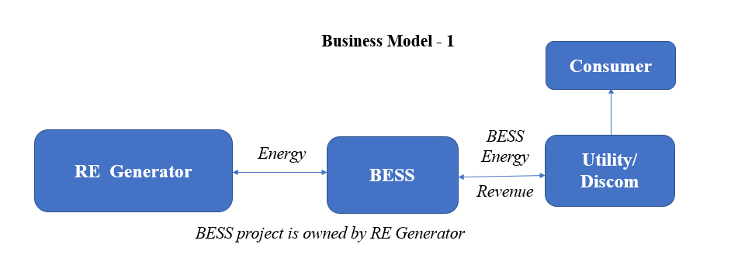
Figure 2. BM 1 of BESS
8.2 Business Model 2: BESS for Distribution Purpose
This would be tolling arrangement where BESS developer would procure power from the buyer (local distribution licensee/open access consumer) during off-peak period and give it back during peak period after discounting for cycle efficiency of the BESS Figure 3. The tariff for such an arrangement shall be mutually agreed by the BESS developer and the buyer. In case of tolling arrangement by the distribution licensee, it shall obtain approval for the arrangement from the appropriate authorities.
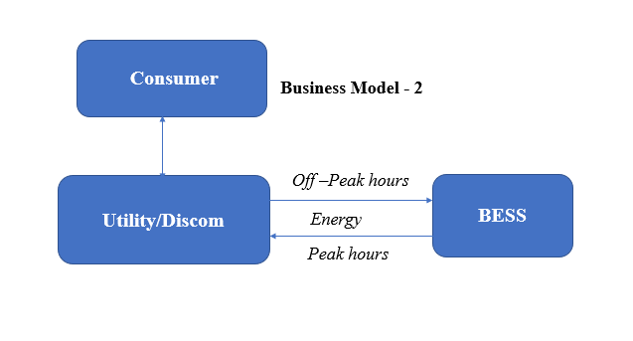
Figure 3. BM 2 of BESS

8.3 Business Model 3: Business Model (BESS as a Distribution Asset)
This model is almost similar to Model 2, the only difference is of ownership or investment in the BESS system. Here, BESS could be owned and operated by the distribution utility itself. Thus, Discoms can establish BESS either through Capex or OPEX /Energy Storage Service Agreement (ESSA) route. In case of Capex route, discoms would undertake competitive bidding for procurement of the system. Discoms may supply power to BESS for charging and scheduling of ESS shall be the responsibility of discoms. Such BESS shall primarily be charged from RE sources and Discoms shall utilize such ESS for compliance towards RPO as per applicable norms.
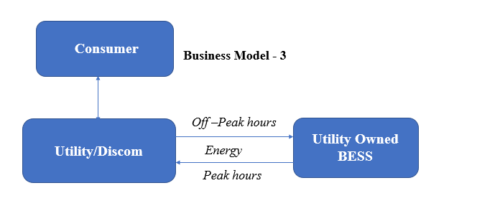
Figure 4. BM of BESS as distribution asset

8.4 Business Model 4: (BESS as a Transmission Asset)
BESS could be useful for congestion management, ancillary services, and deferral of new investment. These applications would require BESS at transmission level. The transmission licensee shall not enter into any contract or otherwise engage in the business of trading of electricity on exchanges. Model is almost similar to BM 2, & 3 only difference is ownership and capital investment, which will be mange by the Transmission entity in place of distribution utility.
8.5 Business Model 5: Independent BESS
In this model, BESS developer would procure power for charging from the energy market (during off peak hours) or by entering into a PPA with any RE generator (Fig. 5). The tariff for procuring power from the BESS shall be discovered primarily through mutual negotiation of both parties. In this model, BESS developer will only invest in project and may sell the energy to utility or to consumers directly through merchant energy markets during peak hours.
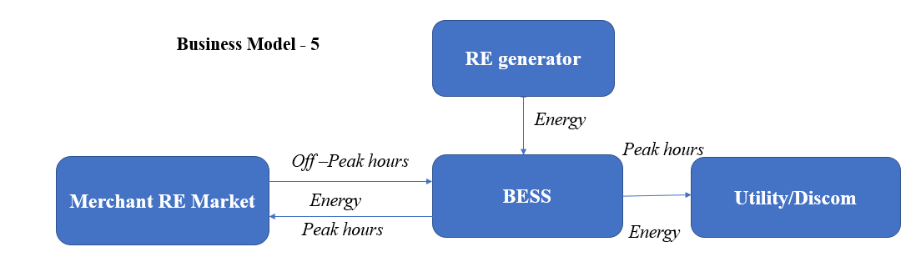
Figure 5. BM of BESS as independent system

9. Drivers and Barriers for BESS Deployment in India
Energy storage have several advantages mentioned in the previous sections. In addition, power plant operators are more interested in using cost effective and TaylorMade solutions to tackle variability of RE. Thus, it is clearly evident that BESS can remove the constraints associated with renewable energy. Storage also has indirect benefits even to conventional plants as during excess energy generation plants may charge the storage system, which could increase the PLF of such plants otherwise they need to shut their operation in the low demand period. Irrespective of all these benefits. Nascent technologies always have certain drivers and barriers those play major role in the large-scale dissemination of such technologies. These drivers and barriers could be the technological, regulatory, or financial etc. Important drivers and barriers of BESS deployment especially in the context of India are briefly summarized here.

9.1 Policy & Regulatory Drivers
- National Energy Storage Mission: The Government of India has created the draft National Energy Storage Mission to promote energy storage
- National Tariff Policy: Mandatory procurement of RE power for DISCOMs and Waiver on inter-state transmission charges for RE power transmitted through the grid to promote open access for large end customers (1 MW and above)
- National Programme on Advanced Chemistry Cell (ACC) Battery Storage: The Government approved INR 18,100 Crore PLI scheme for building manufacturing facilities for battery storage in India. The plan is to set up a 50 GWh manufacturing capacity
9.2 Barriers for BESS Deployment
- Unavailability of high tariffs for BESS integrated VRE. Higher tariffs are difficult proposition for already financially weaker DISCOMS (Distribution companies)
- Even if peak rates in India are higher than off-peak rates by 15 to 20%. This is far less than when compared to US, UK, Australia where the difference is around 200-400%
- Traditionally India has manufactured Lead Acid Batteries. India domestic manufacturing for Lithium-ion and other technologies is at nascent state. Almost 70-75% Lithium-ion batteries are imported from China and Hong Kong. Increasing shipping costs increases the project costs.
- Higher import duties is another hurdle for large scale adoption
- The ancillary market services by BESS including (Voltage regulation, Frequency regulation, Black start facility, Inertia) needs to open up further.
- Technological Constraints: The NTPC tender (500 MW/3,000 MWh) requires a 6-hour BESS solution, while BESS is not a viable option beyond a 4 hour solution. There is a focus to increase the duration to 6- 8 hours, these are still not on a commercial scale resulting in the need for redundancies.
- Lack of standardization: On account of diverse technical requirements and different policy processes there is a lack of standardization within BESS. Each supplier has different tech specs which can be a hindrance to scale.
- Electricity losses (Transmission & Distribution in India): As per one of the working papers from Center for Social and Economic Progress, India has highest transmission losses (technical + non-technical) in the range of 21% compared to 6% in France & Australia and 10% for South Africa and Indonesia. Commercial losses are higher than the typical AT&C losses, which are only reported for the distribution networks. Overall rates of loss can be affected by a number of factors, including maintenance requirements, quality of infrastructure, distance between generator and consumer, poor monitoring and the occurrence of theft. This creates another hindrance in wide scale adoption of BESS
- Restriction to open access: Only end consumers with sanctioned load of 1MW and above are eligible to procure power through open access route. Few states try to limit purchase through open access to protect state-owned DISCOMs. This decreases avenues for dispatchability of power by BESS.
- BESS charging with coal: India's grid infrastructure has been developed with coal plants in mind. So, to mitigate additional infrastructure for grid evacuation, utility scale BESS would have high prospects of charging via thermal power (coal + gas). This would have implication on the prospect of BESS being green energy to be used with VRE -thereby creating ESG issues and subsequently reduced investments.

10. Market of BESS & Key Players
The grid-scale battery market size is projected to grow from $7.72 billion in 2022 to $30.95 billion by 2029, at a CAGR of 21.9% during the forecast period. Reason being is the technological advancement, which has led to a sharp increase in the energy density of the lithium-ion battery market even while decreasing the overall cost of lithium-ion batteries, has enabled the increase in the grid-scale battery deployment. Owing to the aforementioned factors, the lithium-ion battery segment is expected to witness the fastest growth rate during the forecast period.

Asia-Pacific is the fastest-growing market owing to the rapid rate of industrialization and urbanization, which has led to an increase in demand for electricity. Developing countries like India are aiming to create 275 GW of total wind and solar capacity by 2027. Favourable policies, such as the energy efficiency standards and increasing peak demand charges, is expected to drive the demand for grid-scale batteries in the region. Renewable energy’s share of installed capacity is forecast to rise to 43% by 2027. With the growing renewable sector, the demand for grid-scale batteries, to address the challenges related to intermittency in renewable power generation, is expected to grow. Furthermore, due to technological innovations and improved manufacturing capacity, lithium-ion battery chemistry has experienced a steep price decline of over 80% from 2011-2018, and prices are projected to decline further. Furthermore, the recycling of Li-ion batteries is expected to secure the supply of raw materials, such as cobalt and lithium, and reduce the dependence on extracting and refining materials from mineral resources. Recycling of lithium-ion battery that is currently being used in EVs offers an opportunity for companies to utilize the refined constituent materials, for manufacturing lithium-ion batteries that are to be used for Energy Storage Systems (ESS). The grid scale battery market is moderately fragmented and classified under three categories Manufacturer, EPC’s, Service providers. The global grid-scale battery market size is projected to grow from $7.72 billion in 2022 to $30.95 billion by 2029, at a CAGR of 21.9% during the forecast period.
In this market the players in the manufacturing sectors are mostly global companies some of the leading players in the grid-scale battery manufacturer are listed in Table 4
Table – 4. Key market players of BESS
Category | Key Market Players | Country
Battery Manufacturer | LG Chem, Samsung, Kokam | South Korea
 | Siemens Energy | Germany
 | Panasonic, GS Yuasa, Toshiba, NGK Insulator | Japan
 | Fluence, Tesla, GE, | US
 | BYD, Narada, EVE energy Ltd. | China
 | ABB | Switzerland
 | Saft | France
 | S&C Electric, Black & Veatch | US

11. Way Forward
Despite several challenges, polices of government and increase round the clock RE power demand are ensuring the bright future of BESS in India. This will also boost by the technological advancement and large-scale investments. Segments like electric utilities, and C&I are seeming to be the most favourable sector for BESS. However, cost of BESS still is a barrier and its difficult to predict the future reduction due to gap in demand and supply globally. Battery cells share 80%-85% cost of overall system and presently, country is totally depended on the import. However, its expected that globally the prices of li-ion will reduce and affordably in India will also increase. Moreover, GoI. of India has also come out with progressive policy and regulation measures in terms of tax rebate and excise duty relaxation. Initial capital subsidy/viability gap funding and performance linked incentives could also play an important role to tackle the hurdle of higher capital investments in BESS. It was predicted that Govt. energy projects will need 51 GW capacity of BESS in Indi by 2030. Thus, it means every year country require 6GW-8GW of capacity addition annually till 2030. According to a RE research firm Maricom corporate funding for energy storage companies rose from 55% to $ 26.4 billion until 2022 reported as highest ever. With ground-breaking technological developments, government initiatives, and stakeholder participation, the possibilities for achieving an energy storage system ecosystem will significantly expand in the future. Bloomberg NEF (BNEF) research implies that India may emerge as the third largest country in terms of BESS installation by 2040. The rate at which the energy storage sector grows in the future will depend on how quicky market participants move to build trust in the safety of their technologies.

ªAuthor for Correspondence: ipurohitresearch@gmail.com
https://mnre.gov.in/the-ministry/physical-progress
https://www.nrel.gov/docs/fy18osti/71151.pdf
https://www.wrpc.gov.in/wrpc/DSM_REPORT_MSLDC.pdf
https://www.sciencedirect.com/science/article/abs/pii/S0038092X20300992#:~:text=The%20main%20objective%20of%20the,the%20inverter%20is%20not%20violated.
https://www.sciencedirect.com/science/article/pii/S1364032121010066
https://www.iea.org/energy-system/electricity/grid-scale-storage
https://en.wikipedia.org/wiki/Battery_storage_power_station
https://www.tatapower.com/media/PressReleaseDetails/1899/indias-largest-solar-and-battery-storage-project-awarded-to-tata-power-solar-of-inr-945-crore
https://www.seci.co.in/whats-new-detail/2226
https://www.eqmagpro.com/wp-content/uploads/2021/10/BESS-Guidelines-final.pdf
https://www.seci.co.in/whats-new-detail/2205
https://cea.nic.in/wp-content/uploads/irp/2023/05/Optimal_mix_report__2029_30_Version_2.0__For_Uploading.pdf
https://www.niti.gov.in/making-india-aatmanirbhar-advance-battery-storage
https://e-amrit.niti.gov.in/assets/admin/dist/img/new-fronend-img/report-pdf/India-Energy-Storage-Mission.pdf
https://powermin.gov.in/en/content/tariff-policy
https://pib.gov.in/PressReleasePage.aspx?PRID=1846078#:~:text=The%20Government%20has%20approved%20the,outlay%20of%20%E2%82%B9%2018%2C100%20crore.
https://pib.gov.in/PressReleasePage.aspx?PRID=1846078#:~:text=The%20Government%20has%20approved%20the,outlay%20of%20%E2%82%B9%2018%2C100%20crore.
https://www.globenewswire.com/news-release/2023/04/11/2644107/0/en/Grid-Scale-Battery-Market-to-Reach-USD-30-95-Billion-by-2029-at-21-9-CAGR-Advantages-of-Grid-scale-Battery-Adoption-to-Propel-Market-Growth-Fortune-Business-Insights.html#:~:text=Pune%2CIndia%2C%20April%2011%2C,during%20the%202022%2D2029%20period.
https://www.iea.org/news/global-electricity-demand-is-growing-faster-than-renewables-driving-strong-increase-in-generation-from-fossil-fuels
https://www.marketsandmarkets.com/Market-Reports/battery-energy-storage-system-market-112809494.html#:~:text=BYD%20Company%20Limited%2C%20SAMSUNG%20SDI,portfolio%20and%20solid%20geographic%20footprint.
https://energy.economictimes.indiatimes.com/news/power/opinion-how-india-can-effectively-utilize-energy-storage-systems-to-address-energy-challenge/95419026#:~:text=BloombergNEF%20(BNEF)%20research%20implies%20that,power%20flows%2C%20which%20increases%20revenues.

