**Micro plastic Contamination in Cooum River Sediment: A Case Study from Chennai, India**

1Sanju P, * 1Mohamed Afzal J, 1Arfat Nazir

1Department of Geology, University of Madras, Guindy Campus

Chennai, India-600025

*Corresponding Author: Afzal J E-mail [mohamedafzal15dec@gmail.com](mailto:mohamedafzal15dec@gmail.com)

2J. Christinal, 2R.karthik, 2G.M.Moorthy and 2S.Muthusamy

2PG and Research Department of Geology

V.O.Chidambaram College, Thoothukudi-628008, Tamil Nadu, India

(Affiliated to Manonmaniam Sundaranar University, Tirunelveli)

**ABSTRACT**

Microplastic pollution has emerged as a critical global environmental issue, posing serious threats to ecosystems and human health. This study focuses on investigating the extent of microplastic contamination in the sediment of the Cooum River, an urban river in Chennai, India, heavily impacted by industrial activities, urbanization, and inadequate waste management practices. Understanding the presence and effects of microplastics in the sediment of the Cooum River is crucial for developing effective pollution mitigation and restoration strategies. The study involved collecting sediment samples from ten different locations along the Cooum River. These samples were subjected to rigorous laboratory analysis, employing various methods to assess microplastic abundance, distribution, color, size, shape, and composition in the study area. A total of 2433±101 (mean ± standard error n=10) MPs per kg of dry wt microplastic particles were identified in the Cooum River sediment samples. Transparent microplastics were found to be the most prevalent (31%), followed by blue and red microplastics. Additionally, the majority of microplastics were below 1000 µm in size, indicating the dominance of small-sized particles in the sediment. The most common microplastic shapes were fibers, fragments, and films. Using Raman spectroscopy, the study determined the composition of the microplastics, with nylon and polypropylene identified as the dominant polymers present. Other compositions included PMMA (polyMethyl methacrylate), polystyrene, and polyethylene.In conclusion, this study provides valuable insights into the nature and extent of microplastic pollution in the sediment of the Cooum River. The findings underscore the urgent need for collaborative efforts among policymakers, environmental agencies, and local communities to effectively mitigate microplastic pollution, restore the ecological health of the river, and safeguard the well-being of both the river's ecosystem and human populations.

**Keywords**: Microplastics, Cooum River, pollution, sediment, , Raman Spectroscopy,Polymers,Chennai

1. **INTRODUCTION**

Microplastics, which are tiny plastic fragments measuring less than 5 mm in size, have emerged as a significant environmental concern worldwide [1]. These particles can arise from the intentional production of small-scale plastics or result from the breakdown and fragmentation of larger plastic objects [2]. Microplastics are prevalent in rivers and estuaries, posing risks to both ecosystems and human health [3]. Estuaries are vital transitional zones where freshwater rivers meet and mix with salty ocean waters, supporting diverse habitats and playing crucial ecological roles [4]. The sediments and biota in river estuaries operate as natural collectors for the microplastics that are carried by rivers from different sources. Estuaries feature intricate hydrodynamic processes that can affect how microplastics are distributed and deposited within their ecosystems [5].

Microplastics can enter river systems through various sources such as inefficient waste management, industrial discharges, and urban runoff, subsequently being transported and deposited in estuarine habitats. Once in the estuaries, microplastics can negatively interact with biota and sediments, impacting the overall ecosystem health [6]. ). Wastewater is typically released into drainage canals, which go to rivers. Furthermore, it was noted that domestic waste from activities like washing clothes and everyday use of personal care products was a major source of fibre pollution in the environment.[7]. Fragmented particle is the results of the breakdown of larger plastic goods through mechanical and UV-weathering, which occur in river [8]. Microplastics in river estuaries have the potential to travel great distances and stay in the ecosystem for lengthy periods of time. In estuarine ecosystems, variables including hydrodynamics, sedimentation rates, and biological interactions determine their fate and behaviour. [9]. Microplastics in river estuaries may have broader environmental effects through influencing sediment dynamics, nutrient cycling, and the condition of estuarine ecosystems as a whole [10]. Fish, mollusks, and crabs are just a few of the aquatic creatures that might consume microplastics in river estuaries. They have the potential to cause physical injury, gastrointestinal obstructions, and the possible transmission of harmful compounds linked to the microplastics [3].

1. **STUDY AREA**

This study focuses on investigating microplastic contamination in the sediment of the Cooum River, an urban river located in Chennai, India. The Cooum River is highly polluted due to industrial activities, urbanization, and inadequate waste management practices (Jeevanantham et al., 2018). Originating from a dam at Kesavaram, approximately 48 km west of Chennai, the Cooum River's flow diminishes as it approaches the Vanagram area due to the discharge of domestic and industrial waste. Before joining the Bay of Bengal, the river traverses the districts of Kanchipuram, Thiruvallur, and Chennai, covering a distance of approximately 68 miles. (Figure 1)

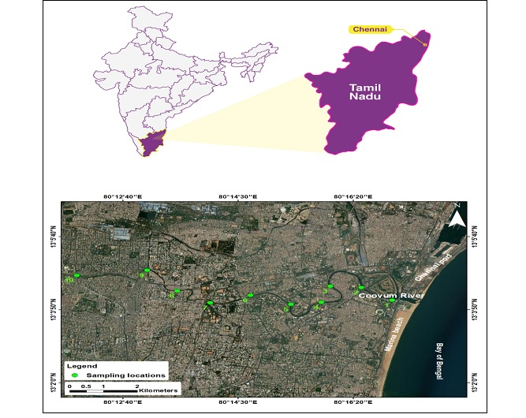

**Figure 1:The Study Area Showing the sample locations**

Investigations of microplastic pollution in urban rivers use the Cooum River as a key case study. The Cooum River is essential to the city's socioeconomic and cultural structure, but substantial pollution has been caused by industrial activity, urbanisation, and poor waste management techniques (Jeevanantham et al., 2018).

As a result, the river is now in serious danger of being unusable. For the Cooum River to be cleaned up and returned to health, it is crucial to comprehend the presence and effects of microplastics in the waterway.

1. **MATERIALS AND METHODS**

Field sampling techniques were employed along the Cooum River to collect sediment samples from multiple locations. The sampling locations were predetermined using ARC-GIS 10.3, and the coordinates were verified for accuracy using a field GPS device. A total of [number] sediment samples were collected from [number] different locations along the Cooum River. The collected sediment samples were then transported to the laboratory for further analysis. In the laboratory, the sediment samples underwent several processing steps. Initially, the wet samples were sieved using a 5 mm screen to remove large debris while retaining particles smaller than 5 mm. Subsequently, the sediment was oven-dried at 60 °C, homogenized, and passed through a 5 mm testing sieve to eliminate coarse debris and organic plant residues [11]. To remove organic debris and calcareous phases, 30 g of dried sediment was treated with a 30% hydrogen peroxide (H2O2) solution and then 2 N HCl. Density separation technique was employed to further extract microplastics from the sediment. The pre-treated estuarine sediments were thoroughly mixed with a pre-made zinc chloride solution (density: 1.58 g/cm^3) and filtered using a vacuum pump assembly and 0.45 μm Whatman® nitrocellulose membrane filter paper. The filtration procedure was repeated three times to enhance extraction efficiency. The retained microplastics on the filter paper were examined using an optical stereo zoom microscope, and their distribution was determined. The morphological classification of the microplastics, including fiber, pellet, fragment, and film, was based on the methodology proposed by [12]. The collected microplastics from the sediment samples were further analyzed based on their color, shape, size, and composition using an optical stereo zoom microscope (model: Leica DMC 4500). The results were presented in pie charts to depict the distribution of microplastics in terms of color, shape, size, and composition.

1. **RESULT AND DISCUSSION**

The analysis of sediment samples from the Cooum River yielded a total of 2433±101 (mean ± standard error n=10) MPs per kg of dry wt microplastic particles were identified in the Cooum River sediment samples. These microplastics were identified and characterized based on their abundance, color, size, shape, and composition.

The high number of microplastic particles found in the sediment samples indicates a significant contamination of microplastics in the Cooum River. The highest count of microplastics was observed at location 8, with 85particles, while the lowest count was found at location 6, with 55 particles. These findings indicate the widespread occurrence of microplastic pollution in the sediment of the Cooum River.

The microplastics in the sediment samples exhibited a range of colors. The most abundant colors observed were transparent, followed by blue, white, orange, red, yellow, black, green, purple, and brown. Transparent (33%) > Blue (18%) > White (11%) > Orange (10%) > Red (9%) > Yellow (6%) > Black (6%) > Green (3%) > Purple (3%) > Brown (1%).The presence of different colored microplastics suggests a variety of plastic sources contributing to the pollution in the river (Figure 2)

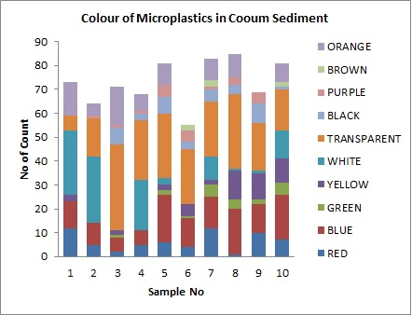

**Figure 2: Colour of Microplastics in cooum river sediments**

The size distribution of microplastics in the sediment samples was analyzed. The majority of microplastics were smaller than 1000 µm, accounting for approximately 78% of the particles. The remaining 22% of microplastics were larger than 1000 µm. The prevalence of small-sized microplastics indicates their ability to accumulate in the sediment and potentially pose a risk to benthic organisms. (Figure 3)

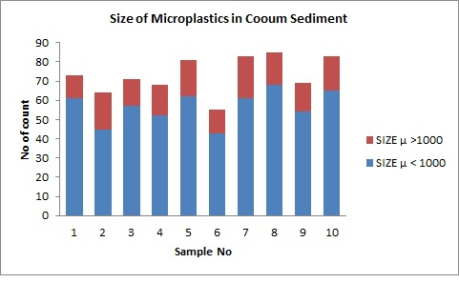

Size >1000 µm

Size <1000 µm

**Figure 3: Size of Microplastics in Cooum RiverSediments**

The predominant shapes of microplastics in the sediment samples were fibers, fragments, films, beads, foam, and pellets. Fibers were the most common shape; the presence of fiber-shaped microplastics suggests potential sources from rope, fishing-related activities, and daily use items such as clothing and personal care products. (Figure 4 and 5)

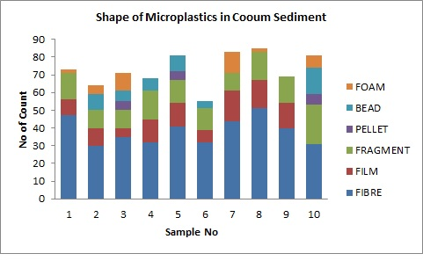

**Figure 4: Shape of Microplastics in Cooum River Sediment**

|  |  |  |
| --- | --- | --- |
| Fibre | Film | Fragment |

**Figure5:The photographs showing different polymers**

|  |  |
| --- | --- |
|  | |
| **(A) Nylon** | **(B)Polypropylene** |
| **(C) Polystyrene**  **Figure 6: Raman Spectrum Graphs showing different types of polymers** | |

The composition of microplastics in the sediment samples was analyzed to determine the types of plastics present. The most prevalent compositions were nylon, polypropylene, PMMA, polystyrene, and polyethylene. Nylon and polypropylene were the dominant compositions, with nylon accounting for 50% and polypropylene for 18% of the microplastics. These compositions suggest a range of plastic products and materials contributing to the microplastic pollution in the Cooum River. ( Figure 6&7)

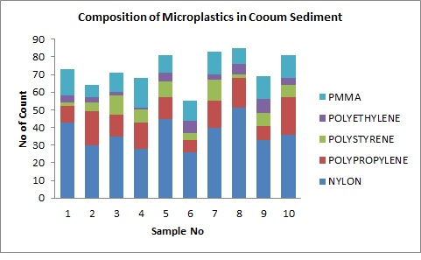

**Figure7:The Composition of Polymers in cooum river sediments**

The results of this study indicate that the sediment of the Cooum River is highly contaminated with microplastics. The abundance of microplastic particles, along with their diverse colors, sizes, shapes, and compositions, highlights the complex nature of microplastic pollution in the river ecosystem. The high abundance of microplastics in the sediment samples suggests a continuous input of plastic waste into the river, likely stemming from various sources such as industrial discharges, urban runoff, and improper waste management practices. The presence of different colors indicates the presence of a wide range of plastic products and materials that contribute to the pollution. The predominance of small-sized microplastics in the sediment suggests their ability to settle and accumulate in the riverbed [13]. This accumulation poses a potential risk to benthic organisms, as they can ingest these particles and be exposed to the associated contaminants. The presence of fiber-shaped microplastics, particularly from rope and fishing-related activities, highlights the influence of human activities on microplastic pollution in the Cooum River [14].

The composition analysis revealed the dominance of nylon and polypropylene, which are commonly used in various consumer and industrial products. The presence of these high-density plastics in the sediment, especially near the estuary mouth, indicates their sinking and accumulation in the sediment due to their density [15]. This emphasizes the importance of understanding hydrographic phenomena, such as surface currents, wave motions, and winds, in controlling the distribution and spread of microplastics in the river.

Overall, the findings of this study demonstrate the significant contamination of microplastics in the sediment of the Cooum River. This highlights the urgent need for effective waste management strategies, improved industrial practices, and public awareness to mitigate microplastic pollution and restore the ecological health of the river. Continued monitoring and research are necessary to assess the long-term impacts of microplastics and evaluate the effectiveness of implemented management strategies.

**Table 1: Table Showing the colour, size and Shape of the Microplastics in Cooum Sediment Samples**

|  |  |  |  |  |  |  |  |  |  |  |
| --- | --- | --- | --- | --- | --- | --- | --- | --- | --- | --- |
| **SAMPLE .NO** | **1** | **2** | **3** | **4** | **5** | **6** | **7** | **8** | **9** | **10** |
| **RED** | **12** | **5** | **2** | **5** | **6** | **4** | **12** | **1** | **10** | **7** |
| **BLUE** | **11** | **9** | **6** | **6** | **20** | **12** | **13** | **19** | **12** | **19** |
| **GREEN** | **0** | **0** | **1** | **0** | **2** | **1** | **5** | **4** | **2** | **5** |
| **YELLOW** | **3** | **0** | **2** | **0** | **2** | **5** | **2** | **12** | **11** | **10** |
| **WHITE** | **27** | **28** | **0** | **21** | **3** | **0** | **10** | **1** | **1** | **12** |
| **TRANSPARENT** | **6** | **16** | **36** | **25** | **27** | **23** | **23** | **31** | **20** | **17** |
| **BLACK** | **0** | **0** | **7** | **3** | **7** | **3** | **5** | **4** | **8** | **1** |
| **PURPLE** | **0** | **1** | **1** | **1** | **5** | **5** | **1** | **3** | **5** | **0** |
| **BROWN** | **0** | **0** | **0** | **0** | **0** | **2** | **3** | **0** | **0** | **2** |
| **ORANGE** | **14** | **5** | **16** | **7** | **9** | **0** | **9** | **10** | **0** | **8** |
| **SIZE μ < 1000** | **61** | **45** | **57** | **52** | **62** | **43** | **61** | **68** | **54** | **65** |
| **SIZE μ >1000** | **12** | **19** | **14** | **16** | **19** | **12** | **22** | **17** | **15** | **18** |
| **FIBRE** | **47** | **30** | **35** | **32** | **41** | **32** | **44** | **51** | **40** | **31** |
| **FILM** | **9** | **10** | **5** | **13** | **13** | **7** | **17** | **16** | **14** | **0** |
| **FRAGMENT** | **15** | **10** | **10** | **16** | **13** | **12** | **10** | **16** | **15** | **22** |
| **PELLET** | **0** | **0** | **5** | **0** | **5** | **0** | **0** | **0** | **0** | **6** |
| **BEAD** | **0** | **9** | **6** | **7** | **9** | **4** | **0** | **0** | **0** | **15** |
| **FOAM** | **2** | **5** | **10** | **0** | **0** | **0** | **12** | **2** | **0** | **7** |
| **TOTAL** | **73** | **64** | **71** | **68** | **81** | **55** | **83** | **85** | **69** | **81** |

1. **CONCLUSION**

The study conducted on the sediment microplastics in the Cooum River provides valuable insights into the extent and characteristics of microplastic pollution in this urban river ecosystem. The results demonstrate that the Cooum River is heavily contaminated with microplastics, indicating a pressing environmental issue. The abundance of microplastic particles found in the sediment samples indicates a significant presence of microplastics in the river. The diverse colors, sizes, shapes, and compositions of the microplastics highlight the complexity and variety of plastic pollution sources in the river. The prevalence of small-sized microplastics and the dominance of fiber-shaped particles suggest the potential risks to benthic organisms and ecological processes in the river ecosystem. The presence of high-density plastics, such as nylon and polypropylene, sinking and accumulating in the sediment underscores the need to consider hydrographic phenomena and the role of estuarine processes in microplastic distribution.The findings of this study emphasize the urgent need for comprehensive waste management strategies, improved industrial practices, and public awareness to mitigate microplastic pollution in the Cooum River. Effective measures should be implemented to prevent further input of plastics into the river and to restore the ecological health of the ecosystem. Furthermore, the presence of microplastics in the Cooum River raises concerns about potential human health risks. Microplastics can enter the food chain through the consumption of contaminated seafood, potentially exposing humans to harmful chemicals associated with microplastics.

In conclusion, the study highlights the significant contamination of microplastics in the sediment of the Cooum River and the importance of addressing this issue. Collaborative efforts from policymakers, environmental agencies, industries, and local communities are crucial to mitigate microplastic pollution, restore the health of the river ecosystem, and safeguard human well-being. Continued monitoring and research are essential to evaluate the long-term impacts of microplastics and assess the effectiveness of implemented management strategies.

**REFERENCE**

[1] Z. Akdogan and B. Guven, “Microplastics in the environment: A critical review of current understanding and identification of future research needs,” *Environmental Pollution*, vol. 254, p. 113011, Nov. 2019, doi: 10.1016/j.envpol.2019.113011.

[2] R. C. Thompson *et al.*, “Lost at Sea: Where Is All the Plastic?,” *Science*, vol. 304, no. 5672, pp. 838–838, May 2004, doi: 10.1126/science.1094559.

[3] Z. Yuan, R. Nag, and E. Cummins, “Human health concerns regarding microplastics in the aquatic environment - From marine to food systems,” *Science of The Total Environment*, vol. 823, p. 153730, Jun. 2022, doi: 10.1016/j.scitotenv.2022.153730.

[4] G. Carleton Ray and J. McCormick-Ray, “Estuarine Ecosystems,” in *Encyclopedia of Biodiversity (Second Edition)*, S. A. Levin, Ed., Waltham: Academic Press, 2013, pp. 297–308. doi: 10.1016/B978-0-12-384719-5.00244-6.

[5] A. G. López, R. G. Najjar, M. A. M. Friedrichs, M. A. Hickner, and D. H. Wardrop, “Estuaries as Filters for Riverine Microplastics: Simulations in a Large, Coastal-Plain Estuary,” *Front. Mar. Sci.*, vol. 8, p. 715924, Aug. 2021, doi: 10.3389/fmars.2021.715924.

[6] S. Chatterjee and S. Sharma, “Microplastics in our oceans and marine health,” *Field Actions Science Reports. The journal of field actions*, no. Special Issue 19, Art. no. Special Issue 19, Mar. 2019.

[7] C. Gaylarde, J. A. Baptista-Neto, and E. M. da Fonseca, “Plastic microfibre pollution: how important is clothes’ laundering?,” *Heliyon*, vol. 7, no. 5, p. e07105, May 2021, doi: 10.1016/j.heliyon.2021.e07105.

[8] S. N. Dimassi, J. N. Hahladakis, M. N. D. Yahia, M. I. Ahmad, S. Sayadi, and M. A. Al-Ghouti, “Degradation-fragmentation of marine plastic waste and their environmental implications: A critical review,” *Arabian Journal of Chemistry*, vol. 15, no. 11, p. 104262, Nov. 2022, doi: 10.1016/j.arabjc.2022.104262.

[9] H. Kye, J. Kim, S. Ju, J. Lee, C. Lim, and Y. Yoon, “Microplastics in water systems: A review of their impacts on the environment and their potential hazards,” *Heliyon*, vol. 9, no. 3, p. e14359, Mar. 2023, doi: 10.1016/j.heliyon.2023.e14359.

[10] K. Zhang *et al.*, “Understanding plastic degradation and microplastic formation in the environment: A review,” *Environmental Pollution*, vol. 274, p. 116554, Apr. 2021, doi: 10.1016/j.envpol.2021.116554.

[11] S. Sruthy and E. V. Ramasamy, “Microplastic pollution in Vembanad Lake, Kerala, India: The first report of microplastics in lake and estuarine sediments in India,” *Environmental Pollution*, vol. 222, pp. 315–322, Mar. 2017, doi: 10.1016/j.envpol.2016.12.038.

[12] C. M. Free, O. P. Jensen, S. A. Mason, M. Eriksen, N. J. Williamson, and B. Boldgiv, “High-levels of microplastic pollution in a large, remote, mountain lake,” *Marine Pollution Bulletin*, vol. 85, no. 1, pp. 156–163, Aug. 2014, doi: 10.1016/j.marpolbul.2014.06.001.

[13] K. Waldschläger *et al.*, “Learning from natural sediments to tackle microplastics challenges: A multidisciplinary perspective,” *Earth-Science Reviews*, vol. 228, p. 104021, May 2022, doi: 10.1016/j.earscirev.2022.104021.

[14] H. S. Auta, C. U. Emenike, and S. H. Fauziah, “Distribution and importance of microplastics in the marine environment: A review of the sources, fate, effects, and potential solutions,” *Environment International*, vol. 102, pp. 165–176, May 2017, doi: 10.1016/j.envint.2017.02.013.

[15] K. Radhakrishnan *et al.*, “POTENTIAL ECOLOGICAL RISK ASSESSMENT STUDIES BASED ON SOURCE AND DISTRIBUTION OF MICROPLASTICS FROM THE SURFACE SEDIMENTS OF TROPICAL BACKWATERS, KERALA, INDIA,” *Total Environment Research Themes*, vol. 7, p. 100063, Sep. 2023, doi: 10.1016/j.totert.2023.100063.