Robotic in Agriculture
N. R. Gatkal^{1*}, J. K. Khurdal, and S. M. Nalawade

^{1,2}Ph. D. Student, ³Professor and Head, Department of Farm Machinery and Power Engineering, Dr. Annasaheb Shinde College of Agricultural Engineering and Technology, Mahatma Phule Krishi Vidyapeeth, Rahuri, Ahmednagar, Maharashtra, India-413722. *Corresponding author email address: narayan96378@gmail.com

Introduction:
The goal of modern farming is to increase the agricultural productivity, quality and decreases the cost in a sustainable manner that depends on minimum use of labor. The use of digital farming and site-specific precision management are the two possible solutions to improve agricultural productivity. These issues were solved by using sensors in agricultural operations to collect data as well as by using different robots for field operations. To meet the food requirements of 9.8 billion people by 2050, various researchers, scientists, farmers, and growers will need to develop a viable method to produce more food from less land (King, 2017). This is equivalent of daily food for an entirely new town of 200000 people. The various digital tools, sensors and control technologies were incorporated to speed up the design and development of agricultural robot, highlighting considerable potential and advantages for modern farming. This development takes long time from digitalizing fields as well as plants by promptly and accurately gathering correct temporal and geographical information to complete non-linear control task for robot navigation. It is already possible to operate guided autonomous tractors and other agricultural equipment in orchards and row crops using local and global sensors. The crops sown between rows and orchards are already mature. Global navigation satellite system and class autonomous for John Deere ITEC Pro (Deere & Company, Moline, Illinois), uses for controlling the steering operation, and (Harsewinkel, OstwestfalenLippe, Germany), which combine the features of cam pilot steering and computer vision (3D) as well as GPS based control to use the features on the ground. In various facets of digital farming (Wolfert et al., 2017) and precision agriculture (Chlingaryan et al., 2018), one of the crucial components of agricultural field robot and manipulators. With the development of control theory, application of these agricultural robot in digital farming has growing interest in autonomous, transforming traditional labours in to high tech industrial jobs that are drawing money from investors, qualified engineers, and businesses. The robot can be used for variety of farming operation such as crop scouting, pest and weed control (Oberti et al., 2016), harvesting (Bloch et al., 2018; Shamshiri et al., 2018; Eizicovits et al., 2016; Longo and Muscato, 2013; Barth et al., 2016), targeted spraying (Adamides et al., 2017; Gonzalez-de-Soto et al., 2016), pruning ((Ishigure et al., 2013; Kawasaki et al., 2008), milking (Drach et al., 2017; Bach and Cabrera, 2017), phenotyping (Ruckelshausen et al., 2009), and sorting (Comba et al., 2016), even if many are still in the prototype stage.
These applications might be particularly difficult to fully automate, in contrast to the industrial situation. Since an agricultural robot must operate in a highly dynamic environment while also touching, sensing, or manipulating the crop and its surroundings precisely, it is essential to have as little influence as possible while still enhancing productivity (De Baerdemaeker et al., 2001). Despite the availability of robot platforms for more precise, accurate and speedily operation their use in agriculture is constrained by the difficult constraints posed by unstructured settings and uncertain activities. For instance, different components of automation and robots are needed in closed-field plant production facilities like greenhouses (Shamshiri et al., 2018) to meet the need for off-season fruit and vegetable cultivation. The various arrangements of plant shape and size, branches, stems, fruit color, leaves, obstacle, texture and weather affects should be taken into account by a robot for spraying, de-leafing, harvesting and manipulation and end-effector for such tasks in a dynamic, complex, and uncertain environment. For instance, during fruit harvesting, the sensing mechanism must determine the fruit ripeness in the presence of various in the presence of various disturbances in an unanticipated diverse weather condition, while the actuation mechanism must perform motion and path planning to move inside the plant system or tree canopy with the least amount of collision in order to delicately grasp and remove the soft fruit.

Types of robots:

Demeter: Robot complainer Demeter It is essential to agree on the labor requirements for growing and producing yields through mechanization. At harvest time, robots in agriculture are at their most inappropriately functional. Wheat and lucerne can be harvested by Demeter (Fig. 1). The Roman goddess of domesticity inspired the name of this robot. Demeter is self-derived, disregarding any human instruction. This results in fatigue from continual labor, which lowers agricultural productivity.

In contrast, a robotic harvester may work around the clock and never stop executing its duties. Demeter has cameras installed, and these allow it to distinguish between crops that are being sliced and those that aren't. This information explains where to drive, where to set the cutting section, and when to go close to the end of a crop cord so that it can rotate throughout. It also provides a position for a motor supervisor. It is made up of a system that provides tractors, then reapers, with three steps of mechanization. The first one is the "sails control" phase, which drives, steers, and guides the cutter part while also being offered to its operator. Second, a "drone" phase that enables a user to ambiguously swap many reapers The development of an autonomous system will finally allow reapers to completely harvest an arena without any operator control (Bak and Jacobsen. 2004).

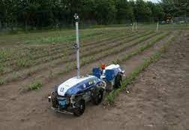

Fig. 1: Demeter

Weed Controller Robot:

Working in agriculture frequently entails challenging conditions, including defined field boundaries and lose, soft, and abrasive surfaces. The development of modern weed control tools which can eliminate human operator entirely from organically grown sugar cane, vegetables, and herbicide use ranging 75 percent to 100 per cent more yields (Fig. 2). It is used in various filed operation such as vegetation that is frequently displaced. The deployment of farming robot to reduces extra labour requirement. A robot which have four wheel roll drive was developed by the Danish Farm Authority. The goal of the weed-eliminating device is to eradicate weed. Weed control in row crops carried out by using a weed controller in the spaces between the rows. Herbicide usage is greatly reduced when weeds are visualized in a smart way that can understand how harvests are organized and guide themselves directly between them (Bak and Jacobsen. 2004).

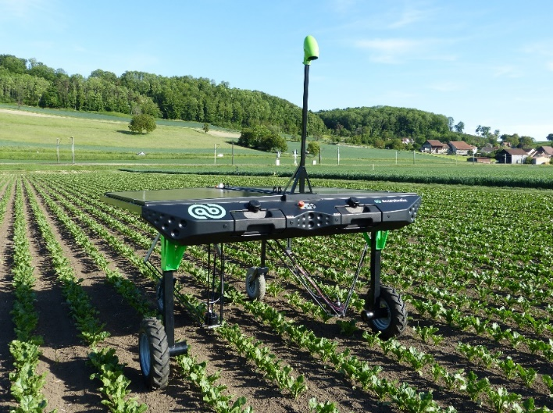

Fig. 2: Weed Controller Robot

Treebot: Researchers are keeping an eye on ecological changes in the woods with the help of a valiant portable robot. Treebot, the high-tech Tarzan of the robot world, is the first of its kind to combine networked sensors, a wireless internet connection, and a webcam. It is motorised and has wheels that allow it to go down and up in order to pick up tests and parameters intended for in-depth research. Treebot was created by the US Centre for Embedded Network Sensing in California. Pinpoint, a Linux operating system, was used for programming. A crucial piece of a researcher's ecological observational apparatus is the Treebot," stated William Kaiser, a professor. The appreciation of communication within the atmosphere and environment is crucial to the biological community (Bak and Jacobsen. 2004).

Fruit picking robot: When fruits in areas being farmed in orchards are ready for harvest, fruit reaping is a seasonal activity that takes place (Fig. 3). Since the early 1980s, the fundamental tenets of robots that harvest fruit have been established. These ideas started with different techniques for harvesting crops. Fruit picking, on the other hand, is entirely automated; high-tech employment, a producer of farm tools, and agricultural invention are therefore necessary (Baeten et al., 2015). With no damage to the tree's leaves or branches, the fruit-picking robots go in search of ready fruit to pluck.

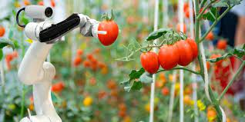

Fig. 3: Fruit picking robot

Seeding Robots: The most important step in field production is sowing. Sowing seeds in precise locations is made possible by seed-sowing robots, which helps farmers save time and money. There have been numerous practical seeding robots developed and extensively used up to the present day (Fig. 4). A four-wheeler, stepper and servo motor were used in the creation of the precision sowing robot for wheat (Haibo et al., 2015). The seeding rate exceeded 93 per cent atypical speed of sowing. The authors suggested a soil-digging, seed-planting, and soil-covering robot (Raj et al., 2019). Both the function of adding fertilizer and watering is available. developed and placed to the test a seeding and micro dose fertilization robot (Bhimanpallewar et al., 2020). It was anticipated that the robot would be able to plant various seeds, and the results of the trial showed excellent prototype performance. Kumar and Ashok, (2021) designed and developed an intelligent seed-sowing robot that was fully automated and IoT system was used to control the robot operation. The robot was propelled by a combination of stepper motors and DC motors.

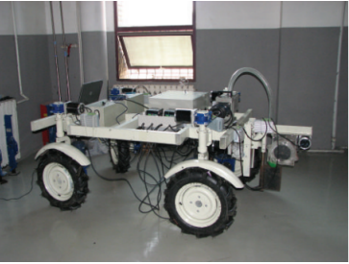

Fig. 4: Seeding robot

Crop Protection Robots: In general, harmful pesticides are manually sprayed on crops as part of traditional crop protection, which is hazardous for farmers' health. Developed a smart robotic system to spray pesticide using high efficiency and trajectory using calculations and control algorithm of navigation for automatic pesticide application (Meshram et al., 2022). Using a fuzzy control system, Deshmukh (2020) developed a multipurpose robot for spraying pesticide to identify diseased plants and accurately spraying pesticide.

The improper use of pesticides in traditional crop protection methods, however, increases production costs and has a negative environmental impact (Shang et al., 2019). This problem should be resolved by more precise crop protection techniques. The Japanese-made Yamaha R-MAX, a leading platform for aerial pesticide spraying Cheng (2006), is a well-known piece of equipment. Ghafar (2020) designed a spraying robot that is less expensive to use to spray fertilizers and insecticides, as seen in Figure 5. In addition to pest control, crop protection is also an important aspect of the overall management of the environment. an automatic planting and soil and water monitoring gardening robot. Martini (2020) developed an agricultural field robot which can measure moisture content, irrigation of crops, application of pesticide to crops, among other things, was based on DTMF which can controlled by remotely (Srivastava et al., 2014). Sori (2018) designed and developed a weeding robot for paddy fields. According to test results, this robot, which has two wheels, touch screens sensors, and a turning azimuth sensor, may remove weeds by agitating the soil and obstructing sunlight, potentially, increasing output.

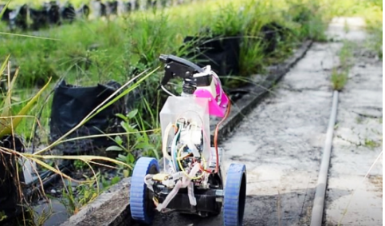

Fig. 5: Prototype model of agril. Robot moving along a crop path (Ghafar et al., 2020)

Field Information Collecting Robot: Gathering data in agricultural field is more labour consuming and challenging, the information gained as a result helps farmers make smart decisions. In light of this, field data collection robots have been created to carry out this task. A mobile robotic technology for plant phenotyping high throughput field based was developed, put into use, and verified by Bayati and Fotouhi (2018) at the University of Saskatchewan to monitor canola plants (Fig. 6). The technology can automatically collect and analyze wide-angle photos of plant canopies. It has been shown that this invention will raise farm productivity while lowering long-term costs. A mobile robotic technology for plant phenotyping field based high throughput was developed, put into use, and verified by Bayati and Fotouhi (2018) at the University of Saskatchewan to monitor canola plants. The technology can automatically collect and analyses wide-angle photos of plant canopies. It has been shown that this invention will raise farm productivity while lowering long-term costs. Iqbal (2020) was designed ROS driven mobile based robot for specific area and collecting plant phenotyping data with lower error 6.6 to 4 per cent for plot volume and height of canopy of plant, respectively. Cubero (2020) designed and developed a Robhortic farming robot for identification of pests and diseases in horticultural crops as shown in Figure 10. There have been significant advancements in navigation and neural network algorithm which results of the technological improvement of collection-gathering data. A neural network algorithm for gathering field information was improved by Gu (2020) by adjusting the path tracking to guarantee steady mobility, slight deviation, and human-machine separation.

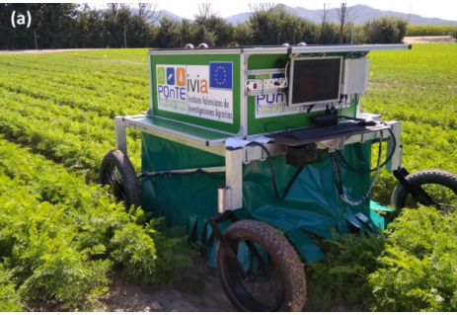

Fig 6. Remotely operated Robhortic in carrot field (Cubero et al., 2020).

Crop Harvesting Robots:

The cutter machine for paddy crop has been used over the long periods of time. An algorithm was developed for autonomous operation of harvesting which was based existing mechanical framework (Chen ET AL., 2020; Qi ET AL., 2002; Qi ET AL., 2021). An autonomous maize harvester system at a 95.4 percent rate of deviation at typical speed of operation of harvester was developed (Geng 2022). These improvements serve as a standard for enhancing the automatic row alignment method, which is noteworthy. Figure 7 illustrates how Li (2020) deep-learning system based on ICNet was developed a robotic harvester. With a pruned model, this autonomous harvester achieved 96.6 per cent success rate of collision avoidance when moving at average speed of operation. Li (2020) created an improved detection algorithm in response to the shortcomings of the present navigation algorithms employed by harvester robots with 96.6 per cent success rate more than the least square method. Pooranam (2020) developed a swarm robotic harvester to assist farmers with extensive threshing, reaping, cleaning and enhancing PSO algorithm. They were able to maximize the harvesting process by using a straightforward mathematical operation. Wang (2020) Researchers looked at a novel method for designing a path to robotic harvesting which might increase stable operation, hence boosting performance efficacy, while taking into account the significant overflow and protracted time to convergence caused by huge initial directional errors.

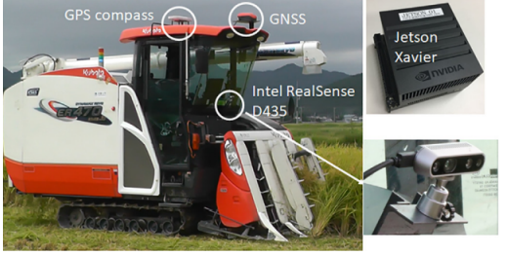

Fig. 7: Crop Harvesting Robots

Robot for vegetable and Fruit harvesting:

A human power cannot adequately fulfil the growing needs of consumers for agricultural goods. Additionally, sophisticated robotic can be a efficient way to enhance the along with growing fields for the markets advancements in agriculture, processing and preservation technology. A five most important fruit and vegetable harvesting robot are introduced as follows.

Transplanting Robot:

Accuracy and stability are two crucial metrics for transplant performance. In order to control hydraulic transplanting robots, Jin (2020) suggested an advanced control strategy using manipulators. Due to this, the stability and transplanting accuracy were enhanced. Three degrees of freedom transplanting robot was developed (Yang et al., 2020). In a further test, it was discovered that the transplanting robot could still be successful 95.3% of the time even when the speed was 30 m/s. A multi-task transplanting robot with a 90% success rate was built and tested by Han (2022), even while it was moving 960 plants per minute per gripper. It is anticipated that future studies will combine mechanical and agronomic requirements. More affordable items for smallholder farmers are also predicted to be designed. Figure 8 shows an advanced sweet potato transplanting robot created by Liu (2022) that had two degrees of freedom path control. In light of the various terrain types, it is noteworthy that this machine can automatically adopt a variety of transplanting strategies. The required minimum depth of planting and angle at which seedling should be erected met the practical standards for mechanically transplanting sweet potatoes at 94.7% and 94.8%, respectively.

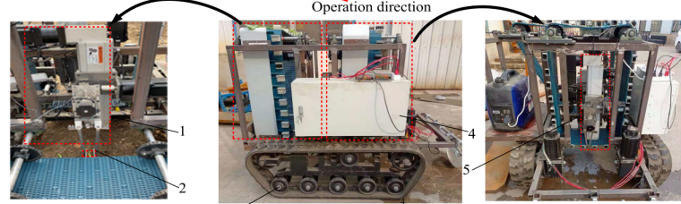

Fig. 8: Transplanting Robots

Fruit and Vegetable Patrolling Robots:

Robots that monitor for fruits and vegetables generally travel on their own, acquire a variety of data, and then report back to farmers with the findings. They collect information on pests, environmental factors, and fruit and vegetable growth. Zhou et al., (2020) developed a tomato finding scouting robot and use YOLOV4 to determine their maturity based on colour proportion analysis. It is important to note that in the natural greenhouse, accurate identification rate is very high it can approach 95% and speed of detection is higher than 5 frames/second. An information-gathering robot was created by Iida et al. [67] to gather environmental data such temperature, humidity and CO₂ content. They also used a prototype to confirm the proposed robot's utility.

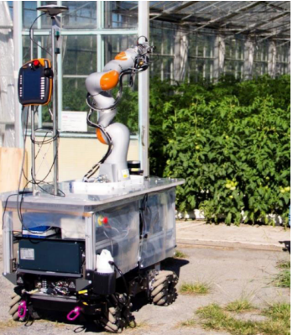

Fig 9. Greenhouse GreenPatrol Robot platform (Martin et al., 2021)

By utilising the Web of Things, Wang et al. (2022) designing and developing GreenPatrol robot is able to communicate processed information to operator and direct farmers to plant in a scientific manner. Applications for intelligent planting are benefited by the introduction of the web of things for agricultural productivity. Martin et al. (2021) ROS-based Robot framework (Figure 9) design incorporates several robotic skills including navigation and manipulation effectively, to identify early infestations. New mobile robotic manipulators are now conceivable thanks to these creative

fixes.

Pesticide Spraying Robots:

Pesticide application on fruits and vegetables has the same negative environmental effects as pesticide application on field crops because it uses excessive spraying ranges. In order to obtain more precise spraying, numerous pesticides spraying robots have been developed. These robots use a variety of techniques, including flow control devices, sensor (Ultrasonic) and nozzles (Fig. 10). The development of robots that spray pesticides has attracted a lot of research interest. The autonomous spraying robot was developed by Cantelli (2019) and consists of a vehicle and a spray application system. Experimental studies were then carried out to demonstrate that the two components working together could produce a spraying operation that was both safer and more precise. A semi-autonomous robot with servo-controlled spray nozzles that can climb Areca nut trees was created by (Bhat et al., 2019). Higher output and quality can be achieved with this method. Additionally, this resolves issues with the constraints of human labour. In order to spray pesticides precisely and include obstacle avoidance capability, an autonomous pesticide sprayer (Kassim et al., 2020) was created and put into use. Furthermore, it is used for other crops such as rock melons, tomato and pineapples. From the angles of spraying pressure, waterproofing, and updating the monitoring system, more research was taken into consideration. Seol (2022) proposal for a semantic segmentation-based flow control system for smart spray application robot. After that, contrastive field studies showed that the suggested system functioned better than the existing control approaches.

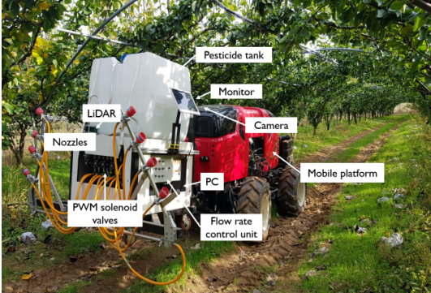

Fig. 10: Pesticide Spraying Robots

Gardening Robots:

Autonomous gardening robot systems find it difficult to maintain a garden with distinctive features because of the dynamic conditions generated by growth of plants and variation in season (Fig. 11). When gardening robots are cutting hedges, the garden maps for robotic navigational uses are affected since its shape and look are altered. Because of this, navigation systems should consider the presence of pitches and the gardening robot's moving strategy. This topic has received a tremendous amount of research attention. The first outdoor robot, called TrimBot 2020, was designed as a robotic lawn mower that could prune and trim plants. By combining cutting-edge path planning and optical servo systems, Strisciuglio et al. (2015) invented a prototype. For the purpose of watering indoor gardens, technique of robot irrigation was developed. To detect dry soil a moisture sensor meter used an Arduino microcontroller to boost the water flow and to make up for one shortcoming of this job, an automatic fertilizer sprayer was created. As seen in Figure 16, a pruning manipulator for jujube was created in and has five degrees of freedom. A performance test was then carried out to confirm the great features for automatic machines and of the automatic equipment, which have 85.16R success rate and little positioning error.

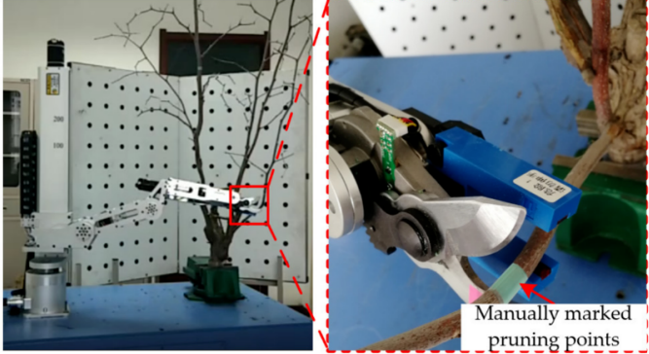

Fig. 11. The pruning test (Zhang et al., 2022).

Fruit and Vegetable Picking Robots:

Robot harvesting are classified in to two such as bulk and selective harvesting (Fountas et al., 2020) which includes for picking kiwi, strawberries, tomato, apples and more fruits (Wang et al., 2022). Williams (2019) developed a robot that can select kiwi fruit (Fig 12). This particular sort of robot for selecting kiwi fruit has four harvesting arms, an end effector system, and a machine vision system. The robot specifically uses a convolutional neural network (CNN) to do semantic segmentation on canopy visual data. However, only 51% of the kiwi fruits in the test orchard were effectively harvested by the unique robotic kiwifruit harvesting system due to obstacles and losses. For apple-harvesting robots, Kuznetsova (2020) Using YOLOv3 algorithm incorporating both pre- and post-processing was developed as the basis for a system that uses machine vision to identify apple. When compared to normal YOLOv3, the fruit detection rate increased by both stages of processing from 9.1% to 90.8%. Agricultural R&D firm Octonion has developed a fully autonomous picking robot (De Preter et al., 2018) that can recognize and collect ripe fruits without harming them. The prototype picked strawberries quickly, in just 4 seconds. Based on RGB-D, Li (2020) developed a reliable harvesting robot algorithm for finding lychee clusters automatically, enabling gathering in large scale environmental condition(Figure 12). In field tests, a single lychee string could be handled in just 0.464 seconds.

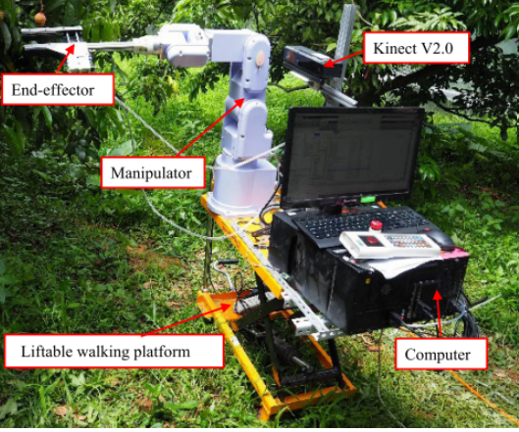

Fig 12. Robotic system for lychee harvesting (De Preter et al., 2018)

Animal Husbandry Robots:

Animal agriculture frequently experiences severe crises because of its protracted investment cycles and high output stakes. When a crisis develops, the yield of meat and dairy products decreases correspondingly, raising the cost of production. As a result, people are starting to notice the need for a cleverer approach to managing farms effectively.

Breeding Robots:

Breeding animals, including livestock as well as poultry, is an important component of agricultural production system that yields huge returns. Therefore, improving livestock and poultry breeding has great potential. In comparison to other breeding improvement techniques, disinfection is the most fundamental, beneficial, and all-encompassing approach.
Feng (2020) developed a productive disinfecting robot to handle the labour-intensive cleaning task. The disinfection robot subsequently possessed an evaluation of performance, and the findings demonstrated that it did a very good job of providing the fundamental requirements. Feng (2021) improved a robot for disinfectant spraying in chicken buildings in 2021 that was able to operate autonomously and remotely. As a result, our research provides technological assistance for intelligent production.
Li (2021) developed an intelligent gadget dependent on IoT in order to maintain an eye on the henhouse environment conditions and track laying rates in an effort to understand the relationship between the production environment and laying rate. They discovered that enough ventilation and an appropriate temperature are generally two important elements for laying chickens. Internet technology was used in the breeding of chickens (Li et al., 2018). They created a sophisticated, remote-controlled system that can keep an eye on the hens and update real-time data using a variety of sensors. Therefore, the deployment of such a network allows the chicken house in the woods to develop into an organic whole.

Animal Feeding Robot:

Another labor-intensive task is feeding animals and poultry on time, and it can be challenging to calculate the appropriate amounts of fodder. Automating livestock feeding can lower manpower and feed expenses while reducing wasteful feed usage. This makes automating the process the standard approach to feeding animals (Fig. 13;14).

In order to reduce the need for artificial labour and ensure a comfortable pig breeding environment, Peng (2020) proposal and design for a pig breeding system for robot which led to a significant increase in production efficiency. In Nepal, an animal feed technology which put food along the fence and following an established route was set into effect (Karn et al., 2019). The constructed robotic vehicle permitted successful operation in the intended working environment. Another labor-intensive task is feeding animals and poultry on time, and it can be challenging to calculate the appropriate amounts of fodder. Automating livestock feeding can lower manpower and feed expenses while reducing wasteful feed usage. This makes automating the process the standard approach to feeding animals. On dairy cattle farms, a feed-pushing robot's path needs to be planned, Rumba (2018) suggested an iterative pile-pushing method based on force feedback. Notably, the corresponding adjustment can support smart dairy farm.

Pavkin (2021) developed feed pusher robot for robotic mechanization. Researchers subsequently designed and developed reliable model to evaluate their simulation model, and the findings indicated that the autonomous robot may greatly simplify the feeding process by doing labour-intensive tasks. The vision system's accuracy was tested by the animals at the feeding station. A pusher robot with automated navigation capabilities was developed by Tian (2022) using a 3D lidar system. Additionally, they suggested a sophisticated avoiding obstacle technique to solve issues in challenging open circumstances. These innovations help with sustainable dairy farm.

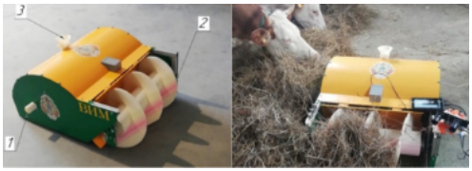

Fig. 13. Robotic Pusher: 1. Feeding additive dispenser outlet, 2. Pusher auger (Pavkin et al., 2021).

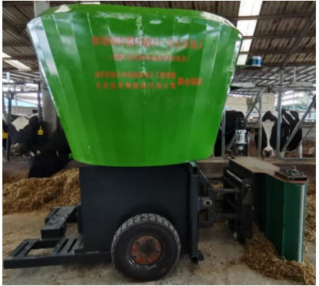

Fig. 14. Pusher robot (Tian et al., 2022).

Egg Collecting Robots:

Large-scale poultry houses make it unpleasant and messy to collect eggs; autonomous technology can greatly alleviate this condition. Figure 22 illustrates how Vroegindeweij (2018) effectively developed and tested a mobile robot which can move autonomously with higher maneuverability, watch over the chickens, avoid obstacles, and gather eggs, pointing to a promising future for sophisticated poultry houses (Fig 15; 16).

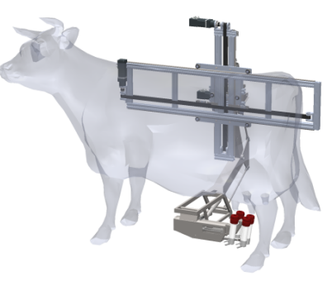

Fig. 15. Kinematic model of a milking robot (Borla et al., 2021).

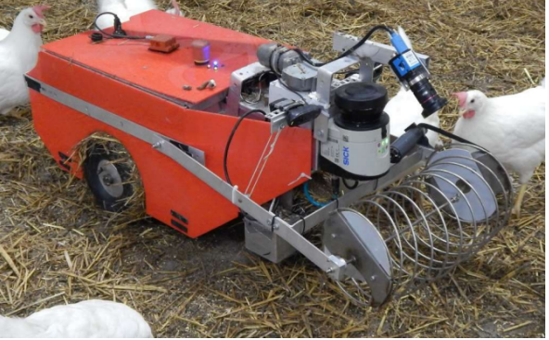

Fig. 16: Poultry Bot among hens in the test environment (Vroegindeweij et al., 2018).

Advantages
- Robot works continuously without tiring of sicked.
- Higher speed of operation and closer tolerance, it minimizes the errors.
- With minimum errors they can operate with higher velocity and quality operation.
- Use of robot decreases the pesticide requirement up to 80% for agricultural spraying operations.
- Robot is more efficient, precise and can work in between tress, rows, and ponds.
- Application of robot in agriculture create employment of youth.
- Robot decreases the cost of production.
- It combines the features of fertilizer as well as spraying operation simultaneously.
- The size is very small which can be operated in row crops for collection of data and farming operation such as weeding, spraying, mowing and fertilizing.
- The cameras used in robot and drone captures the information of identification of weeds, pests, diseases and stress.
- Robot operation gives and replacement of human operators with better return on investment by using effecting solution.

Disadvantages
- The initial cost of robot is very high.
- For robot operation takes repairs and maintenance for smooth running.
- With the speedy operation labours lose their employment.
- Robot cahne the farming operation.
- Robot takes energy cost and their maintenance.
- Robot take high cost of development and research.
- Farmers is lack of about robotic operations.
- They need trained person for operation of robot.
Summary:
- Last ten years, there has been a considerable increase in research activities aimed at creating agricultural robots that can efficiently do laborious field jobs. Robotics has not developed to a commercial level for application in agriculture, with the exception of milking robots, which were developed in the Netherlands.
- Research on robotic weeding and harvesting has drawn increasing attention in recent years due to a shrinking workforce and rising production costs, but the fastest weeding and harvesting prototype robots currently on the market are nowhere near fast enough to compete with a human operator.
- With the introduction of the SWEEPER, technology for robotic fruit harvesting is now getting closer to being a commercially available item. Modifying the current mechanical harvesting methods with some robot features for other crops, such as citrus and apples, which may be picked in large quantities for the juice industry, highly efficient and effective than utilizing a single robot system.
- A key problems that need to be resolved for the robot are accuracy and speed improvements for application in agricultural operations, however, in contrast to industrial and military scenarios, the absence of ample research funding and budgets in agriculture has slowed this process down.
- To increase efficiency in the case of robot harvesting, it is advised to improve sensing operation (detection of fruit), acting (Movement of manipulator, fruit attachment, identification and collection), and improving systems (pruning of leaf and plant shape).
- The development of a practical and affordable robot for agricultural operation necessitates cross-disciplinary cooperation in a number of fields, including engineering, horticultural, deep learning, computer science, dynamic control, mechatronics, instrumentation, sensors, intelligent system, crop management, system integration and design of software.
- It was also noted that research should concentrate on creating straightforward manipulators in order for automatic work to successfully carry out farming duties, multi-robot systems, etc. Building a swarm of small-scale robots and drones that work together to optimize farming inputs and reveal withheld or concealed information is actually one of the academic trends and research focuses in agricultural robotics.
- The issues of robot cannot be automatic till date which requires some types of humans-robot collaboration as well as modifications to the crop planting breeding agricultural field and greenhouses..
References.
Adamides G, Katsanos C, Parmet Y, Christou G, Xenos M, Hadzilacos T, et al. HRI usability evaluation of interaction modes for a teleoperated agricultural robotic sprayer. Appl. Ergon. 2017; 62: 237–246.
Alsalam, B.H.Y.; Morton, K.; Campbell, D.; Gonzalez, F. 2017. Autonomous UAV with vision based on-board decision making for remote sensing and precision agriculture. In Proceedings of the 2017 IEEE Aerospace Conference, Big Sky, MO, USA, 4–11. 1–12.
Bach A and Cabrera V. Robotic milking: Feeding strategies and economic returns. J. Dairy Sci., 2017; 100(9): 7720–7728.
Bak, T. and H. Jacobsen. 2004. Agricultural Robotic Platform with Four Wheel Steering for Weed Detection. Biosystems Engineering 87: 2125-136. doi:10.1016/j.biosystemseng.2003.10.009.
Barth R, Hemming J, van Henten E J. Design of an eye-in-hand sensing and servo control framework for harvesting robotics in dense vegetation. Biosyst. Eng. 2016; 146: 71–84.
Bayati, M.; Fotouhi, R. A mobile robotic platform for crop monitoring. Adv. Robot. Autom. 2018, 7, 1000186.
Bhat, A.G. Arecanut tree-climbing and pesticide spraying robot using servo controlled nozzle. In Proceedings of the 2019 Global Conference for Advancement in Technology (GCAT), Bangalore, India, 18–20 October 2019; pp. 1–4.
Bhimanpallewar, R.N.; Narasingarao, M.R. AgriRobot: 2020. Implementation and evaluation of an automatic robot for seeding and fertiliser microdosing in precision agriculture. Int. J. Agric. Resour. Gov. Ecol. 16, 33–50.
Bloch V, Degani A, Bechar A, A methodology of orchard architecture design for an optimal harvesting robot. Biosyst. Eng. 2018; 166: 126–137.
Borla, N.; Kuster, F.; Langenegger, J.; Ribera, J.; Honegger, M.; Toffetti, G. Teat Pose Estimation via RGBD Segmentation for Automated Milking. arXiv 2021, arXiv:2105.09843.
Cantelli, L.; Bonaccorso, F.; Longo, D.; Melita, C.D.; Schillaci, G.; Muscato, G. A small versatile electrical robot for autonomous spraying in agriculture. AgriEngineering 2019, 1, 391–402.
Chen, J.; Qiao, H. Motor-cortex-like recurrent neural network and multi-tasks learning for the control of musculoskeletal systems. IEEE Trans. Cogn. Dev. Syst. 2020, 14, 424–436.
Cheng, R.P.; Tischler, M.B.; Schulein, G.J. R-MAX Helicopter State-Space Model Identification for Hover and Forward-Flight. J. Am. Helicopter Soc. 2006, 51, 202–210.
Chlingaryan A, Sukkarieh S, Whelan B. Machine learning approaches for crop yield prediction and nitrogen status estimation in precision agriculture: A review. Comput. Electron. Agric, 2018; 151: 61–69.
Comba L, Gay P, Ricauda Aimonino D. Robot ensembles for grafting herbaceous crops. Biosyst. Eng., 2016; 146: 227–239.
Cubero, S.; Marco-Noales, E.; Aleixos, N.; Barbé, S.; Blasco, J. Robhortic: A field robot to detect pests and diseases in horticultural crops by proximal sensing. Agriculture 2020, 10, 276.
De Baerdemaeker J, Munack A, Ramon H, Speckmann H. Mechatronic systems, communication, and control in precision agriculture. IEEE Control Syst, 2001; 21(5): 48–70.
De Preter, A.; Anthonis, J.; De Baerdemaeker, J. Development of a robot for harvesting strawberries. IFAC-PapersOnLine 2018, 51, 14–19.
Deshmukh, D.; Pratihar, D.K.; Deb, A.K.; Ray, H.; Bhattacharyya, N. Design and Development of Intelligent Pesticide Spraying System for Agricultural Robot. In Proceedings of the International Conference on Hybrid Intelligent Systems; Springer: Cham, Sweizerland, 2020; pp. 157–170.
Drach U, Halachmi I, Pnini T, Izhaki I. Degani A. Automatic herding reduces labour and increases milking frequency in robotic milking. Biosyst. Eng., 2017; 155: 134–141.
Eizicovits D, van Tuijl B, Berman S, Edan Y. Integration of perception capabilities in gripper design using graspability maps. Biosyst. Eng., 2016; 146: 98–113.
Feng, Q.; Wang, B.; Zhang, W.; Li, X. Development and Test of Spraying Robot for Anti-epidemic and Disinfection in Animal Housing. In Proceedings of the 2021 WRC Symposium on Advanced Robotics and Automation (WRC SARA), Beijing, China, 19 August 2021, pp. 24–29.
Feng, Q.C.; Wang, X. Design of disinfection robot for livestock breeding. Procedia Comput. Sci. 2020, 166, 310–314.
Fountas, S.; Mylonas, N.; Malounas, I.; Rodias, E.; Hellmann Santos, C.; Pekkeriet, E. Agricultural robotics for field operations. Sensors 2020, 20, 2672.
Gené-Mola, J.; Gregorio, E.; Cheein, F.A.; Guevara, J.; Llorens, J.; Sanz-Cortiella, R.; Escolà, A.; Rosell-Polo, J.R. Fruit detection, yield prediction and canopy geometric characterization using LiDAR with forced air flow. Comput. Electron. Agric. 2020, 168, 105121.
Gené-Mola, J.; Gregorio, E.; Guevara, J.; Auat, F.; Sanz-Cortiella, R.; Escolà, A.; Llorens, J.; Morros, J.R.; Ruiz-Hidalgo, J.; Vilaplana, V.; et al. Fruit detection in an apple orchard using a mobile terrestrial laser scanner. Biosyst. Eng. 2019, 187, 171–184.
Geng, A.; Hu, X.; Liu, J.; Mei, Z.; Zhang, Z.; Yu, W. Development and Testing of Automatic Row Alignment System for Corn Harvesters. Appl. Sci. 2022, 12, 6221.
Ghafar, A.S.A.; Hajjaj, S.S.H.; Gsangaya, K.R.; Sultan, M.T.H.; Mail, M.F.; Hua, L.S. Design and development of a robot for spraying fertilizers and pesticides for agriculture. Mater. Today Proc. 2021, https://doi.org/10.1016/j.matpr.2021.03.174.
Gonzalez-de-Soto M, Emmi L, Perez-Ruiz M, Aguera J, Gonzalez-de-Santos P. Autonomous systems for precise spraying – Evaluation of a robotised patch sprayer. Biosyst. Eng., 2016; 146: 165–182.
Gu, Y.; Li, Z.; Zhang, Z.; Li, J.; Chen, L. Path tracking control of field information-collecting robot based on improved convolutional neural network algorithm. Sensors 2020, 20, 797.
Haibo, L.; Shuliang, D.; Zunmin, L.; Chuijie, Y. 2015. Study and experiment on a wheat precision seeding robot. J. Robot.
Han, L.; Mao, H.; Kumi, F.; Hu, J. Development of a multi-task robotic transplanting workcell for greenhouse seedlings. Appl. Eng. Agric. 2018, 34, 335–342.
Iqbal, J.; Xu, R.; Sun, S.; Li, C. Simulation of an autonomous mobile robot for LiDAR-based in-field phenotyping and navigation. Robotics 2020, 9, 46.
Ishigure Y, Hirai K, Kawasaki H. A pruning robot with a power-saving chainsaw drive. in Mechatronics and Automation (ICMA), 2013 IEEE International Conference on, 2013; pp.1223–1228.
Jin, X.; Chen, K.; Zhao, Y.; Ji, J.; Jing, P. Simulation of hydraulic transplanting robot control system based on fuzzy PID controller. Measurement 2020, 164, 108023.
Johan Baeten, Kevin Donnén, Sven Boedrij, Wim Becke rs, Eric Claese "Autonomous Fruit Picking Machine: A Robotic Apple Harvester", Field and Service Robotics Volume 42 of the series Springer Tracts in Advanced Robotics pp 531-539.
Karn, P.; Sitikhu, P.; Somai, N. Automatic cattle feeding system. In Proceedings of the 2nd International Conference on Engineering and Technology, KEC Conference 2019, Lalitpur, Nepal, 26 September 2019.
Kassim, A.; Termezai, M.; Jaya, A.; Azahar, A.; Sivarao, S.; Jafar, F.; Jaafar, H.; Aras, M. Design and development of autonomous pesticide sprayer robot for fertigation farm. Int. J. Adv. Comput. Sci. Appl. 2020, 11, http://dx.doi.org/10.14569/IJACSA.2020.011 0269.
Kawasaki H, Murakami S, Kachi H, Ueki S. Novel climbing method of pruning robot. in SICE Annual Conference, 2008; pp.160–163.
King A. Technology: The Future of Agriculture. Nature, 2017; 544: S21.
Kumar, P.; Ashok, G. 2021. Design and fabrication of smart seed sowing robot. Mater. Today: Proc. 39, 354–358.
Kuznetsova, A.; Maleva, T.; Soloviev, V. Using YOLOv3 algorithm with pre-and post-processing for apple detection in fruitharvesting robot. Agronomy 2020, 10, 1016. 95. Li, J.; Tang, Y.; Zou, X.; Lin, G.; Wang, H. Detection of fruit-bearing branches and localization of litchi clusters for vision-based harvesting robots. IEEE Access 2020, 8, 117746–117758.
Li, B.; Yang, Y.; Qin, C.; Bai, X.; Wang, L. Improved random sampling consensus algorithm for vision navigation of intelligent harvester robot. Ind. Robot. Int. J. Robot. Res. Appl. 2020, 47, 881–887.
Li, H.; Li, M.; Li, J.; Zhan, K.; Liu, X. The Environment Intelligent Monitoring and Analysis for Enclosed Layer House with Four Overlap Tiers Cages in Winter. In Proceedings of the International Conference on Computer and Computing Technologies in Agriculture; Springer: Berlin/Heidelberg, Germany, 2017; pp. 292–300.
Li, J.; Tang, Y.; Zou, X.; Lin, G.; Wang, H. Detection of fruit-bearing branches and localization of litchi clusters for vision-based harvesting robots. IEEE Access 2020, 8, 117746–117758.
Li, W.; Cao, Y.; Cui, J.; Li, D. Design of Automatic Breeding System for Chickens under the Forest. In Proceedings of the 8th International Conference on Management and Computer Science (ICMCS 2018); Atlantis Press: Dordrecht, The Netherlands, 2018, pp. 657–661.
Li, Y.; Iida, M.; Suyama, T.; Suguri, M.; Masuda, R. Implementation of deep-learning algorithm for obstacle detection and collision avoidance for robotic harvester. Comput. Electron. Agric. 2020, 174, 105499.
Liu, Z.; Lv, Z.; Zheng, W.; Wang, X. Trajectory Control of Two-Degree-of-Freedom Sweet Potato Transplanting Robot Arm. IEEE Access 2022, 10, 26294–26306.
Longo D, Muscato G. Design and simulation of two robotic systems for automatic artichoke harvesting. Robotics, 2013; 2(4): 217–230.
Martin, J.; Ansuategi, A.; Maurtua, I.; Gutierrez, A.; Obregón, D.; Casquero, O.; Marcos, M. A Generic ROS-Based Control Architecture for Pest Inspection and Treatment in Greenhouses Using a Mobile Manipulator. IEEE Access 2021, 9, 94981–94995.
Martini, N.P.D.A.; Tamami, N.; Alasiry, A.H. Design and Development of Automatic Plant Robots with Scheduling System. In Proceedings of the 2020 International Electronics Symposium (IES), Surabaya, Indonesia, 29–30 September 2020; pp. 302–307.
Meshram, A.T.; Vanalkar, A.V.; Kalambe, K.B.; Badar, A.M. Pesticide spraying robot for precision agriculture: A categorical literature review and future trends. J. Field Robot. 2022, 39, 153–171.
Oberti R, Marchi M, Tirelli P, Calcante A, Iriti M, Tona E, et al. Selective spraying of grapevines for disease control using a modular agricultural robot. Biosyst. Eng, 2016; 146: 203–215.
Pavkin, D.Y.; Shilin, D.V.; Nikitin, E.A.; Kiryushin, I.A. Designing and Simulating the Control Process of a Feed Pusher Robot Used on a Dairy Farm. Appl. Sci. 2021, 11, 10665.
Peng, L.; Jiang, Z. Intelligent automatic pig feeding system based on PLC. Rev. Científica De La Fac. De Cienc. Vet. 2020, 30, 2479–2490.
Pooranam, N.; Vignesh, T. A Swarm Robot for Harvesting a Paddy Field. Nat.-Inspired Algorithms Appl. 2021, 137–156.
Qi, W.; Liu, X.; Zhang, L.; Wu, L.; Zang, W.; Su, H. Adaptive sensor fusion labeling framework for hand pose recognition in robot teleoperation. Assem. Autom. 2021, 41, 393–400..
Qi, W.; Su, H.; Aliverti, A. A smartphone-based adaptive recognition and real-time monitoring system for human activities. IEEE Trans. Hum.-Mach. Syst. 2020, 50, 414–423.
Raj, R.; Aravind, A.; Akshay, V.; Chandy, M.; Sharun, N. A seed planting robot with two control variables. In Proceedings of the 2019 3rd International Conference on Trends in Electronics and Informatics (ICOEI), Tirunelveli, India, 23–25 April 2019; pp. 1025–1028.
Ruckelshausen A, Biber P, Dorna M, Gremmes H, Klose R, Linz A, et al. BoniRob–an autonomous field robot platform for individual plant phenotyping. Precis. Agric. 2009; 9(841): 1.
Rumba, R.; Nikitenko, A.; et al. Development of free-flowing pile pushing algorithm for autonomous mobile feed-pushing robots in cattle farms. Eng. Rural. Dev. 2018, 958–963.
Seol, J.; Kim, J.; Son, H.I. Field evaluations of a deep learning-based intelligent spraying robot with flow control for pear orchards. Precis. Agric. 2022, 23, 712–732.
Shamshiri R R, Hameed I A, Karkee M, Weltzien C. Robotic harvesting of fruiting vegetables: A simulation approach in V-REP, ROS and MATLAB. Proceedings in Automation in Agriculture-Securing Food Supplies for Future Generations, 2018, InTech.
Shamshiri R R, Kalantari F, Ting K C, Thorp K R, Hameed I A, Weltzien C, et al. Advances in greenhouse automation and controlled environment agriculture: A transition to plant factories and urban agriculture. Int J Agric & Biol Eng, 2018; 11(1): 1–22.
Shang, Y.; Hasan, M.K.; Ahammed, G.J.; Li, M.; Yin, H.; Zhou, J. Applications of nanotechnology in plant growth and crop protection: A review. Molecules 2019, 24, 2558.
Sori, H.; Inoue, H.; Hatta, H.; Ando, Y. Effect for a paddy weeding robot in wet rice culture. J. Robot. Mechatronics 2018, 30, 198–205.
Srivastava, A.; Vijay, S.; Negi, A.; Shrivastava, P.; Singh, A. DTMF based intelligent farming robotic vehicle: An ease to farmers. In Proceedings of the 2014 International Conference on Embedded Systems (ICES), Coimbatore, India, 3–5 July 2014; pp. 206–210.
Tian, F.; Wang, X.; Yu, S.; Wang, R.; Song, Z.; Yan, Y.; Li, F.; Wang, Z.; Yu, Z. Research on Navigation Path Extraction and Obstacle Avoidance Strategy for Pusher Robot in Dairy Farm. Agriculture 2022, 12, 1008.
Vasconez, J.P.; Delpiano, J.; Vougioukas, S.; Cheein, F.A. Comparison of convolutional neural networks in fruit detection and counting: A comprehensive evaluation. Comput. Electron. Agric. 2020, 173, 105348.
Villacrés, J.F.; Auat Cheein, F. Detection and characterization of cherries: A deep learning usability case study in Chile. Agronomy 2020, 10, 835.
Vroegindeweij, B.A.; Blaauw, S.K.; IJsselmuiden, J.M.; van Henten, E.J. Evaluation of the performance of PoultryBot, an autonomous mobile robotic platform for poultry houses. Biosyst. Eng. 2018, 174, 295–315.
Wang, L.; Liu, M. Path tracking control for autonomous harvesting robots based on improved double arc path planning algorithm. J. Intell. Robot. Syst. 2020, 100, 899–909.
Wang, Z.; Xun, Y.; Wang, Y.; Yang, Q. Review of smart robots for fruit and vegetable picking in agriculture. Int. J. Agric. Biol. Eng. 2022, 15, 33–54.
Williams, H.A.; Jones, M.H.; Nejati, M.; Seabright, M.J.; Bell, J.; Penhall, N.D.; Barnett, J.J.; Duke, M.D.; Scarfe, A.J.; Ahn, H.S.; et al. Robotic kiwifruit harvesting using machine vision, convolutional neural networks, and robotic arms. Biosyst. Eng. 2019, 181, 140–156.
Wolfert S, Ge L, Verdouw C, Bogaardt M J. Big data in smart farming – A review. Agric. Syst., 2017; 153: 69–80.
Yang, Q.; Jia, C.; Sun, M.; Zhao, X.; He, M.; Mao, H.; Hu, J.; Addy, M. Trajectory planning and dynamics analysis of greenhouse parallel transplanting robot. Int. Agric. Eng. J. 2020, 29, 64–76.
Zhang C, Gao H, Zhou J, Cousins A, Pumphrey M. O, Sankaran S. 3D robotic system development for high-throughput crop phenotyping. IFAC-PapersOnLine, 2016; 49(16): 242–247.
Zhang, B.; Chen, X.; Zhang, H.; Shen, C.; Fu, W. Design and Performance Test of a Jujube Pruning Manipulator. Agriculture 2022, 12, 552.

