Solar Cells: Types and Applications
Rajveer Kaur
Department of Physics
Guru Nanak College, Sri Muktsar Sahib 152026 (Punjab) India
Email: rjvrbrar05@gmail.com

Abstract:
A non-renewable form of energy, solar energy is produced by the sun. There are numerous uses for this energy. One such application is the conversion of solar energy into electrical form by solar cells. These solar cells can be constructed using a variety of materials. The advancements made in various cells from one generation to the next will be covered in this chapter. The first generation works with silicon-based solar cells, while the second generation deals with thin films. However, technological advancements have led to the third generation, which has enhanced solar cells' efficiency by a number of factors. Today's globe is in need of third generation solar cells, which have become more and more popular. This chapter also highlights the comparison of various solar cells. It further underlined the applications of these solar cells in the domestic and commercial worlds.
Keywords: Solar Energy, Generation, Cells.
- Introduction

  - Sunlight: Source of energy

Solar energy is produced by the sun, which is a star. Sunlight may be used to generate solar energy, which can then be transformed into several other forms of energy. Visible, infrared, and ultraviolet rays are just a few of the electromagnetic radiations that the sun generates. Using the most recent technological goods, these radiations can subsequently be transformed into energy or heat, depending on the user's preference. (Ashok, S. 2023).
The nuclear fusion process occurs at the sun's core. When four hydrogen atoms combine to form a helium atom, some of the mass is transformed into energy. Four hydrogen atoms have a mass of 4.03130 a.m.u, while one helium atom has a mass of 4.00268 a.m.u. The net variation in these atoms' masses is 0.02862 a.m.u. This little mass radiates thermal energy, which has a half-life of around 100 years and is sufficient to power a 60-watt lamp. (Spanel Planetarium 2022). There are numerous advantages of this clean energy.
- Renewable and Sustainable: Because the sun will continue to emit energy for billions of years, it will be both renewable and sustainable.
- Less Pollution: Solar energy is a pure form of energy and is devoid of any toxic substances. Furthermore, it enhances environmental quality and lowers air pollution levels.
- Low Operating Costs: The solar panels needed to generate electricity require little upkeep, and the electricity generated using this approach can last for roughly a decade.
- Independent Source: Since most nations import fossil fuels, their reliance on solar energy for a range of uses might lessen their susceptibility to disruptions and price changes.
- Employment: The addition of additional energy sources will result in more job opportunities across a variety of industries, including manufacture, installation, and maintenance.
- Technological Advancement: Solar technology advancements have increased efficiency, reduced maintenance costs, and improved the types of devices being employed.
- Low transmission losses: By localizing solar power generation, energy losses can be kept to a minimum.
Despite the fact that solar energy has many benefits, there are also drawbacks. First of all, when the weather is unfavorable, it is more challenging to use solar energy for its intended purposes. Second, there may be some fluctuations in the value of current since the strength of radiations varies throughout the day. Thirdly, solar power is not accessible at night. The geographic position of the place is also taken into consideration while installing solar power systems because sufficient sunshine is needed for generation. The effects of these drawbacks are being lessened via research and development in this area, making solar energy a viable sustainable choice. (Lakatoset al. 2011; Sharma et al.2015).

1.2 Solar Cell

Silicon is the primary semiconductor material used in solar cells. When sunlight strikes these cells, electric current is generated. By transforming this current into an appropriate form, it can be applied to a variety of uses. A lot of research is being done on the manufacturing process of these solar cells to achieve high conversion efficiencies. Photovoltaic cells are another name for solar cells. A solar panel is a grouping of small solar cells. These cells are organized in a specific arrangement to provide a large amount of electricity. Following is the mechanism that goes on inside the solar cell:
- Holes (p-type) and electrons (n-type) gets generated when sunlight falls on the surface of solar cell.
- Separation of charge carriers, holes and electrons.
- Collection of these carriers on respective electrodes and thus a potential difference gets developed across the junction.

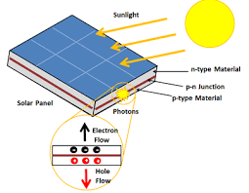
Figure 1. Solar panel
In order to achieve high efficiency, solar cells are designed using a variety of semiconductor materials. Modern solar panels are used on roofs to generate high power and are covered in glass sheets. There are various varieties of solar cells, and each has unique properties. (Choubey et al.2012).

- Types of solar cells

Alexandre-Edmond Becquerel made the initial observation of a photovoltaic cell in 1839. In the past, sunlight was turned into power using solar cells composed of thin silicon wafers. The first silicon-based solar cell was created by Russell Ohl in 1946. Modern solar cells operate on the basis of the creation of electrons and holes in a semiconductor material, which has two distinct layers, p-type and n-type. When photons collide with a semiconductor material junction, the electrons gain energy and jump into the conduction band, leaving a hole in the process. Electrical power is produced in such a process through the generation of holes and electrons. (Askari et al. 2015).On the basis of materials used in such a photovoltaic cells, solar cells are classified in different classes as discussed in the following sections.

  - First generation Solar Cells: Wafer based

- Monocrystalline Solar cells: These cells are constructed from a single crystal. The manufacturing process employs the Crochralski method. A large ingot is cut into Si crystals in this specific kind of technique. The finished bars will be entirely natural. These solar cells are highly expensive as a result of their purity. These cells' efficiency ranges from 17% to 18%. Due to the hexagonal or spherical shape of these solar cells, when solar panels are built using them, some empty space is left. Such solar cells have a 50-year lifespan. (Sharma et al.2015).
- Polycrystalline (Multicrystalline) Solar cells: The silicon used in these solar cells is composed of many crystals. Melting rods made of various silicon crystals is followed by the pouring of the molten silicon into square molds. Such a method does not yield identical solar cells every time. Although these solar cells are less expensive than monocrystalline solar cells, they are less efficient. The efficiency of this type of solar cell is between 12% and 14%. Due to the square design of these solar cells, there is less vacant space between the cells. (Sharma et al. 2015).

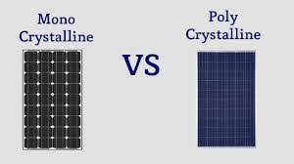

Figure 2. Monocrystalline and Polycrystalline solar panels

  - Second generation Solar Cells: Thin-film Solar cells

By depositing thin layers of specific photovoltaic materials onto a substrate, thin-film solar cells are created. Glass, metal, or plastic are all acceptable substrates. Its benefits include lightweight and flexibility. However, compared to crystalline silicon cells, its efficiency is low. These solar cells feature absorbing layers that are 1 micron thick, whereas silicon wafers have absorbing layers that are 350 microns thick.
Second generation solar cells can be further classified into three types:
- Amorphous Silicon (a-Si) Thin-Film: Low temperatures can be used to create this type of solar cell. Therefore, substrates with lower energy requirements can be employed. It can be incorporated into flexible or curved surfaces. These solar cells are created by taking a substrate and coating the back of it with silicon material that has been doped. The silicon material employed in this process has an ambiguous atom structure. Additionally, this type of solar cell is affordable and widely accessible. These solar cells have a conducting side that is silver in color and a dark brown reflecting side. It has a 4%–8% efficiency range as far as productivity is concerned. However, these can be utilized in locations where the sun only shines briefly. (Sharma et al. 2015).
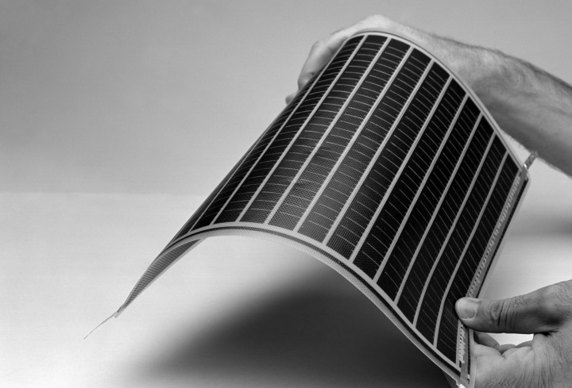
Figure 3 Amorphous Silicon PV modules

- Cadmium Telluride (CdTe) Thin-Film: Band gap of CdTe is 1.5 eV. It is direct band gap semiconductor and hence absorption of light is easy. It has high optical absorption coefficient. It is chemically stable. Due to these features, it is one of the most in-demand materials that can be used in designing of such thin-film solar cells. Moreover, CdTe solar cells are more economical as compared to other thin films solar cells. It consists of a p-n heterojunction which contains p-type layer of CdTe layer that matches with window layer made up of n-doped cadmium sulfide. Following are the steps involved in manufacturing process of such a cell:

- A substrate material is chosen such as glass.
- Polycrystalline material is taken from which CdTe solar cells are to be made.
- Deposition method is used in which multiple layers of CdTe are coated on substrate.
Its efficiency lies between 9%-11%. The main disadvantage of such kind of cell is the use of Cadmium in it. Cadmium is a toxic agent. It can accumulate in animals, plants and human bodies. Recycling process of such a material is also expensive (Askari et al. 2015; Sharma et al. 2015).
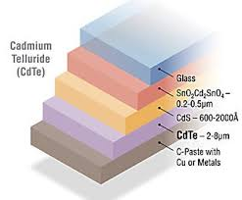
Figure 4. Five layers of CdTe Solar Cell

- Copper Indium Gallium Selenide (CIGS) Thin-Film: These solar cells contain the four elements copper, indium, gallium, and selenide. In order to gather current, the electrodes are constructed on the front and rear surfaces. Due to the high absorption coefficient of this type of solar cell, a significantly thinner coating is needed for them. Sputtering, evaporation, electrochemical coating, and electron beam deposition are the methods used during its production. The semiconductor also has a direct band gap. Its efficiency ranges from 10% to 12%. It has a lengthy lifespan. (Askari et al. 2015; Sharma et al. 2015).
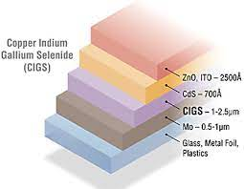
Figure 5. Copper Indium Gallium Selenide Solar cell

  - Third generation Solar Cells: Emerging new technology

Third generation solar cells have been introduced so that conversion efficiency could be increased and cost of the material used should be decreased.

- Nanocrystal Solar cells: These cells are known as quantum dot solar cells (QDSC). These types of solar cells can take the place of bulk materials like Si, CdTe, or CIGS. Quantum dots have adjustable bandgaps, which enables them to absorb the most energy possible. These employ absorbing photovoltaic materials from transition metal groups with nanocrystal sizes as their size range. As depicted in the image, quantum dot material is placed between the hole and electron transport channel. A silicon solar cell is known to have an efficiency range of 30%-33%. Efficiency factor rises in direct proportion to the number of layers in a cell
.
Type of cell | Band gap | Efficiency
Two layer cell | 1.64 eV, 0.94 eV | 44%
Three layer cells | 1.83 eV, 1.16 eV, 0.71 eV | 48%
Infinite layer cells | - | 86%

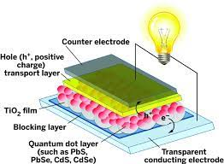

Figure 6. Quantum dot Solar Cell
Principal benefits of quantum dot solar cells include:
- We can modify the band gaps by size-based quantum confinement, which enhances optical response.
- Multiple charge carriers can be produced from one photon using quantum dots.
Recombination of charge carriers, which is the primary drawback of every solar cell, is the only restriction that happens in such cells. (Rehman et al. 2023).

- Concentrated Solar cells
One of the newest technologies, it is becoming more and more popular in research and development. Here, optics is being used in a way that concentrates a lot of energy on a small area. The placement of mirrors and lenses allows sunlight to be focused on a specific location. The optics underlying this phenomenon is that when radiation strikes certain lenses or mirrors, the light is focused and a significant amount of heat energy is generated. It is a notable solar cell in the solar industry. The amount of energy that is focused on a certain area relies on the type of lens system being employed. These solar cells are more than 40% efficient. These solar cells have advantages such as rapid response times, the absence of moving parts, and the involvement of thermal mass. It can be produced in various sizes. (Philipps et al. 2015)
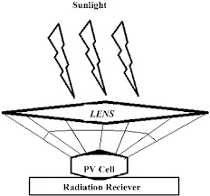
Figure 7. Concentrated Solar Cells
- Dye-sensitized solar cells
DSSCs use a dye-coated semiconductor to absorb light and generate electricity. These are also known as G cells as the first DSSC was made by Michel Gratzel at Swiss Federal Institute of technology. Molecular dyes are used between electrodes. These cells have four different parts: a semiconductor electrode, a dye sensitizer, a redox mediator, and a counter electrode. These solar cells are flexible, translucent, and rather appealing. They are also inexpensive. Its efficiency is higher than 10%. The only problem with these cells is that dye molecules breakdown when they are exposed to ultraviolet or infrared radiation, which reduces their lifetime and stability. However, because of their translucent qualities, they can be used in low-light situations and in some creative applications. (Suhaimiet al. 2015).

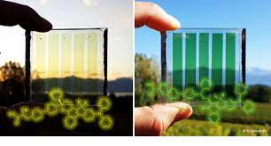
Figure 8. Dye Sensitized Solar Cells

- Organic Solar cells

Organic solar cells use organic materials, such as polymers or small molecules, to generate electricity. They have the potential for low-cost and flexible applications but currently have lower efficiency compared to other types of solar cells. It was invented by Tang et al. at Kodak Research Lab. Yu et al. mixedpoly [2-methoxy-5-(2’-ethylhexyloxy)-p-phenylene vinylene] (PPV), C60 and its other derivatives to develop the first polymer solar cell. He obtained high power conversion efficiency. These cells are made up of thin functional layers that are coated on a polymer foil or ribbon. In order to absorb sunlight, different materials can be used like conducting polymers. These kinds of solar cells has opened door for other stretchable solar devices that includes textiles and fabrics. (Min, Ho 2016).
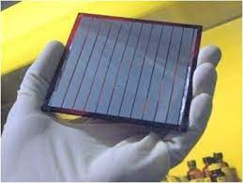
Figure 9. Organic Solar Cells

- Perovskite Solar Cells
Perovskite solar cells are a rapidly emerging technology that uses materials with a perovskite crystal structure. The material used in these cells are class of compounds, ABX₃ where X is a halogen namely I⁻, Br⁻, Cl⁻ and A and B are cations of different sizes. They are superiors as compared to conventional and thin film based solar cells. In case of conventional solar cells, multiple processing steps are needed and temperature of about 1000º C is generated. Moreover in some cases, vacuum facilities are also required. The conversion efficiency in this case is 31%. They can be made with low-cost manufacturing processes and have shown remarkable efficiency improvements in a short time. However, they are still being developed and face challenges related to stability and durability (Ahn et al. 2015; Tina et al. 2015; Shiet al. 2015)
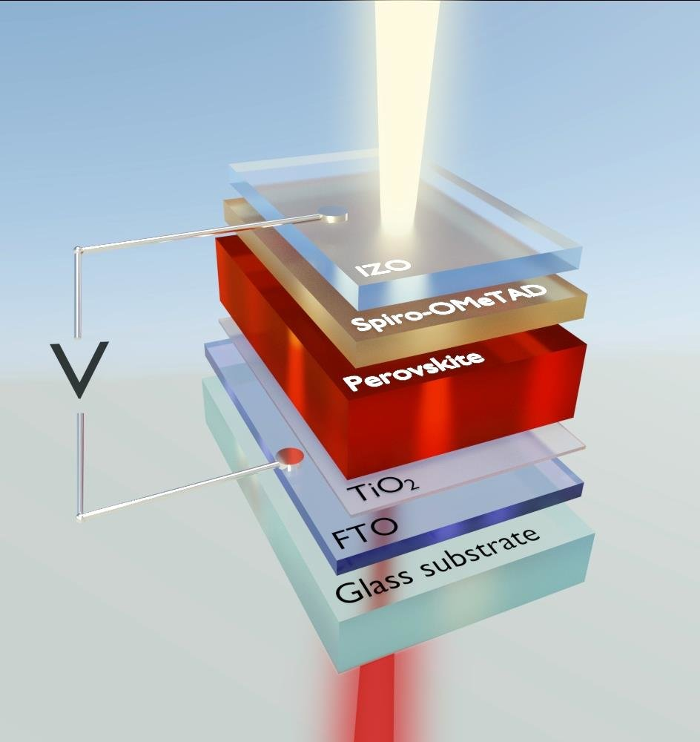
Figure 10. Perovskite Solar Cells

- Tandem Solar Cells
Tandem solar cells boost total efficiency by combining two or more different solar cell materials with complementary absorption spectra. For instance, one layer might absorb high-energy photons while a different layer absorbs photons with lesser energy. Solid Si solar cells have an efficiency of approximately 25% and a band gap of just 1.1 eV, which allows them to absorb low energy photons. Perovskite's band gap can range from 1.6 eV to 2.3 eV, allowing it to absorb some photons with high energy. Tandem solar with a 4T capacity has four terminals. Both solar cells are manufactured independently. Both are positioned over one another after being brought together. Tandem solar panels can be installed on top, and Si-based panels can be installed at the bottom. Two terminals are all that are needed to create 2T Tandem solar cells; therefore high-end machinery and additional considerations are needed. A silicon solar cell is first created, and then a perovskite layer is applied on top of that. Due to the transparency of tandem solar cells, light can easily travel from them to lower Silicon solar cells. This type of cell can raise efficiency all the way up to 44%.
Each type of solar cell has its own strengths and weaknesses in terms of efficiency, cost, flexibility, and suitability for various applications. Ongoing research and development are continually pushing the boundaries of solar cell technology to improve efficiency and accessibility (Ašmontaset al 2023).
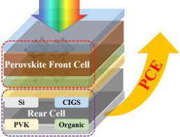
Figure 11. Tandem Solar Cell

- Comparison of solar cells

- In terms of efficiency
Third generation solar cells are more efficient as compared to other generations (Ankur et al. 2019; Sharma et al. 2015)

Graph 1: Comparison of maximum efficiency corresponding to type of solar cell

- In terms of cost effectiveness
First generation is two times more expensive than second and third generation solar cells (Ankur et al. 2019; Sharma et al. 2015).

Graph 2: Comparison of Expensiveness with respect to different generations of solar cells
- Applications of solar cells
- Homes: There are several uses for solar energy in homes. Solar energy can be stored in batteries and utilized for a variety of things by installing photovoltaic cells on the roof of the home.
- Commercial Uses: Buildings' rooftops can be fitted with solar panels or PV modules, which can supply electricity to the many offices housed there. These cells capture the sun's energy and transform it into useful forms so that it can be used for a variety of tasks.
- Power pump: It is clear that in today's technologically advanced world, agriculture depends on the use of solar panels. These solar power sources can be connected to power pumps to sustain the flow of water.
- Swimming pools: Keeping the water heated in pools during the warmer months requires a lot of energy. In order to keep the water warm using solar energy, a solar blanket can be added to the pool. In order to keep water warm throughout the winter, a solar heating setup with heating panels can also be constructed.
- Street lighting: Street lights can use solar energy. It has the capacity to store solar energy throughout the day, and at night, this energy is further transformed into electricity to power the lights. Many countries throughout the world employ this technology to lessen their reliance on fossil fuels for the production of power.
- Solar Cars: Using solar panels in automobiles is possible. Solar light can be used to recharge solar automobiles. These absorb solar energy and transform it into electric power. The batteries that are placed in solar cars further store this electrical energy so that it can be used at night.
The solar cells are being updated to increase efficiency as a result of technological improvement. Carbon nanotubes are an example of such a development. It may improve cells' capacity to absorb light. (Askari Mohammad Bagher et al. 2015).

- Conclusion
In order to meet the high energy demand, solar power generations have been developed. It offers numerous advantages as compared to other forms of energy like fossil fuels and other deposits. Although the methods used in generation of electrical energy is same in every cell but the efficiency factor depends upon the type of material that is being used in a cell. Each kind of material used in a cell has its own advantages and disadvantages. Tandem solar cells can convert maximum solar energy into electrical form. Also, other kinds of cells are economical and viable. However, different considerations are to be considered in choosing a particular cell for different kinds of applications. The research on achieving the efficiency towards maximum percentage is still going on and it is the need of the today’s world.

References:
- Ahn, N., Son, D.-Y., Jang, I.-H., Kang, S.M., Choi, M. and Park, N.-G. (2015). Highly Reproducible Perovskite Solar Cells with Average Efficiency of 18.3% and Best Efficiency of 19.7% Fabricated via Lewis Base Adduct of Lead(II) Iodide. Journal of the American Chemical Society, 137, 8696-8699. http://dx.doi.org/10.1021/jacs.5b04930
- Ankur Kumar Bansal, Dinesh Kumar, Dr. Mukesh Kumar. (2019). A Review Paper on Development in Material Used in Solar Pannel as Solar Cell Material. SSRG International Journal of Mechanical Engineering, vol. 6, no. 6, pp. 35-41, 2019. https://doi.org/10.14445/23488360/IJME-V6I6P107
- Ashok, S. (2023). Solar energy. Encyclopedia Britannica. Available at: https://www.britannica.com/science/solar-energy.
- Askari Mohammad Bagher, Mirzaei Mahmoud Abadi Vahid, Mirhabibi Mohsen. (2015). Types of Solar Cells and Application. American Journal of Optics and Photonics. Vol. 3, No. 5, pp. 94-113. Doi: 10.11648/j.ajop.20150305.17.
- Al-Ezzi, A.S.; Ansari, M.N.M. (2022) Photovoltaic Solar Cells: A Review. Appl. Syst. Innov., 5, 67. https://doi.org/10.3390/asi5040067.
- Ašmontas, S., & Mujahid, M. (2023). Recent Progress in Perovskite Tandem Solar Cells. Nanomaterials, 13(12), 1886. MDPI AG. Retrieved from http://dx.doi.org/10.3390/nano13121886.
- Choubey, P. C., Oudhia, A., & Dewangan, R. (2012). A review: Solar cell current scenario and future trends. Recent Research in Science and Technology, 4(8). Retrieved from https://updatepublishing.com/journal/index.php/rrst/article/view/942.
- Lakatos, Laszlo & Hevessy, G. & Kovács, J. (2011) Advantages and Disadvantages of Solar Energy and Wind-Power Utilization. World Futures. 67. 395-408. DOI: 10.1080/02604020903021776.
- Min, Ho. (2016). A Review on the Organic Solar Cells. Australian Journal of Basic and Applied Sciences. 10. 21-24.
- Philipps, S.P., Bett, A.W., Horowitz, K. and Kurtz, S. (2015). Current Status of Concentrator Photovoltaics (CPV) Technology. Report Version 1.2, Fraunhofer Institute for Solar Energy Systems (NREL).
- Rehman, Fatima & Syed, Iqrar & Khanam, Saira & Ijaz, Sumbel & Mehmood, Haris & Zubair, Muhammad & Massoud, Yehia & Mehmood, Muhammad Qasim. (2023). Fourth Generation Solar Cells: A Review. Energy Advances. DOI: 10.1039/D3YA00179B.
- Sharma, S., Jain, K. and Sharma, A.(2015) Solar Cells: In Research and Applications—A Review. Materials Sciences and Applications, 6, 1145-1155. Doi: 10.4236/msa.2015.612113.
- Shi, D., Zeng, Y. and Shen, W. (2015). Pervoskite/c-Si Tandem Solar Cell with Inverted Nanopyramids: Realizing High Efficiency by Controllable Light Trapping. Scientific Reports, 5, Article No. 16504.
- Spanel Planetarium. (2022). The Sun and Nuclear Fusion. Available at: https://www.wwu.edu/astro101/a101_sun.shtml.
- Suhaimi, S., Shahimin, M.M., Alahmed, Z.A., Chyský, J. and Reshak, A.H. (2015).Materials for Enhanced Dye-Sen-sitized Solar Cell Performance: Electrochemical Application. International Journal of Electrochemical Science, 10, 28- 59.
- Tina Casey. (2015). An Article on Perovskites Will Power New Low-Cost & Highly Efficient Solar Cells. Clean Technical.

