Establishing a bio-methanization facility to produce manure and biogas from solid waste that is organic in nature in rural areas
Jithendra S¹, Jagdish H Godihal²
¹Research Scholar, Civil Engineering Department, Presidency University, Bengaluru
²Professor, Civil Engineering Department, Presidency University, Bengaluru

Abstract: The Swach Bharat Mission was introduced on October 2, 2014, by the Prime Minister of India, in an effort to considerably speed up efforts to attain universal sanitation. Animal waste, food scraps, crop byproducts, market garbage, and faecal sludge are just a few of the bio-waste types that are produced in great amounts in rural India. There are around 310 million livestock 66 million sheep, 135 million sheep’s, and approximately 10 million pigs in India, according to the 20th Livestock Census of India, 2015. A minimum of 5,257 tons of trash are thought to be produced by cattle every day. Additionally, according to estimates from the Indian Agricultural Research Institute, India produced 620 million tons of agricultural leftovers in 2014, of which 100 million tons were burned on farms and 300 million tons were processed as garbage. The "Galvanising Organic Bio-Agro Resources Dhan" (GOBAR-DHAN) project was launched as a key component of managing organic waste to keep villages clean, enhance people' livelihoods, and produce money and energy by digesting solid waste from agriculture and animal dung. Anaerobic microbial breakdown of organic material produces biogas, which contains the energy-dense gas methane. This process can provide energy and a nutritious residue that can be utilised as a fertiliser under regulated circumstances. Biogas may be produced and utilised as fuel for vehicles, heat, or power. The method can employ a variety of substrates, and different furnace technologies are available based on the characteristics of the substrate. Methane synthesis is the result of a complicated microbiological process involving a wide variety of microorganisms that frequently collaborate closely due to the restricted growth energy. In addition to operational conditions such as process temperature, entering material influences the microbial population structure. In order to keep villages clean, it is anticipated that the GOBAR-DHAN plan would work with residents to manage solid waste in villages safely and effectively, particularly bio-agro waste.
Keywords: Galvanizing Organic Bio-Agro Resources Dhan (GOBAR-DHAN), Garbage, organic waste management, anaerobic digestion.
Introduction
Due to the restricted quantity of energy available for development, the microbiological process that produces methane is complicated and requires a wide variety of bacteria, many of which operate in intimate partnerships. In addition to operating factors like process temperature, the entering material shapes the structure of the microbial population [1]. An unbalanced microbial population can give rise to instability in processes or even outright failure of the process [2]. Many important factors, such the quality of the gas and the amounts of degradation intermediates, are often examined to guarantee steady operation. Even though the method of anaerobic digestion has been used to create biogas for a long time, there are still a lot of issues that must be addressed. for the process to optimize operation and gas yields and properly utilize the tremendous energy [2]. Individual and communal biogas plants can be built in villages/taluk/districts. However, the program requires a minimum of a single prototype community-level biogas plant each district [3]. In coordination with other programs like the Ministry of New and Renewable Energy's New National Biogas Manure Program, the States and Districts can design more GOBAR-DHAN projects. To make the model GOBAR-Dhan projects long-lasting and to support commercial models, the districts should ideally start community-level initiatives close to Gaushalas for an ongoing supply of organic wastes. To launch new projects across the town, taluk, and districts levels, suitable business models should be used [4]. The State/District may also mimic the pilot projects in order to establish new GOBAR-Dhan initiatives at the rural areas, wherever necessary and feasible/viable, using their own money or collaborating with other State or Central Government program [5].

- Objectives
The scheme's projected benefit is cleaner communities due to solid waste management, higher regional earnings and jobs, and less environmental impact. As a result, it intends to achieve the following impact:
- Sanitation: Improved sanitation via trash reduction in communities and overall cleanliness Farmers will profit from biological processed sludge in biogas generators, which is full of manure, as a substitute to artificial fertilizers.
- Health: Reduced occurrences of plasmodium and other asepsis associated disorders by minimizing waste quiescence in communities and increasing indoor air characteristics, this is otherwise influenced by manure slurry & fuel combustion.
- Energy: Villages become self-sufficient in green energy by utilizing bio-waste to create bio-energy, reducing fires & reliance on trees.
- Employment: Rural youths and skilled to a limited extent technicians can profit from skilling and prospective occupations such as garbage collection, transit to treatment plants, plant management, operation and maintenance, sale and distribution of produced biogas and bio-slurry, & so on.

- Planning and Implementation
The GP could plan unique biogas facilities in all of its communities by identifying families with more than 5 animals and putting cow manure along roadsides. The money for such initiatives will be provided under the MNRE's NNBOMP scheme. For such individual units, biogas production facilities of 1-3 m3 might be planned. If a hamlet has enough common area and a large cow population, biogas plants with capacities of 4-10 m3 might be constructed for the community. The funding standards will be in compliance with the MNRE's NNBOMP plan. The G.P where the initiative is being conducted must be active in distributing I.E.C and raising perceptions about the benefits of waste segregation, biogas, and bio-slurry, as well as providing assistance in project managing bio-slurry [6]. GP should also guarantee that plant bio-slurry is not disposed of in drains.

- Case study:
To undertake integrated Bio-Energy Project through optimal utilization of locally available resources at Shree Guru Muppinarya Ashram Beeranakere Math Taluk- Shivamogga District
Beeranakere village of Kunchenahalli Gram Panchayath in Shivamogga Taluk of Shimogha District has been identified for the Implementation of GOBAR-DHAN project, The village is 17Kms away from Shivamogga Taluk headquarters.
Preliminary baseline survey details are as under
Table 1: Baseline survey details
Sl.No | CONTENTS | DETAILS
1 | Co-ordinates of the project site | Lat-14.03927  Lon-75.57890
2 | Project site area | 10 acre
3 | Total households of the project village | 262
4 | Population of the village | 963
5 | Water source availability | Bore well
6 | Total cattle population of the project site | 55
7 | Total Live Stock other than cattle’s | -
8 | Total Number of Hostel | 0
9 | Estimated quantity of food waste in the project area | 12kg/day
10 | Estimated quantity of cattle dung that can be collectable | 875 Kg/day
11 | Estimated quantity of wet waste generated from commercials | 50 Kg/day
12 | Is there availability of Community land  If Yes belongs to GP- Yes/No | Yes  Belongs to Shree Guru Muppinarya Ashram Beeranakere Math

  - Proposed Technology
A plant that produces biogas is where methane is created. Organic matter, such as compost (human or animal) or kitchen waste, is ground up with water and supplied into the plant's intake, where it is utilized for fueling the plant. The big tank (biogas reactor) will subsequently undergo anaerobic fermentation to produce biological gas. Biogas is a gas combination formed by the decomposition of organic waste in a lack of oxygen (anaerobically), mostly methane and carbon dioxide. Biogas may be made from a variety of raw sources, including farm waste, compost, garbage, plant-based garbage, green waste, and organic waste. Biogas is a type of renewable energy. It is additionally referred to as "Bio Gas" in India. Anaerobic digestions with methanogen or anaerobic organisms that decompose matter within an enclosed structure, or fermentation of biodegradable materials, create biogas. An anaerobic digester, biological digester, or bioreactor is the name given to this closed system. Biogas is mostly made up of the gases methane, or CH₄, and carbon dioxide (CO₂), with trace amounts of hydrogen sulphide (H₂S), moisture, and siloxanes. Gases such as methane, hydrogen, and carbon monoxide (CO) may all be combusted or oxidized with oxygen. Due to this energy release, biogas may be used as a biofuel; it can be used for any type of heating, including cooking. It may also be utilized to convert energy in petrol into heat and electricity in an engine powered by gasoline.
Similar to how natural gas is compressed into CNG and used to power cars, biogas may be compressed once the carbon dioxide has been removed. Biogas may be cleaned and enhanced to natural gas standards when it is converted to bio methane. Because of its continuous cycle of production and consumption and lack of extra carbon dioxide emissions, biogas is regarded as a renewable resource. Organic material changes and is used as it grows. After then, it keeps growing in an infinite loop. When it comes to carbon, the major bio resource absorbs from the atmosphere the same quantity of carbon dioxide that is eventually released when the material is converted to energy.
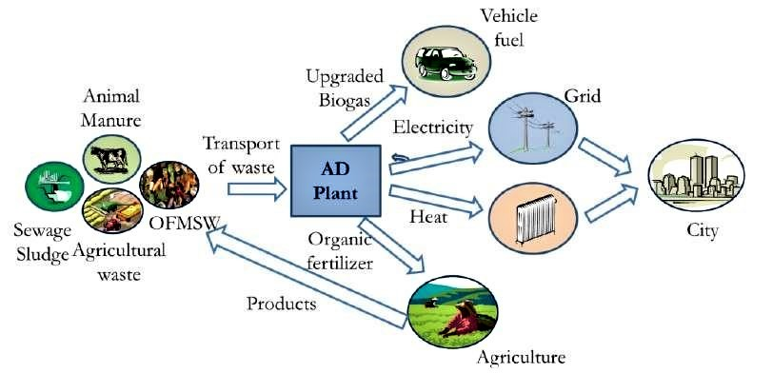
Figure1: Process of Biogas plant
  - Construction
The biogas plant is having the following five sections:
- The blending tank: Present above the ground level.
- The Inlet tank: The mixing tank opens underground into a sloping inlet chamber.
- Digester: A massive tank known as the digester is entered from the inlet chamber's bottom. This is covered by floating fiber drum. The digester has an outlet with a valve for the supply of biogas.
- Discharge tank: The digester opens from below into an outlet chamber.
- Overflow vessel: A tiny overflow tank is accessible from the top of the outlet chamber.
  - Floating-Drum Type / KVIC Model Biogas Plant
The aforementioned plants have a well-shaped subterranean digester that is connected at the bottom of both sides of a partition wall for its intake and outflow pipes. The digester features inverted drums (gas holder) made of stainless steel that slides up and down along a guide pipe as gas is gathered and consumed. The digester is stabilized by a wedge-shaped support and orientation structure at the level of the partition wall. The pressure from the drum's weight causes the gas to go through the pipes and out to the sites of usage. This model's operating life is comparatively short. The drum must be painted on a regular basis to prevent corrosion damage. In addition, because the metal sheet gas holder functions as an excellent conductor of heat and the interior temperatures of the digester decreases, this model stops working when the temperature drops below 10 degrees Celsius. To meet the demands of the consumers, these manufacturing facilities can be of any size.
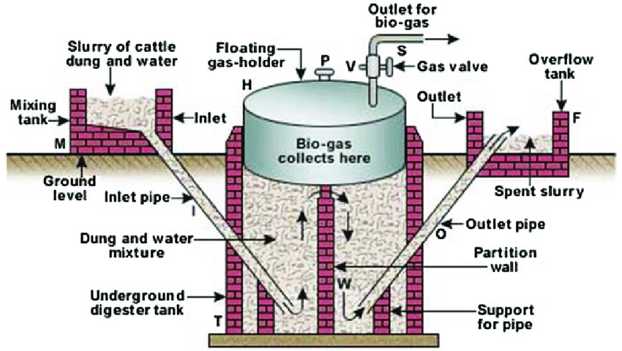
Figure 2: KVIC Model Biogas Plant

- Size of the Plant
Broadly speaking the sustainable kitchen waste availability is more than adequate for the projected feedstock requirements. It is proposed 40m3 Biogas Plant to treat available feed stock because for 8 Kg of feedstock 1m3 biogas will be produced. Dimension of a biogas plant refers to how much biogas (in cubic meters) may be produced within in a 24-hour period. It is estimated that a cow produces 15 kg of dung on average, and that 0.04 m3 of biogas may be produced from each kilogram of dung. As a result, around 1.0m3 of biogas is produced using 25 kg of cattle manure.
Table 1: Components details
COMPONENTS | VALVES
Available feed stock (food/kitchen waste) | 62 kg/day
Biogas production from available feed stock | 8m3
Available feed stock (Cattle dung) | 900 kg/day
Biogas production from available cattle dung | 36 m3
Total required size of biogas plant | 45 m3

  - Site for installation of Biogas Plant
The selection of site for installation of biogas plant is as follows.
- In order to prevent water from building up close to the biogas plant, the location of the plant is higher than the surrounding area.
- To prevent foundation fractures, the biogas plant is located distance from the home.
- To reduce the cost of supply gas line and manure carriage, the biogas plant installation location is close to the kitchens and animal shed.
- The location of the biogas plant installation is outside. There are no trees close to the plant, which allows it to receive the maximum benefits of sunshine and prevents tree roots from damaging the biogas plant.
- A biogas plant will be buried in order to prevent dome (gas holder) cracks.
- The site is 100 m away from the point of gas utilization.
- The site is away from the living spaces because; the kitchen waste may cause health and environmental hazards during transpiration and processing.
- Space is available for Pre-treatment, crushing, chopping with crushing machine, pre- treating etc.
  - Mechanism of Biogas
Mechanism of biogas plant characterized under following points
- Receiving unit - Sludge, lipids, and other organic materials can all be supplied to the biogas plant as the substrate receiving unit.
- Renewable resources like maize, beets, or grass serve as feed both for animals like pigs and cows and also for the microbes that live in the biogas plant.
- Manure and dung are also fed into the biogas plant.
- Digester/Pre storage - The substrate is broken down by the microorganisms in the Digester at a temperature of around 38 to 40 °C, without the presence of light or oxygen. Methane is the primary component of the biogas produced by this fermentation process. But the biogas also includes corrosive hydrogen sulphide.
- Gas storage dome - Once the substrate has fermented, it is moved to the storage tank for fermentation byproducts, where it can be collected and used in other ways.
- Remaining materials can be used to make high-quality fertilizer. The benefit: Because biogas manure is less viscous, it seeps into the ground more rapidly. Additionally, the fermentation byproduct frequently has a higher fertilizer value and is less overpowering to the sense of smell. But another choice is to dry it and then use it as dry fertilizer.
- The tank's floating drum is used to store the biogas before it is burnt in the combined heat and power plant (CHP) to produce electricity and heat. The electrical grid receives the electricity right away..
- The heat produced can be used to heat a structure, dry wood, or harvest items.
- Biogas processing.
- Gas supply to the national grid or gas filling stations
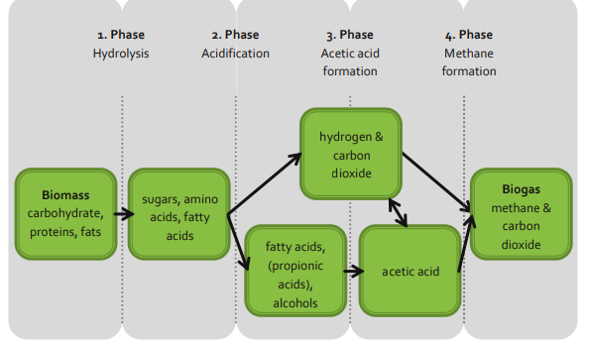
Figure 3: Mechanism in the digester

  - Analysis and Discussion
Assessing the potential for Installation of Community Level Biogas in Shree Guru Muppinarya Ashram Beeranakere Math Beeranakere

1 | Access to the project's intended site Kutcha Road | Well connected, Back side of From dining hall
AVAILABILITY OF WATER AND ELECTRICITY
2 | Water source at the site: | Bore well
3 | Water source away from the site: | Tanks
4 | Length in meters: | 250 Mts
5 | Availability of electricity connection (Yes/No) | yes
AVAILABILITY OF RAW MATERIALS AT ON SITE
6 | Waste available from Cattle shed | Kg/Day
7 | Cows : 45 | 900
8 | Calf : | -
9 | Waste available from Kitchen and Dining hall | 30
10 | Cooked Rice and left over food
11 | Vegetables peels | 20
12 | Food served Banana Leaves | -
13 | Flowers | -
 | Total Onsite Biomass Generation(A) | 950

AVAILABILITY OF RAW MATERIALS OFF SITE
1 | Households | -
2 | Bulk generator (adjoining gaushala, markets, etc.) | -
3 | Hotels | 2
4 | Shops | 10
 | Total Offsite Biomass Generation(B) | 12
 | Grand Total(A+B) | 962

CURRENT WASTE DISPOSAL MECHANISM
1 | Wet waste | Composting
2 | Dry waste | Handed over to SWM unit
3 | Liquid waste | Septic tank and soak pit
AVAILABLE SITE FOR INSTALLMENT OF BIO-GAS PLANT
4 | Length of site | 100 m
5 | Width | 20 m
6 | Area | 200 m²
PRESENT ENERGY CONSUMPTION FOR COOKING
7 | Quantity of LPG used per day : Kgs/day | 3.0 Kg/Day
8 | Biomass used kgs/day | 25 Kg/Day
COLLECTION MECHANISM
9 | Method of collection | Auto
BIO-GAS TECHNOLGY USED
Technology types
1 | Fixed Dome Biogas plant | Floating dome design biogas plant
2 | Floating Dome Design Biogas Plant
3 | Prefabricated model Biogas Plant
4 | Bag Type Biogas Plant (Flexi model)
5 | Capacity of Biogas Plant | 45M³
6 | Size of the Digester | 3.65 m depth  1.82 m radius
 | Biogas slurry whether to be used as: Production
7 | Liquid bio-slurry(or) | Liquid bio slurry
8 | Solid/dewatered/dried slurry fertilizer
9 | Biogas slurry management | Application along with other agri waste to produce manure
10 | Biogas Storage | Fiber floating drum

  - Capital Cost of the plant
SL.NO | PARTICULARS | QTY | COST
1 | Cost of the plants | 45M³ | 11,25,000
 | Total |  | 11,25,000

  - Annual Income
Sl.No | Items |  | Unit cost (Rs.)
1 | Manpower | 1 | 10,000
2 | Electricity | 1 unit | 1000
3 | Water | -- | 1000
4 | Chemical (commercial grade NaOH) | -- | --
 | Total |  |  | 12000
 | Yearly |  |  | 1,44,000
Land requirement for 45 M3
Capacity of the plant (kg/day) |  | Land requirement (m2)
962 |  | 50

  - CONCLUSION
Biogas technology is a viable worldwide enterprise, owing to the availability of established production methods and uses, and also because of promising future technologies. Because of the abundant supply of cheap feedstock’s and the accessibility of a broad spectrum of biogas uses including heating, producing electricity, use as gasoline, and raw material for further processing and production of sustainable chemicals such as hydrogen and carbon dioxide, as well as biofuels, biogas technology is viable and sustainable. Biogas production is flexible in terms of size, ranging from small-scale to large-scale industrial digesters, and a wide variety of possible feedstock allows it to be produced everywhere in the world. Biogas production and consumption are increasing internationally, and it has the potential to be a leading affordable alternative for producing sustainable bioenergy. Main advantages of Bio-gas plant are
- It is an environmentally benign fuel, and the raw materials needed for biogas generation are abundant in communities.
- It not only generates biogas but also provides nutrient-rich slurry for agricultural cultivation.
- It reduces the health risks of smoke in poorly ventilated rural families who cook with dung cake and firewood.
- It contributes to environmental cleanliness by eliminating open piles of manure and other waste products that attract flies, insects, and illnesses.

Reference
- M. Mohammad, W. W. Mohamad Ishak, S. I. Mustapa, and B. V. Ayodele, “Natural gas as a key alternative energy source in sustainable renewable energy transition: a mini review,” Frontiers in Energy Research, vol. 9, 2021.
- C. Gürsan and V. de Gooyert, “The systemic impact of a transition fuel: Does natural gas help or hinder the energy transition?” Renewable and Sustainable Energy Reviews, vol. 138, p. 110552, 2021.
- A. Azam, M. Rafiq, M. Shafique, and J. Yuan, “Renewable electricity generation and economic growth nexus in developing countries: An ARDL approach,” Economic Research-Ekonomska Istraživanja, vol. 34, no. 1, pp. 2423–2446, 2021.
- S. Sahota, G. Shah, P. Ghosh et al., “Review of trends in biogas upgradation technologies and future perspectives,” Bioresource Technology Reports, vol. 1, pp. 79–88, 2018.
- V. Moreau and F. Vuille, “Decoupling energy use and economic growth: Counter evidence from structural effects and embodied energy in trade,” Applied Energy, vol. 215, pp. 54–62, 2022.
- R. Kumar, R. Jilte, and M. H. Ahmadi, “Electricity alternative for e-rickshaws: an approach towards green city,” International Journal of Intelligent Enterprise (IJIE), vol. 5, no. 4, pp. 333–344, 2018.
- S. Achinas, V. Achinas, and G. J. W. Euverink, “Atechnological overview of biogas production from biowaste,” Engineering, vol. 3, no. 3, pp. 299–307, 2017.
- G. Pasternak, “Chapter 9- Electrochemical approach for biogas upgrading,” Emerging Technologies and Biological Systems for Biogas Upgrading, Academic Press, pp. 223–254, 2021.
- D. J. Stevens, Hot gas conditioning: recent progress with larger-scale biomass gasification systems, National Renewable Energy Lab. (NREL), USA, 2001,
- R. F. T. Tagne, X. Dong, S. G. Anagho, S. Kaiser, and S. Ulgiati, “Technologies, challenges and perspectives of biogas production within an agricultural context. The case of China and Africa,” Environment, Development and Sustainability, vol. 23, no. 10, pp. 14799–14826, 2021, 10.1007/s10668-021-01272-9.

