FEASIBILITY AND ECONOMIC ASPECTS OF WIND FARM INSTALLATION IN THE STATE OF JHARKHAND

ABSTRACT

In ancient time people does not know that what is an electricity means no any knowledge of an electricity. But in 600 BC finally we came to know that what is an electricity. we do lot of things and utilized for our daily purposes by the help of an energy sources. In ancient time they used for many purposes such as farming, water sources, helps at night to visible, pumping water and many more things for utilized. Today’s date we are getting an electricity from many sources like RES & NRES. Due to NRES its effects global warming day by day which make a whole in our ozone layer due to that its effects peoples, animals, & all living organism. Not in India but all over the world each Country Government are investing in RES. From RES we can generate an electricity from nature & also its reduced cost of generation energy sources as compared to NRES. The RES which give’s a clean energy and also fulfill the demand of consumers.

1. Introduction
Generation of power by the help of wind which we are getting from nature or we can say RES. The WPP (Wind power plant) which convert KE (Kinetic Energy) into RE (Rotating Energy) So by the help of rotating blades its transfer the energy to generator. It’s convert {KE – ME} & the generator converts{ME – EE} the WPP Growth very fast since 2001.
2. Wind power plant and its working

WM (Wind mill) / WPP (Wind power plant) that convert (KE-ME) & generator that converts (ME– EE). It is shown in the figure that how its working, how to GE (Generate Electricity).The WPP Blades has there own structure known as AFS (Air Flow Structure) from which laminar flow can be minimize. If we talk about the WB (Wind Blade) & its tower its depend upon the power production of WM, Air, Areas to setup the WPP.

SN  (Serial numbers) | MWPPM  (Mega watt production per minute) | WPPTS  (Wind power plant tower size) | WPPBS  (Wind power plant blade size)
1 | 1MW-2MW | 175F-220F | 75F-266F
2 | 3MW-4MW | 275F-425F | 275F-300F
3 | 5MW-6MW | 465F-510F | 335F-375F
4 | 7MW-8MW | 545F-625F | 395F-477F
5 | 9MW-10MW | 640F-705F | 515F-580F
6 | 15MW-17MW | 745F-830F | 620F-735F

Table 2.1 {Towers and Blades detail}
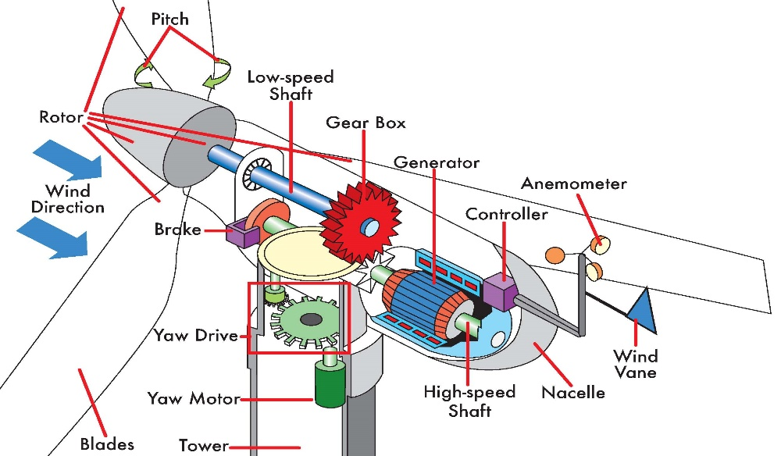

Fig 2 {a}
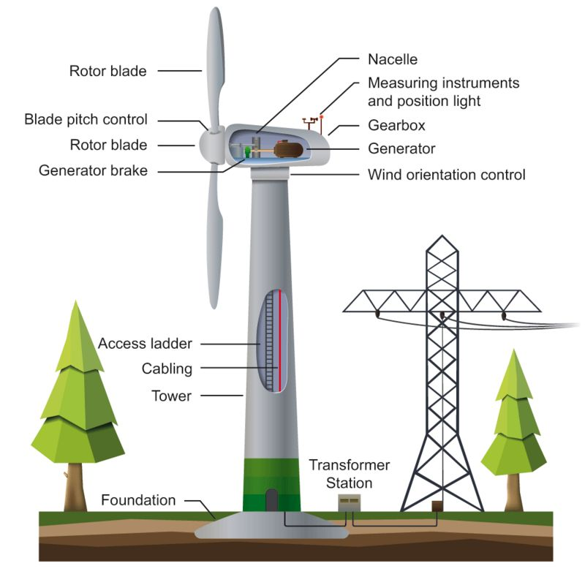

Fig 2{a} & 2{b} Working of wind power plants.
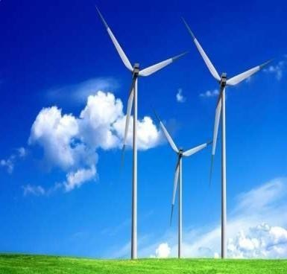
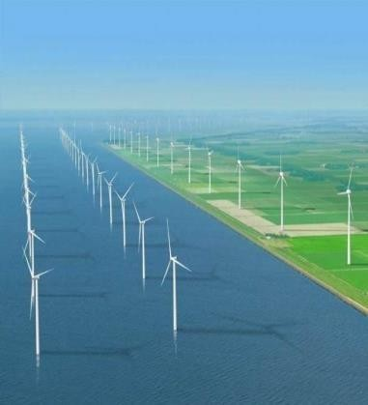
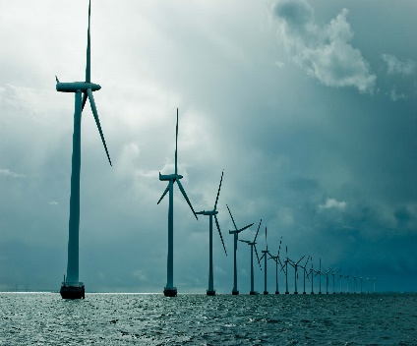
The wind Blades rotates very slowly Its turns per minutes around 8 RPM – 10 RPM or 8 RPM – 12 RPM. But if we talk about the Thermal power generation station its rotates is around 3000 RPM. If we are generating an electricity at the speed of 8 RPM – 12 RPM thus its cannot able to generate an electricity for huge amount.so that you can easily seen in the diagram that there is a Nacelle part which automatic move there direction where airy direction is moving the blades are connected to the shaft & shaft connected to gear box which increase the revolution of blade 1000 RPM – 1500 RPM. The generators converts (ME-EE) some controllers are also there which send the signals to the control room. The Anemometer tell the directions of air that in which direction air is flowing.

Fig {c}: ONSWPP Fig {d} : OSWPP Fig {e} : NSWPP

- ONSWPP = {On shore wind power plants}
- OSWPP = {Off shore wind power plants}
- NSWPP = {Near shore wind power plants}

Anywhere we cannot able to setup the WPP, Airey places matters, So before setup the WPP Planning is very necessary. The minimum speed should be 10 km/h – 15km/h So that a small amount of energy sources can be generated to fesible for district’s. But if we talk about the high amount of wind generation the speed should be minimum 50 km/h to 60km/h Higher airey places are good for setup the WPP.
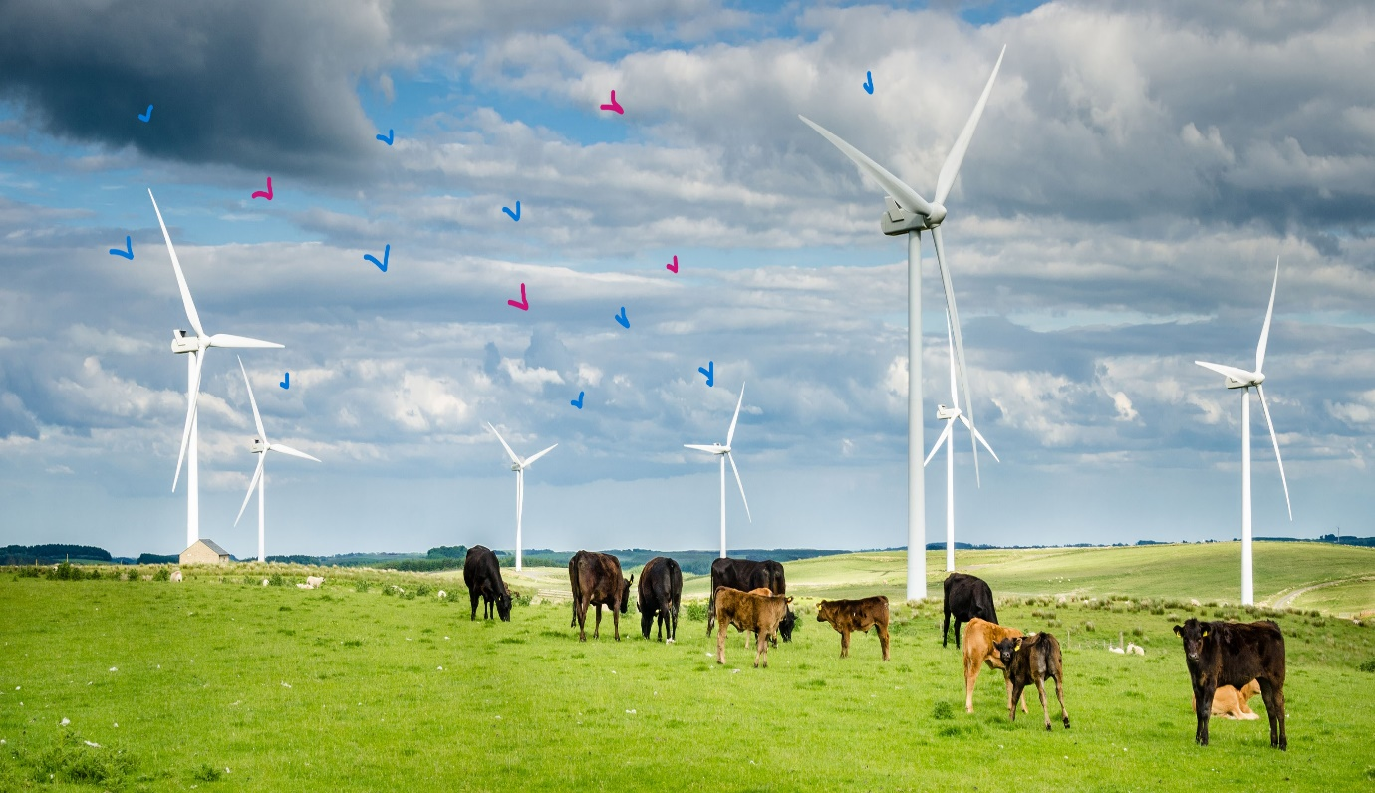
3. Challenges and Opportunity
Fig 3.1: Challenges in wind generation

- It’s a very difficulty to chose places to setup the WPP. Reasons WPP is totally dependent upon Air. Without air it’s not possible to generate energy sources. So that it’s a big issue to setup the WPP anywhere.
- It’s produces humming and irritating’s sounds which effects all living organism’s specially Human beings. Also its kills thousands of birds per months also its effects farming.
- To prevent the birds we are using a radian on its blade so that birds can be easily able to seen from such a far distance and they never came near to thr WPPB { Wind power plants blades}
4. Literature Survey

- In terms’ of generation India produce 7500 MW but consumed 3415 MW only. India became 4th largest country in the world & in consumption 3rd. Still the remaining energy sources are sells to other country so that they gets benefits.
- After surveying and studying finally I came to know that till 2050 the RES {Renewable energy sources} will take place over NRES {Non renewable energy sources} which is very good news. The NRES Effects the global warming which makes whole in ozone layers. If continuously we depend upon NRES thus Its destroyed every things in nature, Human beings and all living organism.
- To Setup the WFPP {Wind farm power plants}its cost is too much high. If we talk about single wind pole of 5.5 MWPP {Mega watt production power} thus its cost around 15 Crore – 20 Crore think how much its costly but this OWMT {One wind mill tower} fulfill around 40000 Homes yearly very easy if the airy conditions is very good. Its clean energy, reliable & polluted free .
5. Mathematical Calculation of Wind Velocity

Mathematical example solutions taken from the state of Gumla districts of year 2018 January on the basis of daily & hourly wise.

9.2+8.2+7.1+7.2+8.6+6.3+2.2+2.6+7.5+5.7+9.2+6.9+6.5+3.4+3.7+11.3+2.8+7.5+7.3+9.5+2.0+1.7+2.8+6.4+5.2+6.5+5.1+9.5+8.6+9.4+6.3

31

= 196.23
------------------------------
31

= 6.33

Table 5.1 : An {AAWV}Average annual wind velocity for {24}districts of Jharkhand year 2K18.
D  {Dist} | J  {Jan} | F  {Feb} | M  {Mar} | A  {Apr} | M  {May} | J  {Jun} | J  {July} | A  {Aug} | S  {Sep} | O  {Oct} | N  {Nov} | D  {De}
D{Dhanbad} | 7.66 | 16.2 | 9.6 | 2.92 | 2.83 | 2.93 | 2.82 | 2.84 | 2.91 | 2.84 | 2.95 | 2.83
R {Ranchi} | 9.87 | 13.5 | 12 | 13.5 | 14.3 | 17.4 | 22.6 | 18 | 19.5 | 14.3 | 13.2 | 15.1
B {Bokaro} | 9.53 | 13.5 | 12.2 | 12.7 | 14 | 15.3 | 22.5 | 16.2 | 17.5 | 14.8 | 12.9 | 14.7
D{Deogha} | 7.6 | 18.7 | 11.1 | 9.12 | 1.1 | 1.1 | 1.1 | 1.1 | 1.1 | 1.1 | 1.1 | 1.1
G {Giridhi} | 7.31 | 19.3 | 1.1 | 1.1 | 1.1 | 1.1 | 1.1 | 1.1 | 1.1 | 1.1 | 1.1 | 1.1
HZB | 9.81 | 12.8 | 12.6 | 13.2 | 15.4 | 16.7 | 23.2 | 17.5 | 19.5 | 14.7 | 13.2 | 15.3
R{Ramgar} | 10.2 | 13.8 | 13.2 | 13.2 | 14.9 | 17.1 | 23.6 | 18.3 | 19.3 | 15.3 | 12.8 | 18.8
D {Dumka} | 6.33 | 19.6 | 9.11 | 5.65 | 2.31 | 1.1 | 1.1 | 1.1 | 1.1 | 1.1 | 1.1 | 1.1
K {Khunti} | 10.3 | 13.2 | 12.6 | 12.9 | 14.6 | 15.3 | 22.8 | 18.3 | 19.7 | 14.5 | 12.8 | 13.4
G {Gumla} | 6.22 | 17.2 | 8.64 | 4.87 | 1.1 | 1.1 | 1.1 | 1.1 | 1.1 | 1.1 | 1.1 | 1.1
L{Loharda} | 10.2 | 13.3 | 13.2 | 13.6 | 14.8 | 17.5 | 23.2 | 17.6 | 20.2 | 15.2 | 12.9 | 14.8
P {Palamu} | 7.62 | 22.3 | 12.3 | 5.12 | 5.68 | 4.65 | 4.32 | 4.86 | 3.91 | 3.92 | 1.47 | 2.03
J {Jamtara} | 5.3 | 4.36 | 4.97 | 3.25 | 3.97 | 4.95 | 4.16 | 4.03 | 4.23 | 3.53 | 2.58 | 3.28
P{Paku} | 7.92 | 14.3 | 11.2 | 6.27 | 5.38 | 5.38 | 4.93 | 4.87 | 5.35 | 5.32 | 3.75 | 4.31
S{Simdega} | 1.91 | 1.1 | 1.1 | 1.1 | 1.1 | 1.1 | 1.1 | 1.1 | 1.1 | 1.1 | 1.1 | 1.1
G{Garhwa} | 8.81 | 15 | 14.4 | 9.53 | 10.28 | 8.95 | 26.5 | 24 | 22.9 | 21.2 | 20.3 | 19.5
G{Godda} | 5.32 | 4.87 | 6.67 | 3.84 | 4.76 | 5.62 | 6.52 | 5.41 | 6.42 | 4.53 | 3.22 | 4.66
C {Chatra} | 14 | 17.2 | 18.3 | 20.2 | 19 | 18.7 | 15.8 | 18.4 | 17.6 | 15.2 | 14.3 | 10.3
S{Sahibgan} | 12.3 | 13.6 | 19.2 | 18.2 | 22.2 | 18.2 | 17.6 | 15.9 | 22.7 | 14.5 | 15.6 | 22.3
KQR | 13.6 | 16.6 | 18.6 | 19.3 | 20.2 | 19.2 | 16.3 | 16.6 | 17 | 14.7 | 13.4 | 10.3
LTHR | 4.68 | 13.3 | 11.2 | 5.21 | 5.21 | 4.87 | 4.21 | 4.55 | 4.11 | 4.92 | 1.47 | 2.11
SKW | 6.99 | 9.33 | 11.7 | 14.5 | 12.3 | 10.31 | 11.3 | 13.2 | 11.2 | 9.31 | 7.21 | 7.21
ESB | 6.64 | 10.55 | 12.8 | 13.32 | 11.84 | 9.87 | 9.97 | 10.87 | 10.9 | 8.61 | 6.51 | 6.52
WSB | 7.31 | 7.85 | 12 | 14.2 | 13.4 | 8.41 | 9.37 | 9.87 | 11.0 | 9.41 | 8.28 | 7.24

Table 5.2 : An {AAWV}Average annual wind velocity for {24}districts of Jharkhand year 2K19.

D  {Dist} | J  {Jan} | F  {Feb} | M  {Mar} | A  {Apr} | M  {May} | J  {Jun} | J  {July} | A  {Aug | S  {Sep} | O  {Oct} | N  {Nov | D  {De}
D {Dhanbad} | 5.63 | 13.8 | 8.92 | 3.09 | 2.99 | 2.92 | 2.67 | 2.95 | 2.87 | 2.82 | 3.01 | 2.93
R {Ranchi} | 10.0 | 13.6 | 11.87 | 13.4 | 14.3 | 17.3 | 24.7 | 19.8 | 19.5 | 14.3 | 13 | 14
B {Bokaro} | 8.92 | 13.8 | 12 | 13.2 | 13.4 | 15.9 | 24.2 | 15.2 | 19.3 | 19.2 | 13.2 | 14.3
D {Deoghar} | 5.79 | 16.3 | 9.76 | 1.1 | 1.1 | 2.32 | 1.99 | 1.1 | 1.1 | 1.1 | 1.1 | 1.1
G {Giridhi} | 9.32 | 18.8 | 10.32 | 1.1 | 1.87 | 1.1 | 1.1 | 1.1 | 1.1 | 1.1 | 1.1 | 1.1
HZB | 10.3 | 12.6 | 12.9 | 13.9 | 14.8 | 14.8 | 21.6 | 18.1 | 18.8 | 14.3 | 12 | 15.3
R {Ramgarh} | 10.0 | 12.9 | 12.9 | 12.4 | 15.2 | 16.5 | 24.3 | 19.2 | 19.4 | 14 | 13.9 | 19.3
D {Dumka} | 7.3 | 14.8 | 9.32 | 8.11 | 1.1 | 1.1 | 1.1 | 1.1 | 1.1 | 1.1 | 1.1 | 1.1
K {Khunti} | 11.2 | 11.3 | 12.7 | 12.8 | 15.3 | 15.1 | 19.3 | 18.8 | 19.6 | 13.8 | 13.9 | 13.7
G {Gumla} | 6.32 | 16.2 | 9.32 | 1.1 | 1.1 | 1.1 | 1.1 | 1.1 | 1.1 | 1.1 | 1.1 | 1.99
L{Lohardaga} | 9.52 | 13.4 | 12.8 | 13 | 13.8 | 17.9 | 20.3 | 19.3 | 18.9 | 15.2 | 13.2 | 13.6
P {Palamu} | 7.39 | 21.5 | 14.5 | 4.11 | 4.32 | 4.52 | 4.37 | 4.65 | 3.17 | 3.55 | 1.33 | 1.31
J {Jamtara} | 5.36 | 5.22 | 4.27 | 3.22 | 3.52 | 4.87 | 4.65 | 4.11 | 4.22 | 3.09 | 2.96 | 3.09
P{Pakur} | 8.11 | 14.6 | 12.3 | 6.19 | 5.86 | 5.31 | 4.34 | 5.31 | 5.39 | 5.66 | 4.27 | 4.26
S {Simdega} | 1.46 | 1.32 | 1.1 | 1.1 | 1.1 | 1.1 | 1.1 | 1.1 | 1.1 | 1.1 | 1.1 | 1.1
G {Garhwa} | 8.87 | 13.6 | 14.3 | 10.32 | 10.27 | 9.11 | 26.2 | 24.5 | 23.2 | 21.4 | 21.2 | 20.4
G{Godda} | 5.82 | 5.02 | 6.87 | 4.32 | 4.39 | 6.71 | 6.25 | 6.51 | 6.33 | 4.34 | 3.57 | 4.09
C {Chatra} | 15.3 | 17 | 19.3 | 20.3 | 19.7 | 18.3 | 16.5 | 20.2 | 17.3 | 14 | 14.6 | 14.2
S {Sahibganj} | 12.6 | 12.8 | 19.3 | 19.2 | 22.5 | 18.6 | 17.6 | 18.2 | 23.3 | 14 | 14.5 | 21
KQR | 15.1 | 16.7 | 17.7 | 19.8 | 19.6 | 19.5 | 16.8 | 17.8 | 13.4 | 16.7 | 13.4 | 11.6
LTHR | 6.11 | 16.5 | 11.2 | 11.2 | 4.98 | 4.34 | 3.87 | 4.55 | 3.66 | 3.37 | 1.96 | 1.99
SKW | 6.32 | 9.34 | 11.6 | 14.6 | 12.8 | 10.55 | 12.3 | 12.6 | 12.4 | 9.12 | 7.72 | 6.99
ESB | 6.65 | 9.52 | 11.5 | 14.1 | 11.3 | 9.33 | 9.69 | 10.6 | 10.5 | 8.66 | 5.63 | 6.31
WSB | 7.06 | 8.93 | 11.3 | 14.6 | 14.3 | 9.51 | 9.55 | 9.62 | 9.86 | 9.61 | 7.69 | 7.53

Table 5.3 : An {AAWV}Average annual wind velocity for {24}districts of Jharkhand year 2K20.
D  {Dist} | J  {Jan} | F  {Feb} | M  {Mar} | A  {Apr} | M  {May} | J  {Jun} | J  {July} | A  {Aug | S  {Sep} | O  {Oct} | N  {Nov | D  {Dec}
D {Dhanbad} | 6.99 | 13.8 | 9.6 | 2.96 | 2.64 | 2.66 | 2.59 | 2.99 | 2.91 | 2.58 | 2.78 | 2.98
R {Ranchi} | 10.3 | 11.6 | 13.4 | 13.6 | 16.8 | 20.5 | 18.3 | 20.2 | 14.2 | 12.1 | 12.3 | 14
B {Bokaro} | 9.62 | 13.9 | 12.8 | 12 | 13.8 | 14.6 | 22.4 | 16 | 15.6 | 14.3 | 12.8 | 14.6
D {Deoghar} | 7.13 | 17.5 | 9.87 | 3.4 | 1.1 | 1.1 | 1.1 | 1.1 | 1.1 | 1.1 | 1.1 | 11
G {Giridhi} | 10.9 | 12.3 | 10.57 | 3.46 | 3.11 | 1.1 | 1.1 | 1.1 | 1.1 | 1.1 | 1.1 | 11
HZB | 10.1 | 13.4 | 13.1 | 13.2 | 13.8 | 16.3 | 22.7 | 17.5 | 19.3 | 14.5 | 12 | 13.6
R {Ramgarh} | 10.2 | 13.6 | 12.9 | 13.4 | 14.2 | 17.4 | 19.5 | 18.5 | 20 | 14.8 | 13.5 | 17.6
D {Dumka} | 6.06 | 16.7 | 8.53 | 1.32 | 1.1 | 1.1 | 1.1 | 1.1 | 1.1 | 1.1 | 1.1 | 1.1
K {Khunti} | 9.87 | 13.8 | 13 | 12.6 | 13.7 | 16.5 | 21 | 15.9 | 19.5 | 14.6 | 13.3 | 13.5
G {Gumla} | 4.93 | 11.6 | 13.8 | 2.3 | 1.1 | 1.1 | 1.1 | 1.1 | 1.1 | 1.1 | 1.1 | 1
L{Lohardag} | 9.67 | 13.4 | 12.6 | 13.7 | 13.5 | 17 | 24.5 | 18.3 | 19 | 14.6 | 17.5 | 14.3
P {Palamu} | 7.01 | 21.5 | 12.3 | 6.11 | 5.52 | 4.62 | 4.52 | 4.22 | 3.26 | 3.51 | 1.92 | 1.86
J {Jamtara} | 5.3 | 4.56 | 4.31 | 3.14 | 3.28 | 4.24 | 4.29 | 4.66 | 3.28 | 2.87 | 2.32 | 3.11
P{Pakur} | 8.12 | 15.3 | 11.2 | 6.16 | 5.9 | 5.64 | 4.34 | 4.68 | 5.52 | 4.99 | 4.11 | 3.27
S {Simdega} | 1.22 | 1.1 | 1.1 | 1.1 | 1.1 | 1.1 | 1.1 | 1.1 | 1.1 | 1.1 | 1.1 | 1
G {Garhwa} | 8.06 | 15 | 14.3 | 9.23 | 10.23 | 9.25 | 26.2 | 23.3 | 22.4 | 22.5 | 20.5 | 18.2
G{Godda} | 6.12 | 4.56 | 6.42 | 3.86 | 4.34 | 5.61 | 6.57 | 5.33 | 6.22 | 4.23 | 3.29 | 4.57
C {Chatra} | 15.1 | 17.6 | 17.5 | 19.8 | 20.6 | 17.8 | 16.3 | 14.3 | 16.8 | 14.8 | 14.2 | 9.79
S {Sahibganj} | 12 | 12.6 | 12.9 | 18 | 22.2 | 18.6 | 18.1 | 21 | 14.9 | 14.8 | 22.1 | 18.5
KQR | 14.5 | 17.9 | 18.6 | 20.5 | 17.5 | 17.4 | 18.5 | 17.4 | 19.5 | 13.8 | 10.3 | 10.8
LTHR | 4.66 | 14.6 | 13.5 | 5.22 | 5.68 | 4.22 | 4.24 | 4.34 | 4.05 | 3.58 | 2.31 | 1.99
SKW | 7.42 | 8.25 | 12.4 | 13.8 | 13.6 | 10.66 | 11.6 | 11.9 | 10.6 | 7.25 | 7.23 | 7.24
ESB | 6.22 | 8.23 | 12.3 | 13.8 | 11.3 | 8.99 | 10.5 | 10.7 | 8.24 | 6.5 | 6.44 | 5.62
WSB | 8.12 | 8.64 | 11.7 | 14.2 | 13.5 | 8.68 | 8.75 | 10.0 | 9.69 | 8.31 | 8.01 | 6.59

Table 5.4 : An {AAWV}Average annual wind velocity for {24}districts of Jharkhand year 2K21.
D  {Dist} | J  {Jan} | F  {Feb} | M  {Mar} | A  {Apr} | M  {May} | J  {Jun} | J  {July} | A  {Au} | S  {Sep} | O  {Oct} | N  {Nov | D  {Dec}
D{Dhanbad} | 7.7 | 13.4 | 8.6 | 3.11 | 2.31 | 2.81 | 2.72 | 2.84 | 2.91 | 2.64 | 3.1 | 2.82
R {Ranchi} | 9.7 | 14.3 | 11.8 | 13.3 | 14.8 | 16.3 | 22.3 | 18.6 | 19.4 | 13.2 | 11 | 13.2
B {Bokaro} | 10.0 | 12.8 | 12.7 | 12 | 13 | 15.3 | 22.4 | 16.2 | 17.3 | 15.2 | 12.4 | 15.3
D {Deoghar} | 18.0 | 10.0 | 5.32 | 1.1 | 1.1 | 1.1 | 1.1 | 1.1 | 1.1 | 1.1 | 4.31 | 1.1
G {Giridhi} | 7.51 | 18.8 | 10 | 8.72 | 1.1 | 1.1 | 1.1 | 1.1 | 1.1 | 1.1 | 1.1 | 1.1
HZB | 9.0 | 13.6 | 12.6 | 13 | 13.8 | 17.3 | 22.8 | 17.6 | 18.4 | 15.3 | 12.4 | 15.5
R{Ramgarh} | 9.95 | 13.2 | 12.8 | 13.3 | 13.8 | 16.9 | 24.6 | 17.3 | 20.6 | 13.8 | 13 | 18.5
D {Dumka} | 6.9 | 17.6 | 8.15 | 6.7 | 1.1 | 1.1 | 1.1 | 4.31 | 1.1 | 1.1 | 1.1 | 1.1
K {Khunti} | 10.7 | 13.2 | 13.4 | 12.2 | 13.8 | 14.8 | 22.6 | 19.5 | 19.3 | 14.9 | 14.1 | 14.3
G {Gumla} | 5.32 | 17.8 | 9.22 | 1.1 | 1.1 | 1.1 | 1.1 | 1.1 | 1.1 | 1.1 | 1.1 | 1.1
L{Lohardag} | 10.2 | 13.6 | 13 | 13.3 | 14.8 | 17.3 | 23 | 18.3 | 20.2 | 14.3 | 12.6 | 14.5
P {Palamu} | 6.55 | 23.2 | 12.6 | 5.41 | 5.32 | 4.72 | 4.26 | 4.32 | 4.22 | 3.46 | 1.52 | 1.75
J {Jamtara} | 5.66 | 4.35 | 4.56 | 3.55 | 4.22 | 4.25 | 4.25 | 4.15 | 4.14 | 3.6 | 3.56 | 2.36
P{Pakur} | 7.62 | 15.4 | 11.5 | 6.12 | 5.35 | 5.66 | 4.32 | 3.54 | 6.5 | 3.3 | 3.41 | 3.99
S {Simdega} | 1.21 | 1.22 | 1.1 | 1.1 | 1.1 | 1.1 | 1.1 | 1.1 | 1.1 | 1.1 | 1.1 | 1.1
G {Garhwa} | 8.33 | 15 | 14.3 | 10.66 | 10.25 | 8.93 | 26 | 24.9 | 23.2 | 21.5 | 20 | 18.3
G{Godda} | 4.89 | 4.69 | 6.31 | 4.32 | 4.69 | 5.62 | 6.94 | 5.66 | 6.31 | 4.08 | 3.51 | 3.98
C {Chatra} | 13.6 | 19 | 18.4 | 18.6 | 19 | 14.6 | 15.4 | 17.6 | 19.7 | 10.8 | 10.2 | 10.1
S{Sahibgan} | 13.4 | 13.8 | 19 | 18.7 | 22.1 | 20.6 | 17.3 | 18.3 | 14.3 | 16.5 | 15.3 | 20
KQR | 13.6 | 16.7 | 18.9 | 19.4 | 20.3 | 19.5 | 15.4 | 17.5 | 17.3 | 14.5 | 13.5 | 9.99
LTHR | 11.9 | 15.7 | 10.66 | 5.32 | 5.66 | 5.11 | 5.19 | 4.59 | 4.27 | 3.29 | 3.27 | 3.16
SKW | 6.99 | 8.87 | 10.32 | 14.2 | 12.7 | 10.6 | 11.5 | 11.9 | 11.2 | 7.69 | 7.99 | 7.11
ESB | 6.51 | 9.54 | 9.99 | 13.8 | 12.7 | 9.33 | 9.14 | 11.2 | 11.4 | 8.82 | 6.4 | 6.23
WSB | 7.32 | 8.12 | 12.1 | 14 | 13.6 | 7.35 | 7.99 | 10.3 | 10.5 | 9.25 | 9.24 | 9.06
Table 5.5 : An {AAWV}Average annual wind velocity for {24}districts of Jharkhand year from {2018 – 2021} respectively which shoes its wind velocity

D  {Dist} | J  {Jan} | F  {Feb} | M  {Mar} | A  {Apr} | M  {May} | J  {Jun} | J  {July} | A  {Aug | S  {Sep} | O  {Oct} | N  {Nov | D  {De}
D {Dhanbad} | 6.09 | 14.8 | 9.25 | 2.99 | 2.71 | 2.84 | 2.71 | 2.89 | 2.9 | 2.74 | 2.94 | 2.88
R {Ranchi} | 9.58 | 13.4 | 12.2 | 13.4 | 15 | 17.7 | 17.5 | 18.9 | 18.3 | 13.6 | 12.5 | 14.2
B {Bokaro} | 9.58 | 13.7 | 12.5 | 12.5 | 13.6 | 15.3 | 22.9 | 15.8 | 17.64 | 15.6 | 12.8 | 14.7
D {Deoghar} | 9.1 | 16.4 | 9.24 | 3.16 | 1.1 | 1.34 | 1.27 | 1.1 | 1.1 | 1.1 | 1.74 | 1.1
G {Giridhi} | 8.44 | 17.8 | 8.52 | 3.09 | 1.65 | 1.1 | 1.1 | 1.1 | 1.1 | 1.1 | 1.1 | 1.1
HZB | 10.0 | 13.5 | 12.9 | 13.2 | 14.5 | 16.3 | 22.7 | 17.7 | 19 | 14.7 | 12.5 | 14.9
R {Ramgarh} | 10.2 | 13.2 | 13.0 | 13.1 | 14.6 | 17 | 23.1 | 18.3 | 19.7 | 14.5 | 13.2 | 18.5
D {Dumka} | 6.5 | 17.7 | 8.9 | 4.57 | 1.34 | 1.1 | 1.1 | 1.74 | 1.1 | 1.1 | 1.1 | 1.1
K {Khunti} | 10.4 | 13 | 13 | 12.7 | 14.4 | 15.3 | 21.8 | 18.1 | 19.4 | 14.5 | 13.5 | 13.8
G {Gumla} | 5.81 | 16.1 | 10.1 | 2.09 | 1.1 | 1.1 | 1.1 | 1.1 | 1.1 | 1.1 | 1.1 | 1.27
L{Lohardaga} | 10.0 | 13.6 | 13 | 13.4 | 14.3 | 17.3 | 22.9 | 18.3 | 19.5 | 14.8 | 13.8 | 14.4
P {Palamu} | 7.05 | 22.4 | 13 | 5.17 | 5.24 | 4.62 | 4.35 | 4.56 | 3.71 | 3.67 | 1.54 | 1.79
J {Jamtara} | 5.04 | 4.52 | 4.7 | 3.28 | 3.79 | 4.65 | 4.3 | 4.19 | 4.02 | 3.32 | 2.81 | 3.02
PKR {Pakur} | 8.0 | 15.1 | 12 | 6.18 | 5.67 | 5.47 | 4.58 | 4.65 | 5.66 | 4.91 | 3.87 | 4.07
S {Simdega} | 1.4 | 1.2 | 1.2 | 1.1 | 1.1 | 1.1 | 1.1 | 1.1 | 1.1 | 1.1 | 1.1 | 1.1
G {Garhwa} | 8.6 | 15 | 14.5 | 9.9 | 10.3 | 9.1 | 26.4 | 24.1 | 22.8 | 21.5 | 20.5 | 19.1
G{Godda} | 5.6 | 4.9 | 6.6 | 4.1 | 4.6 | 5.9 | 6.52 | 5.66 | 6.33 | 4.35 | 3.37 | 4.41
C {Chatra} | 14.5 | 17.8 | 18.6 | 20.0 | 20.1 | 18.0 | 12.8 | 17.7 | 17.7 | 13.9 | 13.3 | 10.9
S {Sahibganj} | 13.0 | 13.5 | 18.2 | 18.5 | 22.1 | 19.1 | 17.7 | 18 | 19.7 | 14.8 | 16.4 | 20.6
KQR | 14.0 | 17.1 | 18.6 | 19.9 | 19.9 | 19.2 | 16.7 | 17.4 | 16.8 | 14.9 | 12.7 | 10.6
LTHR | 6.8 | 16 | 11.0 | 6.6 | 5.5 | 4.7 | 4.36 | 4.56 | 4.04 | 3.82 | 2.09 | 2.27
SKW | 7.3 | 9 | 11.5 | 14.5 | 12.8 | 10.5 | 11.6 | 12.4 | 11.3 | 8.33 | 7.52 | 7.15
ESB | 6.6 | 9.8 | 12 | 14 | 11.7 | 9.39 | 9.87 | 10.8 | 10.4 | 8.29 | 6.29 | 6.24
WSB | 7.6 | 8.8 | 12 | 14.5 | 13.6 | 8.47 | 9.01 | 9.93 | 10.4 | 9.2 | 8.29 | 7.53
6. Result and Comparison’s

Fig 6 {a} Wind speed chart of yearly & monthly graph of all districts.

Fig 6 {b} Wind speed chart of yearly & monthly graph.{Small production}

Fig 6 {c} Wind speed chart of yearly & monthly graph {No production}

Fig 6 {d} Wind speed chart of yearly & monthly graph.{Large production}
7. Conclusion and Futures Scope
The RES Which produce GE{green environment}Which makes the system more stability, economics, reliability, offering jobs etc. While surveying I found that only few states which produce a huge amount of ES {Energy Sources}such as SKW, ESB, WSB, KQR, SBG, CTR, GHD, LAD, HZB, BKSC, RAH, KHU & RNC. and remaining districts cannot able to produced an electricity.
References
[1] Sanjay Kumar Kar, Atul Sharma, Wind power developments in India, Renew. Sustain. Energy Rev. 48 (2015) 264–275.
[2]. Alam Sarkar Jen Wind energy potential evaluation for power generation in selected districts of Jharkhand: Energy Sources, Part A: Recovery, Utilization, and Environmental Effects: Vol 40, No 6 (tandfonline.com) https://doi.org/10.1080/15567036.2018.1454548
[3] Sanjay sharma kara, Atul kara, Renewable energy represents an area of tremendous opportunity for India.35 (2013) 233-253
[4].R.SenTimeanddatehttps//www.timeanddate.com/weather/india/deoghar/historic?monthD escribed hourly monthly and yearly wind speed data of Jharkhand
[5]. T. V. Ramachandra and G. Hegde, “Energy trajectory in India: challenges and opportunities for innovation,” Journal of Resources, Energy and Development, vol. 12, no. 1- 2, pp. 1–24, 2016
[6] Atul Sharma, Jaya Srivastava, Kar Kumar Sanjay, Anil Kumar, Wind energy status in India: a short review, Renew. Sustain. Energy Rev. 16 (2012) 1157–1164.
[7]. S. Al-Yayai, & Y. Charabi. (2015). Assessment of large-scale wind energy potential in the emerging city of Duqm (Oman). Renewable and Sustainable Energy Reviews, 47, 438– 447. https://doi.org/10.1016/j.rser.2015.03.024.
[8]. S. D. Pohekar and M. Ramachandran, “Application of multi-criteria decision making to sustainable energy planning—a review,” Renewable and Sustainable Energy Reviews, vol. 8, no. 4, pp. 365–381, 2004.
[9] https://www.weather.com/weather/india/deoghar/historic?month=12&year=2027
[10]. S. Gaddada, & S. P. K Kodicherla. (2016). Wind energy potential and cost estimation of wind energy conversion systems (W.E.C.S.s) for electricity generation in the eight selected locationsof the Tigray region (Ethiopia). Renewables, 2016(3), 10.https://doi.org/10.1186/s40807-016-0030-8.
[11]. M. Bolinger, R. Wiser, 2012. Understanding wind turbine price trends in the U.S. over the past decade. Energy Pol. 42, 628–641.
[12]. C.M.H. Mon´e, M. Bolinger, J. Rand, D. Heimiller, J. Ho, 2015. of Wind Energy Review. Cost 2017.
[13]. Government of India, 2018a. Commissioned Wind Power Projects in Karnataka.Karnataka Renewable Energy Development Limited. http://kredlinfo.in/wind/commissioned_status.pdf. (Accessed 25 August 2018).
[14]. History/background, ministry of new and renewable energy, government of India.https://mnre.gov.in/history-background. (Accessed 8 August 2018).Hossain, Jami, Sharma, D., 2015. Report on India’s Wind Power Potential.
[15]. S. Al-Suleiman, M. Fessehaye, K. Yetilmezsoy, A. Al-Ghafir, A. Al-Brashdi, N. Al-Hajri, & S. Al-Bulushi. (2019). Optimization of an inverted multi-stage double slope solar still: an environmentally friendly system for seawater purification. Desalination and Water Treatment, 141, 42–50. https://doi.org/10.5004/dwt.2019.23474.environmentally friendly system for seawater purification. Desalination and Water Treatment, 141, 42–50. https://doi.org/10.5004/dwt.2019.23474..
[16]. S. Al-Yahyai, Y. Charabi, A. Gastli, & A. Al-Badi. (2012). Wind farmland suitability indexing using multi-criteria analysis. Renewable Energy, 44, 80– 87. https://doi.org/10.1016/j.renene.2012.01.004.
[17]. Y. Charabi, S. Al-Yhyai, & A. Gastli. (2011). Evaluation of NWP performance for wind energy resources assessment in Oman. Renewable and Sustainable Energy Reviews, 15(3), 1545–1555. https://doi.org/10.1016/j.rser.2010.11.055.
[18]. K.S.P. Kumar, & S. Gaddada. (2015). Statistical scrutiny of Weibull parameters for wind energy potential appraisal in the area of northern Ethiopia. Renewables, 2, 14. https://doi.org/10.1186/s40807-015-0014-0.
[19]. M. Moein, S. Pahlavan, M. Jahangiri, & A. Alidadi Shamsabadi. (2018). Finding the minimum distance from the national electricity grid for the cost-effective use of diesel generator-based hybrid renewable systems in Iran. Journal of Renewable Energy and Environment, 5(1), 8–22. https://doi.org/10.30501/jree.2018.88377.
[20]. V. Khare, S. Nema, and P. Baradar, “Solar-wind hybrid renewable energy system: A review,” Renewable Sustainable Energy Rev. 58, 23–33 (2016). https://doi.org/10.1016/j.rser.2015.12.223
[21]. I. Mamma and J. Appelbaum, “Shadow analysis of wind turbines for dual use of land for combined wind and solar photovoltaic power generation,” Renewable Sustainable Energy Rev. 55, 713–718 (2016). https://doi.org/10.1016/j.rser.2015.11.009
[22]. R.B. Hiremath, S. Shikha, and N. H. Ravindranath, “Decentralized energy planning; and application-a review,” Renewable and Sustainable Energy Reviews, vol. 11, no.5, pp. 729–752, 2007.
[23]. R.B. Sholapurkar and Y. S. Mahajan, “Review of wind energy development and policy in India,” Energy Technology & Policy, vol. 2, no. 1, pp. 122–132, 2015.
[24]. J. Hossain, V. Sinha, and V. V. N. Kishore, “A GIS-based assessment of the potential for wind farms in India,” Renewable Energy, vol. 36, no. 12, pp. 3257–3267,2011

[25]. O. Badran and E. Abdulhadi, “Evaluation of factors affecting wind power generation in
Jordan,” in Proceedings of the 7th Asia-Pacific Conference on Wind Engineering, Taipei, Taiwan,
November 2009.
[26]. H. I. Lee, H.-Y. Kang, and C.-C. Chang, “An integrated interpretive structural modeling- fuzzy analytic network process benefits, opportunities, costs and risks model for selecting technologies,” International Journal of Information Technology and Decision Making, vol. 10, no. 5, pp. 843–871, 2011.
[27]. O. Ozgener and L. Ozgener, “Exergy and reliability analysis of wind turbine systems: a case study,” Renewable and Sustainable Energy Reviews, vol. 11, no. 8, pp. 1811–1826, 2007.
[28]. J. A. Baroudi, V. Dinavahi, and A. M. Knight, “A review of power converter topologies for wind generators,” Renewable Energy, vol. 32, no. 14, pp. 2369–2385, 2007.
[29]. G. M. J. Herbert, S. Iniyan, E. Sreevalsan, and S. Rajapandian, “A review of wind energy technologies,” Renewable and Sustainable Energy Reviews, vol. 11, no. 6, pp. 1117–1145, 2007.
[30]. Phadke, R. Bharvirkar, and J. Khangura Reassessing Wind Potential Estimates for India: Economic and Policy Implications, Environmental Energy Technologies Division, International Energy Studies, 2012.
[31]. M. R. Nouni, S. C. Mullick, and T. C. Kandpal, “Techno-economics of small wind electric generator projects for decentralized power supply in India,” Energy Policy, vol. 35, no. 4, pp. 2491–2506, 2007.
[32]. D. G. Rajakumar and N. Nagesh, “Estimating windmill cluster performance: a multicriteria approach,” Journal of Sustainable Manufacturing and Renewable Energy, vol. 2, no. 3-4, pp. 93–107, 2013.
[33]. NRDC—Council for energy environment and water and SHAKTI Foundation—Issue paper A Second Wind for India's Energy Market: Financing Mechanisms to Support India's National Wind Energy Mission, August 2014.
[34]. S. Peribesh, Biodiversity-Ecosystems Management, and the Green Economy, State Pollution Control Board, Bhubaneswar, India, 2010.
[35]. R.E Murray, S. Jenne, D. Snowberg, D. Berry, D. Cousins, 2019. Techno-economic analysis of a megawatt-scale thermoplastic resin wind turbine blade. Renew. Energy 131, 111– 119.
[36]. L. Neij, 2008. Cost development of future technologies for power generation—a study based on experience curves and complementary bottom-up assessments. Energy Pol. 36 (6), 2200–2211.
[37]. J. Buen, 2006. Danish and Norwegian wind industry: the relationship between policy
instruments, innovation, and diffusion. Energy Pol. 34 (18), 3887–3897. Global Wind Report,http://gwec.net/wp-content/uploads/vip/GWEC_PRstats2017_EN- 003_FINAL.pdf, (2017) , Accessed date: 22 October 2018.
[38]. National Offshore Wind Energy Policy. Ministry of New and Renewable Energy
[39]. National Institute of Wind Energy. Ministry of New and Renewable Energy.Governmentof India (Wind Energy Division) No. 51/58(Cab.)/2011-WE. http://www.fowind.in/uploads/default/files/news/stuff/83f27fc705a9090f00da25ccc76e0b 9d.[accessed on 01.08.2016]. of India. http://niwe.res.in/department_wra_100m%20agl.php [accessed on 01.08.2016].
[40]. Annual Report 2015-2016, Ministry of New and Renewable Energy, http://mnre.gov.in/file-manager/annual-report/2015 2016/EN/Chapter%208/chapter_8.htm,Accessed date: 25 July 2016.
[41]. M. Singh, Offshore wind energy-potential for India, Region 10 Conference (TENCON) IEEE, 2016, pp. 2624–2627.
[42]. J.K. Jethani, Challenging in wind energy, 2017, pp. 20–25 https://mnre.gov.in/october- 2017/Images/20-25.pdf.
[43]. Indian Wind Energy Association, http://www.inwea.org/tariffs.htm, Accessed date: 22 October 2018.
[44]. Australian Energy Market Operator, “Wind turbine plant capabilities report-2013 wind integration studies,” 2013.
[45]. J. Lerner, M. Grundmeyer, and M. Garvert, “The importance of wind forecasting,” Renewable Energy Focus, vol. 10, no. 2, pp. 64–66, mar 2009. [Online]. Available: 10.1016/s1755-0084(09)70092-4
[46]. G. Giebel and G. Kariniotakis, “Wind power forecasting—a review of the state of the art,” in Renewable Energy Forecasting. Elsevier, 2017,pp. 59–109. [Online]. Available: 10.1016/b978-0-08-100504-0.00003-2
[47]. V. Yaramasu, A. Dekka, M.J. Durán, S. Kouro, B. Wu, PMSG-based wind energyconversion systems: survey on power converters and controls, IET Electr. Power Appl. 11 (6) (2017 Jul 1) 956–968.

.

.

