Pro drug development
Abstract
Prodrugs are drugs that have been biochemically or enzymatically modified in a way that allows the parent drug to be released once within the body. After being released, the substance may produce its desired pharmacological effect. The selection of prodrug design as a strategy is a viable solution for addressing various challenges encountered in drug discovery and development, aspects include durability, safety, lability, dissolution, transport, and medication specificity. Prodrug design is a novel method for targeting drugs by altering their physiochemical, biological, or pharmacokinetic features. Approximately 10-14% of pharmaceutical substances that have received global approval can be categorized as prodrugs. This chapter presents a thorough examination of the introduction, classification, rationale of prodrug approach, and various methodologies employed in prodrug drug design. It also delves into the many ways prodrug design might be used to the pharmaceutical industry. Furthermore, it examines the essential functional groups that can be employed in the design of prodrugs.
Keywords: Prodrug design, drug development, pharmacokinetic, drug discovery

1. INTRODUCTION
A "prodrug" is a molecule that, via metabolic biotransformation, may become a "active drug" after originally having no pharmacological action. This alteration may take place before to, during, or after absorption, or at predetermined locations throughout the body[1]. Adrian Albert first used the term "prodrug" in 1958 to describe "therapeutic agents that are initially inactive but can be converted into one or more active metabolites." This process occurs before the substance exhibits any pharmacological activity. The term "Drug Latentiation" is widely used to describe prodrug design in the scientific literature[2].
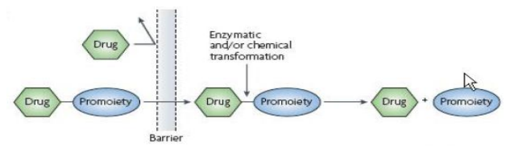
Figure 1: Fate of prodrug approach
Limited bioavailability, inadequate absorption, unpleasant responses, and first pass metabolism are only some of the unfavourable physiochemical and biological features shared by the vast majority of pharmacological compounds. Physical, chemical, or biological approaches may be used to reduce the aforementioned problems, hence increasing the therapeutic efficacy of these medications. The controlled release formulations used in physical procedures include the sustained release and extended release formulations. Taking a biological approach requires making adjustments to how a patient takes their medication, which may or may not be well received. Finally, we turn to pharmacologic intervention, namely the administration of a prodrug, as our third and last strategy. This strategy has been deemed more effective than either physical or biological approaches.

1.1 Objectives of prodrug design
Bringing active medications to the appropriate active sites is one of prodrugs key goals.
• If we want to get the pharmacological benefits we want while keeping unwanted metabolic and toxicological consequences to a minimum, we need to find the right balance[3].
• To increase the clinical and therapeutic efficacy of medications with unfavorable qualities that would otherwise limit their clinical use.
• Not to use drugs in combination in the clinic in the hopes of increasing one drug's efficacy or decreasing the other's side effects. The delivery to the site of action or equal absorption is not guaranteed by simultaneous administration. Therefore, the mutual prodrug notion is applicable when concomitant administration of two synergistic medications is required. Mutual prodrugs are synthesised with the pharmacological purpose of improving the efficacy, delivery, and safety of both parent drugs[4].

2. NEED TO DESIGN PRODRUG
The bioavailability and therapeutic effectiveness of the parent chemical must be carefully considered prior to the manufacture of a prodrug for a particular pharmacological agent. The prodrug is intended to increase the bioavailability and therapeutic efficacy of the parent drug. The development of a prodrug depends on a number of crucial aspects[5].
- This study focuses on the enhancement of pharmaceutical parameters, such as solubility, chemical stability, organoleptic quality, and reduction of adverse effects, in order to address challenges related to local administration and the inherent properties of active drugs.
- The degree of presystemic metabolism of the active medication impacts pharmacokinetic factors such as absorption, time profile, and organ or tissue-selective delivery. As presystemic metabolism decreases, these parameters tend to increase[6].
- In order to reduce the toxicity and drug resistance of a parent active medication, pharmacodynamics factors play a significant role, while simultaneously enhancing the therapeutic/selectivity index[7].
Based on the parameters discussed above, it can be concluded that the utilization of a prodrug strategy has emerged as a well-established and influential method for enhancing the pharmaceutical, pharmacokinetic, Throughout the drug development process, pharmacokinetic and pharmacodynamic features of a possible active drug candidate [8].

3. CLASSIFICATION OF PRODRUGS:
Based on their chemical make-up, lipophilicity, bioactivation strategy, and catalyst, prodrugs may be divided into two classes[9].
A. Carrier – linked prodrugs.
B. Bio precursor prodrug.
A. Carrier linked prodrug:
The molecule has a functional group that can be broken down by enzymes, such as ester hydrolysis, thereby exposing the active pharmaceutical agents. Ideally, the group that is eliminated should possess pharmacological inactivity and non-toxicity, while the connecting bond should exhibit lability to ensure effective activation in an in vivo setting. Conjugation of a carrier moiety to the active pharmaceutical component alters the pharmacokinetics and pharmacodynamics of the resulting "carrier-linked prodrug." [10].
The classification of a carrier is contingent upon its nature.
- Prodrugs that act in two stages (sometimes called "double prodrugs" or "cascade-latentiated prodrugs"): The active pharmaceutical component in a prodrug is attached by chemical bonds to an inert carrier or transport molecule, most often an ester or amide. The lipophilicity of these prodrugs has been significantly altered as a result of the carrier that is attached to them. The active pharmaceutical compound is liberated through hydrolytic cleavage, which can occur either through chemical or enzymatic processes. After in vivo enzymatic or non-enzymatic assault, the prodrug and carrier should not be hazardous[11].
- Tripartate Prodrug: In this situation, the drug moiety is not bound to the carrier moiety in any way. The linker is attached to the carrier molecule once the drug moiety has been conjugated to the linker.
- Macromolecular prodrugs: Carrier molecules are used in many contexts, and they may be any number of macromolecules containing proteins, peptides, polymers, polysaccharides, and dextrans [12].
- Site- specific prodrugs: A carrier's role in medication delivery is to deliver the medicine's active ingredient to a precise location.
- Mutual prodrug: Where another physiologically active medication is utilized as the carrier rather than a benign one. Mutual prodrugs are a kind of synergistic combination of two drugs with complementary pharmacological effects. It's possible that selecting a carrier with a biological action similar to the parent medication's might result in synergistic action, or that selecting a carrier with a biological action not present in the parent drug would result in additive benefit. The carrier might be another medication, one that helps the primary drug reach its target tissue or organ. Some undesirable effects of the parent medications may be avoided by using the carrier drug[13].
B. Bioprecursor/Metabolic precursor:
In this method, a carrier molecule is not used. To achieve the desired therapeutic effect, an inactive medication is chemically modified to produce a product that is already an active drug or is metabolized into an active form. This procedure might include either oxidation or reduction in the chemical reaction.(for instance, amine aldehyde carboxylic acid)[14].
3.1 Recent Classification of Prodrugs
Prodrugs may be separated from the pharmacologically active drug molecule at different stages of the conversion process. This information might help clarify the kinetics of site conversion and the relative contributions of the prodrug as well as the active parent drug to the product's efficacy and safety. This research yields a further categorization of the prodrugs [15]:
• Type I
• Type II
Type I prodrugs include antiviral nucleoside analogues and lipid-lowering strains, Type II extracellularly converted prodrugs include etoposide phosphate, valganciclovir, fosamprenavir, antibody-directed enzyme prodrugs, gene-directed enzyme prodrugs, and virus-directed enzyme prodrugs.
Both type, i.e., Type I as well as Type II, are further classified into their subtypes:
• Type I
1. Type IA
2. Type IB
• Type II
1. Type IIA
2. Type IIB
3. Type IIC
Prodrugs classified as Type IA undergo metabolism at the cellular sites where their therapeutic effects are exerted, whereas Type IB prodrugs are metabolized into their active parent drugs through metabolic tissues, such as the liver.
Therapeutically relevant tissues/cells (Type IIC) or the systemic circulation (Type IIB) are responsible for the extracellular conversion of type II prodrugs. Important enzymes involved in this process include esterases and phosphatases. Table 1 [15] provides a selection of examples for Type I and Type II prodrugs.
Chemical stability, high solubility in aqueous solutions, effective transcellular absorption, as well as resistance to hydrolysis during the absorption phase are all hallmarks of an effective prodrug[16].
Table 1: Recent classification of prodrugs
Type of  Prodrug | Subtypes | Site of  conversion | Tissues | Examples
Type I | Type IA | Intracellular | Target tissues/cells | Acyclovir  5-Fluorouracil L-Dopa
 | Type IB | Intracellular | Metabolic tissues like liver and GI  mucosal cells | Captopril Phenacetin  Carbamazepine
Type II | Type IIA | Extracellular | GI Fluids | Loperamide oxide  Sulphasalazine
 | Type IIB | Extracellular | Systemic circulation or other extracellular  compartments | Chloramphenicol succinate
 | Type IIC | Extracellular | Target tissue/cells | ADEPT  GDEPT VDEPT

4. FUNCTIONAL GROUPS AMENABLE TO PRODRUG DESIGN
It is advisable to incorporate the design of a suitable prodrug structure during the initial phases of preclinical development, taking into account the potential impact of prodrugs on the distribution, effectiveness, and toxicity of the parent drug [17] . When designing a prodrug structure, it is imperative to thoroughly analyze several significant factors. These factors encompass
Parent drug: Which functional groups may be changed chemically to form prodrugs.
Promoiety: Ideally, this should be quickly and safely eliminated from the body. When choosing a promotiety, it's important to consider the patient's current health, their treatment options, and how long they want to stay on those options[18].
Parent and prodrug: The four phases of pharmacokinetics—absorption, distribution, metabolism, and excretion—must be well understood.
Prodrugs may be made using various functional groups, such as carboxyl, hydroxyl, amine, phosphate/phosphonate, andas well as carbonyl. Prodrugs may be made by rearranging functional groups such as esters, carbonates, carbamates, amides, phosphates, as well as oximes[19].

5. PRODRUG INCORPORATED DRUG DELIVERY
For greatest effectiveness, the colloidal drug delivery system must contain the highest amount of medication. This is because the system releases the drug that has been encapsulated when it is in circulation or after being recognized by a cell [20].
Liposome: Liposomes are composed of a lipid bilayer with water molecules interspersed between the lipid bilayers. Based on the drug's physicochemical qualities, Both the lipid bilayer and the aqueous environment may incorporate it. The drug with lower hydrophobicity demonstrates reduced entrapment efficiency. However, the entrapment effectiveness of the delivery method is enhanced by increasing their hydrophobicity through fatty acid derivatives. The entrapment effectiveness of the prodrug tramcinolone palmitate, for instance, was 85%[21], whereas triamcinolone acetonide, with 5% entrapment efficiency, displayed lower efficacy in this regard.
Lipoprotein: Since lipoproteins are not immunogenic, the reticuloendothelial system doesn't recognize them when they circulate in the bloodstream transporting lipids. Neo HDL particles are made up of a core of nonpolar triglycerides, a monolayer of phospholipids, and a membrane, as well as an apoprotein embedded in the phospholipids. [22] Since apoproteins are required for LDL identification, the medicine in question must be incorporated into the lipid moiety; however, most drugs lack the essential lipophilicity, necessitating the development of a lipophilic prodrug.
Emulsion: Sustained delivery strategies, such as passage targeted to macrophages as well as active targeting by ligand attachment, need the medicine's lipophilicity for production as an oil in water emulsion. Esterification of etoposide yields a phenolic hydroxy derivative that is soluble in cholesteryl ester oil lipid emulsions, making etoposide suitable for use as a lipophilic prodrug[23].
Solid Lipid Nanoparticle: Nanoparticles with a solid core of phospholipids included a solid core of high melting point triglyceride. It has the potential for extended release since it uses natural lipids and the medicine is incorporated into the triglyceride core. [24] Incorporating the medicines into the triglyceride phase of the emulsion (for sustained release) is preferable. The inclusion of the Azidothymidine palmitate ester prodrug is more efficient than the cleavage of Azidothymidine.

5.2 Methods of Evaluation of Prodrugs
Absorption, distribution, and elimination (ADME) are all influenced by the drug's physical and chemical characteristics, including its solubility, lipophilicity, pH, surface area, and molecular weight. The most crucial factors among these that determine how drugs act in vivo are pH, solubility, and lipophilicity..
Solubility Measurement: A surplus of each mutual prodrug is placed in separate vials with various solvents, For the solubility test, 24 hours of stirring at 37 °C are used to dilute a 10 ml sample with the solvent of choice (deionized water, n-hexane, phosphate buffers of varied pH values, etc.). Spin the mixtures at 900 RPM for 5 minutes, and then strain the supernatant through a cellulose acetate membrane filter. After the filtrates have been diluted appropriately, an appropriate analytical method, such as HPAE-PAD, UV spectroscopy, or HPLC, is used to quantify the concentration of mutual prodrug in each sample[25].
Determination of Partition Coefficients: Lipophilicity is often evaluated by measuring the molecule's partition coefficient between water or a buffer as well as n-octanol or cyclohexane. A key structural element influencing both the pharmacokinetics and pharmacodynamics of medicines is lipophilicity. Ammonium ions are produced by a chemical compound's partition coefficient. [26] Since urine has a slightly acidic pH in the bladder, methenamine is used as an antiseptic for the urinary system. The pills are enteric coated to stop this prodrug from hydrolyzing in the stomach's acidic environment.
In vitro pH Hydrolysis study: Hydrolysis tests in aqueous buffer are carried out to ascertain whether or not the prodrug hydrolyzes, and if so, to what extent. This information may be used to speculate on what happens to mutual prodrugs in the system. Hydrolysis kinetics may be studied by recording the reaction rate and the half-life (t1/2), as well as the rise in free drug concentration over time. [27]

6. RATIONALE OF PRODRUG APPROACH

Prodrugs having improved water solubility:
Many active medicinal agents don't dissolve well in water, which is a big problem because these active agents could be used to treat diseases. Getting the best stability is one of the hardest parts of finding new drugs. By increasing the rate of dissolving, the prodrug method helped solve the problem of many medicinal drugs not being able to dissolve in water. Phosphoric acid and amino acid esters or amides may be employed. [28], [29] Phosphate esters are often used to make it easier for drugs that are taken by mouth or given by a parent to dissolve in water. [30] Endogenous phosphatase enzymes take the phosphate ester prodrug, like fosphenytoin sodium phosphate prodrug, and turn it into the active parent drug. In order to increase their water solubility, active parent medications are often mixed with amino acid esters or amide prodrugs. Acyclovir (1), gancyclovir (2), valacyclovir (3), and valganciclovir (4) are all made more water-soluble by being converted to their valine esters. [31] The solubility of acyclovir in water is between 15% and 30%, while the solubility of its valine-prodrug in water is 50%. [32], [33] These prodrugs are easily absorbed by intestinal epithelial cells through small peptide transporters (PEPT 1). (Figure 2)
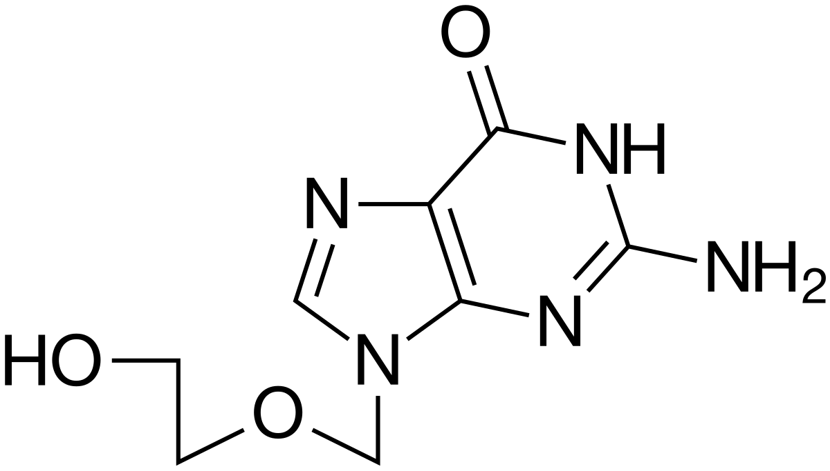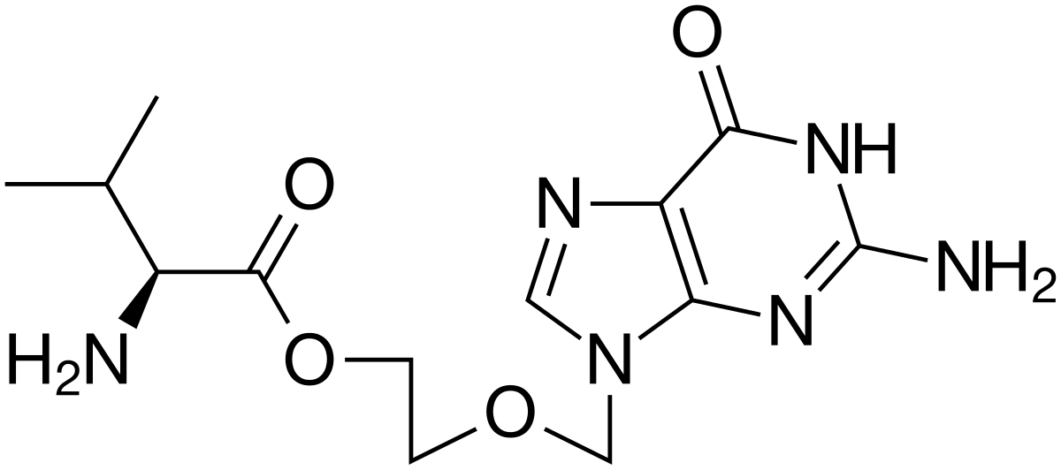
(1) (2)
Figure 2: Chemical Structures of Acyclovir and its Valine-Prodrug
- Prodrugs as support materials
After administration, the medication must go through a number of pharmacokinetic and pharmacological obstacles. Today's site-selective drug delivery method, or prodrug design method, is employed to address this issue. Sodium-dependent multivitamin transporter (SMVT) as well as monocarboxylic acid transporter-1 (MCT), both of which are present in the colon, recognise gabapentin enacarbil, the prodrug of gabapentin (3), as a substrate. The pharmacokinetics, bioavailability, and absorption of gabapentin enacarbil (4) are superior to those of the parent medication gabapentin. [34] ACE inhibitors, antiviral medications, and anticancer prodrugs are further examples of drugs that function as a substrate for (PEPT 1) (Figure 3).
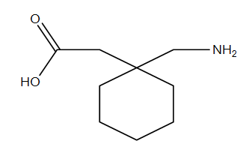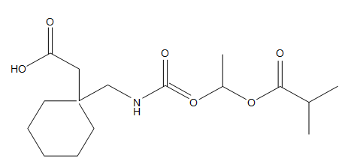
(3) (4)
Figure 3: Chemical Structures of Gabapentin and Gabapentin enacarbil
- Prodrugs with enhanced lipophilicity
Since phospholipids make up biological membranes, lipophilicity is necessary for transport across these membranes. Drugs that are polar or ionized may be transformed into esters to increase their lipophilicity. [35] In order to create more lipophilic aryl and alkyl esters, hydrophilic groups including hydroxyl, thiol, carboxyl, phosphates, and amines may be found in parent medicines. The enzymatic activity of esterase may change these esters into their active parent medication. [36] Consider the polar, permanently charged molecule dabigatran, which has an extremely limited bioavailability owing to its strong polarity. Bioavailability of dabigatran was dramatically increased with the addition of the prodrug etexilate, which masked the drug's polarity.
The roles played by groups containing carboxylic acid ester or carbamic acid ester are distinct. Timolol (5) is a derivative of o-butyryl timolol (6), a prodrug with a logP/D value of 2.08 compared to timolol's logP/D value of 0.04.[18] [37] (figure 4).
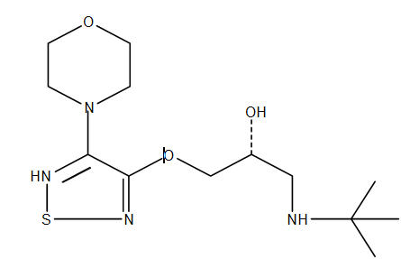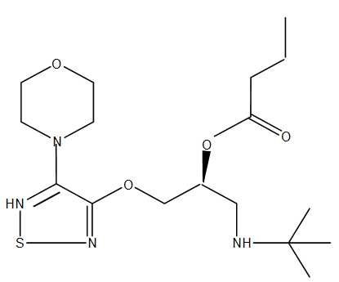
(5) (6)
Figure 4: Chemical Structures of Timolol and its prodrug
- Chemotherapeutic prodrugs for enhanced effectiveness and targetability:
Many ailments are treated with chemotherapy. One of the most common conditions treated with chemotherapeutic medicines is cancer. The bulk of anticancer drugs work by preventing cell growth and stopping the cell cycle at a certain point in order to exercise their oncostatic effects. However, since many oncostatic medications have poor tumor cell selectivity, they often harm normal cells in addition to tumor cells. As a result, this issue reduces these medicines' long-term efficacy. The prodrug strategy attempts to solve this issue. Anticancer prodrugs must be transported to tumour cells, where they may be transformed into their deadly parent drugs by endogenous or engineered enzymes. Overexpressed molecules in cancer cells but not in healthy ones may be the target of certain anticancer medicines. Target ligand-conjugated prodrugs, prodrugs that are cleavable by enzymes, prodrugs that are connected with membrane transporters, and polymeric prodrug, and enzyme-activated prodrug treatment (ADEPT) are all subsets of the novel family of chemotherapeutic prodrugs. [38]
- Prodrug impact on presystemic excretion and metabolism:
Presystemic metabolism in the liver and GI tract has an impact on the drug's availability in systemic circulation. The drug's effectiveness was reduced because to its presystemic metabolism. This issue has been solved using a variety of administration route modifications, formulation innovations, such as the sublingual route, and controlled release formulations. The prodrug method may also block presystemic metabolism by masking the functional groups that are metabolically labile. For example, terbutaline experiences fast presystemic metabolism; Therefore, it was halted by replacing the phenolic groups in its structure with bis-dimethylcarbamate. [39] An further issue with excessive excretion is linked to the parent drug's increased solubility in water. By integrating lipophilic promoters, this may be regulated.
- Prodrugs' function in CNS delivery
Many therapeutic chemicals cannot pass the blood-brain barrier (BBB), which is a key obstacle in the development of CNS-acting medications. Endothelial cells from brain micro vessels joined by very tight connections make up the BBB. Epithelial cells have transporter proteins on both the luminal as well as abluminal sides. allowing chemicals to be transported across the BBB with a carrier. Thus, there are three possible entry points for drugs into the brain.[40]
(a) Polar group masking to enhance passive diffusion.
(b) Increasing the transport across the BBB that is mediated by carriers or receptors.
(c) Reducing the amount of drug efflux into the blood from the brain. [41]
The following list includes the different endogenous transporters found at the BBB's brain capillary endothelial:
- LAT1 (Large neutral amino acid transporters)
- MCT (Monocarboxylic acid transporters)
- GLUT1 (Glucose transporters)
- PEPT1 (Peptide transporters)
- OCT (Organic cation transporters)
- OAT (Organic anion transporters)
- CNT (Concentrative nucleoside and nucleotide transporters)
The targeted prodrug approach has been proposed as a means to enhance pharmaceutical bioavailability and BBB permeability. The targeted prodrugs' production is influenced by the target site's cells, tissues, enzymes, and transporters. Before the prodrug is created, extensive understanding about target site transporters, enzymes, and how they interact with parent drugs or ligands to be recognized there is necessary. [42], [43] Thiorphan (7), for instance, has a low BBB permeability, but its thiol derivatives have been shown to have a remarkable BBB penetration and a great analgesic efficacy. These derivatives include thiorphan's monoacylated product (S-acetylthiorphan, 8) and its benzyl ester (Acetorphan, 9). [44], [45]
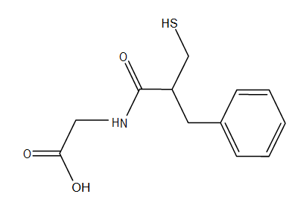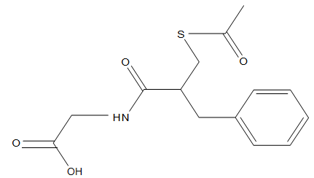
(7) (8)
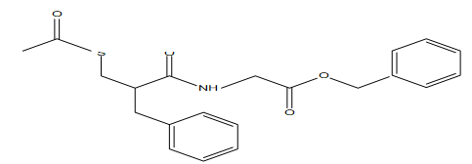
(9)
Figure 5: Chemical structures of Thiorphan, S-acetylthiorphan, and Acetorphan

6.1 Methods for Optimising Prodrug Distribution in the Intended Setting
To avoid the unwanted effects of their parent medication, prodrugs might be designed to target certain enzymes or carriers. Understanding carrier systems and enzymes that are capable of targeting is crucial for this kind of targeted prodrug creation. As a result, the targeted prodrugs will be separated into two primary categories: those that target certain membrane transporters and those that target specific enzymes.
(A) Membrane transporter prodrug design
With the aid of transporters, a variety of medicinal medicines have significantly improved their ability to traverse cellular membranes. These transporters are crucial for drug metabolism, elimination, and uptake. Because these transporters have such a significant impact on the pharmacokinetic properties of the drug, learning more about them is crucial. It has been postulated that interactions with these membrane transporters are part of how a given medication gets disposed of in the body. The transporters are found mostly in the liver, kidneys, and intestines, but are also found in other organs because of the crucial roles these organs play in the absorption, distribution, and elimination processes. [46]
SLC (Solute Carriers) as well as ABC (ATP Binding Cassette) are the two main types of drug transporters. The transporters may be categorised as either efflux transporters or influx transporters based on which way they carry the substrate through the cell membrane. The ATP hydrolysis reaction energy is used by the ABC transporters to expel substrate from the cell, therefore classifying them as efflux transporters and into the extracellular environment. Since the SLC transporters allow for the diffusional uptake of substrates, they fall under the category of influx transporters. The substrate concentration gradient and the ion connections across the membrane dictate whether SLC transporters work as unidirectional or as both influx as well as efflux transporters. Understanding the interplay between apical as well as basolateral membrane transporters in epithelial cells is crucial at this time. It is crucial to study efflux and influx transporters in organs such the gut, liver, as well as kidney in order to understand the magnitude and direction of drug movements in these tissues. Figures 12, 13, and 14 below illustrate the transporters found in the colon, liver, and kidney [47].
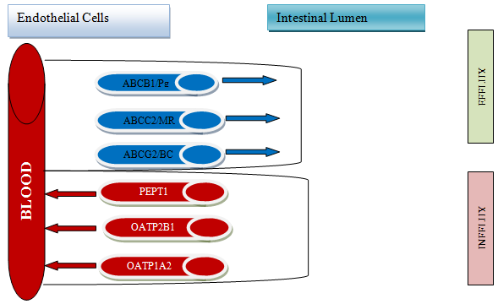
Figure 6: gastrointestinally expressed transporters. The red molecules are efflux transporters that return the substrate to the intestinal lumen, while the blue molecules are influx transporters that move the substrate from the intestinal lumen into the blood.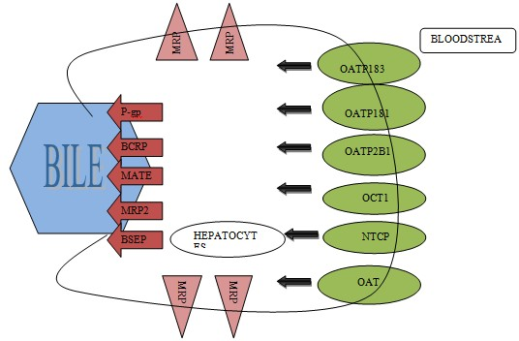
Figure 7: Hepatocyte-expressed transporters. There are two types of transporters in the liver; blue ones carry medications from the bloodstream into the hepatocytes where they are metabolised, while red ones carry drugs and their metabolites out of the liver and into the bile or back into the bloodstream.
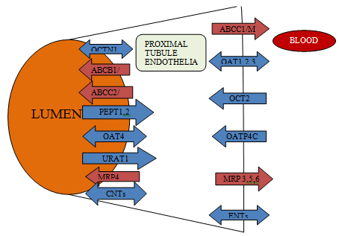
Figure 8: Transporters expressed in the proximal tubule of the kidney. Substrates in the circulation are transported back into renal epithelial cells by blue influx transporters on the basolateral membrane (BLM). Transporters that transfer substrates back into the bloodstream are coloured red.
(B) Prodrug Design: Selecting Particular Enzymes
The strategy of designing enzyme-targeted prodrugs may be utilized extensively to enhance oral medication absorption as well as site-specific drug administration. Enzymes may be a significant target for enhancing the absorption of oral medications. [48] Second, site-specificity, which is required for localised actions with minimal systemic side effect, is a key justification for utilizing enzyme-targeted prodrugs. [10] This section will explore how enzyme focused prodrug design may increase the site specificity of prodrugs.
- Enzyme-Targeted Prodrug Approach for Site-Specificity:
Enzyme-targeted prodrug therapy works by having a tissue-specific enzyme activate a prodrug, which is subsequently metabolised by the body. The enzyme found in the tissue may be more concentrated or specialized to that tissue. Today, it has been proposed that enzyme-targeted site-specificity plays a crucial role in cancer treatment. It has been discovered that large levels of activating enzymes provide prodrugs their site-specificity and are in charge of effectively treating animal tumors. [38] It was shown that large concentrations of activating enzymes in human tumours are unusual, and that these enzymes are not linked to any specific tumour type. [38] Therefore, adopting the enzyme focused strategy to treat human tumors presented significant challenges. Prodrug activation enzymes need to be localised in the particular cancer cells before they can be administered, hence new methods have been proposed as a viable treatment. The terms for these approaches are:
ADEPT (Antibody Directed Enzyme Prodrug Therapy)
GDEPT (Gene Directed Enzyme Prodrug Therapy).
- Prodrug Site-Specificity: The ADEPT and GDEPT Concept in General
By creating a compound with a monoclonal antibody that selectively targets tumour cells, The ADEPT method involves bringing the drug-activating enzyme to the surface of cancer cells. Systemic administration of the non-toxic prodrug leads to cytotoxic effects on tumour cells due to the drug-activating enzyme is already in place, so it may turn the medicine into a poison. [49], [50] Combinations of antibodies, enzymes, and prodrug have proven that ADEPT is effective against several types of human tumour xenografts. [51] Rather of giving the patient the active medicine directly, By combining a prodrug (an inactive form of the active drug) with a gene that is decoded in the target cells, the GDEPT technique may produce the enzyme directly. An enzyme gene is delivered to cancer cells and healthy cells through vectors, where it activates the prodrug. In GDEPT, vector delivery presents the greatest difficulty. The search-and-destroy strategy and the induction strategy have been proposed as the two basic sorts of tactics.
Vectors are supplied locally in the induction method to boost the immune system and kill tumour cells, while in the hunt & destroy technique they specifically target tumour cells for elimination. When it comes to the success of this approach, the choice of vectors for gene delivery is critical. Vectors may be created in a lab, but those produced from microorganisms, such as viruses and bacteria, are more frequent. In both ADEPT and GDEPT, enzyme choice is a primary source of anxiety. Here are some things to keep in mind when picking an enzyme for ADEPT or GDEPT:
- The enzyme would be simple to deal with because of its monomeric structure and low molecular weight, and protein modification would be theoretically possible.
- Non-human or non-mammalian enzymes are the favoured targets, and for good reason.
- When it comes to specificity, enzymes of a microbial origin are crucial. [52] (Table 2)
Table 2: Endogenous Enzymes Responsible For Prodrug Activation
CLASS | ENZYME | DRUG | PRODRUG | P’COLOGY
Oxidoreductase | Aldehyde Oxidase | 5-ehynyluracil | 5-ethynyl2(1H)- pyrimidinone | Mechanism-based inhibitor of dihydropyrimidine dehydrogenase (DPD)
 | Amino acid oxidase | Hydrogen peroxide | d-alanine | Oxidative stress
 | Cytochrome P450 reductase | Nitroxide radical | Tirapazamine | DNA alkylation and oxidative stress
 | DT- diaphorase | Semiquinone radical | Diaziquone | DNA alkylation and oxidative stress
 | Cytochrome P450 | AQ4 | AQ4N | Topoisomerase II inhibitor
 | Tyrosinase | Phenol mustard | Phenyl mustard | DNA alkylation
Transferases | Glutathione Stransferase | 6-MP | PTA | Antimetabolite
 | Thymidine phosphorylase | 5-FU | 5’-deoxy-5- flurouridine | Interferon stimulates pyrimidine nucleoside phosphorylase expression.
Hydrolases | Carboxyl esterase | 5-FU | Capecitabine | Thymidylate synthase inhibitor
 | Alkaline phosphatase | 3-AP | 3-AP phosphate
 | β-glucuronidase | paclitaxel | Paclitaxel glucuronide | Microtubule binding
Lyases | Cysteine conjugate-β-lyase | Selenol | SeCys conjugate | Apoptosis

APPLICATION OF PRODRUG
Pharmaceutical Applications
1) Improvement of taste
The drug's bitter, acidic, or caustic taste is a major factor in low compliance, especially among paediatric patients. There are two methods that may be used to mask the drug's unpleasant taste.
- One, the medicine becomes less soluble in the mouth.
- Second, to eliminate the perception of bitterness or sourness by decreasing the drug's affinity for taste receptors.
- Flavor-enhanced prodrug
2) Improvement of odor
Strong odours are associated with substances that have a high vapour pressure (and a low boiling point).
- For instance, ethylmercapto, a medication beneficial in treating leprosy, is transformed into its phthalate ester, which has a foul odour at boiling point (B.P.) 35c.
- High-B.P., odourless diethyldithio-isopthalate. After being rubbed into the skin, the esters in the prodrug are metabolised by thioesterase into the parent drug.
3) Change of physical form of drug
• Some medications that are only available as liquids, particularly those with very high doses, cannot be made into tablets. In order to transform a liquid medicine into a solid prodrug, a symmetrical molecule with a stronger propensity to crystallise must be formed.
• Ethyl mercapto- and trichloro-ethanol esters are an example;
4) Reduction in GIT irritation
By making direct touch, stimulating acid secretion more, and interacting with the mucosal layer, which certain drugs irritate and harm the stomach mucosa. This is notably true with salicylates among NSAIDs. They bring about an acidic stomach and ulcers.
5) Reduction of pain on injection
• Intramuscular injections may be painful when the medication precipitates into the surrounding cell or when the fluid is extremely acidic, alkaline, or alcoholic.

• For instance, clindomycin hydrochloride's limited water solubility and phenytoin's alkaline solution contribute to the discomfort of injection. Clindamycin's 2-phosphate ester, a more water-soluble prodrug, is one way to get around this problem.
6) Enhancement of chemical stability
• Stability may occur either throughout the drug's self-life or in the GIT after oral administration. In the case of an intravenous drug, steadiness in self-life is crucial. Lyophilization, the process of transforming a liquid into a powder that must be reconstituted before use, is the standard method. Another viable option for raising the agent's stability is prodrug design.
• Azacytidine, a medication used to treat cancer. This medication is easily hydrolyzed in water, while its bisulfiteprodrug is resistant to hydrolysis and degradation at acidic pH, in addition to being more soluble in water.
Activation of the prodrug takes place at a physiological PH of 7.4.
Pharmacokinetic application
1) Enhancement of bio-availability (lipophilicity)
Increasing bioavailability by increasing lipophilicity has several benefits, the most notable of which is a decreased need for new dose.
For instance, about a third as much bacampicillin is needed to get the same results as ampicillin.
2) Prevention of presystemic metabolism
• The use of corticosteroid esters or prodrugs may reduce the significant first-pass hepatic metabolism that occurs with a number of corticosteroids.
• Triamcin is one such example.
Drugs with short biological half-lives must be dosed more often. Controlled drug release and prodrug strategies may be used to get around this problem.
1. How quickly the prodrug enters the bloodstream once it has been applied or injected;
2. The pace at which the prodrug is metabolised in the body.
The rate at which a prodrug is metabolised by the liver is known as its "prodrug hepatic clearance”.
3) Reduction of toxicity
- A drug's design should aim to create a compound with both high activity and minimal toxicity.
- Prodrug design has been utilised before to deal with the problem of systemic medications generating undesirable local effects, such as gastrointestinal discomfort with NSAIDs.
- Bioprecursorsulindac is still another example. It is transformed to a sulfoxide, which is easier on the stomach and allows for improved absorption into the bloodstream.
4) Site-specific drug delivery
• When a medicine enters the bloodstream, it travels to all parts of the body, both the intended target and the rest of the body.
LIMITATIONS OF PRODRUG DESIGN:
Prodrug design has been quite effective in reducing a number of undesired drug features, The assessment of pharmacological, pharmacokinetic, toxicological, and clinical features, in particular, may provide a number of novel difficulties.
Pharmacological issues: Preliminary in vitro screening approaches, such as binding tests, reuptake of neurotransmitters, as well as enzyme inhibition assessment, are not possible since bioactivation to their active species is needed.
Toxicological issues include releasing pharmacokinetic modifiers that may trigger enzymes or modify drug excretion, producing hazardous byproducts, and using up important molecules throughout the prodrug activation process. These toxicity mechanisms are unique to prodrugs and are not present in parent drugs.
Pharmacokinetic Issues: Problems in the pharmacokinetic investigations suggest that the mutual prodrug is not the optimal substrate for the activating enzymes. Numerous misunderstandings may result from pharmacokinetic research. One must consider the variations in their separate time periods of action when comparing mutual prodrugs and parent compounds. In other cases, mutual prodrugs may not reach their full potential until far later than their parent substances. a comparison of AUC is a more appropriate criterion.
Clinical stage issues: Animal tests' ability to predict human behaviour is also under dispute. Although two prodrugs derived from the same parent medicine may seem to have equivalent active doses in rats, this may not be the case in human research.
Conclusion
The development of prodrugs has great potential to increase the therapeutic efficacy and/or decrease the adverse effects of pharmacologically active treatments. This approach improves the drug's solubility, stability, permeability, bioavailability, and biological half-life, and administration efficiency by directing it to specific tissues. Therefore, the incorporation of prodrugs into the standard model of drug development should come as no surprise. A rising number of newly authorised pharmacological substances are prodrugs, demonstrating their significance. Although prodrug design has come a long way, particularly in the early phases of drug development, Much research and development is needed before prodrugs may be considered cutting edge in modern pharmacotherapy.
References
[1] J. H. Burn, Medical Pharmacology, vol. 2, no. 5260. 1961. doi: 10.1136/bmj.2.5260.1131.
[2] P. R. Ram, P. Priyanka, L. Shreekrishna, and S. Saroj, “Research Article Prodrug As a Novel Approach of Drug Delivery- a Review,” vol. 5, no. 3, pp. 5–9, 2015.
[3] Gennaro A, “The Science and Practice of Pharmacy.,” vol. 6(11). 2000.
[4] K. Kumar, “Drug Design: An Overview,” Med. Anal. Chem. Int. J., vol. 3, no. 2, pp. 232–241, 2019, doi: 10.23880/macij-16000136.
[5] B. Testa, “Prodrugs: bridging pharmacodynamic/pharmacokinetic gaps,” Curr. Opin. Chem. Biol., vol. 13, no. 3, pp. 338–344, 2009, doi: https://doi.org/10.1016/j.cbpa.2009.04.620.
[6] K. Laine and K. Huttunen, Enzyme-Activated Prodrug Strategies for Site-Selective Drug Delivery. 2011. doi: 10.1002/9783527633166.ch10.
[7] D. Teagarden and N. Sandeep, “Prodrugs: Challenges and Rewards (Part 1, Biotechnology: Pharmaceutical Aspects).,” 2007.
[8] V. J. Stella, “Prodrugs: Some Thoughts and Current Issues,” J. Pharm. Sci., vol. 99, no. 12, pp. 4755–4765, 2010, doi: https://doi.org/10.1002/jps.22205.
[9] . K. M. ., . S. A. ., . D. R. ., and . P. S. ., “A Prodrug Design: Synthesis and Biological Screening of Cox II Inhibitor,” J. Curr. Pharma Res., vol. 3, no. 2, pp. 784–790, 2013, doi: 10.33786/jcpr.2013.v03i02.002.
[10] V. Abet, F. Filace, J. Recio, J. Alvarez-Builla, and C. Burgos, “Prodrug approach: An overview of recent cases,” Eur. J. Med. Chem., vol. 127, pp. 810–827, 2017, doi: https://doi.org/10.1016/j.ejmech.2016.10.061.
[11] M. W. H. Richard B. Silverman, The Organic Chemistry of Drug Design and Drug Action. 1992. doi: 10.1016/c2009-0-22221-5.
[12] N. R. Srinivas, “The rationality for using prodrug approach in drug discovery programs for new xenobiotics: opportunities and challenges,” Eur. J. Drug Metab. Pharmacokinet., vol. 36, no. 2, pp. 49–59, 2011, doi: 10.1007/s13318-011-0035-z.
[13] M. Markovic, S. Ben-Shabat, and A. Dahan, “Prodrugs for improved drug delivery: Lessons learned from recently developed and marketed products,” Pharmaceutics, vol. 12, no. 11, pp. 1–12, 2020, doi: 10.3390/pharmaceutics12111031.
[14] N. Das, M. Dhanawat, B. Dash, R. C. Nagarwal, and S. K. Shrivastava, “Codrug: An efficient approach for drug optimization,” Eur. J. Pharm. Sci., vol. 41, no. 5, pp. 571–588, 2010, doi: 10.1016/j.ejps.2010.09.014.
[15] K. M. Wu, “A new classification of prodrugs: Regulatory perspectives,” Pharmaceuticals, vol. 2, no. 3, pp. 77–81, 2009, doi: 10.3390/ph2030077.
[16] K. Beaumont, R. Webster, I. Gardner, and K. Dack, “Design of Ester Prodrugs to Enhance Oral Absorption of Poorly Permeable Compounds: Challenges to the Discovery Scientist,” Curr. Drug Metab., vol. 4, no. 6, pp. 461–485, 2005, doi: 10.2174/1389200033489253.
[17] J. Rautio et al., “Prodrugs: Design and clinical applications,” Nat. Rev. Drug Discov., vol. 7, no. 3, pp. 255–270, 2008, doi: 10.1038/nrd2468.
[18] J. B. Zawilska, J. Wojcieszak, and A. B. Olejniczak, “Prodrugs: A challenge for the drug development,” Pharmacol. Reports, vol. 65, no. 1, pp. 1–14, 2013, doi: 10.1016/S1734-1140(13)70959-9.
[19] B. M. A. Sanches and E. I. Ferreira, “Is prodrug design an approach to increase water solubility?,” Int. J. Pharm., vol. 568, no. May, p. 118498, 2019, doi: 10.1016/j.ijpharm.2019.118498.
[20] T. Ye et al., “Prodrugs incorporated into nanotechnology-based drug delivery systems for possible improvement in bioavailability of ocular drugs delivery,” Asian J. Pharm. Sci., vol. 8, no. 4, pp. 207–217, 2013, doi: 10.1016/j.ajps.2013.09.002.
[21] J. L. Zaro, “Lipid-Based Drug Carriers for Prodrugs to Enhance Drug Delivery,” AAPS J., vol. 17, no. 1, pp. 83–92, 2015, doi: 10.1208/s12248-014-9670-z.
[22] M. G. Márquez, R. Dotson, S. Pias, L. V. Frolova, and M. S. Tartis, “Phospholipid prodrug conjugates of insoluble chemotherapeutic agents for ultrasound targeted drug delivery,” Nanotheranostics, vol. 4, no. 1, pp. 40–56, 2020, doi: 10.7150/ntno.37738.
[23] L. Huang, J. Yang, T. Wang, J. Gao, and D. Xu, “Engineering of small-molecule lipidic prodrugs as novel nanomedicines for enhanced drug delivery,” J. Nanobiotechnology, vol. 20, no. 1, p. 49, 2022, doi: 10.1186/s12951-022-01257-4.
[24] N. Yadav, S. Khatak, and U. V. Singh Sara, “Solid lipid nanoparticles- A review,” Int. J. Appl. Pharm., vol. 5, no. 2, pp. 8–18, 2013, doi: 10.9790/3013-26103444.
[25] C. A. S. Bergström and A. Avdeef, “Perspectives in solubility measurement and interpretation,” ADMET DMPK, vol. 7, no. 2, pp. 88–105, 2019, doi: 10.5599/admet.686.
[26] K. Mazumder et al., “In silico analysis and experimental evaluation of ester prodrugs of ketoprofen for oral delivery: With a view to reduce toxicity,” Processes, vol. 9, no. 12, 2021, doi: 10.3390/pr9122221.
[27] S. Liu et al., “Synthesis and biological evaluation of paclitaxel and vorinostat co-prodrugs for overcoming drug resistance in cancer therapy in vitro,” Bioorganic Med. Chem., vol. 27, no. 7, pp. 1405–1413, 2019, doi: 10.1016/j.bmc.2019.02.046.
[28] A. M. Ahmad, “Potential pharmacokinetic interactions between antiretrovirals and medicinal plants used as complementary and African traditional medicines,” Biopharm. Drug Dispos., vol. 28, no. 3, pp. 135–143, 2007, doi: 10.1002/bdd.
[29] C. E. Müller, “Prodrug approaches for enhancing the bioavailability of drugs with low solubility,” Chem. Biodivers., vol. 6, no. 11, pp. 2071–2083, 2009, doi: 10.1002/cbdv.200900114.
[30] V. J. Stella and K. W. Nti-Addae, “Prodrug strategies to overcome poor water solubility,” Adv. Drug Deliv. Rev., vol. 59, no. 7, pp. 677–694, 2007, doi: 10.1016/j.addr.2007.05.013.
[31] D. Vytla, R. E. Combs-Bachmann, A. M. Hussey, S. T. McCarron, D. S. McCarthy, and J. J. Chambers, “Prodrug approaches to reduce hyperexcitation in the CNS,” Adv. Drug Deliv. Rev., vol. 64, no. 7, pp. 666–685, 2012, doi: 10.1016/j.addr.2011.11.007.
[32] G. E. Granero and G. L. Amidon, “Stability of valacyclovir: Implications for its oral bioavailability,” Int. J. Pharm., vol. 317, no. 1, pp. 14–18, 2006, doi: 10.1016/j.ijpharm.2006.01.050.
[33] S. Jana, S. Mandlekar, and P. Marathe, “Prodrug Design to Improve Pharmacokinetic and Drug Delivery Properties: Challenges to the Discovery Scientists,” Curr. Med. Chem., vol. 17, no. 32, pp. 3874–3908, 2010, doi: 10.2174/092986710793205426.
[34] D. Psimadas, P. Georgoulias, V. Valotassiou, and G. Loudos, “Molecular Nanomedicine Towards Cancer :,” J. Pharm. Sci., vol. 101, no. 7, pp. 2271–2280, 2012, doi: 10.1002/jps.
[35] W. G. Eisert, N. Hauel, J. Stangier, W. Wienen, A. Clemens, and J. Van Ryn, “Dabigatran: An oral novel potent reversible nonpeptide inhibitor of thrombin,” Arterioscler. Thromb. Vasc. Biol., vol. 30, no. 10, pp. 1885–1889, 2010, doi: 10.1161/ATVBAHA.110.203604.
[36] S. Blech, T. Ebner, E. Ludwig-Schwellinger, J. Stangier, and W. Roth, “DABE po ヒト（Galtineが使用）,” Drug Metab. Dispos., vol. 36, no. 2, pp. 386–399, 2008, doi: 10.1124/dmd.107.019083.atrial.
[37] K. M. Huttunen and J. Rautio, “Prodrugs - An Efficient Way to Breach Delivery and Targeting Barriers,” Curr. Top. Med. Chem., vol. 11, no. 18, pp. 2265–2287, 2011, doi: 10.2174/156802611797183230.
[38] R. Mahato, W. Tai, and K. Cheng, “Prodrugs for improving tumor targetability and efficiency,” Adv. Drug Deliv. Rev., vol. 63, no. 8, pp. 659–670, 2011, doi: 10.1016/j.addr.2011.02.002.
[39] L.-A. Svenssont, A. Tunek, and A. B. Stability, “BlOACTlVATlON OF PRESYSTEMICALLY STABLE PRODRUGS *,” vol. 19, no. 2, pp. 165–194, 1988.
[40] N. J. Abbott, A. A. K. Patabendige, D. E. M. Dolman, S. R. Yusof, and D. J. Begley, “Structure and function of the blood-brain barrier,” Neurobiol. Dis., vol. 37, no. 1, pp. 13–25, 2010, doi: 10.1016/j.nbd.2009.07.030.
[41] M. M. Patel, B. R. Goyal, S. V Bhadada, J. S. Bhatt, and A. F. Amin, “Getting into the Brain,” CNS Drugs, vol. 23, no. 1, pp. 35–58, 2009, doi: 10.2165/0023210-200923010-00003.
[42] A. Dahan, M. Khamis, R. Agbaria, and R. Karaman, “Targeted prodrugs in oral drug delivery: The modern molecular biopharmaceutical approach,” Expert Opin. Drug Deliv., vol. 9, no. 8, pp. 1001–1013, 2012, doi: 10.1517/17425247.2012.697055.
[43] R. Karaman, “Prodrugs design based on inter- and intramolecular chemical processes,” Chem. Biol. Drug Des., vol. 82, no. 6, pp. 643–668, 2013, doi: 10.1111/cbdd.12224.
[44] J. M. Lecomte et al., “Pharmacological properties of acetorphan, a parenterally active ‘enkephalinase’ inhibitor,” J. Pharmacol. Exp. Ther., vol. 237, no. 3, pp. 937–944, 1986.
[45] D. M. Lambert, F. Mergen, J. H. Poupaert, and P. Dumont, “Analgesic potency of S-acetylthiorphan after intravenous administration to mice,” Eur. J. Pharmacol., vol. 243, no. 2, pp. 129–134, 1993, doi: 10.1016/0014-2999(93)90371-N.
[46] P. D. Dobson and D. B. Kell, “Carrier-mediated cellular uptake of pharmaceutical drugs: An exception or the rule?,” Nat. Rev. Drug Discov., vol. 7, no. 3, pp. 205–220, 2008, doi: 10.1038/nrd2438.
[47] T. M. Sissung et al., “Transporter pharmacogenetics: Transporter polymorphisms affect normal physiology, diseases, and pharmacotherapy,” Discov. Med., vol. 13, no. 68, pp. 19–34, 2013.
[48] G. L. Amidon, G. D. Leesman, and R. L. Elliott, “Improving intestinal absorption of water‐insoluble compounds: A membrane metabolism strategy,” J. Pharm. Sci., vol. 69, no. 12, pp. 1363–1368, 1980, doi: 10.1002/jps.2600691203.
[49] K. N. Syrigos and A. A. Epenetos, “Antibody directed enzyme prodrug therapy (ADEPT): a review of the experimental and clinical considerations,” Anticancer Res., vol. 19, no. 1A, pp. 605–613, 1999, [Online]. Available: http://europepmc.org/abstract/MED/10226606
[50] G. Xu and H. L. Mcleod, “Strategies for Enzyme / Prodrug Cancer Therapy 1,” vol. 7, no. November, pp. 3314–3324, 2001.
[51] H. K. Han and G. L. Amidon, “Targeted prodrug design to optimize drug delivery,” AAPS PharmSci, vol. 2, no. 1, pp. 48–58, 2000, doi: 10.1208/ps020106.
[52] K. D. Bagshawe, “Antibody directed enzymes revive anti-cancer prodrugs concept,” Br. J. Cancer, vol. 56, no. 5, pp. 531–532, 1987, doi: 10.1038/bjc.1987.237.

