BIOMASS AS A FUTURE GREEN RENEWABLE ENERGY RESOURCE : CHALLENGES AND OPPURTUNITIES
Dr. Rekha Israni
Assistant Professor ,DAV COLLEGE ,Ajmer
Abstract :
Sustainable development in India for economic development ,energy security ,mitigating climate change and global economy can be enhanced by deploying renewable energy resources in India. In today’s era fossil fuels are replaced by renewable energy resources to meet out environmental challenges. Biomass is the most commonly utilized energy resource
INTRODUCTION
Energy is a fundamental quantitative property which is imperative element of all areas of economies and influencing all spheres of life. It is used in many different ways and for many different things, from a nation's domestic and industrial needs to its operational and defense needs.
The outbreak of the novel corona virus pandemic demonstrated graphically the significance of energy to the global economy. Countries were forced to take drastic confinement measures, such as lockdowns and national border closures, in order to prevent the spread of this highly contagious virus. The slowing down of economic activities, the majority of which are dependent on transportation, which in turn requires energy for its sustainability, was an unintended but inevitable consequence of such measures. The global airline industry was virtually paralyzed, with the tourism industry suffering the most. What followed unavoidably was a sharp fall in the worldwide fuel interest for the transportation and assembling areas. This served as a stark reminder of the connection that exists between a nation's economy and its energy supply. The majority of the energy utilized in this present reality is petroleum derivative energy, and its greater part is utilized for transportation and power age. Not all nations of the world have their own oil assets, however they all need to get to this energy asset to fuel their assembling, transportation and power age areas. A differential pricing structure emerges as a result of the issues that arise in the supply chain, with the most remote nations bearing the highest costs. But large number of the countries are on the verge of development or not considered as developed countries.
There has been a global shift toward alternative energy sources, particularly for power generation and transportation among other reasons. Among these elective structures, renewable energy which generally exists as solid biomass , fluid and biogases stands apart as an undeniable decision. Bioenergy which is considered as an alternatives to fossil fuels are renewable and, as a result, emit less greenhouse gas. Additionally, they are more readily available than other fuels in nations without their own indigenous fossil fuel resources. .
The main objective of this chapter is to consider the different types of bioenergy as perfect energy options for power age, transportation and environmental change alleviation. This chapter covers all methods of the conversion and utilization of these fuel sources.
Energy Utilisation Sectors
We want to arrange energy use to comprehend it better. This is best finished by posing the inquiries
• What is energy and where does energy come from, and
• what is energy utilized for?
Oil, coal, natural gas, nuclear energy, hydro, wind, solar, solid biomass, liquid and gaseous biofuels, geothermal energy, and, to a lesser extent, ocean energy are the energy sources that are utilized the most frequently today. They may be broadly classified into following sectors on the basis of origin :
- Conventional energy resources which originates underground and are mineral based like fossil fuels,petroleum ;
- nuclear energy which is also derived from underground sources; and
- Non conventional energy, which includes hydro, wind, solar, biomass, biofuels, and ocean energy and is readily replenished from terrestrial sources.

Besides these ,geothermal energy is a peculiar phenomenon. In spite of the fact that it starts from underground sources and is completely non-sustainable, it is considered as environmentally friendly power. Generally petroleum products and thermal power are considered into the non-renewables, and sunlight based, hydro, wind, biomass, biofuel, geothermal and sea energy into the renewable
People and nations as a whole use energy for a wide range of purposes. Typically, this usage is broken down into energy use sectors. An ordinarily involved classiﬁcation for these financial areas comprises of the homegrown, business, modern, transport and electrical power age areas. They may once in a while likewise incorporate the mining and horticulture areas. However, additional sectorial classifications are also considered.
The conversion of biological mass to energy which is also called bio-energy includes wide varieties ,diﬀerent types and sources of biomass incorporating choices of change, end-use appli-cations and prerequisites of foundation. The cultivation of non food energy crops also called dedicated crops like woody energy crops or Short energy crops(SRC) and grasses which are perennial like orchard , among others, can yield biomass. by gathering ranger service and other buildups of plants like timberland depreciation, straw and so on . This also includes sludges from industrial waste and domestic waste of organic origin and from the waste themselves. The energy creation by biomass utilization is just a single form of sustainable power which can be utilized to reduce energy production and its proper use on the worldwide level.Likewise with any energy sources there are limitations on the utilization and appropriateness of biomass and it should cope with crude oil derivatives and energy restore capable sources like breeze, sunlight based and wave power
SOURCES OF BIOMASS
Biomass refers to the natural material that is utilized for the development of energy considered as Bioenergy. Biomass is fundamentally tracked down through living or as of dead plants and natural squanders from modern and homegrown use. The course of energy transformation from biomass incorporates warm change, synthetic change, biochemical change and electrochemical change. A geothermal power plant works by tapping the steam or boiling water repositories underground the earth and the intensity is utilized to drive an electrical generator. Hydroelectric or hydropower energy is a form of renewable energy that outfits the force of water moving, for example, water streaming over a turbine to produce energy. Hydroelectric turbine is a revolving machine that changes the kinetic energy of water and possible energy into mechanical work. The water turbine of hydroelectric power plant has a significant impact on the plant's conversion efficiency, which can reach 95% in large installations.
Biomass is a form of renewable energy derived from organic matter including living and non living plant matter, animal matter, and their waste products. These materials are referred to as biomass resources. Biomass sources are derived either from waste materials or from non cropy devoted energy crops.
Any material which is unusable ,undesirable and unwanted can be considered as waste that has been disposed of on the grounds that it no longer has any evident worth to the client or that creates a disturbance or an expected poison in the nearby environment. If the natural byproducts from one cycle, was utilized as essential wellspring of feedstock in another interaction, for instance, squander cardboard, wood and paper reused into papers, books and magazines, then, at that point, assuming that all the materials considered as waste were financially changed over into power, heat, fluid biofuels, or synthetic compounds, then, at that point, they could be considered as a biomass resources Biomass solid energy resources are classified into following categories:
• Agricultural Waste Horticultural Deposits are the non-consumable materials that stay after the collect of the eatable bits of the harvests, for example, corn, wheat, grain and sugar stick. Horticultural deposits additionally incorporates different parts of plants like leaves, husks, their roots , stems. Bioenergy non-food crop residues are used to make bioethanol and biolubricants for their starches, sugars, fats and oils. These non crop residues are grown alongside food crops and these agricultural residues don't require additional land space, which is a benefit.
• Waste from Food processing is the waste from different industrial processes, including the production of breakfast and cereal bars, fresh and frozen vegetables, and alcoholic beverages. These wastes and residues can be either solids usually dry or liquids that are watery. Maturation of fluid squanders and oils from handling of food can produce alcohol particularly ethanol.
• Municipal Waste They are commonly known as garbage or trash . They are either collected manually by the refuse or garbage collector men or directly transferred directly to the recycling center. Metropolitan solid waste, for example, especially paper, corrugated fiberboard and disposal of items from food , is an appealing wellspring of interminable biomass feedstock. Be that as it may, not all metropolitan waste is reasonable as a source of biomass , particularly waste obtained from metals and plastic waste.
•Animal Waste These wastes are obtained from farms, ranches, slaughterhouses, fisheries ,products of dairies or any grouping of animals into goliath domesticated animals creating a lot of excrement and sewage slop. At wastewater treatment plants, animal waste, liquid sewage, and human generated waste from metropolitan areas provides significant chemical energy and gases which can be converted into electrical energy. Treatment of animal waste generates biogas and combustible methane which can then be utilized for transportation and heating.
•Herbaceous Energy Harvests: This includes grasses and vegetables developed on grassland that are practically without woody tissue . The majority of the time, herbaceous food crops like rice , maize, wheat, and sugarcane are excellent sources of biomass. A few results or buildups of harvest development like stalks can also generates as herbaceous biomass.
The tropical grasses like switchgrass , miscanthus are essentially responsible for production of herbaceous yields and the yields are generally quicker than woody trees and can deliver higher measures of feedstock of biomass within a limited period. These herbaceous plants typically only survive for a single seasonal growing.
• Energy From Woody Crops The majority resources forming biomass are derived from liganaceous energy crops, which include softwoods and hardwoods. Woody biomass can also be a residue from different forest activities like timber waste, from wood processing like industrial wood, and wood shavings and from wood products with no life span ,for example bulky waste, demolition, and pallets. Fast-growing trees and plantations are the basic sources of liganaceous energy crops. The biomass from woody crops is cut into uniform, little pieces generally referred as wood chips. Profoundly productive and non-contaminating burners and ovens can be intended to consume these woody chips for warming and cooking.
•Lipids are diverse group of organic compounds which are water insoluble oils and fats but soluble in organic solvents obtained from late living biomass. Waxes, animal fats and greases, rapeseed oil, palm oil, and others are examples. Sustainable lipid feedstock additionally incorporates green growth, microorganisms' and other such miniature life forms. Green growth are among the quickest developing sorts organic entities on the planet, with about portion of their weight being oil. The fluid fuel from biomass generally as liquor,alcohol or ethanol, can be utilized to create biodiesel to control trucks like vehicles and even aeroplanes.
Biomass Resources which are accessible for production of energy envelops a large number of plants and materials going from farming and woods crops explicitly developed for purpose of energy , horticultural , timberland squanders and deposits, squanders from food handling and fisheries, metropolitan waste including sewage contamination , oceanic plants and green growth.
TECHNOLOGIES INVOLVED IN BIOMASS CONVERSION
The useful forms of energy can be created from biomass through different processes which are as follows:
(1) The "conventional domestic" utilization of agricultural residues, charcoal and firewood in developing nations for cooking , space warming and lighting. In this transformation the efficiency of the biomass to helpful energy by and large lies somewhere in the range of 5% to 15%.
(2) The "conventional industrialisation" involves biomass utilization for handling of tea , tobacco, pig iron, blocks and tiles, and so on, where the biomass products are frequently viewed as a "free" sources of energy. Less incentives are generally expected to utilize the biomass productively so change of the products to helpful energy usually happens at an effectiveness of 12% or below 12%.
(3) "Modern Industries" are practically adopting cutting-edge technologies for thermal conversion of biomass having expected transformation efficiencies are somewhere in the range of 30% - 55%.
(4) Biological methods of conversion such as fermentation for alcohol and anaerobic digestion for biogas production.
(5) Chemical change Technologies which involves newer advancements ("fuel cell") are equipped for by-passing the entropy-directed Carnot limit and depicts the most extreme hypothetical transformation efficiencies of warm units.
By and large, biomass-to-energy transformation innovations need to manage a feedstock that can be exceptionally in the form of mass and energy thickness, size, dampness content, and irregular stockpile. Therefore many of today's industrial technologies are hybrids between biomass and fossil fuels in which fossil fuels are utilized for the process of drying, preheating, and fuel supply maintenance in the event that supply of biomass is disrupted.
There are a variety of processes that can be used to transform biomass into useful forms of energy. Parameters that impact the decision of transformation phenomenon are: the sort and feedstock amount of biomass , the ideal type of energy, for example end-use prerequisites, ecological norms, financial circumstances, and task explicit variables. The process path that is followed by the available kinds and quantities of biomass is frequently determined by the requirement of energy form. There are three basic categories that can be used to classify the technologies for converting biomass into energy:
• Direct combustion processes
• Chemical and thermal processes
• Biochemical cycles.
- Direct methods of combustion
Deposits like woodchips, hogfuel, sawdust, bark, dark alcohol, bagasse, straw, Municipal Solid waste (MSW), and food industry squander are oftentimes utilized as feedstocks.
Direct burning heaters can be isolated into two general classifications and are utilized for delivering either direct intensity or steam. Dutch stoves, spreader-stoker and power module heaters utilize two-stages. The primary stage is utilized for drying and potentially incomplete gasification, while the subsequent stage is utilized for complete burning.. Further developed variations of these frameworks use turning or vibrating meshes to work with debris expulsion, with some water cooling requirement
The subsequent gathering, includes suspended and fluidised bed heaters which are all around used with fine molecule biomass feedstocks and liquids. In suspension heaters the particles are scorched while being kept in suspension by the implantation of turbulent preheated air which may as at this point have the biomass particles mixed in it. The burning medium in fluidised bed combustors is a boiling bed of pre-heated sand at temperatures ranging from 500 to 900 °C. The biomass fuel is either dropped into the bubbling sand on the off chance that it is sufficiently dense to sink there, or it is infused assuming it is particulate or liquid These frameworks hinder the prerequisite for grates, however require strategies for preheating of either air or sand, and thus require cooled water infusion frameworks for less massive feedstocks of biomass and fluids.
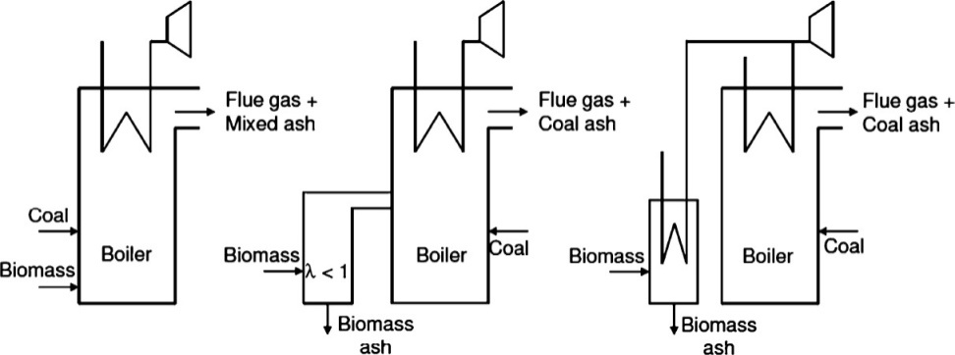
COFIRING

Figure 1 :Different Types Of Cofiring
Co-firing is a modern practice which involves fossil fuel, usually coal alongwith a feedstock of biomass that has made it possible for biomass feedstocks to enter the energy market quickly and cheaply. Cofiring has various benefits, particularly where energy generation is a requirement.
Co-firing biomass with coal in boilers comes is of three types
• Direct cofiring - The biomass and the coal are mixed in a similar heater. The factories for the crushing of the fuel and the burners might be isolated. This relies upon the biomass utilized and its fuel properties. This idea is generally ordinarily utilized, in light of the fact that it is the least demanding to execute and generally practical.
• Indirect cofiring: In this method, a biomass gasifier turns solid biomass into a clean fuel gas. The gas can be mixed with coal in a similar heater . As a result, biomass can also be utilized, although it can be challenging to grind. The gas can be cleaned and sifted before use, to eliminate pollutions .
• Parallel cofiring: A separate biomass boiler can also be installed in the steam system of a coal power plant to raise steam parameters like pressure or temperature. A lot of biomass can be used with this method.
2.THERMOCHEMICAL PROCESSES :This process involves following four processes :
(a) Pyrolysis (b) Catalytic liquification (c) Carbonisation (d) Gasification
(a) Pyrolysis : It is the process of heating lignocellulosic materials (organic matter) in low or no air by applying high heat. The interaction can create charcoal, natural condensable fuels (pyrolytic fuel oil),gases which are non-condensable , acetone , acetic acid, and methanol. This cycle can be changed in accordance with charcoal, pyrolytic oil, gas, or formation of methanol with fuel- efficiency of 95.5%.
The charcoal and fuel oils produced at the facility contain 68%of the energy in the raw material of biomass. The heating value of charcoal in British thermal units (Btu) is comparable to that of coal, and virtually there is no sulfide to create pollution in the atmosphere. The excess energy are in the gaseous state which are non-condensable and are utilized to co-produce steam and power. Each huge amount of biomass changed over completely to powers as such creates roughly 27 percent of charcoal, 14 percent of pyrolytic fuel oil, and 59 percent of moderate Btu gas.
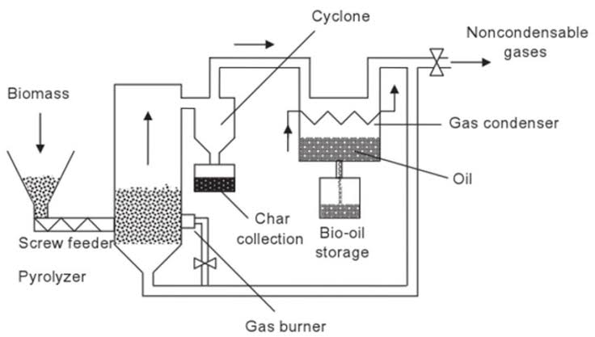
Fig. 2. Pyrolysis

The feedstock of biomass is exposed at higher temperatures and lower oxygen levels and in this manner repressing total ignition and might be completed under tension. Biomass is debased to carbon particles in single unit like methane ,Carbon monoxide and H₂ delivering a vaporous blend termed as "producer gas." Additionally, CO₂ may be produced, but due to the reactor's pyrolysis, it is converted back into CO and water; this water further guides the response.
(B) Catalytic liquefaction :This method has the capacity to make products with a energy of higher density and better quality. Additionally, less processing is required to make these products marketable. A thermochemical conversion that takes place in the liquid phase at a lower temperature and higher pressure is known as catalytic liquefaction. It stands in the need of either an impetus or a high hydrogen fractional strain. To make hydrogenation easier, a homogeneous hydrotreating catalyst is directly blended with the reaction mixture. Similar to non-catalytic liquefaction, a solvent which is hydrogen donar can be used for stabilization of the cracked products through transfer of hydrogen. Additionally, molecular hydrogen is hydrogenated in situ on the feed, cracked products, and dehydrogenated solvent. The solvent can be recovered , recycled during the process almost in so many cases.
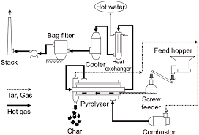
Figure 3 Liquification Process
© Carbonization: It is a centuries-old pyrolytic procedure made better for making charcoal. Conventional techniques for charcoal formation mainly focus on the utilization of earth hills or pits that are covered which involves heaping of wood . The control of the working conditions is much of the time rough and mainly depends on experience. The effectiveness of transformation utilizing these conventional methods is exceptionally low.
During carbonisation a large portion of wood are dispensed with the unpredictable parts; this cycle is additionally called "dry wood refining." Gathering of Carbon is basically because of a decrease in the degrees of hydrogen and oxygen in the wood.
Industrial production at larger scale now achieves efficiencies of more than 30 percent (by weight) as a result of the modernization of the charcoal industry.
There are three primary methods for making charcoal:
a) internally warmed (by controlled ignition of the natural substance),
b) externally warmed (utilizing fuelwood or petroleum products), and
c) hot flowing gas (answer or converter gas, utilized for the development of synthetic compounds).
Remotely oxygen is permitted to warmed reactors that are totally rejected and hence give better quality charcoal for a bigger scope. However, once pyrolysis has begun, the utilization of an external fuel source is required, which may come from the "producer gas." Recycling warmed gas reactors offer the possibility to create large amounts of charcoal and related results, yet are as of now restricted by high venture costs for huge scope plant.
(d) Gasification
Gasification of biomass is a warm cycle which changes over natural carbonaceous materials, (for example, shells ,wood squander, pellets, waste from farms, energy crops) into a burnable gas involved carbon monoxide , hydrogen and carbon dioxide . This is accomplished at high temperatures by responding the material ,without completely burning it, utilizing a controlled level of oxygen channel. The subsequent gas blend is referred as syngas. At temperatures of around 600°C to 1000°C, strong biomass goes through warm decay to frame gas-stage items which normally incorporate CO, H₂, CH₄, CO₂, and H₂O.
There are four phases associated with gasification process:
• Drying zone: The temperatures in this zone ranges from 150 to 200 °C whereby the heat arising from lower zones evaporates feedstock moisture in the drying zone. Vapours descend and mix with those coming from the oxidation zone gas.
Pyrolysis Zone :The warm decay of biomass at low oxygen levels at temperatures varying between 200°C to 600°C.
• Combustion Zone : The oxidation alters the gas's calorific value in the presence of a reactive gas (air , pure oxygen), as it exits the gasifier. The utilization of air as receptive gas is normal.
• Reduction Zone: The results of the combustion zone i.e. hot gases and gleaming burns move into the decrease zone. A series of reduction reactions occurs between the hot gases (CO, H₂O, CO₂, and H₂) and char as there is not sufficient Oxygen in this high-temperature zone for continuation of oxidation process.

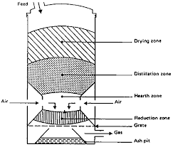
Fig.4. Different Zones of Gasification
(3)Biochemical Phenomenon.
• Anaerobic Fermentaion.
• Methane Generation in Landfills.
• Fermentation Ethanol .
• BioDiesel fuel
Anaerobic Fermentation.
Reactors which are anaerobic are mostly utilized part for the formation of biogas rich in methane from excrement (human and creature) and harvest deposits. They employ bacterial cultures mixed methanogenically that are distinguished by clearly defined growth-optimal ranges of temperatures. These blended societies permit digesters which are worked over a wide range of temperature ; for example above 0°C to 60°C.
Biogas, which contains approximately 55% methane and can be utilized as a good energy source for cooking and lighting, is produced by the bacteria when they are working properly. After processing the manure using the digester, an odorless, non-toxic sludge is produced. Additionally, a little nitrogen and other nutrients are relatively lost during digestion, making it an excellent fertilizer. In fact, digester sludge contains more nitrogen than cattle manure which is left for drying in the field; a considerable amount of nitrogen intensifies in new excrement become volatised while drying in the sun. Then again, in the processed slime ,small amount of the nitrogen is volatilised, and a portion of the N₂ is changed over into urea as urea is more promptly open by most of the plants than a large number of the N₂ intensifies tracked down in compost, and hence the manure worth of the slime may really be higher when compared with new excrement.
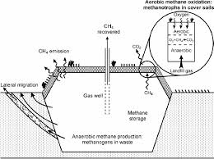

Fig. 5. Anaerobic Fermentation
(b) Methane Generation in Landfills
Landfills for civil strong waste are a wellspring of biogas. Biogas is delivered normally by anaerobic microorganisms in metropolitan strong waste landfills and is called landfill gas. A few landfills lessen landfill gas outflows by catching and consuming or erupting the landfill gas. CO₂ is produced when methane in landfill gas is burned, but CO₂ is a weaker greenhouse gas than methane. Numerous landfills gather landfill gas, treat it to eliminate CO₂, water fume, and hydrogen sulfide, and afterward sell the methane. The methane gas is used to generate electricity in some landfills.
© Ethanol Fermentation.

The import of energy supplies and their reliance on other countries can be lessened if ethanol is primarily used as an alternative to imported oil. The significant additions made in maturation advances currently make the development of ethanol to be used as a good substitute of a petrol and enhancer of fuel, both monetarily serious (given specific presumptions) and naturally valuable.
The most usually involved raw material by emerging nations is sugarcane, because of its high efficiency when provided with adequate water. Sweet sorghum or Tapioca root also called cassava may become the preferred raw material in areas with limited access to water. Modern management techniques and the high residual energy potential of sugarcane feedstock are additional benefits that makes production possible which is sustainable and eco- friendly while allowing for continued sugar production. Different feedstocks incorporate sugarbeet rich in saccharide, and starch rich potatoes,maize and wheat .
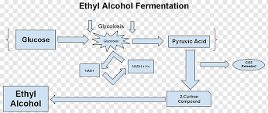
Figure 6 Fermentation Of Ethanol
Biomass transformation into alcohol particularly ethanol incorporates (a) pretreatment (b) enzymatic hydrolysis (c) fermentation and (d) refining. Pretreatment some of the time incorporates mechanical size decrease which should be trailed by areas of strength for a pretreatment to separate lignocellulosic structure solubilizing hemicellulose or potentially lignin to form cellulose more open to hydrolytic chemicals. For ethanol fermentation, cellulose glucose is released through enzyme hydrolysis. The two stages should be possible together using a solitary step referred as concurrent saccharification and maturation (SSF). The amount of ethanol can be acquired by focusing on refining in lignocellulosic biorefinery process, steps, for example, enzymatic hydrolysis should be worked at high strong stacking.
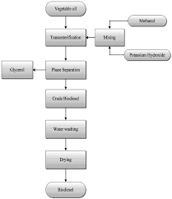
Fig. 7. Biodiesel from ethanol fermentation
Diesel engines incorporates vegetable oils for burning in for more than 100 years. A wide variety of plant species of annual and perennial type can be used to obtain the raw oil. Oil palms, coconut palms, the physica nut, and the Chinese Tallow Tree are perennials. Sunflower, soybean,rapeseed and groundnut are annuals. These significant number of plants can deliver exceptional oil returnsh, with positive energy and carbon adjusts.
It is necessary to change the crude oil to keep away from issues related with different varieties of raw materials. The crude oil can go through Kolbe electrolysis which is warm or reactant breaking, , or transesterification processes to get better improved attributes. Untreated oil brings on some issues like fragmented ignition, bringing about the progress of dingy buildups, gums and waxes and so forth. Likewise, wrong viscosities can bring about unfortunate atomization of the oil additionally bringing about unfortunate ignition. Deposition on the cylinder walls can occur as a result of oil polymerization.
Biodiesel which is synthesized from vegetable oils like yellow oil, used cooking oils, or creature fats. The fuel is generated by transesterification; an interaction that converts fats , oils into biodiesel alongwith glycerin as a coproduct. Roughly 100 parts of oil or fat are trated with 10 parts of a short-chain liquor normally methanol within the sight of an impetus (typically sodium hydroxide or potassium hydroxide to frame 100 parts of biodiesel and 10 parts of glycerin (or glycerol). Glycerin, a sugar, is a coproduct normally used for the production of drugs and beauty care products.
Greases which are recycled and are not processed or converted into biodiesel or refined oils from plants should not be used as biodiesel for vehicle fuel. Fatty substances like fats are considerably thicker than biodiesel. When biodiesel is mixed with vegetable oil of low grade can cause different machinery issues like long haul motor stores, ring staying, lube-oil gelling, and other relevant issues that can reduce motor life.
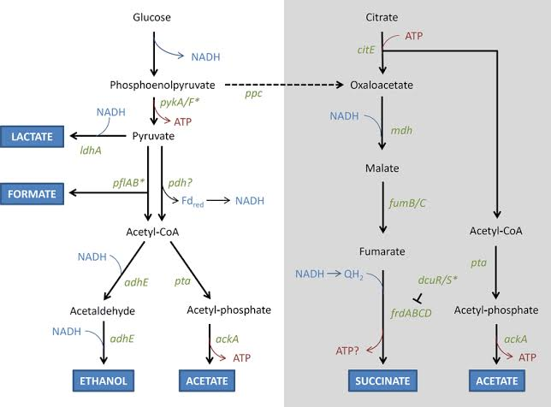
Figure 8
Advantages of Biomass Energy
The benefits of Biomass is yet a subject of many discussions when compared with other sustainable energy sources. Biomass has numerous advantages over non-renewable energy sources because of decrease in the emissions of carbon amount . The primary advantages of biomass are:
• Biomass as a sustainable energy source: The advantage of biomass energy is that biomass is inexhaustible source of energy and it can't be drained. Biomass generally got from plants, that implies for however long plants are going on this planet, biomass will be accessible as environmentally friendly energy source.

  - Biomass assists climate change : Biomass nodoubt helps to reduce the amount of greenhouse gas emissions and these emissions have more impact on global warming and which inturn effect climate changes. Though biomass is responsible for certain level of emissions and this level is far smaller as compared to currently dominant energy sources i.e. fossil fuels. The fundamental difference between biomass and fossil fuels when it comes to amount of carbon emissions is that all the CO₂ which has been absorbed by plant for its growth is going back in the atmosphere during its burning for the production of biomass energy while the CO₂ produced from non renewable energy sources is only going to atmosphere where it increases Earth’s greenhouse effect and adds to global warming.
  - Cleaner and Greener environment: The third principal advantage of biomass energy is that biomass can assist with cleaning our current circumstance.. World population is continously increasing, and with the expansion in population there is also a problem of increased waste and its proper disposal is required. Most of the garbage ends up in water resources like rivers, water streams, oceans thereby disturbing nearby ecosystems and having negative impact on human health. Rather than contaminating our planet with this waste we could involve it for the production of biomass energy which helps in cleaning our current circumstances from various types of pollution
  - Biomass as abundant resource of energy: Biomass which is considered as available energy source and can be produced from agriculture, forests, fisheries, aquaculture, algae and waste. Many energy and environment experts analysed that when we consider both economic and environmental prospectives of energy sources biomass is on top of the list among all the available energy sources.
  - Biomass-fuelled electrical and thermal applications balanced by Green House Gases emission: The biomass systems show net GHG emissions savings ranging between 40% of the substituted fossil alternatives to 4% of GHG. Thus, the aspects of the environmental benefit is more, and the total effective value will depend on the particular application like technology, scale etc. The total Green House Gases emissions from contaminated biomass fuels (non-tradables) are set at 0, since these fuels are available anyway. The existence of gases emitted from green house cannot be avoided, but all GHG emissions associated with their production should be allocated to the products from which they are the unavoidable result.
  - Biomass Energy is Carbon Neutral: The carbon which is released into the environment during biomass combustion is absorbed from tree’s life at a point in the atmosphere -so what it absorbs ends up with its release back in atmosphere. Generally speaking, the carbon released is re- absorbed by another plant so it is never added in the atmosphere in the first place. With renewable sources of energy like fossil fuel, the carbon released during combustion has been inaccessible to the atmosphere for millennia and therefore additional carbon is added in the atmosphere.
  - Reduces landfills waste : Most waste generated at domestic places is either plant matter or biodegradable. This sort of waste can be channeled to more profitable use. Biomass energy generation utilizes any waste that would have otherwise found way into landfills. This limits the impacts of waste in landfills to the atmosphere. This effect may be compounded by contamination of local habitats and wildlife ecosystems destruction. Limited or reduced waste means decrease of land intended for landfills which in turn provide more space for human habitats
Conclusions
Biomass can be considered as a green renewable energy resource which helps in reducing global warming by displacing the burning of fossil fuels. So biomass is a traditional energy resource and plays a pivotal role in reducing the adverse environmental impact or environmental pollution.

References
- ADAS, 1992. The potential of miscanthus as a fuel crop. ETSU Report ETSU B 1354.
- BP 2019 BP Statistical Review of World Energy 2019 [accessed 5 April 2021]. Available from https://bp.com/content/dam/bp/business-sites/en/global/corporate/pdfs/energy-economics/stat- istical-review/bp-stats-review-2019-full-report.pdf
- McLaughlin, S. et al., 1996. Evaluating physical, chemical and energetic properties of perennial grasses as biofuels. In: Proceed- ings of the BIOENERGY’96, September 15–20, Nashville, TN, USA.
- Price, B., 1998. Electricity from Biomass. Financial Times Business Ltd., ISBN 1 84083 0735
- REN21 2019 Renewables 2019 Global Status Report 2019 [accessed 5 April 2021]. Available from https://ren21.net/wp-content/uploads/2019/05/gsr_2019_full_report_en.pdf
- Singh A and Bijay P 2020 Mitigating through renewable energy: an overview of the requirements and challenges ed A Singh and R Deo Translating the Paris Agreement into Action in the Paciﬁc (Cham: Springer Nature) ch 2 pp 29–58
- Transport Studies Group, Univ. Westminster, 1996. Transport and Supply Logistics of Biomass Fuels, vol. 1. Supply chain options for biomass fuels. ETSU Report B/W2/00399/Rep/2
- World Energy Council 2013 World Energy Resources: Solar [accessed 5 April 2021]. Available from https://worldenergy.org/assets/images/imported/2013/10/WER_2013_8_Solar_revised.pdf

