A COMPREHENSIVE STUDY ON FUZZINESS AND INTERNET OF THING (IOT) AND REAL-LIFE APPLICATIONS
I. S Kharsyntiew¹* Fokrul A. Mazarbhuiya¹*, M. Shenify², A. S. Wungreiphi¹, and J. Kez¹
1 Department of Mathematics, School of Fundamental Sciences Assam Don Bosco University, Tapesia, Assam-782402, INDIA
Email: ibanskharsyntiew@gmail.com , fokrul.mazarbhuiya@dbuniversity.ac.in, wungreiphias@gmail.com, janetkrengma@gmail.com
2 Department of Computer Science, AlBaha University, Albaha, Saudi Arabia
Email: maalshenify@bu.edu.sa
*For correspondence: (ibanskharsyntiew@gmail.com , fokrul.mazarbhuiya@dbuniversity.ac.in)

ABSTRACT
Fuzziness has gained ground in every area of human understanding because of its capacity to handle the most realistic systems. It has several theoretical and real-world applications in fields including medicine, security, and the stock market, among others. One of the methods for replicating human mind is generally recognised as fuzzy set. It has been demonstrated to be effective in addressing a range of real-life issues linked to the aforementioned domains. Internet of Things (IoT) is one area where this is applicable. IoT technology has improved human life by enabling a variety of practical smart applications. The Internet of Things (IoT) is made up of many digital devices that are connected to one another and generate a lot of data for calculations. In this chapter, we propose to discuss about different notions of fuzziness like fuzzy logics, fuzzy graphs etc. along with their applications We also discuss a small example to show how fuzzy logic is used in household appliances specifically washing machines. It is also discussed about IoT, key-features, their advantages and disadvantages with applications Finally, it is also discussed the various applications of fuzzy in the context IoT.
The section 1, discusses introduction describing various stages of development in this field. The section 2 reviews the definitions of fuzzy sets and its applications. A brief discussion on fuzzy graphs and its applications will be found in Section 3. The definitions of IoT, key features, advantages and disadvantages are discussed in section 4. Real-life applications of IoT are discussed in Section 5. Some important applications of fuzzy in the context of IoT are discussed in section 6 and finally, we conclude our work with a brief conclusions and references given in the last section.
Keywords: fuzzy sets, fuzzy logic, fuzzy logic control fuzzy graphs, applications
- INTRODUCTION
More frequently, we have observed that genuine or factual events cannot be described by the classical or crisp set [1]. It is obvious that a "class of real numbers," "class of intelligent students," or "class of tall girls and boys" does not, from a classical mathematical perspective, constitute a set. Nevertheless, it is true that such ill-defined "classes" play a significant role in human thought, particularly in the areas of pattern recognition, information transfer, and abstraction. Fuzzy set theory is a new branch of set theory that has emerged in connection with the aforementioned concepts. It was first presented by Lofti A. Zadeh in 1965 as an extension of the conventional notion of a set (Zadeh, 1965). A fuzzy set is a class of objects whose members lack precise definitions [2]. Fuzzy sets provide a more realistic representation of reality than the conventional binary representation in mathematics. The idea is crucial for demonstrating the finite degree of precision in mental representations because membership in fuzzy sets is progressive [3]. Following the creation of fuzzy sets, it has been noted that several other subjects or areas of research connected to fuzzy sets have also been developed, including fuzzy graphs and fuzzy logic, which have many uses in a range of fields, including computer sciences, artificial intelligence, agriculture, and medicine.
Lotfi A. Zadeh, the theory's inventor, released the first article on the fuzzy set theory in 1965. Between 1965 and 1975, Zadeh expanded the basis of the fuzzy set theory by creating fuzzy similarity links, linguistic hedges, and fuzzy decision-making. A few research teams in Japan started looking on fuzzy set theory in the 1970s. In 1970, Mamdani invented the first fuzzy logic controller. In 1977, certain industrial settings in Europe and Japan began to employ fuzzy logic. Due to its popularity in Japan at the beginning of the 1980s, fuzzy logic saw a rebirth in the US at the conclusion of the decade [4].
There are huge numbers of applications that rely on sensors that provide essential information that changes over time, largely due to the development of IoT (Internet of Things) [5], and connected real time data sources. Streaming and time-series data availability has increased exponentially due to IoT. Analysis of this data can provide valuable insights. IoT systems enable users to achieve greater automation, analysis and integration within the system. They enhance the reach and accuracy of these areas. IoT leverages existing and emerging technology in sensing, networking and robotics. IoT leverages recent software advances, declining hardware prices, and changing attitudes towards technology. New and advanced elements bring significant changes in the supply of products, goods and services; and in the social, economic and political impact of these changes.
- SOME IMPORTANT CONCEPTS RELATED FUZZY SETS AND APPLICATIONS
  - FUZZY SET AND FUZZY LOGIC
The fuzzy set itself is known as the fuzzy logic and the fuzziness of any set is described by fuzzy logic. If X is a collection of objects denoted generically by $x$ then a fuzzy set A in X is a set of ordered pairs A= {( $x$,$µ_{A}$($x$))} where $µ_{A}$(x) is the membership or grade function of $x$ in A that maps X to [0,1]. [1]
Example: Let X be a set of natural numbers from 1 up to 10 i.e.,
$$X=\{1,2,3,4,5,6,7,………,10\}$$
A = “natural number close to 5”
$$µ_{A}\left(x\right)=\{({\left(5^{2}-x^{2})-1\right)}^{-1}\}$$
$$A=\frac{0.04}{1}+\frac{0.045}{2}+\frac{0.05}{3}+\frac{0.1}{4}+\frac{1}{5}+\frac{0.1}{6}+\frac{0.043}{7}+\frac{0.026}{8}+\frac{0.018}{9}+\frac{0.013}{10}$$
  - FUZZY LOGIC CONTROL
Fuzzy logic controller proceeds in three steps. First step is fuzzification. In this, crisp variable is converted in fuzzy variable. In second step some rules are set up in the form of If -Then and inference system works. The third step is defuzzification. In this resulting fuzzy output is converted back into crisp variable [6].
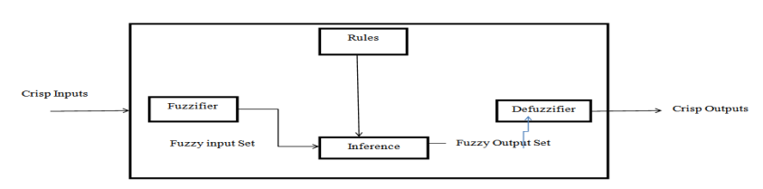
Fig 1: Fuzzy Logic System

  - APPLICATIONS OF FUZZY SETS AND FUZZY LOGIC
Fuzzy mathematics is based on fuzzy sets and is an extension of traditional mathematics. The scope of fuzzy logic extends far beyond mathematics. In this study, we will look at a few uses of fuzzy logic which have been shown to be effective. In chemical science, Davidson and Hayward [8] looked at many examples using fuzzy control systems. For example, in the case of Almardy, the study showed that the fuzzy control system was effective in protecting a long buried pipeline by applying current to a set of anodes. The study also showed that the use of the fuzzy control system helped to minimize the power used in protecting the pipeline.
In agriculture, the work of [9] looked at the uses of fuzzy logic for pest management, disease management, and weed management. They also looked at using fuzzy logic to develop expert system for different crops and to analyse and study soil.
In washing machines, fuzzy logic is used to help the washing machine achieve an economical wash. For example, using fuzzy logic, the following input parameters will help the washing machine: Amount of dirt, Type of dirt, Sensitive cloth, Amount of cloth [7]. The concept of fuzzy logic Inference system is used to calculate the percentage of chances of selection of a candidate to win the election. There are basically Mamdani and Sugeno types of most commonly used fuzzy inference systems are present in MATLAB toolbox named Fuzzy Logic Toolbox [10]. Other areas of research, like the medical field and environmental sciences, also use fuzzy logic.
  - APPLICATION OF FUZZY LOGIC ON WASHING MACHINE
A washing machine’s most important duty is to clean the cloths without damaging them. In order to achieve it, the output parameters of fuzzy logic, which are related to washing, must be paid importance. Inputs and outputs of fuzzy logic system are shown in figure 2.

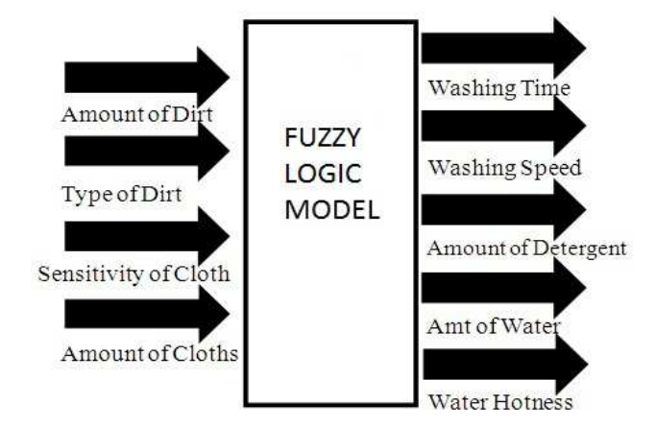
Fig 2: Inputs and outputs of the system

The input and output parameter’s membership function values, names, upper and lower limits are being set based on a given problem. The membership functions, with upper and lower limits, of input and output parameters are shown in figure 3 and 4 respectively. Figure 3 and figure 4 show membership functions of input and output respectively and also their upper and lower limits.

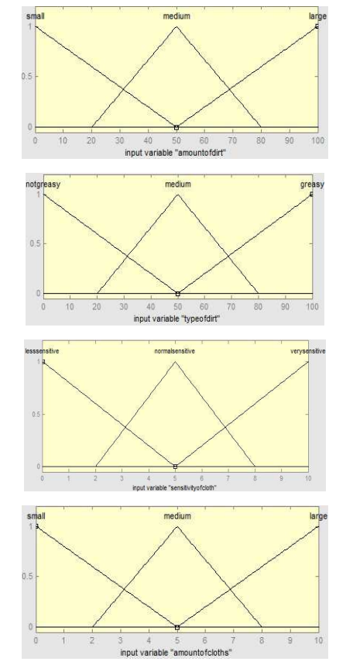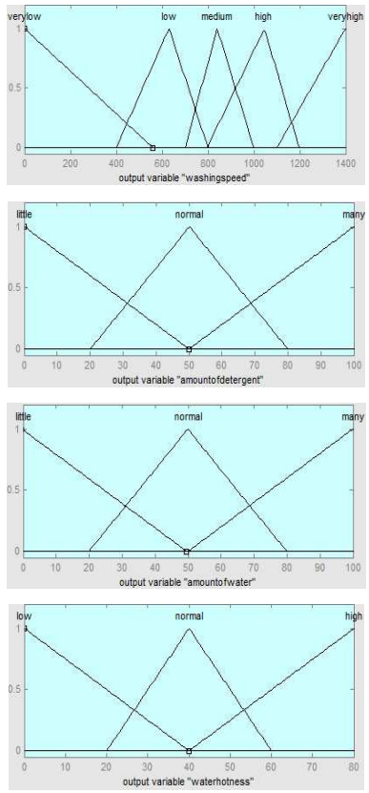
Fig 3: Fuzzy logic input membership functions Fig 4: Fuzzy logic output membership functions

Fuzzy rules have been established for the modelling of washing machine. The whole system has been developed by using MATLAB’s fuzzy logic toolbox [11].

- SOME IMPORTANT CONCEPTS RELATED FUZZY GRAPHS AND APPLICATIONS
  - FUZZY GRAPH
Rosenfeld developed fuzzy graphs ten years after Zadeh published his seminal study "Fuzzy Sets." A number of fundamental graph-theoretic notions, including bridges, paths, cycles, trees, and connectedness, have fuzzy analogues, and Rosenfeld has discovered some of their features. It is commonly known that graphs are essentially illustrations of relationships. For visualizing data on the connections between items, a graph is a valuable tool. Edges depict relationships, whereas vertices identify the items. It makes sense that when there is ambiguity in the description of the items, their relationships, or both, we would need to develop a "fuzzy graph model". [12]
3.2 DEFINITION: Let E be the (crisp) set of nodes. A fuzzy graph is then defined by
$$G\left(x_{i},x_{j}\right)=\{(\left(x_{i},x_{j}\right),μ\left(x_{i},x_{j}\right))|\left(x_{i},x_{j} \right)∈E×E\}$$
where $(x_{i},σ\left(x_{i}\right))$ and $(x_{j},σ\left(x_{j}\right))$ are called fuzzy points or fuzzy vertices and $\left(g,μ\left(x_{i},x_{j}\right)\right)or \left(g,μ\left(g\right)\right)$ are called the fuzzy lines or fuzzy edges of the fuzzy graph.
If $g=\left(x_{i},x_{j}\right)$, then the fuzzy points $(x_{i},σ\left(x_{i}\right))$ and $(x_{j},σ\left(x_{j}\right))$ are called adjacent points and the fuzzy point $(x_{i},σ\left(x_{i}\right))$ and the line $(g,μ\left(x_{i},x_{j} \right))$ are incident with each other. If two distinct fuzzy lines $(g_{1},μ\left(g_{1}\right))$ and $(g_{2},μ\left(g_{2}\right))$ are incident with a common fuzzy point, then they are called fuzzy adjacent lines [1].
Example:
($x_{1}, 0.6)$ ${(x}_{1}x_{2},0.4)$ ($x_{2}, 0.4)$

${(x}_{1}x_{4},0.3)$ ${(x}_{2}x_{3},0.3)$

($x_{4}, 0.4)$ ${(x}_{3}x_{4},0.4)$ ($x_{3}, 0.6)$
In the above figure,
- ($x_{1}, 0.6)$, ($x_{2}, 0.4)$, ($x_{3}, 0.6)$ and ($x_{4}, 0.4)$ are the fuzzy points.
- ${(x}_{1}x_{2},0.4)$, ${(x}_{2}x_{3},0.3)$, ${(x}_{3}x_{4},0.4)$ and ${(x}_{1}x_{4},0.3)$ are the fuzzy edges.
- ($x_{1}, 0.6)$ and ($x_{2}, 0.4)$ are fuzzy adjacent points.
- ${(x}_{1}x_{2},0.4)$ joins ($x_{1}, 0.6)$ with ($x_{2}, 0.4)$ hence ${(x}_{1}x_{2},0.4)$ is incident with ($x_{1}, 0.6)$ and ($x_{2}, 0.4)$.
- Since ${(x}_{1}x_{2},0.4)$ and ${(x}_{2}x_{3},0.3)$ are incident with ($x_{2}, 0.4)$ hence ${(x}_{1}x_{2},0.4)$ and ${(x}_{2}x_{3},0.3)$ are adjacent edges.

3.3 APPLICATION OF FUZZY GRAPHS
Fuzzy graph has a wide range of applications. Some of these applications are given below:
- TRAFFIC LIGHTS PROBLEM AND ITS SOLUTION BY FUZZY: The traffic lights problem consists of controlling a traffic lights system in such a way that certain level of security will be attained. This problem has been studied as an intersection graph. The traffic lights problem can be modelled by graph colouring. Vehicles will go from one direction to another direction and each intersecting point shows the possible accidental zones of two arrows. But number of vehicles in all paths are not always equal. Due to this reason, we consider it as fuzzy set whose membership value depends upon on vehicles number. If the number of vehicles in any path is high, then its membership value will be high and if the number of vehicles in any path is low then its membership value will be low [13]

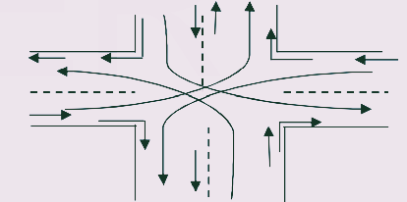

- A NEW MODEL OF TELECOMMUNICATION NETWORK, TFN: A Telecommunication network is a social network. In this system it has been proposed a method to represent telecommunication network by fuzzy graph [13].
- IoT
  - Key Features
The most vital features of IoT include artificial intelligence, connectivity, sensors, active engagement, and small device use. A brief review of these features is given below:
- Connectivity – New enabling technologies for networks, and IoT networking in particular, mean that networks are no longer limited to large providers. Networks can operate on a much smaller scale and at a much lower cost while still being feasible. IoT creates these tiny networks among its system devices.
- AI – The internet of things (IoT) makes almost anything “intelligent”, which means it improves every aspect of our lives with the help of data capture, AI algorithms and networks.This could mean upgrading your fridge and cupboards to automatically detect when your milk and favourite cereal run out, and then automatically place your order with your favourite grocery store that’s compatible with the real world..
- Active Engagement – Most of today’s engagement with connected technology is passive. IoT introduces a whole new way of engaging with active content, products, or services.
- Sensors – Without sensors, IoT loses its uniqueness. Sensors act as defining tools that turn IoT from a simple network of devices to an active system.
- Small Devices – As predicted, devices have grown smaller, more cost-effective, and more efficient as time went on. IoT takes advantage of purpose-made small devices to provide its accuracy, scalability and flexibility.
4.2 IoT − Advantages
The benefits of IoT extend to every aspect of life and business. Below is a brief overview of some of IoT’s benefits:
- Improved Customer Engagement – Existing analytics suffers from blind spots and glaring inaccuracies; and as mentioned earlier, engagement remains a passive process. IoT completely changes this, enabling richer and more meaningful engagement with audiences.
- Enhanced Data Collection – The problem with modern data collection is that it is limited and designed to be used passively. IoT takes data collection out of those silos and puts it where people really want it to be used to understand our world. IoT enables an absolute picture of everything.
- Technology Optimization – The same tools and data that enhance the customer journey also enhance device usage and help drive more powerful technology enhancements. IoT opens up a world of essential functional and field information.
- Reduced Waste – The Internet of Things (IoT) makes it clear where improvements need to be made. While traditional analytics only provide surface-level insights, IoT delivers real-world data that leads to better resource management.
  - IoT − Disadvantages
The Internet of Things (IoT) has a lot of advantages, but it also has a lot of problems. Here are some of its main problems:
- Privacy – The advanced nature of the IoT gives access to large amounts of personal information in extremely granular detail without the consent of the user
- Security – The IoT creates a network of devices that are always in communication with each other. The system provides limited control over these devices, even though there are security measures in place. This leaves users vulnerable to a wide range of attack types.
- Complexity – For some, IoT systems are difficult to design, set up, and maintain because they leverage multiple technologies and a wide range of emerging enabling technologies.
- Compliance – The IoT, like any other business technology, is subject to regulatory compliance. Due to the complexity of the technology, the compliance challenge seems insurmountable when many view standard software compliance as a battle.
- Flexibility – Many people are worried about how easy it is for an IoT system to connect to another system. They’re worried about having multiple conflicting or locked systems.
- Real-life applications of IoT technology
In below we discuss some real-life applications to the futuristic trends of IoT technology.
  - Government and Safety
Infrastructure-as-a-Service (IoT) for government and safety enables better law enforcement and defense, better urban planning, and better economic governance. IoT fills gaps, addresses many existing shortcomings, and broadens its scope. For instance, IoT helps city planners gain a better understanding of their design impact, and governments gain insight into the local economy.
  - Home and Office
From the convenience of our homes to the convenience of our offices, from the convenience of our businesses to the convenience of the organizations we interact with on a daily basis, IoT offers a personalised experience that enhances our overall satisfaction, productivity, and safety. For instance, IoT can enable us to customise our office space to optimise our work.
  - Health and Medicine
The IoT is pushing us towards our vision of the future of medicine that leverages a highly interconnected network of advanced medical devices. IoT today has the potential to significantly improve medical research, medical devices, medical care and emergency care. Integrating all elements provides greater precision, greater attention to detail, quicker responses to events and continuous improvement while reducing typical operating costs for medical research and organizations.
  - Marketing and Content Delivery
The way IoT works is similar to the way technology, analytics and big data work today. Existing technologies collect specific data to create metrics and trends over time, but this data often lacks granularity and precision. IoT, on the other hand, looks at more behaviours and analyses them in different ways. This results in more information and granularity, which provides more robust metrics and trends. IoT enables organizations to better understand and respond to customers’ needs or wants. It increases business efficiency and strategy, while improving the overall consumer experience by delivering only the right content and solutions.
  - Improved Advertising
Today’s advertising is over-the-top and under-targeted. Even with today’s analytics, modern advertising is failing. IoT promises diverse and personalized advertising, rather than a single-size-fits-all approach. It turns advertising from noise to noise. Because consumers interact with advertising via IoT, rather than passively consuming it, advertising becomes more functional and useful for people looking for solutions in the marketplace or wondering if solutions exist.
  - Air and Water Pollution
Excess and poor targeting are two of the biggest problems in today’s advertising. Even with today’s analytics, modern advertising is failing. IoT promises diverse and tailor-made advertising rather than a monolithic approach. It turns advertising from noise to an integral part of everyday life because consumers engage with advertising via IoT rather than passively consuming it. This makes it more functional and useful for people looking for solutions in the marketplace or wondering if solutions are out there.
  - Extreme Weather
Today’s powerful, high-tech systems enable deep monitoring, but they are limited by the use of broad instruments, like radar and satellite, rather than a more granular solution. Their smaller-scale instruments don’t have the same precision targeting of more powerful technology. New advances in IoT promise more granular data, greater accuracy, and scalability. High-level forecasting requires high-level detail and scalability in terms of range, instrument types, and deployments. This enables early detection and responses to reduce the risk of human life and property loss.
  - Commercial Farming
Today’s high-tech commercial farms have been using cutting-edge technology and biotech for a long time, but the Internet of Things (IoT) brings more access to automation and deeper analysis. Much commercial farming, such as weather monitoring, relies on human labor and is still limited in its automation. IoT enables operations to remove most of the human involvement in system operation, farming analysis and monitoring. The systems detect changes in crops, soil and environment and more. Optimize standard processes by analyzing large data collections. Prevent health risks (such as E. coli) and allow for better control.

- Some important applications fuzzy in IoT.
In below, we discuss some real life applications where fuzzy has been used in the IoT-based technology.
  - Fuzzy set consensus analysis in IoT resource ranking:
The complexity of the procedures for discovering, classifying, and selecting suitable resources to meet customer demands is related to the growing resource offers connected to the Internet. In [14] the uncertainties in the specification and processing of customer preferences, via consensual analysis is studied. They studied the relationship between restricted equivalence functions, more generally, consensus measures, and the possibility of building the latter using the former. Thus, consensus measures of fuzzy values and consensus measures on fuzzy sets are both defined by aggregations, such as the arithmetic mean and the exponential mean. Based on the interval-valued fuzzy logic they considered inaccuracies related to the measurements beyond the uncertainties, modelling the imprecision of expertise in classifying a set of resources in the IoT based on the IT2FL-EXEHDA-RR Model.
  - Fuzzy in IoT Devices for Smart Home to Assist Blind People for Navigation:
The demand of devices for safe mobility of blind people is increasing with advancement in wireless communication. Artificial intelligent devices with multiple input and output methods are used for reliable data estimation based on maximum probability. A model of a smart home for safe and robust mobility of blind people was proposed in [15]. Fuzzy logic has been used for simulation. Outputs from the internet of things (IoT) devices comprising sensors and bluetooth are taken as input of the fuzzy controller. Rules have been developed based on the conditions and requirements of the blind person to generate decisions as output. These outputs are communicated through IoT devices to assist the blind person or user for safe movement. The proposed system provides the user with easy navigation and obstacle avoidance.
  - Fuzzy logic-based IoT health monitoring:
The field of Health Monitoring is gaining popularity at present. With the reason that every family member will be employed and busy, the health monitoring of elderly people and patients has become very crucial. In [16] a system was developed a system where the caretakers can get the information of the temperature and the pulse rate of the people being monitored at home. It also provides information about the air quality in the home so that the system generates an alarm if any hazardous gas is detected. There fuzzy logic was used for real time monitoring and analysis of the data collected from temperature sensor, Heart beat sensor and Gas sensor. Based on the trained data and the collected data from the sensors outliers will be detected. The collected data sent to the cloud can be downloaded using the Thing speak platform. The future work has also been proposed and is planned to automate the message sending of the outliers detected to the caretakers and the doctors using deep learning.

- CONCLUSION
The idea of fuzzy has changed the mathematical landscape significantly, enabling it to make significant contributions to other fields of study. Similarly, introduction of IoT technology has enabled a significant change in the life and work of people. Numerous real-world issues that could not be resolved by Boolean logic or conventional logic have been addressed using fuzzy logic, fuzzy graphs IoT etc. This study has depicted a brief over on notions fuzzy and their real life applications particularly in machines. It has addressed the applications fuzzy graphs to study the issues associated with traffic and accident-prone locations. Further, the study also covers IoT technology, key features, advantages and disadvantages, and some real life applications with examples. Finally, the study also covers the applications of fuzzy on some of IoT-based systems. We can therefore draw the conclusion that studies are effective and very helpful for analysing situations that can only be fully understood by the human intellect. We can infer from the examples provided that it is a crucial idea that will require extensive future study.

REFERENCES
[1] Zimmermann, H.J. (1985) Fuzzy Set Theory and Its Applications. Kluwer, Boston, 11-17
[2] L.A. Zadeh, Fuzzy sets, Information and Control, 8 (1965) 338-353.
[3] D. Dubois, W. Ostasiewicz, H. Prade, Fuzzy Sets: History and Basic Notions Fundamentals of Fuzzy Sets, The Handbooks of Fuzzy Sets Series, 7 (2000) 21-124

[4] Cengiz Kahraman, Başar Öztayşi, Sezi Çevik Onar, A Comprehensive Literature Review of 50 Years of Fuzzy Set, International Journal of Computational Intelligence Systems, 9 (2016) 3-24.
[5] P. Sethi, and S. Sarangi, Internet of things: Architectures, protocols, and applications, Journal of Electrical and Computer Engineering, pp. 1–25,2017. doi:10.1155/2017/9324035.

[5] Poonam Gupta. Application of Fuzzy Logic in Daily Life. International Journal of Advanced Research in Computer Science. 2017; 8(5):1795-1800.
[6] Renu Makkar, Application of fuzzy logic: A literature review, International Journal of Statistics and Applied Mathematics 2018; 3(1): 357-359
[7] Hayward, Davidson. Fuzzy Logic Application, Analyst. 2003; 128:1304-1306.
[8] Philomine Roseline TN, Ganesan, Clarence Tauro JM. A study of Applications of Fuzzy Logic in Various Domains of Agricultural Sciences. International Journal of Computer Applications (0975 -8887). 2015, 15-18.
[9] M. Demetgul, O. Ulkir, and T. Waqar, Automation, Control and Intelligent Systems, 2, 27, 2014.
[10] Tohida Rehman, Fuzzy Rule Based Candidate Selection Evaluator by Political Parties, International Journal of Advanced Research in Computer Science, Volume 8, No. 3, March – April 2017
[11] R.Myna , Application of Fuzzy Graph in Traffic, International Journal of Scientific & Engineering Research, Volume 6, Issue 2, February-2015
[12] ¹A Muneera,²Dr. R.V.N. Srinivas Rao, Study on fuzzy graphs and applications, ¹Department of Mathematics, Andhra Loyola Institute of Engineering and Technology, ²Department of Mathematics, KL University, Vijayawada.
[13] S. Samanta and M. Pal, Telecommunication System Based on Fuzzy Graphs, J Telecommun Syst Manage ISSN: 2167-0919 JTSM, Volume 3(1), pp. 1-6.
[14] L. de Souza Oliveira, A. Argou, R. Dilli, A. Yamin, R. Reiser, B. Bedregal, Exploring fuzzy set consensus analysis in IoT resource ranking, Engineering Applications of Artificial Intelligence, Vol. 109, March 2022, 104617
[15] Shahzadi Tayyaba, Muhammad Waseem Ashraf, Thamer Alquthami, Zubair Ahmad, and Saher Manzoor, Fuzzy-Based Approach Using IoT Devices for Smart Home to Assist Blind People for Navigation, Sensors (Basel). 2020 Jul; 20(13): 3674. doi: 10.3390/s20133674
[16] Vani K S and Rajesh Rayappa Neeralagi, IoT based Health Monitoring using Fuzzy logic, International Journal of Computational Intelligence Research ISSN 0973-1873 Volume 13, Number 10 (2017), pp. 2419-2429.

