PEARL CULTURE-
A REVIEW FROM CLASSICAL TO FUTURISTIC BIOTECH

Dr Prafulla Chandra Rout
Assistant Professor of Zoology
Model Dregee College, Deogarh, Odisha, India 768108
Email id: pcr.bana@gmail.com

ABSTRACT
Started from Kokichi Mikimoto in 1888 of Japan ,Pearl culture has a long journey up to completion of genome map of Pinctada fucata ,Pearl oyster in 2017.Now attempts are made to isolate the nacre secreting gene(s),combine with other vectors and insert to a suitable host to get quality Pearl for Commercial Pearl farming .The present chapter includes a review of the biotechnology involved in it.
Key words :- Nacre ,Nacrein ,mineralization ,reverse transcription PCR ,linkage group . Introduction Pearls appear as jewellers envy ,the legislature of astrologers ,medicines of Ayurved ,the symbol of Aristocracy ,the Pride of ornaments and units of Peerless wealth .From the beginning of human civilization till date of genetic Engineers it has attracted human being with its great lusture. The art of Pearl culture started as a classical Biotechnology by Kokichi Mikimoto (1888) and still remains unexplored with a great futuristic Potentiality.
In Sanskrit literature ,it is mentioned that during “Swati Naksharta”,when a drop of water fall between the mantle and nacre layer ,then Pearl develops in an oyster.Chineese are known to use Pearl since 2300BC. Koutilya has also explained about Pearl in his “Arthasastra”.Now various institutions like CMFRI ,Tutikorin are actively involved in Pearl culture Practices.
What is Pearl ? Naturally Pearl is mostly a spherical or irregular body formed by deposition of nacre secreted by epithelial cells of mantle in response to irritations caused by external or internal stimuli like sand grains ,Parasites and other foreign Particles composition includes CaCO3,chonchiolin (C32H18N2O11) in the matrix which also contains Chitin ,fibroin ,Ca++,Zn++ ,mg++ and soluable acidic proteins for crystal nucleation GAGs.Anyimproportionatecomposition disfigures Pearl.Health of the oyster and Ecology of the water also plays and important role in Pearl formation.

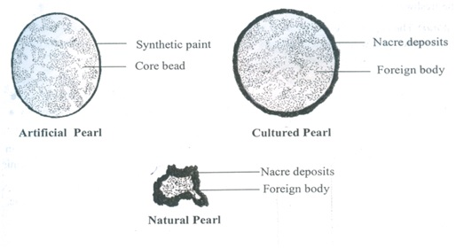

Fig1; Types of Pearls
Major Pearl oysters The Pearl oysters are mostly marine bivalves belonging to the genus Pinctada ,under the family Pteriidae ,order Lanellibronchiata.
- Pinctada maxima – Gold/silver lip Pearl oyster Australia ,Burma ,Thailand ,Indonesia
- Pinctada fucata :- Yellow lip Pearl oyster,Red sea Persion ,India China ,Korea ,Japan and western Pacific ocean.
- Pinctada margaritifora :- Black lip Pearl oyster ,Persion Gulf ,Red sea ,Sudan ,Indonesia India , Japan and Pacific.
- Pinctada chemnizii :- Gulf of manner

Freshwater Pearl oysters include 1. Lamellidommarginalis 2. Lamellidomcarrianus 3. Lanellidomcorrugate
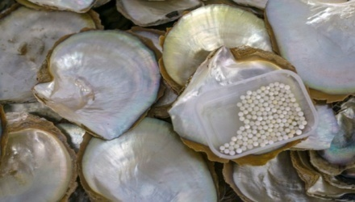
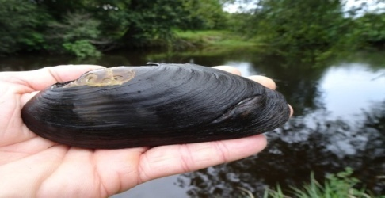

Fig2. Pearl oysters : a) Fresh water and b) Marine water
Formation of Pearl : Naturally formation of Pearl includes invasion of a foreign particle into the mantle epithelium followed by continuous secretion of nacre in concentric layers around it up to several years .This principle is exploited in artificial pearl culture practices .The entire biotechnology is based on this involving i) Selection of site ii) Supply and rearing of spot iii)Protection from enemies iv)Preparation and insertion of nucleus v)Post operative treatment vi)Harvesting
FUTURISTIC TRENDS : The future of Pearl Culture is bright with a great potential of commercial production through modern biotechnology( Chellam A. et.al.1998) . To improve the technology of pearl production, the following measures are needed :
1. Enhancement of the quality of environment.
2. Improve biological needs of oysters
3. Improve genetic and biological aspects of the oysters.
Environmental and biological needs are under continuous improvement over the years but the third aspect, i.e. genetic and biological improvements are highly essential. Various modern workers are involved in improvement of Pearl culture particles through various studies .A matrix protein “Pmarg-Pearlin” involved in nacre farm work formation has been identified in Pinctada margaritifera [Montagnaric etal.2011 ] Nature of development and function of Pearl sacs from regenerated mantle graft tissue has been thoroughly studied in Pinctada margaritifora (Kishore P.etal.-2015 ) A complete genome map of Pinctada fucata has been worked out taking 14linkage groups in the species (Xiaoong Du et.al 2017) which shows that Pearl formation is a complex process involving many genes at a time for nacre secretion mineralization ,fibroin & Chitin deposition involvement of VWA Proteins and acidic glycosamine glycans.
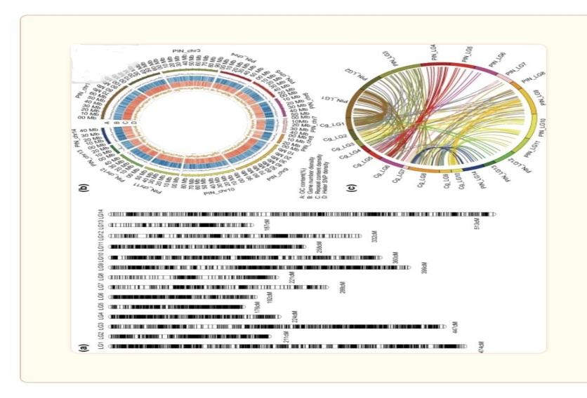

Fig;3 Complete Genetic Map of P. fucata martensii ( Drawn from Xiaon Du et.al.2017)
CONCLUSION :- Something is known and Still more things are to be done for Pearl Culture in future. All the above processes are merely the foot steps towards a futuristic biotechnology of Pearl culture. Sequencing techniques have identified the genes responsible for Pearl formation .Events like selection of a suitable vector ,Preparation of recombinant DNA and insertion into a host need to come ahead to get good marketable quality Pearl in future .
REFERENCES
- Blay C, s planes and C Long(2018): Cultured Pearl surface quality profiling by the shell matrix protein gene expression in the Bio-mineralized pearl sac Tissue of Pinctada margaritifera. Marine Biotechnology 20.490-501
- C Montagnani , B Marie, F Marin, C Belliard, F Riquet, A Tayalé, I Zanella-Cléon, E Fleury, Y Gueguen, D Piquemal, N Cochennec-Laureau (2011): Pmarg-pearlin is a matrix protein involved in nacre framework formation in the pearl oyster Pinctada margaritifera. Chem Biochem 12(13) 2033-2043.
- Chillam A, Victor ACC AND Josef S ( 1998): Biotechnological Aspects in Marine Pearl Production: Proc. First Natl. Semi. Mar. Biotech.
- Cheng Q, Wanqing Hu and Zhiyi B (2021) Research Trends of Development on Pearl Bivalve Mollusks Based on a Bibliometric Network Analysis in the Past 25 Years. Sec. Marine Fisheries, Aquaculture and Living Resources.
- J. Vidya, S R vasudevan, Suja C Paulose , I Divipala (2018) Nacre formation by epithelial Cell Culture from mantle of the black-lip pearl oyster, Pinctada margaritifera-Invitro- Cell Dev boil.Anim- Aug54(70 477-485.
- P. Kishore and P C Southgate (2015): development and formation of Pearl sacs grown from regenerated mantle graft tissue in the black-lip pearl oyster,Pinctada margaritifera. Fish and Shellfish Immunology 45(2) 567-573.
- Suja, C P (2019): In vitro Pearl Culture Techniques: A Biotechnological Approach. CMFRI Special Publication (131). ICAR - Central Marine Fisheries Research Institute, Kochi.
- Xiaodong Du, Guangyi Fan, Yu Jiao, He Zhang, Ximing Guo, Ronglian Huang, Zhe Zheng, Chao Bian, Yuewen Deng, Qingheng Wang, Zhongduo Wang, Xinming Liang, Haiying Liang, Chengcheng Shi, Xiaoxia Zhao, Fengming Sun, Ruijuan Hao, Jie Bai, Jialiang Liu, Wenbin Chen, Jinlian Liang, Weiqing Liu, Zhe Xu, Qiong Shi, Xun Xu, Guofan Zhang, Xin Liu (2017): The pearl oyster Pinctada fucata martensii genome and multi-omic analyses provide insights into biomineralization.
Giga Science 8 (6) Gig059.

