Customer Segmentation for Marketing

Dishant Banga
Sr. Data Analyst
Bridgetree, LLC Mooresville, NC, USA
dishant.u.banga@gmail.com

Abstract- Customer segmentation is a crucial marketing strategy that involves dividing a target market into distinct groups based on shared characteristics, behaviours, or preferences. It allows businesses to better understand their customers and tailor their marketing efforts to specific segments, ultimately driving customer satisfaction, loyalty, and business growth. This article provides an overview of customer segmentation, its benefits, and various methods commonly used in the process. It emphasizes the importance of data-driven approaches and highlights the role of advanced analytics techniques in identifying meaningful customer segments. The article explores different segmentation variables, including demographic, psychographic, behavioural, and geographic factors, and discusses their relevance in understanding customer behaviour and preferences. It emphasizes the need for selecting variables that align with business objectives and provide actionable insights. Furthermore, the article delves into the methodology of customer segmentation, outlining the key steps involved, such as data collection, data analysis, segment profiling, and evaluation of segment viability. It emphasizes the iterative nature of the process, emphasizing the need for continuous monitoring and refinement of segmentation strategies. The article also presents real-world examples of customer segmentation, showcasing how businesses across various industries have successfully implemented segmentation strategies to improve targeting, personalization, and customer experiences. Lastly, the article discusses the challenges and limitations of customer segmentation, such as data quality issues, dynamic market conditions, and the need for ongoing segmentation updates. It emphasizes the importance of integrating segmentation with other marketing strategies and leveraging technology solutions for effective implementation. By understanding and leveraging customer segmentation, businesses can gain valuable insights into their customer base, enabling them to develop tailored marketing strategies, enhance customer experiences, and drive business success.

Keywords: Machine Learning, K-means clustering, Principal Component Analysis (PCA), Unsupervised Learning

- INTRODUCTION

In the dynamic and competitive landscape of modern business, understanding customers has become more critical than ever before. Companies across industries are continuously striving to gain insights into their customer base to deliver personalized experiences, targeted marketing efforts, and ultimately, superior products and services. This is where customer segmentation emerges as a powerful strategic tool.

Customer segmentation is the process of dividing a company's diverse customer base into distinct groups or segments based on shared characteristics, behaviours, preferences, or needs. By creating meaningful segments, businesses can gain a deeper understanding of their customers' distinct traits and develop tailored strategies that resonate with specific groups. This segmentation approach allows companies to move beyond one-size-fits-all marketing, focusing on personalized and relevant interactions with customers.

In this introduction to customer segmentation, we will explore the significance of this practice in contemporary marketing and how it has revolutionized the way businesses interact with their clientele. We will delve into the benefits of customer segmentation, such as improved customer acquisition and retention, enhanced customer loyalty, efficient resource allocation, and the ability to identify new growth opportunities. Moreover, we will discuss the different types of customer segmentation approaches, including demographic, psychographic, behavioural, geographic, and firmographic, highlighting how each offers unique insights into customer behaviour and preferences.

As we embark on this journey through the realm of customer segmentation, it becomes evident that this practice is not just a marketing tactic but a strategic imperative. Customer segmentation empowers businesses to navigate the complexities of a diverse customer base, unlock hidden patterns, and forge stronger connections with customers. By harnessing the power of segmentation, companies can elevate their marketing efforts, strengthen their competitive edge, and cultivate long-term customer relationships that drive sustained business growth.

Customer segmentation is a critical aspect of effective marketing. By dividing your customer base into specific groups based on shared characteristics, you can create targeted marketing campaigns that are more likely to resonate with your audience and drive engagement. Customer segmentation is a pivotal strategy in modern marketing that involves dividing a company's customer base into distinct groups based on shared characteristics and behaviours. It allows businesses to understand their customers on a deeper level, tailor their marketing efforts, and deliver personalized experiences that resonate with specific segments. This introduction provides an overview of customer segmentation, its importance, and the key references that contribute to its understanding and implementation.
- Theoretical Frameworks and Approaches: Numerous theoretical frameworks have been proposed to guide customer segmentation efforts. These frameworks include demographic, psychographic, behavioural, geographic, and firmographic segmentation. Each approach offers unique insights into customer behaviour and preferences. For instance, demographic segmentation divides customers based on age, gender, income, and other demographic variables, while psychographic segmentation considers lifestyle, values, and personality traits [1][5].
- The Importance of Customer Segmentation: Customer segmentation plays a crucial role in today's dynamic and competitive business environment. By recognizing that customers are not homogeneous, businesses can identify diverse segments with unique preferences, needs, and behaviours. This understanding allows for more targeted and effective marketing strategies, improved customer acquisition and retention, and enhanced overall customer satisfaction.[1][2]
- Benefits of Customer Segmentation: Customer segmentation offers numerous benefits to businesses. By tailoring marketing messages and strategies to specific segments, companies can increase customer engagement, conversion rates, and loyalty. Segmentation also enables efficient allocation of resources by focusing efforts on high-value customer segments, optimizing product development and pricing strategies, and identifying opportunities for growth and market expansion. [3][4]. Here are some ways in which customer segmentation can benefit your marketing efforts:
  - Personalization: By understanding your customers' unique characteristics and preferences, you can tailor your marketing messages and offerings to better meet their needs. According to a survey by Epsilon, 80% of consumers are more likely to do business with a company that offers personalized experiences.
  - Improved ROI: Targeted marketing campaigns are more likely to drive engagement and conversions, resulting in a higher return on investment (ROI) for your marketing efforts. According to a study by Campaign Monitor, targeted campaigns generate 58% of all email revenue.
  - Customer Loyalty: By showing your customers that you understand their needs and preferences, you can build stronger relationships and foster customer loyalty. According to a survey by Accenture, 91% of consumers are more likely to shop with brands that recognize, remember, and provide relevant offers and recommendations.

- Methodologies for Customer Segmentation: Various methodologies are employed in customer segmentation, each capturing different dimensions of customer behaviour and characteristics [5][6]. These methodologies include:
- Demographic Segmentation: Demographic segmentation involves dividing customers based on demographic factors such as age, gender, income, education, occupation, and family size. This approach provides a broad understanding of customer characteristics and is often used as a starting point for segmentation. [7][11]
- Psychographic Segmentation: Psychographic segmentation focuses on customers' attitudes, values, interests, and lifestyle choices. It considers customers' personalities, motivations, and purchasing behaviours, allowing businesses to create segments based on shared psychographic profiles [6][12].
- Behavioural Segmentation: Behavioural segmentation categorizes customers based on their purchasing behaviour, usage patterns, brand loyalty, and engagement with the company. It considers factors such as frequency of purchases, average order value, product/service usage, and response to marketing stimuli [13][14].
- Geographic Segmentation: Geographic segmentation divides customers based on their geographical location, such as country, region, city, or even neighbourhood. It recognizes that customer needs and preferences can vary based on geographic factors, enabling businesses to target specific locations with tailored marketing strategies [15][16]
- Firmographic Segmentation: Firmographic segmentation is primarily used in business-to-business (B2B) contexts and involves segmenting customers based on firmographics, such as industry, company size, revenue, and organizational structure. This approach helps businesses customize their offerings and marketing messages to specific B2B segments [17][18].
- Data-driven Segmentation: Data-driven segmentation leverages advanced analytics techniques, including machine learning algorithms and data mining, to identify patterns and segments within large datasets. It enables businesses to uncover hidden insights and create highly granular and precise customer segments. [19][20].
- Hybrid Segmentation: Hybrid segmentation combines multiple segmentation methodologies to create more robust and detailed customer segments. For example, a company might use a combination of demographic, psychographic, and behavioural factors to create segments that encompass both customer characteristics and behaviours [5][6].

- Applications in Different Industries: Customer segmentation has been widely applied across various industries, including retail, hospitality, e-commerce, and telecommunications. For example, in the retail industry, segmentation based on purchase history and preferences helps customize product recommendations and loyalty programs. In the hospitality industry, segmentation based on travel behaviour and preferences enables targeted marketing campaigns for different types of travellers. Starbucks: Starbucks uses customer segmentation based on their purchase history and behaviour to create targeted marketing campaigns [9][10].
    - Amazon: Amazon uses customer segmentation based on their browsing and purchase history to recommend products and promotions that align with each customer's interests. For example, if a customer has recently purchased a book on cooking, Amazon may recommend other cooking-related products or offer promotions on kitchen appliances.
    - Nike: Nike uses customer segmentation based on their psychographic characteristics to create campaigns that align with each customer's unique lifestyle and values. For example, they may target customers who prioritize health and fitness with ads that emphasize the benefits of their products for an active lifestyle.
    - Airbnb: Airbnb uses customer segmentation based on their location to create campaigns that are specific to each region or city. For example, they may offer promotions or discounts for popular destinations during peak travel seasons or highlight unique and interesting experiences that are only available in certain locations.
    - Coca-Cola: Coca-Cola uses customer segmentation based on their demographic characteristics to create campaigns that are tailored to each customer group. For example, they may create separate ads for different age groups or genders, each emphasizing different aspects of their brand and products that are most relevant to that group.

- METHODOLOGY

While customer segmentation steps may not have specific references associated with them, the following outline provides a general framework for the process:

- Define Objectives: Clearly articulate the objectives and goals of the customer segmentation effort. This could include improving marketing effectiveness, enhancing customer satisfaction, increasing customer retention, or identifying new market opportunities.
- Collect Data: Gather relevant data about your customers from various sources such as customer databases, CRM systems, surveys, social media, and website analytics. Utilize both quantitative and qualitative data to gain a comprehensive understanding of customer characteristics and behaviors.
- Identify Segmentation Variables: Determine the key variables or criteria to segment your customers. These variables can include demographic (age, gender, income), psychographic (lifestyle, values, attitudes), behavioral (purchase history, frequency, loyalty), geographic (location, region), and firmographic (company size, industry) factors. Select variables that are meaningful, actionable, and aligned with your objectives.
- Analyze the Data: Apply appropriate data analysis techniques such as statistical analysis, clustering algorithms, or machine learning to identify patterns and group customers into segments. Use tools like Excel, SPSS, R, or Python to analyze the data and derive meaningful insights.
- Develop Segment Profiles: Create detailed profiles for each customer segment based on their shared characteristics. Describe the demographics, behaviours, preferences, and needs of customers within each segment. This helps in understanding their unique requirements and tailoring marketing strategies accordingly.

- Evaluate Segment Viability: Assess the viability and potential value of each segment by considering factors like segment size, growth potential, profitability, accessibility, and compatibility with your company's resources and capabilities. Prioritize segments that offer the greatest potential for success.
- Targeting and Positioning: Develop targeted marketing strategies for each segment, including messaging, promotions, product offerings, and channel selection. Customize your marketing efforts to align with the specific needs, preferences, and motivations of each segment. Position your brand to differentiate and resonate with the targeted segments.
- Implement and Monitor: Implement the segmented marketing strategies across various channels and monitor their performance. Continuously track and measure key metrics such as customer engagement, conversion rates, customer satisfaction, and ROI. Regularly evaluate and refine your segmentation approach based on the insights gained from monitoring results.

- STEPS TO DEVELOP CUSTOMER SEGMENT PROFILES

- Machine Learning terminologies

- K-means Clustering: K means clustering is an unsupervised machine learning algorithm used to train the model and split the unclassified data into clusters or groups. The goal of the algorithm is to reach the optimal number of clusters for the given data. Here K represents the numbers of clusters. The optimal value of K is decided using the Elbow graph. As showing the below figure 1 the optimal value of clusters is 3, which is Elbow point.

Figure 1: K-means clustering Elbow Graph

- Principal Components Analysis (PCA): Principal component analysis (PCA) is a widely utilized technique for dimensionality reduction in large datasets. Its purpose is to transform a high-dimensional set of variables into a smaller set while retaining most of the original information. The primary objective of dimensionality reduction is to strike a balance between reducing the number of variables and maintaining an acceptable level of accuracy. By reducing the complexity of the data, it becomes more manageable for exploration, visualization, and analysis. Moreover, machine learning algorithms can operate more efficiently. In essence, PCA allows for the extraction of a reduced set of variables, known as principal components, that capture the most significant variation within the original data. By transforming the data into a new coordinate system defined by these principal components, PCA maximizes the variance along the first principal component and subsequent components while ensuring their orthogonality. This process allows for an accurate representation of the original dataset while achieving dimensionality reduction.

- Steps to build the segmentation using Python 2.3.3

- The code begins by importing the necessary libraries, including pandas for data handling, scikit-learn for clustering algorithms, and matplotlib for visualization.
- The customer data is loaded from a CSV file using pd.read_csv() and stored in the data DataFrame.
- Relevant features for segmentation (e.g., Feature1, Feature2, Feature3) are selected from the DataFrame and stored in the variable X.
- The features are scaled using StandardScaler to ensure they have zero mean and unit variance, which is important for k-means clustering.
- The code performs customer segmentation using k-means clustering. You can adjust the n_clusters parameter to specify the desired number of segments.
- Each customer is assigned a segment label based on the clustering results, which are stored in the segment_labels variable.
- The segment labels are added to the original dataset by creating a new column named "Segment" in the data DataFrame.
- The segment means (average values of each feature within each segment) are computed using groupby().
- A spider plot (also known as a radar plot or star plot) is created to visualize the segment means. The categories (features) are plotted on the angular axis, and the values are plotted on the radial axis.
- Each segment is represented by a line in the spider plot, with different segments highlighted using different colors or line styles. The area enclosed by each line represents the average values of the corresponding segment for each feature as shown in Figure 2.
- The spider plot is customized by setting the figure size, adjusting the axis settings, and adding gridlines and labels.
- Finally, the spider plot is displayed using plt.show().

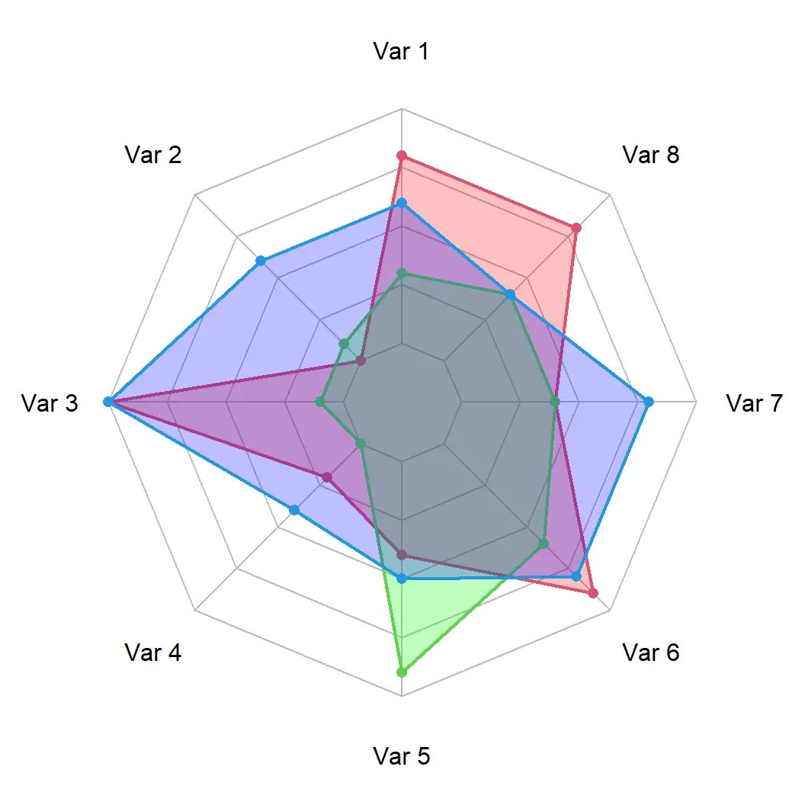
Figure 2 : Spider graph representing clusters

In the above example, 8 variables were selected using the PCA machine learning algorithm and those were used to create the different segments. The explanation of segments are below:
Red: this cluster has high Var 1, Var 3, Var 6, Var 8 ; mid Var 4, Var 5 , Var 7 and low Var 2
Purple: this cluster has high Var 2, Var 3, Var 6, Var 7 ; mid Var 1, Var 4, Var 5 , Var 8
Green: this cluster has high Var 5 ; mid Var 1, Var 6, Var 7, Var 8 and low Var 2, Var 3, Var 4

- CONCLUSION

In summary, customer segmentation is a powerful tool that can help you create targeted marketing campaigns, drive engagement and conversions, and build stronger relationships with your customers. By understanding your customers' unique characteristics and preferences, you can create more effective marketing strategies and improve the ROI of marketing effort.
REFERENCES

- Kotler, P., & Armstrong, G. (2017). Principles of Marketing. Pearson.
- Wedel, M., & Kannan, P. K. (2016). Marketing analytics for data-rich environments. Journal of Marketing, 80(6), 97-121.
- Gupta, S., & Lehmann, D. R. (2006). Managing customers as investments: The strategic value of customers in the long run. Pearson Prentice Hall.
- Verhoef, P. C., Lemon, K. N., Parasuraman, A., Roggeveen, A., Tsiros, M., & Schlesinger, L. A. (2009). Customer experience creation: Determinants, dynamics, and management strategies. Journal of Retailing, 85(1), 31-41.
- Wind, Y., & Mahajan, V. (2001). Convergence marketing: Strategies for reaching the new hybrid consumer. Financial Times Prentice Hall.
- Aaker, D. A., Kumar, V., & Day, G. S. (2001). Marketing research. John Wiley & Sons.
- Kotler, P., & Armstrong, G. (2017). Principles of Marketing. Pearson.
- Verhoef, P. C., Neslin, S. A., & Vroomen, B. (2007). Multichannel customer management: Understanding the research-shopper phenomenon. International Journal of Research in Marketing, 24(2), 129-148.
- Buhalis, D., & Law, R. (2008). Progress in information technology and tourism management: 20 years on and 10 years after the Internet—The state of eTourism research. Tourism Management, 29(4), 609-623.
- Dibb, S., & Simkin, L. (2013). Market segmentation success—Making it happen! Market segmentation success: Making it happen!, 5-23.
- Wells, W. D., & Prensky, D. (1996). Consumer behavior. John Wiley & Sons.
- Schiffman, L. G., & Kanuk, L. L. (2010). Consumer behavior. Pearson Education.
- Gupta, S. (2012). Customer lifetime value concepts and models. Foundations and Trends® in Marketing, 6(1), 1-71.
- McDonald, M., & Dunbar, I. (2004). Market segmentation: How to do it and how to profit from it. John Wiley & Sons.
- O'Guinn, T. C., Allen, C. T., & Semenik, R. J. (2008). Advertising and integrated brand promotion. Cengage Learning.
- Hollensen, S. (2015). Marketing management: A relationship approach. Pearson Education.
- Kotler, P., & Keller, K. L. (2015). Marketing management. Pearson.
- Wedel, M., & Kannan, P. K. (2016). Marketing analytics for data-rich environments. Journal of Marketing, 80(6), 97-121.
- Berry, M. J., & Linoff, G. S. (1997). Data mining techniques: For marketing, sales, and customer relationship management. John Wiley & Sons.
- D. Banga and K. Peddireddy, "Artificial Intelligence for Customer Complaint Management," International Journal of Computer Trends and Technology, vol. 71, no. 3, pp. 1-6, 2023, doi: 10.14445/22312803/IJCTT-V71I3P101.

