Chapter
WASTE MANAGEMENT IN FOOD AND AGRICULTURAL INDUSTRIES

Introduction:
In the 21st century due to industrialization and urbanization, agriculture and farming are decreasing day by day at lowest level and global warming and environment problems are having direct and indirect huge impact on our human life by food and agricultural waste too. The wise strategy has to be taken with multi layered technology solutions for food and agricultural waste management. Many countries are already taking action to reduce food and agricultural waste, but the challenges ahead remain significant and we need to step up efforts. When we strive to make progress towards reducing food and agricultural waste, it can highly effective in our efforts of best management of food cost, environmental problems and greenhouse gases.
Food and agricultural waste management has become a major concern in the present day context. Food and agricultural waste are already crossed the limit to destroying our environment and planet. Therefore, food and agricultural waste management needs to be applied effectively through refuse, reduce, recycle, repurpose and reuse.
What is waste?
Waste (or wastes) are unwanted or unusable materials. Waste is any substance discarded after primary use, or is worthless, defective and of no use. A by-product, by contrast is a joint product of relatively minor economic value. A waste product may become a by-product, joint product or resource through an invention that raises a waste product's value above zero.

Need for Waste Management:

The main motive of waste management is to reduce the adverse effects of waste on human health as well as on the environment. Our environment is degrading. It isn’t going to be a long time before our Earth becomes incapable of sustaining the vast amount of waste generated and the harmful effects it has.
In such a scenario, the importance of waste management cannot be stressed enough. Countries all over the world are finally waking up to the dangers of not handling their waste properly.
What is waste management?
Waste management or waste disposal includes the processes and actions required to manage waste from its inception to its final disposal. This includes the collection, transport, treatment, and disposal of waste, together with monitoring and regulation of the waste management process and waste-related laws, technologies, and economic mechanisms.

Waste Management Hierarchy:-
The waste management hierarchy is an approach that focuses on prioritizing waste management practices with the goal to achieve sustainable waste management. It establishes the order of waste management options, from the most preferred to the least preferred one:
- Prevention:- According to waste hierarchy, waste prevention must be top priority for sustainable waste management. Waste prevention typically does not lie in the waste management practices, as it focuses on avoiding a substance to become waste.
- Minimization:- Waste minimisation is a set of processes and practices intended to reduce the amount of waste produced. By reducing or eliminating the generation of harmful and persistent wastes, waste minimisation supports efforts to promote a more sustainable society. Waste minimisation involves redesigning products and processes and/or changing societal patterns of consumption and production.
- Reuse:- Reuse is the action or practice of using an item, whether for its original purpose (conventional reuse) or to fulfill a different function (creative reuse or repurposing). It should be distinguished from recycling, which is the breaking down of used items to make raw materials for the manufacture of new products. Reuse – by taking, but not reprocessing, previously used items – helps save time, money, energy and resources.
- Recycling:- Recycling is the process of converting waste materials into new materials and objects. This concept often includes the recovery of energy from waste materials.
- Disposal :- Waste disposal includes the processes and actions required to manage waste from its inception to its final disposal. This includes the collection, transport, treatment, and disposal of waste, together with monitoring and regulation of the waste management process and waste-related laws, technologies, and economic mechanisms.
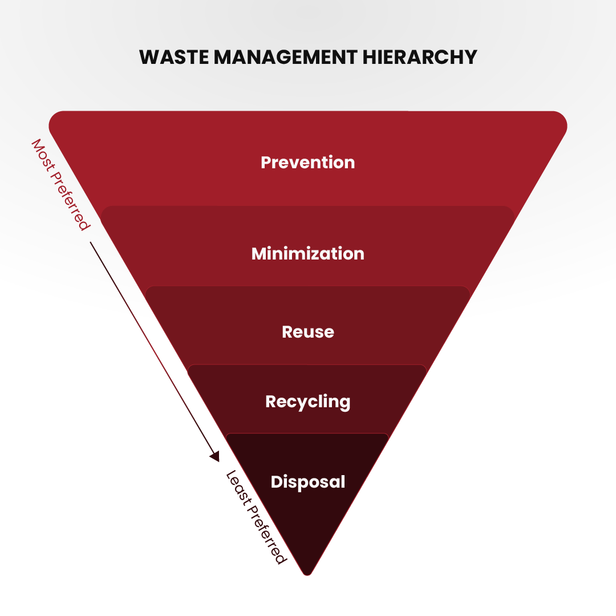
Food and agricultural waste management:-
Food and agricultural waste management system is a planned system in which all the necessary components are installed and managed to control and use by-products of food and agricultural production in a manner that sustains or enhances the quality of air, water, soil, plants, animals and energy resources.

Food and agricultural waste management technology for sustainable agriculture:-
The process of collection, transport, disposal, recycling and monitoring of agricultural waste is called food and agricultural waste management is undertaken to recycle the food and agricultural waste so as to reduce the ill effects of wastes on environment, health and aesthetics. Various techniques are used for the management of waste which includes land-filling, incineration, anaerobic digestion, pyrolysis, plasma gasification, recycling, composting. Anaerobic digestion produces bio fuel in the form of biogas. Plasma gasification results in the generation of electricity from waste. Recycling of food and agricultural waste involves the collection, sorting and reprocessing of waste into new products. Vermin composting is the preferred form of composting as it results in the formation of vermin compost called black gold due to the presence of rich nutrients and growth promoting factors in it.
Due to industrialization, urbanization and increase in population density, there has been an increase in the accumulation of waste. The waste includes radioactive substance, agricultural wastes, food wastes, industrial wastes, municipal wastes. Garbage and paper waste etc. There has been decrease in the availability of open land and space for disposal of waste due to intensive use of agricultural land for residential, industrial and commercial purpose. In order to reduce the load of food and agricultural wastes on earth, the collection, transport, recycling and disposal of food and agricultural wastes needs to improvised.
The process of collection, transport, disposal, recycling and monitoring of food and agricultural wastes is called food and agricultural waste management. Food and agricultural waste management can be costly so it is important to understand the various effective, sustainable and safe means of its management. The three points ‘R s “Reduce, Reuse, and Recycle have become basic tenet in food and agricultural waste management due increase in generation of wastes, increasing in processing costs and decrease in available landfill space. There should be flexibility in food and agricultural waste management systems in light of changing environmental, social and economic conditions. To optimize, evaluate, adapt and define food and agricultural waste management systems, the information and feedback can be obtained from system analysis.
The reduction of food and agricultural wastes is placed at the top of waste management hierarchies because the best means waste management is to reduce waste by not creating it in first place. The reduction of food and agricultural waste can also be achieved through the reuse of products. The reduction and reuse of wastes save natural resources, reduces generation of wastes and reduces the cost associated with food and agricultural waste disposal.
Food and agricultural waste management is undertaken to recycling the wastes so as to reduce the ill effects of wastes on environment, health and aesthetics. The waste may be either in solid, liquid or gaseous form. The process of food and agricultural waste management varies for rural and urban areas, for municipal and industrial waste, for developed and developing nations. The management of municipal wastes is responsibility of local government while as the management of agricultural waste is the responsibility of farmers. The developed nations use various novel technologies to reduce the negative impacts of waste or use and effective management to exploit it.
Agricultural Waste Management Categories: -
There are several kinds of raw and solid waste produced in food and agricultural sector. Food and agricultural wastes are released into air, water or land. Solid wastes are the wastes that are deposited at the site where they are produced.
The primary objective of most food and agricultural sector is the production of marketable goods. The successful management must balance the demand on limited resources among many complicated and other dependent systems which includes as follows:
- Cropping system
- Livestock system
- Irrigation and drainage system
- Pest control system
- Reduce conservation system

Food and agricultural waste of different consistencies requires different management techniques and handling equipment. Food and agricultural waste may be in the form of liquid, slurry, semisolid, or solid, waste, such as manure can change consistency throughout the system, all the year. The total solid concentration of manure is the main characteristic that indicates how the material can be handled.
Factors that influence the total solid system concentration includes the climate, type of animal, amount of water consumed by the animal, and the feed type. In most systems, the consistency of the waste can be anticipated or determined.

Food and Agricultural Waste Management Factors: -
- Production: Production is the functions of the amount and nature of food and agricultural waste generated by an agricultural enterprise. The waste requires management if the quantity produced is sufficient enough to become a resource concern. A complete analysis of production includes the kind consistency, volume, location and timing of waste produced. The waste management system may need to accommodate seasonal variations in the rate of production.
- Collection: Collection refers to the initial capture and gathering of waste from point of origin or deposition to a collection point. It also requires scheduling of collection, labor requirements, necessary equipment and structural facilities, management and installation cost.
- Transfer: Transfer refers to the movement and transportation of waste throughout the system. It includes the transfer of the waste from the collection point to the storage facility to the treatment facility.
- Storage: Storage is the temporary containment of the waste. The storage facility of waste management system is the tool that gives the manager control over the scheduling and timing of the system functions.
- Treatment: Treatment is any function designed to reduce the pollution potential or modify the physical characteristics of the waste, such as moisture to facilitate more efficient and effective handling.
- Utilization: Utilization includes reusing and recycling of waste products. Food and agricultural wastes can be used as sources of energy, bedding, mulch, organic matter, plant nutrients which can be marketable.
Food and Agricultural waste management design describe the management, operation, and maintenance of the waste from production to utilization, list of practices to be installed, location of major components, installation schedule.
Typical Food and Agricultural waste management systems are dairy waste management, Beef waste management, swine waste management, poultry waste management, other animals as sheep and goat waste management. Food processing waste, Agricultural chemical waste management.
Food Processing Waste Management: -
Food processing facilities produce large amounts of waste, some of which are suitable for land application. Food processing waste can be solid, slurry, or liquid. The chemical properties of the waste must be determined before a waste handling system can be designed, if the waste is biological in nature, it can be treated and handled much the same as livestock waste.
Waste treatment facilities can be used for some food processing waste. The material must be analysed for its volatile solids content or its biochemical oxygen demand (BOD) concentration so that, volumetric or a real loading rates can be determined. Because some canneries are seasonal, facilities may need to be oversized to accept anticipated periodic heavy organic loading.
Co-mixing food waste with animal manure can significantly increase methane production in an anaerobic digester. Acceptable animal manure to food waste mixture ratios are regulated by each State.
State and local authority must be contacted for necessary permits obtained before land application. Many permits require ongoing monitoring of groundwater and possibly soil and plant matter. Hydraulic loading is often ignored. If the site has a high water table or low permeability, the amount of water that can be applied generally is reduced. In some food processing waste, the level of salt is too high for land application. Most food processing waste land application sites should be designed by a professional who has experience in these type systems.
Agricultural Chemical Waste Management: -
Many agricultural enterprises use large amounts of agricultural chemicals. The use of these chemicals seems to increase the cost of labour increases. With this increased uses comes the potential for surface and groundwater contamination as a result of improper storage of chemical residue, rinse water, and unused chemicals and the improper disposal of empty containers. State and local authority should be considered before planning any chemical handling system.
Conclusion:-
Many governments and civil societies along with private companies in worldwide have taken an appreciable step forward to clean and green the world by different necessary measures by law and using new technology and alternatives to the food and agricultural waste problems. The practice of reusing and reducing the waste by every person must be adopted to save our world planet from environmental disaster.
Similarly, many developed countries must come forward to share their knowledge how to the developing countries at minimum or without any cost for the best management of food and agricultural waste. It is time to think, act seriously without the border of the country because we have only and only one Blue Sky and Blue Earth, must keep continue blue and clear for the next coming generations, years, decades and centuries ahead.
References:-
- https://pecb.com/article/waste-management-in-food-industry
- https://myethicalchoice.com/en/journal/waste-management/the-importance-of-waste-management/
- https://www.earthreminder.com/waste-management-and-its-importance/
- https://www.researchgate.net/publication/345687135_Modern_Waste_Management_Techniques_-_A_Critical_Review
- Food and Agricultural Waste Management; Sanjay Mehrotra ,Professor in Management Hosei University, Tokyo, Japan, Adv Agri Horti and Ento: AAHE-149,May 02, 2021.

