EMI – The need for Shielding

Rajini V Honnungar¹ Prabhavathi C N²
Dept of ECE, R N S Institute of Technology Dept of ECE, R N S Institute of Technology
Bangalore, VTU, INDIA Bangalore, VTU, INDIA
rajinivh@gmail.com prabhacngowda@gmail.com

Abstract :
There are numerous electronic components, circuits, and building blocks used in electronic and RF systems across all industries. Due to an increase in the number of machines and gadgets emitting electromagnetic waves over the past few decades, protecting instruments and people from electromagnetic interference (EMI) has taken on greater importance. Effective EMC shielding aims to shield sensitive electronic circuits and equipment from electromagnetic interference (EMI) and radio frequency interference (RFI). Electromagnetic interference (EMI) shielding for electronic devices has recently become urgently necessary due to the rapid development of 5G communication technologies, where the creation of appropriate EMI shielding materials against harmful electromagnetic radiation plays a crucial role. In the meantime, new shielding applications have a strong need for EMI shielding materials with great flexibility and functional integrity. Additionally, a range of lightweight, multipurpose, flexible EMI shielding materials have been created.
Recently, a number of methodologies and procedures have been put out in the literature for resolving EMI-related issues. Also, efforts have been made to minimise EMI in specific systems and circuits using newer materials.

This chapter briefly examines the approaches and materials that can be used to resolve these interference issues.
Key words: EMI, shielding, 5G technology, interference.
Introduction:
Everyday we come across electromagnetism. In the area of power quality, the useful properties of electromagnetism are not a concern; the interest is in how electromagnetic phenomena affect electrical and electronic devices in an adverse manner. The effect of electromagnetism on proximity devices is called electromagnetic interference (EMI).
EMI Techniques and materials known as shielding[1] are employed in electronic systems and equipment to prevent interference and interruption of an existing electromagnetic signal by external electromagnetic impulses, and vice versa. While stiff shields can be used in some applications, flexibility is increased by creating EMI shielding that is bendable, drapeable, and ideally even stretchable.
The following equipment and gadgets are examples of those that are more likely to create EMI than others: mobile phones, burners, motors, and LED displays. Since it is uncommon for electronics to function in a completely protected environment, products are frequently built to function in the presence of electromagnetic interference (EMI). This functionality would be extremely beneficial for instruments used in the military, aviation sector, or any other field where total reliability is required.
The complexity of electronic systems and gadgets is increasing together with their packing density for quick reaction, which leads to electromagnetic interference[2]. EMI, which consists of numerous broadcasted unwanted signals, may cause unacceptable harm to a system's or piece of equipment's performance. The safety features and communication systems of many electronic devices can be gravely harmed if these problems are not addressed. The most common cause of EMI is electrostatic discharge (ESD). Radio static, distorted television reception manifested as screen flashes, and the click that may be heard on audio systems when a light is turned on are all simple ways for a layperson to recognise this unexpected event.. EMI also causes health hazards such as symptoms of insomnia; nervousness and headache on exposure to electromagnetic waves. High frequency signals which are used in the operation of microprocessor controlled devices and can be transmitted out of the device to the surrounding environment to cause the malfunctioning of nearby equipment. To prevent malfunctioning, electronic devices must be shielded in such a way that both incoming and outgoing interferences are filtered and do not affect nearby devices.
EMI needs to be eliminated for a number of good reasons[3]. Based on statistical analysis of the incidence of cancer in children and adults exposed to electromagnetic fields as a result of wire designs and anomalies discovered at some of the residences, the impacts of fields were determined. These suggested that the fields were to blame for the modestly elevated cancer risks in both children and adults.residences with slightly higher fields, such as those with cell towers, as well as residences with fields that one would expect, were both observed to have cancer. Homes with higher fields had a somewhat higher case count.One study observed a slight increase in nervous system tumours for people living within 500 m (≅1600 ft) of overhead power lines, there has been evidences of childhood leukaemia. Some experiments on rats and mice show that for continuous exposure at high levels of EMF (400 mG) result in occurrence of physiological changes. These EMF levels are well above what humans are normally exposed to at home or at work. On study that exposed humans to high levels of electrical and magnetic fields (greater than 100 times normal) for a short duration showed a slowing of heart rate and malfunctioning of other human response systems.

Theory of EMI Testing:
Every electronic device produces electromagnetic radiation, which is a type of radio frequency. Over the years, a number of solutions have been created to block these unwanted messages. A low-effective shield would attenuate between 10 and 30 decibels, whereas a high-effective shield would attenuate between 90 and 120 decibels. In other words, the more efficient the shielding, the more the signal strength drops off after the barrier [4].
The device must go through radiation and EMI immunity testing to make sure it will work as intended in its environment. The two types of emissions testing also help to ensure that the device's conducted and radiated emissions won't interfere with other electronic equipment. Fig 1 shows the overview of different EMI Measurement Techniques.
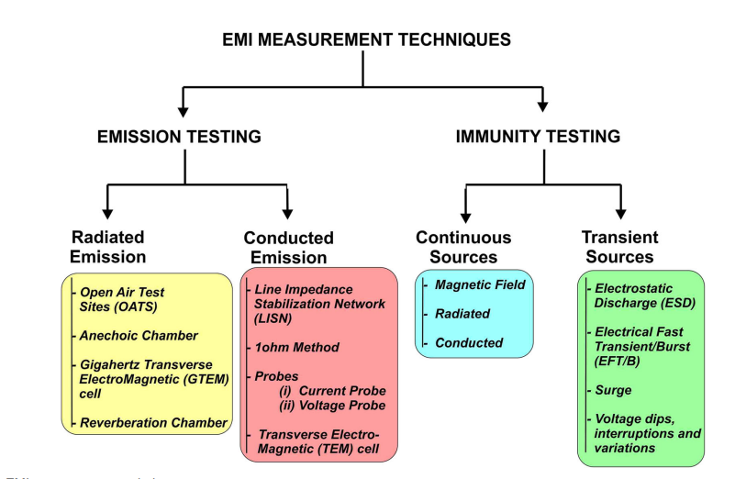

Fig 1. EMI Measurement Techniques

Depending on the test product, EMI emissions and immunity can be measured using radiation and conduction.

Immunity Testing:
Immunity tests, which look at how a product reacts to intermittent and steady electromagnetic energy sources, are used to assess a product's susceptibility to electromagnetic interference (EMI). We submit the apparatus to electromagnetic noise with different frequencies that simulates a power spike in order to evaluate the dependability of the power supply [5].

• Radiated immunity: In these tests, the amount of electromagnetic radiation that the device will typically be exposed to during use is simulated.
• Conducted immunity: In this process, the behaviour of the product is assessed when it is exposed to electromagnetic radiation that was unintentionally transmitted to it via a wire from somewhere else.

Emissions Testing:
The purpose of emissions testing is to determine whether a product's internal electrical systems release no more electromagnetic interference (EMI) than is permitted. The amount of electromagnetic noise a piece of equipment generates can be measured by engineers using antennas, amplifiers, and spectrum analyzers.
• Radiated emissions: In order to determine whether a device's emissions fall within the permitted range for its size and power output, a process is used to quantify the EMI radiation it emits.
• Conducted emissions: The amount of electromagnetic radiation created internally that could potentially be transmitted over a wire and interfere with other systems is what defines this condition.
Radiated emission is a measure of the level of EMI propagated in air by the source. Radiated emission requires a carrier medium such as air or other gases and is usually expressed in volts/meter (V/m) or microvolts per meter (µV/m).
Conducted emission is a measure of the level of EMI propagated via a conducting medium such as power, signal, or ground wires. Conducted emission is expressed in millivolts (mV) or microvolts (µV). A simple example of the occurrence of EMI can be seen in Fig 2.

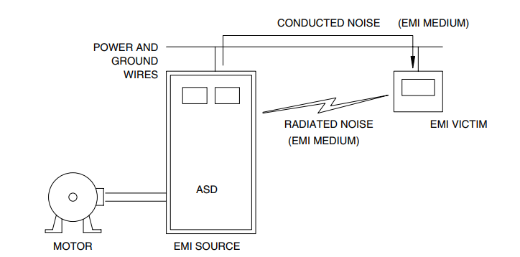

Fig2. Example how EMI occurs

To produce electromagnetic interference, three components must exist, first a source of interference, second a “victim” susceptible to EMI, and third , a medium for the coupling of EMI between the source and the “victim,” which is any device sensitive to the interference. The coupling medium could be inductive or capacitive, radiated through space or transmitted over wires, or a combination of these. Identification of the three elements of EMI as shown in Fig 1. ,allows the EMI to be treated in one of three ways [6]:
- Treatment of the EMI source through filtering, shielding, or isolation.
- By using suitable wiring techniques, conductor routing, and shielding, the coupling medium is eliminated.
- For effective EMI mitigation, more than one option might need to be used, such as shielding, applying filters, or moving the "victim" in some cases.

Table 1 provides the list the skin depth of various materials at different frequencies.

Table 1

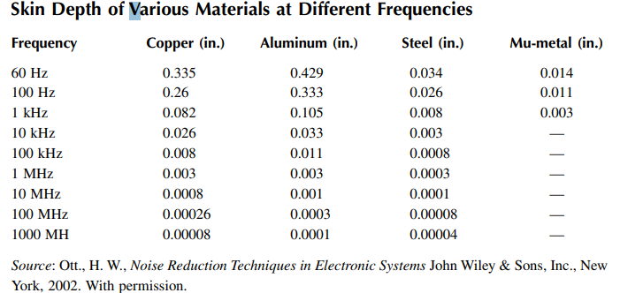

Materials and Methods used for Shielding :
There are various materials and methods available for EMI shielding. This section deals with the different methods and materials employed for EMI shielding [7].

Levels of EMI Shielding:
EMI Shielding Material, From a design engineering perspective, EMI shielding should be considered at all levels from the enclosure to the module to the PCB. A Faraday cage, or a protective structure is used that prevents electromagnetic radiation from entering or exiting an area, is an important component in EMI shielding at these different levels.
. •Enclosure level: EMI shielding of enclosures uses Faraday cage to attenuate signals from within the enclosure. This minimizes signals escaping and causing interference to other equipment within the environment and can prevent outside interference from penetrating the enclosure. So in both directions the problem could be solved.
• Module level: Module-level shielding is the shielding of active components, such as drives, displays, etc., within the electronics enclosure to protect those components from internal interference.
• PCB level: Shielding at the PCB level consists of shielding of individual components, such as integrated circuits, with shielding cans, for example, making a small Faraday cage for those components. Fig3 shows the different levels of EMI shielding.
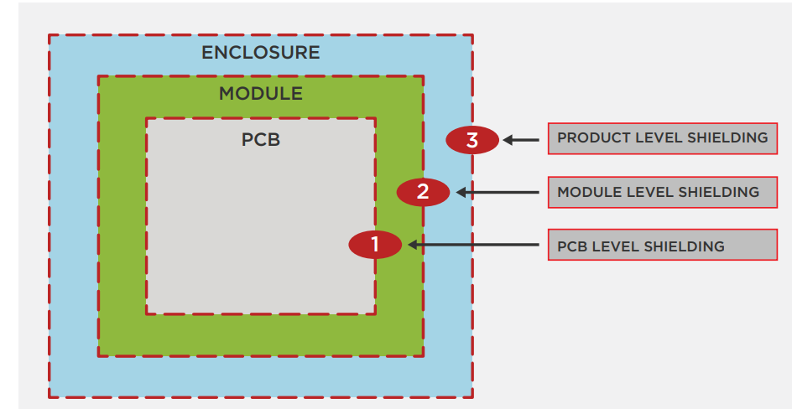
Fig 3: Levels of EMI shielding
Courtesy : Recent Advances in Design Strategies and Multifunctionality of Flexible Electromagnetic Interference Shielding Materials , Junye Cheng etAl.
Transparent conductive coating and EMI mesh are the two types of EMI shielding that are now available. Transparent conductive coating is available on: 1) Film or 2) Glass. EMI mesh includes: 1) Wire Mesh, 2) Micromesh, and 3) Laser mesh. Each option offers varying levels of light transmission, attenuation, and sheet resistance. Traditionally, coated glass offered higher light transmission than EMI mesh. Due to recent advances in the field current EMI shielding products do offer higher light transmission than traditional products. EMI mesh offers a wider effective attenuation range than coated glass. Also, sheet resistance is significantly lower in EMI mesh filters compared to coated conductive coatings. Fundamental factors for mesh size and colour include: openings per inch and blackening of the mesh. Other factors to contemplate when considering EMI shielding include: 1) Grounding options such as bus-bars and conductive tape 2) Mesh angle 3) Enhancement options.
Fig4 shows the different EMI shielding techniques[8].
Other types of shielding are also available as follows:
- Metal shielding:
Metals may absorb, reflect, and transmit electromagnetic radiation in addition to being good electrical conductors.
The primary reason that metals are used in so many various applications is their capacity to carry heat and electricity. In order to prevent damage, electrical equipment that generates heat or has a considerable buildup of static charges is usually grounded using metal conductors. As a result, heat and static charges may disperse. In a manner similar to this, metal shields and covers are used to either stop high frequency electromagnetic radiation from the equipment from issuing or to shield the device from radiation from the outside.A common material for creating shielding enclosures is mumetal. a highly permeable alloy consisting of 14% iron, 79.5% iron, 5% copper, and 1.5% chromium. Other metals and materials that can be used as shields include brass, aluminium, silver, nickel, stainless steel, metalized polymers, and composites of conductive carbon and graphite. The brittleness of carbon/graphite, the low impact resistance of aluminium, and the high density of stainless steel are some of the disadvantages of these conductive composites. The metal shield is susceptible for corrosion, which leads to Rusty Bolt Effect of nonlinearity to cause intermodulation problem especially in sea environment.
- Plastic material shielding :
Plastic housings don't reflect or absorb EMI because polymers are naturally insulating materials. The thermoplastics do not prevent the majority of the energy waves from entering or leaving the housing, which results in interference problems. Technical solutions have been carefully examined to increase the electrical conductivity of plastics by way of
1. Conductive Coating on Plastics in order to reduce EMI.
2. Using conductive fillers when compounding.
3. ICP, or intrinsically conductive polymers.
Conventional plastics can contain a conducting substance and still function as excellent electrical insulators with resistivities between 1015 and 1018 cm [9]. One of the early materials used for this was carbon black. Due to its graphitic structure, carbon black is a semiconductor; its typical dry resistivity ranges from 20 to 0.5 cm; when used as a filler in rubbers and plastics, it lends the material conductive and antistatic properties. the thermosetting plastic matrix, such as epoxy or polyester, to which aligned glass and carbon filaments are continually added to produce composite materials with extraordinarily high specific strengths and stiffness. The SCF filled composites exhibit higher SE at lower filler loading compared to carbon black filled ones [10].
When compared to the microwave frequency range (100-2000 MHz), the SE of these composites is shown to be larger at the X-band frequency range (8-12 GHz). SCF-containing composites are technically useful materials in the X-band region (SE 20dB). The high modulus (15 to 20 MPa) and adequate electrical conductivity of resins containing 30% graphite fibres make them suitable for several EMI shielding applications. The ability of carbon and Kevlar composite panels to provide adequate EMI SE has been demonstrated.Electrical and mechanical properties of conductive rubber composites based on Ethylene - Propylene - Diene Rubber (EPDM), Acrylonitrile butadiene rubber (NBR) and 50/50 (w/w ratio) blends of EPDM/NBR containing different loading of short carbon fiber (SCF). The volume resistivity of all fiber - rubber composites increases with the increase in temperature, and the rate of increase in resistivity against temperature depend on the loading of carbon fiber and the nature of the base polymer [11].
Continuous carbon- fiber composite with a carbon-matrix is more effective for shielding, more reflective and more conductive when compared to an epoxy matrix reaching EMI SE of 124 dB at 0.3 MHz–1.5 GHz.
The fillers utilised are PAN-based carbon fibre, aluminium flakes, stainless steel fibres, and aluminum-coated glass fibres. The primary polymers employed are ABS, polyphenylene oxide polystyrene mix, nylon 6,6, and polyphenylene sulphide (PPS). and looked at the SE experiments in the 1 GHz range under various exposure scenarios. He discovered that chemical exposures had no effect on compounds that got their electrical conductivity from conductive carbon black or carbon fibres. the PMMA-encased exfoliated graphite composite. Hot pressing can be used to directly mould this composite of exfoliated and encapsulated graphite. This moulded product outperformed the mechanically mixed exfoliated graphite-PMMA composite in terms of electrical conductivity and EMI SE.The electromagnetic interference shielding effect by flexible graphite. The SE is exceptionally high 130 dB at 1–2 GHz higher than that of solid copper. In addition to conventional shielding applications, flexible graphite can serve as a shielding gasket material, due to its resilience.
Stainless steel fibers : ABS, nylon 6.6 (PA 6.6), polycarbonate, and polyphenylene oxide are among the thermoplastics that contain stainless steel fibres packed with 7% (w/w) steel fibres. These compounds typically have shielding efficiency between 36 and 42 dB.
Due to the distribution of the conducting threads within it, the composite material would function more like a conducting mesh for electromagnetic shielding purposes. The SE attained in the X-band area was around 11 dB. Additionally, they claimed that a rise in specimen thickness would roughly double SE. The incident electric field, aperture size, fibre orientation inside the composite material, and properties of the material all have an impact on the SE. This composite material is used for shielding purposes as well as to build electromagnetically absorbent walls.
Aluminum fibers : Copper fibres have the highest intrinsic electrical conductivity of any metal, while aluminium fibres have the benefit of having a low specific gravity. However, in a typical environment, surface oxidation can happen to either of these materials. The SE of EMI was studied by Osawa and Kobayashi 30 using polyethylene, a variety of chatter-machined metal fibres (aluminium, copper, steel, and brass), and carbon fibre. They looked at the effects of filler content and thermal treatment of the composites at 80oC in air.
Brass was generated first, followed by steel, copper, aluminium, and carbon. While brass and steel and carbon fibre systems showed very little and very small thermal deterioration of SE, respectively, copper and aluminium systems showed a notable amount of degradation.
Among the several flakes and powders, only aluminium flakes, which have a high aspect ratio and have economic significance in EMI shielding composites, are available as fillers. Although their astronomical price severely limits their application, silver, gold, and platinum precious metal powders are also used. These specialised materials are mostly used in conductive epoxy adhesives for EMI shielding gaskets and attaching electronic components, as well as in conductive elastomers for similar purposes. ABS, Nylon, PC, PET, PPO, and PS are frequently used as matrices. The shielding performance of 30 to 40 dB can be reached at a 40 weight percent loading.
Nickel Coated Graphite Fibers.: The favourable reinforcing qualities of carbon/graphite fibres are combined with the conductivity of the metal coating in nickel coated graphite fibres, which are employed as conductive additives for polymers.
For EMI shielding, intrinsically conductive polymers (ICP) offer an alternative to conventional materials. For EMI shielding, the two conducting polymers that are most frequently employed are polyaniline (PAn) and polypyrrole (PPY). Conjugated polymers, or conducting polymers, are good candidates for systems that can be given metallic conductivity since they exhibit electronic conductivity when doped. One of their primary difficulties is the difficulty to produce useful products from intrinsically conductive polymers (ICP). This is especially true for PAn, a chemical known for its reputation as being environmentally stable, having a moderate level of electronic conductivity, and being economically viable.
Conducting polyaniline: The use of textile materials as substrates and reinforcing materials for many polymers has wide industrial applications and discussed in many papers.
Polyaniline composites , Polypyrrole composites are also used for many applications.
Transparent Conductive Coating :A transparent conductive coating is used to trap a number of EMI emissions.
1) Coated Glass has strong optical qualities and low to moderate EMI shielding. A transparent conductive oxide, such as indium tin oxide (ITO), is an illustration of a transparent conductive coating. For electrical displays that need high-quality optical qualities, this is the best choice. Any device can be made to comply with the Federal Communications Commission's Class A (electrical equipment used in offices) and Class B (in households) regulations by adding an ITO coating. ITO is regarded as a resistor since it is a flawed conductor. ITO has a low resistance, and the unit of measurement for sheet resistance or conductive coating resistance is /sq.
2) Depending on the spectrum of the EMI emissions, coated film offers modest to moderate EMI shielding together with good optical qualities. Coated films are more prone to ITO cracks and surface abrasions than coated glass is because PET is frequently used as the substrate layer. It typically has a 15 [/sq] sheet resistance. While decreasing resistance will lower optical quality, it won't increase the effectiveness of the shield.
Electromagnetic shielding using Aluminium foil : The type of incident field, the foil's thickness, and the frequency all affect how well aluminium foil shields. The two main components of shielding efficacy are reflection and absorption loss. Even a thin sheet of aluminium, which is not magnetic but is an excellent conductor, nearly completely reflects an incident electric wave. The electric field weakens below 100 MHz in frequency. Low frequency magnetic fields are not very well attenuated by thin sheets of aluminum[11].
Electromagnetic shielding using Carbon nanotubes (non-metal) and polystyrene(Thermocol, dielectric) :
Electromagnetic Shielding Using Graphene :
In recent years, there has been a lot of research into polymer composites using carbon nanotubes with the goal of enhancing the mechanical properties of the composites for shielding purposes. Carbon nanotubes have extraordinary electrical qualities in addition to their exceptional mechanical properties. In addition to their exceptional mechanical and electrical qualities, carbon nanostructures also have a fascinating property that makes them lightweight structures for electromagnetic interference (EMI) shielding.
When compared to gold film of the same thickness, CVD-produced graphene exhibits EMI shielding efficiency that is more than seven times greater. A single or a few atomic layers of graphene can be used to create an ultrathin, transparent, weightless, and flexible EMI barrier, which improves shielding.

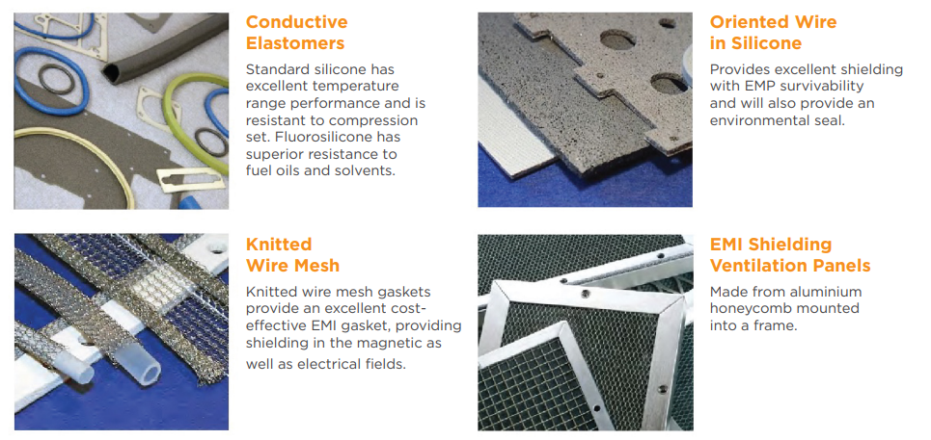

Figure 4. Various EMI shielding Techniques
Courtesy : ELECTROMAGNETIC INTERFERENCE SHIELDING A Key Component of Engineering Design Trends, Insights, and Design Considerations, Kemtron Limited.
Table 2 provides the list of EMFs produced by common household equipments [12].
Table 2 EMF in common household equipments.
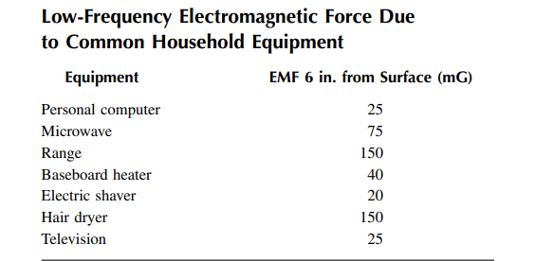
Courtesy : CRC press
Even if the EMF levels can be regarded as high, most of the time the exposure time is brief. The effects of exposure to low-frequency fields are not yet fully understood, thus it is wise to use caution and steer clear of extended exposure to electrical and magnetic fields. Keeping enough space between the EMF source and those in the vicinity can help reduce exposure. Electrical and magnetic fields become weaker the further they are from the source, as we previously witnessed.
CONCLUSION :
We are surrounded by electromagnetic fields, and they are not always bad. Radios, televisions, and cell phones, for instance, would not function without these fields. The door would not automatically open and the garage door opener could not be used from the comfort of a moving vehicle. For daily life, electromagnetic energy is required. Unexpectedly, some electronic gadgets could be susceptible to the fields. Fortunately, the amount of fields these devices are exposed to can be decreased. Shields, filters, and isolation techniques are helpful tools that enable us to survive in the EMI environment, as was previously stated. Finding the source of the interference, the "victim's" level of tolerance, and the medium that allows for interaction between the two is necessary. For an effective solution to any EMI problem, all three aspects must be understood.
This review chapter begins with a thorough overview of the definition and origins of EMI, followed by a look at its historical context. Also covered in detail are the methods often used to measure EMI under the two main headings of emission testing and immunity testing. For EMI measurements, radiated emission and conducted emission are the two types of emissions that are taken into account. Anechoic chambers, GTEMs, and reverberation chambers are examples of chambers used for radiated emission testing. Conducting emission testing allows you to quantify the electromagnetic interference (EMI) that is produced when voltages and currents within the EUT's circuitry suddenly fluctuate. approaches like the LISN, 1X, probe, and TEM cell approaches are employed to do this. This review focuses on both broad strategies used to lessen EMI caused by an electrical equipment in addition to the EMI measurement techniques already discussed. The employment of electromagnetic shields, EMI filters, modifications to the circuit topology, and the spread spectrum technique are some of these techniques. Since electromagnetic shielding is likely the most popular EMI reduction method, special consideration is given to it. Theoretically, many techniques used to assess a material's ability to shield are described. The review chapter covers both the measuring techniques and the reduction procedures, covering the entire subject of EMI. Consequently, it might be advantageous for both experienced researchers and new researchers to gain a thorough understanding of electromagnetic interference.

ACKNOWLEDGEMENTS:
The Authors are very grateful to Management and Authorities of R N S Institute of Technology, who have supported throughout for the successful completion of the Book chapter.
References :
- Electromagnetic Interference (EMI): Measurement and Reduction Techniques Phalguni Mathur And Sujith Raman , Journal of ELECTRONIC MATERIALS, Vol. 49, No. 5, 2020.
- D.G. Baker, Electromagnetic Compatibility: Analysis and Case Studies in Transportation (New York: Wiley, 2015.
- Testing and Measurement Techniques Part 8: Power Frequency Magnetic Field Immunity Test, Document IEC 61000-4 (2009).
- K.L. Kaiser, Electrostatic Discharge (Boca Raton: Taylor & Francis Group, (2006).
- EMI Shielding: Methods and Materials—A Review S. Geetha,1 K. K. Satheesh Kumar,2 Chepuri R. K. Rao,1 M. Vijayan,1 D. C. Trivedi.
- Advanced Test Equipment Corp. What is EMI/EMC Testing? Available at: https://www.atecorp.com/ solutions/emc-testing. Accessed December 7, 2022.
- Schelkunoff, S. A.; Friis, H. T. Antennas, Theory and Practice. New York, N. Y.: Wiley and Sons; 1957.
- X. C. Tong, Advanced materials and design for electromagnetic interference shielding (CRC Press, New York, 2009)
- Testing and Measurement Techniques Part 2: Electrostatic Discharge Immunity Test, Document IEC 61000-4 (2008).
- K. Nagai, D. Anzai, and J. Wang, in 2017 IEEE Conference on Antenna Measurements \& Applications (CAMA), pp. 144–145 (2017).
- T. Ishida, S. Nitta, F. Xiao, Y. Kami, and O. Fujiwara, in 2015 IEEE International Symposium on Electromagnetic Compatibility (EMC), pp. 839–842 (2015).
- P.S. Katsivelis, I.F. Gonos, and I.A. Stathopulos, J. Electrostat. 77, 182 (2015).
- T. Yoshida, in 2016 Asia-Pacific International Symposium on Electromagnetic Compatibility (APEMC), pp. 445–447 (2016).
- M. Kohani, A. Bhandare, L. Guan, D. Pommerenke, and M.G. Pecht, IEEE Trans. Electromagn. Compat. 60, 1304 (2018).
- J. Zhou, K. Ghosh, S. Xiang, X. Yan, A. Hosseinbeig, J. Lee, and D. Pommerenke, IEEE Trans. Electromagn. Compat. 60, 1313 (2018).
- J. Park, J. Lee, C. Jo, B. Seol, and J. Kim, in 2018 40th Electrical Overstress/Electrostatic Discharge Symposium (EOS/ESD), pp. 1–6 (2018).
- J. Koo, L. Han, S. Herrin, R. Moseley, R. Carlton, D.G. Beetner, and D. Pommerenke, IEEE Trans. Electromagn. Compat 51, 611 (2009).
- Z. Zhou and Q. Jiang, in 2002 3rd International Symposium on Electromagnetic Compatibility, pp. 718–721 (2002).
- Testing and Measurement Techniques Part 4: Testing and measurement techniques—Electrical fast transient/burst immunity test, Document IEC 61000-4, (2012).
- B. Xiao, H. Yu, J. Wan, L. Jifang, in 2017 IEEE 5th International Symposium on Electromagnetic Compatibility (EMC-Beijing), pp. 1–4 (2017).
- T. Williams, EMC for Product Designers, 5th ed. (London: Newnes, 2016), pp. 215–217.

