Optimizing Wind Energy: Unleashing the Potential of AI in MPPT and Load Forecasting

Deepak Rathod
Research Scholar, Department of Renewable Energy, Rajasthan Technical University, Kota, Rajasthan Pin – 324010, India.
deepak.phd21@rtu.ac.in

Dr. Lata Gidwani
Associate Professor, Department of Electrical Engineering, Rajasthan Technical University, Kota, Rajasthan, Pin- 324010, India.
lgidwani@rtu.ac.in

Rohan Gupta
Assistant Professor, Department of Electrical and Electronics Engineering, Shri Vaishnav Vidyapeeth Vishwavidyalaya, Indore, Madhya Pradesh
Pin – 453111, India.
rohangupta@svvv.edu.in

ABSTRACT
The world, a revolutionary transition is currently taking place. The way individuals live their lives is changing as a result of this revolution, which is also upending conventional corporate structures and established processes. Similar to other industries, the power sector is undergoing a profound shift. Change in the power sector is driven by factors such as distributed energy sources, electric vehicles, enhanced metering and communication infrastructure, management algorithms, energy efficiency initiatives, and new digital solutions. Artificial intelligence techniques have been increasingly used in recent years to address problems pertaining to renewable energy because of their capacity to resolve complex nonlinear data structures. The potential for technical advancement to hasten the global adoption of renewable energy in the future. The quickest technological transformation is being driven by artificial intelligence (AI) at the moment. Wind turbines must therefore be as efficient at converting energy as feasible in order to utilise wind power to its maximum potential. An overview of AI-based Maximum Power Point Tracking (MPPT) for wind energy systems is presented in this research. Working conditions have a significant impact on yield because wind energy conversion systems (WECS) are growing more sophisticated as a result of unforeseen changes in wind speed conditions. The ideal yield is often challenging to achieve. MPPT controllers are getting a lot of attention because of this. Both the Artificial Neural Networks (ANN) and the Fuzzy Logic (FL) employed in WES are thoroughly examined in this review. And it reveals the strategies most usually employed to deliver the best yield feasible in a variety of circumstances. For control and optimisation, both ANN and FL may be used in place of more conventional ways; the approaches are gathered and examined based on the application. Statistics are offered for both the methods used in this field and their possible future advances. A comprehensive bibliography has been completed, suggestions for additional research have been made, and a number of issues have come up. In the end, scholars, energy planners, and legislators should find this platform useful for future study in wind power systems.

Keywords— Neural Networks, Soft Computing, Intelligent Control fuzzy logic systems of types 1 and 2, respectively.

ABBREVIATIONS

AI | Artificial Intelligence
ANN | Artificial Neural Networks
FL | Fuzzy Logic
MPPT | Maximum Power Point Tracking
WECS | Wind Energy Conversion Systems

INTRODUCTION

The world's energy demand is anticipated to increase quickly. In terms of rapid industrialisation, rapid population growth, and social development [1], [2]. In fact, electrical energy is essential to modern existence and is dependent on modern industry. For a new generation of electricity, the race is on. Due to the increasing demand for energy and the strain on conventional energy sources, which has a severe impact on the environment, the energy sector has been asked to accelerate research into alternative energy sources. Wind energy requires technological and financial improvements as one of the most lucrative and rising sectors. Technology-related efforts are concentrated on fully harnessing the wind [3]. Thus, under various wind speed conditions, the peak power may be retrieved using MPPT algorithms. An MPPT approach's framework primarily consists of two essential components. In the first phase, an algorithm is used to locate the set point with the greatest power. The control signal is created in the second section using a variety of control mechanisms. Therefore, developing an efficient MPPT approach will be made possible by boosting the effectiveness of each component [4]. Numerous researchers have published MPPT control methods for wind energy systems, including tip speed ratio [5], power-signal feedback [6], optimal torque control [7], and hill climbing search [8], as well as variants on these strategies [9], [10], in the literature to address these challenges. Due to the unpredictable nature of environmental variables, these strategies might not be effective in finding the MPP. In recent research, WECS effectiveness has been increased across a number of investigations using soft computing and AI-based methodologies. A wide range of solutions that are useful for addressing complicated systems and representing higher levels of uncertainty have been developed by several academics using AI tools. The MPPT problem can also be solved effectively, adaptably, and computationally intensively using AI approaches [11], [12]. In fact, AI can make WES run more effectively and economically. WES can optimise power output, lower maintenance costs, increase energy yield, and enhance system stability and dependability by utilising AI technologies. Artificial intelligence seeks to comprehend how people think in order to develop intelligent creatures that can successfully tackle some difficult challenges [13]. Information retrieval, databases, medical, commerce, robotics, art, etc. are just a few of the numerous fields where artificial intelligence is used. In essence, a range of learning theories, such as neural learning, statistical learning, evolutionary learning, etc., form the foundation of artificial intelligence [14], [15]. But in this essay, we'll concentrate on how AI works well and is useful in contexts like wind energy system optimal control. This study specifically contributes to the thorough and in-depth analysis of MPPT techniques based on AIs. ANNs and FLC [11] are generally the two most important AI methods for MPPT, and both are depicted in Fig. 1. Additionally, among them, neural learning stands out as being the most frequently used in a variety of sectors [16].
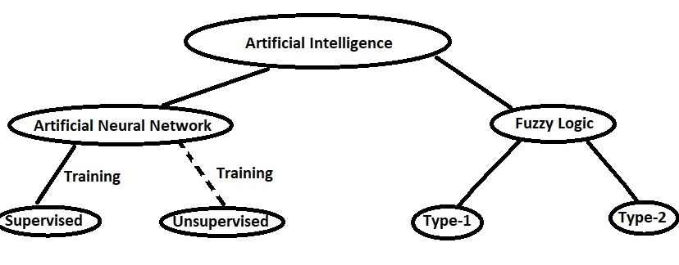
Figure 1: MPPT strategies based on artificial intelligence

First, the advanced ANNs are built on the base of organic neurons. These structures provide a sound solution for problems that cannot be solved analytically [3]. An ANN is composed of simple processing units known as neurons and the weighted connections that connect them. Fig. 2 displays a general illustration of the ANN structure. Four key characteristics—the information display, input and output data associations, training methodology, topology, and training technique—can be used to distinguish an ANN from other types of models. When the ANN receives a dataset and starts a training phase, it modifies the weights of the connections between neurons. The training will be referred to as supervised training if the output is known; otherwise, it will be known as unsupervised training [3], [17] (Fig. 1). Second, Zadeh introduced fuzzy logic, also referred to as FL, for the first time in 1975 [18]. A FLC is a particular kind of control system that makes use of FL to choose the appropriate control action. A FLC can be used to regulate a wind turbine's functioning in the context of wind energy. The controller employs FL algorithms to identify the best control action to be done, such as altering the generator torque or speed and the blade pitch or yaw angle to optimise power generation. The controller gets data from sensors on the turbine, such as wind speed and direction. FLCs can also be utilised for forecasting and management of wind farms. A FLC is composed of three primary components: a defuzzification module, an inference engine, and a fuzzification module [19]. Fig. 3 shows the fundamental structure of an FLC. A FLC processes the input variables through a set of rules to produce the controller's output. In contrast to specific numerical values, linguistic phrases like "low," "medium," and "high" are generally used to define the regulations. This enables the controller to take into account a range of values rather than simply one value for each input and output. Although fuzzy logic has various applications, including in the fields of classification, control, and pattern recognition, we'll concentrate on how it functions correctly and how it might be useful for tasks like wind turbine optimal control in this review. Type-2 fuzzy logic, which is an enlarged form or generalisation of type-1 fuzzy logic, also makes it feasible to represent with a high degree of imprecision [20]. In this paper, after going through brief introduction, first section deals with forecasting as application of artificial intelligence. This section contains different methods of forecasting in Photovoltaic system and wind energy system. It is followed by application of artificial intelligence in maximum power point tracking, here also different techniques of machine learning that has been proposed by various authors, have been discussed. Next section is related to inverter and how different artificial intelligence system has been developed to address different issues of inverter system. Final section concludes with overall benefits and challenges of artificial intelligence in renewable energy system.
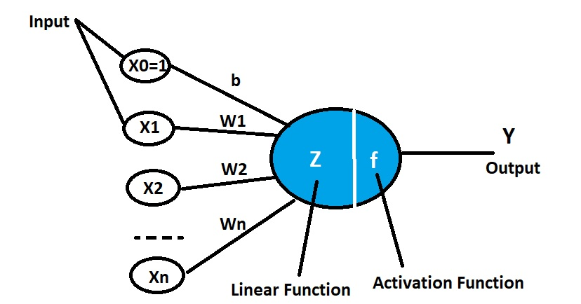

Figure 2: Structure of a biological neuron vs artificial neuron

.
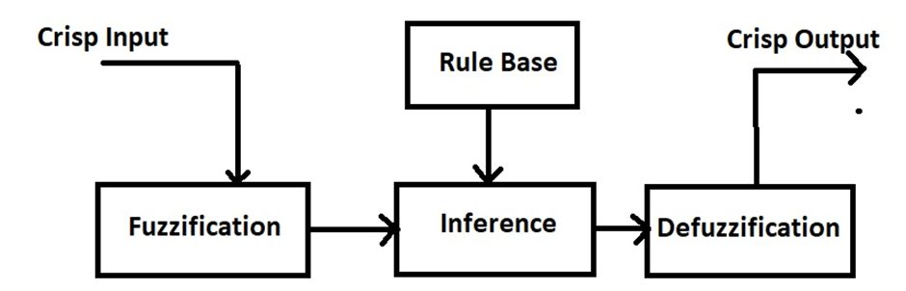

Figure 3: A basic structure of a FLC

WIND PREDICTION

Due to the stochastic nature of wind supply, wind energy systems differ from traditional thermal generation systems in how power is produced. Forecasting in wind generation systems focuses on the issues of balancing the mismatch between generation and demand in the power system. The neural network, which consists of the common multi-layer perceptron, is the method for wind forecasting that has been employed most frequently throughout research. The most frequently recommended neural network architectures for short-term wind speed forecasting use multi-layer perceptrons. Recurrent neural networks were proposed by Elman et al. better performance is provided by a simultaneous recurrent neural network represented by particle swarm optimisation [21]. A hybrid approach (ANN and fuzzy logic) is created by combining two artificial intelligence techniques, and it is known as an adaptive neural fuzzy system model (ANFIS). When determining the system characteristics and creating an exact model requires a lot of work, fuzzy logic models are utilised. Forecasting wind speed also makes use of the Bayesian approach. At the wind park, models based on fuzzy logic are also being developed for predicting wind speed and power production. Usually, learning based on genetic algorithms is used to train these models. The effectiveness of short-term forecasting has improved from minutes to hours. These models' heavy computing requirements and numerous fuzzy rule bases are their key flaws.

MAXIMUM POWER POINT TRACKING

A control system that is supplied by an appropriate algorithm and used to produce an ideal duty cycle is what maximum power point tracking entails. The power DC-DC converter uses this duty cycle to get the most power possible out of the PV array. Efficiency concerns, an increase in total cost, lost energy, implementation issues, and design-specific issues are some of the issues that arise when designing the best MPPT technique for PV systems. For photovoltaic systems, a number of MPPT techniques have been developed, including perturbation and observation (P&O) [23], hill climbing [25], incremental conductance [24], etc. New approaches, such as fuzzy logic, offer superior performance over traditional approaches in terms of response time and reduced oscillations at the highest power point, but they have drift concerns with changing irradiance data [22]. The input parameters that are chosen as features in the artificial neural network-based MPPT technique for PV systems include short circuit current, open circuit voltage, output current, terminal voltage, and environmental or ambient factors like module temperature, solar irradiance incidence on the module, and wind speed. These parameters enter the neural network model's input layer, go through the hidden layer, and finally the output layer produces the estimated duty cycle of the DC-DC converter needed to monitor the maximum power point. Neuronal weights are changed throughout training in order to map output from input. The system complexity, data accessibility, and processing demands all have a substantial impact on the decision about the number of input variables and nodes. The effectiveness and accuracy of a neural network-based The design and execution of the algorithm in the hidden layers determine the maximum power point tracker [26]. A feed-forward-back propagational approach is used by many proposed artificial neural network-based MPPT controllers to train their models. For the adjustment of the weight link, information is transmitted in both forward and backward directions in this kind of ANN.Different sets of inputs are applied to the hidden layer using various weight magnitudes, and the output layer receives the outcome in the end. To reduce the difference between the actual and anticipated output of the ANN model, a back propagation network is trained using a gradient decent technique for weight adjustment between each layer [27], [28], and [29]. Fuzzy logic-based perturbation and an observed MPPT control system both offer top performance in solar-based PV systems. Using a DC-DC converter, the power generated by the photovoltaic system is transferred to the load. The maximum power point is tracked by a fuzzy logic-based MPPT control system using the measured values of PV panel current and voltage. Based on measurements of the PV panel's current and voltage, a fuzzy logic-based control system determines the size of voltage change necessary to match the maximum power. By adjusting the duty cycle of the DC-DC converter, the P&O maximum power point tracking (MPPT) system will estimate the new working voltage for the PV panel [30]. The inference rule basis, which may be assessed by trial and error, serves as the foundation for the fuzzy logic MPPT controller [31]. Fuzzy logic is created using a rule set to obtain perturbed voltage and takes into account changes in power and changes in power with regard to voltage as inputs. The fact that fuzzy logic-based MPPT approaches do not require exact knowledge of the PV module parameters or accurate modelling of the system is one of their main advantages [32]. Fractional order fuzzy logic (FOFLC) has been created to control (compared to standard fuzzy logic-based MPPT), accelerate MPPT, and prevent deviation from the maximum power point [33].
A summary of studies using the ANN technique for the MPPT unit is shown in Table I. ANNs have been demonstrated to be useful for a number of applications, and they may be used with other approaches in hybrid systems to increase their contribution.

Table 1: A Brief Description of Some of The Literature’s Applicable ANN-MPPT

Reference /year | Type of Controller | Objective
copy | More table copy
[17] / 2022 | RBFNN | A RBFNN tracker offers a simple and effective method of enhancing WECS effectiveness
[9] / 2021 | ANN | A smart-sensor less controller for improving tracking of optimal torque by ANN for WECS
[36]/ 2021 | Type 2 FLC | Implemented a robust an interval type-2 FLC into WECS
[35]/ 2019 | RBFNN | Improved MPPT based on RBFNN using gradient descent algorithm and the modified PSO algorithm
[34]/ 2012 | Type 2 FLC/GA | designed an interval type-2 FLC using GA for velocity regulation in a DC motor

CHALLENGES AND FUTURE DIRECTIONS

The wind system's output is significantly affected by its surroundings. This causes fluctuations in the output yield. Without an MPPT controller, it is impossible for wind systems to produce the maximum amount of energy. Finding the MPPT techniques with the least amount of tracking error, the quickest performance, and the least amount of oscillation around the MMP is an essential criterion for selecting the best MPPT techniques [11]. Therefore, the primary objectives of an MPPT are speed, precision, resilience, and precision. Therefore, artificial intelligence (AI) optimisation techniques may be deemed preferable to conventional methods. Adjusting AI-based techniques, such as ANN, to produce the optimal MPP requires significant effort. In addition, before ANN can be used in the MPPT control unit, it must be correctly trained with a large number of measurements to ensure accurate results. Other than that, FL controllers rely on rule base development and membership operations. There is no accepted method for defining the controller's parameters precisely [11]. The AI algorithms are more complex than conventional ones and are more effective at tracking. In fact, the adaptability and versatility of these technologies to address nonlinear problems are their primary benefits [11, 17]. Neural networks have disadvantages in real-world applications, such as the magnitude of the required inputs, extrapolation errors, overtraining of the networks, and difficulties in network optimisation [3, 17]. Fuzzy controllers can handle nonlinear situations robustly and do not require system-specific data, but their design is typically founded on trial and error [4]. Productivity and efficiency are the two most essential aspects of a good system in the industrial revolution, and technology and the environment are the focal points of research and investment. Thus, the fourth industrial revolution is heavily reliant on AI, and numerous machine learning approaches have seen significant evolution. Currently, the systems will be responsible, secure, and ultimately sustainable.

CONCLUSION

In this paper, the application of machine learning in various areas of the renewable energy system is analysed, along with the opportunities and obstacles it presents. Machine learning offers a highly accurate and self-adjusting model for forecasting, provided it is not subject to bias. Numerous studies have demonstrated that with an accurate model, load balancing for renewable energy systems can be enhanced, thereby increasing the highly desirable penetration of renewable energy in power systems. Machine learning can also be used in maximum power point tracking systems, where its primary benefit is that it is less susceptible to input noise and can also provide faster performance. For optimum power point tracking, hybrid systems employing both machine learning and conventional methods have also been developed. In addition to these applications, machine learning can be used to resolve numerous issues in inverters and provide smooth output power even when intermittent renewable energy sources are present. The escalating cost of machine learning systems is a significant issue due to the highly specialised computational hardware required. Operations involving data preprocessing and data cleansing can incur significant overhead. In addition, machine learning is highly susceptible to bias, which can render entire models ineffective. Thus, it can be stated that machine learning requires cautious design and implementation and that with the proper machine learning model, numerous issues associated with renewable energy systems can be resolved. The most important aspect of this study is that it provides an overview of various components where artificial intelligence has been applied, and thus provides a thorough understanding of how various components benefit from AI. This paper serves as a starting point for anyone who wishes to investigate artificial intelligence in renewable energy systems in greater depth. In the future, additional research can be conducted on a variety of other issues related to renewable energy systems, such as battery deterioration. In addition, additional research is required to examine the various issues that can be resolved through the application of artificial intelligence.

REFERENCES

- R.-E. Precup, T. Kamal, and S. Z. Hassan, Advanced control and optimization paradigms for wind energy systems. Springer, 2019.
- M. Farooq, A. Ramli, and A. Naeem, “Biodiesel production from low ffa waste cooking oil using heterogeneous catalyst derived from chicken bones,” Renewable Energy, vol. 76, pp. 362–368, 2015.
- A. P. Marugan, F. P. G. M ´ arquez, J. M. P. Perez, and D. Ruiz-Hern ´ andez, ´ “A survey of artificial neural network in wind energy systems,” Applied energy, vol. 228, pp. 1822–1836, 2018.
- S. Ganjefar, A. A. Ghassemi, and M. M. Ahmadi, “Improving efficiency of two-type maximum power point tracking methods of tip-speed ratio and optimum torque in wind turbine system using a quantum neural network,” Energy, vol. 67, pp. 444–453, 2014.
- S. Eriksson, J. Kjellin, and H. Bernhoff, “Tip speed ratio control of a 200 kw vawt with synchronous generator and variable dc voltage,” Energy Science & Engineering, vol. 1, no. 3, pp. 135–143, 2013.
- D. Kumar and K. Chatterjee, “A review of conventional and advanced mppt algorithms for wind energy systems,” Renewable and sustainable energy reviews, vol. 55, pp. 957–970, 2016.
- M. Yin, W. Li, C. Y. Chung, L. Zhou, Z. Chen, and Y. Zou, “Optimal torque control based on effective tracking range for maximum power point tracking of wind turbines under varying wind conditions,” IET Renewable power generation, vol. 11, no. 4, pp. 501–510, 2017.
- S. Lalouni, D. Rekioua, K. Idjdarene, and A. Tounzi, “Maximum power point tracking based hybrid hill-climb search method applied to wind energy conversion system,” Electric Power Components and Systems, vol. 43, no. 8-10, pp. 1028–1038, 2015.
- D. Belkhiri and M. R. E. M. Alaoui, “Improved tracking of optimal torque by artificial neural network for wind energy systems,” International Review on Modelling and Simulations (IREMOS), vol. 14, no. 2, 2021.
- B. Driss, S. Farhat, K. Abdelilah, and E. M. A. M. Rachid, “Adaptive control for variable-speed wind generation systems using advanced rbf neural network,” in 2020 1st International Conference on Innovative Research in Applied Science, Engineering and Technology (IRASET). IEEE, 2020, pp. 1–5.
- A. O. Baba, G. Liu, and X. Chen, “Classification and evaluation review of maximum power point tracking methods,” Sustainable Futures, vol. 2, p. 100020, 2020.
- M. Seyedmahmoudian, B. Horan, T. K. Soon, R. Rahmani, A. M. T. Oo, S. Mekhilef, and A. Stojcevski, “State of the art artificial intelligencebased mppt techniques for mitigating partial shading effects on pv systems–a review,” Renewable and Sustainable Energy Reviews, vol. 64, pp. 435–455, 2016.
- R. S. Michalski, J. G. Carbonell, and T. M. Mitchell, Machine learning: An artificial intelligence approach. Springer Science & Business Media, 2013.
- S. R. P. Norvig, “Artificial intelligence: A modern approach 3rd ed,” Harlow Pearson Education, 2016.
- D. L. Poole and A. K. Mackworth, Artificial Intelligence: foundations of computational agents. Cambridge University Press, 2010.
- S. K. Jha, J. Bilalovic, A. Jha, N. Patel, and H. Zhang, “Renewable energy: Present research and future scope of artificial intelligence,” Renewable and Sustainable Energy Reviews, vol. 77, pp. 297–317, 2017.
- D. Belkhiri, L. Elmahni, and M. R. E. M. Alaoui, “Intelligent controller for maximum power extraction of wind generation systems using ann,” International Journal of Nonlinear Sciences and Numerical Simulation, 2022. [Online]. Available: https://doi.org/10.1515/ijnsns-2021-0198.
- [18] E. H. Mamdani, “Advances in the linguistic synthesis of fuzzy controllers,” International Journal of Man-Machine Studies, vol. 8, no. 6, pp. 669–678, 1976.
- S. Subiyanto, A. Mohamed, and M. Hannan, “Intelligent maximum power point tracking for pv system using hopfield neural network optimized fuzzy logic controller,” Energy and Buildings, vol. 51, pp. 29–38, 2012.
- K. Mittal, A. Jain, K. S. Vaisla, O. Castillo, and J. Kacprzyk, “A comprehensive review on type 2 fuzzy logic applications: Past, present and future,” Engineering Applications of Artificial Intelligence, vol. 95, p. 103916, 2020.
- A. M. Foley, P. G. Leahy, A. Marvuglia, and E. J. McKeogh, “Current methods and advances in forecasting of wind power generation,” Renewable Energy. 2012.
- S. D. Al-Majidi, M. F. Abbod, and H. S. Al-Raweshidy, “A novel maximum power point tracking technique based on fuzzy logic for photovoltaic systems,” Int. J. Hydrogen Energy, 2018.
- Jaipal and T. Ramesh, “Solar Powered Based Water Pumping System Using Perturb and Observation MPPT Technique,” in 2018 IEEE International Students’ Conference on Electrical, Electronics and Computer Science, SCEECS 2018, 2018.
- N. Kumar, I. Hussain, B. Singh, and B. K. Panigrahi, “Self-Adaptive Incremental Conductance Algorithm for Swift and Ripple-Free Maximum Power Harvesting from PV Array,” IEEE Trans. Ind. Informatics, 2018.
- M. Karabacak, L. M. Fernandez-Ramirez, T. Kamal, and S. Kamal, “A new hill climbing maximum power tracking control for wind turbines with inertial effect compensation,” IEEE Trans. Ind. Electron., 2019.
- M. Seyedmahmoudian et al., “State of the art artificial intelligencebased MPPT techniques for mitigating partial shading effects on PV systems – A review,” Renewable and Sustainable Energy Reviews. 2016.
- Syafaruddin, E. Karatepe, and T. Hiyama, “Artificial neural networkpolar coordinated fuzzy controller based maximum power point tracking control under partially shaded conditions,” IET Renew. Power Gener., 2009.
- S. J. Chiang, K. T. Chang, and C. Y. Yen, “Residential photovoltaic energy storage system,” IEEE Trans. Ind. Electron., 1998.
- M. M. Atiqur Rahman and A. H. M. A. Rahim, “An efficient wind speed sensor-less MPPT controller using artificial neural network,” in 2015 International Conference on Green Energy and Technology, ICGET 2015, 2015.
- C. S. Chim, P. Neelakantan, H. P. Yoong, and K. T. K. Teo, “Fuzzy logic based MPPT for photovoltaic modules influenced by solar irradiation and cell temperature,” in Proceedings - 2011 UKSim 13th International Conference on Modelling and Simulation, UKSim 2011, 2011.
- S. Padmanaban, N. Priyadarshi, M. Sagar Bhaskar, J. B. HolmNielsen, V. K. Ramachandaramurthy, and E. Hossain, “A Hybrid ANFIS-ABC Based MPPT Controller for PV System With AntiIslanding Grid Protection: Experimental Realization,” IEEE Access, 2019.
- F. Keyrouz, “Enhanced Bayesian Based MPPT Controller for PV Systems,” IEEE Power Energy Technol. Syst. J., 2018.
- S. Tang, Y. Sun, Y. Chen, Y. Zhao, Y. Yang, and W. Szeto, “An Enhanced MPPT Method Combining Fractional-Order and Fuzzy Logic Control,” IEEE J. Photovoltaics, 2017
- Y. Maldonado and O. Castillo, “Genetic design of an interval type-2 fuzzy controller for velocity regulation in a dc motor,” International Journal of Advanced Robotic Systems, vol. 9, no. 5, p. 204, 2012.
- R. Sitharthan, T. Parthasarathy, S. Sheeba Rani, and K. Ramya, “An improved radial basis function neural network control strategy-based maximum power point tracking controller for wind power generation system,” Transactions of the Institute of Measurement and Control, vol. 41, no. 11, pp. 3158–3170, 2019.
- A. V. Hemeyine, A. Abbou, A. Bakouri, M. Mokhlis, and S. M. o. M. El Moustapha, “A robust interval type-2 fuzzy logic controller forvariable speed wind turbines based on a doubly fed induction generator,” Inventions, vol. 6, no. 2, p. 21, 2021.

