Static structural analysis of excavator bucket teeth

Jayaswamy S.,
PG scholar manufacturing science and engineering
Department of Mechanical Engineering
GhousiaCollege of Engineering
Ramanagara, Karnataka India
jssgowda@gmail.com

Mohammed Imran.,
Assistant professor
Department of Mechanical Engineering
Ghousia College of Engineering
Ramanagara, Karnataka India
mechmdimran@gmail.com

ABSTRACT

Heavy construction machinery such as an excavator is frequently used in mining, construction, and other industries. The JCB loader market in India is continuously expanding, according to off-highway research about equipment analysis. The bucket tooth of the machine is one of the factors affecting its productivity. An inadequately designed set of teeth will ultimately result in less effective excavation. The excavator teeth are among the parts that receive very little consideration from the industry that makes them. The bucket tool is one of the most important parts of an excavator. It is normally composed of a steel alloy and has projecting teeth on its cutting side to break down difficult materials and guard against dryness and bucket damage. Due to the nature of abrasive fields, excavator bucket teeth must support a particular geometrical shape in order to penetrate and withstand the digging process on the ground, gravels, stones or any other abrasive field.
The purpose of this paper is to use the ANSYS Workbench 2023 R1 software to design excavator bucket teeth. The model is made using ANSYS Design Modeler, mesh is performed and boundary conditions applied. Calculated forces are applying at the tip of the excavator bucket teeth and static analysis carried out to analyze the structural strength. In this study, the stresses created at the tip of the bucket teeth of an excavator are calculated. The excavator bucket's structural analysis was done after various design changes. The action of various stresses and deformations on the excavator bucket under various loads was examined during the analysis, which was done on two different types of materials are structural steel and AISI-1040 compared.

Keywords—excavator, bucket teeth, steel mixture, structural analysis

INTRODUCTION

Modern knowledge and technology are expanding quickly with the help of many sophisticated devices and human resources. There is a huge need for knowledge development to meet the demands of the global market and harsh competition. To meet those demands, the engineers are working to invent and discover new solutions. By fostering a sophisticated environment and inspiring the workforce to develop effective machines, materials, tools, and other equipment, academics, researchers, and businesses are attempting to meet market need. These tools can assist to streamline work procedures, cut down on working hours, and increase the plant's overall efficiency. for the construction of large projects like roads, bridges, flyovers, skyscrapers, airports, shipyards, buildings, operations for moving materials, etc. Therefore, we require machinery that can do rigorous tasks more quickly and effectively, such as excavating, digging the earth, loading it onto conveyors, tractors, or trucks, or transporting the material. An excavator is a piece of heavy machinery that is frequently used for excavating. It is a part for handling bulk materials and is available in a variety of sizes and forms. Excavator is a large piece of machinery used to dig holes, lay foundations, and perform other tasks in the mining, building, and excavation sectors. The cutting side of an excavator bucket is often equipped with protruding teeth to break down hard material and prevent wear and damage to the bucket. It is constructed of steel, alloy steel, and structural steel. The abrasiveness of soil particles in the field brought on by the nature of the ground when the bucket teeth breakdown the material requires the excavator bucket teeth to have a supportive loading capacity of materials like damp ground, pebbles and other abrasive materials. Excavator bucket teeth are frequently made of alloy steel. Therefore, it is crucial for designers to produce equipment that is not only highly reliable and efficient but also lightweight and inexpensive, with the design remaining secure under all loading scenarios. The most effective method for calculating a structure's strength and stress as well as buckling, deformation wear, and fatigue under known load and boundary conditions is finite element analysis (FEA). Utilising ANSYS Workbench software and finite element analysis, a thorough examination has been conducted to comprehend the stress created in the excavator's teeth for all design factors. With the use of the FEM, governing energy laws or governing differential equations may be transformed into a set of matrices that can be solved for a rough answer.

II.LITERATURE REVIEW

SujitLomate et.al.[1], The evaluation process of bucket capacity and the digging forces necessary to prepare the ground for light- and heavy-duty construction work are the main topics of this paper. This technique can be used for autonomous excavation task operations and provides the prediction of digging forces. The excavator mechanism's finite element analysis can be used to analyze strength and stress using the evaluated digging forces as boundary conditions and loading conditions. For the static force analysis of the mini hydraulic excavator attachment, an analytical method is provided. This study's goal is to develop an excavator bucket with a smooth material flow and powerful digging forces. Kalpak.S et.al.[2], Due to the abrasive nature of soil particles, the excavator bucket tooth must support heavy loads of materials like soil and rock while also being subjected to abrasion wear. Due to impact load and abrasive wear, it lost a tooth. This essay examines the bucket teeth analysis performed on excavators to determine where failure actually occurred.Sumar Hadi Suryo et.al.[3], The main findings of this paper is to penetrate and withstand the digging process on the ground, gravel, stones or any other abrasive field, an excavator bucket tooth must have a supporting geometrical shape. The bucket tool grinds the material because that is a property of the field naturally. Mixed iron is frequently used as the material for excavator bucket tools because it is convenient to obtain and economic. The surface that transports hard materials, such as mining machinery, also needs to have a high hardness value. To find the appropriate material in this area, a precise analysis should be conducted. According to the simulation results, the portion of the bucket tooth that is directly in contact with the soil at its end is under the most stress. During use, it may result in bucket tooth end failure due to wear, bending, cracking, and fracture. It has been discovered that the finite element method can be used to improve the quality of geometry forms. The calculation of bucket curling force yielded the largest force value for the excavator. The maximum force that can be measured is 8285.06 N in magnitude.209.3 MPa is the maximum stress value for bucket teeth. The bucket tooth form is regarded as safe because this value is still below the permissible stress value. The bucket tooth's right angle has the highest stress value. The bucket tooth's largest deformation value in the under-pressure area is 0.0681 mm. Bhavesh kumar et.al. [4], Excavators are primarily used to remove material from below the ground's natural surface so that it can be loaded onto trucks or tractors. Excavator parts are subjected to heavy loads as a result of difficult working conditions. The excavator's mechanism must function consistently in a variety of working situations. Therefore, it is imperative that the designers produce a piece of machinery that is not only highly reliable but also lightweight and inexpensive, with a design that is secure under all loading scenarios. Conclusion: Analysis of forces and strengths plays a significant role in the design of excavator parts. The most effective method for calculating a structure's strength under known load and boundary conditions is finite element analysis (FEA). A computer-aided drawing model of the parts that will be analyzed should typically be created before the FEA. It is also possible to lighten the mechanism's weight by FEA optimization task performance. In order to develop new excavator attachments, this paper provides a platform for understanding the modeling, finite element analysis, and optimization of backhoe attachments that have already been done by other researchers for related applications.Manishaet.al. [5], In this paper, he discussed how an excavator is a typical heavy-duty hydraulic machine that is operated by a person and used for a variety of general versatile construction tasks, including digging, leveling the ground, carrying loads, dumping loads, and straight traction. After performing such an operation, there is a chance that the pin in the tooth adapter assembly will break and the tooth point may bend. This paper's goal is to create an excavator bucket using the CREO-parametric 2.0 software. IGES file format is used to export the model for meshing in the analysis software. Forces and boundary conditions are applied at the tip of the excavator bucket's teeth. The analysis program ANSYS13.0 is used for static analysis. This paper calculates the stresses created at the tip of the bucket teeth of an excavator. Error percentage when comparing stress analyses and stress ANSYS results were calculated.

III. OBJECTIVE AND METHODOLOGY

Objective
This project aims to enhance the working life of excavator bucket teeth. This work aimed to accomplish the following objectives.
- To enhance the durability of the excavator bucket teeth. This could involve exploring different materials.
- Optimize the design of the excavator teeth,the project aimed to analyze the existing tooth design and identify areas for improvement. This could involve determining the teeth shape, size, and configuration to ensure maximum efficiency and longevity.
- Analyzing the tooth performance,the study could analyze factors such as boundary condition, load capacity, impact resistance, and design characteristics to understand how the teeth behave over time and examine areas for improvement.

Methodology
- Study about Backhoe loader Bucket teeth.
- Software-Assisted Three-Dimensional Modeling
- Data observation and calculation.
- Material used
- Analysis of Backhoe loader Bucket teeth by ANSYS WORKBENCH 2023 R1.

- Research on backhoe loaders tooth buckets
Bucket teeth are one of the most often replaced components in an earth-moving machine because they come into close contact with the ground when the excavator is operating, leading to breakage, wear and strain, and buckling. Inadequate bucket teeth design and material composition will result in an ineffective working process, significant wear and damage to the teeth, waste of time and money overall, and a decline in production. Direct measurements of the bucket tooth's dimensions can be taken prior to analysis or simulation, and an ANSYS design modeller can then be used to create a three-dimensional model of the bucket tooth based on that size.

- Software-Assisted Using three dimensions to model
Software must be used for loading simulation and boundary condition application in order to make the process simpler and more precise. Ansys Workbench 2023 was the finite element analysis (FEA) programme utilised in this study. All of the bucket teeth's points may be examined using this programme under certain loading conditions. The typical JCB bucket tooth is the sort of bucket tooth that was modelled during the simulation procedure. Since it has a wide range of applications and is frequently employed in excavation operations, the standard type was chosen. This bucket tooth's true size and form were taken into account when modelling it. Utilising the same programme, modelling was completed. The bucket tooth's dimensions, including its length, breadth, and height, were determined by measuring before being built. Table shows the bucket tooth's total dimensional dimensions.
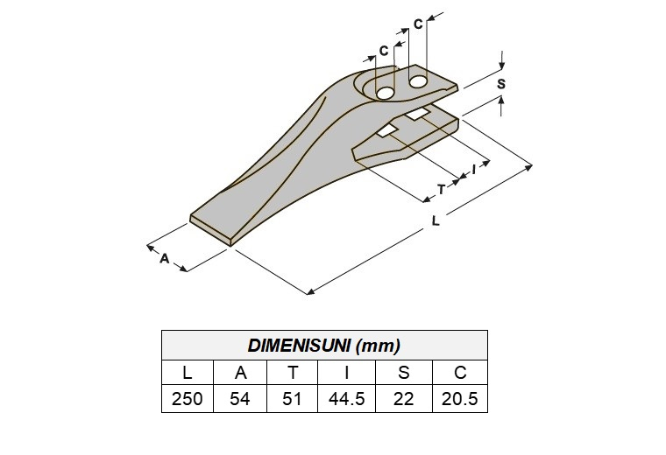
Fig 1 Size of the bucket's teeth [8]

Table 1 Size of the bucket's teeth [8]
Dimension (mm)
L | A | T | I | S | C
240 | 67 | 62 | 44 | 22 | 20

After determining the bucket tooth geometry's fixed dimensions, the design process was carried out using the ANSYS workbench software. The software created the bucket tooth design as displayed in Fig 1.

- Data observation and calculation.
In actuality, the dynamic angle configuration of the excavator arm and bucket causes its angle to change constantly. It shouldnot, however, examine every excavator orientation or configuration. Therefore, the static configuration is set to maximize power before being used in this study [8].

- Bucket Curling Force (F_{b})
According to SAE J1179, the cylinder provided the maximum radial force for the bucket tooth (also known as the bucket curling force) F_{b}.As a result of the cylinder bucket and radius tangent d_{D}, there is a digging force of 1. The bucket should be placed to receive the greatest moment output from the bucket cylinder and connecting component. Since the other ranges in equation (2) are constant [9], F_{b} becomes maximum when the d_{A} range is maximum.
${ F}_{b} =\frac{Bucketcylinderforce}{d_{D}}\left(\frac{d_{A} X d_{c}}{d_{b}}\right)$ (2)
$$Bucket cylinder force = \left(working stress\right)× \left(cylinder bucket longitudinal section\right)$$
Equation 3 can be illustrated as follows if the cylinder bucket piston's diameter is D_{B} (mm), the working force is P (MPa), and all other ranges are in mm:
${ F}_{b} = \frac{p X \left(\frac{π}{4}\right)D_{B}}{d_{D}}\left(\frac{d_{A} X d_{C}}{d_{B}}\right)$ (3)
- Bucket Crowd Force (Fs)
The digging force known as the bucket crowd force F_{s} is produced by the tangent radius d_{f} and arm cylinder. The position of the arm should maximize the moment of the arm cylinder and bucket. The following equation is used to determine the maximum value F_{S}if the arm cylinder center is parallel to the connecting line between the pin cylinder arm and the boom nose pin:
${ F}_{s} = \frac{p X \left(\frac{π}{4}\right)D_{A}^{2} X d_{E}}{d_{F}}$ (4)
- Von Mises Stress Theory
This theory makes a larger assumption regarding friction stress failure than the maximum friction stress theory does. Utilizing Von Mises stress, an equation with stress on three axes makes planning analysis simpler.
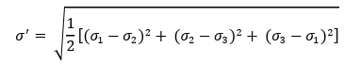

It will fail if: $σ^{'} ≥S_{y}$

From trials that have been done, it reveals that distortion energy theory (von Mises) assumes failure with the highest carefulness in all quadrants [7]

- Bucket Curling Force (Fb) and Bucket Crowd Force (Fs)
- Bucket curling force (Fb)

$${ F}_{b} = \frac{28.9 X \left(\frac{π}{4}\right)80}{1496}\left(\frac{594 X 453}{631}\right) =41425.34752 N$$
The numbers of the tooth in the bucket are 5, thus loading of F_{b} accepted by a tooth is F_{b} divided by 5:

F_{b} = 41425.34752/5 = 8285.06 N

$${ F}_{s} = \frac{28.9 X \left(\frac{π}{4}\right){95}^{2} X 829}{4415}=38479.86374 N$$

The numbers of the tooth in the bucket are 5, thus loading of F_{S} accepted by the tooth is F_{S} divided by 5:

- Force Vector

F=8285.06 N

$\frac{Fx}{F}$= cos32$°$

F_{X} = 7026.12 N

$\frac{Fy}{F}$= sin32$°$

F_{Y} = 4390.4 N
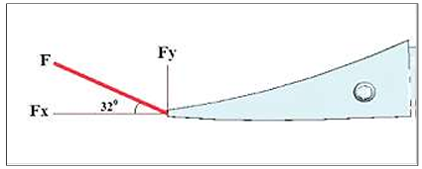
Fig 2 Diagram of free-pressuring object [5]

- Material used
Material selection is one of the most crucial and significant steps in the structural or mechanical design process. The bucket teeth continue to operate under challenging circumstances, such as extremely high-impact loads acting on the bucket while it is in use and increased component wear. The choice of material is influenced by factors such as density, Poisson's ratio, yield strength, and ultimate strength. The following materials, including structural steel, and AISI 1040 have been used to make excavator bucket teeth. Based on cost and performance, the best material for a tooth is selected for the application. For this study, structural steel and AISI 1040 were employed as well as bucket teeth from the casting process. Table 2 provides specifications of the substance used to create bucket teeth.
Table 2 Properties of structural steel material
Particulate | Structural Steel | AISI 1040
Density ton/mm³ | 7.85× 10⁻⁹ | 7.845× 10⁻⁹
Coefficient of Thermal Expansion /ºC | 1.2× 10⁻⁵ | 1.2× 10⁻⁵
Specific Heat MJ /ton ºC | 4.34× 10⁸ | 4.34× 10⁸
Thermal Conductivity W/ mm ºC | 6.05× 10⁻² | 6.05× 10⁻²
Compressive Yield Strength MPa | 250 | 250
Tensile Yield Strength MPa | 250 | 435
Tensile Ultimate Strength MPa | 460 | 670
Young's Modulus MPa | 2.0 × 10⁵ | 2.05 × 10⁵
Poisson's Ratio MPa | 0.3 | 0.29
Bulk Modulus MPa | 1.6667 × 10⁵ | 1.627 × 10⁵
Shear Modulus MPa | 76923 | 79457

The bucket teeth modelling material's characteristic is related to Table. Results of tests conducted in laboratories were used to determine a material's properties.

- Analysis steps
One method for solving natural problems numerically is the finite element method. A differential or integral equation could be used to explain an event in nature. Due to this, one method for solving partial and integral differential forms is the finite element method. The finite element approach typically allows users to determine how a physical system has evolved through time or space using one or more variables.The finite element method is a good approach for estimating displacement, stress, and tension on a structure when applying load.In order to tackle some engineering problems that are closely associated to computer development and other aspects like computer-aided design (CAD) and computer-aided engineering (CAE), the finite element method is one of the numerical approaches that is used.There are five basic steps to using finite element technique software, and they are as follows:

- Creating a 3D model
In this study a finite element model to analyze the distribution of stresses in the cutting tooth. As shown the solid object in Fig 3 consists of a holder, a component from the cutting tooth with an improved edge. The cutting teeth are attached to the holder by a joint and are a separate component. It is true that the holder is a rectangular steel structural tube, but it is also feasible that the other components of the structure are constructed from a different type of steel.
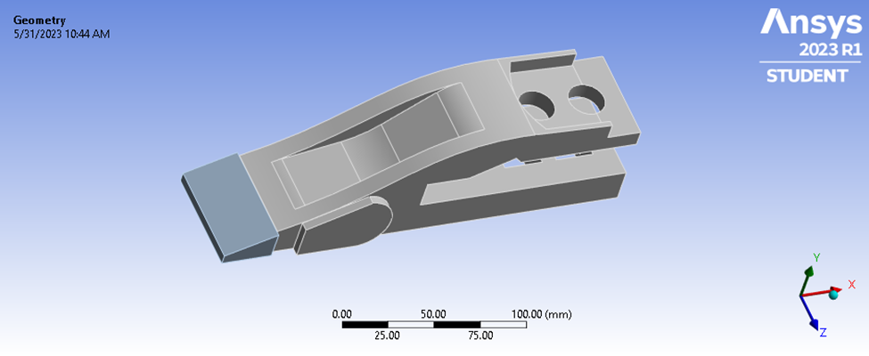
Fig 3 Finite Element Analysis Geometrical Model.

- Define the materials
Specify the materials for the 3D simulation model of an excavator bucket. For conducting various simulations, ANSYS offers the option to alter the material for each part.

- Application of forces
Applying loads is necessary in order to perform static structural analysis for an excavator bucket initially.Forces are loads that are applied to an assembly for simulation purposes, and these forces cause stresses and deformations in the assembly.
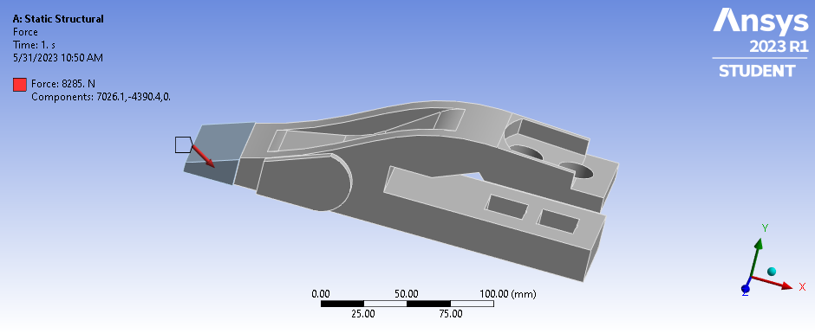
Fig 4 Finite Element Analysis Geometrical Model of the loading condition

- Mesh plot
The mesh aids in reducing the time and effort needed to get precise outcomes. Because meshing often consumes a sizable percentage of the time required to acquire simulation results, ANSYS helps by developing better and more automated meshing tools. The mesh of bucket teeth in Figure 5 contains 7337 elements with a 20 mm diameter, 19754 nodes, and nodes. An element of the bucket teeth model for the backhoe loader is a solid tetrahedron.

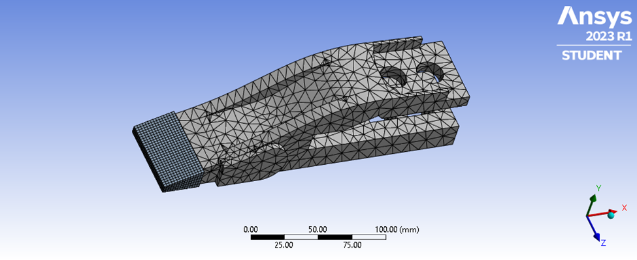
Fig 5 Finite Element Analysis Geometrical Model of the Meshing Tooth

- Boundary condition and loading
Constraining the degrees of freedom on a model is what boundary conditions do. Real-world circumstances serve as the basis for the boundary condition. At circular holes applied fixed support and squired displacement is applied. Calculated resultant force shows 8285 N shown in fig.6.
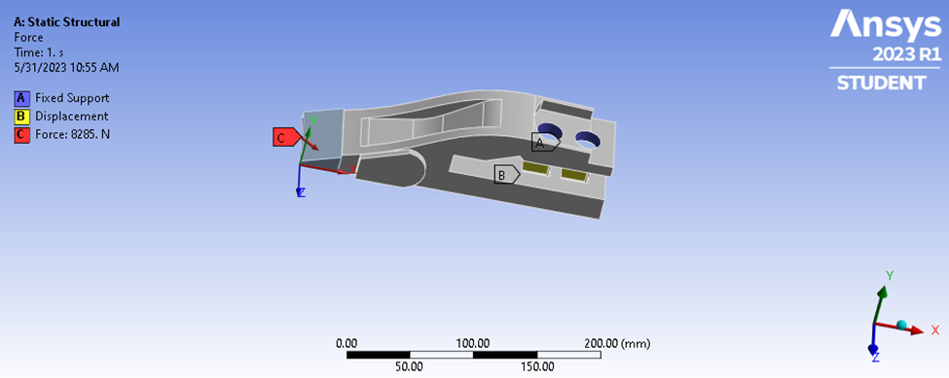
Fig 6 Finite Element Analysis Geometrical Model of the boundary condition

- Analysis of the bucket teeth from a backhoe loader
Von Misses stresses are used as a criterion in determining the onset of failure in steel materials, and the materials in the presented study for the parts of the bucket teeth are of steel materials, so the design of all parts should be on the basis of Von Misses stresses. Static structural analysis was performed for bucket teeth to see if the stresses are within the limits, and structural optimization was performed for a backhoe loader bucket teeth to reduce the weight.This means that the following requirement must be met for a part's design to be safe or to work under safe stress.Safe working stress = Yield stress/Factor of safety. Consider Factor of safety 1.5 [3]

IV. RESULTS AND DISCUSSION

- Static structural results

Case 1- Without slot for structural steel material
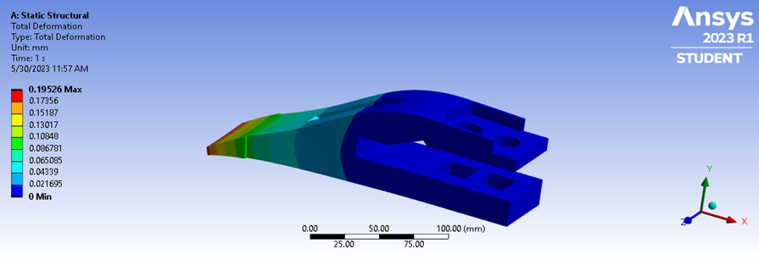
Fig 7 Displacement in the bucket teeth of structural steel material
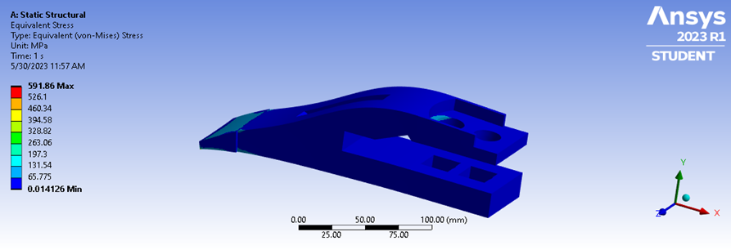
Fig 8 Stress in the bucket teeth of structural steel material

Case 2- Without slot for AISI 1040 steel material
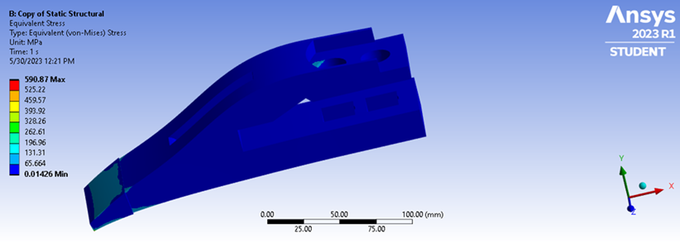
Fig 9Stress in the bucket teeth of AISI 1040 steel material

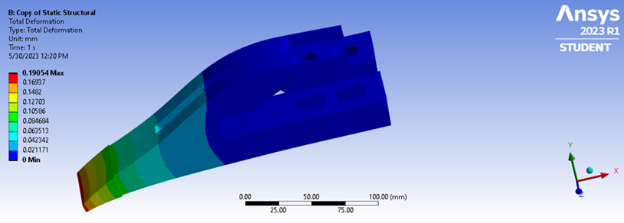
Fig 10 Displacement in the bucket teeth of AISI 1040 steel material

Case 3- With slot for structural steel material
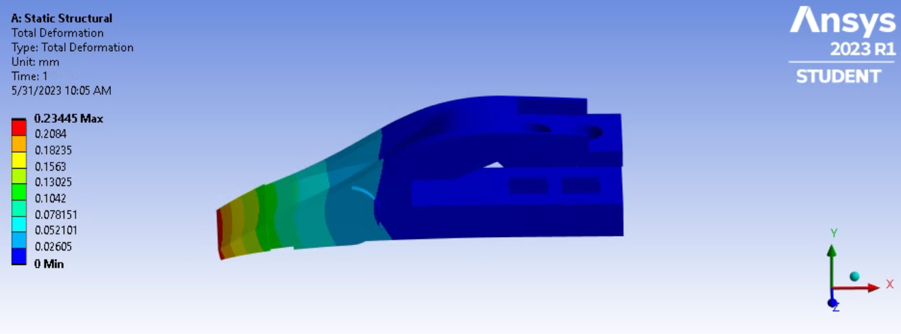
Fig 11 Displacement in the bucket teeth
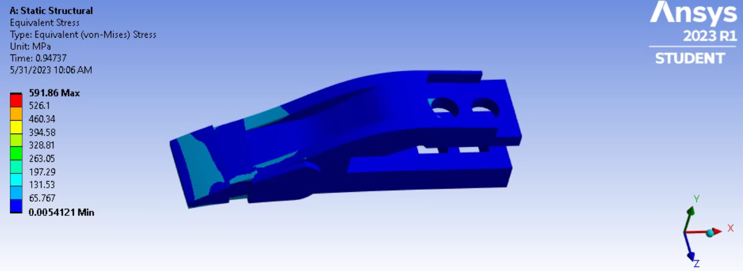
Fig 12 Stress in the bucket teeth

Discussion
Table 4 without slot (before design modification)
Type of material | Total deformation (mm) |  |  | Von-mises stress (Mpa) |  |  | Safe working stress (Mpa)
 | Min | Avg | Max | Min | Avg | Max
Structural steel | 0 | 0.09763 | 0.19526 | 0.014126 | 295.93 | 591.86 | 166.67
AISI 1040 | 0 | 0.09527 | 0.19054 | 0.01426 | 295.43 | 590.87 | 290

Table 5 With slot (after design modification)
Type of material | Total deformation (mm) |  |  | Von-mises stress (Mpa) |  |  | Safe working stress (Mpa)
 | Min | Avg | Max | Min | Avg | Max
Structural steel | 0 | 0.11722 | 0.23445 | 0.0054121 | 295.93 | 591.86 | 166.67
From the table 4 and table 5 can conclude that total deformation changes with changing of material and design of the tooth but stress remains the same for the same material even with modification of design.

V. CONCLUSION
- Deformation in elastic limits occurs when stresses are below the yield strength according to Hook's law.
- It has been discovered that the finite element method can be applied to improve the quality of geometry forms.
- The failure can be reduced by redesigning the tooth better, talking about force calculations, and improving the geometry of the bucket teeth for better material loading and digging.

VI.ACKNOWLEDGMENT
I would like to take this opportunity to express my sincere gratitude and respect to Dr. MD. Imran, our guide, It was a pleasure for me to work under his invaluable, never-ending direction, technical support, and ongoing encouragement, which motivated us. We appreciate the faith he placed and nurtured us.
I also want to thank Dr. Mohsin Ali the respected head of our other teaching department, for supporting us and giving us this wonderful opportunity.
Finally, I would like to express our gratitude to everyone who assisted us in this research, either directly or indirectly.

REFERENCES

- SujitLomate, SiddaramBiradar, KetanDhumal,AmolWaychal, “Design and Shape Optimization of Excavator Bucket,”(IRJET)Volume: 03 e-ISSN: 2395 -0056 to p-ISSN: 2395-0072
- Kalpak. S. Dagwar,R.G. Telrandhe, IJRMET Vo l . 5.2015 ISSN : 2249-5762.
- Sumar Hadi Suryo, Athanasius Priharyoto Bayuseno, Jamari, Gilang Ramadhan“Simulation of Excavator Bucket Pressuring Through
Finite Element Method,” in cej, Vol. 4 , No. 3 , March, 2018
- Bhaveshkumar P. Patel and Dr. J.M.Prajapati,”AReviewOn Kinematics Of Hydraulic Excavator‟s Backhoe Attachment”, International Journal of Engg. Science and Technology (IJEST) Vol.No.3.Issue No.3.March 2011
- Manisha P. Tupkar, Prof. S.R. Zaveri,“Design and Analysis of an Excavator Bucket”, International Journal of Scientific Research
Engineering Technology, Vol. 4, Issue 3, March 2015.
[6] Fernandez, J. E., Vijande, R., Tucho, R., Rodriguez, J., and Martin, A. “Materials selection to excavator teeth in mining industry.”
Elsevier, Wear 250 (2001): 11-18. Doi: https://doi.org/10.1016/S0043-1648(01)00624-X.
[7] Budynas, R. G., Nisbett, J. K., and Shigley, J. E. Shigley's mechanical engineering design. New York: McGraw-Hill, 2011.
[8] Liu, Y. “Choose the Best Element Size to Yield Accurate FEA Results While Reduce FE Model’s Complexity” 1 (2013): 13–28.
[9] SAE International. SAE J1179: Hydraulic Excavator and Backhoe Digging Force. Warrendale: SAE, 1990.

