Fractional Flow Reserve (FFR): Clinical Applications and Implications

Mr. ADNAN MAJEED BHAT,
Lecturer, Department Of Cardiac Technology,
School of Allied Health Sciences, AarupadaiVeedu Campus, Paiyanoor,
Vinayaka Mission’s Research Foundation- DU.
ambhat1011@gmail.com

ABSTRACT
Fractional flow reserve (FFR) provides an objective measurement of the severity of ischemia caused by coronary stenoses in downstream myocardial regions. Data from the interventional cardiology realm have suggested benefits of a FFR-guided percutaneous coronary intervention (PCI) strategy. Limited evidence is available on the use of FFR to guide coronary artery bypass grafting (CABG). The most recent data have shown that FFR might simplify CABG procedures and optimize patency of arterial grafts without any clear impact on clinical outcomes. The aim of this review was to summarize the available data on FFR-based CABG and discuss the rationale and potential consequences of a switch toward FFR-based surgical revascularization strategy.

INTRODUCTION
Fractional Flow Reserve (FFR) is a widely recognized and essential tool in the field of interventional cardiology. This chapter explores the principles, methods, clinical applications, and implications of FFR, highlighting its role in guiding treatment decisions for patients with coronary artery disease.
Fractional flow reserve (FFR) is an objective method to assess the functional significance of coronary artery lesions. FFR is defined as the ratio of maximal achievable blood flow in coronary artery to the hypothetical maximal achievable blood flow in the same artery in the absence of stenosis. It is derived from the ratio of the mean distal coronary artery pressure to the mean aortic pressure during the period of maximum hyperemia. Initial studies suggested that the cut-off value of 0.75 was reliable in the identification of ischemia-producing lesions. Afterwards, several outcome studies validated the cut-off value of 0.80, which is actually widely accepted.
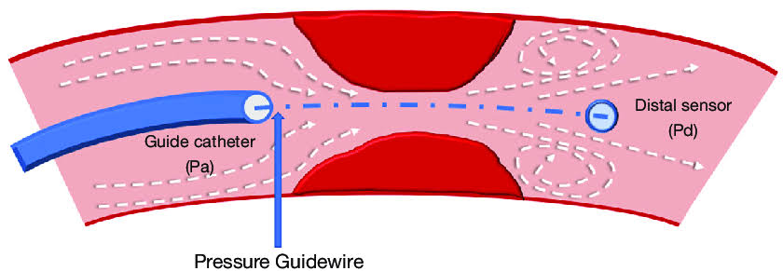

PRINCIPLE OF FFR
FFR is rooted in the concept that not all coronary stenoses are equally significant in causing ischemia. It measures the pressure drop across a coronary lesion during maximal hyperemia, providing a physiological assessment of lesion severity. FFR is calculated as the ratio of mean distal coronary pressure to mean aortic pressure during hyperemia. An FFR value below 0.80 typically indicates hemodynamically significant stenosis, guiding treatment decisions.

MEASUREMENT OF FFR
Guide wire Insertion: A pressure-sensing guidewire is threaded through the coronary artery, across the stenosis of interest.
Inducing Hyperemia: Maximal coronary hyperemia is induced, often using intravenous adenosine, to simulate conditions of increased demand.
Pressure Measurements: Distal coronary pressure and aortic pressure are measured simultaneously to calculate FFR. FFR = Pd/Pa (Pd = distal coronary pressure, Pa = aortic pressure).
A normal result ranges from 0.94 to 1. Any number below that means you need some type of treatment because your blood flow is less than what it should be. For example, if your FFR is 0.75, your narrow section of the coronary artery is causing a 25% decrease in pressure.
If your fractional flow reserve shows that your coronary artery blockage isn’t bad, you don’t need angioplasty and a stent. You can take medicine instead.

.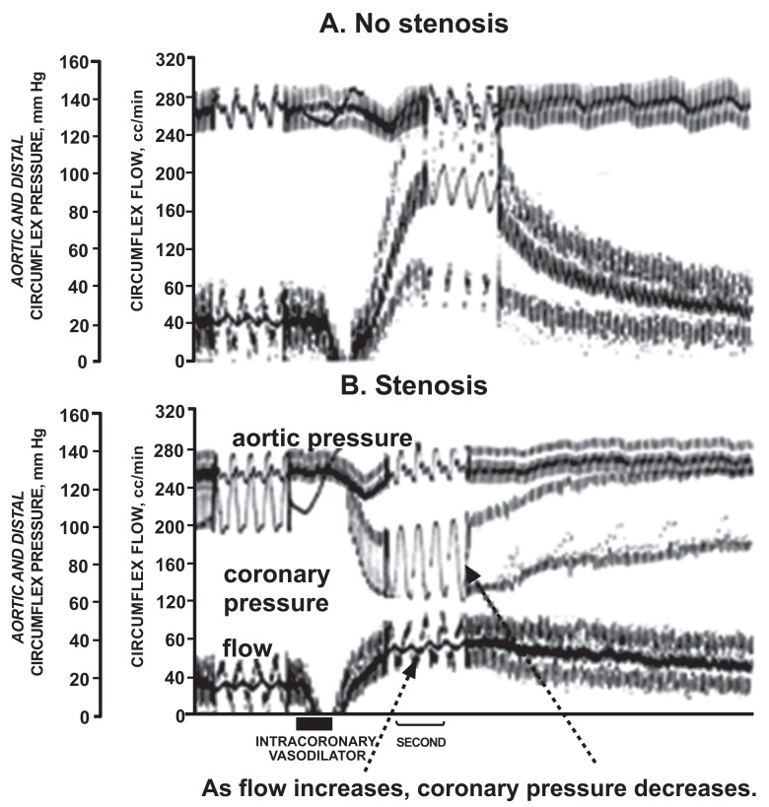
FIGURE 01: Tracings demonstrating fractional flow reserve

Tracings demonstrating fractional flow reserve (FFR) as a measure of coronary flow reserve. Shown are coronary blood flow and aortic and coronary pressure tracings from a dog without a coronary stenosis (A) and a severe stenosis (B). A hyperemic response was induced by the coronary vasodilating effect of a contrast injection, indicated by the bar at the bottom of the figure. Without a stenosis (A), the contrast caused a marked increase in coronary blood flow, with little divergence of pressures. However, with a stenosis (B), the contrast increased coronary blood flow modestly with a marked increase in the aortic-distal coronary pressure gradient. FFR is the ratio of coronary to aortic pressure at maximum hyperemia and reflects the flow reserve.

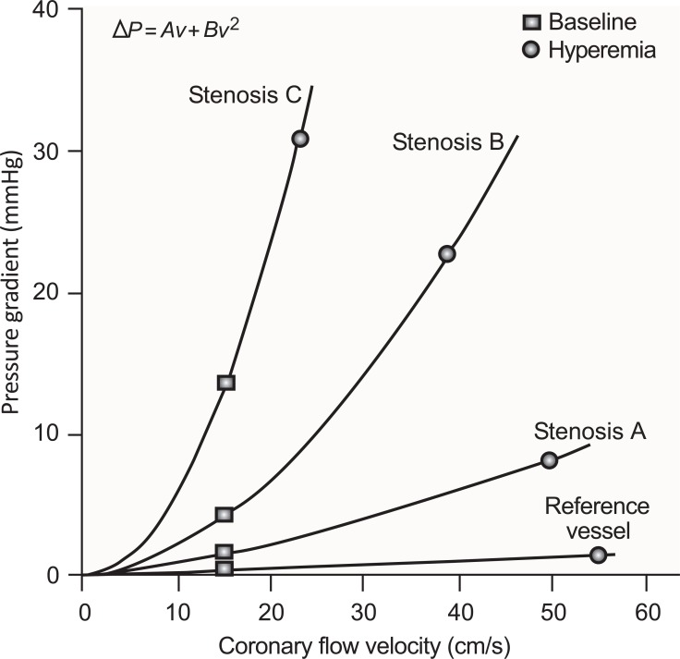

FIGURE 02: Relationship between Coronary Flow Velocity and Pressure gradient.
The pressure drop across a coronary stenosis (Δ P) is a direct function of coronary flow velocity (v). The steepness of this relationship increases with stenosis severity (from Stenosis A to C). For a given stenosis, the pressure gradient at baseline (square) is determined by resting microvascular resistance and that at maximal hyperemia (circle) is determined primarily by the vasodilator capability of the downstream resistance vessels, although the physical factors described in the text may pose a limitation. The relationship between Δ P and v is defined by the equation at the top of the figure. The first and second terms represent pressure loss caused by viscous friction and expansion losses at the exit of the stenosis, respectively. The coefficients A and B are determined by stenosis geometry and the rheological properties of the blood.

CLINICAL APPLICATIONS
- Identifying Hemodynamically Significant Stenoses: FFR assists in distinguishing between anatomically significant lesions and those that induce ischemia, aiding treatment decisions.
- Optimizing Revascularization: FFR guides interventional cardiologists in selecting lesions that would benefit most from revascularization, minimizing unnecessary procedures.
- Deferred Revascularization: Lesions with FFR > 0.80 are often managed conservatively, avoiding interventions and their associated risks.
- Multi-Vessel Disease: FFR helps prioritize lesions in multi-vessel disease, determining which lesions require immediate intervention.
- Serial Assessment: FFR can monitor lesion progression over time, informing treatment strategies and assessing the success of prior interventions.
- Enhanced Decision-Making: FFR provides objective data to guide treatment choices, leading to more informed and evidence-based decisions.
- Risk Stratification: FFR values are associated with long-term outcomes, aiding in risk stratification and treatment planning.
- Cost-Effectiveness: FFR minimizes unnecessary interventions, optimizing resource utilization and reducing healthcare costs.
- Patient-Centered Care: FFR contributes to personalized care by tailoring interventions to the individual patient's needs and physiology.

LIMITATIONS AND CONSIDERATIONS
There are no absolute contraindications for FFR tests.3 Second- and third-degree atrioventricular blocks, sick sinus syndrome without pacemaker, prolong QT- interval, severe hypotension, heart failure and obstructive pulmonary disease are relative contraindications for intravenous administration of adenosine. Generally, invasive diagnostic procedures should not be attempted if invasive therapeutic options don’t exist.

FFR test measurements have limitations in patients with small-vessel disease, diffuse coronary artery disease and left ventricular hypertrophy.18 These conditions may lead to underestimation of severity of coronary stenosis due to the restriction in blood flow after pharmacological vasodilation and corresponding decrease in distal coronary blood pressure.

Several comorbidities can influence performance and safety of FFR tests.3 The accuracy of FFR tests may be affected in older patients due to the age-associated changes in microvasculature, leading to higher observed FFR values independent of degree of stenosis. Similarly, patients with diabetes mellitus can have falsely elevated FFR values due to microvasculature pathology and impaired response to vasodilators administered during the test. This could lead to reduced treatment of elderly and diabetic patients when FFR values are used as guidelines.

Although the true effect of the diseased microvasculature on FFR values is still debated, it has been shown that PCI interventions guided by FFR are equally beneficial in patients older than 65 years of age with multivessel disease as in younger patients with the same disease and in patients with and without diabetes, compared to angiography-guided PCI.

Adenosine Response: Patient responses to adenosine can vary, potentially affecting FFR measurements.

Microvascular Disease: FFR may underestimate stenosis significance in the presence of microvascular dysfunction.
Lesion Location: FFR may not fully account for the influence of collateral circulation and side branches on overall coronary blood flow.

EMERGING TRENDS AND FUTURE DIRECTIONS
- Instantaneous Wave-Free Ratio (iFR): A technique similar to FFR but with specific pressure measurements during a different phase of the cardiac cycle, potentially reducing the need for adenosine administration.
- Virtual FFR (vFFR): Computational fluid dynamics and advanced imaging are being explored to predict FFR values non-invasively, enhancing clinical decision-making.

CONCLUSION
Fractional Flow Reserve is a pivotal advancement in interventional cardiology, bridging the gap between anatomical and physiological assessments of coronary lesions. Its clinical applications and implications have transformed the way cardiologists approach coronary artery disease, leading to more precise treatment decisions, improved patient outcomes, and a patient-centered approach to care. As technology evolves, FFR continues to be an indispensable tool, guiding interventions based on the physiological significance of coronary lesions.

REFERENCES

[1]. Bruyne BD, Fearon WF, Pijls NHJ, et al. Fractional Flow Reserve–Guided PCI for Stable Coronary Artery Disease. New Engl J Medicine. 2014;371(13):1208-1217.

[02]. Pijls NHJ, Bruyne B de, Peels K, et al. Measurement of Fractional Flow Reserve to Assess the Functional Severity of Coronary-Artery Stenoses. New Engl J Medicine.1996;334(26):1703-1708.

[03]. Neumann FJ, Sousa-Uva M, Ahlsson A, et al. 2018 ESC/EACTS Guidelines on myocardial revascularization. Eur Heart J. 2018;40(2):87-165.

[04]. https://www.sciencedirect.com/science/article/pii/S1936879819325713

[05]. https://www.ncbi.nlm.nih.gov/pmc/articles/PMC4539407/#B1

[06]. https://my.clevelandclinic.org/health/diagnostics/23556-fractional-flow-reserve

[07]. https://www.researchgate.net/figure/nvasive-fractional-flow-reserve-FFR-in-the-catheter-laboratory-to-guide_fig1_347519313

[08]. https://www.thecardiologyadvisor.com/ddi/fractional-flow-reserve-ffr

