VALORIZATION OF GRAPE WINERY WASTE FOR VALUE ADDITION IN THE WINE INDUSTRY

Ms. Swati Bhatt
Department of Life Sciences
Christ (Deemed to be University),
Bengaluru, Karnataka, India
swati.bhatt@science.christuniversity.in

Ms. Vinanthi Rajalakshmi K S
Research Scholar, Department of Life Sciences
Christ (Deemed to be University),
Bengaluru, Karnataka, India
vinanthi.rajalakshmi@res.christuniversity.in

Ms. Akanksha Tarafdar
Department of Life Sciences
Christ (Deemed to be University),
Bengaluru, Karnataka, India
akanksha.tarafdar@science.christuniversity.in

Dr. Erumalla Venkata Nagaraju
Associate Professor, Department of Biochemistry
Indian Academy Degree College (Autonomous)
Bengaluru, Karnataka, India
venkatanagarajue@gmail.com

Dr. Kuppusamy Alagesan Paari
Assistant Professor, Department of Life Sciences
Christ (Deemed to be University),
Bengaluru, Karnataka, India
paari.ka@christuniversity.in

ABSTRACT

Wine is the most celebrated beverage due to its property of promoting health benefits, producing polyphenols and non-flavonoid compounds. The possible ways of valorization of grape agro-waste into productive bioactive compounds are dependent on the type of waste material obtained. All liquid waste extracted during the process of pressing contains high amounts of antioxidants. Techniques like solvent-based and pressurized liquid-based extractions are eco-friendly. The most important wastes produced while wine production includes pomace (64%), stalk (15%), lees (12%), and water waste (10%). Most of these wastes are used to produce by-products like methane, oil, and polyphenols whilst others undergo composting and result in the formation of biofertilizers. The process of wine-making or vinification has been discussed elaborately in this article, followed by the wastes obtained and the various methodologies implemented to improve the waste product for capitalization. The applications of the newly formed products across all fields have also been discussed. This current review aimed to provide an overview of the extensive research done from 2005 to 2022 on the conversion of vinification by-products into high-value-added products. These value-added products can be used for commercialization in agrochemical, industrial, and nutraceutical arenas and for the minimization of the pernicious effects. These products otherwise would have caused detrimental effects on the environment and the economy of the consistently developing human population.

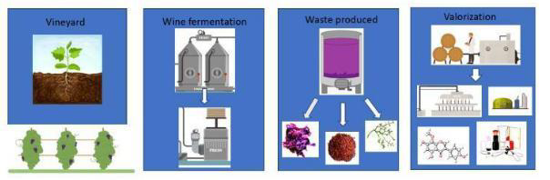
Keywords: Flavanol, French Paradox, catechin, stilbenes, polyphenolic compounds, biorefinery.
Wine extraction from vineyard to valorization process
- INTRODUCTION

Over the centuries, the art of winemaking has set its deep roots in human heritage. In accordance with human history, it has been observed that wine is a beverage that is unanimously consumed. While mainly consumed for pleasure, wine also has several medical utilities and has been used in such aspects for several years. The first reference to winemaking is biblical, wherein, Noah was said to have planted a grapevine after the flood and used that for producing wine [13]. The Italians and the Spanish soon followed with 40.1 million hectolitres and 30.4 hectolitres respectively [43]. The French were the first in the world to produce wine on a large scale starting with 41.4 million hectolitres. Wine making in the early Grecian and Roman empires as well as the middle eastern civilization has been also evidenced [13]. The statistical data from France highly suggest the shielding properties of red wine against a diet consisting of high fats. This data is notably known as ‘The French Paradox’. In 1979, St. Leger et al. constructed this idea after they discovered an inverse relation between wine consumption and coronary heart disease mortality rate, having observed the lowest mortality rate in France [13]. It was observed that in spite of the French having relatively high concentrations of saturated fat and cholesterol in their diets, they also consumed sufficient amounts of antioxidants (from vegetables and unsaturated fats). This seemed to play a key role in enhancing their immunity.The French constantly consumed red wine in moderate quantities over the course of a week, while others tended to drink excessively. It was discovered that the central causative factor of the French Paradox was the polyphenol content of red wine. According to the recent literature, the supervised intake of red wine exhibits various health benefits such as prevention of malignant tumors, Diabetes mellitus Type I, myocardial infarction, and autonomic disorders.
Generally, the components present in wine are polysaccharides, alcohol, tannins, phenolic compounds, and proteins. Substantially, polyphenols present in wine are responsible for the beneficial effects it portrays. Polyphenols are aromatic compounds with hydroxyl groups containing ring structures. They exhibit strong antioxidant properties and therefore, are the desired component in the fields of cosmetics and pharmaceuticals [19]. They have been reported to have positive effects on the levels of different microorganisms and their functions present in the human body. Nevertheless, these positive health effects of polyphenols are limited to the consumption rate and availability. Properties like Brix value, density, labile acidity, alcoholic content, fragrance, acerbity, and turbidity give each wine its unique attribute] [18]. Due to these properties of wine, a novel remedial paradigm has been developed called wine therapy. In this method, an individual is to be submerged in a wine barring alcohol. Apart from this, the most indispensable and massively researched properties of wine are their antioxidant and radical scavenging effects [13].
Every year, in Italy, the amount of dry matter produced by remnants of the agricultural, food and pharmaceutical industry is 21 Tg. Italy is famous for its wine production. A vineyard of an area of approximately 2587 square miles produces around 6.5 Tg of wine-producing grapes. Grape marc constitutes skin, stalk and seeds. Grape skins have the highest amount of dry matter, which is around 72%. Different residues have differing levels of chemicals such as tannins, oils, inorganic elements and moisture. Globally, the most common ways to utilize these lees are as fodder for livestock, in pharmaceuticals and cosmetics as well as in the agrarian economy. There are an immense number of benefits of wine waste. Toscano et al (2015) addressed the study of utilization of grape peels in the process of composting. Maier et al (2016) confirmed, through their research, that grape seed oil is a rich source of polyphenols with antioxidant properties. High smoke point of grape seed oil makes it suitable for cooking. Until 2010, for distillation purposes in Italy, it was mandatory to use fresh and fermented grape marc. Only recently, the laws concerning usage of winery waste have been altered, permitting their use in different industries.
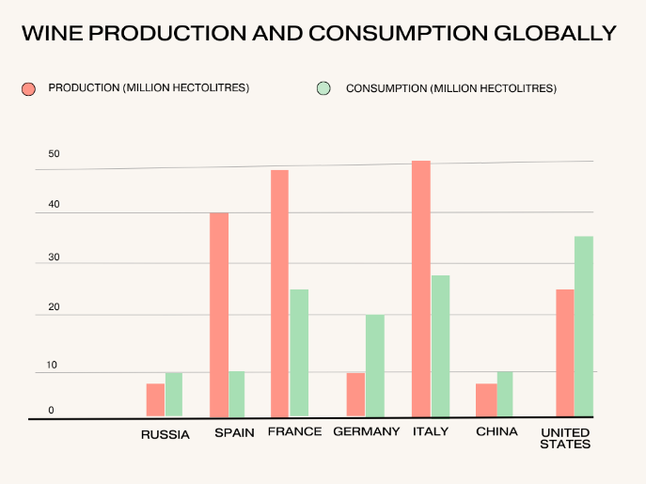
Graph 1. Global Wine Consumption and Production
The valorization or reprocessing of the wastes produced during wine fermentation by adding certain chemical compounds such as Polyvinylpolypyrrolidone, hemicellulose, pentoses, 5-C polymers for the purpose of increasing their value productivity in other collateral fields contributes to the development of a sustainable environment. There are two kinds of waste produced during wine harvesting: Solid and Liquid waste. Under solid wastes, there are stalks, stems, grape marc, pomace, and lees. Along with this wastewater is produced as liquid waste [12]. The recycling of these by-products has a multitude of benefits like the production of cheaper products, minimum storage space, lesser cost production, and an economically friendly nature. This is because they are plant-derived substances [15].
The deposition of extensively produced wine waste is important to reduce the energy crisis. Valorization techniques are sustainable and a useful initiative toward mitigating improper waste disposal. This article reviews the separation of solid and liquid wastes from different stages of wine-making and their applications in the production of useful compounds in the fields of agriculture, cosmetics, food industry, and pharma industry. Some wastes produced are hazardous to the environment and to reduce these harmful effects valorization is performed.

- WASTE PRODUCTION FROM WINE AND THEIR PROPERTIES

A. Vinification
Vinification includes the steps to produce wine. There are five basic stages of Vinification. Stage I is harvesting or picking which is done during the month of July after thorough checking of pH, acidity, sugar levels, and ethanol content. After harvesting the grapes are brought into the winery and the undamaged grapes are selected. During this stage, the grapes are prepared for primary fermentation and the distinction between white wine and red wine occurs. For red wine, the pulp and the skin (tannins) of the grape are utilized which gives it its characteristic red color. Whereas, for white wine, only grape juice is utilized. There should be minimal contact between the grape skin and the grape juice for the production of white wine. Rosé wine is commonly prepared from the juice of red grapes which are kept in contact with their dark skins for a sufficient time for the development of their characteristic pink color. This process is called maceration or saignée. However, there is another method of rosé production which is by mixing white and red wine. After crushing the grapes and removing the skin they are moved on to the pressing stage. A bladder press made up of stainless steel is used for pressing grapes. Then the grapes are transferred into stainless steel tanks for clarification. Artificial yeast Saccharomyces cerevisiae or naturally occurring ambient yeast is added to the must for the initiation of primary fermentation.

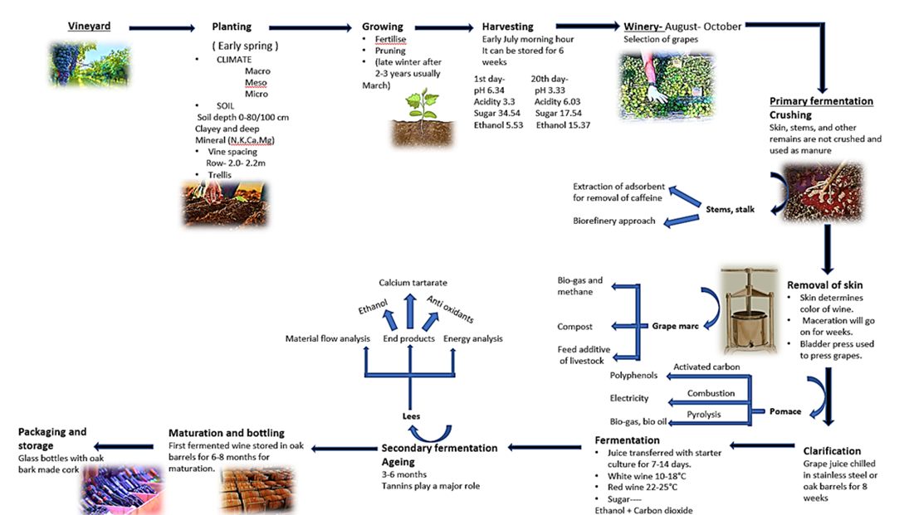

Figure 1. Vinification and waste extraction

The conversion of sugar present in the must into ethanol and carbon dioxide is performed by the yeast and this process often takes up to two weeks. For a wine to taste better a process called aging of wine is conducted.[17] The aging process varies according to the grape species being used and tends to deliver a wine of good composition with optimum levels of polyphenols, tannins, and sugar. For example, Beaujolais nouveau wines require over 20 years to achieve their best quality. Nonetheless, this aging process is restricted to only 12% of all red wines and 8% of all white wines as others will attain maturity in as less of a time as a year and will taste better than they would after 5 years [2]. The process of vinification completely depends on the winemaker. They can combine or modify any of these stages based on the grape quality and their target wine's style. The fermented wine is stored in oak barrels usually for 6-8 months for maturation. The production of sparkling wine requires a variation in the usual wine-making process.

B. Wastes and their properties
During harvesting, in the months of August to October, the process of pruning is conducted which is basically destemming of the grape plants. The pruned grapes are then sent for selection and the discarded stalk may be utilized for valorization. The stems obtained as waste after the crushing process might be utilized as a precursor of phenolic antioxidants. Various studies have already been conducted on grape skin and seeds as a source of convenient by-products. Only recently researchers are focusing on grape stems as a potential source. It was discovered that flavon-3-of monomers (Catechin and Epicatechin) are present in excessive amounts in grape stems. Phenolic compounds like stilbenes are present in lesser quantities [27]. These bioactive compounds are utilized for performing many significant biological activities. The pulp obtained after maceration is known as grape marc or grape pulp. This may also contain the seed and branches of the plant and it is then termed grape pomace. Grape pomace is one of the most opulent agro-industrial wastes obtained from the waste produced in the wine industry. Seventy-eight metric tonnes of grapes are produced annually worldwide.
Vinification claims up to 57% of this production. Approximately 20-25% of grape production ultimately is obtained as grape pomace. Although grape pomace has a high polyphenolic content it also has a very low pH which makes it a dangerous pollutant for the environment. The cumulation of untreated grape pomace has the capability of impeding germination. Due to the difference in fermentation and maceration processes in white and red wine production the grape pomace (GP) of white wine has higher polyphenolic content. Hence, white GP poses a higher potential risk to the environment and has to be handled equally carefully. Amongst other uses of GP in the fields of pharmaceuticals, nutrition, and cosmetics, it can also be utilized for bio-energy, bio-gas, and butanol production. For the production of lactic acid and bacterial cellulose, GP is a common carbon source in the bacterial culture media [9]. After fermentation and filtration, a residue is formed at the bottom of wine containers known as “wine lees”. There are three kinds of wine: first fermentation lees, second fermentation lees, and aging lees. It is composed of solid and liquid portions with cellulosic materials inorganic salts, lignin, and tartaric acid constituting the solid portion and ethanol and lactic acid in the liquid portion. Wine lees vastly depend upon the environment and agricultural conditions and the topography of the land on which the grape is grown. They have an acidic pH, high oxygen demand, and potassium and phenolic compounds [6].

- VALORISATION OF WASTE INTO BIOACTIVE COMPOUNDS

The production of wine industrially generates a high amount of waste, some of which have detrimental effects on the environment. As the number of waste increases, it is important to find ways to recycle them. Grape, one of the world's massively grown fruits, produces 20% of pomace during wine-making. This pomace can be managed by land-filling, composting, and combustion.

- Pomace
A minor percentage of pomace is sent for the distillation process, which is then converted into fertilizer and animal feedstock [14]. Grape pomace (GP) contains sugars, phenolics, tartrate, and fibers. GP has 50-70% moisture content depending on the variety of grape and its ripening period. Lignin concentration present is 16.8-22.2%. There are two constituents of the GP cell wall: peptides (37-54%) and cellulose (27-37%). [16] Grape pomace can be used to generate single-cell proteins and cellulose present in bacteria by the method of fermentation. Various compounds like ethanol, gluconic acid, carotenoids, and citric acid can be produced by solid-state fermentation (SSF). This kind of fermentation involves the utilization of microorganisms growing on wet solids. A significant property of SSF is low contamination due to a reduced amount of water content which decreases effluents. Integration of grape pomace into agronomical fields causes the disruption of root growth.[26] Soil enhancement can also be achieved by aerobic winery wastewater treatment. Combining grape pomace in vermicomposting with poultry litter improves cattle fodder quality. Grape pomace can also be used in the rejuvenation of food constituents and nutraceuticals, that minimize the risk of lethal diseases. Grape pomace has two fates: distillation and direct extraction. When it undergoes distillation, it gets converted into brandy or is utilized for pigment extraction.
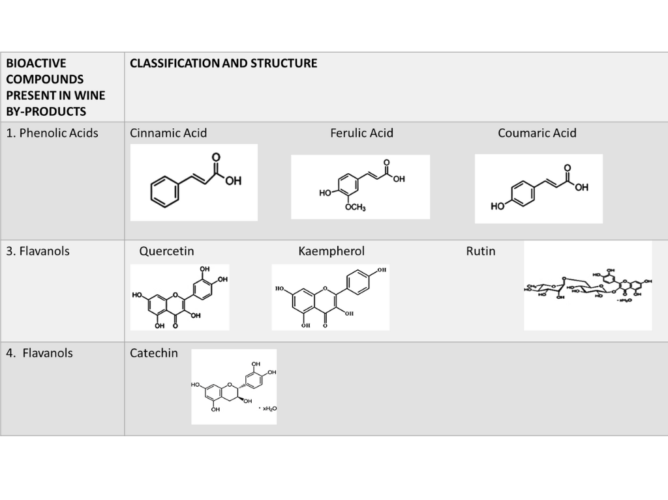
Table 1. Classification of bioactive compounds present in wine by-products

On the other hand, during direct extraction grape seeds are separated and the fiber obtained undergoes further processing to produce tartaric acid. The manufacture of phenolic compounds from grape seeds has finite uses due to the atrocious costs of extraction. Grape seeds contain proanthocyanidins, which are popularly known for their antihypertensive properties. It also contains flavonoids (catechin and anthocyanins), gallic acid, ellagic acid, and stilbenes (resveratrol). Grape seed is considered to be a vital source of alpha-tocopherol (vitamin E) which prevents free radical mutation in human cells. [41] The oil obtained from grape seeds contains antioxidants and is beneficial to reduce cholesterol levels. Grape seed oil is the only oil that is considered to increase high-density lipoprotein (HDL or good cholesterol) and low-density lipoprotein (LDL or bad cholesterol). For the revitalization of skin cells, protection against UV rays, and strengthening of the skin barrier, the grape seed oil is an elixir [39]. Grape pomace is separated in the pressing stage. Using different procedures, phenolic compounds, flavonoids, and proanthocyanidin are extracted. The phenolic content in the grape pomace is determined with the help of the Folin-Ciocalteu (FC) reagent. Flavonoid content is measured based on the complex made up of aluminum with those specific flavonoids. Pomace helps to prevent soil erosion by maintaining the pH due to its acidic nature. Black grape pomace has more polyphenolic content [42]. GP (seeds, skin, and some pulp) showed a high amount of phenolics while studying the flavanol profile. Grape skin contains quercetin-3-O-glucuronide and quercetin-3-O-glucoside in a considerably high amount [40]. Phenolic compounds present in plants come under secondary metabolites. They are substances that contain aromatic rings with hydroxyl groups and their derivatives. Phytoalexin produced by the plant as a result of the pathogenic attack is a stilbenoid. One of the best and largely produced polyphenols is a flavonoid. Flavonoids have many applications in the agro-food industry and they also serve as coveted materials for high-value products. There are many methods of identifying bioactive compounds from grape pomace. The first method is based on a hydrolysis reaction. The factors affecting the rate of the reaction are temperature and pressure. These two factors play a key role in influencing the attributes of water. Secondly, colorimetric tests are performed for the estimation of phenolic compounds present in grape pomace. The reagent used is FC reagent and absorbance is calculated at 750 nm. This colorimetric test can also be utilized to attest to the quality of grape pomace hydrolysates. The next method in use is HPLC analysis which helps in the identification of monosaccharides in grape pomace and quantifying phenolic compounds. Several different methods are used for the extraction of bioactive compounds. For phenolic compounds, hydroalcoholic extraction, extraction using acetone water, and using citric acid are performed [39]. In the manufacture of cosmetic products, the ingredients are directly extracted from the maceration of GP using glycerine, propylene, and sunflower oil. Ultrasonic-assisted maceration is a methodology followed for this. GP fractionation was performed to identify seven distinct recoveries with different concentrations of water and methanol. Different kinds of assays are performed such as lipoxygenase assay (iron-containing enzyme), elastase assay (endopeptidase), hyaluronidase assay (enzyme for the degradation of hyaluronic acid), and collagenase assay (enzyme to cleave collagen) [28]. GP is considered hazardous due to their high energy molecule content such as lignin and sugar. Its reactivity is suitable for combustion or pyrolysis reactions due to its high flammability. The minimum ignition energy of GP is less than 1000 millijoules. The energetic potential of a dusty compound depends on C-O and O-H bonds present [12].

- Wine Lees
After the completion of malolactic fermentation, maceration, clarification, filtration, and other general procedures of vinification, a water-based waste product is left as a residue in the bottom of the oak barrels, this is known as "wine lees". After grape pomace and marc, these are the second most important wine by-products. Conventionally used for the aging process of wine due to its applications in the enhancement of the sensory characteristics of wine, wine lees are a consistent source of high-value compounds like polyphenols. Anthocyanin is one such polyphenol. Although it is also extracted from grape skin, anthocyanin is present in wine lees at ten times higher concentration. Anthocyanins present in wine lees are furnished with high antioxidant, anti-radical, and metal chelating properties which make them suitable mode for carrying out biochemical mechanisms which require hindrance to lipid oxidation by the formation of peroxides. The geographical and climatic conditions greatly influence wine lees quality. An important part of valorization is the selection of a good extraction technique that will have a decreased environmental impact. The main disadvantages of the traditional extraction technique are the prolonged time period, increased volumes of extraction sorbents, and low selectivity. Novel extraction techniques like ultrasound-assisted extraction, pressurized liquid extraction, and so on are preferred because of the decreased time period, minimum detrimental effect on the environment, and utilization of environment-friendly innovative sorbents [38,25]. Frozen and dried wine lees undergo Microwave-Ultrasound combined treatment and enzymatic pre-treatments followed by traditional solid-liquid extractions for polyphenol extractions. After these procedures, a solid component and a liquid component are formed. The liquid component is abundant in polyphenols. The solid component consists of reducing sugars which are the synthetic integrant for feedstock for fermentation. The solid fraction also undergoes supercritical water (SCW) hydrolysis to produce biomass feedstock [29,22]. Wine leaves represent 2-6% of the total volume of wine produced. It is the perfect basic constituent for commercial manufacturing of tartaric acid and ethanol. However, it is not suitable to be used as animal feed due to its high phenolic content. Microwave-assisted extraction techniques are utilized for obtaining phenolic compounds from wine lees, whereas ultrasound-assisted extraction techniques are implemented for Squalene recovery. They can also be used as a potential food additive due to their abundant fatty acid composition. Apart from these wine lees can be used as a nutrient supplement in fermentative processes for lactic acid and xylitol production. Notwithstanding, the aforementioned propositions do not utilize the complete potential of wine lees. In recent studies, a new biorefinery approach has been implemented for the utilization of wine lees for obtaining ethanol, tartaric acid, and antioxidants on one hand and on the other hand incorporating them into yeast cells to substantiate generic fermentation feedstock [10,26].

- Grape Stems
Grape stems are separated before it undergoes further vinification steps to avoid the contingency of wine or adverse effects of organoleptic properties. The proportion of stems present in the processed raw matter is 1.4-7%. As of 2009, grape stems could only be used as animal feedstock or for enhancing soil nutrients. Grape stem composition can be further studied for its antioxidant properties and the presence of dietary fibers. The average moisture present in grape stems varies from 55-80% based on the type of grape. There is no difference found between red wine and white wine grape stems. The grape stem contains gallic acid (hydroxybenzoic acid derivative), syringic acid, and protocatechuic acid. Hydrolysable tannins are derivatives of gallic acid. Grape stems extracted from red and white wine grape varieties exhibit trans-capric acid. Flavanols present in grape stems contain quercetin derivatives mainly quercetin-3-O-glucuronide. These flavonoids have a double bond present between carbon 2 and carbon 3, with a hydroxyl group in carbon 3. Various kinds of sugars like glucuronides, galactosides, and glycosides are bound to these flavanols. Phenolic compounds made up of two aromatic rings joined by an ethylene bridge called stilbenes are found in lower abundance [40,11]. Grape stems contain 7% protein and 1.7% soluble sugars. There are two kinds of fibers found in grape stems: insoluble fibers which constitute cellulose and hemicellulose whilst soluble fibers are pectins. It is difficult for the human digestive system to absorb or assimilate the fibers present in the grape stem which reduces its nutritional value. The combination of polyphenols with micronutrients present in grape stems like vitamins C and E makes it a beneficial material. The compounds extensively in grape stems are catechin, capric acid, ferulic acid, syringic acid, and so on. [26] Anthocyanins like malvidin-3-O-glucoside and malvidin-3-O-rutinoside are also found in grape stems.
Grape stems can be used to produce bioenergy due to their property as lignocellulosic compounds which require the least amount of pre-treatment like transportation and processing costs. It is a good source of cellulose which makes it suitable for industrial works like manufacturing paper, food industries, and other pharmaceutical industries. The presence of lignin helps in the formation of resins, meta sequestration, paintings, and other coatings. [3] SSF procedures can be performed in order to produce raw materials from the sugar content present in the grape stem. These can be used to manufacture oxidative rancidity inhibitors due to their free radical scavenging property. The phenolic compounds detected in grape stems are beneficial for diabetes patients as it helps in regulating insulin levels in the body. The antimicrobial activity of grape stems works efficiently on the inhibition of various species of lactic acid bacteria, which further controls the effects of bacteria during malolactic fermentation [1]. Reverse phase high-performance liquid chromatography (RP-HPLC) is performed for chromatographic analysis of phenolic compounds. In this phenolics are distinguished on the basis of mass to charge ratio and the ultraviolet spectrum. NP-HPLC is a type of chromatographic technique performed to analyze polymers and flavan-3-ols present in grape stems. FC reagent can be used to study phenolic content [27,37]. Apart from the aforementioned techniques, there have been other advancements in the fields of extraction such as solid-liquid extraction (flavanols, proanthocyanidins), microwave-assisted extraction (quercetin, anthocyanin), ultrasound-assisted extraction (anthocyanin, flavan-3-ols) and supercritical fluids extraction [40].

D. Grape Stalks
The grape stalk is composed of several fibers like lignin and cellulose with a high percentage of elements such as nitrogen and potassium. Vineyards have low amounts of organic matter present in the soil which can be overcome by grape stalk composting which has a high crop production value. With the help of SSF and biological lignin removal, grape stalks can be converted to feedstock for humans and animals. It can also undergo the removal of metal ions and the production of antioxidants [39]. Stocks have high carbon content which makes them suitable for obtaining activated carbon. The ash content is higher in grape stalk than in eucalyptus wood and seeds of different fruits. Before activation of carbon, the leaching step is performed in order to study high metal content. A decrease in ash content is observed up to 70% when the leaching step is performed between activation and carbonization. Metal ions extraction yielded a good amount of sodium and potassium when leaching was done with water at boiling temperatures. After leaching, the activation process is performed using phosphoric acid [8].
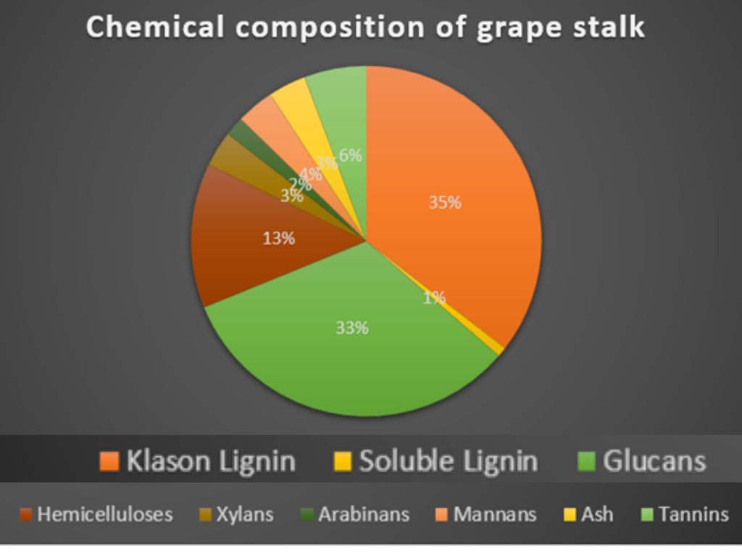
The cellulose and hemicellulose present in grape stalk serves as an antioxidant by the separation of fermentable sugars (enzymatic treatment for biofuel) and phenolic compounds. As mentioned above, grape stalks have high concentrations of metal ions that serve as sorbent for paracetamol and reagent methylene blue. The chemical constitution of the grape stalk depends on geographical factors, climatic factors, grape species, and harvesting periods. The polyphenol content of grape stalk can be measured with the help of spectrophotometry keeping gallic acid as standard. Tannins present in stalks are separated by the process of precipitation using a methylcellulose solution. The main factor of the grape stalk which is its ash content is measured by digesting ashes using hydrochloric acid and studying the observations under atomic absorption spectroscopy. To analyze the functional groups, present in grape stalks, Fourier transforms infrared ray (FTIR) analysis is conducted [30,31,32]. The average production of grape stalks per year is 5 tones. Under lignocellulosic feedstock biorefinery (LCF biorefinery) the stalks undergo biochemical conversion, thermochemical conversion, and pyrolysis gasification which produces syngas, methane. Biochemical conversion leads to the formation of lignin, natural adhesives, sulfur-free solid fuel, furfural, lubricants, and cellulose [42,33,35].
Graph 2. Chemical composition of grape stalk
- Vinasses
Vinasse is the liquid waste obtained after fermentation and distillation of alcoholic beverages. The products that are obtained are lactic acid and tartaric acid. It is necessary to dispose or utilize vinasse as it is corrosive in nature and it has high chemical oxygen demand. [45] Vinasses have a major concentration of oxygen, mineral salts and are acidic in nature. [44] It undergoes solubilization, alkali treatment, and microwave treatment to obtain desired products. The untreated vinasse is used as a component in nutrient media for the production of lactic acid. The liquid waste obtained from white wine can be used to produce xylitol.
Vinasse has various applications in the field of aquaculture and fungal biomass production.[31] Natural food and beverage preservatives like citric acid and phosphoric acid can be replaced by tartaric acid obtained from vinasses. Researchers have studied the use of winery liquid waste in the production of cellulose as a substrate for glucose, Acetobacter xylinus. Several fungi like Aspergillus niger can also be added to vinasse for the production of single-cell protein [42]. Vinasse can be treated by using technologies like biodigestion, fertirrigation, and thermal concentration. Vinasse is used as a fertilizer to meet the potassium requirement of the soil. This is mostly practiced in Brazil. [44]

- FUTURE RESEARCH PERSPECTIVES

The substituents of grapes along with the extensive variations of each constituent affect the processing differently, influencing the yield in must, its quality, and the wine produced. Apart from these factors, industrial profit and loss determined by the quality and quantity of the by-products are also influenced. The bunches are the skeletal structure of the grapes and can be used as natural fertilizers in viticulture or as biofuel. Wine yeast obtained can be used as a secondary raw material for alcohol, tartaric acid, and feed flour. The tartar can be used for the production of calcium tartrate and tartaric acid. Tartar cream is also called wine stone. The vinasse obtained after distillation contains tartrates of calcium chloride and lime milk [7]. The wastes produced due to vinification cause lots of environmental issues due to their neutralized and fermented nature and due to the presence of various hazardous compounds. Hence, in the present world, it has become essential to convert these detrimental effects into positive effects with an added nutritional and industrial advantage [36,20,21]. Waste can be perceived as a practically inexhaustible resource and can be used for the generation of combined heat and power (CHP) and fertilizers for growing industrialization. In the forthcoming years, these industries will be revolutionized further and a shift will be observed towards more recyclable energy. Through artificial materials, seeds, food wastes, and other waste products so as to reduce our carbon footprint. Natural resources are non-renewable and as the world progresses, due to the increasing demand observed with the growing population, minimal usage of natural resources is being practiced to ensure sustainability. Hence, the employment of waste as a profitable commodity and alternative source of energy production is an attraction for upcoming industries.
Due to the increased demand for waste products the costs of traditional treatment methods of waste are reaching exorbitant rates. Since these methods require comparatively more effort, resources and precautions for safe discharge into the environment these methods are not desirable anymore. The concept of the biorefinery is considered to be a more prudent approach. There is nothing innovative about the utilization of agrochemical materials for manufacturing other products. On the other hand, using plant biomass as a precursor to show various complex physicochemical processing methods is a comparatively novel idea. This concept was first observed in the 1980s for the working of the petroleum refinery. Though fruitful, this method has several disadvantages due to the presence of lignin, carbohydrates, fats, proteins, vitamins, and dyes in plant-based biomass, it's used as a bio-conversion substrate is often expensive due to the prerequisites for its pre-treatment [23,24]. It requires large acres of land to be extensively cultivated leading to land feeds for crop development, shortage of feedstock, and geographical and climatic constraints. Hence, recently the whole crop concept has been replaced with the water-based concept which involves the utilization of lignocellulose feedstock. But every method has its drawbacks and this method calls for expensive pre-treatment procedures for the production of cellulose and hemicellulose. Hence, researchers and other bodies of operation want to replace the main feedstock to waste materials. This approach is highly beneficial for the environment and economically as well [42,3,4,5].
In recent years, it has been observed that people consume dietary supplements in various forms like tablets or jellies for boosting their immunity against diseases. Several literatures evidenced that antioxidant supplements could be utilized as a preventive measure for various neurological and cardiovascular diseases. Flavan-3-of compounds like catechin and epicatechin and their polymers have shown various antioxidant properties. According to research conducted in 2010, it was observed that flavan-3-ol compounds could be obtained from wine waste seeds using water as a solvent. It includes in vivo and in vitro methods and this discovery is a great achievement in the treatment of Alzheimer's and Parkinson's diseases. This is because nervous tissues are always at a risk from reactive oxygen species (ROS) produced during regular somal oxygen metabolism. These neurodegenerative disorders can be controlled to an extent by the antioxidant properties of flavan-3-ol compounds which inhibit oxidative degradation [34]. A recent case study conducted in the Republic of Moldova shows an intricate link between the activities of the vine sector and the agrochemical and biotechnological industries. One of the most pivotal components of the human economy in these recent times of organization is the industry. In the Republic of Moldova special importance has been entrusted to the use of synthetic resources and less use of natural resources which are non-renewable. They are aiming for a circular economic development model which consists of a complete recycling process leading to "zero" waste production. The polluting load of non-processed wine by-products is approximately equivalent to a population of 3-4 million inhabitants in Moldova; the waste obtained from the wine sector is processed, capitalized, and marketed as a means to counteract this negative effect. Statistical data has shown that the largest amount of waste in the Republic of Moldova from the years 2013 to 2027 is and will be from the food and liquor sector. The approximate harvest per annum of grapes for the last three years (2017-2019) was equal to 280 thousand tonnes according to the Wine Register of the Republic of Moldova. The by-products generated were about 70 thousand tonnes in the form of stems, pomace, yeast and so on which can be commercialized in marketable commodities such as protein flour, oil, arthritic acid, and enotanin [7,41]. More development is required in the areas that concern commercial aspects like food-grade, sustainability, and functionality.

V. CONCLUSION

In conclusion, there are several products of significant value that can be produced from wine by-products. The only requirement is the proper processing, extraction, and capitalization of the waste materials as raw materials. Being rich in antimicrobial and antibacterial properties, wine waste has various implementations in the medicinal field. Wine lees and wine stalk has been used in nutrient medium for the growth of microorganisms. While, fortified grape pomace has proved to be the finest commodity. Furthermore, the area of wine lees for production of raw materials needs to be taken at commercial levels. Hence, it can be concluded that the valorization of vinification by-products is an economical and environment-friendly approach during these times of globalization.

- ACKNOWLEDGEMENT

We would like to extend our gratitude to our mentor, Dr. K.A. Paari for guiding us through the intricacies of writing a review article on the given topic. We also wish to acknowledge the support received from the Center for Research, CHRIST University (MRPDSC – 1936).

- REFERENCES

[1] A. Barros, A. Gironés-Vilaplana, A. Texeira, N. Baenas, and R. Domínguez-Perles, “Grape stems as a source of bioactive compounds: application towards added-value commodities and significance for human health,” Phytochemistry Reviews, vol. 14, no. 6, pp. 921–931, Jun. 2015, doi: https://doi.org/10.1007/s11101-015-9421-5.
[2] S. B. Swami et al., “Fruit wine production: A review,” J. Food Res. Technol., vol. 2, no. 3, pp. 93-100, 2014.
[3] A. Bucić-Kojić, et al., “‘Winery Production residues as feedstocks within the biorefinery concept.’ Engineering Power,” Bull. Croat. Acad. Eng., vol. 17, no. 1, pp. 11-17, 2022.
[4] V. Canuti, et al., Proc. XXIV Workshop on the Developments in the Italian PhD Research on Food Science, Technology and Biotechnology, 2019, pp. 1-584.
[5] M. V. L. Chhandama, A. C. Chetia, K. B. Satyan, Supongsenla Ao, J. V. Ruatpuia, and S. L. Rokhum, “Valorisation of food waste to sustainable energy and other value-added products: A review,” Bioresource Technology Reports, vol. 17, p. 100945, Feb. 2022, doi: https://doi.org/10.1016/j.biteb.2022.100945.
[6] A. Cortés, M. T. Moreira, and G. Feijoo, “Integrated evaluation of wine lees valorization to produce value-added products,” Waste Management, vol. 95, pp. 70–77, Jul. 2019, doi: https://doi.org/10.1016/j.wasman.2019.05.056.
[7] C. Diaconu and L. Bugaian, Valorization of Winery Waste. Case of the Republic of Moldova, 2021.
[8] Ana Cristina Deiana, Maria Fabiana Sardella, H. G. Silva, A. Amaya, and N. Tancredi, “Use of grape stalk, a waste of the viticulture industry, to obtain activated carbon,” vol. 172, no. 1, pp. 13–19, Dec. 2009, doi: https://doi.org/10.1016/j.jhazmat.2009.06.095.
[9] J. Diaz-Ramirez, L. Urbina, A. Eceiza, A. Retegi, and N. Gabilondo, “Superabsorbent bacterial cellulose spheres biosynthesized from winery by-products as natural carriers for fertilizers,” International Journal of Biological Macromolecules, vol. 191, pp. 1212–1220, Nov. 2021, doi: https://doi.org/10.1016/j.ijbiomac.2021.09.203.
[10] C. Dimou et al., “Wine lees valorization: Biorefinery development including production of a generic fermentation feedstock employed for poly(3-hydroxybutyrate) synthesis,” Food Research International, vol. 73, pp. 81–87, Jul. 2015, doi: https://doi.org/10.1016/j.foodres.2015.02.020.
[11] O. Dorosh et al., “Vine-Canes Valorisation: Ultrasound-Assisted Extraction from Lab to Pilot Scale,” Molecules, vol. 25, no. 7, p. 1739, Apr. 2020, doi: https://doi.org/10.3390/molecules25071739.
[12] E. Danzi, et al., “Biomass from winery waste: Evaluation of dust explosion hazards,” Chem. Eng. Trans., vol. 86, pp. 301-306, 2021.
[13] J. Fehér, G. Lengyel, and A. Lugasi, “The cultural history of wine - theoretical background to wine therapy,” Open Medicine, vol. 2, no. 4, Jan. 2007, doi: https://doi.org/10.2478/s11536-007-0048-9.
[14] M. Ferri et al., “From winery waste to bioactive compounds and new polymeric biocomposites: A contribution to the circular economy concept,” Journal of Advanced Research, vol. 24, pp. 1–11, Jul. 2020, doi: https://doi.org/10.1016/j.jare.2020.02.015.
[15] J. García-Lomillo, M. L. González-SanJosé, R. Del Pino-García, M. D. Rivero-Pérez, and P. Muñiz-Rodríguez, “Antioxidant and Antimicrobial Properties of Wine Byproducts and Their Potential Uses in the Food Industry,” Journal of Agricultural and Food Chemistry, vol. 62, no. 52, pp. 12595–12602, Dec. 2014, doi: https://doi.org/10.1021/jf5042678.
[16] “GJRA | Global Journal For Research Analysis (GJRA),” World Wide Journal - GJRA. https://www.worldwidejournals.com/global-journal-for-research-analysis-GJRA/recent_issues_pdf/201 (accessed Jun. 20, 2023).
[17] X. X. Guo, “Study of aging and production of wine from grape fruit by fermentation process,” Ethnobotanical Leafl., vol. 2005, no. 1, p. 4, 2001.
[18] R. Gutiérrez-Escobar, M. J. Aliaño-González, and E. Cantos-Villar, “Wine Polyphenol Content and Its Influence on Wine Quality and Properties: A Review,” Molecules, vol. 26, no. 3, p. 718, Jan. 2021, doi: https://doi.org/10.3390/molecules26030718.
[19] J. Herbst, Aqueous two-phase systems for the extraction of polyphenols from wine solid waste [Diss.]. Stellenbosch: Stellenbosch University, 2019.
[20] J. J. Hunter et al., ‘Vineyard management for environment valorisation.’ VIIIth Int. Terroir Congress, 2010.
[21] M. Jesus, A. Romaní, F. Mata, and L. Domingues, “Current Options in the Valorisation of Vine Pruning Residue for the Production of Biofuels, Biopolymers, Antioxidants, and Bio-Composites following the Concept of Biorefinery: A Review,” Polymers, vol. 14, no. 9, p. 1640, Apr. 2022, doi: https://doi.org/10.3390/polym14091640.
[22] J. Kassongo, Esmaeil Shahsavari, and A. Ball, “Dynamic Effect of Operational Regulation on the Mesophilic BioMethanation of Grape Marc,” vol. 26, no. 21, pp. 6692–6692, Nov. 2021, doi: https://doi.org/10.3390/molecules26216692.
[23] Gaceu et al., “Researches regarding the superior valorisation of by-products from the winery industry, and the obtaining of bakery products with functional properties,” Annals Acad. Rom. Sci. S. Agric. Silviculture Vet. Med. Sci., vols. 1/2020, 2020.
[24] L. Ruggieri, et al., “Recovery of organic wastes in the Spanish wine industry. Technical, economic and environmental analyses of the composting process,” J. Cleaner Prod., vol. 17, no. 9, pp. 830-838, 2009 doi:10.1016/j.jclepro.2008.12.005.
[25] B. Mathew, M. S. Sambo Datsugwai, E. S. David, and U. Harriet, “Production of wine from fermentation of grape (vitis vinifera)&nbsp; and sweet orange (citrus seninsis) juice using saccharomyces cerevisiae&nbsp; isolated from palm wine,” International Journal of Current Microbiology and Applied Sciences, vol. 6, no. 1, pp. 868–881, 2017. doi:10.20546/ijcmas.2017.601.103
[26] D. D. Milinčić et al., “Phenolic compounds and biopotential of grape pomace extracts from PROKUPAC red grape variety,” LWT, vol. 138, p. 110739, 2021. doi:10.1016/j.lwt.2020.110739
[27] J. A. Nieto, S. Santoyo, M. Prodanov, G. Reglero, and L. Jaime, “Valorisation of grape stems as a source of phenolic antioxidants by using a sustainable extraction methodology,” Foods, vol. 9, no. 5, p. 604, 2020. doi:10.3390/foods9050604
[28] H. Plainfossé et al., “Valorisation of Ribes nigrum L. Pomace, an agri-food by-product to design a new cosmetic active,” Cosmetics, vol. 7, no. 3, p. 56, 2020. doi:10.3390/cosmetics7030056
[29] B. Poulain et al., “Subcritical water: An original eco-sustainable process for wine lees valorization?” in Vino Anal. Sci., vol. 2022, 2022.
[30] D. Pujol et al., “Chemical characterization of different granulometric fractions of grape stalks waste,” Industrial Crops and Products, vol. 50, pp. 494–500, 2013. doi:10.1016/j.indcrop.2013.07.051
[31] J. M. Salgado, et al., Valorisation of Vinasses by Recovery Tartaric Acid and Bioproduction of Lactic Acid and Emulsifiers by Lactobacillus Pentos, 2013.
[32] Â. C. Salvador et al., “Vine waste valorisation: Integrated Approach for the prospection of bioactive lipophilic phytochemicals,” International Journal of Molecular Sciences, vol. 20, no. 17, p. 4239, 2019. doi:10.3390/ijms20174239
[33] C. Santini, A. Cavicchi, and L. Casini, “Sustainability in the wine industry: Key questions and research trendsa,” Agricultural and Food Economics, vol. 1, no. 1, 2013. doi:10.1186/2193-7532-1-9
[34] G. Scola et al., “Flavan-3-ol compounds from wine wastes with in vitro and in vivo antioxidant activity,” Nutrients, vol. 2, no. 10, pp. 1048–1059, 2010. doi:10.3390/nu2101048
[35] Scola, G., Kappel, V., Moreira, J., Dal-Pizzol, F., & Salvador, M. (2011). Antioxidant and anti-inflammatory activities of the winery wastes seeds of Vitis labrusca. Ciência Rural, 41(7), 1233-1238. https://doi.org/10.1590/s0103-84782011000700020
[36] A. Soceanu, S. Dobrinas, A. Sirbu, N. Manea, and V. Popescu, “Economic aspects of waste recovery in the wine industry. A multidisciplinary approach,” Science of The Total Environment, vol. 759, p. 143543, 2021. doi:10.1016/j.scitotenv.2020.143543
[37] G. Squillaci et al., “Grape canes from typical cultivars of Campania (southern Italy) as a source of high-value bioactive compounds: Phenolic profile, antioxidant and antimicrobial activities,” Molecules, vol. 26, no. 9, p. 2746, 2021. doi:10.3390/molecules26092746
[38] D. Tagkouli et al., “Towards the optimization of microwave-assisted extraction and the assessment of chemical profile, antioxidant and antimicrobial activity of Wine Lees extracts,” Molecules, vol. 27, no. 7, p. 2189, 2022. doi:10.3390/molecules27072189
[39] E. T. Nerantzis and P. Tataridis, “Integrated enology-utilization of winery by-products into high added value products,” J. Sci. Technol., vol. 1, no. 3, pp. 79-89, 2006.
[40] A. Teixeira et al., “Natural bioactive compounds from winery by-products as Health Promoters: A Review,” International Journal of Molecular Sciences, vol. 15, no. 9, pp. 15638–15678, 2014. doi:10.3390/ijms150915638
[41] G. Toscano et al., “Analysis of the characteristics of the residues of the wine production chain finalized to their industrial and Energy Recovery,” Biomass and Bioenergy, vol. 55, pp. 260–267, 2013. doi:10.1016/j.biombioe.2013.02.015
[42] V. Vişanu, “Valorization of grape pomace by fertilization.” The closing conference of the Intelligent valorisation of agro-food industrial wastes project, 2SOFT/1.2/83, 2022.
[43] M.-P. Zacharof, “Grape winery waste as feedstock for bioconversions: Applying the biorefinery concept,” Waste and Biomass Valorization, vol. 8, no. 4, pp. 1011–1025, 2016. doi:10.1007/s12649-016-9674-2
[44] S. C. Rabelo, A. C. da Costa, and C. E. Vaz Rossel, “Industrial Waste Recovery,” Sugarcane, pp. 365–381, 2015. doi:10.1016/b978-0-12-802239-9.00017-7
[45] L. A. Cortez, R. Baldassin, and E. de Almeida, “Energy from sugarcane,” Sugarcane Biorefinery, Technology and Perspectives, pp. 117–139, 2020. doi:10.1016/b978-0-12-814236-3.00007-x

