RECURRENT LOWER RESPIRSTORY TRACT INFECTION IN A CASE OF MUSCULAR DYSTROPHY
ABSTRACT
This is a rare case of a 19 year old boy who presented to the emergency department with severe respiratory distress. He was diagnosed as “Lower Respiratory Tract Infection in the background of Muscular Dystrophy”. The onset was subacute and the patient had such recurrent episodes of Lower Respiratory Tract Infections in the past 3years. The patient was wheelchair bound. On examination, he had marked kyphoscoliosis, spO2 of 71%@room air with crepts and wheeze. Echo, HRCT Thorax and Blood investigations are mentioned subsequently. He was conservatively treated and discharged.
INTRODUCTION
Muscular dystrophy, namely Duchenne variety, is the most common type of inherited neuromuscular disorder which can be broadly divided into 3types:
- DUCHENNE TYPE
- BAKER TYPE
- FASCIOSCAPULOHUMERAL TYPE (Landouzy DeJerine disease)

Muscular dystrophy is an X-Linked Recessive inheritance with Xp21 Dystrophin gene mutation. A patient suffering from this condition typically presents with proximal muscle weakness by around 3years of age and elicits GOWER sign. The weakness begins from calf muscles typically and involves the vastii group of muscles early around 6years of age.
Respiratory compromise is common as intercostal group of muscles along with diaphragm weakens over time and Tidal volume drops sharply. The Expiratory flow keeps declining around 13 years of age and the most common cause of early death being Chronic ventilator failure due to respiratory muscle paralysis alongside Cardiomyopathy.

CASE REPORT

This is a case of a 19 year old boy presenting to the emergency with severe respiratory distress since last 2days. It was gradual in onset and progressive in nature. The patient was a case of Muscular Dystrophy diagnosed at 6years of age. He had recurrent such attacks of pneumonia and lower respiratory tract infections in the past 3years.
ON EXAMINATION:
He was wheelchair bound since six years of age with marked kyphoscoliosis. Speech abnormalities noted.
BP- 138/70mmHg, Pulse rate 105/min and normal in character with elevated pulse volume. spO2-71%@Room air. CBG-137mg/dl. Diaphoresis present.
No signs of Pallor, Icterus. B/L pedal Edema present. Mild-Moderate cyanosis could be elicited by bluishness of ear lobules. Clubbing could be seen. No visible/dilated neck veins and palpable lymph nodes and neck glands.
Respiratory rate was around 24-26/min. Pattern was Abdominothoracic in a propped up position.
ON AUSCULTATION:
Bilateral basal coarse crepts, bilateral wheeze and rhonchi throughout all zones of lung field. Bilateral Reduced air entry (Left >Right).
S1 and S2 audible with no adventitious heart sounds.

REPORTS DURING HIS HOSPITAL STAY
PARAMETRES | RESULTS | REFERENCE
Complete Haemogram
Haemoglobin | 12.5 g/dl | 13-18
R.B.C Count | 0 | 4.5-5.5
W.B.C Count | 9100 | 4000-10000
Differential count
Neutrophil | 82% | 40-70
Lymphocyte | 14% | 25-35
Monocyte | 01% | 2-8
Eosinophil | 03% | 1-4
Basophil | 00% | 0-1
ESR | 30mm in 1st hr | 5-20
Urea | 15mg/dl | 10-50
Creatinine | 0.67md/dl | 0.5-1.8
Na+ | 135mosm/L | 135-150
K+ | 5mosm/L | 3.5-5.5
LIVER FUNCTION TEST
Total bilirubin | 0.75 | 0-1
Indirect bilirubin | 0.21 | Upto 0.25
Direct bilirubin | 0.54 | Upto 0.75
SGOT | 125 | Upto 46
SGPT | 194 | Upto 40
ALP | 241 | 40-250
Total Protein | 8.5 | 6.4-8.3
ALBUMIN | 4.9 | 3.5-5
GLOBULIN | 3.6 | 2-3.5
A G RATIO | 1.4

URINE ANALYSIS

Routine examination---WITHIN NORMAL LIMITS
Microscopic examination—Pus cells 15-18/hpf. Bacteria present.
Culture & Sensitivity—No growth

Serum Phosphocreatine kinase – 19,560 u/L

HRCT THORAX (PLAIN)

-COLLAPSE NOTED AT LINGULA SEGMENT
- REST OF LUNG PARENCHYMA HAS DIFFUSE PATCHY OPACITIES
-DIFFUSE FATTY ATROPHY OF PARASPINAL MUSCLES AND MUSCLES OF ANTERIOR ABDOMINAL WALL
-KYPHOSCOLIOTIC DEFORMITY OF DORSAL SPINE

ECHOCARDIOGRAPHY

-NORMAL LV CAVITY SIZE
- GLOBAL HYPOKINESIA
- LV DIASTOLIC DYSFUNCTION-----LVEF 40-45%
-REDUCED DIASTOLIC COMPLIANCE

PULMONARY FUNCTION TEST

Normal, FVC >80% 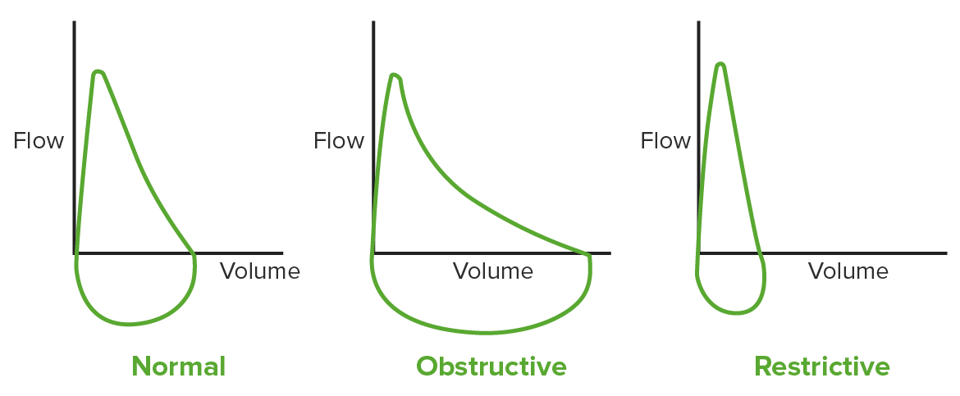
Restrictive lung disease
FVC<80%
Expiratory volume is 1st second: Reduced
FEV1/FVC = NORMAL OR INCREASED
Extrinsic lung disease
Residual volume: normal
Total lung capacity Reduced RV/TLC = INCREASED
TIDAL VOLUME DROPPING TO LESS THAN 20% RESULTS IN NOCTURNAL DYSPNOEA AND HYPOVENTILATION.

Discussion
Duchene’s Muscular Dystrophy (DMD) is the type with rapid onset, fast progression and death by 8-10years of age (median value). Baker’s type on the other hand, has a much insidious onset, indolent progression and death typically around 18-25 years of age.

GENERAL CONSIDERATIONS OF THE DISEASE INCLUDE
GOWER SIGN (+) due to early involvement of Vastus lateralis, Gluteus group and definitely Gastrocnemius and soleus resulting in it’s pseudohypertrophy making the patient wheelchair bound.
Tongue muscle pseudo-hypertrophy followed resulting in DYSARTHRIA.
Psuedohypertrophy of Deltoid and Infraspinatus, typically VALLEY SIGN, rendered widening the intra-scapular region accentuating the Kyphoscoliosis.
RESPIRATORY CONSIDERATIONS
KYPHOSCOLIOSIS CAUSES RESTRICTIVE PATTERN OF LUNG PATHOLOGY. The fraction of expired air in the first second as well as the Tidal volume sharply declined within early to mid adolescence.
There is, in total, a loss of proximal muscle mass replaced by fatty tissue which causes it’s pseudohypertrophy like the Intercostal group. Diaphragm involvement is insidious.
FORCED VITAL CAPACITY (FVC) shows a typical ascending phase, plateau phase followed by a descending phase. This patient, as from the history of recurrent Lower respiratory Tract Infections and Pneumonia, clearly indicated to have a declining FVC, a marker of Respiratory insufficiency. Declining FVC contributed by both declining Inspiratory capacity and Expiratory Reserve volume. Routine Spirometry is a must as it has one of the most important PROGNOSTIC VALUE.
Recurrent infections and respiratory insufficiency has already resulted in Lingular lobe collapse and in further course pertain to collapse of other lung segments, atelectasis of a lobe and Bronchiectasis thereby GROSSLY REDUCING THE VOLUME AND SURFACE AREA FOR GAS EXCHANGE.

CARDIOVASCULAR CONSIDERATIONS
As mentioned in the Echo report, Global wall hypokinesia can be noted. Pathoanatomical background includes dysfunctional cardiomyocytes and impulse generation pathway being replaced by fibrofatty tissue. Cardiomyopathies are an adolescent development as the patient’s early Echo report (10years) showed only Regional wall motion abnormality with a near normal ejection fraction.
This replacement results into declining myocardial contractility, decreased systolic function and Heart Failure which again contributes towards Lower respiratory tract infections. Heart failure in the patient was the result of pedal edema and bibasal crepitations. Seen with especially deletion of exons 48 to 53.
Arrythmias could be a presentation even though the ECG did not show any evidence of arrhythmia in the patient. Sudden cardiac death may ensue.
Further investigations like, Thallium Scinitigraphy, Cardiac MRI and Magnetic Resonance Spectroscopy to look for the type of Cardiomyopathy, perfusion and reduced dystrophin expression could have been done but was beyond the scope.

TREATMENT MODALITY AND CONCLUSION
As the mutation in the Dystrophin gene is bound to produce gradual weakness and dysfunction of the skeletal, respiratory and cardiac muscles, Respiratory Insufficiency, Recurrent Lower Respiratory Tract Infections and Cardiomyopathy following heart failure is an inevitable fate.
CHEST PHYSIOTHERAPY plays a key role in combating collapse, secretion stasis and bronchiectasis causing pneumonia.
STEROIDS are a mainstay with prolonged therapy, reduce the progression of the disease mainly exacerbations.
During exacerbations, potent antibiotics as in this case Piperacillin – Tazobactam; regular interval nebulization and most importantly use of Intermittent CPAP with an attempt to correct scoliosis in an early reduce progression.
PIRFENIDONE, a synthetic pyridine, also used in Idiopathic pulmonary fibrosis was used in the treatment of this patient assumed to slow the deposition of fibrofatty tissue thereby slowing the disease progression.

IN CONCLUSION, BAKER’S MUSCULAR DYSTROPHY (in this case) PRESENT WITH A PROGRESSIVE DECLINING RESPIRATORY AND CARDIAC FUNCTION ALONG WITH BRAIN FUNCTIONS (Early onset epilepsy and cortical atrophy) AND THE MOST COMMON CAUSE OF DEATH BEING CHRONIC RESPIRATORY INSUFFICIENCY AND CARDIOMYOPATHY RESULTING IN SUDDEN CARDIAC DEATH.

References
- Harrison’s Principle of Internal Medicine 21e
- Nelson’s Textbook of Paediatrics 21e
- OP GHAI Textbook of Paediatrics 9e
- European Respiratory Journal on Duchenne Muscular Dystrophy
- National Library of Medicine journal on cardiovascular of Becker’s Muscular Dystrophy
- Fishman’s Pulmonary diseases and disorders 5e

