**ARDUINO BASED SMART PARKING SYSTEM**

**[1]Mr.N.Nagarjuna,[2] Mrs.P.Lavanya Kumari,[3]Ms.V.Bhulakshmi, [1],[3]Assistant Professor,[2]Associate Professor**

**[1],[2],[3] Department of Computer Science and Engineering(Data Science)** [**Email:[1]nagarjuna.nagaram@gmail.com**](mailto:Email:[1]nagarjuna.nagaram@gmail.com), **[2]lavanya.madina@gmail.com [3]**[**varipalli.bhulakshmi19@gmail.com**](mailto:varipalli.bhulakshmi19@gmail.com)

[1],[2],[3]Vignan Institute of Technology and Science, Hyderabad, Telangana.

**ABSTRACT:**

In response to the escalating issue of modern-day traffic congestion, the development of smart auto parking systems has emerged as a promising solution. Our team has successfully created an Arduino-based car parking system with the goal of optimizing parking space utilization and enhancing overall traffic flow.This innovative system provides invaluable assistance to drivers in locating available parking spaces swiftly and efficiently. It achieves this through the utilization of Infrared (IR) sensors, which are adept at detecting the presence or absence of vehicles within the parking area. By employing this technology, we aim to not only enhance convenience but also contribute to the improvement of urban traffic management.The application of parking management software is pivotal in automating various aspects of parking administration. This software streamlines processes related to enforcement, issuance, and overall facilitation of parking services. This is particularly valuable for a diverse range of entities, including private garages, public parking facilities, municipal authorities, and educational institutions that allocate space for parking purposes.One notable feature of our system is the ability for drivers to quickly locate available parking slots, ultimately saving them valuable time. This is made possible by incorporating IR sensors that provide accurate distance estimates. The Arduino microcontroller plays a central role in processing the sensor input, generating the necessary output, and displaying the results on a 20x4 LCD display. The successful implementation of this system was achieved through the precise programming of both the IR sensors and the Arduino microcontroller.

***Keywords— Arduino, IR Sensors, LCD Screen, Servo motor.***

**1. INTRODUCTION:**

Urban congestion resulting from cars searching for parking spaces constitutes a substantial 30% of city traffic congestion. Historically, the equilibrium of parking supply and demand has been managed through collaborative efforts of cities, businesses, and real estate developers. However, it is abundantly evident that merely augmenting the number of parking spaces will not suffice to resolve this congestion conundrum.In response to this challenge, innovative parking methodologies leveraging intelligent technology have emerged, offering a more equitable approach to parking management. These methods seek to effectively regulate the dynamic link between parking supply and demand. Termed as "smart parking," this approach has become an essential component of comprehensive urban mobility plans. It encompasses the integration of cutting-edge technologies to streamline the operation, monitoring, and management of parking facilities.The market potential for companies specializing in smart parking services, both within domestic markets and abroad, is substantial. The United States notably commands a significant share, accounting of the global smart parking systems market. Smart parking systems are underpinned by a diverse array of technologies. These include vehicle sensors for precise occupancy detection, wireless connectivity for seamless communication, and sophisticated data analytics for informed decision-making. What renders smart parking a practical and viable alternative today are the strides made in ancillary industries. This encompasses advancements in mobile payment technologies, in-car navigation systems, and customer service applications for smartphones.At its core, the smart parking concept hinges on the seamless flow of information. This encompasses the ability to access, collect, analyze, transmit, and respond to data regarding parking utilization. This informational backbone empowers parking managers and drivers alike to tap into real-time data streams from intelligent devices. This capability enables them to make informed decisions on parking choices, thus maximizing the utilization of available parking spaces. This represents a monumental leap forward in optimizing urban mobility and mitigating the traffic congestion associated with parking.

Increasing the number of parking spaces alone is insufficient to alleviate congestion [1]. To address this issue, innovative parking solutions leveraging intelligent technology aim to provide a more balanced perspective on parking, effectively managing the link between supply and demand [2]. This approach, known as smart parking, is a crucial component of urban mobility planning, utilizing cutting-edge technologies to streamline the operation, monitoring, and management of parking facilities [3].The potential for growth in companies offering smart parking services, both domestically and internationally, is substantial. The United States holds a significant share, accounting for 46% of the global market for smart parking systems, with total global sales reaching $93.5 million [4].Smart parking systems rely on a range of advanced technologies, including vehicle sensors, wireless connectivity, and sophisticated data analytics [5]. This has become a practical solution thanks to advancements in related industries like mobile payments, in-car navigation, and customer service applications for smartphones [6].At the heart of the smart parking concept lies the ability to access, acquire, analyze, transmit, and act upon information about parking usage [7]. This empowers parking managers and drivers to access real-time data from intelligent devices, enabling them to make informed decisions and maximize the utilization of available parking spaces [8]. This represents a significant leap forward in optimizing urban mobility and reducing traffic congestion associated with parking.

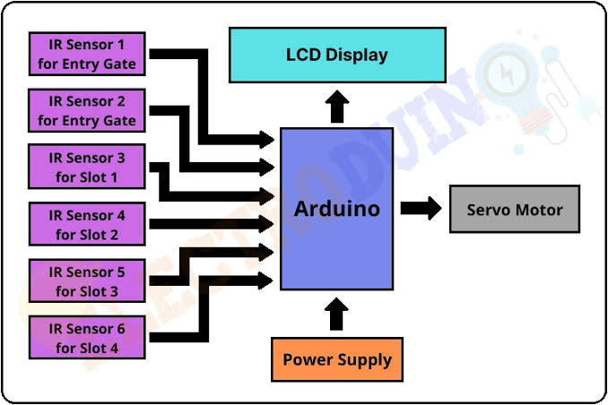**2. BLOCK DIAGRAM OF SMART PARKING SYSTEM:**

Figure: BLOCK DIAGRAM OF SMART PARKING SYSTEM

**2.1 DESCRIPTON OF BLOCK DIAGRAM:**

* Above is a diagram of the "SMART PARKING SYSTEM".
* primarily, it is made up of three blocks.
* Blocks 1 through 3 are the input, the data processing system, and the output.
* To identify the car at the parking lot entry, we link the sensors to the input block.
* Then, our second component, the data processing system, will store that input.
* Data processing system using Servo Motor and Arduino
* Here, the user-provided data is processed in accordance with their input, and following processing, the output signal is presented on the LCD.
* When the output block receives a signal from the data processing system, it shows the availability of parking slots on the LCD and opens and closes the barrier in accordance with the user. The output block is made up of a servo motor barrier.

**3. IMPLEMENTATION:**

We may upload sketches and write code to any official Arduino board using the web editor for Arduino.

Developers can write code, read tutorials, set up boards, and share creations on an online platform made possible by the Arduino IDE (Integrated Development Environment). was created to offer consumers a continuous workflow.

Step 1 − As seen in the accompanying image, the first two things we need are an Arduino board (you can choose your favourite board) and a USB cord. A standard USB cable (A plug to B plug), the kind you'd use to connect to a USB printer, is required whether you're using an Arduino UNO, Arduino Duemilanove, Nano, Arduino Mega 2560, or Diecimila.

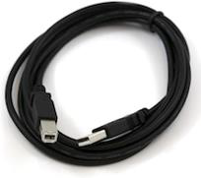

Figure: USB Cable (A plug to B plug)

If we want to use the Arduino Nano, we will require an A to Mini-B cable, as seen in the

accompanying illustration.

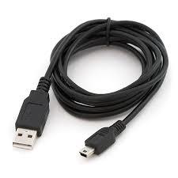

Figure: Cable of Arduino Nano

**Step 2 − Download Arduino IDE Software**

We may download several versions of the Arduino IDE from the Download page on the official Arduino website. We must pick software that is compatible with Windows, iOS, or Linux. When file has completed downloading, unzip it.

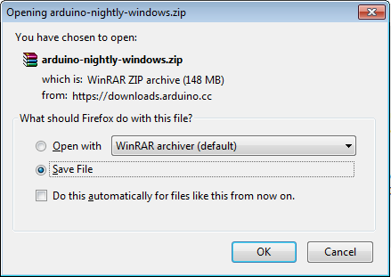

Figure: Download Arduino Ide Software

**Step 3 − Power up your board**

USB ports on computers and external power supplies are automatically used to power the Arduino Uno.

**Step 4 − Launch Arduino IDE**

We need to unzip the folder after downloading the Arduino IDE application. The folder contains an application icon with the text "application.exe" and the symbol infinity. To launch the IDE, double-click the icon.

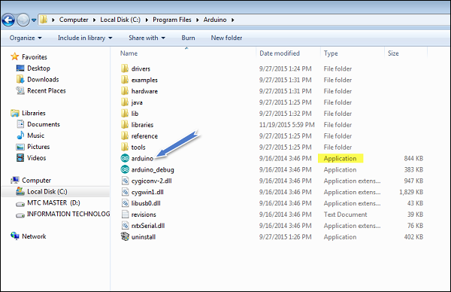

Figure: Launch Arduino IDE

**Step 5 − Open your first project**

Following the software's debut, you have two options:

• Begin a new project.

• Introduce a current project as an example.

To begin a new project, select File > New.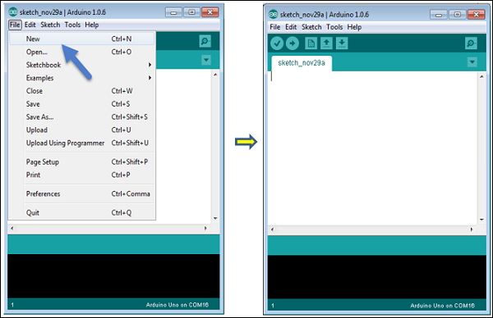

Figure: Create Project in Arduino

Choose File > Example > Basics > Blink to open an existing project example.Open Project

Figure: Create an Example

We're concentrating on only one of the Blink situations here. A little delay is followed by the LED being turned on and off. You may select one more example from the list.

**Step 6: Choose your Arduino board**

To avoid any issues when uploading your programming to the board, we must select the proper Arduino board name that corresponds with the board linked to your computer. Go to the Tools Board to choose a board.

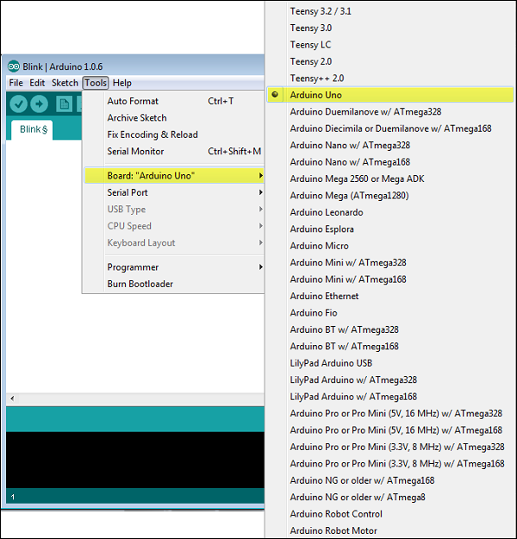

Figure: Selecting Arduino Board

Here, the Arduino Uno board has been chosen in accordance with our project, but we must choose the name that corresponds to the board we are using.

**Step 7 − Select your serial port**

Select the serial device for the Arduino board. In the menu, choose Serial Port under Tools. This is most likely COM3 or above because COM1 and COM2 are normally reserved for hardware serial ports. The entry for the Arduino board that disappears should be our primary focus. We may verify this by unplugging the Arduino board and restarting the menu. Upon returning to the board, we will select the serial port we previously selected.

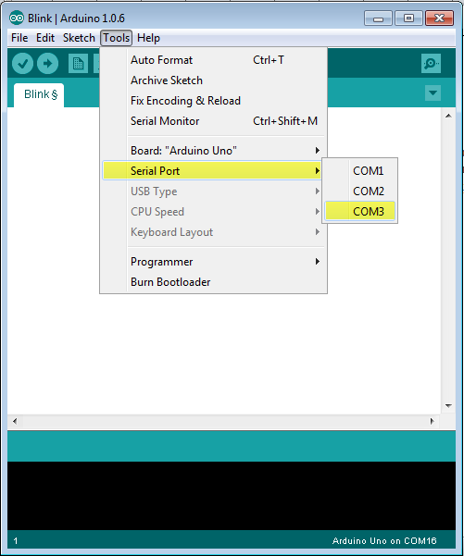

Figure: Selecting Serial Port

**Step 8 − Upload the program to your board**

We must first show how each symbol in the Arduino IDE toolbar works before talking about how to upload our programming to the board.

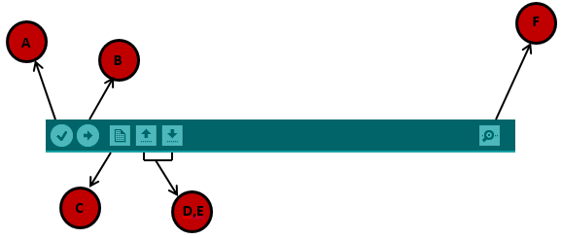

Figure: Uploading the Program

A-Used to determine whether there are any compilation errors.

B-Applied when programming an Arduino board.

C-Shortcut for starting a new drawing.

D- is used to open one of the example sketches right away.

E-Save your sketch.

F - A serial monitor is used to send and receive serial data to and from a circuit board.

At this time, just select "Upload" from the environment's menu. The board's RX and TX LEDs will start to flash after a little delay. The status bar will show "Done uploading" if the upload was successful.

Note: We must physically press the reset button on our Arduino Mini, NG, or other board before choosing the upload option in the Arduino software.

**4. FUTURE EXPANSION:**

It is possible to improve the system by integrating further features, like internet booking over GSM, which allows the driver to reserve a parking space at home or while travelling to a shopping centre. Additionally, image processing might be included into the system to allow users to immediately pay for parking with their mobile phones using technology that recognizes cars by their license plates.

**5. CONCLUSION:**

In this Arduino-based automobile parking project, a servo barrier is implemented to open automatically as a car approaches. Similarly, when another car arrives, the barrier is triggered to open. To provide real-time feedback, an LCD display is incorporated to indicate when all parking slots are occupied, displaying the message "slots are full".The project utilizes two Infrared (IR) sensors for effective operation. The first IR sensor functions to initiate the barrier opening and also updates the display with the number of available parking spaces. Meanwhile, the second IR sensor plays a crucial role in detecting when a car exits the parking area. This triggers the necessary actions to update the system with the newly available parking space.Overall, this Arduino-based parking system employs a combination of IR sensors, a servo motor, and an LCD display to facilitate seamless and efficient parking operations. It ensures that parking spaces are utilized optimally, providing a convenient and automated solution for both incoming and outgoing vehicles.In conclusion, our Arduino-based car parking system represents a significant advancement in addressing the challenges posed by modern traffic congestion. By leveraging smart parking technologies, we aim to not only optimize parking space usage but also contribute to the overall improvement of traffic flow in urban environments. The integration of IR sensors, along with advanced programming techniques, has culminated in the creation of an efficient and user-friendly solution for both drivers and parking facility operators.

**6. REFERENCES:**

[1] *Agarwal, P., Sharma, S., Gupta, L., & Manideep, B. (2017). Smart electronic garbage management system-based IoT. International Journal of Soft Computing and Engineering (IJSCE), 7(1), 93-96.*

[2] Ali, Z. H., Ali, H. A., & Badawy, M. M. (2015). Internet of Things (IoT): definitions, challenges and recent research directions. *International Journal of Computer Applications*, *128*(1), 37-47.

[3] Chowdary, U. V., Rohith, K., Sandeep, P., &Ramu, M. (2015). Home Automation System Using IR Sensors. International Journal of Electrical and Electronic Engineering (IJEEE), 4(6), 11–16.

[4] Deekshitha, D. D., Malavika, & Soumya.(2017). Traffic Monitoring System Using IR Sensors. *International Journal of Advance Research, Ideas and Innovations in Technology*, *3*(3), 1045-1057.

[5] Kousalya, S., Priya, G. R., Vasanthi, R., & Venkatesh, B. (2018). IOT based smart security and smart home automation. *International Journal of Engineering Research & Technology (IJERT)*, *7*(04), 43-46.

[6] Larisis, N., Perlepes, L., Stamoulis, G., &Kikiras, P. (2013). Intelligent Parking Management System Based on Wireless Sensor Network Technology. Sensors and Transducers Journal, 18(Special Issues), 100–112.

[7] Mitra, S., Mishra, P., Daniel, J. A., & Balaji, S. (2019). Smart light for home with automatic direction and intensity adjustment using arduino. *International Journal of Recent Technology and Engineering (IJRTE)*, *8*, 479-484.

[8] Bhor, V., Morajkar, P., Gurav, M., Pandya, D., & Deshpande, A. (2015). Smart garbage management system. *International journal of engineering research & technology (IJERT)*, *4*(03).

[9] Rani, L. P. J., Kumar, M. K., Naresh, K. S., & Vignesh, S. (2017, March). Dynamic traffic management system using infrared (IR) and Internet of Things (IoT). In *2017 Third International Conference on Science Technology Engineering & Management (ICONSTEM)* (pp. 353-357). IEEE.