Data Transmission with Light Source Using

Li-Fi Technology

V.Pavithra,

Department of Electronics and Communication,

SNS College of Engineering,

Coimbatore, India.

S.Pragadeswaran*,

Department of Electronics and Communication,

Karpagam Institute of Technology, Coimbatore, India.

praga1994@gmail.com

K.Raja,

Department of Electronics and Communication,

Gnanamani College of Technology,

Namakkal, India.

K.Sangeetha,

Department of Electronics and Communication,

SNS College of Engineering,

Coimbatore, India.

ABSTRACT

As many of us are using wireless networks nowadays in many areas. Sending the data through LED light that varies in intensity faster than a human eye can identify. This technology is named as Li-Fi which stands for Light Fidelity and this was introduced by one German Physicist named Harald Haas. Li-Fi is a wireless optical networking technology that uses light-emitting diodes (LEDs) for transmission. The term of Li-Fi mainly refers to Visible Light Communication (VLC)Technology.This Li-Fi technology mainly uses light as a medium to deliver high-speed communication. This Li-Fi technology also answers the challenges of the 5G network. Many issues of wireless communication can be effective solutions by VLC technology. A Li-Fi provides better connectivity and security than Wi-Fi. Since Bluetooth and Wi-Fi are the two prominent short-range wireless technology but to increase advanced technology we go Li-Fi technology. This Li-Fi technology in the future can be used for Laptops,Tablets, and Smartphones in an eco-friendly and economical way to transmit data very easily through light in a room.

Key Words : LED, VLC, 5G network, Li-Fi, Wi-Fi.

INTRODUCTION

Transferring data from one place to another is one of the most important in day-to-day activities. The current wireless networks that connect us to the internet are very slow when multiple devices are connected. As the number of devices that access the internet increases, the fixed bandwidth available makes it more and more difficult to enjoy high data rates. Nowadays, everyone is interested in using Mobile phones, Laptops to communicate with other people through Wi-Fi systems and this technology Wi-Fi is widely used in all public areas like Homes, Hotels, and airports by people, also the time usage of the wireless system is increasing exponentially every year capacity is going down, due to the limitation of Radio Frequency (RF) resources, so we are going to suffer from the severe problem. To overcome this problem in the future, Professor Harald Haas, an expert in optical wireless communications proposed in 2011 a brilliant and applicable solution by using light to transmit the data, he demonstrated how a light-emitting diode (LED) bulb is equipped with signal processing technology. It could stream a high-definition video to a computer and he showed that one watt LED light bulb would be enough to provide net connectivity to four computers. This technology is known as Light Fidelity. This technology is a short-range wireless communication system based on light illumination from LED and uses visible light as a signal carrier instead of a traditional RF carrier as in Wi-Fi. In the future where the data for Laptops, Smartphones, and mobile phones are transmitted through light in a room in a secure way. This technology can be shown seriously in future communication.

LITERATURE SURVEY

The paper by Dr.Latha.R and Smith Mandolkar, "Data Communication Between Two PCS using Li- Fi Technology-2022" is used under Li-Fi technology as Li-Fi (Light Fidelity) uses light for transmitting data. In Li-Fi technology, various light sources like LED, tube light, laser diode, and the array of LEDs are used to transmit data. Data is transmitted by the flickering of LED in the form of 1's and 0's which is sensed by light-sensitive sensors e.g., Photodiode, phototransistors, solar panels, LDR, etc. The possibilities of Li-Fi are numerous, it uses Visible Light Communication (VLC) technique, and has a larger bandwidth than Wi-Fi. Wi-Fi will grow rapidly in the next decade. Which in turn brings out the high dosage of RF waves to the environment, which is harmful to human beings. Li-Fi can be used as an alternative technology for Wi-Fi as it uses light for transmitting data instead of RF waves. In this paper, successful bi-directional data transmission takes place between two PCs using Arduino UNO. Two PCs transmit as well as receive the data. LED/Array of LEDs is used as the source of Transmission and a phototransistor is used for receiving the data. The application of Li-fi is used in hospitals as the main media of communication between systems and devices like live tracking of the patient condition like heart rate, and blood pressure. Using Arduino and LDR to transfer the alpha-numeric and image data prototype through Li-Fi technology has been developed and presented in this paper.
Hybrid Li-Fi Networks -2021 was designed by Lai Zhou, and Majid Safari, and used for indoor wireless communications,one promising approach is to coordinate light fidelity (Li-Fi) network. Namely hybrid Li-Fi networks (HL Nets). This hybrid network combines the high-speed data transmission of Li-Fi. To HL Nets, starting with a framework of system design in the aspects of network architectures, cell deployments, multiple access and modulation schemes, illumination requirements, and backhaul. Key performance metrics and recent achievements are then reviewed to demonstrate the superiority of HL Nets against stand-alone networks. The unique challenges facing HL-Nets are elaborated on key research topics including user behavior modeling, interference L management, handover, and load balancing. Moreover, the potential of HL Nets in the application areas is presented, exemplified by indoor positioning and physical layer security. To tackle the looming spectrum shortage in RF, wireless communication technologies employing extremely high frequencies have drawn significant attention. Among these technologies is light fidelity (Li-Fi). Using light waves as signal bearers, this relatively new technology can exploit the vast optical spectrum, nearly 300 THz. Li-Fi access points (APs) can be integrated into the existing lighting infrastructure, realizing a dual-purpose system that provides illumination and communication at the same time. Recent research demonstrates that with a single light-emitting diode (LED),Li- Fi can achieve peak data rates above 10 Gbps.

PROBLEM STATEMENT

As Li-Fi is much faster than Wi-Fi. Li-Fi can be used in almost all places where Wi-Fi connectivity is not possible such as aircraft and underwater because Wi-Fi can transmit data over radial distances. Li-Fi has also been said to be cheaper to implement as compared to other wireless communications. And due to security reasons, there will be many devices connected to the same network so there will be hacks of data and lag of connectivity this can be overcome using Li-Fi technology, therefore Li Fi wins over Wi-Fi. Like any radio frequency transmission, a wireless network signal can transmit data to a wide variety of interferences. so we go for Li-Fi technology.
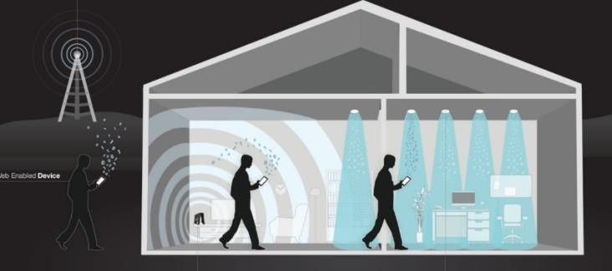

Figure.1. Li-Fi Transmission

- EXISTING SYSTEM

A design and prototype implementation of a new home automation system that uses Wi-Fi technology as a network infrastructure connecting its parts. The proposed system consists of two main components. The first part is the server (webserver), which presents a system core that manages, controls, and monitors users' homes. Users and the system administrator can locally or remotely (internet) manage and control system code. The second part is the hardware interface module, which provides an appropriate interface to the sensors and actuators of a home automation system. Wi-Fi technology is used by a server, and hardware interface module to communicate with each other. The proposed system has great flexibility by using Wi-Fi technology to interconnect its distributed modules to the home automation server. That will decrease deployment costs and will increase the ability of upgrading, and system reconfiguration. The system will make use of secure wireless LAN connections between distributed hardware modules and servers, and secure communication protocols between users and server.

PROPOSED SYSTEM

Due to the security reasons in Wi-Fi and the chances to get many signals in the same device at the same time, so the network issue is happening. To overcome this, we go for the advanced Li-Fi technology. And Li-Fi is very fast compared to Wi- Fi. And the main problem faced by Wi-Fi technology is the network can split into vast areas so the data can be stolen by any person. Whereas Li-Fi can pass the data through a certain closed surface area only. And many persons will use the Wi-Fi network at the same time which creates a lag in network connectivity.
Whereas in Li-Fi as it passes the data through the light on a closed surface these issues can be avoided in this Li-Fi technology. The main advantage of Li-fi technology is it can be Used in water also. Whereas Wi-Fi cannot be used in such applications. Li-Fi is a state-of-the-art technology for short-range wireless communication systems which is convenient for data transmission via LEDs by illumination. The Li-Fi utilizes common household LED (light emitting diodes) light bulbs to enable data transfer, boasting speeds of up to 224 gigabits.

BLOCK DIAGRAM

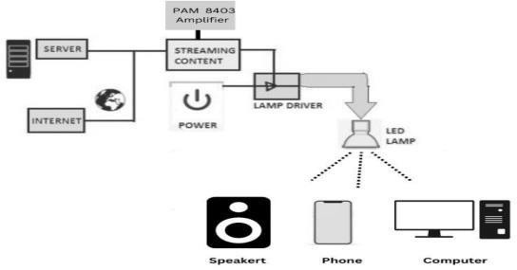

Figure.2. Data Transmission with light source using Li-Fi Technology

- HARDWARE REQUIREMENTS

The hardware used in this project is PAM 8403 Amplifier board, Resistance 100 ohm, LED, Solar Panel, Battery 9v, Speaker, Aux Cable, and Switch.

WORKING

The working of Li-fi technology is fully based on light. In which the data can be transferred using a light source. The LED light transmits the data signal as input to the solar panel and transmits through the PAM amplifier board using a 4-volt battery and speaker the audio signal is received as an output. As light passes in a straight direction, the data can pass on a closed surface.

APPLICATIONS:

- Medical and Healthcare:
Because of over-radiation, the operating surfaces do not allow Wi-Fi, and Wi-fi is used in almost all hospitals. Computers, mobile phones, Laptops, etc., blocks the signals from medical and monitoring places. Li-Fi can solve this problem using Li-Fi technology. It is the most important part of the surgical light head and is used for the current medical instruments. Patient records can be shared in a fast and secure manner. Li-fi can be used by patients to check the real-time status of their prescriptions on smartphones or pharmacy terminals while waiting to collect their scripts.

Aircraft:
Li-Fi technology is perfect for airplane applications because it does not interfere with radio signals which are equal to Wi-Fi which uses radio waves. Instead of Wi-Fi, Li-Fi can take the advantage of the source light. As Wi- Fi cannot able to transfer data in aircraft though aircraft have multiple lights so data can be transmitted using Li- Fi technology. Each light can transfer the data in the aircraft to the passenger’s laptops, smartphones, and tablets.

Underwater
This comes under Li-Fi technology as light can enter deep water. radio waves quickly absorb water preventing underwater radio communications, but light can transmit for large distances. Since light can travel through water, Li-fi baes communication offers much greater mobility. The light level in the ocean contains most commercial fishes and is home to many protected marine mammals and turtles.

Education
As Li-Fi is the latest and trending technology that can provide high-speed internet access, so it can replace Wi-Fi in educational institutions. The new learning technology in schools become asmart way in connecting teachers and students so educational institutions can be benefited by using this technology. some schools are even started using Li-Fi technology.

Industries

It becomes a new approach to combining manufacturing processes and technology such as the internet of things (IoT), and artificial intelligence (AI) to improve automation and communication and using real-time data. The electronic company uses a new data transmission in its house production to gain experience and include in the development of Li-Fi for wireless industrial communication. In the production line the transmission of data to machines and the collection of operating data between sender and receiver.

X.A. ADVANTAGES

Data transmission will be faster when compared to Wi-Fi. In some tests it even reaches 224Gbps. Li-fi is used in very sensitive areas such as aircraft, hospitals, and even underwater.
It tends to operate in invisible places.
It is very easy to implement in the easiest way.
Since many places have lights in offices, and educational institutions so they can transmit data using this technology.
Li-Fi can be used as the safest wireless network as it cannot able to pass through opaque structures, Li-Fi internet is available only to the users within a room and cannot be reached by users in other rooms or buildings.
Light must be on to transmit data, so when there is no need for light, it can be reduced to a point where it appears off to the human eye, but is still on and working.

B. DISADVANTAGES:

The widespread use of Wi-Fi is a majorfactor preventing the use of Li-Fi. The limitations of Li-Fi make it a difficult task to replace conventional Wi-Fi networks.
Internet cannot be used without a light source this could limit the locations and situations in which Li-Fi could be used.
It cannot transmit the data through walls so the signal range is limited. It cannot pass through opaque obstacles.
A whole new infrastructure for Li-Fi would need to be constructed.
It demonstrates extremely high data speed and there is no clarity about how it is being implemented.

XI. LIMITATIONS:

Light cannot pass through objects, so if the receiver is inadvertently blocked in any way, then the signal will immediately be cut out.
Only works if there is a direct line of sight (LOS) between the transmitter and receiver.
You can’t have a light bulb that provides data to a high-speed moving object or provide data in a remote area where there are trees, walls, and obstacles.
Reliability and network coverage are the major issues to be considered by the companies while providing VLC services.
High installation cost of the systems can be complemented by large-scale implementation of VLC though adopting this technology will reduce further operating costs like electricity charges, maintenance charges, etc.

XII. RESULT & DISCUSSION

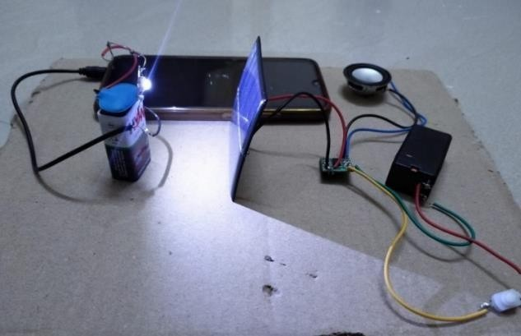

Figure.3.Result of Li-Fi technology.

As a growing number of people and their many devices access wireless internet,the airwaves are becoming increasingly clogged, making it more and more difficult to get a reliable, high-speed signal. This may solve issues such as the shortage of radio- frequency bandwidth and allow internet where traditional radio-based wireless isn't allowed such as aircraft or hospitals. And Li-Fi technology is used in underwater applications too. Where Wi-Fi cannot. Underwater ROVs (Remotely Operated Vehicles) operate from large cablesthat supply their power and allow them to receive signals from their pilots above.But they together used in ROVs is not long enough to allow them to explore larger areas. If their wires were replaced with light say from submerged, high-powered lamps then they would be much freer to explore.

FUTURE SCOPE

Each of our devices is connected to the internet as we move into the internet world. As light is everywhere and free to use, there is a great scope for the use and evolution of using Li-Fi technology. The data can be transmitted and encrypted in a secure way by using light. Li-Fi can prove to improve quality of life. Though it will not completely replace Wi-Fi but also reduces the disadvantages faced by other wireless communications. The light intensity can amplify the signal for longer-distance data transmission. The Li-Fi technology can be used to make each LED bulb into a Li-Fi hotspot to transmit data wirelessly. With the ever-growing demand for connectivity, Li- Fi would be able to combine illumination and wireless data transmission to accelerate the relay of data across the universe.

CONCLUSION

The Li-Fi technology become more commercial and become a great technology in the field of wireless communication. The Li-Fi becomes an advanced technology in the future era. This technology comes up with large advantages over Wi-Fi. Many researchers and companies are working under this Li-Fi technology. It can solve issues such as a shortage of radio frequency, and radio spectrum. Li- Fi become an upcoming growing technology for developing inventions and technology. Through this network we can give a better clean, migrate, and safer communication network. Therefore, the development of Li-Fi technology can be extended to different platforms of human life.

REFERENCES

- Latha.R, Smith Mandolka(2022)-Data Communication Between Two PCS using Li-Fi Technology International Journal of Engineering Research & Technology,27301.ISSN-16576-8603.
- Sathiya. G, Basheeth.A (2021)-Hybrid Li- Fi networks Based Data Access System, IJERT, International Journal of Engineering Research & Technology, Vol.6 Issue 5,24 Apr 2021.ISSN-2278-0181.
- Kalita, C.S.; Barooah, M. Li-Fi Based Handoff Technique in VANET. In Proceedings of the 2020 International Conference of Computer Performance Evaluation. Compe, Shillong, India, 2–4 July 2020R.
- Soltani, M.D.; Purwita, A.A.; Zeng, Z.; Chen, C.; Haas, H.; Safari, M. An orientation-based random waypoint model for user mobility in wireless networks. In Proceedings of the 2020 IEEE International Conference on Communications Workshops (ICC Workshops), Dublin, Ireland, 7–11 June 2020.
- Karthika, S. Balakrishnan, (2015). Wireless Communication using Li-Fi Technology SSRG International Journal of Electronics and Communication Engineering (SSRG-IJECE), Vol. 2 Issue 3, Mar 2020.
- Arfaoui, M.A.; Soltani, M.D.; Tavakkolnia, I.; Ghrayeb, A.; Assi, C.; Safari, M.; Haas, H. Measurements-based channel models for indoor LiFi systems. IEEE Trans. Wire. Common. 2019, 20, 827– 842.
- Purwita, A.A.; Soltani, M.D.; Safari, M.; Haas, H. Terminal Orientation in OFDM- Based LiFi Systems. IEEE Trans. Wirel. Commun. 2019, 18, 4003–4016.
- Khandal, D., Jain, S. (2014). Li-Fi (Light Fidelity): The Future Technology in Wireless Communication, International Journal of Information & Computing Technology, Vol. 4 No. 16, 2015
- Shubham Chatterjee, Shalabh Agarwal, Asoke Nath, "scope and Challenges in Light Fidelity(LiFi)Technology in Wireless Data Communication", International Journal of Innovative Research in Advanced Engineering(IJIRAE), Issue 6, Vol 2, Page 1-9,(June 2014).

