Tourism and hospitality

Introduction
Hospitality and Tourism focuses on the management, marketing and operations of restaurants and food services, lodging, attractions, recreation activities, and conventions. Providing great hospitality makes guest feel welcome, comfortable, and valued, leading to an experience that encourages them to return and recommend your business to others.
This chapter aims to outline the Significance of tourism, history of mass tourism, development factors of Tourism and how can we increase tourism.

History of Mass Tourism
The nature of tourist product has dramatically changed after the Second World War, especially between 1960’s and 1980’s. While the marketing practice is “customer oriented” nowadays, post-war conditions were completely different and marketing was “sales oriented”. There were remarkable supplies for many products across Europe and tourism was not an exception to this. On the other hand, the economical and technological developments that changed tourism in the mentioned period could be summarized as follows:
• The greater prosperity of the population at large
• Paid (salaried) holidays for many European workers
• A new use of excess aeroplanes after the war
• Technical improvements in aircraft production which made it possible to fly further and faster
• A greater sense of democracy and equality fostered by the war effort
• Better education
• Better packaging of the opportunities by tour operators
• Spread of television, bringing images of the rest of the world to almost every household.

Development factors of tourism
The factors that cleared the way for mass tourism for its golden age are namely technology, production and management related changes in the progress. The factors that cleared the way for mass tourism for its golden age are namely technology, production and management related changes in the progress. However it’s completely a different story in Europe because of the demographical and economical structures of the continent. The European mass tourism market has grown relatively from richer and more developed European countries’ tourism demand for holidays to rather less developed southern (in other words Mediterranean) countries. The necessity for travelling international inside (short-haul) the continent has brought new actors as organizers in tourism, namely tour operators. Tour operators, charter flights, and inclusive tours –especially holiday packages- are the identifiers of European mass tourism in the golden age of mass tourism. On the other hand, the common factors that changed the world tourism business and accordingly mass tourism could be summarized as being technology, air transportation, accommodation companies, tour operators, conglomerates and mass consumption depending on holiday needs.

Significance of tourism
Tourism is an important, even vital, source of income for many regions and countries. Its importance was recognized in the Manila Declaration on World Tourism of 1980 as “an activity essential to the life of nations because of its direct effects on the social, cultural, educational, and economic sectors of national societies and on their international relations.”
Tourism brings in large amounts of income into a local economy in the form of payment for goods and services needed by tourists, accounting for 30% of the world’s trade of services, and 6% of overall exports of goods and services. It also creates opportunities for employment in the service sector of the economy associated with tourism.
The tourism industry in India accounts for roughly five percent of the country’s GDP, since people from all over the world go there to experience its rich culture and customs. Achieving development objectives is the key aim of tourist strategy implementation. The following graph shows the contribution of tourism in GDP.
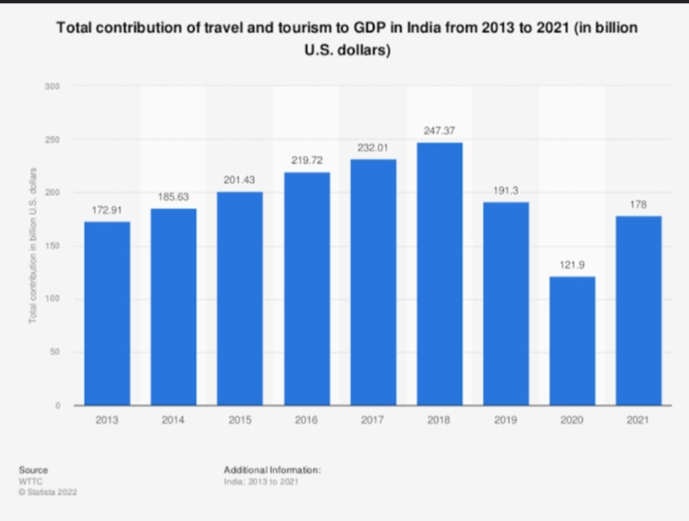

How can we increase tourism?
- Increase the number of hotels, roads, toilets and so on to meet the needs of the tourist.
- Space the attractions out more, so that tourists are also spread out and carrying capacity is not reached so quickly.
- Advertise are key to grabbing attention of your potential tourists.
- We must develop the underdeveloped region so that tourists will be attracted more.
- Tourism can also help in granting employment for economic growth.
- We can also make a website and upload videos of a tourist place.
- Nowadays online system is working everywhere so we must focus on accepting online bookings.
- Promote local events and festival that will attract foreign tourists
- Adopting foreign countries ideas and innovation for tourism.

Conclusion
As we have seen in this chapter, tourism industry is the largest industry in India and has potential to stimulate the economic growth of the country. It becomes important for all citizens to develop the tourism infrastructure and maintain tourist destinations, railway stations, airports, rest houses, and hotels.

References:
https://m.economictimes.com
https://pro.regiondo.com
https://rezdy.com
cdn.intechopen.com
Tourism and hospitality management edited by Lucius Walker

