REVIEW ON SOLAR ELECTRIC GRASS CUTTER

Shah Dhavalkumar Ashokbhai Shukla Virang Kishorchandra
Lecturer Lecturer
BMU, Surat BMU, Surat
dhavalshah111120@gmail.com virangshukla_1983@yahoo.co.in

Mr. Nimeshkumar Maheshbhai Lad Ketan Shashikant Shah
Lecturer Lecturer
Laxmi Institute of Technology, Sarigam BMU, Surat
nimeshlad20@gmail.com ketanshah_369369@yahoo.in

ABSTRACT:
Solar grass cutter uses blades to cut a lawn. It is very useful device and its construction is very simple. It is used in shops, gardens colleges etc. Main aim is to control the pollution. In this project solar grass cutter is constructed for various applications. The main components used in this project are battery, microcontroller, relay, sensor etc.

1. INTRODUCTION

The first grass cutter was invented in 1830 by Edwin Budding, England. The cutter was designed to aim to cut the grass on grounds. Different grass cutters are available in market. Electric grass cutter consumes electricity and requires motors. Gasoline grass cutter requires fuels for running.

2. OBSERVATION ISSUES OF ELECTRIC GRASS CUTTER

• Possibilities of limited reach and trip hazards.
• Problem in wet areas
• Short running time,
• Cannot handle tall or thick areas of grass efficiently.
• Requirement of long extension wire.
• single phase induction motor is used. Weight is more. Difficult to shift from one place to another.

3. OBJECTIVE
The main aim was to construct grass cutter with renewable energy. It saves fossil fuels. The grass cutter is designed such that it can use sun energy, reduce pollution and manpower.

4. LITERATURE SURVEY:

According to Amit Ankit Gupta, Kishan Narayan Birla, Renu Rani in title “Solar Grass cutter Using Ultrasonic Sensor” In this project we are using
Microcontroller for controlling various operation of grass cutter. Grass cutter operates automatically by the help of sensor which helps to detect the obstacle and avoiding collision. Ms.Y. Rutuja in “Automatic Solar grass Cutter”, the system has a smart functionality that allows it’s to cover the complete area of a lawn or garden by detecting corners using ultra sonic sensors and moving in a raster manner in order to cover the entire area. Jatinder K, AbhishekT, Ravinder S, RahulK. in “Manufacturing Of solar Grass cutter” The design objective is to
Come up with a mover that is portable, durable, easy to operate and maintain.

5. METHODOLOGY

BLOCK DIAGRAM
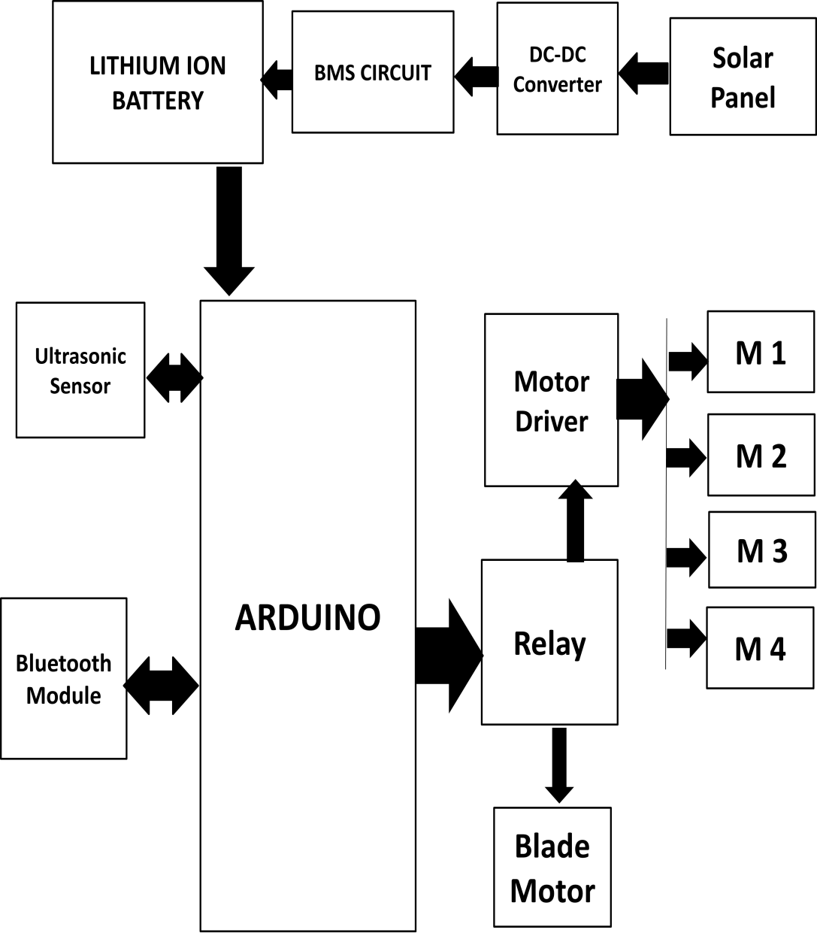

6. WORKING

In the construction of solar electric grass cutter, panels are mounted in particular arrangements so it can receive solar radiation from sun. The solar panel converts sun energy in to electrical energy. The energy is stored in battery. The charger is used in solar grass cutter. Its function is to increase currents from panels during the charging of battery. The charger disconnects solar panel when they are fully charged and connects the panel when charging in battery is low. Motor is connected to batteries through connecting wires. The grass cutter can also be operated with Bluetooth module, moves forward and backward by commands given by micro controller.
7. ADVANTAGES

1. It environmental free.
2. No need of external supply.
3. It is very cheap.
4. No fuel is required.
5. Easy to operate.
DISADVANTGES
1. Require charging for a long time.

APPLICATIONS

1. Schools
2. Colleges
3. Playgrounds
4. Farms

8. CONCLUSION

Today world is suffering from energy crisis. The cutter is designed with aim of reducing pollution and also reduces global warming. The solar grass cutter will meet energy generation needs. It will be used anywhere with the help of chargeable battery and work easily with the help of sun light. However in monsoon difficulties may be faced when sunlight is not proper.

9. FUTURE SCOPE

Modification can be done to obtain better results. The efficiency can be gained by controlling device mechanism and speed of motor. The blades can change to get better result. In future more efficient grass cutter can be designed by improving all factors and parameters. This will become base model for future needs.

10. REFERENCE

[1] P.Amrutesh, B.Sagar and B.Venu, solar grass cutter with liner blades
By using scotch yoke mechanism, international journal of engineering,
Research and application.vol, 4, 2016, 2248-9622.
[2] E.Naresh, Boss babu and G.Rahul cutting machine by solar power,
International journal and magazine of engineering, technology, management
And research, vol.3, 2016, 2348-4845.
[3] Sujendran S.and Vedanta P.smart lawn mower for grass trimming
International journal of science and research, vol.3, 2014, 2319-7064
[4] Praful P.Ulhe, Manish D. Inwate, Fried D.Wankhede and
Krushnakumar S.Dhakle modification of solar grass cutting
Machine, international journal for Innovative research in science and
Technology, vol.2.2016, 2349-6010.
[5] Sultan Mohyuddin, Digesh K D, Vivek T K, Nazeya Khanam F and
Vidyashree H V, Automatic Grass Cutter, International Journal of Science,
Technology and Engineering, Vol.2, 2016, 2349-784X.

