Consumer Purchase Intention: A review of green marketing practices in India and the influence of Socio-demographic characteristics

Ms. Sweety Kumari
Ph.D. Scholar, Sharda School of Business Studies, Sharda University, India
2021370177.sweety@dr.sharda.ac.in

Abstract
The focus of this paper is to analyze the impact created by the promotion of green marketing on the purchase intention of Indian consumers with respect to their cultural, geographical, ethical, gender, instructional and age background. This study enhances the construct and usefulness of green marketing. The results explains that price has the major role in influencing consumers from different background and young adults are more inclined towards green purchase due to environmental awareness. It was also discovered that eco-friendly items and green marketing methods had a beneficial relationship. Environmental knowledge is connected to age and education. The outcome may be advantageous for managers, marketers, and the new emerging markets to germinate suitable green marketing strategies to fulfill the demands of consumers according to the dynamic environment. The results suggest that green marketing strategies can be effective in influencing consumer behaviour in the Indian market, but their effectiveness may vary depending on the socio-demographic characteristics of the target audience. This paper provides valuable insights for businesses seeking to promote environmentally friendly products in India and suggests the need for a more nuanced understanding of the consumer behaviour in the context of green marketing. This might even be instrumental for research purpose to attribute any findings relating to the abstracted model of green marketing. The research method for this study is conceptual modelling and literature review.
Keywords: - green marketing, green purchase intention, environmental attitude, theory of planned behavior
Introduction and Background of the Study
Green marketing has emerged as an essential tool for companies to promote environmentally friendly products and services. As consumers become more environmentally conscious, their purchasing behaviour has shifted towards eco-friendly products. The current study intends to investigate how green marketing affects Indian customers' propensity to buy. Furthermore, socio-demographic characteristics will be examined as a moderator of this relationship.
In today’s world where pollution, global warming is at an alarming stage and India being the third largest emitter of carbon with 6.8% of the total global emission: concerns have been expressed by manufacturers and consumers. They have diverted their need for environmentally friendly products. Simultaneously Indian markets are also shifting towards green marketing.
The diverse subcultures that make up India's diversified population each have their own unique set of values, beliefs, and social customs. Demographic variables include characteristics of customers including gender, age, and educational attainment. These traits have a significant impact on how customers behave. They have an impact on customer choice. As a result, “Alimi and Workneh” (2016) found that customer demographic traits including age, education, income, and gender can have a big impact on how they choose to spend their money.
The term “GREEN MARKETING” pertainns to marketing of products that are environmentally nonhazardous. It is a follow of processing and advertising product supported by their actual and perceived environmental property. It also includes a wide variety of operations including changing the product, altering the production method, using eco-friendly packaging, and changing advertising. Environment marketing and Ecological marketing are the two much similar terms used with for marketing. The concept of green marketing came into limelight in late 1980’s. It all began in Europe when some manufacturing goods were found harmful to the natural environment. In the early 1990’s, people began to be more cautious about preservation of natural environment. It was later named as “sustainable green marketing”. Customers are essential to helping marketers acquire a competitive edge. To make their use of green marketing effective and successful, marketers must understand the demands and behaviours of Indian customers. In the recent survey of “National Geographic Society” and the “International polling firm” Globe scan [2018] to determine consumer green behavior called “consumer greendex” the top-rated countries under developing economies were India, China, South Korea, Brazil etc. However, environment friendly behaviour has also increased in India since 2012. This study will highlight the fundamental element that influence the Indian consumers attitude, understanding, awareness and preference towards green buying decisions and socio- demographic characteristics like age, gender, geographical region, culture, and academic background are considered as moderator to determine the results.

Objective of the Study
The goal of this paper is to discover and explore numerous aspects that influence Indian customers' inclination to make green purchases with the demographic components acting as a moderator. The purpose of this study is to comprehend consumer knowledge of green purchasing and its advantages.

Literature Review
Andreea Orindaru, et al, (2021) explains that “COVID-19” problem has accelerated the trend toward more organic, inexpensive, and local products, which shows no signs of slowing down. In Europe, 30% of respondents want to increase their spending on healthy food and wellbeing in 2021 than they did in 2020, and 24% of population are planning to spend more in 2021 than they did in 2020. 19% want to spend more on eco-friendly products, while 19% are expecting to spend more on regional and local items products. Many personal elements, particularly economic concerns, continue to influence these patterns. Consumers with more discretionary money are less prudent in their spending. Spending habits are changing, and people are becoming more interested in health and nutrition. Lower-income people make up most of the population. People are more concerned with what they can afford than with what they require eating options that are more nutritious. Changes in consumer behaviour toward a more careful attitude to food consumption might indicate that the customers are reducing wastage of food and leading to a more sustainable way of consumption. Food waste reduction is an important goal since we squander 931 million tonnes of food globally, with families accounting for 61%. But at the other end, this more watchful behaviour could be the result of increased concerns about current and future financial situations, rather than a greater understanding of the harmful effects of unsustainable consumption patterns, which, regrettably, may imply that once these worries subside, the improper consumption patterns will return.
Liao, Y. K., Wu, W. Y., & Pham, T. T. (2020) took assistance of value-based adoption technique to state the results important on the intention of green buying. He further explains that green word of mouth has bring a level of credibility towards green products as through this the consumer would infer friends, relatives, and colleagues about constructive effects of green product or a brand and will promote green consumption. He further explains with the assistance of communication theory and perspective behavior context theory which might result in favourable outcome like investment or purchase. Green advertisement features a positive impact on client behaviour towards the brand. The author conjointly added that eco-friendly purchase intention is qualified by the robust result of the environmental publicity on social media.
Mrs. Vaishali and Dr. M. Hemanathan (2020) states that in the recent times everywhere the globe there's associate degree argument occurring regarding the Climate change, pollution, erosion, dwindling biological species populations, and so forth. Consumers are getting noticeably involved regarding a negative environmental situation problem. The shift within the buyer’s perspective to shop for the non-biodegradable and hazardous merchandise to green marketing created several business issues to implement the eco-friendly selling. Firms are under a great deal of stress to adjust to the novel amendment in order to maintain a long-term presence on the market and fulfil their goals. Because inexperienced merchandise necessitates creativity in packaging, products, processes, and promotion, among other things. In today's global market, most nations have made green products a priority as part of their “corporate social responsibility” activities. Consumers seem willing to pay more for ecologically friendly items than for other things. If a company claims to be environmentally friendly but then uses non-eco-friendly products or practices, the company's reputation may be jeopardized. The influence of the “covid- 19” disease on customers' attitudes toward green products demonstrates a favourable association between the use of green products and changes in consumer income over time: Most of the responders in the survey were female. The responders had a high level of education. Many of the responders are between the ages of 25 and 35. Many of the participants utilize eco-friendly goods because they were conscious about their benefits. Seventy percent of those polled worked in the private sector. 50 percent of the respondents earn between 25,000 and 35,000 each year.
Alharthey, B. K. (2019) explains that price has the major role in influencing shoppers from different background and young adults are more inclined towards green purchase due to environmental awareness. It was also witnessed that there is correlational statistics between eco-friendly merchandise and green marketing practices. It’s steered that marketers ought to focus a lot on green packaging and green advertisement as it can master the purchase decisions of consumers. He continues by saying that knowledge of green products and environmental harm is one of the primary factors influencing the purchase of environmentally friendly items. Age and education are associated with environmental awareness.

Research Methodology
In order to create the theoretical framework, secondary sources were employed to collect information by consulting books, past research works, papers, and scientific journals.

Conceptual Framework
Based on review of literature, important variable was identified, which influences purchase intention

Figure: 1
Conceptual Model
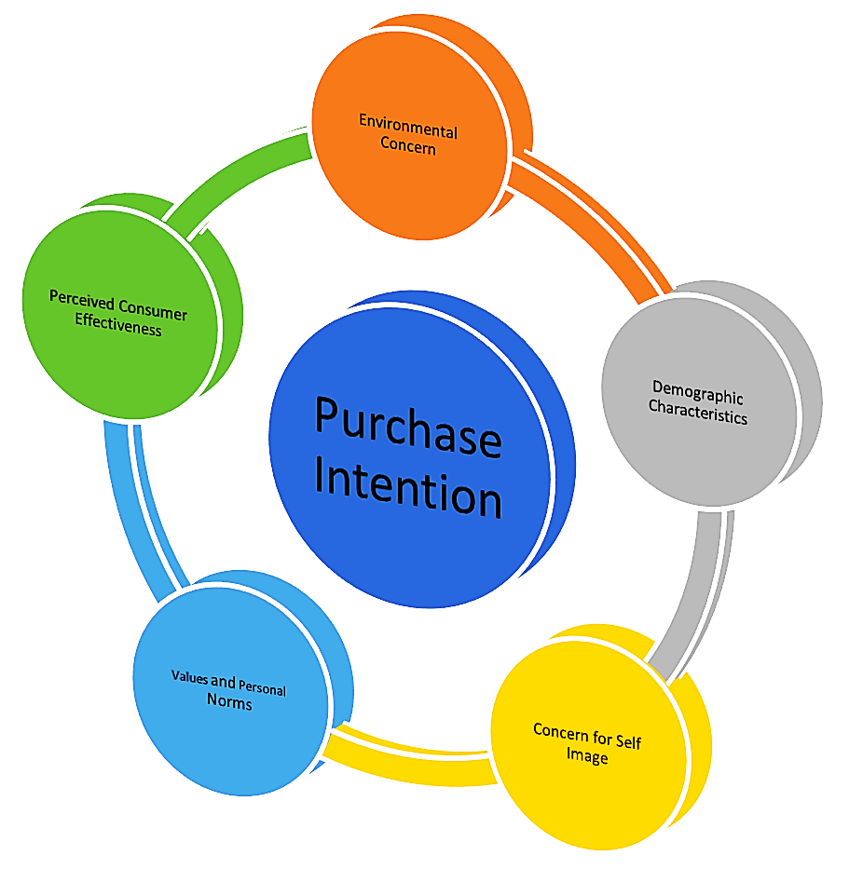
Factors impacting green purchase intentions of Indian consumers
- Environmental concern
Environmental concern refers to the attitude that a person has towards the environment and environmental issues. As consumer knowledge of environmental issues has increased, some businesses have marketed their products and services to position themselves as environmentally friendly (Lee C., Lim S.-Y,2020); (Situmorang T.P.,et al, 2021); (Wu B., et al, 2021); (Wang F.,et al, 2021). Individuals' environmental concern can manifest itself in several ways, from beliefs to actual behaviours (such as recycling and buying eco-friendly goods). In addition, Maichum, et al, (2016) found a connection between Thai consumers' intentions to buy green products and their level of environmental concern. Environmental knowledge act as a medium to establish a relationship between eco-friendly attitude and green behaviour. The results suggest that environmental understanding may positively influence customer green purchase intention and conduct. However, more study is needed in this area to determine the impact of environmental awareness on green purchasing intentions.
- Demographic characteristics
Age, gender, and income are just a few examples of the demographic factors that influence how people behave and make decisions. It differs from society to society and from nation-to-nation (Alharthey, B. K., et al, 2019). One study shows how young consumers in urban areas make greener shopping selections as a result of the price of green products. Pricing therefore affects youthful clients' purchase decisions. (Bhowal and Kalita, 2016). These criteria are widely used for study in the area of green marketing. Young people are more inclined than older people to buy environmentally friendly products because they are more aware of the natural world and their social environment. (Govender and Govender, 2016). According to (Wang, L, et al, 2020) money and education have a large impact on green buying attitudes, however the desire to behave in a green manner is greatly influenced by age and money. The study also shows notable disparities between male and female impacts on green purchasing attitudes and green behaviour intention.
- Concern for self-image
A person's self-perception about themselves is what they believe about themselves in order to be accepted by their reference group. When an individual works to portray themselves as environmentally friendly and behaves in an environmentally friendly manner while under the influence of a reference group, this phenomenon is known as care for one's self-image (Werff, Steg, & Keizer, 2013). Social media is also a main component to encourage people to adopt green lifestyle. Therefore, the person wearing an eco-friendly label will prefer to buy eco-friendly items, and we are speculating that an individual's environmental self-image is strongly correlated with their desire to make green purchases.
- Values and personal norms
Specifically, altruism, universalism, and kindness were found to have a beneficial influence on eco-friendly goods purchasing intention and actual purchase. Individualistic ideals like health and safety coexist with hedonistic ones like enjoying food, were found to have a beneficial impact on the purchase of green items, particularly green food products. Individualistic values were found to have a higher effect than altruistic values on the purchase of green food items in several research. Purchase intentions and actual purchases were also found to be influenced by moral and personal norms.
- Perceived consumer effectiveness
It is described as "consumers' assessment of the potential impact of their consumption on the overall issue." Several research discovered a link between perceived customer effectiveness and sustainable product purchase intentions. Buyers buying intention was shown to be indirectly influenced by perceived consumer effectiveness since it had a substantial influence on consumer attitudes, subjective norms, and perceived behavioral control, all of which affected customer purchase intention. As a result, it is possible to conclude that customer perceptions of efficacy and green purchasing intention and behaviors are linked. (Orîndaru, et al, 2021)
Several studies have examined the effect of TPB constructs on the purchase intention of green products (Cui, Lui, & Guo, 2018; Kaur & Singh, 2017). Due to perceived limitations, the TPB model emphasises that customers cannot solely base their purchasing decisions on volitional criteria (Paul et al., 2016). Perceived behavioural control, which is a new variable added to the TPB model and is described as the perception of the perceived ease or difficulty of carrying out the provided behaviour. The three predictors of intention that result in purchasing behaviour in the TPB model are “attitude”, “subjective norm”, and “perceived behavioural control”. Consumers' purchasing intentions may be influenced by sociodemographic factors including “age”, “gender”, “income”, and “education”. (Khan, 2017; Shrum, Lowrey, & Pandelaere, 2014). Studies have shown that young customers are more likely to purchase eco-friendly products than old age customers (Shrum et al., 2014). Moreover, women have been found to be more environmentally conscious and likely to purchase green products than men (Khan, 2017). Furthermore, there has not been any clear academic emphasis given to the moderating effect that customer demographics have on the link between consumer rights knowledge, customer perception, and purchase intention. As a result, this study was carried out to better understand these interactions.

Joshi, Y., & Rahman, Z. (2015) concluded that consumers favorable behavior towards green products does not end up in actual buying actions and many of them do not buy green products and on the other hand high value, Low accessibility, and a lack of customer confidence in eco-friendly items have become significant obstacles to the buying of environmentally friendly goods. The organization should focus more on “GREEN THINKING.” Social influence was found to have a positive correlation with perspective towards green products and the eco-friendly purchase intention.

Discussions
This study seeks to boost the construct of environment friendly merchandise and eco-friendly marketing practices. Environmentally friendly products and green selling practices, on the other hand, will benefit both the environment and customers. This study tries to identify the important elements that affect novice shoppers' purchasing behaviour, as well as their impact on purchase decisions. This study emphasizes the necessity of preserving the environment using green products composed of less damaging components. The objective of this research is to discover in what way socio-demographic factors impact buyers purchasing decisions for environmentally friendly items. The research findings suggests that price has the major role in influencing consumers from different background and young adults are more inclined towards green purchase due to environmental awareness. Consumer attitudes towards choosing green products are significantly influenced by age and income; income also has a strong impact on intention. This study specifically demonstrates that young people (those between the ages of 18 and 30) have greater levels of intention and that female customers are more likely to choose green products than male consumers are. It was also discovered that eco-friendly items and green marketing methods had a beneficial relationship. It is advised that marketer should focus more on green packaging and green advertisement as it can master the purchase decisions of consumers. Also understanding of green products and environmental impact is among the most vital factors influencing sustainable product purchases. Environmental knowledge is connected to age and education.

Literature gap
This study conjointly has some boundaries on the far side that future analysis could be pursued. The first constraint is that due to the limited population. The need of the hour is to pay heed to green concepts and encourage more research in the respective area. Various research has been already been conducted regarding green marketing in western countries as compared to India. In relation to the existing situation, researchers should look at the causes and reasons for lethargic and slow growth in the adoption and marketing of environmentally friendly products. The study of more specific buying behaviours and choices, such as energy-saving products, organic food, and recycling of plastic baggage, is intriguing. Future studies can be conducted to better comprehend the challenges and reasons when unfair selling practises in a society are punished with rigorous punishment. Also greenwashing could also be a topic to explore. Researchers could focus on young generation green buying habits and environmental concerns because most of the users of green products mainly ranges from 18 to 30 years of age.

Conclusion
Advertisement related to environment, value and ecological packaging have a positive relationship with consumers purchase intention.
Price has the major role in influencing consumers from different background and young adults are more inclined towards green Purchase.
Age and education of consumer Is associated with environmental literacy and will prefer green Product in ecological packaging if it is cost befitting.
The research conducted discovered that the green customer's sense of value, including perceived environmental value and environmental image, substantially and favourably influences attitudes towards green products.
Consumers favourable behaviour does not end up in actual buying action and many of them do not buy green products, whereas High costs, Low convenience, and lack of consumers trust in green marketing emerged as a serious barrier towards eco friendly purchase.
According to "Theory of planned behaviour" components, "attitude," followed by "perceived behavioural control," was found to be the largest predictor of desire to buy green goods. Green products should be targeted first to those consumers in India who are environmentally conscious since they have a positive track record. Purchasing green products has become a way of life for many people. When customer attitudes are favourable, they will show a greater care for the environment and will be more inclined towards reducing their environmental impact. Policymakers should establish measures that emphasise dos and don'ts to raise public awareness related to unsustainable consumption, as well as distinct campaigns that emphasize the negative consequences of everyday habits by enlisting "opinion influencers" such as celebrities, athletes, and others.
When the demographic characteristics of customers are looked at, it is found that while green purchasing is influenced by environment knowledge, green price, and green product features for male consumers, it is solely influenced by green advertising for female consumers. And this outcome demonstrates the need for businesses to incorporate gender into their green marketing efforts.

References

Alharthey, B. K. (2019). Impact of green marketing practices on consumer purchase intention and buying decision with demographic characteristics as moderator. International Journal of ADVANCED AND APPLIED SCIENCES, 6(3), 62–71.
Andreea Orîndaru & Maria-Floriana Popescu & Ștefan-Claudiu Căescu & Florina Botezatu & Margareta Stela Florescu & Carmen-Cristina Runceanu-Albu, (2021). "Leveraging COVID-19 Outbreak for Shaping a More Sustainable Consumer Behavior," Sustainability, MDPI, vol. 13(11)
Bandar Khalaf Alharthey, (2019) Arab East Colleges, Riyadh, Saudi Arabia, Impact of green marketing practices on consumer purchase intention and buying decision with demographic characteristics as moderator, International Journal of Advanced and Applied Sciences Journal homepage: http://www.science-gate.com/IJAAS.htm
Bhowal A and Kalita AC (2016). ‘Green pricing’ and ‘green buying decisions’ a case study of young consumers. International Journal of Innovative Research and Development.
Govender JP and Govender TL (2016). The influence of green marketing on consumer purchase behavior. Journal of Environmental Economics.
Joshi, Y., & Rahman, Z. (2015). Factors Affecting Green Purchase Behaviour and Future Research Directions. International Strategic Management Review, 3(1–2), 128–143.
Lee C., Lim S.-Y. (2020) Impact of environmental concern on image of internal gscm practices and consumer purchasing behavior. J. Asian Financ. Econ. Bus.
Liao, Y. K., Wu, W. Y., & Pham, T. T. (2020). Examining the Moderating Effects of Green Marketing and Green Psychological Benefits on Customers’ Green Attitude, Value and Purchase Intention. Sustainability, 12(18), 7461.
Maichum K., Parichatnon S., Peng K.-C. (2016) Application of the extended theory of planned behavior model to investigate purchase intention of green products among thai consumers. Sustainability.
Mrs. Vaishali, Dr. M. Hemanathan (2020), Impact of Covid 19 On Customers Attitude Towards Green Product. With Special Reference to Chennai City– Pal Arch’s Journal of Archaeology of Egypt/Egyptology
Situmorang T.P., Indriani F., Simatupang R.A., Soesanto H. (2021) Brand positioning and repurchase intention: The effect of attitude toward green brand. J. Asian Financ. Econ. Bus.
Tan, C. N. L., Ojo, A. O., & Thurasamy, R. (2019). Determinants of green product buying decision among young consumers in Malaysia. Young Consumers, 20(2).
Wang F., Lu Y., Li J., Ni J. (2021) Evaluating Environmentally Sustainable Development Based on the PSR Framework and Variable Weigh Analytic Hierarchy Process. Int. J. Environ. Res. Public Health.
Wang, L., Wong, P. P., & Narayanan, E. A. (2020). The demographic impact of consumer green purchase intention toward Green Hotel Selection in China. Tourism and Hospitality Research, 20(2).
Wu B., Fang H., Jacoby G., Li G., Wu Z. (2021) Environmental regulations and innovation for sustainability? Moderating effect of political connections. Emerg. Mark. Rev.
Zhang, X., & Dong, F. (2020). Why Do Consumers Make Green Purchase Decisions? Insights from a Systematic Review. International Journal of Environmental Research and Public Health, 17(18), 6607.

