\

Optical Non-Contact Fuel Level Indicator For Automotive Application

Manvantar R Girimaji, Dhanush V Appaji.
1 Student, Malnad College of Engineering,2 student, Malnad College of Engineering

***************************************************************************************

Abstract:
Fuel indicator is an integral part of any automotive instrument cluster. Measurement of the fuel remaining in the reservoir is an important factor in order to calculate the distance which can be travelled with the remaining fuel. Different types of fuel indicator systems are available in the market which are prone to non linearity and mechanical loading. In India, the percentage of people using mopeds are comparatively high and replacement of the fuel tank if damaged demands a very big-budget affair. therefore it calls for a solution. Consequently, the paper proposes to design and fabricate low-cost fuel indicator system which overcomes these vulnerabilities. The system addresses the problem of non-linear behaviour of fuel level indicator typically employing a float and a potentiometer. The system uses an LED as a source of light and a number of LDR’s as receivers. As the light passes through the optical opening in the tank it gets diffused, absorbed and reflected through the fuel. The amount of light received on the other side is a function of fuel present in the reservoir. Since there is multiple receiving points (LDRs) whose readings are averaged, the readings have negligible effect from the turbulence within the reservoir due to the shaking of vehicle itself. In the fabrication of the a signal condition circuit is used in order to convert resistance in voltage and is assembled with an Arduino that quantifies and presents the volume on an LCD.

Introduction:
Fuel indicator is used to convey the information regarding the volume of the fuel remaining in the reservoir of the vehicle along with other critical data such as speed of the vehicle, odometric reading. Various methods are employed in order to achieve the same feat. These principles include, but are not limited to Pressure sensing[5], magneto-metric Floats, Weight sensing[5]. The most widely used technique consists of a Float with a signal conditioning circuit(fig. 1). In case of critical fuel sensing applications like aviation and aerospace, weight of the fuel is considered since the volume of the fuel changes with respect to temperature.

The proposed fuel sensor system aims to overcome these issues by using a passive sensor that does not require an active power supply. This ensures that the sensor is not affected by physical orientation and mechanical forces, providing accurate measurements regardless of the shape and size of the fuel tank.

The system also utilizes the dynamic memory of an Arduino to keep a record of the fuel entering the tank and the fuel present at any given time. This helps in accurately calculating the volume of fuel in the tank.

The goal of the proposed system is to provide a cost-efficient solution without compromising on the accuracy of measurement. It aims to improve upon existing analog strip or capacitive sensor techniques, which are inefficient or costly to install.

By developing a more reliable and accurate sensing method, the proposed system can provide accurate volume measurements of fuel in liters in the fuel tank. This information can be relayed to the driver through a digital fuel indicator system, allowing for better monitoring and management of fuel levels.
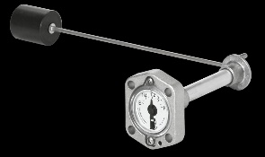

Figure 1 Float type fuel level indicator

1.3 Literature survey:
To ensure the research work involved in the design of an optical absorbance-based fuel indicator system with enhanced features, a literature survey is carried out.
The following are the learnings from the following sources.

In[1] The purpose of this paper is to propose modifications to the existing float meter and pressure transducer sensor by segmenting them and utilizing LTCC innovations, ultimately enhancing their durability and efficiency for large-scale usage. Additionally, the paper discusses the transmission of techniques to remote areas during the measurement process, where the float is located within the measuring medium.

[2The proposed principle of buoyancy states that when a floating object is immersed in a liquid, it experiences an upward force equal to the weight of the displaced liquid. This principle explains why objects float or sink in liquids.

The principle of radar level detector is similar to that of an ultrasonic sensor. It measures the time it takes for a microwave pulse to travel from a non-contacting transducer to the liquid level and back, by detecting the reflected echo. This method is used to accurately determine the level of liquid in a container.In order to use the radar level detector, monochromatic light is used. Monochromatic light refers to light of a single wavelength or color. When this light is reflected from the surface of a liquid, it gets dispersed. This dispersion is then measured by the detector to determine the level of the liquid. Another study employed the use of a Light Dependent Resistor (LDR) as a sensor. The LDR operates on the principle that the voltage across it is a function of the incident luminance. In other words, the resistance of the LDR changes based on the amount of light falling on it. This principle was utilized to achieve the main goal of the study.In [3] LDR sensor resistance will change according to changes in light intensity. The amount of resistance will be greater according to the magnitude of the distance between the LDR sensor and the light source. This difference in the intensity and resistance of visible light can illustrate to students that polychromatic light consists of several monochromatic light with different wavelengths.

In [4] the article explains the various methods of liquid level measurement since its inception. From the working basic glass level gauges and floats, to hydrostatic methods like displacers, bubblers and differential pressure transmitters have been explained in brief. Then it throws light on the principle of working of advanced technics like magneto strictive level transmission, and ultra-sonic level transmitters. This article gives a surface idea of all the current level measurement technics and their draw backs in brief.

Proposed System:
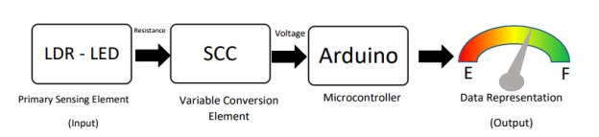
Figure 2 Block Diagram of the proposed system
The paper proposes a low cost, contactless system, that could potentially replace the conventional float system. As shown in the diagram, LDRs and LEDs are placed at the top and the bottom respectively (Converse is also possible). The intensity of light being transmitted at bottom by the LED is, by logic, higher than the intensity of light being received at the top by the LDR. It was chosen as a source of light as it low cost, small and has a longer life compared to florescent or other forms of light. The amount of light that is lost, in other words, absorbed by the fluid in between is proportional to the “path length” or the height if the fluid. If the cross section of the container is known, the volume of the fluid can be computed with acceptable levels of accuracy.

Design and Methodology:
LED
Figure 3 Schematic diagram of the System
The initial developmental trials were carried out using a transparent PET bottle as shown in the figure. The level of fluid was systematically varied, and resistance values of the LDR was recorded. Here are some factors that were considered during the process.
- The intensity of LED greatly affected the result. The supply voltage was kept constant throughout the development.
- The testing was initially done with water, then water – ink combination, water - food colour, and finally with petrol. The system was developed with a petrol level measuring system. Critical elements would have be redesigned for a diesel measuring system.
- The Transparency of the container was also an issue. Initially a transparent PET bottles, then an semi transparent malt box and finally an actually a tank from an old moped was used in the final stage demonstration..
- The colour of the LED was chosen in accordance with linearity of the change in resistance of the LDR. As shown in figure, green LED had the most linear performance. Usage of red LED was ruled out as the colour of the fluid under measurement was near to red. A red fluid would not absorb any amount of red colour.

The probes of the LDR were fed to a signal condition circuit that would proportionally convert resistance to voltage. This was required as microcontroller would need voltage as an input and resistance would not do the job. The microcontroller was programmed to take average of 3 resistance values in case of a tilt in the tank. It would then compute the volume of the fuel by multiplying the level of the fuel with the cross sectional area of the tank at that point. This was then printed on the LCD through I2C protocol.

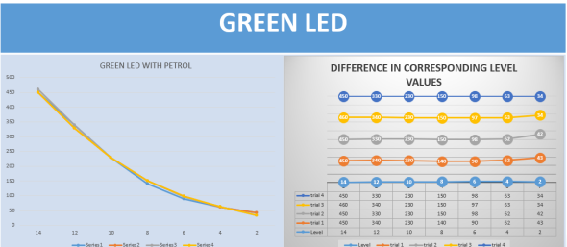
Figure 4 Level v/s Resistance readings with x axis level in CMs and resistance Y in Kilo Ohms
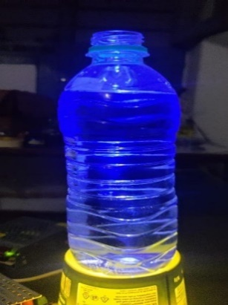
Figure 5 Initial iteration of the model with PET bottle

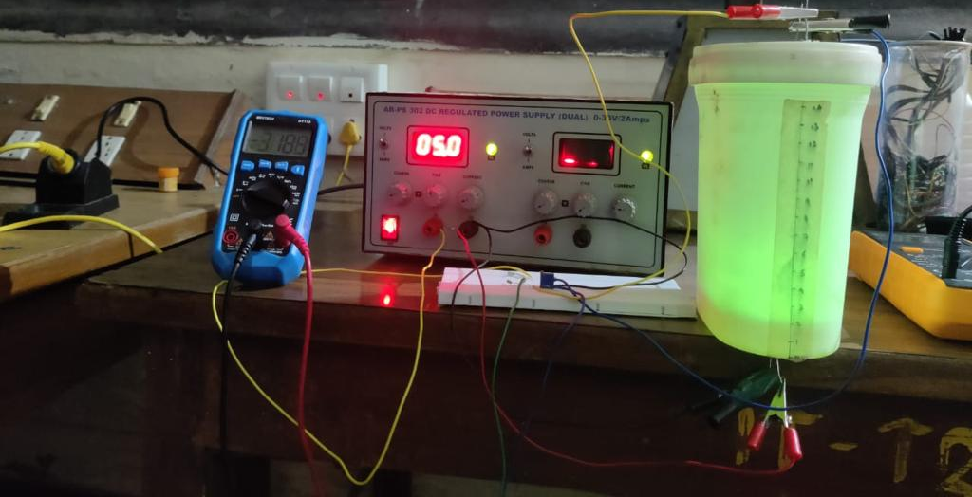
Figure 6 Intermediate iteration of the model with semi transparent Malt BOX

.
Figure 7 Final Stages of the model with Actual Petrol tank from a vehicle

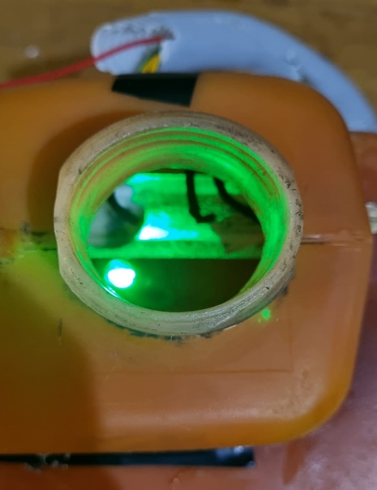
LDR
LED
Figure 8 Arrangement of optical pair within the tank

References:
- G. N. Popa, I. Popa, C. M. Diniş, and A. Iagăr, “Resistive stepped transducer used for water level measurement,” in Proceedings of the 1st WSEAS International Conference on Sensors and signals, 2008, pp. 66–71.
- Bera, S.C., Mandal, H., Saha, S., and Dutta, A.A. 2014. Study of A Modified Capacitance-Type Level Transducer for Any Type of Liquid. IEEE Transactions on Instrumentation and Measurement. 46(2): 641-649. doi:10.1109/TIM.2013.2282194
- Marinho, F., Carvalho, C.M., Apolinario, T.R., and L. Paulucci, L. 2019. Measuring Light with Light Dependent Resistors: An Easy Approach for Optics Experiments. European Journal of Physics, 40(3): 035801
- N. I. Klyuev, Measurement of the Liquid Level in the Fuel Tank of Rocket, January 2016, American Journal of Aerospace Engineering
- Brajesh Kumar, G Rajita, and Nirupama MandalView all authors and affiliationsA Review on Capacitive-Type Sensor for Measurement of Height of Liquid Level, Volume 47, Issue 7, Sage Journals.
- Hall Sensors for Fuel Level Sensing,

