BIOMASS AS A FUTURE GREEN RENEWABLE ENERGY RESOURCE : CHALLENGES AND OPPURTUNITIES
Dr. Rekha Israni
Assistant Professor ,DAV COLLEGE ,Ajmer
Abstract :
Sustainable development in India for economic development ,energy security ,mitigating climate change and global economy can be enhanced by deploying renewable energy resources in India. In today’s era fossil fuels are replaced by renewable energy resources to meet out environmental challenges. Biomass is the most commonly utilized energy resource
INTRODUCTION
Energy is a fundamental quantitative property which is imperative element of all areas of economies and influencing all spheres of life. It is used in many different ways and for many different things, from a nation's domestic and industrial needs to its operational and defense needs.
The onset of the COVID-19 pandemic demonstrated graphically the significance of energy to the global economy. Countries were forced to take drastic confinement measures, such as lockdowns and national border closures, in order to prevent the spread of this highly contagious virus. The slowing down of economic activities, the majority of which are dependent on transportation, which in turn requires energy for its sustainability, was an unintended but inevitable consequence of such measures. The global airline industry was virtually paralyzed, with the tourism industry suffering the most. What followed unavoidably was a sharp fall in the worldwide fuel interest for the transportation and assembling areas. This served as a stark reminder of the connection that exists between a nation's economy and its energy supply. The majority of the energy utilized in this present reality is petroleum derivative energy, and its greater part is utilized for transportation and power age. Not all nations of the world have their own oil assets, however they all need to get to this energy asset to fuel their assembling, transportation and power age areas. A differential pricing structure emerges as a result of the issues that arise in the supply chain, with the most remote nations bearing the highest costs. But large number of the countries are on the verge of development or not considered as developed countries.
There has been a global shift toward alternative energy sources, particularly for power generation and transportation among other reasons. Among these elective structures, bioenergy (in the form of solid biomass , fluid and gaseous biofuels) stands apart as an undeniable decision. Bioenergy which is considered as an alternatives to fossil fuels are renewable and, as a result, emit less greenhouse gas. Additionally, they are more readily available than other fuels in nations without their own indigenous fossil fuel resources. [1].
The main objective of this chapter is to consider the different types of bioenergy as perfect energy options for power age, transportation and environmental change alleviation. This chapter covers all methods of the conversion and utilization of these fuel sources.
Energy Utilisation Sectors
We want to arrange energy use to comprehend it better. This is best finished by posing the inquiries
• What is energy and where does energy come from, and
• what is energy utilized for?
Oil, coal, natural gas, nuclear energy, hydro, wind, solar, solid biomass, liquid and gaseous biofuels, geothermal energy, and, to a lesser extent, ocean energy are the energy sources that are utilized the most frequently today. They may be broadly classified into following sectors on the basis of origin :
- non-renewable energy sources like fossil fuels (oil, coal, flammable gas) which are mineral based that originates underground;
- nuclear energy which is also derived from underground sources; and
- renewable energy, which includes hydro, wind, solar, biomass, biofuels, and ocean energy and is readily replenished from terrestrial sources.

Besides these ,geothermal energy is a peculiar phenomenon. In spite of the fact that it starts from underground sources and is completely non-sustainable, it is considered as environmentally friendly power. Generally petroleum products and thermal power are cosidered into the non-renewables, and sunlight based, hydro, wind, biomass, biofuel, geothermal and sea energy into the renewable
People and nations as a whole use energy for a wide range of purposes. Typically, this usage is broken down into energy use sectors. An ordinarily involved classiﬁcation for these financial areas comprises of the homegrown, business, modern, transport and electrical power age areas. They may once in a while likewise incorporate the mining and horticulture areas. However, additional sectorial classifications are also considered.
The transformation of biomass to energy (likewise called bio-energy) includes an extensive variety of diﬀerent types and wellsprings of biomass, change choices, end-use appli-cations and foundation prerequisites. The cultivation of dedicated energy crops like short rotation crops(SRC) and perennial grasses, among others, can yield biomass. by gathering ranger service and other plant buildups (timberland thinnings, straw, and so on.); and from the wastes themselves, including sludge from organic industrial waste and organic domestic waste.The utilization of biomass to create energy is just a single type of sustainable power that can be used to lessen the effect of energy creation and use on the worldwide environment. Similarly as with any energy asset there are limitations on the utilization and appropriateness of biomass and it should contend with petroleum derivatives as well as with other restore capable energy sources like breeze, sunlight based and wave power
SOURCES OF BIOMASS
Biomass refers to the natural material that is utilized for the development of energy considered as Bioenergy. Biomass is fundamentally tracked down through living or as of dead plants and natural squanders from modern and homegrown use. The course of energy transformation from biomass incorporates warm change, synthetic change, biochemical change and electrochemical change. A geothermal power plant works by tapping the steam or boiling water repositories underground the earth and the intensity is utilized to drive an electrical generator. Hydroelectric energy is a type of energy that outfits the force of water moving, for example, water streaming over a cascade to produce power. A water turbine is a revolving machine that changes over motor energy and possible energy of water into mechanical work. The water turbine used in a hydroelectric power plant has a significant impact on the plant's conversion efficiency, which can reach 95% in large installations.
Bio-renewable resources are all forms of organic materials, including living and dead plant matter, animal matter, and their waste products. These materials are referred to as biomass resources. Biomass assets are by and large named being either squander materials or devoted energy crops.
A waste material can be any metropolitan strong waste and modern waste material that has been disposed of on the grounds that it no longer has any evident worth to the client or which addresses a disturbance or even an expected poison to the nearby climate. If the natural byproducts from one cycle, was utilized as essential wellspring of feedstock in another interaction, for instance, squander cardboard, wood and paper reused into papers, books and magazines, then, at that point, assuming that these waste materials were financially changed over into power, heat, fluid biofuels, or synthetic compounds, then, at that point, they could be considered as a biomass resources Biomass solid energy resources are classified into following categories:
• Agricultural Waste Horticultural Deposits are the non-consumable materials that stay after the collect of the eatable bits of the harvests, for example, corn, wheat, grain and sugar stick. Horticultural deposits additionally incorporates plant leaves, husks, a few roots and stems. Bioenergy non-food crop residues are grown for their starches, sugars, or oils, which can be used to make bioethanol and biolubricants. These non crop residues are grown alongside food crops and these agricultural residues don't require additional land space, which is a benefit.
• Food processing waste is the waste from a wide range of industrial processes, including the production of breakfast and cereal bars, fresh and frozen vegetables, and alcoholic beverages. These wastes and residues can be in the form of dry solids or liquids that are watery. Maturation of fluid squanders and oils from food handling can create Ethanol.
• Municipal Waste Items that are discarded in the garbage and trash are referred to as municipal solid waste. They are either collected by the dustbin men or taken to the recycling center. Metropolitan strong waste, for example, especially paper, cardboard, and disposed of food items, is an appealing wellspring of interminable biomass feedstock. Be that as it may, not all metropolitan waste is reasonable as a biomass asset, particularly metallic and plastic waste.
•Animal Waste from ranches, farms, slaughterhouses, fisheries and dairies or any grouping of animals into goliath domesticated animals cultivating offices delivers a lot of excrement and sewage slop. At wastewater treatment 1 plants, liquid sewage, animal waste, and human waste from urban areas provide a constant supply of chemical energy and gases that can be turned into electrical power. Biogas and combustible methane are produced during the treatment of animal waste, which can then be used for transportation and heating.
•Herbaceous Energy Harvests that have practically no woody tissue, for example, grasses and vegetables developed on prairies. The majority of the time, food crops like maize, wheat, rice, and sugarcane are excellent sources of herbaceous biomass. A few results or buildups of harvest development, like stalks and stems, can likewise be considered as herbaceous biomass.
Switchgrass and miscanthus structure the essential production of herbaceous yields as these tropical grasses will generally become quicker than woody trees and can deliver higher measures of biomass feedstock in a lot more limited period. These herbaceous plants typically only survive for a single growing season.
• Woody Energy Crops The majority of biomass resources are derived from woody energy crops, which include softwoods and hardwoods. Woody biomass can also be a residue from forestry activities (timber waste), from wood processing (industrial wood, sawdust, and wood shavings), and from end-of-life wood products (bulky waste, demolition, and pallets). Fast-growing trees and plantations are the primary sources of woody energy crops. Woody biomass is cut into uniform, little pieces called wood chips. Profoundly productive and non-contaminating burners and ovens can be intended to consume these chips for cooking and warming.
•Lipids are water insoluble oils and fats got from as of late living biomass. Waxes, animal fats and greases, rapeseed oil, palm oil, and others are examples. Sustainable lipid feedstock additionally incorporates green growth, microorganisms' and other such miniature life forms. Green growth are among the quickest developing sorts organic entities on the planet, with about portion of their weight being oil. The fluid biofuel, as a rule as liquor or ethanol, can be utilized to create biodiesel to control vehicles, trucks, and even planes.
Biomass Resources which are accessible for energy production envelops a large number of plants and materials going from farming and woods crops explicitly developed for energy purposes, horticultural and timberland squanders and deposits, squanders from food handling and fisheries, metropolitan waste including sewage slop, as well as oceanic plants and green growth.
BIOMASS CONVERSION TECHNOLOGIES
Biomass can be converted into useful forms of energy through a number of different processes.
(1) The "traditional domestic" use of agricultural residues, fuelwood, and charcoal in developing nations for cooking , lighting, and space heating. In this transformation the efficiency of the biomass to helpful energy by and large lies somewhere in the range of 5% to 15%.
(2) The "conventional industrialisation" utilization of biomass for handling of tobacco, tea, pig iron, blocks and tiles, and so on, where the biomass feedstock is frequently viewed as a "free" energy source. There is generally less incentive to utilize the biomass productively so change of the feedstock to helpful energy usually happens at an effectiveness of 12% or less.
(3) "Modern Industries" are experimenting with cutting-edge thermal conversion technologies having expected transformation efficiencies are somewhere in the range of 30 and 55%.
(4) Newer "chemical change" advancements ("fuel cell") which are equipped for by-passing the entropy-directed Carnot limit and depicts the most extreme hypothetical transformation efficiencies of warm units.
(5) Methods of "biological conversion," such as fermentation for alcohol and anaerobic digestion for the production of biogas.
By and large, biomass-to-energy transformation innovations need to manage a feedstock which can be exceptionally factor in mass and energy thickness, size, dampness content, and irregular stockpile. As a result, many of today's industrial technologies are hybrids between biomass and fossil fuels, utilizing fossil fuels for drying, preheating, and maintaining fuel supply in the event that biomass supply is disrupted.
There are a variety of processes that can be used to transform biomass into useful forms of energy. Factors that impact the decision of transformation process are: the sort and amount of biomass feedstock, the ideal type of the energy, for example end-use prerequisites, ecological norms, financial circumstances, and task explicit variables. The process path that is followed by the available kinds and quantities of biomass is frequently determined by the form of the energy that is required. There are three basic categories that can be used to classify the technologies for converting biomass into energy:
• Direct combustion processes
• Chemical and thermal processes
• Biochemical cycles.

- Direct methods of combustion
Residues like woodchips, sawdust, bark, hogfuel, black liquor, bagasse, straw, municipal solid waste (MSW), and food industry waste are frequently used as feedstocks.
Direct burning heaters can be separated into two general classifications and are utilized for delivering either direct intensity or steam. Dutch stoves, spreader-stoker and power module heaters utilize two-stages. The first stage is used for drying and possibly partial gasification, while the second stage is used for complete combustion. Further developed adaptations of these frameworks use turning or vibrating meshes to work with debris expulsion, with some requiring water cooling.
The subsequent gathering, incorporate suspension and fluidised bed heaters which are by and large utilized with fine molecule biomass feedstocks and fluids. In suspension heaters the particles are scorched while being kept in suspension by the infusion of turbulent preheated air which may as of now have the biomass particles blended in it. The combustion medium in fluidised bed combustors is a boiling bed of pre-heated sand at temperatures ranging from 500 to 900 °C. The biomass fuel is either dropped into the boiling sand if it is dense enough to sink there, or it is injected if it is particulate or fluid. These frameworks hinder the requirement for grates, however require strategies for preheating the air or sand, and may require water cooled infusion frameworks for less massive biomass feedstocks and fluids.
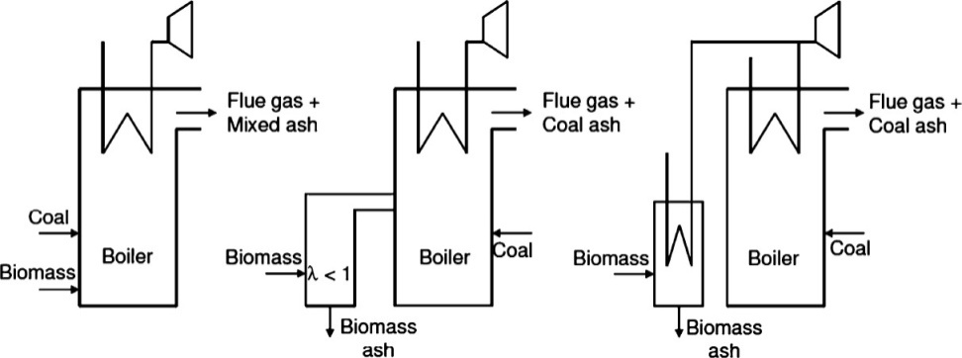
COFIRING

Figure 1 :Different Types Of Cofiring
Co-firing a fossil fuel, usually coal, with a biomass feedstock is a modern practice that has made it possible for biomass feedstocks to enter the energy market quickly and cheaply. Cofiring has various benefits, particularly where energy generation is a requirement.
Co-firing biomass with coal in boilers comes is of three types
• Direct cofiring - The biomass and the coal are mixed in a similar heater. The factories for the crushing of the fuel and the burners might be isolated. This relies upon the biomass utilized and its fuel properties. This idea is generally ordinarily utilized, in light of the fact that it is the least demanding to execute and generally practical.
• Indirect cofiring: In this method, a biomass gasifier turns solid biomass into a clean fuel gas. The gas can be mixed with coal in a similar heater . As a result, biomass can also be utilized, although it can be challenging to grind. The gas can be cleaned and sifted before use, to eliminate pollutions .
• Parallel cofiring: A separate biomass boiler can also be installed in the steam system of a coal power plant to raise steam parameters like pressure or temperature. A lot of biomass can be used with this method.
2.THERMOCHEMICAL PROCESSES :This process involves following four processes :
(a) Pyrolysis (b) Catalytic liquification (c) Carbonisation (d) Gasification
(a) Pyrolysis : It is the process of heating lignocellulosic materials (organic matter) in low or no air by applying high heat. The interaction can create charcoal, condensable natural fluids (pyrolytic fuel oil), non-condensable gasses, acetic acid, acetone and methanol. The cycle can be changed in accordance with favor charcoal, pyrolytic oil, gas, or methanol creation with a 95.5% fuel- efficiency.
The charcoal and fuel oils produced at the facility contain 68 percent of the energy in the raw biomass. The heating value of charcoal in British thermal units (Btu) is comparable to that of coal, and there is virtually no sulfide to pollute the atmosphere. The excess energy is in non-condensable gases that are utilized to co-produce steam and power. Each huge amount of biomass changed over completely to powers as such creates roughly 27% charcoal, 14% pyrolytic fuel oil, and 59% moderate Btu gas.
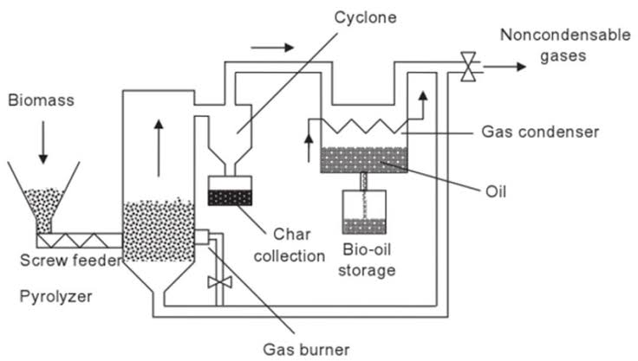
Fig. 2. Pyrolysis

The biomass feedstock is exposed to high temperatures at low oxygen levels, in this manner repressing total ignition, and might be completed under tension. Biomass is debased to single carbon particles (methane and Carbon monoxide) and H₂ delivering a vaporous blend called "producer gas." Additionally, carbon dioxide may be produced, but due to the reactor's pyrolysis, it is converted back into CO and water; this water further guides the response.
(B) Catalytic liquefaction This method has the potential to make products with a higher energy density and better quality. Additionally, less processing is required to make these products marketable. A thermochemical conversion that takes place in the liquid phase at a low temperature and high pressure is known as catalytic liquefaction. It requires either an impetus or a high hydrogen fractional strain. To make hydrogenation easier, a homogeneous hydrotreating catalyst is directly added to the reaction mixture. Similar to non-catalytic liquefaction, a hydrogen-donor solvent is used to stabilize the cracked products through hydrogen transfer. Additionally, molecular hydrogen is hydrogenated in situ on the feed, cracked products, and dehydrogenated solvent. In most cases, the solvent is recovered and recycled during the process
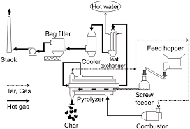
Figure 3 Liquification Process
© Carbonization: It is a centuries-old pyrolytic procedure made better for making charcoal. Conventional techniques for charcoal creation have focused on the utilization of earth hills or covered pits into which the wood is heaped. Control of the response conditions is much of the time rough and depends intensely on experience. The transformation effectiveness utilizing these conventional methods is accepted to be exceptionally low.
During carbonisation a large portion of the unpredictable parts of the wood are dispensed with; this cycle is additionally called "dry wood refining." Carbon gathers basically because of a decrease in the degrees of hydrogen and oxygen in the wood.
Large-scale industrial production now achieves efficiencies of more than 30% (by weight) as a result of the modernization of the charcoal industry.
There are three primary methods for making charcoal:
a) internally warmed (by controlled ignition of the natural substance),
b) externally warmed (utilizing fuelwood or petroleum products), and
c) hot flowing gas (answer or converter gas, utilized for the development of synthetic compounds).
Remotely warmed reactors permit oxygen to be totally rejected, and hence give better quality charcoal for a bigger scope. However, once pyrolysis has begun, they require the use of an external fuel source, which may come from the "producer gas." Recycling warmed gas frameworks offer the possibility to create enormous amounts of charcoal and related results, yet are as of now restricted by high venture costs for huge scope plant.
(d) Gasification
Biomass gasification is a warm cycle which changes over natural carbonaceous materials, (for example, wood squander, shells, pellets, farming waste, energy crops) into a burnable gas involved carbon monoxide (CO), hydrogen (H) and carbon dioxide (CO₂). This is accomplished by responding the material at high temperatures, without completely combusting it, utilizing a controlled oxygen (O) channel. The subsequent gas blend is called syngas. At temperatures of around 600 to 1000°C, strong biomass goes through warm decay to frame gas-stage items which normally incorporate CO, H₂, CH₄, CO₂, and H₂O.
There are four phases associated with gasification process:
• Drying zone: At temperatures ranging from 150 to 200 °C, the heat from the lower zones evaporates feedstock moisture in the drying zone. Vapours descend and mix with those coming from the oxidation zone. A piece of the fume is changed over into oxygen with the rest of held in the maker gas.
Pyrolysis Zone This is the warm decay of biomass in low oxygen conditions at temperatures going from 200 to 600°C.
• Combustion Zone : In the presence of a reactive gas (air or pure oxygen), oxidation alters the gas's calorific value as it exits the gasifier. The utilization of air as receptive gas is the more normal.
• Reduction Zone: The results of the oxidation zone, hot gases and gleaming burn, move into the decrease zone. A number of reduction reactions take place between the hot gases (CO, H2O, CO2, and H2) and char because there is insufficient O2 in this high-temperature zone for continued oxidation.

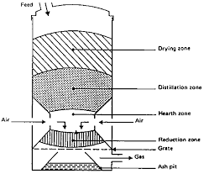
Fig.4. Different Zones of Gasification
(3)Biochemical Phenomenon.
• Anaerobic Fermentaion.
• Methane Generation in Landfills.
• Fermentation Ethanol .
• BioDiesel fuel
Anaerobic Fermentation.
Anaerobic reactors are for the most part utilized for the creation of methane rich biogas from excrement (human and creature) and harvest deposits. They employ mixed methanogenic bacterial cultures that are distinguished by clearly defined growth-optimal temperature ranges. These blended societies permit digesters to be worked over a wide temperature range for example above 0°C up to 60°C.
Biogas, which contains approximately 55% methane and can be used as a source of energy for cooking and lighting, is produced by the bacteria when they are working properly. After the manure has been processed through the digester, an odorless, non-toxic sludge is produced. Additionally, it has lost relatively little nitrogen and other nutrients during digestion, making it an excellent fertilizer. In fact, digester sludge contains more nitrogen than cattle manure left to dry in the field; a considerable lot of the nitrogen intensifies in new excrement become volatised while drying in the sun. Then again, in the processed slime little of the nitrogen is volatilised, and a portion of the nitrogen is changed over into urea. Urea is more promptly open by plants than a large number of the nitrogen intensifies tracked down in compost, and hence the manure worth of the slime may really be higher than that of new excrement.
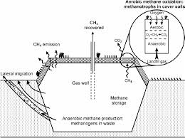

Fig. 5. Anaerobic Fermentation
(b) Methane Generation in Landfills
Landfills for civil strong waste are a wellspring of biogas. Biogas is delivered normally by anaerobic microorganisms in metropolitan strong waste landfills and is called landfill gas. A few landfills lessen landfill gas outflows by catching and consuming or erupting the landfill gas. CO2 is produced when methane in landfill gas is burned, but CO2 is a weaker greenhouse gas than methane. Numerous landfills gather landfill gas, treat it to eliminate CO2, water fume, and hydrogen sulfide, and afterward sell the methane. The methane gas is used to generate electricity in some landfills.
© Ethanol Fermentation.

In order to lessen their reliance on energy supplies imported from other countries, ethanol is primarily used as an alternative to imported oil. The significant additions made in maturation advances currently make the development of ethanol for use as a petrol substitute and fuel enhancer, both monetarily serious (given specific presumptions) and naturally valuable.
The most usually involved feedstock in emerging nations is sugarcane, because of its high efficiency when provided with adequate water. Sweet sorghum or cassava may become the preferred feedstocks in areas with limited access to water. Modern management techniques and the high residual energy potential of sugarcane feedstock are additional benefits that make sustainable and environmentally friendly production possible while allowing for continued sugar production. Different feedstocks incorporate saccharide-rich sugarbeet, and starch rich potatoes, wheat and maize.
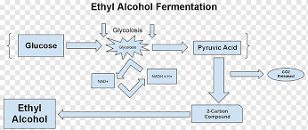
Figure 6 Ethanol Fermentation
Transformation of biomass to ethanol incorporates (1) pretreatment, (2) enzymatic hydrolysis,(3) fermentation, and (4) refining. Pretreatment some of the time incorporates mechanical size decrease which should be trailed by areas of strength for a pretreatment to separate lignocellulosic structure solubilizing hemicellulose or potentially lignin to make cellulose more open to hydrolytic chemicals. For ethanol fermentation, cellulose glucose is released through enzyme hydrolysis. The two stages should be possible together in a solitary step called concurrent saccharification and maturation (SSF). To acquire high ethanol focus for refining in lignocellulosic biorefinery process, steps, for example, enzymatic hydrolysis or SSF should be worked at high strong stacking.
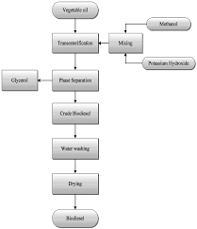
Fig. 7. Biodiesel from ethanol fermentation
Vegetable oils have been burned in diesel engines for more than 100 years. A wide variety of annual and perennial plant species can be used to obtain the raw oil. Oil palms, coconut palms, the physica nut, and the Chinese Tallow Tree are perennials. Sunflower, groundnut, soybean, and rapeseed are annuals. A significant number of these plants can deliver exceptional returns of oil, with positive energy and carbon adjusts.
Change of the crude oil is important to keep away from issues related with varieties in feedstock. The oil can go through warm or reactant breaking, Kolbe electrolysis, or transesterification processes to get better attributes. Untreated oil brings on some issues through fragmented ignition, bringing about the development of dingy buildups, waxes, gums and so forth. Likewise, wrong viscosities can bring about unfortunate atomization of the oil additionally bringing about unfortunate ignition. Deposition on the cylinder walls can occur as a result of oil polymerization.
Biodiesel is created from vegetable oils, yellow oil, utilized cooking oils, or creature fats. The fuel is created by transesterification; an interaction that converts fats and oils into biodiesel and glycerin (a coproduct). Roughly 100 pounds of oil or fat are responded with 10 pounds of a short-chain liquor (normally methanol) within the sight of an impetus (typically sodium hydroxide [NaOH] or potassium hydroxide [KOH]) to frame 100 pounds of biodiesel and 10 pounds of glycerin (or glycerol). Glycerin, a co-item, is a sugar normally utilized in the production of drugs and beauty care products.
Recycled greases that have not been processed into biodiesel or raw or refined plant oil are not biodiesel and should not be used as vehicle fuel. Fats and oils (fatty substances) are considerably more thick than biodiesel, and low-level vegetable oil mixes can cause long haul motor stores, ring staying, lube-oil gelling, and other support issues that can diminish motor life.7
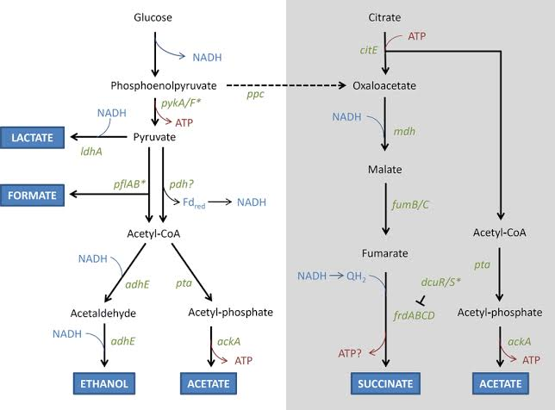
Figure 8
Advantages of Biomass Energy
Biomass benefits are still subject of many debates when compared with other renewable energy sources. However, biomass has many advantages over fossil fuels due to reduction of the amount of carbon emissions. The main benefits of biomass are:
  - Biomass is a renewable energy source: The benefit of biomass energy is that biomass is renewable source of energy and it cannot be depleted. Biomass mostly derived from plants, that means as long as plants are going on this planet, biomass will be available as renewable energy source.
  - Biomass helps climate change : Biomass indeed helps reduce the amount of greenhouse gas emissions that give more impact to global warming and climate change. Though biomass is connected with certain level of emissions this level is far smaller compared to currently dominant energy sources, fossil fuels. The basic difference between biomass and fossil fuels when it comes to amount of carbon emissions is that all the CO₂ which has been absorbed by plant for its growth is going back in the atmosphere during its burning for the production of biomass energy while the CO₂ produced from fossil fuels is only going to atmosphere where it increases Earth’s greenhouse effect and adds to global warming.
  - Cleaner and Greener environment: The third main benefit of biomass energy is that biomass can help clean our environment. World population is constantly increasing, and with the increase in population there is also a problem of increased waste which needs to be properly disposed. Many of the garbage ends up in rivers, water streams, oceans harming nearby ecosystems and having negative impact on human health. Instead of pollution our planet with all this garbage we could use it for the production of this energy and it helps cleaning our environment from many different form of pollution.
  - Biomass is widely available source of energy: Biomass is widely available energy source. The sources are from agriculture, forestry, fisheries, aquaculture, algae and waste. Many energy experts agree that when you combine economic and environmental character of energy sources biomass is on top of the list as one of the best energy sources.
  - Green House Gases emission balances for biomass-fuelled electricity and heat applications: Some biomass systems show net GHG emissions savings of more than 40% of the substituted fossil alternatives, while some others only score 4%. Thus, the span of the environmental benefit is wide, and the effective value will depend on the particular application situation (technology, scale etc). The total GHG emissions from contaminated biomass fuels (non-tradables) are set at 0, since these fuels are available anyway. There existence cannot be avoided, and all GHG emissions associated with their production should be allocated to the products from which they are the unavoidable result.
  - Biomass Power is Carbon Neutral: Biomass power is carbon neutral. Any carbon that is released into the atmosphere during combustion of biomass is absorbed from the atmosphere at one point in the tree’s life – so what it took out ends up going back. In many cases, the carbon released is re- absorbed by another plant so it never reaches the atmosphere in the first place. With fossil fuels, the carbon released during combustion has been inaccessible to the atmosphere for millennia and therefore adds additional carbon to the atmosphere.
  - Reduces amount of waste in landfills: Most waste produced in homes is either plant matter or biodegradable. This kind of waste can be channeled to more profitable use. Biomass energy generation utilizes any waste that would have otherwise found way into landfills. This minimizes the impacts of waste in landfills to the environment. This impact may be compounded by contamination of local habitats and destruction of wildlife ecosystems. Minimized waste means reduction of land intended for landfills, hence, more space for human habitats

.

References
- ADAS, 1992. The potential of miscanthus as a fuel crop. ETSU Report ETSU B 1354.
- Singh A and Bijay P 2020 Mitigating through renewable energy: an overview of the requirements and challenges ed A Singh and R Deo Translating the Paris Agreement into Action in the Paciﬁc (Cham: Springer Nature) ch 2 pp 29–58
- World Energy Council 2013 World Energy Resources: Solar [accessed 5 April 2021]. Available from https://worldenergy.org/assets/images/imported/2013/10/WER_2013_8_Solar_revised.pdf
- REN21 2019 Renewables 2019 Global Status Report 2019 [accessed 5 April 2021]. Available from https://ren21.net/wp-content/uploads/2019/05/gsr_2019_full_report_en.pdf
- BP 2019 BP Statistical Review of World Energy 2019 [accessed 5 April 2021]. Available from https://bp.com/content/dam/bp/business-sites/en/global/corporate/pdfs/energy-economics/stat- istical-review/bp-stats-review-2019-full-report.pdf

