COMPARATIVE ANALYSIS OF BIOACTIVE COMPOUNDS IN DRY BLACK AND GREEN GRAPES Vitis Vinifera (L.) by GC-MS

¹S. Vasantha, S. ²Subramaniyan, ³S. V. Bakiya Lakshmi, ⁴C. Karpaga Sundari
^{1&4}Assistant Professor, Department of Botany, A.V. V. M Sri Pushpam College (Autonomous) Poondi, Thanjavur
²Assistant Professor, Department of Zoology, H. H The Rajahs College, Pudukottai
³Assistant Professor, Department of Biotechnology, Bon Secours College for Women, Thanjavur
Affiliated with Bharathidasan University, Tiruchirappalli

Corresponding : subravasanth76@gmail.com, subramanian2376@gmail.com, bakiyalakshmi.sv@gmail.com, sundarikarpagam1981@gmail.com

Abstract

The study indented to examine the therapeutic potentials of V. vinifera through GC/MS characterization. The ethanolic extracts of Black and Green dry grapes were undergone qualitative analysis. The consequences of qualitative phytochemical analysis of black and green grapes extracts confirmed the presence of alkaloids, flavonoids, glycosides, saponins, tannins, carbohydrates, phytosterol, and triterpenoids, whereas flavonoids were absent in green grapes. The black dry grape possessed Antioxidant, hypocholesterolemic, Antiandrogenic, hemolytic, Alpha reductase inhibitor, Anti-inflammatory, Antimicrobial, and anti-cancer compounds. The black grapes have a special steroid compound namely Pregn-5-en-20-one, 3,16- bis[(trimethylsilyl)oxy]-, (3beta,16alpha) possessed Uterine endothelium activity. Similarly, the green dry grape showed fifteen bioactive compounds that possessed Anti-inflammatory, Antimicrobial, anti-cancer, Hepatoprotective and Diuretic, Anti leukemia activity, Anti cataract hypolipidemic properties, and anti-larvicidal activity. In addition, male sex hormone compounds, namely Testosterone and Androst-4-en-3-one, 17-hydroxy-, (17.beta.)-. The study shows that both green and black grapes possessed different bioactive especially omega fatty acids found in green grapes. These findings are essential and light up the position of dry grapes as a future supplement that could prevent detrimental outcomes. in this take look at, it turned into counseled that the consumption of purposeful food is beneficial in the prevention of numerous illnesses.

Keywords: V. vinifera, GCMS, Bioactive compounds, Antioxidant, Anticancer

Introduction
Grapes, a natural product, organically a berry fruit, of the deciduous woody vines of the blooming plant family (Vitis). Vitis Vinifera is an character from the Vitaceae circle of relatives, nearby to southern Europe and Western Asia and advanced around the world. Grapes are regarded as rich wellsprings of polyphenolic mixes, consisting of catechin, epicatechin, gallic acid, procyanidins and Anthocyanin. the entire phenolic compounds found in purple grapes seed is sixty two%. Grape seed has a excessive convergence of vitamin E, linoleic acid, flavonoids and phenolic procyanidins. The seed extract from grape seeds which might be separated, dried and wiped clean to create polyphenolic mixes rich possessed antioxidants and oligomeric proanthocyanidins which had antidiabetic cardioprotective, hepatoprotective, anti-carcinogenic, anti-microbial, Vaso-relaxation, protection towards membrane oxidation, inhibit platelet aggregation, anti-viral activity, and steel chelating homes anti-most cancers agent, antimicrobial and mitigating houses. it is broadly speaking used for commercial purposes whilst oral grape seed extract is used in capsules or pills. The grape seeds are used in natural drugs, even as the fruit is fed on as a dietary supplement (Mohanad Jawad Kadhim et al.,2017).
Vitis Vinifera is used in conditions like hemorrhages, iron deficiency, skin problems, syphilis, bronchial asthma, jaundice, bronchitis, calming and many others. V.vinifera seed includes lipid, protein, carbohydrates and 5-8% polyphenols. The grape seed extract (GSE) has been reported to own a broad pharmacological and healing outcomes spectrum. together with antioxidative, antiinflammatory, and antimicrobial sports, as well as having cardioprotective, hepatoprotective, and neuroprotective consequences. The seeds of the grape are utilized in natural medicine and as a nutritional complement (Chedea et al., 2010). Therefore, the have a look at become to investigated bioactive compounds evaluation of Dry black and green grapes Vitis Vinifera (L.).
2. MATERIALS AND METHODS
2.1 COLLECTION OF SAMPLE
The dry black and green grapes (Vitis Vinifera) were purchased from PPDS at Thanjavur. The samples had been color dried for 15 days and ground into quality powder. The powder fabric is changed into stored in air-tight polythene luggage till use.

2.2 Preparation of extract
10 g of grape powder had been taken one by one and boiled in 200mL of distilled water and then heated at 60-70°C to get a concentrated solution. The extracts have been filtered the use of a muslin cloth after which by way of Whatman no 1 filter paper. The extract changed into then concentrated with the use of a rotary vacuum evaporator; residues had been gathered, dried, and used for the experiment. The extracts of samples have been subjected to a qualitative test for the identification of diverse plant constituents through the Harborne method (1973).
ANALYSIS OF BIOACTIVE COMPOUNDS BY GC-MS
The GC-MS evaluation of the sample changed into performed the use of a Shimadzu GCMS-QP2010 fuel chromatography-mass spectrometer interfaced with a rapid Mass quadrupole mass spectrometer, geared up with an Rtx-5 fused silica capillary column (30 X0.25 mm, with 1 Cm movie thickness). The oven temperature becomes programmed from 100⁰C to 320⁰ C at 100⁰C/min and held for 10 min. Helium become used as provider gasoline at a glide of one.0 mL/min. The injector temperature turned into 250 ⁰C, injection length 1 µL neat, with a cut-up ratio of 1:10. The interface and MS ion supply were maintained at 320⁰C and 2 hundred⁰C respectively and the mass spectra were taken at 70eV with a mass experiment variety of 40-700 amu (atomic mass unit). data coping with becoming completed the usage of GCMS solution software.
Identity of Compounds Interpretation of the mass spectrum of GC-MS turned carried out the usage of the mass spectral database of country wide Institute of widespread and technology (NIST) having more than 62,000 styles. The spectrum of the unknown thing turned into as compared with the spectrum of the known additives saved within the NIST library. The name, molecular weight and structure of the additives of the take a look at substances have been ascertained.
3. RESULT AND DISCUSSION
3.1 Qualitative analysis
The end result of qualitative phytochemical analysis of the chosen fruit extracts revealed the presence of alkaloids, flavonoids, glycosides, carbohydrates, saponins, tannins, phytosterol, and triterpenoids in black grapes; whereas flavonoids had been absent in green grapes. The present study for phytochemical analysis qualitatively was analyzed in dry black and green grapes (Vitis Vinifera ) (Table 1).
Table 1. Qualitative analysis of phytochemicals in Dry Black and Green Grapes
(Vitis Vinifera )
S.No. | PHYTOCHEMICAL | BLACK | GREEN
1 | Alkaloids | Present | Present
2 | Flavonoids | Present | Absent
3 | Glycosides | Present | Present
4 | Carbohydrates | Present | Present
5 | Saponins | Present | Present
6 | Tannins | Present | Present
7 | Phytosterol | Present | Present
8 | Triterpenoids | Present | Present

3.2 GC-MS analysis of Black and Green grapes (Vitis Vinifera )
Diverse bioactive compounds, inside the dry black and green Viti’s vinifera extracts, had been identified thru GC-MS analysis. The identity of some of the important phytoconstituents become primarily based on the peak place, retention time, and molecular weight and their pharmacological activity have been primary pharmaceutically vital compounds from the GC fractions of decided on samples. various compounds found in aqueous extracts of grape peel and seed have been indexed with their pharmacological activity (table 2 &3) to represent the chromatogram of aqueous extracts of decided on Vitis Vinifera .
The Diterpenoids compound particularly 2-Pentadecanone, 6,10,14-trimethyl changed into found in black grapes. in addition to that eleven-Octadecenoic acid, methyl ester, 9,12-Octadecadienoic acid (Z,Z)-, methyl ester, Hexadecanoic acid, methyl ester and Tridecanoic acid, 12-methyl-, methyl ester changed into the present which confirmed Antioxidant, hypocholesterolemic, Antiandrogenic, hemolytic, Alpha reductase inhibitor, Anti inflammatory, Antimicrobial and Anticancer hobby. The inexperienced grapes have a unique steroid compound specifically Pregn-5-en-20-one, 3,16- bis[(trimethylsilyl)oxy]-, (3beta,16alpha) possessed Uterine endothelium activity. (table 2).
further, the green dry grape confirmed fifteen bioactive compounds specifically Gamma.-Sitosterol, nine,19-Cyclolanost-24-en-3-ol, Lanosterol, Lup-20(29)-en-3-one, Ferrocene, [(hexadecyloxy)carbonyl, 9,19-Cycloergost-24(28)-en-3-ol and Friedelan-3-one have antiinflammatory, Anti microbial, Anti most cancers, Hepato protecting and Diuretic, Anti leukemia interest, Anti cataract pastime, hypolipidemic property and anti larvicidal activity. in addition , male intercourse hormone compounds were additionally gift, namely Testosterone and Androst-4-en-3-one, 17-hydroxy-, (17.beta.)-. The a look suggests that both inexperienced and black grapes possessed one-of-a-kind bioactive especially omega fatty acids had been located in green grapes, male intercourse stimulating hormones had been present in inexperienced grapes, in which because the black grape possessed uterine enhance compound. ( Table 3).
Table 2. Compounds identified in Black Grapes
Name of the compound | Mol. Formula | PA % | Compound Nature | Structure | Biological Activity
Glycerin | C₃H₈O₃ | 2.17 | simple polyol compound | 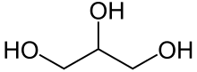 | Sweeteners in the food industry and humectants in pharmaceutical formulations
Tridecanoic acid, 12-methyl-, methyl ester | C₁₅H₃₀O₂ | 2.03 | Fatty acid methyl ester. | 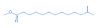 | Antifungal and antibacterial activities.
Phenol, 3-isopropoxy-5-methyl- | C₁₀H₁₄O₂ | 2.70 | Phenol | 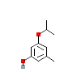 | No activity reported
2-Pentadecanone, 6,10,14-trimethyl | C₁₈H₃₆O₂ | 3.23 | Diterpenoids | 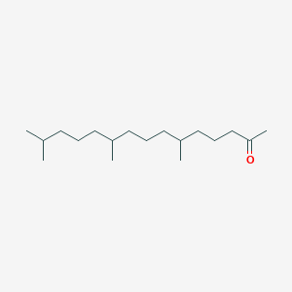 | Antimicrobial
Hexadecanoic acid, methyl ester | C₁₇H₃₄O₂ | 10.47 | Palmittic acid | 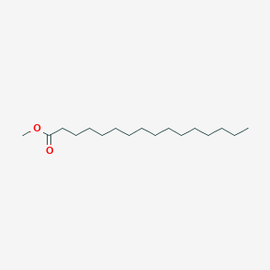 | Antioxidant, hypocholesterolemic, Antiandrogenic, hemolytic, Alpha reductase inhibitor
9,12-Octadecadienoic acid (Z, Z)-, methyl ester | C₁₉H₃₄O₂ | 11.22 | omega 6 unsaturated fatty acid | 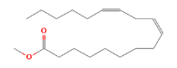 | Anticancer
11-Octadecenoic acid, methyl ester | C₁₉H₃₆O₂ | 9.39 | Oleic acid | 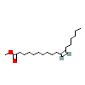 | Hypercholesterolemic, Dermatitigenic, Anti-inflammatory
Phytol | C₂₂H₄₂O₂ | 34.58 | acyclic diterpene | 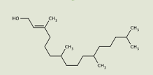 | Flavour and fragrance
l-Leucine, N-(trifluoroacetyl)-, tetradecyl ester | C₆H₁₃NO₂ | 3.66 | Aminoacid | 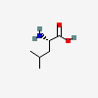 | preventing muscle loss
Benzoic acid, 2-(1-isopropyl)- | C₇H₆O₂ | 1.90 | Aromatic compound | 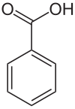 | Antimicrobial activity
2'-Methoxy-2,4-dinitrodiphenylamin | C₁₃H₁₁N₃O₅ | 3.21 |  | 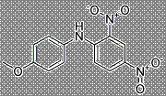 | No activity reported
Pregn-5-en-20-one, 3,16- bis[(trimethylsilyl)oxy]-, (3beta,16alpha) | C₂₇H₄₈O₃Si₂ | 9.45 | Steroid | 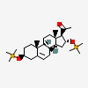 | Uterine endothelium activity
5-Methyl-2-trimethylsilyloxy-acetophenone | C₁₂H₁₈O₂Si | 1.77 | Essential oil | 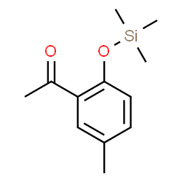 | Antioxidant and antimicrobial

Table 3: Compounds identified in Green Grapes
Name of the compound | Mol. formula | PA % | Compound Nature | Structure | Biological Activity
Gamma.-Sitosterol | C₂₉H₅₀O | 1.10 | Phyto sterol | 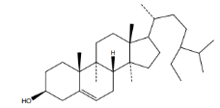 | hypolipidemic property
9,19-Cyclolanost-24-en-3-ol | C32H52O | 8.52 | Triterpenoid | 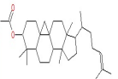 | Anti-mosquito and larvicidal
alpha.-Amyrin | C₃₀H₅₀O | 1.58 | Pentacyclic triterpene | 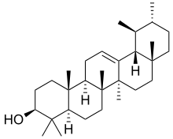 | Antimicrobial and anti-inflammatory activity
Lanosterol | C₃₀H₅₀O | 1.26 | Plant sterol | 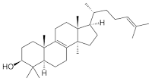 | prevent cataracts
Lup-20(29)-en-3-one | C₃₀H₄₈O | 20.31 | Triterpenoid | 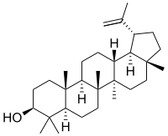 | Anti leukemia activity
9,19-Cyclolanost-23-ene-3,25-diol, | C₃₀H₅₀O | 21.09 | triterpenoid of the sterol class | 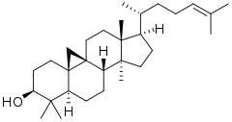 | Antibacterial activity
Phenol, 4-(2-thienylmethyl)- | C₁₅H₁₂OS₂ | 2.95 | Phenol | 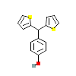 | No activity reported
Testosterone | C₁₉H₂₈O₂ | 1.17 | Steriod | 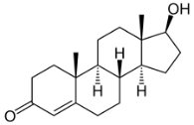 | Sex hormone
Phenol, 4,4'-methylenebis[2,6-bis 1,1-dimethyl ethyl)- | C₂₉H₄₄O₂ | 2.54 | Phenol | 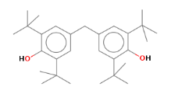 | No activity reported
Ferrocene, [(hexadecyloxy)carbonyl | C₁₀H₁₀Fe | 1.82 | Organometallic compound with iron | 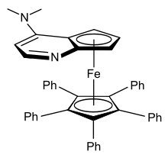 | Anticancer
9,19-Cycloergost-24(28)-en-3-ol, | C₃₂H₅₂O₂ | 17.62 | Plant sterol | 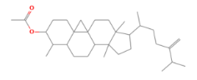 | Anti-inflammatory, Antimicrobial, Anti-cancer, Hepatoprotective, and Diuretic
Friedelan-3-one | C₃₀H₅₀O | 3.67 | Triterpenoid | 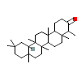 | Antimicrobial
Androst-4-en-3-one, 17-hydroxy-, (17.beta.)- | C₁₉H₂₈O₂ | 3.54 | Steroid | 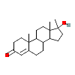 | Regulation of spermatogenesis
Histidine, N-trifluoroacetic-4-iod o-, methyl ester | C₇H₁₁N₃O₂ | 1.48 | Amino acid | 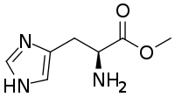 | No activity reported

Conclusion
The results of qualitative phytochemical evaluation of black grape extract confirmed the presence of alkaloids, flavonoids, glycosides, saponins, tannins, carbohydrates, phytosterol and triterpenoids, wherein as flavonoids become absent in green grapes. The black grapes having a unique steroid compound specifically Pregn-5-en-20-one, 3,sixteen- bis[(trimethylsilyl)oxy]-, (3beta,16alpha) possessed Uterine endothelium action. Further the green dry grape showed fifteen bioactive compounds. in addition, male sex hormone compounds were present, specifically Testosterone and Androst-four-en-three-one, 17-hydroxy-, (17.beta.)-. further studies are had to isolate natural active principle of the extract as well as to clarify their exact mechanism of activity in diverse diseases using community pharmacology to increase the Nutraceutics for sustainable healthy life.

REFERENCE
Amerine, M.A. and Joslyn, M.A., Table wines. 2nd edition. Berkeley and Los Angeles: University of California press pp. 997, (1967).
Bupesh, G., T.S. vijayakumar, S. Manivannan, M. Beerammal, E. Manikadan, P. Shanthi and A.A. Vijaya, 2016. Identification of secondary metabolites, antimicrobial and antioxidant activity of grape fruit ( Vitis Vinifera ) skin extract. Diabetes Obesity Int. J., Vol. 1, No. 1.
Burin, V.M., N.E. Ferreira-Lima, C.P. Panceri and M.T. Bordignon-Luiz, 2014. Bioactive compounds and antioxidant activity of Vitis vinifera and Vitis labrusca grapes: Evaluation of different extraction methods. Microchem. J., 114: 155-163.
Chedea,V.S., Braicu,C. and Socaciu,C., Antioxidant/prooxidant activity of polyphenolic grape seed extract. Food Chem., 121: 132-139, (2010).
Chedea,V.S., C. Braicu and Socaciu, C. 2010. Antioxidant/prooxidant activity of polyphenolic grape seed extract. Food. Chem.121: 132-139.
Dulundu,E., Ozel,Y. and Topaloglu,U., Grape seed extract reduces oxidative stress and fibrosis in experimental biliary obstruction. J. Gastroenterol Hepatol., 22: 885-892, (2007).
Harborne, J. B. (1973). Phytochemical methods: A guide to modern techniques of plant analysis. Chapman and Hall Ltd, London.; Pp. 279.
Kadhim, M.J., A.B. Al-Rubaye and I.H. Hameed, 2017. Determination of bioactive compounds of methanolic extract of Vitis vinifera using GC-MS. Int. J. Toxicol. Pharmacol. Res., 9: 113-126.
Maier,T., Schieber,A., Kammerer,D. and Carle,R., Residues of grape (Vitis Vinifera L.) seed oil production as a valuable source of phenolic antioxidants. Food Chemistry, 112: 551-559, (2009).
Mohanad Jawad Kadhim, Abeer Fauzi Al-Rubaye. Determination of Bioactive Compounds of Methanolic Extract of Vitis Vinifera Using GC-MS. International Journal of Toxicological and Pharmacological Research. 2017; 9(2): 113 – 126.
Shenoy,S.F., Keen,C.L.,Kalgaonkar,S. and Polagruto,J.A., Effects of grape seed extract consumption on platelet function in postmenopausal women. Thromb. Res., 121: 431-432, (2007).
Yilmaz Y, Toledo R.T. Health aspects of functional grape seed constituents. Trends Food Sci Tech. 2004; 15: 422 – 433.

