Hybridization of Internet of Things (IoT) and Cloud Computing

Author 1:
S.B.S.Younus,
Assistant Professor,
Department of Information Technology,
Sadakathullah Appa College,
Rahmath Nagar, Tirunelveli – 627 011,
Tamilnadu, India.

Author 2:
A.Mohammed Asik Ali,
Assistant Professor,
Department of Computer Science,
Sadakathullah Appa College,
Rahmath Nagar, Tirunelveli – 627 011,
Tamilnadu, India.

Introduction

The concept of the Internet of Things (IoT) symbolizes an era-defining shift that has seamlessly integrated itself into contemporary life, captivating the imagination of professionals across industry and academia. Positioned as a trailblazing wave of technology, IoT's influence permeates a diverse spectrum of business sectors. Forecasts indicate that the IoT ecosystem could encompass an estimated 64 billion devices by 2025, placing it at the forefront of the Big Data revolution. This entails a profound analysis of its vast volume, substantial value, varied composition, rapid transmission, and precision. The evolution of the Internet of Things primarily revolves around the enhancement of a framework that fosters full compatibility between protocols and software, enabling a cohesive interconnection of entities.
The structural foundation of IoT consists of an intricate amalgamation of software components, electronic elements, actuators, sensory mechanisms, detection devices, and wireless interfaces. This composite system is engineered to assimilate data, establishing the following pivotal characteristics:
- The advancement of IoT technology facilitates the integration of objects with the internet, utilizing both wired and wireless networks to enable the exchange of information.
- Technologies such as Near-field Communication (NFC), Zigbee, Radio Frequency Identification (RFID), Bluetooth, and Wi-Fi form the crux of the wireless sensory network within IoT devices.
- These sensory components can be interfaced with various technological platforms including Long-term Evolution (LTE), General Packet Radio Service (GPRS), Third Generation of Mobile Telephony (3G), and Global System for Mobile Communication (GSM).
- The efficacy of an IoT system predominantly stems from a triad of crucial components that govern its functionality:
  - Perception

• Middleware (Incorporating Edge, Fog, and Cloud Computing)
- Application
Cloud computing, with its expansive storage capacity and computational prowess, emerges as an instrumental solution to a myriad of challenges within the IoT domain. This synergistic confluence of cloud computing and IoT has culminated in a paradigm referred to as the "Cloud of Things" (CoT), a model widely employed by various industrial sectors and manufacturers to elevate system performance and augment productivity. Scholarly explorations have delved into the utilization of the cloud as a platform for Big Data analysis, specifically focusing on storage and processing. Recent investigations have unveiled that the journey towards energy-efficient technology is fraught with obstacles that warrant future resolution.
In the contemporary landscape characterized by the exponential growth of the Internet of Things (IoT), the generation of voluminous real-time data presents formidable challenges to conventional cloud computing network architectures. Traditional cloud infrastructures, confined to limited data centers, are often distanced from remote devices, creating a latency barrier. Edge computing emerges as a potent solution to this predicament, providing proximate computing resources to IoT edge devices. This innovative approach has the potential to catalyze a novel ecosystem for IoT advancement, heralding an unprecedented chapter in technological innovation.

Internet of Things (IoT)

In 1999, the British technological visionary Kevin Ashton coined the term "IoT," short for "Internet of Things," envisioning a paradigm where various sensors enable physical objects to connect with the virtual world. In this context, a "thing" might encompass any tangible entity on Earth, irrespective of whether it serves as a communication device. Although the notion of IoT has gained wide traction, a unanimous definition remains elusive. One interpretation posits that the IoT refers to the integration of devices capable of generating, exchanging, and leveraging data without relying on centralized computing. This philosophy transcends the domain of personal computers, enabling networks and computational resources to intertwine objects, sensors, and routine items.
The Oxford Dictionary offers its insight, defining IoT as an Internet-centric structure that facilitates communication and information sharing among electronic components embedded in r2e1al-world objects. In a similar vein, the RFID group describes it as a cohesive global network of interlinked objects employing standard communication protocols, thus making them universally accessible.

Three-layered architecture of IoT

The typical architecture of IoT can be visualized in three primary strata, as depicted in Figure 1: the perception layer, the middleware layer, and the application layer. These layers function in synchrony across various platforms, from the edge to the fog and the cloud.

Perception layer

Within the IoT ecosystem, actuators and environmental devices relay information to the perception layer, where it is responsible for identifying, collecting, and processing this data before transmitting it to the network segment. This layer's capability extends to monitoring other physical parameters or recognizing intelligent objects. It further collaborates with the IoT node to facilitate local and micro-network configurations.

Middleware

Operating as the "processing layer," the middleware assumes a central role in analyzing, managing, and archiving the extensive data influx from the perception layer. Its multifaceted functionality encompasses diverse services catering to the layers below, employing technologies such as high-performance computing tools, cloud computing, and information management systems. This level introduces an abstraction layer that caters both to developers and end-users, streamlining accessibility.

Application layer

The application layer assumes the task of delivering application-specific client services. It thereby supports a plethora of applications, including environmental monitoring like air quality assessment, infrastructure optimization in smart buildings, advancements in precision agriculture, urban development in smart cities, and innovative healthcare solutions. Ensuring data integrity, authenticity, and security are integral components of this layer, all converging towards the realization of an intelligent and interconnected environment.
2T1he interconnected fabric of the IoT, symbolized by this three-layered architecture, represents a profound shift in technological thinking. It fuses physical reality with the digital realm, redefining how we interact with the world around us. The harmonious orchestration of these layers contributes to a landscape that's not only more informed but also more responsive and intelligent, paving the way for a future filled with endless possibilities.
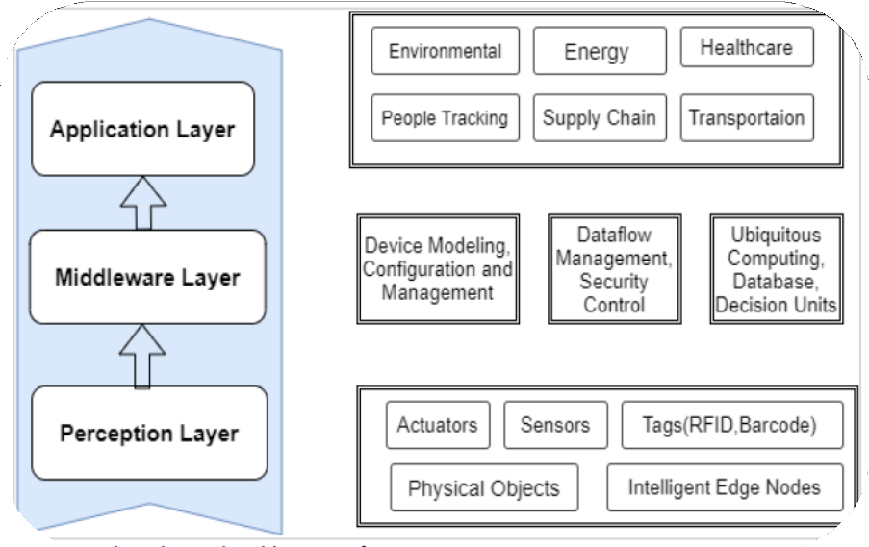

Figure 1: Three Layered Architecture of IoT

Cloud Computing

Throughout recent decades, cloud computing has undergone various transformations and been referred to by different names. As defined by the National Institute of Standards and Technology (NIST), cloud computing represents a service delivery paradigm, characterized by its effortless, on-demand access to an adaptable pool of computing resources. These resources can be swiftly mobilized and allocated with minimal oversight or administrative input. With the maturation of utility-based computing, a natural progression towards cloud computing appears on the horizon, potentially heralding a more intelligent mechanism for real-time service provision. One of the standout virtues of cloud computing lies in its ability to liberate Information Technology (IT) from the confines of fundamental system configurations, enhancing its adaptability and efficiency. Recent scholarly explorations reveal that scientific procedures engaging with Big Data necessitate a cooperative model to be devised and operationalized. Within the context of cloud computing, salient features have been identified, such as quantifiable services, immediate elasticity, scalable solutions, multi-tenancy, pooled resources, and extensive network access facilitated by on-demand service.

Figure 2 elucidates the concept of cloud computing, delineating its operational mechanics and structure. The representation illustrates how cloud computing is not merely a technological advancement but a conceptual evolution in computing. By leveraging these core features, it fosters a flexible and robust environment that can dynamically respond to varying demands, encapsulating a future-facing vision for technological deployment and utilization. The integration of cloud computing within existing and emerging fields is indicative of a strategic shift towards more responsive, scalable, and efficient digital landscapes.

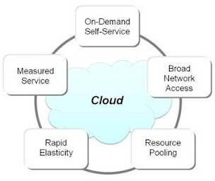

Figure 2: Cloud Computing Characteristics

On-demand self-service

There are many cloud-based services that can be provided without the service provider having to do anything. Most of these services include space for storing data, instances of databases, and examples of virtual machines. Production companies can offer a self-service web interface can be used to access cloud accounts and tracking services. An end-user can set up
databases and share storage without help from the IT boss of the provider.

Extensive Network Access

A wide range of user apps on the network can connect to cloud services. Even though the business likes strong, high-bandwidth networks, a local area network (LAN) or the internet in a private cloud are both good options. Quality of service (QoS) in cloud computing depends a lot on the size and speed of the network. It has been common to use different network-accessible technologies, like smart phones, laptops, desktops, and personal computers, to make thin and dense heterogeneous business solutions easier to use.

Multi-tenancy and resource pooling
Cloud computing tools can be used in environments with more than one customer. With multiple tenancies, a single piece of software or real infrastructure can be used by many different clients while still keeping their data private and safe. In multitenant systems, different services, such as memory, processing power, storage space, and network resources, are given to different users based on what they need (virtual resources are assigned or moved based on what each user requires). The term "resource pooling" means that physical goods are shared by more than one client.
The provider's pool of resources should be big enough and varied enough to meet a wide range of customer wants while keeping the economy stable. When resources are shared, it shouldn't hurt the performance of mission-critical industrial apps. In cloud computing, it is very important to schedule tools. The study says that the current methods for scheduling tasks are based on a number of different scheduling factors.

Ease of elasticity and scalability

Cloud computer services can be expanded to meet the needs of a business. It is one of the most important parts of cloud computing. Cost, efficiency, and access can all be changed without any penalties. It lets companies that make things quickly make and ship any cloud computer resource. This feature can be used to store data, run cloud software, or help with marketing. Scalability is more flexible and down-to-earth. Scalability adds or takes away resources on the fly to meet changing program needs within the limits of the network.

Measured service
IT services in the cloud can be changed to fit the needs of a business. It is a very important part of cloud computing. The price, how well it works, and who can use it can all

be changed without any costs. It makes it easy for companies that make things to make and
ship any cloud computing resource quickly. This function can store data, run software in the

cloud, or help with marketing. Scalability is less rigid and more real-world. Scalability lets you add or remove resources on the fly to meet changing program needs within the network's limits.

Edge computing technology

Edge computing is a data networking approach that focuses on processing data as close to the source as possible to cut down on latency and bandwidth use. Edge computing is a type of spread computing that moves computation and data storage closer to where it is needed to speed up response times and save bandwidth.

Role of edge computing in IoT technology

In IoT technology, edge computing changes the way that millions of IoT devices handle, process, and send out data. With the rapid rise of internet-connected technologies, the IoT and new technologies that need real-time cloud services tend to support sophisticated computing systems. With edge computing, data is reviewed at the edge of the local network before it goes to the fog and the cloud. This makes IoT Edge processing fast, reliable, independent of network connectivity, and scalable. Figure 3 shows the design of the Internet of Things, the edge, the fog, and the cloud.

Fusion of IoT and Cloud Technology

The Internet of Things is a network of real objects that are connected to the internet and can collect, share, and use data. In cloud computing, resources are given out as a service over the internet. With the Internet of Things and cloud computing working together, new apps have been made that could change the way we live and work. Also, combining the IoT with the cloud is an obvious step forward for the technology. The cloud is the best place to store and look at the huge amounts of data that IoT devices make. It also lets you handle and analyze data in real time, which is needed for things like predictive maintenance and energy management. IoT and cloud- based technologies have come a long way in the last ten years. Researchers are interested in these technologies because they are different and can be used in many ways. In the study world, the term for the integrated model is not well known.

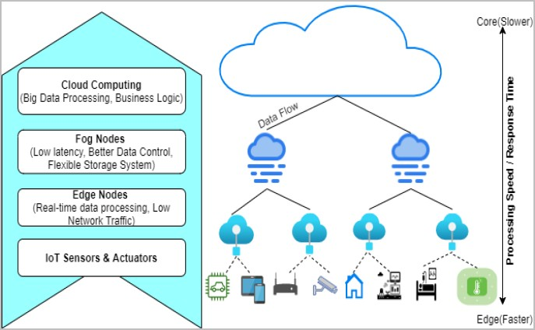

Figure 3: IoT, Edge, Fog and Cloud Architecture

Integration of IoT and Cloud Computing

One of the pivotal aspects of the Internet of Things (IoT) lies in its capacity to leverage the virtually limitless capabilities of cloud computing. This integration encompasses areas such as computational power, storage, and energy efficiency, propelling technology beyond conventional constraints. Utilizing a cloud-centric computing approach, data protection is enhanced, and multifaceted applications become feasible. Conversely, cloud computing has the potential to enrich IoT by engendering innovative applications that address tangible problems across diverse domains and enabling novel implementations in varied real-world scenarios.
In contrast to their complex requirements, IoT devices inherently possess minimal processing power and storage capacity. Consequently, these constrained devices often serve as data conduits, channeling information to cloud environments for advanced processing and storage. The sphere of cloud computing, applications and devices interact through an intermediary layer, abstracting the underlying complexity and functionality necessary for integration. This paradigm is poised to significantly influence applications grappling with data acquisition, assimilation, and dissemination in a multi-cloud ecosystem.
Contemporary research focusing on the fusion of IoT with cloud computing explores the practical implications in areas such as green buildings, smart cities, intelligent vehicles, and industrial automation. The synthesis of IoT devices and sensors with cloud-driven analytics and decision-making holds promising prospects for enhancing speed, safety, and overall quality of life.
Future research concerning the amalgamation of IoT and cloud computing will likely be steered by issues encompassing data privacy, security, scalability, energy efficiency, and interoperability. Further exploration is essential to discern how the unique attributes of this technological convergence can be harnessed to spawn applications that resonate with end- users' needs and aspirations.

Architecture for Cloud-Based IoT
A comprehensive cloud-based architecture for IoT must be adept at managing a vast array of devices and sensors, along with the voluminous data they generate. The architecture must be equipped for real-time processing and analysis of this data, while also being sensitive to the stringent demands for security and privacy inherent to IoT applications.
An IoT-oriented cloud model can be conceptualized in three distinct strata: the hardware layer, the networking layer, and the application layer. The foundational physical layer is tasked with acquiring environmental information, which it conveys to the subsequent network layer. This layer, in turn, provides an extensive suite of services, forming the basis for further interaction.
Figure 4 offers a visual depiction of the cloud-based IoT infrastructure, illustrating the nuanced interplay between these layers. The image underscores the integral role of cloud technology in constructing a versatile and robust framework, thereby paving the way for a new era of interconnectedness and intelligent responsiveness. This architecture sets the stage for innovative developments that could redefine how technology interfaces with everyday life, establishing a new paradigm for an interconnected world.

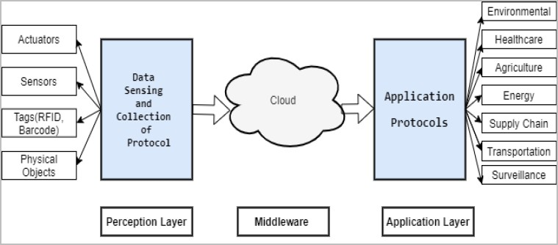

Figure 4: Cloud of things Architecture IoT-Cloud Applications Across Various Sectors
The amalgamation of Internet of Things (IoT) and cloud computing has catalyzed innovation across different sectors. This integration facilitates the collection, storage, and analysis of data through interconnected sensors and gadgets. Here's an exploration of its applications across healthcare, environmental monitoring, and agriculture.

Healthcare
Cloud-Based Monitoring and Assistance: Remote Health Monitoring: Healthcare providers can employ IoT-enabled applications to monitor patients' vital statistics and well-being from a distance. These applications can synchronize with sensors and devices attached to patients, sending real-time data to the cloud for analysis.
Enhanced Patient Care: A synergized IoT-cloud infrastructure enables healthcare professionals to offer timely interventions and personalized care plans. Hospitals are integrating sensor networks to track patients' health and administer necessary treatments.
Data-Driven Decision Making: Stored and analyzed in the cloud, this information can help in accurate diagnosis, prognosis, and management of various medical conditions.

Environment Monitoring
Real-time Analysis of Environmental Data: IoT devices can monitor environmental factors such as air quality, water levels, and pollution. The data collected is sent to the cloud for examination, forming a basis for preventive and corrective measures.

Smart Home Integration: IoT is integral to the emergence of smart homes, where devices are interconnected to provide automated services based on user preferences. Whether it's energy efficiency or home security, cloud-based analysis can lead to improved functionality and user experience.
Sustainability: By continuously monitoring and adapting to environmental changes, these technologies support sustainability and ecological balance.

Agriculture
Field Monitoring Through Mobile Devices: Farmers are utilizing IoT and cloud technologies to oversee their fields remotely. This includes watering, pest control, applying fungicides, and other essential practices.
Integration of Smart Objects: The agricultural and poultry industries are increasingly incorporating IoT-enabled devices. These assist in monitoring soil conditions, weather patterns, and livestock health.
Precision Agriculture: IoT-cloud synergy in agriculture leads to precision farming, where data- driven decisions maximize yield and minimize resource usage. This approach has shown to increase efficiency and sustainability in the agricultural sector.

Smart city
A place that uses technology well IoT-cloud applications can help cities better handle their infrastructure and resources. Some IoT-driven smart city projects are showing that they are good for everyone. The growth of smart cities is helped by a number of communities. There are a lot of important new ideas that help build smart cities, like how to handle energy and transportation.

Industrial
Industrial IoT, or IIoT, is a new way to handle smart devices, sensors, and computer systems in an industrial setting. IIoT lets businesses get real-time information about their inventory and manufacturing units, as well as a sensor-based alarm system that lets staff know what's going on. The future and direction of the devices are decided by what data is collected and how it is analyzed.

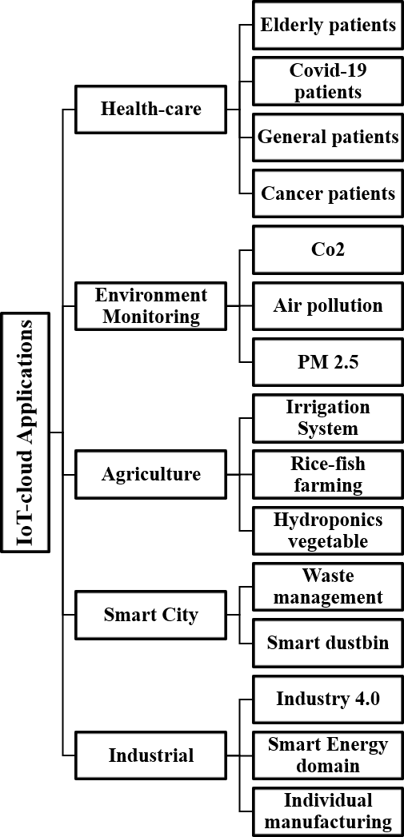

Figure 8: Taxonomy of IoT-cloud applications

Benefits of Hybridization of IoT and cloud
IoT-enabled services use a lot of different kinds of devices, like integrated devices, sensor devices, communication devices, and mobile devices. The IoT-based system can't store and handle large amounts of sensor-driven data because it doesn't have enough storage and processing power. Because of this, the IoT system will need help to get around these problems.
Cloud computing gives you unlimited storage space, a lot of computing power, and a

wide network speed,
among other things, that could help the
IoT system deal with the
problems we've already talked about. Cloud computing tools are flexible, so they can grow or shrink to meet the needs of the IoT environment. Big Data analytics that are done in the cloud could also help with the study of sensor data. IoT-based apps work better and can be trusted more when they combine cloud computing with the IoT paradigm. The Internet of Things (IoT) and cloud software can work together to do a number of useful things.

Data transmission
Cloud-based IoT model low proficient communication. IoT applications offer low-cost data transmission between systems. Cloud computing enables the cost. Effective and efficient connection, control, and exchange of data through the use of hybridized applications.

Storage
The IoT environment is made up of a lot of gadgets and sensors that work together and send out a lot of data in real time. This amount of data is too much for the IoT's local store to handle. Also, more IoT devices are making both organized and unstructured data. Normal databases can't hold so many different kinds of info at once. IoT devices can solve this problem of where to store data by using cloud computing. In cloud computing, a group of computers are linked together and have a lot of storage built in. IoT systems that use the cloud let users keep data and access it from anywhere in the world. Also, this huge amount of data storage can be used to deal with the different kinds of devices by allowing analytics and system changes.

Processing
IoT gadgets can do simple things with computers. Because of this, they can't handle the
huge amount of data made by millions of smart, connected devices. By splitting the real computer into several virtual ones, cloud computing gives IoT devices the ability to do computations. Pay-per-use gadgets that can connect to the Internet can be used to rent a virtual computer. Because IoT technology is being mixed with cloud services, end users can get cheap computer power while making a lot of money.

Modern capacities
IoT-enabled devices connect a lot of working gadgets to each other. Different protocols and ways are used by these devices to talk to each other. So, it's hard to get all of these different gadgets to work together. Also, it might be hard to get the best reliability and performance. Scalability and ease of use are two ways to describe cloud computing. By combining cloud computing and IoT, users can be sure that their apps will be more reliable, scalable, secure, and efficient.

Models for the cloud of things
The main ways to use cloud computing are through Software as a Service, Infrastructure as a Service, and Platform as a Service. With the combination of the cloud and the Internet of Things (IoT), new distribution methods have been made, such as:
- Sensing as a Service (SaaS) is a service that lets you get to the data that IoT devices collect.
- Integration Platform as a Service (IPaaS) lets you find out what devices are connected to a network and set up rules for controlling access to them.
- The Database as a Service (DBaaS) includes both database management and storage services.
- Internet of Things (IoT) devices can connect to the internet through Ethernet as a Service (EaaS).
- Sensor and Actuation as a Service (SAaaS) makes sure that sensors and devices are controlled automatically.
Putting IoT and cloud technology together is hard, and there are still a lot of problems that need to be fixed. Several good worries have been brought up below:

Privacy and security considerations.

The integration of IoT with cloud technology facilitates the seamless transition of data from physical spaces to virtual cloud environments. This intermingling, while replete with advantages, also poses substantial challenges and risks.

- Authorization and Access Control: Ensuring that only legitimate users can access specific data requires meticulous planning around authorization rules and procedures. Care must be taken to delineate access levels and permissions in a manner that safeguards sensitive information while providing the necessary access to authorized entities.

- Security Concerns and Challenges: IoT devices within the cloud context create an array of complex security concerns. The ambiguity in service-level agreements (SLAs), the sanctity of data protection, and the remote accessibility of systems contribute to an intricate security landscape. Several prominent concerns include:
  - Multi-tenancy Issues: The cohabitation of multiple tenants in a shared environment can lead to vulnerabilities. Utilizing public key cryptography, sensitive information can be isolated among various tenants, thereby reducing risks.
  - User Takeover and Virtual Machine Recovery: These alarming issues require dedicated attention and mitigation strategies, as they can lead to significant breaches in security protocols.

- Innovative Solutions: In response to these intricate challenges, researchers are exploring sophisticated solutions to enhance security within the IoT-cloud nexus. For example, technologies such as Artificial Neural Networks (ANN) and Cloud Trace Back (CTB) are being employed to trace the origin of attacks, providing a more robust defense mechanism against malicious activities.

Ipv6 addressing strategies
Most people agree that the Internet is an important part of the IoT. IPv4 is very important to the Internet of Things. With CoAP (Constrained Application Protocol), devices and computers can talk directly to each other over the internet. As part of improving these technologies in the future, network address translation (NAT) processes will be taken away so that each IoT model can have its own IP address. IPv6 is being made to get around the limits of IPv4 by giving each device a 128-bit Internet Protocol address. RESTful APIs have a lot of benefits, such as being

able to be used on almost any Internet-connected device, working on different platforms, and
following REST protocol agreements. IPv6 can be used with integrated IoT devices through the
IP protocols 6LoWPAN and ZigBee. However, some systems have not yet added these protocols. IPv6 is used by the Internet of Things network, which was started by people.

Interoperability
Interoperability is a big problem in cloud-based IoT models because IoT devices are different and work on their own. Over the past few years, there has been a lot of work done in this area to bring up this problem. Because there are so many different kinds of cloud platforms and applications, the answers offered by each method are different. Lack of flexibility can also make it hard to make applications that work across platforms and domains.

Intelligent Analytics
Data Interpretation: Through intelligent analytics, it is possible to decipher, analyze, and interpret the extensive volumes of data harvested by IoT devices. This includes the identification of patterns, trends, outliers, and the application of predictive analytics.
Automated Control Systems: Beyond mere analysis, intelligent analytics can pave the way for automation. This translates into enhanced efficiency, safety, energy management, and the introduction of streamlined processes.
Customer Experience Enhancement: Tailoring services and offerings to the individual needs of customers becomes feasible through intelligent analytics, elevating the user experience to new heights.

Integration Methodology

Need for Interoperability: The demand for a seamless interaction between diverse intelligent cyber-physical models is paramount. A fully realized IoT model hinges on the unification of both existing and emerging systems.
Lack of Standardization: The absence of uniform guidelines and connectivity protocols presents a significant challenge. This is particularly evident in multi-cloud scenarios, where reliance on multiple providers can lead to complexity and inconsistency.

Heterogeneity
Legacy Challenges: The coexistence of varying systems, platforms, operating systems, and services introduces complexities in the integration of IoT with cloud computing. This heterogeneity poses significant challenges, especially as users transition towards multi-cloud solutions.
Provider Dependency: Applications' reliance on the specific capabilities of individual providers further exacerbates the heterogeneity problem, requiring careful consideration and strategic planning.

Standardizations
Many professionals agree that the lack of standards is one of the biggest problems Cloud- IoT models have to deal with. IoT-based Cloud models need standard protocols, interfaces, and application programming interfaces (APIs) to join different smart things and offer unique services. Experts have come up with many ways to apply IoT and cloud technologies.

Edge/Fog computing
Computing can be used at the edge to give services that are built on the cloud. Fog has application services to help clients with their cloud computer needs. In general, fog is a part of the cloud system that connects the cloud to the edge of the network. For services that are sensitive to latency, there need to be more nodes to meet latency limits. Even though Cloud and Fog rely heavily on computing, networking, and processing.

Cloud capabilities
A major security risk is posed to every networked system by an IoT design that is based on the cloud. On both the IoT and cloud sides, there are more ways to attack. Encryption can help protect the safety of data, keep it secret, and prove who the data belongs to in an IoT setting. On the other hand, internal threats can't be stopped, and it's just as hard to use IoT devices with limited features.

Service Level Agreement (S.L.A. implementation)
Cloud-based IoT applications make it possible to send and store data produced within the limits of the application, which can be difficult in some situations.
Not every time, a single provider is enough to make sure a certain amount of QoS. Because of this, it is likely to need the help of more than one cloud service provider to fix SLA violations.

Big Data
Because mobile devices and sensors are everywhere, it's important to use modular solutions. So, you might need to use more than one Cloud service provider to keep S.L.A. files
from being broken. But the flexibility of the cloud services that come up most often is still a problem because it takes time, costs money, and is hard to keep up with QoS.

Power and energy efficiency
In the past 10 years, IoT-enabled applications have made it possible for data to move regularly between IoT devices and the cloud. This has led to the nodes using power quickly. So, the businesses of data processing and transmission continue to put energy efficiency at the top of their lists.

Performance
Several cloud computing and IoT models (such as networking, processing, and storage) are complex to standardize because of their scale-dependent performance requirements.

Reliability
When cloud computing and the Internet of Things (IoT) are combined, it usually makes mission-critical apps less reliable. In the field of clever mobility, for example, vehicles are often moving, and networking and connections between vehicles are often uneven and inefficient. When there aren't enough resources, a number of problems related to systems that crash or aren't always accessible stand out.

Monitoring
Monitoring is an important part of cloud models for batch processing, resource management, SLAs, reliability and security, and debugging. Even though the IoT has problems with speed, volume, and variety, the cloud-based IoT model has the same requirements as any other cloud tracking system.

Key Points Discussion

- Enhanced Efficiency and Productivity
Automation and Remote Monitoring: By integrating automation into everyday tasks and enabling remote observation of gadgets and systems, businesses can significantly increase operational efficiency and productivity.

Improved Decision-making
Real-time Data and Analytics Utilization: Leveraging real-time data through IoT-enabled cloud applications, companies can make informed and effective decisions about various

processes.

Elevated Customer Experience
Personalized Offerings: Utilizing IoT data, businesses can tailor their products and services to meet individual customer needs, thereby enhancing their overall experience.

Cost Reduction:
Automation and Remote Tracking: Through automation and distant monitoring of operations, organizations can minimize expenditures on labor, energy, and other vital resources.

Security Enhancement
Data Protection and User Authentication: Cloud-integrated IoT models can provide robust security features, including data safeguarding and user verification, thus ensuring the integrity and safety of information and preventing unauthorized access.

Superior Scalability
Flexible Integration: Cloud-based IoT structures offer exceptional scalability, allowing organizations to seamlessly add or subtract users and devices in accordance with their changing needs.

Limitations of Hybridization of IoT and Cloud:
The fusion of Internet of Things (IoT) and cloud computing has revealed a plethora of opportunities and challenges. While there's an undeniable potential in this convergence, it's not devoid of obstacles and risks. Here are the key limitations:

Security Problems
- Vulnerability to Attacks: With IoT devices constantly connected to the internet, they become potential gateways for hackers. The intrusion into these devices can lead to data theft and unauthorized control.
- Solutions and Mitigations: Implementing robust security protocols and regular monitoring can help to detect and prevent security breaches. Further research in IoT- specific security measures can mitigate these risks.

Concerns About Privacy
- Data Confidentiality: IoT devices can store substantial personal information, raising concerns about the potential misuse of this data for surveillance or stalking.
• Protecting Privacy: Adhering to privacy regulations, implementing encryption, and educating users about privacy settings can help safeguard personal information.

Stability
- Data Integrity and Availability: The consistency and persistence of data are major challenges. IoT devices might malfunction, and without proper backup, the data could be lost permanently.
- Ensuring Stability: Regular monitoring, proper backup solutions, and fault-tolerant designs can contribute to the overall stability of an IoT network.

Lack of Standards
- Interoperability Issues: Absence of universal standards leads to difficulties in integrating devices and platforms from various IoT services with cloud technologies.
- Standardization Efforts: Collaborative initiatives between industry stakeholders to develop unified standards can facilitate smoother hybridization.

Dependence on the Internet
- Connectivity Dependency: IoT devices rely on the internet to transmit data, and poor connectivity can lead to dysfunction.
- Enhancing Connectivity: Investments in infrastructure and adoption of offline functionalities can lessen this limitation.

Cost
- High Expenses: Integration of IoT and cloud computing requires significant investment in equipment, software, and services.
- Cost Optimization Strategies: Strategic planning, selecting appropriate technologies, and leveraging existing resources can help manage costs.
- Complexity
- Integration Challenges: Combining IoT with cloud computing involves intricate configurations and the orchestration of multiple technologies.
- Simplification Through Innovation: Developing dedicated tools, platforms, and methodologies can alleviate the complexity of hybrid systems.

Conclusion and Future Guidelines
The future of IoT cloud hybridization appears promising yet fraught with complexities. The journey towards complete integration is still in its nascent stages, characterized by significant human intervention, potential errors, and unstable platforms. However, the advantages of cloud capabilities to augment IoT are paving the way for novel business and research opportunities.

In the imminent future, with advancements like edge computing, Big Data, Blockchain, Industrial 5.0, 5G, and Artificial Intelligence, the landscape of IoT applications will broaden. These technologies offer a glimpse into a future where IoT devices seamlessly blend with cloud and on-premises solutions, enabling more efficient data handling and decision-making processes.

The convergence of these technologies not only opens up new vistas for businesses and academia but also mandates continuous innovation, collaboration, and adherence to ethical practices. Emphasizing security, privacy, stability, and interoperability will be paramount in realizing the full potential of IoT cloud hybridization, leading to a more interconnected, intelligent, and responsive world.

