Exploring the potential of biofuels to power the future.
Authors: Agness Chacha¹, Vedashree N¹ and Roopashree R¹*
¹ Department of Chemistry & Biochemistry
*Corresponding Author: Dr Roopashree R
Email id: r.roopashree@jainuniversity.ac.in

INTRODUCTION
Biofuels have been used for centuries, with early civilizations using plant-based materials like wood and animal fats. The modern biofuels industry emerged in the 19th century with the advent of the steam engine. In the late 1800s, alternative to petroleum-based fuels Rudolf Diesel experimented with vegetable oils. The global energy crisis in the 1970s prompted renewed interest in biofuels as a sustainable and renewable energy source. Biodiesel gained traction in the 1990s, obtained from vegetable and animal sources. Ethanol is widely used as a fuel additive produced from crops like sugarcane, corn, and wheat.
Advancements in technology and climate change have propelled the biofuels industry, with researchers exploring innovative methods from non-food feedstocks like algae, agricultural waste, and municipal solid waste. Governments and organizations are implementing policies and incentives to promote biofuel production and use, aiming to reduce usage of fossil fuels, mitigate environmental change, and support rural economies through cultivation of bioenergy crops.
Biofuels are sustainable energy sources obtained from unwanted biotic materials of plants and animals that can replace exhaustible fossil fuels. They are gaining popularity as a means of lowering greenhouse gas emissions and providing space for more sustainable energy. Biofuels are classified into two types: ethanol and biodiesel. Ethanol is the most frequently used biofuel, and it is blended with gasoline to produce a fuel that is used in the majority of vehicles and trucks today. Biodiesel, obtained from vegetable oils and animal fats, is combined with diesel fuel to form a fuel that is utilized in most diesel engines.

Biofuels are renewable, which means they can be produced eternally as long as the necessary biological materials are available. As a result, they are ecofriendly alternative to traditional nonrenewable fuels source which are becoming increasingly expensive and difficult to obtain. Furthermore, biofuels can help bring down greenhouse gas emissions by absorbing carbon dioxide from the crops that are used to create them.

However, there are certain issues concerning biofuel use, such as rivalry with food production and deforestation. Despite these reservations, biofuels are poised to play a growing part in our energy future, as they provide a practical and sustainable response to climate change.

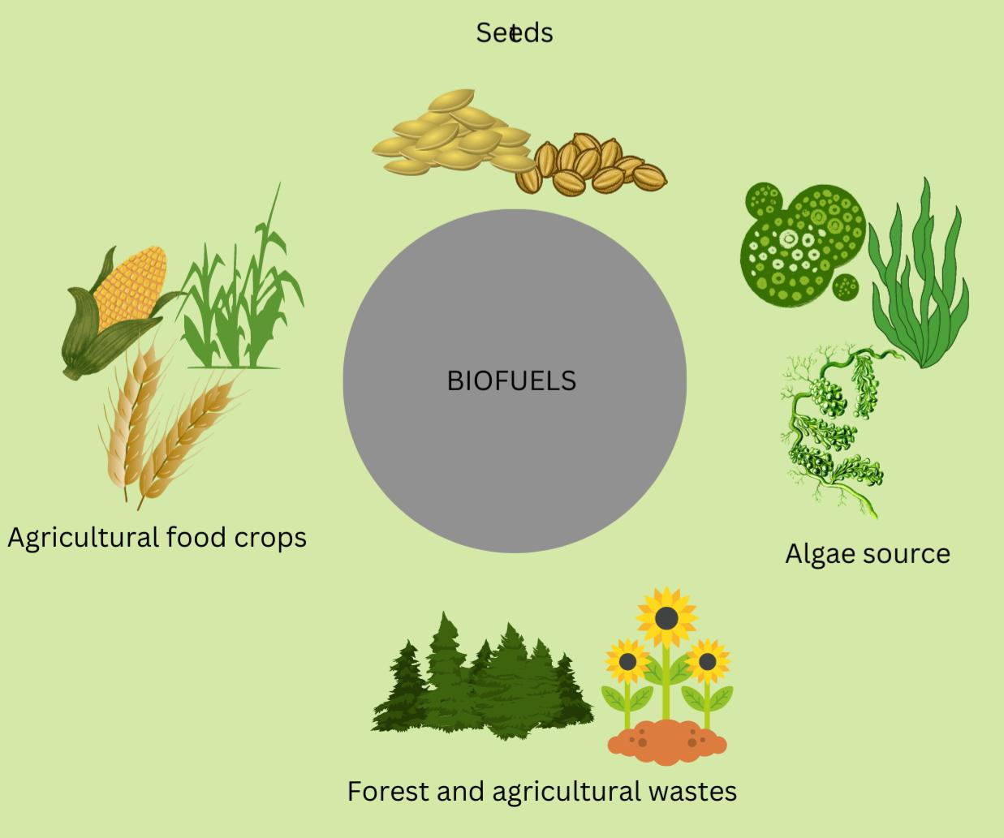

Figure 1. A diagram showing the raw materials for the production of biofuels.

CHARACTERISTICS OF BIOFUELS
- Renewable: Because biofuels are made from living organisms or organic materials that can be cultivated and harvested repeatedly, they are a sustainable and renewable energy source.
- Reduced Carbon Emissions: Compared to fossil fuels, biofuels produce fewer greenhouse gas emissions because the carbon dioxide released from combustion is offset by the carbon dioxide absorbed during the growth of the feed stock.
- Energy Security: Biofuels can lessen reliance on imported fossil fuels by providing a more localized and secure energy supply in areas where biomass can be grown.
- Diverse Feedstock: Biofuels can be produced from a variety of feedstock which includes algae, agricultural residues, and waste materials, providing production flexibility and adaptability.
- Biofuels can be used in existing internal combustion engines and fuel distribution infrastructure, reducing the need for costly changes.
- Job Creation: Biofuel production can drive economic growth and job creation in agriculture and allied sectors, thereby benefiting rural communities.
- Utilization of Waste: Biofuels can be generated from wastes such as food waste, agricultural leftovers, and animal wastes, thereby reducing waste and boosting resource efficiency.
- Biodiversity Preservation: Sustainable biomass cultivation for biofuels can stimulate the use of various agricultural systems that support biodiversity while reducing monoculture practices.
- Carbon catch Potential: Some biofuel production technologies can catch and use carbon dioxide emissions, resulting in a net reduction in atmospheric carbon.
- Localized Production Possibility: Biofuel production can be decentralized, allowing towns and regions to generate their own energy and lessen dependency on centralized energy sources.
- Reduced Air Pollutants: When compared to traditional fossil fuels, biofuels produce fewer harmful air pollutants such as sulfur dioxide and particulate matter.
- Continued research and development in the field of biofuels can lead to innovative production methods, higher energy efficiency, and increased environmental advantages.

CATEGORIES OF BIOFUELS
With the recent advancement in technology and high demand of biofuels, the production of different biofuels has increased abruptly in the world. All the present biofuels used are classified into four generations in accordance to their origin of production, that is raw material required and technology used.
BIOFUELS
First generation biofuels
Second generation biofuels
Third generation biofuels
Fourth generation biofuels

Table 1: Classification of Fuels

1. FIRST GENERATION BIOFUELS
The source of most of the first-generation fuels is crops that have energy containing molecules. They generally utilize edible biomass such as sugarcane, corn, whey, barley, potato wastes and sugar beets. Ethanol and biodiesel are examples of biofuels that are categorized in the first generation. They are produced through various processes like fermentation, distillation, and transesterification.
a) Bioethanol
The process of production of bioethanol utilizes either sugarcane or corn as the raw materials, but the use of sugarcane is simple. Ethanol is produced by fermentation by using yeast cells. The production of bioethanol by sugarcane primarily involves crushing the sugarcane in water to remove sucrose then later purifying it in raw sugar and producing ethanol. Production of bioethanol by sugarcane utilizes less water. On the other hand, utilization of maize in the production of bioethanol requires a larger amount of water for the preliminary step of hydrolysis to release the sugars that are required to be fermented into ethanol. Bioethanol is primarily used as fuel for motor or an additive in gasoline; it is also a promising sustainable energy.
Bioethanol production entails a number of stages that transform biomass into ethanol, a type of biofuel. Here’s a breakdown of the main steps:
- Feedstock Preparation: Biomass feedstock is gathered and prepared, most commonly corn or sugarcane. Chopping, shredding, or grinding may be used to expand the surface area and make it more accessible to enzymes
- Pretreatment is used to break down the biomass’s complicated structure and make cellulose and hemicellulose more accessible for further processing. Steam explosion, acid or alkali treatments, and other procedures are used for pretreatment.
- Enzymatic hydrolysis: Enzymes are added to the pretreated biomass during this stage. Simple sugars such as glucose and xylose are produced by enzymatic degradation of hemicelluloses and cellulose..
Fermentation: In fermentation tanks, the sugars are combined with certain strains of yeast or bacteria. Ethanol and carbon dioxide are produced by fermentation process.
- Distillation: The fermenting combination, called as “mash,” comprises ethanol, water, and other byproducts. Distillation is used to separate and concentrate ethanol from water.
- Dehydration: The ethanol is still combined with water after distillation. To eliminate superfluous water and improve ethanol concentration, dehydration techniques such as molecular sieves or azeotropic distillation are used.
- Denaturing (optional): If the ethanol is intended for industrial or non-beverage applications, it may be denatured by the addition of small amounts of chemicals that render it unfit for consumption and exempt from beverage alcohol taxes.
- Distribution and blending: Ethanol is blended in various quantities with gasoline to produce ethanol-gasoline mixes such as E10 (10% ethanol) or E85 (85% ethanol). These mixtures are subsequently delivered to gas stations.
These procedures are part of the standard process for manufacturing bioethanol from a variety of feedstocks. Other variants and technologies, such as cellulosic ethanol production, may necessitate extra steps or altered procedures.
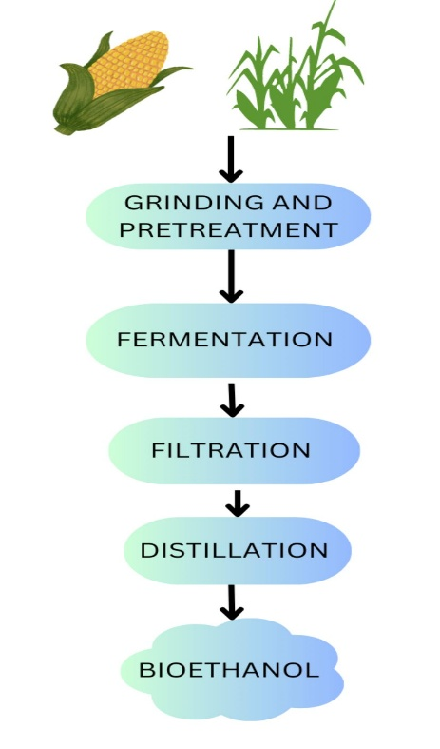

Figure2. An overview summary of the steps involved in bioethanol production.

b) Biodiesel
The process of production of biodiesel is more complex in comparison to the production of ethanol. Even though they both belong to the first-generation biofuels and utilize edible biomass for their production. Biodiesel is obtained from the extraction of oils from plants and seeds. It involves the process of transesterification (the process of conversion of fats or oil into biodiesel and glycerin). Fats or oils extracted from the seeds or plants are reacted with a short chain alcohol usually methanol in the presence of a catalyst (usually Sodium hydroxide (NaOH) or potassium hydroxide (KOH)) to produce biodiesel. It has many applications such that It can be used as vehicle fuel as it’s a clean-burning, renewable substitute of petroleum or diesel, it is also used as heating fuel for domestic needs.
Although the production of first-generation biofuels is advantageous, it has also come to notice that both the production of bioethanol and biodiesel involves utilization of more amount of water leading to depletion of water for other purposes. Moreover, the use of edible crops as biomass to produce these biofuels has an impact in the food market of these crops. The production of these biofuels has led to competition for land and water resources that could otherwise be used in production of food and services for human needs.

Figure3. A diagram showing the transesterification reaction that leads to the production of biodiesel.

The process of producing biodiesel, a renewable alternative to conventional diesel fuel, involves turning vegetable oils or animal fats into biodiesel. Here’s a rundown of the essential phases in biodiesel production:
- Preparation of Feedstock: The first stage is to get feedstock, which can be cooking oil, vegetable oils (such as soybean, canola, or palm oil), or animal fats. If the feedstock is not already liquid, it must be heated to reduce viscosity.
- Transesterification: The feedstock oil or fat is mixed with an alcohol like methanol and a catalyst like sodium or potassium hydroxide. During the process oil’s triglycerides are converted to fatty acid methyl esters (FAME), which are the primary components of biodiesel.
- Separation: The mixture is allowed to settle after transesterification, separating the glycerol (which sinks to the bottom) from the biodiesel (which floats on top).
- Washing and Neutralization: Water is used to remove any remaining contaminants or catalyst from the separated biodiesel. After being washed with water, the biodiesel is neutralized to remove any lingering traces of catalyst or acidic chemicals.
- Drying: To remove any water content, the washed and neutralized biodiesel is dried. Water can cause corrosion in engines and fuel systems, so make sure the biodiesel is dry.
- Quality Control and Testing: Determining viscosity, flash point, and acidity are few tests performed to ensure the quality of biodiesel meeting the criteria required for usage as a fuel.
- Blending and distribution: Depending on regulatory and operational constraints, biodiesel can be blended with petroleum diesel in various quantities (such as B20, which includes 20% biodiesel). The biodiesel blend is then distributed for use in diesel engines.
It is important to remember that the specifics of biodiesel manufacturing may vary depending on the feedstock, production scale, and technology used. The preceding phases provide a high-level summary of the procedure.

ADVANTAGES OF FIRST GENERATION BIOFUELS
1. Readily Available Feed stocks: Because first generation biofuels employ feedstocks that are already widely grown, production is quite simple.
2. Infrastructure Compatibility: They are compatible with existing internal combustion engines and distribution infrastructure.
3. Reduced CO2 Emissions: While they are not carbon-neutral, they emit less net carbon emissions than fossil fuels.

DISADVANTAGES OF FIRST GENERATION BIOFUELS
1. Food vs. Fuel Conflict: Using food crops for biofuel production may result in resource competition between fuel and food production, potentially raising food costs.
2. Land Use Change: Deforestation, habitat degradation, and biodiversity loss can result from the extension of agricultural land for feedstock production.
3. Limited GHG decrease: The overall decrease in greenhouse gas emissions may be insignificant, particularly if factors like land-use change are taken into account.

APPLICATIONS OF FIRST GENERATION BIOFUELS:
- Transportation: To minimize overall emissions, first generation biofuels are frequently employed as blending components in traditional gasoline and diesel fuels.
- Generation of Energy: They can also be utilized in power generation to generate electricity, particularly in distant places where conventional energy sources may be in short supply.
- Industrial Applications: Biofuels have broad applications, including heating and activities that require a fuel source.
- Byproducts: Biofuel byproducts such as glycerol from biodiesel synthesis can be used as humectant, solvent, food preservative and sweetener.
To summarize, first generation biofuels have several advantages, including the use of easily available feedstocks and compatibility with existing infrastructure. They do, however, confront substantial drawbacks, such as rivalry with food production and potential negative environmental consequences.
2. SECOND GENERATION BIOFUELS
The second-generation biofuels are obtained from non-food feedstock such as wheat straws from wheat production, corn husks from corn, wood, forest wastes, industrial wastes and lignocellulosic biomass. Second-generation biodiesel and bioethanol, biogas, syngas, Lean Premixed Prevaporized (LPP) Liquid Biofuels and Dimethyl Ether (DME).
Second-generation biofuels production is more expensive compared to first-generation biofuel production because it requires high energy in pretreatment and distillation process, and the use of enzymes during cellulose hydrolysis.
The main objective of production of second-generation biofuels was to increase the quantity of biofuels that can be produced in a sustainable way without the utilization of edible food crops, reduce carbon emission, reduce energy dependence, increase energy efficiency and hopefully outperform first generation biofuels.
Second-generation biofuels cannot be obtained on an industrial scale due to its high cost of production. Because they are made from non-food feedstocks such as agricultural leftovers, woody biomass, and algae, second generation biofuels are more advanced than first generation biofuels. They intend to alleviate some of the drawbacks of first-generation biofuels.
Second Generation Biofuel Examples:
- Ethanol from Cellulose: Non-edible plant materials such as agricultural wastes (corn Stover, wheat straw), wood chips, and dedicated energy crops (switchgrass) are used to make this. Ethanol is produced by the enzymatic degradation of cellulose and hemicellulose into sugars.
- Biomass-to-Liquid (BTL): fuels are created by gasifying woody biomass to produce syngas (a mixture of hydrogen and carbon monoxide), are converted into liquid hydrocarbons by Fischer-Tropsch synthesis.
- Algae Biofuel: Algae are grown for their lipids, which may then be harvested and processed into biodiesel. Algae have high lipid content and can grow quickly, making them a potential sustainable source.
ADVANTAGES OF SECOND GENERATION BIOFUELS
- Non-food feedstocks: Non-food feedstocks are used in second generation biofuels, minimizing the “food vs. fuel” dilemma.
- Larger Energy Efficiency: When compared to first generation feedstocks, cellulosic materials are often more abundant and have a larger energy content, resulting in superior energy efficiency.
- Environmental Impact: Using agricultural leftovers and other non-food feedstocks can help to reduce land use change and habitat degradation.
DISADVANTAGES OF SECOND GENERATION BIOFUELS
- Technological Difficulties: The processes involved in converting cellulose and hemicellulose into sugars are more complex and require advanced technologies, which can be costly and energy-intensive.
- Scale-up Challenges: Due to the complexity of feedstock processing and conversion, scaling up second generation biofuel production to commercial levels has proven difficult.
- High costs: Second generation biofuel production processes are more expensive than first generation biofuel production processes.
APPLICATIONS OF SECOND GENERATION BIOFUELS:
- Transportation: Fourth generation biofuels might be utilized as drop-in replacements for traditional gasoline, diesel, and aviation fuels, providing a cleaner and more sustainable transportation choice.
- Industrial Applications: These biofuels may find use in industries that require fuels or chemicals, such as plastics, solvents, and other products.
- Waste Conversion: Some fourth generation biofuels can be developed to convert different forms of biomass waste into lucrative fuels.
- Hybrid Systems: They could be used in integrated energy systems to supplement other sustainable energy sources such as solar and wind.

Finally, second generation biofuels provide advantages such as employing non-food feedstocks and lowering environmental effect. However, they suffer technological complexity, scalability, and cost challenges. Continued research and development are critical for overcoming these obstacles and realizing the full potential of second generation biofuels as a more sustainable alternative to traditional fossil fuels.

3. THIRD GENERATION BIOFUELS
Third-generation biofuels are also known as “algae fuel” or “ oilage” because they are obtained by algae. They are considered as the most reliable energy source that has been able to overcome the challenges that are facing the first- and second-generation biofuels. Microalgae are capable of producing approximately 15-300 times more oils for the production of biodiesel than traditional crops and they have short harvesting cycle that significantly increases the yield.
Microalgae are one of the oldest living organisms that are capable of making their own food because they have chlorophyll, and their mechanism is similar to that of higher plants but more efficient. The conversion of microalgal biomass into biofuels can be through: -
- Biochemical conversion
- Chemical reaction
- Direct combustion
- Thermochemical conversion
Third Generation Biofuels Examples:
Algae Biofuels: Algae is the primary focus of third generation biofuels. They can be grown in a variety of habitats, including ponds, bioreactors, and even wastewater. Algae may produce lipids (oils) for biodiesel production as well as carbs for ethanol generation.
Algae biodiesel production
To extract lipids (oils) from algae biomass and convert them into biodiesel, various processes must be taken. Here’s a quick rundown of the essential phases in the manufacturing of biodiesel from algae:
- Cultivation of Algae: Open ponds, closed photobioreactors, and various cultivation systems are used to grow algae. To grow, they require sunlight, carbon dioxide, water, and nutrients. As an energy storage mechanism, algae collect lipids throughout cultivation.
- Harvesting: The algae are harvested from the growth system once they have attained the necessary lipid content. Filtration, centrifugation, and flocculation are harvesting processes that aim to separate algae from the growth medium.
- Drying: Because harvested algae are frequently moist, they must be dried to eliminate extra water. Drying also aids in the preservation of the lipids found within algal cells.
- Cell Disruption: To release the lipids, the dried algal cells must be split open. Cells can be ruptured using techniques such as mechanical crushing, ultrasound, or solvent extraction.
- Extraction of Lipids: The lipids removed from damaged cells are normally in the form of oil. To separate the lipids from the biomass, solvent-based extraction or supercritical fluid extraction can be utilized.
- Transesterification: A transesterification reaction converts the extracted lipids into biodiesel. This includes reacting the lipids with alcohol (like methanol or ethanol) and a catalyst (such as sodium or potassium hydroxide) to form fatty acid methyl esters (FAME) and glycerol.
- Separation and purification: The mixture is allowed to separate after transesterification, with biodiesel floating on top and glycerol settling at the bottom. To remove contaminants, the biodiesel is washed, neutralized, and dried.
- Quality Control and Testing: The biodiesel is subjected to quality control testing to ensure that it meets the criteria required for usage as a fuel. Viscosity, flash point, and acid value are all evaluated properties.
- Blending and distribution: Biodiesel can be blended in various amounts (such as B20) with conventional diesel fuel and distributed for use in diesel engines.
It is important to remember that algal biodiesel synthesis is complicated and requires careful optimization of each stage. There are numerous methods and approaches available to improve the efficiency and sustainability of algae-based biodiesel production.

The following are the advantages of using algae in production of biofuels
- High growth rate and accumulates more amount of lipids.
- High yield because they are all year-round production compared to oilseeds.
- Consume less amount of water.
- Do not require pesticides or herbicides.
- Reduce emission of greenhouse gases by the utilization of carbon dioxide for photosynthesis.
- Used in bioremediation of ammonium, phosphate, and nitrates ions in water.
- Can survive in harsh conditions.
- Production of useful secondary metabolites.
Production of biodiesel by microalgae doesn’t compromise the availability of food crops, water and land for human needs. Due to high accumulation of lipids by microalgae, the lipids are extracted from the algae and are converted into biodiesels and bioethanol.

ADVANTAGES OF THIRD GENERATION BIOFUELS
- High Productivity: When compared to traditional crops, algae can produce a substantially higher yield of oil per unit area, making them a potentially effective feedstock.
- Less Resource-Intensive: Because algae can be produced on marginal land, brackish water, or wastewater, competition for arable land and freshwater resources is reduced.
- Carbon Sequestration: During their growth, algae can absorb carbon dioxide, helping to reduce greenhouse gas emissions.
- Aside from biofuels, algae can be utilized to make food supplements, animal feed, and high-value compounds.

DISADVANTAGES OF THIRD GENERATION BIOFUELS
- Technical Difficulties: Large-scale algae cultivation, harvesting, and oil extraction technology is still being developed, and these operations can be energy-intensive.
- Economic viability: Despite its potential, algae-based biofuel production can be costly, and cost competition with fossil fuels is a hurdle.
- Environmental Issues: Improper algae farming and wastewater discharge can cause eutrophication and habitat damage.

APPLICATIONS OF THIRD GENERATION BIOFUELS:
- Transportation: Third generation biofuels, notably algae-based biodiesel, can be used in transportation as a cleaner alternative to conventional diesel fuels.
- Aviation and Shipping: Algae-based biofuels could help the aviation and shipping industries handle their environmental concerns.
- Algae can be used for the production of bioplastics, chemicals, and other industrial products.
- Wastewater Treatment: By absorbing nutrients and encouraging water filtration, algae growing systems can help treat wastewater.
Finally, third generation biofuels, particularly algae-based biofuels, have a number of advantages, including high production, low resource intensity, and potential carbon sequestration. However, technological hurdles, economic considerations, and environmental issues must all be addressed before the project can be completed.

4. FOURTH GENERATION BIOFUELS
The fourth-generation biofuels utilize genetically modified organisms for the enhancement of biohydrogen production. Advancement of microalgae genetically improves its efficiency in production. Understanding the metabolic pathways of the organism makes it possible for its utilization to its full potential. Due to its capability of high lipids accumulation it's possible to alter its genes and use it as a lipid source.
Important factors such as strain selection are important to get the desired strain of microalgae. Environmental effect, cultivation duration, yield of desired product (lipids), less release of undesirable products should be considered when performing genetic modification of the microalgae.
Fourth Generation Biofuel Examples:
Fourth generation biofuels involve the creation and manipulation of microorganisms such as bacteria and yeast to efficiently convert biomass into biofuels such as ethanol, butanol, or other hydrocarbons.
ADVANTAGES OF FOURTH GENERATION BIOFUELS
- Improved Efficiency: Genetic modification enables microbes to directly create biofuels or precursors, enhancing overall efficiency over traditional fermentation procedures.
- Microorganisms can be designed to synthesize specific biofuel molecules, allowing fuels with desired attributes such as higher energy content or better compatibility with existing engines to be created.
- Reduced Environmental Impact: By improving the conversion process, fourth generation biofuels may generate less byproducts and waste, lowering their environmental impact.

DISADVANTAGES OF FOURTH GENERATION BIOFUELS
- Concerns about Ethical and Safety: The genetic alteration of organisms poses ethical concerns as well as potential ecological problems if these transformed species escape into the ecosystem.
- Complexity: Developing and designing microbes for biofuel generation is a difficult task that necessitates sophisticated understanding in biotechnology and synthetic biology.
- Regulatory Obstacles: Because of safety concerns and potential environmental repercussions, the use of genetically modified organisms in biofuel production may face regulatory obstacles.
APPLICATIONS OF FOURTH GENERATION BIOFUELS:
- Transportation: Fourth generation biofuels might be utilized as drop-in replacements for traditional gasoline, diesel, and aviation fuels, providing a cleaner and more sustainable transportation choice.
- Industrial Applications: These biofuels may find use in industries that require fuels or chemicals, such as plastics, solvents, and other products.
- Waste Conversion: Some fourth generation biofuels can be developed to convert different forms of biomass waste into lucrative fuels.
- Hybrid Systems: They could be used in integrated energy systems to supplement other sustainable energy sources such as solar and wind.
Finally, fourth generation biofuels are an intriguing path for biofuel development because they use advanced biotechnology to design microorganisms for more efficient and sustainable fuel production. While they provide benefits in terms of economy and fuel tailoring, they also raise ethical, safety, and regulatory problems. Continued research and development, as well as careful deployment, will be critical to fulfilling the potential of fourth generation biofuels as a cleaner and more sustainable energy source.

APPLICATIONS OF BIOFUELS
- Heating: Secondary biofuels that undergo refinery are ecofriendly and efficient thus are used as an alternative of natural gas for domestic heating purposes.
- Transportation: Biodiesel is used in vehicles as a fuel replacing diesel since its more efficient and reduces the emission of greenhouse gases thus environment friendly for transportation purposes
- Lubrication: Biofuels provide a sustainable alternative for petrol-based lubricants because it has high cetane numbers and they are cost effective.
- Aviation: Aviation plays a major role in emission and pollution of the atmosphere. The use of biofuels in aviation reduces the risk of emissions.
- Oil-clean operations: Oil spillages are a major drawback in oil extraction and distribution, but biofuels have been seen to address this problem since they contain methyl esters, a powerful solvent that can be used in cleaning the oil spills from the shorelines.

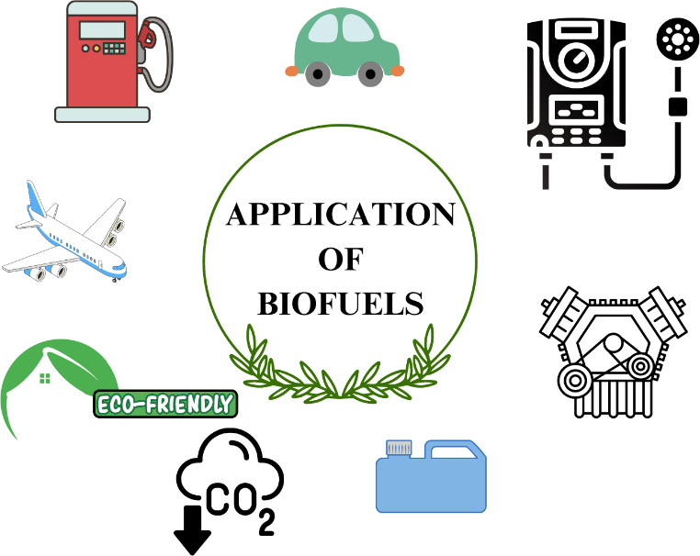
Figure 4. A diagrammatic representation of the applications of biofuels

OVERALL ADVANTAGES OF BIOFUELS
- Efficiency of the fuel: Biofuels offer more efficiency compared to petrol or diesel. They are clean burning fuels and are way superior because they have high cetane number and lubricity.
- Cost effective: When compared to gasoline, biofuels are less cheap, but this is likely to change due to its increasing demand for more efficient extraction processes.
- Durability of vehicle engine: Due to its high cetane number and lubricity they are not likely to damage the engine but rather increase its efficiency. Also, the emission of pollutants by engines that use biofuels is less compared to the ones that use diesel.
- The sources are easily available: Biofuels have different sources such as manure, edible crops, agricultural wastes, forest wastes and algae which are easily available in the environment thus its termed as a renewable energy.
- Its renewable energy: Due to easy availability of the sources of its production it is classified as renewable energy. The crops can be grown again and again after utilization, and the algae have short harvest duration thus it's possible for continuous production of biofuels.
- Reduce greenhouse gases emission: Fossil fuels increase the emission of greenhouse gases when burnt thus increasing global warming. But it's not the same for fuels that are produced from biomass, they don’t emit greenhouse gases when utilized thus they are environment friendly.
- Provide economic security and reduce dependence on foreign fuel: Most countries export fossil fuel which puts the country in massive debt. But the presence of biofuels and their advantages over fossil fuels reduces people’s dependence on fossil fuels thus decreasing a country’s debt.

OVERALL DISADVANTAGES OF BIOFUELS
- High cost of production: This mainly applies for the production of second-generation biofuels since their biomass has to undergo several processes for them to be converted into biofuels. Moreover, the cost of production of the crops in large scale that are needed in the production process is high.
- Leads to monoculture: It refers to the cultivation of the same crop year after year rather than planting other crops. This may lead to depriving the soil of the required nutrients.
- Use of fertilizers: The crops that are required for the production of biofuels require fertilizers so as to grow better. These fertilizers are harmful to the environment and may lead to water pollution.
- Shortage of food and land: Most of the crops used in biofuels production are rich in sugar and most of them are used as food crops. The continuous cultivation of these crops for the purpose of biofuel production will eventually take up the agricultural space to grow crops for consumption and land.
- Over utilization of water: More water is used in the process of biofuel production that might lead to shortage of water and misuse. Also, the crops grown for biofuel production require water for water thus more amount of water will be utilized than the average required for agricultural purposes.
- Industrial pollution and global warming: Large industries that produce biofuels lead to large number of emissions that lead to increase in global warming. Also, burning biofuels that contain hydrogen and carbon produce carbon dioxide which is a source of global warming.

CONCLUSION
Biofuels, which are sourced from organic materials such as crops, algae, and garbage, are critical in tackling major global issues. Biofuels help to mitigate climate change by reducing greenhouse gas emissions by providing a renewable alternative to fossil fuels. They help to provide energy security by diversifying fuel sources and reducing reliance on finite fossil resources. Furthermore, biofuel production can boost rural economies, improve agricultural sustainability, and promote technical innovation. Biofuels have considerable promise in moving to a cleaner and more resilient energy future as a sustainable and environmentally friendly energy choice.
Renewable, clean, environmentally friendly, highly efficient, biofuels may be the answer to production of sustainable energy sources. Biofuels provide a promising alternate energy transition phase without huge changes in the environment and infrastructure. Replacing fossil fuels with biofuels will serve as an important step towards sustainable development.
More research is to be done to overcome the challenges that are facing the process of biofuel production. Despite the fact that biofuels are still seen to be applicable in different fields such as motor fuels in vehicles and it increases the efficiency of the engine, they are also applicable for domestic applications such fuel for heating.
REFERENCES
- Aro, EM. From first generation biofuels to advanced solar biofuels. Ambio45 (Suppl 1), 24–31 (2016). https://doi.org/10.1007/s13280-015-0730-0
- Roland Arthur Lee , Jean-Michel Lavoie, From first- to third-generation biofuels: Challenges of producing a commodity from a biomass of increasing complexity, Animal Frontiers, Volume 3, Issue 2, April 2013, Pages 6–11, https://doi.org/10.2527/af.2013-0010
- Rulli, M., Bellomi, D., Cazzoli, A. et al. The water-land-food nexus of first-generation biofuels. Sci Rep6, 22521 (2016). https://doi.org/10.1038/srep22521.
- Bhuiya, M. M. K., Rasul, M. G., Khan, M. M. K., Ashwath, N., Azad, A. K., &Hazrat, M. A. (2014). Second generation biodiesel: potential alternative to-edible oil-derived biodiesel. Energy Procedia, 61, 1969-1972.\
- Hl, Raghavendra& Mishra, Shashank&Upashe, Shivaleela&Floriano, Juliana. (2019). Research and Production of Second-Generation Biofuels. 10.1002/9781119434436.ch18.
- Patel, Shalu& Dixit, Savita &Suneja, Kavita&Tipan, Nilesh. (2021). Second Generation Biofuel – An Alternative Clean Fuel. SMART MOVES JOURNAL IJOSCIENCE. 7. 13-21. 10.24113/ijoscience.v7i3.364.
- Dragone, Giuliano &Fernandes, Bruno & Vicente, António& Teixeira, José. (2010). Third generation biofuels from microalgae.
- Shokravi, Zahra &Shokravi, Hoofar& Aziz, Maniruzzaman&Shokravi, Hooman. (2019). The Fourth-Generation Biofuel: A Systematic Review on Nearly Two Decades of Research from 2008 to 2019. 10.1201/9780429327773-12.
- https://www.eia.gov/energyexplained/biofuels/
- Biodiesel fuel production by transesterification of oils Hideki Fukuda a, Akihiko Kondo b, Hideo Noda c Received 7 August 2001, Accepted 4 September 2001, Available online 11 February 2002.https://doi.org/10.1016/S1389-1723(01)80288-7
- https://energypost.eu/biofuel-is-approaching-a-feedstock-crunch-how-bad-and-what-must-be-done/
- https://www.britannica.com/technology/biofuel
- Martin, M. A. (2010). First generation biofuels compete. New biotechnology, 27(5), 596-608.
- Naqvi, M., & Yan, J. (2015). First‐generation biofuels. Handbook of clean energy systems, 1-18.
- Gasparatos, A., Stromberg, P., & Takeuchi, K. (2013). Sustainability impacts of first-generation biofuels. Animal Frontiers, 3(2), 12-26.
- Correa, D. F., Beyer, H. L., Possingham, H. P., Thomas-Hall, S. R., & Schenk, P. M. (2017). Biodiversity impacts of bioenergy production: Microalgae vs. first generation biofuels. Renewable and Sustainable Energy Reviews, 74, 1131-1146.
- Smeets, E. M., Bouwman, L. F., Stehfest, E., Van Vuuren, D. P., &Posthuma, A. (2009). Contribution of N2O to the greenhouse gas balance of first‐generation biofuels. Global Change Biology, 15(1), 1-23.
- Eisentraut, A. (2010). Sustainable production of second-generation biofuels: potential and perspectives in major economies and developing countries.
- Mohammadi, M., Najafpour, G. D., Younesi, H., Lahijani, P., Uzir, M. H., & Mohamed, A. R. (2011). Bioconversion of synthesis gas to second generation biofuels: A review. Renewable and Sustainable Energy Reviews, 15(9), 4255-4273.
- Dragone, G., Fernandes, B. D., Vicente, A. A., & Teixeira, J. A. (2010). Third generation biofuels from microalgae.
- Behera, S., Singh, R., Arora, R., Sharma, N. K., Shukla, M., & Kumar, S. (2015). Scope of algae as third generation biofuels. Frontiers in bioengineering and biotechnology, 2, 90.
- Chowdhury, H., &Loganathan, B. (2019). Third-generation biofuels from microalgae: a review. Current opinion in green and sustainable chemistry, 20, 39-44.
- Alam, F., Mobin, S., & Chowdhury, H. (2015). Third generation biofuel from algae. Procedia Engineering, 105, 763-768.
- Abdullah, B., Muhammad, S. A. F. A. S., Shokravi, Z., Ismail, S., Kassim, K. A., Mahmood, A. N., & Aziz, M. M. A. (2019). Fourth generation biofuel: A review on risks and mitigation strategies. Renewable and sustainable energy reviews, 107, 37-50.
- Lü, J., Sheahan, C., & Fu, P. (2011). Metabolic engineering of algae for fourth generation biofuels production. Energy & Environmental Science, 4(7), 2451-2466.
- Moravvej, Z., Makarem, M. A., &Rahimpour, M. R. (2019). The fourth generation of biofuel. In Second and third generation of feedstocks (pp. 557-597). Elsevier.
- Mehmood, M. A., Shahid, A., Malik, S., Wang, N., Javed, M. R., Haider, M. N., ... &Boopathy, R. (2021). Advances in developing metabolically engineered microbial platforms to produce fourth-generation biofuels and high-value biochemicals. Bioresource Technology, 337, 125510.

