FORMS OF MOTION
Dr. Bhanu Pratap and Dr. Rajan Bhatia
FORMS OF MOTION
Most human gestures are generic gestures, a combination of expressions and gestures. Since linear and angular motion are "pure" forms of motion, it is important to break complex motion into linear and angular components when performing an analysis.
Types:
1.Linear motion / Translation
(i) Rectilinear
(ii) Curvilinear
2. Angular motion / Rotation
3. General motion
LINEAR MOTION/TRANSLATION
All points on the body show the same trajectory (motion along a line)
When all parts of an object move the same distance, in the same direction and time.
Pure linear motion involves the motion of a single body in which all system components move at the same speed and in the same direction. Linear motion is also called translational motion or translation. When the body is defined it moves completely and parts of the body do not move towards each other. For example, sleeping passengers are lifted into the air when the plane moves. However, if the driver stands up and reaches for the newspaper, misinterpretation will no longer occur, as the position of the arm relative to the body has changed.
Linear motion can also be thought of as motion along a line. If the line is straight, the motion is linear; If the line is curved, the motion is curvilinear. A motorcycle travels in a straight line while a cyclist stops walking in a straight line. If a cyclist jumps on the bike and the bike does not spin, both the cyclist and the bike (except the spinning wheel) will be spun in the air wind. Similarly, the Scandinavian skier walks in a straight line in a locked position while descending a short hill.
If a skier jumps over a stream and the whole body moves along the curve in the same direction and at the same speed, the motion is curved. When a cyclist or skier rolls downhill, the direction is non-linear and the upper body moves faster than the lower body.
Figure 2-1 displays a gymnast in rectilinear, curvilinear, and rotational motion.
Rectilinear: straight path Curvilinear: curved path
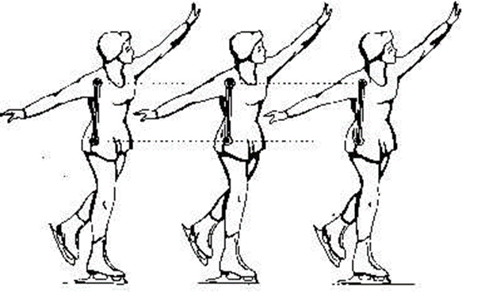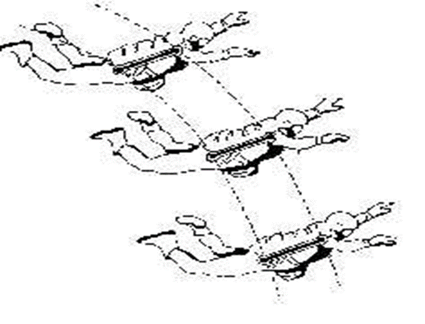

Angular motion / Rotation
Rotation about the axis of rotation When an object moves along a circular path about an axis, they all move at the same angle, direction, and time. The line of rotation / axis of rotation / centre can be inside or outside the body, controlling its position and at right angles to the body plane. For example - horizontal bar, hammer throw, floor exercise - somersaults, rolls, forwards and backwards, etc.
Angular motion is rotation about a central axis, called the axis of rotation, oriented perpendicular to the plane in which the rotation occurs. When a gymnast rotates part of the body in the joint in a perfect circle around an imaginary line (called the axis of rotation) that runs together through the center of the joint, the whole body rotates and the axis of rotation passes through the object. centre. your share. When a springboard diver flips through the air, the whole body rotates again, this time around an imaginary axis of rotation that moves with the body. Almost all human body wants to move towards the parts passing through the center of the joint where the parts that give the feeling of rotation come together. When angular motion or rotation occurs, a part of the body in motion is constantly moving towards another object.
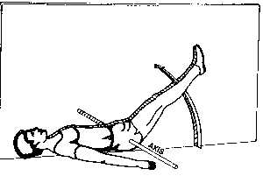
General Motion
It is a combination of motion and angle, or it can be different, such as kinematics. Walk, run, jump. Angled movement of the leg around the hip joint and C.G. Other examples of body movements are cycling, wheelchair, pole vaulting, etc.
When somersaults and turns are combined, movement is movement. Wait for the leaderboard to rotate. When somersaults and turns are combined, movement is movement. While the soccer ball rotates around its central axis, it also rotates in the air (Figure 2.2).
Running is defined as the movement of the body's hips, knees, and ankles. Most human movement is a general movement rather than an angle or angle.
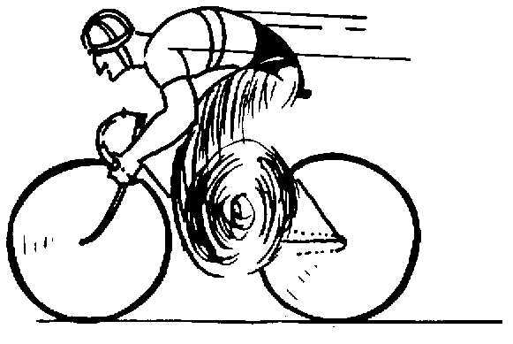

Mechanical Systems
Before determining the nature of the movement, the relevant process should be defined. The entire human body is usually chosen as the identification system. In other cases, however, the system may be described as right-handed and crafted by the right-hander. When hitting the ball, the whole body moves, the arm is mostly angular, and the swing pitch of the ball is linear. The analyst selects the systems to be analyzed based on the desired content.

REFERENCES:
- Bartlett, R. (2016). Introduction to Sports Biomechanics: Analysing Human Movement Patterns. Routledge.
- Knudson, D. (2013). Fundamentals of Biomechanics (3rd ed.). Springer.
- Winter, D. A. (2009). Biomechanics and Motor Control of Human Movement. John Wiley & Sons.
- Winter, D. A. (2009). Biomechanics and Motor Control of Human Movement. John Wiley & Sons.
- Nigg, B. M., & Herzog, W. (2007). Biomechanics of the Musculo-Skeletal System (4th ed.). John Wiley & Sons.
- Hay, J. G. (1993). The Biomechanics of Sports Techniques. Prentice Hall.
- Robertson, G. E., Caldwell, G. E., Hamill, J., Kamen, G., & Whittlesey, S. N. (Eds.). (2004). Research Methods in Biomechanics (2nd ed.). Human Kinetics.
- Zatsiorsky, V. M., & Seluyanov, V. N. (2002). The Biomechanics of the Human Musculoskeletal System. Human Kinetics.
- Winter, D. A. (1990). Biomechanics and Motor Control of Human Movement. John Wiley & Sons.
- Nordin, M., & Frankel, V. H. (2012). Basic Biomechanics of the Musculoskeletal System (4th ed.). Lippincott Williams & Wilkins.

