Overview of Energy Storage Technologies for Micro Grid

¹Suganthi.N,
¹Dayananada Sagar College of Engineering, Visvesvaraya Technological University, Bengaluru- 560078, Karnataka, India,
E-mail id : suganthi_neelagiri@yahoo.com
²P. Usha
²Dayananda Sagar College of Engineering, Visvesvaraya Technological University, Bengaluru- 560078, Karnataka, India
E-mail id : pu1968@yahoo.co.in

Abstract— Renewable energy resources are increasingly being able to reach the utility system. As renewable energy sources like wind and solar are uncontrollable and intermittent, its inclusion may cause issues with the utility grid's dynamics and power quality. The article discusses various energy storage plans that have been employed to lessen these problems. In order to achieve voltage control, frequency control, and active power stabilizations, energy storage techniques are primarily recommended. Implementing energy storage plans aids in improving the power plan's efficacy, reliability, and safety.

Keywords— storage, energy, battery, pumped storage, super capacitor

- INTRODUCTION
The world's need for electricity is growing at this moment as a result of economic and technical advancements. As fossil fuels dry out more and more quickly, it is necessary to use alternate generation sources like renewable energy resources (RES) to meet demand for electricity. Concerns over issues with voltage and frequency stability, as well as utility network consistency, grow as the penetration of RES rises. The voltage and frequency of local buses must always operate within the permitted ranges specified by the appropriate nation's grid code [1]. A major drawback of RES is their intermittency, which poses a threat to the security of the power grid. Thus, energy storage technologies are required to address the discrepancy between energy source and demand. The proper management of energy storage systems may satisfy this requirement.[2][3]. The transfer of electrical energy from a utility network into a form in which it may be stored until converted back to electrical energy is referred to as an Energy Storage (ES) scheme. In order to effectively integrate renewable energy resources into the grid and improve the power quality characteristics, it is required to incorporate high power density and high energy density-based energy schemes into this scenario. By adjusting the references to the dc-dc converters, energy storage devices (ESD) are employed as temporary power units to absorb or supply power. The protective state of charge (SoC) restrictions of these devices must be followed.[4]
Depending on the functionality and type of ES, there are various types of ES schemes available. Some energy storage systems are capacity-oriented and have slow response times. It is used for long-term energy balancing to compensate intermittent renewable energy sources in microgrids and buffer low frequency oscillations of distributed generator output power. By supplying the high frequency component of power, certain energy storage plans are access oriented storage plans with quick response times and the ability to provide transient response in microgrids [5].
- CLASSIFICATION OF ENERGY STORAGE DEVICES
Energy storage schemes can be classified into two different types, based on their application and form of energy stored.
- Depending on Application
Based on application, energy storage schemes can be classified as short -term energy storage schemes and long-term energy storage schemes. Long-term energy storage schemes used for power system applications can usually charge and source electrical power for the duration of minutes or hours and can particularly contribute on the dc microgrid operations to balance voltage, frequency and grid tied operation management [6]. Short-term response energy storage devices are usually applied to improve power quality, principally to sustain the dc microgrid voltage in case of un expected increase in load as well as in sudden dip in generation for short duration i.e under transient conditions [7].
- Depending on form of energy storage
Based on the form of electrical energy stored, energy storage scheme are classified in to five main types such as mechanical, chemical, electrochemical, electrical, and thermal energy storage [8] as shown in figure1.
- ENERGY STORAGE SYSTEMS
Long run and short run power response energy storage schemes will be covered under the five categories of electrical, chemical, electrochemical, mechanical and thermal energy storage Systems.
- Chemical Storage
In chemical ESD, electrical energy is stored in the form of chemical energy. Fuel cell is a type chemical energy system that generates electrical energy from the chemical energy and stores. Fuel cells that change chemical energy directly into electrical energy, in the absence of discharge of contaminating gases or noise. The electrochemical conversion of fuel into electricity is the basis for how fuel cells work. Typically, oxygen or air is delivered into the cathode (positive electrode) of a hydrogen fuel cell while hydrogen gas (H2) is injected into the anode (negative electrode). Hydrogen molecules divide into protons (H+) and electrons (e-) at the anode. While electrons move through an external circuit to form an electric current, protons move through an electrolyte to the cathode. Water (H2O), the major byproduct, is produced at the cathode when oxygen reacts with protons and electrons [9-11]. Operation of fuel cell is shown in Figure:2
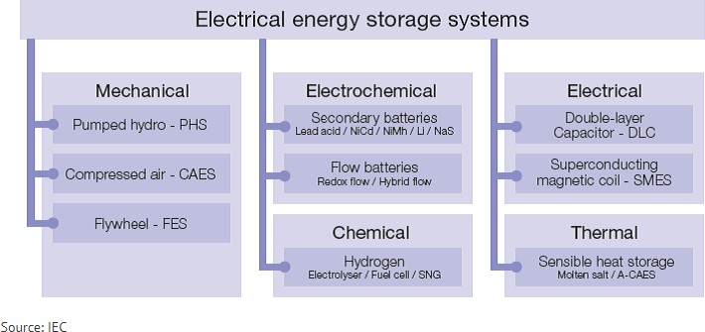
Fig 1 Classification of Energy Storage Systems. [IEC]

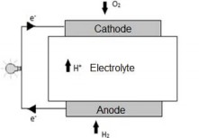

Fig 2 Operation of Fuel Cell
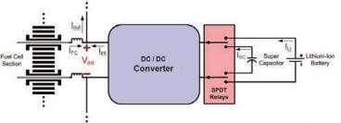
Fig 3 Hybrid connection of Fuel cell with Li-ion.[14]
As demonstrated in figure3, fuel cells can also be employed as part of a hybrid energy system in conjunction with a super capacitor and lithium-ion battery. The advantages of this hybrid connection between a fuel cell and a battery or ultra-capacitor include increased system life periods, longer sustainability times, and higher system-boosted current carrying capacities (up to 360%).[13]

- Electrochemical Energy Storage
Electrochemical ES schemes covers all types of secondary batteries. Batteries translate the chemical energy walled in its active material into electric energy by an electrochemical oxidation-reduction reverse reaction. Batteries are electrochemical ES technologies, each with different characteristics. Below is an summary of the different types of battery system.
Lithium-ion (Li-ion): Lithium manganese oxide is utilized as the cathode material in lithium manganese oxide (LiMnO2) batteries. Li-manganese batteries are ideal for high-load applications like electric automobiles and power tools because of its structure, which provides better security and temperature constancy. Their relatively small storage volume and short lifespan (usually 700 cycles) are significant drawbacks. The combination of nickel and manganese cobalt at the cathode makes lithium nickel manganese cobalt oxide (NMC) batteries one of the most extensively used and successful systems for applications requiring high energy or power densities. The battery's adaptability makes it perfect for a variety of uses, including those in industrial, medical, and electric vehicles (EVs). A further benefit is that it is less expensive than other Li-ion technologies due to the (partial) substitution of nickel for the more expensive metal cobalt at the cathode. NMC successfully operates in the range between 3 and 4.2V, just as other Li-ion technologies.[15][16]. Figure 4 depicts the charging and discharging of a Li-ion battery.
Ni-based batteries: The active ingredients are deposited on a porous nickel electrode in nickel-based batteries. Numerous advancements have been made since their discovery towards the end of the 19th century. The original Ni-based battery was a Nickel Cadmium (NiCd) battery. It has a very long lifespan and, with regular maintenance, can operate more than 1000 times. Additionally, it offers cheaper expenses each cycle, operates well in low temperatures, and charges quickly. Ni-Cd batteries became a viable choice for the aviation sector as a result of these qualities, and they have also been utilised to stabilise wind energy conversion systems. The disposal of these batteries pollutes the earth due to the toxicity of the cadmium; hence alternative battery technologies have taken their place. Additionally, NiCd has a memory effect and a relatively low specific energy density of 45 to 80 Wh/kg. A more recent Ni-based technology, nickel-metal-hydride (NiMH), offers about 40% more energy density than standard NiCd systems. Rechargeable batteries are primarily utilised with it in consumer gadgets. The fact that it may be utilised in a wider variety of temperatures and is simple to recycle is its key benefit.[16]

Flow Batteries: A Flow battery stores energy as chemical molecules dissolved in a liquid electrolyte. Flow batteries maintain the energy in liquid form, as opposed to traditional batteries, which store it in solid electrodes. This enables scalable and adaptable energy storage options. Large-scale energy storage applications frequently take into account flow batteries because of its benefits in terms of capacity, cycle life, and flexibility.
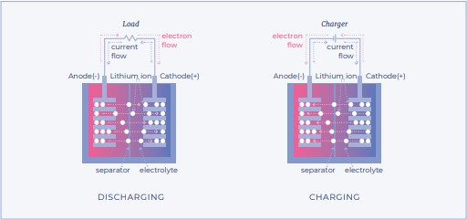
Fig 4 Charging and Discharging of Li-ion battery [16]
The primary distinction between flow batteries and traditional batteries is the energy storage medium—electrolyte in the case of flow batteries, as opposed to electrodes in conventional batteries. The volume of the battery determines its capacity [17]. The most popular type of flow batteries are redox flow batteries, which produce power as a result of the difference in potential between the two tanks. There are other types of flow batteries as well. Both tanks contain the same electrolyte solution, which is a mixture of positively and negatively charged ions, when they are discharged
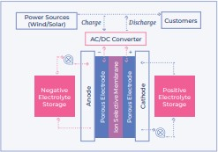

Fig 5 Generation of Electricity in Flow batteries [17]
Lead -Acid Batteries: Lead-acid batteries are made up of flat lead plates submerged in an electrolyte solution. As the positive and negative, respectively, one of its plates is covered in a paste of lead dioxide and is composed of sponge lead. Between the two plates is a divider. Because of the accumulation of lead sulphate on the negative electrode, lead-acid batteries require very long charging durations compared to discharge times, setting them apart from other batteries. Water is added to the electrolyte of lead-acid batteries to prevent water loss. Excess electrons allow hydrogen to be produced, which results in water loss. Because lead-acid batteries involve little care, they are frequently used as backup for UPS systems, emergency power sources, and automotive and traction systems. Cell voltage is 2V, systems have a maximum cycle life of 300, and energy density ranges from 30 to 50 Wh/kg. [18]

Sodium Sulphur (NaS)batteries: Sodium sulphur batteries Molten sodium serves as the negative electrode in molten salt batteries, utilizes melted sulphur as the positive electrode. A solid sodium alumina ceramic, which also serves as the electrolyte, separates the two electrodes. Electrons from the sodium metal atoms are liberated during discharge, creating sodium ions that flow over the electrolyte to the positive electrode and produce electricity. Since Sodium sulphur batteries often operate at temperatures above 300°C, external heaters are frequently needed. They have a high specific energy of 150 Wh/kg or more and a high round-trip efficiency of about 90%. They often serve to stabilize the production of renewable energy sources, reduce peak demand, and provide auxiliary services.[19]

Metal-Air Batteries A metal-only anode, an air cathode, a separator, and the electrolyte make up a metal-air battery. Only ion transformation is permitted due to the separator's insulating properties. Due to the separator's insulating qualities, only ion transformation is permitted during the discharge process.
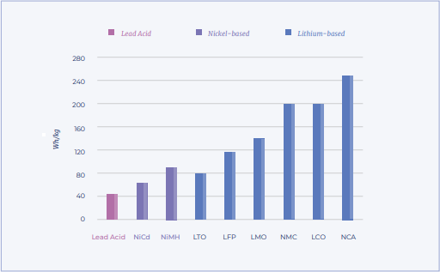

Fig 6 Specific Energy for different batteries[16]

The discharge procedure causes an oxidation reaction (Fig. 6). A metal anode with metal liquified in the liquid electrolyte experiences specific energy for various batteries [16], and an oxygen lessening reaction is formed in the air cathode. Metal-air batteries offer a substantially larger energy capacity (up to 12 KWh/kg, which is comparable to that of petrol) due to the open battery configuration that employs air as the reactant, which has made it particularly appealing to the automotive sector. Since there are still numerous technological issues to be overcome, metal-air batteries have not yet been commercialized.[17]

C .Mechanical Storage
Mechanical ES is the one of the most effective and sustainable energy storage method.. It is a method for packing energy in the form of mechanical work or potential energy, which can later be transformed back into electrical energy or kinetic energy, is known as mechanical energy storage. Mechanical energy storage relies on physical means to store and release energy, as opposed to chemical energy storage in batteries or electrochemical energy storage in capacitors. There are several popular ways to store mechanical energy and the types of mechanical energy storage schemes; flywheel, pumped hydro and compressed air.

Pumped Hydro Storage Systems: Pumped-storage hydroelectric plants store and produce electricity by pumping water between two reservoirs that are at different heights. These systems are adaptable, dynamic, efficient, and environmentally friendly ways to store and deliver huge amounts of electric power. It is a mechanical storage that Utilizes the gravitational potential energy of water. It comprises of two water reservoirs that are situated at various altitudes. The process of pumping water from the lower reservoir to the upper reservoir during times of high electricity production effectively stores excess energy as potential energy. When there is a need for energy or when there is a significant demand for power, water from the higher reservoir is released and allowed to flow through turbines as it flows downhill, producing electricity as shown in Fig.7
Although they require particular geographic circumstances, pumped hydro storage systems are renowned for their great efficiency and substantial storage capacity. The turbine pumps water back uphill in a pumping motion. Turbines discharge the stored water when there is a significant demand for electricity. Due to issues with resource availability and worries about disrupting natural river flows, conventional hydroelectricity has a limited future as an additional energy source. A significant amount of extra storage is needed if variable power generation from solar PV and wind climbs to levels between 50 and 100% of total electricity production [23]. With 97% of the world's storage power (160 GW) and more than 99% of the energy stored, PHES is by far the most popular energy storage technology [21,22]. PHES is an established off-the-shelf technology that is far less expensive than substitutes for extensive energy storage. Mature technologies that can provide 100% renewable electricity at a low cost [24] include solar PV, wind, PHES, and high-voltage DC and AC transmission. This results in significant greenhouse gas emission reductions. Over 100 GW of these technologies have been deployed globally.
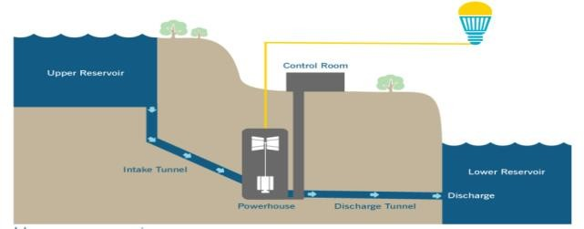
Fig 7 Pumped storage systems[24]
Flywheel Energy Storage Systems: A flywheel is a mechanical device that rotates and stores kinetic energy in the form of rotation. To reduce friction and keep the rotor rotating, it comprises of a large rotor mounted on bearings. Energy is added to the system while charging to speed up the flywheel. The rotating rotor stores this energy as kinetic energy. The flywheel is mechanically attached to a generator or other load when energy is required. The flywheel returns its stored kinetic energy to the electrical system as it slows down.
Although flywheels are renowned for their quick response times and excellent cycle efficiency, their energy density—the amount of energy stored per unit of mass or volume—may be constrained The flywheel energy storage system (FESS) converts kinetic energy—the way in which electrical power is stored—into electrical power via an electrical motor and generator before discharging the stored energy (fig. 8). By charging and discharging stored energy from the FESS, it is possible for the FESS to reduce output fluctuations caused by changes in sunlight in PV panels. In comparison to secondary batteries, the FESS has a long lifespan, a quick response time, and little toxic waste [25]. There should be more emphasis on other flywheel uses. Flywheels are excellent for a variety of applications in power systems, including the micro grid, due to their quick response times. Harmonic compensation has been done using flywheels, which may cut harmonics by around 50% up to the eleventh harmonic [26]. With the aim of maintaining power quality, companies from Europe and the USA have created flywheels that provide ride through for brief power outages, reduce harmonic distortions, eliminate voltage sags, etc.[27].
Compressed Air Energy Storage (CAES): is a means to keep energy produced once for later usage. CAES systems store energy by compressing air into caverns or underground reservoirs. Air is compressed and stored using surplus electricity during times of low electrical demand. When energy is needed, the compressed air is let out, heated by combustion, and expanded through turbines to make electricity.
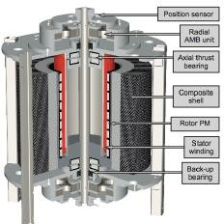
Large-scale energy storage can be provided through CAES systems, which can also be used in conjunction with renewable energy sources. At the utility level, energy produced during off-peak hours can be released to meet peak load hours when energy demand is higher. CAES systems have been used since the 1870s to distribute resourceful, on-demand electricity to communities and industries (fig. 9). Although there are plentiful minor applications, the first utility-scale CAES system with a nameplate capacity of over 290 MW was installed in the 1970s. Regarding its usage, compressed air energy storage (CAES) facilities are basically comparable to pumped-hydro power plants. Though, in this type of plant, ambient air or alternative gas is compressed and stored under pressure in an underground cavern or container in its place of pumping water from a lower to an upper pond during times of extra power. When electricity is needed, heated and expanded pressurized air is used to power a generator [28] by an expansion turbine. Depending on the method, CAES technologies are divided into three categories: isothermal (I), diabetic (D), and adiabatic (A). In order to categorise them, it is helpful to consider how heat is managed during air compression and before air expands [29]. The three main components the CAES system are the compressor, the air storage reservoir, and the expander [30].
Fig 8 Flywheel Energy Storage[23]
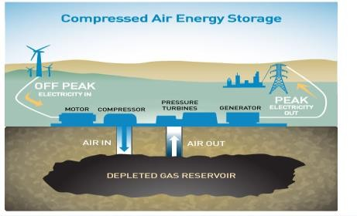

Fig 9 Compressed Air Energy Storage[28]

D.Electrical Energy Storage
Electrostatic energy storage methods, which include capacitors and super capacitors, and magnetic/current energy storage methods are two types of electrical energy storage methods (EESS) [31]. Utility grid electrical energy storage plans are a sophisticated method for enhancing utility system uniformity, safety, and reliability. EESS provides a storage system that stores energy when there is more production than demand and releases it during times of high demand.

Super Capacitors: Super capacitors, also known as electrical double-layer capacitors or super capacitors, are a revolutionary energy storage technique that closes the power and energy density gap between batteries and aluminum electrolytic capacitors [32]. The power density of an ultra-capacitor is ten times greater than that of a battery and its capacity ranges from a few to thousands of farads. Super capacitors provide a higher storage capacity than electrolytic capacitors, a wider operating temperature range, quick charging and discharging, a longer lifespan, no pollution or emissions, and more [33–35]. The energy storage plan is crucial for raising the micro grid's level of power quality. It is possible to modify the super capacitor energy storage scheme through the inverter control unit in order to supply customers with active and reactive power while enhancing power quality [36]. It is extremely appropriate to tackle some of the transient problems in the power schemes, such as an immediate outage brought on by system failures, a sudden rise in voltage, a voltage sag, and so on, because the super capacitor can swiftly sink and discharge electric energy with high power. Currently, the super capacitor can be utilized to regulate and smooth voltage swings by sinking or compensating the power shortage.

Superconducting magnetic energy storage (SMES): This ES Scheme is a technologically improved method of storing energy in a magnetic field. Energy is generated when current flows around coil (fig 10). In order for this to operate SMES scheme resourcefully as an energy storage schemer, the coil should be made of a superconductor with zero electrical resistance to avoid energy losses due to the current circulation.[37]
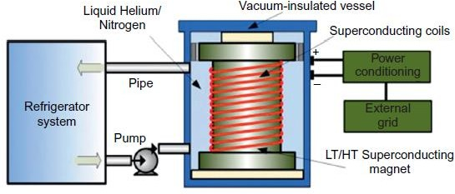
Fig 10 Structural View of SMES[38]

The superconducting magnetic energy storage technique is a type of energy storage that relies on the superconductivity of some materials. Because a superconductor has zero electrical resistance, there is no heat or energy lost as a result of resistivity when a current passes through it. Metal alloys are the best superconducting materials because they can be cooled almost to absolute zero before becoming superconductive. Super conducting coil is charged with electric current when it is in a cooled state, which produces a potent magnetic field where energy is subsequently stored. Up until a low or zero temperature, energy will be stored. Because they are so quick to react, small superconducting energy storage rings have been employed to provide utility grid support services. Large storage systems, however, are prohibitively expensive. Fig. 10 provides a structural picture of the superconducting magnetic energy storage device [38][39].
E. Thermal Energy Storage (TES):
Thermal storage – Thermal storage techniques use ice, hot water, or cold water to store heat for later use. The material chosen for thermal energy storage schemes affects how efficiently thermal energy is stored. They are crucial for incorporating large-scale renewable energy sources, such as concentrated solar thermal technology, which can be used as a dependable and dispatchable source of energy to balance the supply and demand of electricity.[40][41] Due to access being intermittent and solar radiation fluctuating constantly, TES was able to fit into thermodynamic models. By conserving energy, TES not only lowers the gap between supply and demand but also improves the system's performance and thermal stability. Designing effective and cost-effective TES solutions is therefore crucial. However, only a small number of solar thermal plants have used TES extensively worldwide. Additionally, research into the design of TES systems for a range of residential solar applications is also underway [42][43].

- CONCLUSIONS
Micro grid concepts with renewable energy resources, one of the upcoming technologies in the near future, will be made possible by an energy storage system (ESS). utilizing their power generation to solve the problems with intermittent nature of renewable energy sources. In addition to providing certain extra features like load balancing, spinning reserves, and black start capability, ESSs may preserve system reliability. Energy storage technologies and the use of renewable energy sources are urgently needed to address major energy problems including sustainability and environmental protection. Some crucial metrics are needed to account for the variations in electric energy and electric power generation levels caused by short- and long-term fluctuations in renewable resources. Due to their ease of management, controllability, predictability, and flexibility, energy storage becomes crucial for enhancing the electric grid system's reaction capability. The disparity in levels between electricity generation and consumption over short and long-time horizons would be accurately compensated by effective energy storage.

REFERENCES
- Indian Electricity Grid code [online] Available: http://powermin.nic.in/transmission/pdf/Indian_Electricity_Grid_Code.pdf
- J. Wang et al., "Optimization Configuration of Hybrid Energy Storage System Capacity with Grid-connecting Wind Power," 2022 IEEE 3rd China International Youth Conference on Electrical Engineering (CIYCEE), Wuhan, China, 2022, pp. 1-5, doi: 10.1109/CIYCEE55749.2022.9959028. J. Barton and D. Infield, “Energy storage and its use with intermittent renewable energy,” IEEE Trans. on Energy Conv.,, vol. 19, no. 2, pp.441–448, June 2004.
- L. Qiao, M. Li, R. Zhang and Z. Fang, "Research on Control Strategy of SMES-BESS Hybrid Energy Storage System in DC Microgrid," 2022 3rd International Conference on Advanced Electrical and Energy Systems (AEES), Lanzhou, China, 2022, pp. 152-157, doi: 10.1109/AEES56284.2022.10079463.
- N. Tephiruk, P. Jamjang, A. Tawe sap and K. Hongesombut, "Hybrid Energy Storage System to Enhance Efficiency of Renewable Energy Usage," 2022 19th International Conference on Electrical Engineering/Electronics, Computer, Telecommunications and Information Technology (ECTI-CON), Prachuap Khiri Khan, Thailand, 2022, pp. 1-4, doi: 10.1109/ECTI-CON54298.2022.9795622.
- Q. Mao, X. Gong, S. Liu, D. Shi, Z. Wang and D. Liu, "Research on Hybrid Energy Storage System with High Power Density and High Energy Density," 2020 IEEE Sustainable Power and Energy Conference (iSPEC), Chengdu, China, 2020, pp. 2022-2027, doi: 10.1109/iSPEC50848.2020.9351054.
- A. Lahyani et al., “Battery/super capacitors combination in uninterruptible power supply (ups),” IEEE Transactions on Power Electronics, vol. 28, no. 4, pp. 1509–1522,April 2013
- Z. Wang et al., "Research on the active power coordination control system for wind/photovoltaic/energy storage," 2017 IEEE Conference on Energy Internet and Energy System Integration (EI2), Beijing, China, 2017, pp. 1-5, doi: 10.1109/EI2.2017.8245403.
- I. Vechiu, Q. Tabart and S. Bacha, "Hybrid Energy Storage System Power Division in MicroGrids Using a Multilevel Power Converter," 2020 IEEE Power & Energy Society General Meeting (PESGM), Montreal, QC, Canada, 2020, pp. 1-5, doi: 10.1109/PESGM41954.2020.9281726.
- N. A. Rachman, A. Risdiyanto, A. A. Kristi, A. Junaedi, H. P. Santosa and U. Khayam, "Design and Implementation of Energy Management System For Small-Scale Hybrid Power Plant," 2022 5th International Conference on Power Engineering and Renewable Energy (ICPERE), Bandung, Indonesia, 2022, pp. 1-6, doi: 10.1109/ICPERE56870.2022.10037278. L. T. Soo et al. “An overview the electrochemical performance of modified grapheme used as an electro catalyst and as catalyst support in fuel cells.” Applied Catalysis A: General, Vol.497, 2015. pp. 198-210.
- R. Raza et al. ‘Fuel Cell technology for sustainable development in Pakistan- An over-view.” Renewable and Sustainable Energy Reviews, Vol.53, 2016. pp. 450-461
- M. Peksen. “Numerical thermo mechanical modeling of solid oxide fuel cells.” Progress in Energy and Combustion Science, Vol. 48, 2015. pp. 1 -20.
- Adel Merabet et al," Energy Management and Control System for Laboratory Scale Micro grid based Wind-PV-Battery", IEEE Transactions on Sustainable Energy,2017. (journal).
- Abdul Motin Howlader et al "converter design of smart grid Design and Line Fault Protection Scheme of a DC Micro grid Based on Battery Energy Storage System", Energies 2018, 11, 1823(PP)
- Hawke, J., Enjeti, P., Palma, L., & Sarma, H. (2011). A modular fuel cell with hybrid energy storage. 2011 IEEE Energy Conversion Congress and Exposition.
- Hesse, H. H. et al (2017). Lithium-Ion Battery Storage for the Grid — A Review of Stationary Battery Storage System Design Tailored for Applications in Modern Power Grids. Energies 2017,10.
- https://batteryuniversity.com/index.php/learn/article/types_of_lithium_ion.
- Davies, J. T.; Tummino, J. (2018). High-Performance Vanadium Redox Flow Batteries with Graphite Felt Electrodes. Journal of Carbon Research, 4 (1).
- Leung, P. et al. (2012). Progress in Redox flow batteries, remaining challenges and their applications in energy storage. The Royal Society of Chemistry Advances (Issue 27).
- Nguyen, T.; Savinell, R. T. (2010). Flow batteries. The Electrochemical Society Interface, Fall 2010. 7: Zhang, X. et al. (2016).
- Recent progress in rechargeable alkali metal–air batteries. Green Energy & Environment, 1 (1)
- Baldwin “Overcoming barriers to solar and wind energy adoption in two Asian giants: India and Indonesia” Energy Policy 132 pp1216-1228,,September 2019
- Y. S. Mohanned, A. A. Maruf, S. Thomas, G. Koyunlu, U. Usman and S. A. Adeshina, "A Synopsis for Utilization of Energy Storage Systems in Distributed Power Generation," 2019 IEEE PES/IAS PowerAfrica, Abuja, Nigeria, 2019, pp. 204-208, doi: 10.1109/PowerAfrica.2019.8928863. A. Blakers, B. Lu and M. Stocks, “100% renewable electricity in Australia”, Energy, Volume 133, pp 471-482, August 2017
- https://www.duke-energy.com/energy-education/how-energy- works pumped-storage-hydro-plants.
- H. Seino, et al.: ’Study of the Magnetic Bearing Consisting of Coupling of Superconductors Applicable to Support Bearing of Flywheel Energy Storage System’, RTRI REPORT, Vol.22.
K. Yoon-Ho et al., Comparison of harmonics compensation based on wound/squirrel cage rotor type induction motors with flywheel. In Proceeding of the 3rd International Conference on Power electronics and Motion Control, pages 531–536, Xian, China, 2000.
- https://www.pge.com/en_US/about-pge/environment/compressed-air- energy-Storage/ compressed-air-energy-storage. Page (web link)
- M. Budt, D. Wolf, R. Span, J. Yan, Compressed air energy storage An option for medium to large scale electrical- energy storage, Energy Procedia 88 (2016) 698–702.
- Zhao P, Gao L, Wang J, Dai Y. Energy efficiency analysis and off- design analysis of two different discharge modes for compressed air energy storage system using axial turbines. Renew Energy 016;851164-77.
- Chen H et al., Progress in electrical energy storage system: a critical review. Prog Nat Sci 2009;19:291–312
- CHEN Yingfang, LI Yuanyuan, DENG Meigen. Principle and applications of super capacitors[J]. Electronic Components And Materials, 2008,27(4):6-9
- Conway B E.," Electrochemical Super capacitors Scientific Fundamentals and Technological Applications[M]",.New York: Plenum Publishers, 1999.
- Becker H I. Electric double layer capacitor[P].USA: 2800616.1957-07.
- "IEEE Draft Guide to Using IEEE Std 1547(TM) for Interconnection of Energy Storage Distributed Energy Resources with Electric Power Systems," in IEEE P1547.9/D5.4, February 2022 , vol., no., pp.1-82, 23 Feb. 2022.
- Barker, P. P. Ultra capacitors for use in power quality and distributed resource applications. Power Engineering Society Summer Meeting , 2002 IEEE .
- Breeze, P," Superconducting Magnetic Energy Storage", Power System Energy Storage Technologies, pp.47–52,2018
- Luo, X., Wang, Jet al..," Overview of current development in electrical energy storage technologies and the application potential in power system operation"., Applied Energy, 137,2015 .
- Power System Energy Storage Technologies © 2018 Elsevier Ltd
- Sarbu, I.; Sebarchievici, C. Solar Heating and Cooling: Fundamentals, Experiments and Applications; Elsevier: Oxford, UK, 2016.
- Dincer, I.; Rosen, M.A. Thermal Energy Storage: Systems and Application; John Wiley & Sons: Chichester, UK, 2011.
- ] Joseph.A et al., Characterization and real-time testing of phase-change materials for solar thermal energy storage. Int. J. Energy Res. 2016, 40, 61–70.
- Ioan Sarbu et al.,"A Comprehensive Review of Thermal Energy torage", Sustainability, 10(2), 191
- R. Waser, M. Berger, S. Maranda and J. Worlitschek, "Residential-scale demonstrator for seasonal latent thermal energy storage for heating and cooling application with optimized PV self-consumption," 2019 IEEE PES Innovative Smart Grid Technologies Europe (ISGT-Europe), Bucharest, Romania, 2019, pp. 1-5, doi: 10.1109/ISGTEurope.2019.8905440.
- G. Qiao, X. She, T. Zhang, L. Cong, Y. -C. Chen and Y. Ding, "Mechanism of Specific Heat Capacity Enhancement of Molten Salts Based Nanofluids for Thermal Energy Storage - A Molecular Study," 2019 Offshore Energy and Storage Summit (OSES), BREST, France, 2019, pp. 1-7, doi: 10.1109/OSES.2019.8867356.

