Binary PSO based optimization approach for the image classification of mechanical tools

Pradip Dhal
School of Computer Applications,
Kalinga Institute of Industrial Technology, Bhubaneswar, Odisha, India
Email: pradip1780@gmail.com

Pulkit Kumar
Centre for Nondestructive Evaluation (CNDE)
Iowa State University (ISU) Ames, IA, USA
Email: pulkitkumar.maths@gmail.com

Prakash Kumar Jha
Department of Computer Science and Engineering,
Siksha ‘O’ Anusandhan (Deemed to be) University, Bhubaneswar, Odisha, India
Email: jhaprakashkumar0@gmail.com

Buddhadeb Pradhan
Department of Computer Science and Engineering
Institute of Engineering and Management, Kolkata
University of Engineering and Management, Kolkata
Email: buddhadebpradhan@gmail.com

ABSTRACT
Machine tool use is crucial for the industrial industry. Manufacturers can reduce costs, increase productivity, and improve quality by implementing machine tools. Large and small businesses today place online orders for mechanical tool items. Different photos of various products have been displayed on several websites, and companies put their orders on those websites. In this work, we have suggested a hybrid framework built on Feature Selection (FS) with ensemble-based for the Mechanical Tool Classification (MTC) problem. We applied the Binary Particle Swarm Optimization (BPSO) based FS methodology to complete the FS assignment. The ensemble-based classification algorithm has been fed the resulting features after that. We have also used the SMOTE approach to address the class imbalance issue.

Keywords— Classification of mechanical tools; Image classification; Ensemble classification; Feature selection; PSO

INTRODUCTION

The use of machine tools is essential for the manufacturing sector. They make it possible to produce various goods with accuracy and efficiency. By adopting machine tools, manufacturers can lower costs, boost production, and enhance quality. With a tool that completes jobs fast and accurately, you can move on to the next task and save time and energy, doing more in less time. Below are some of the most commonly used tools by mechanics: Screwdriver, Hammer, Pebbels, Rope, Wrench, Torque wrench, Pliers, Spark plug gapper, Oil filter wrench, Oil drain pan, etc. Now a days, large- and small-scale industries give their order online for mechanical tool products. Various images of the different products have been shown online on different websites, and the companies place their orders online. This is a very growing market for the manufacturing industry. Various researchers are working on optimizing image classification for the mechanical tool. In Image Categorization (IC) tasks, Machine Learning (ML) is tremendously beneficial. The following are some of the main benefits of applying ML to IC: automated feature learning, high accuracy, versatility, adaptability to new data, handling variability, scalability, reduced human effort, transfer learning, real-time applications, etc. The primary issue in IC is dealing with the vast amount of features for the classification task. Dimensionality Reduction (DR) is a technique used to reduce the number of features (dimensions) in a dataset while preserving as much relevant information as possible. Feature Selection (FS) and Feature Extraction (FE) are the two methods of DR. FE in IC refers to transforming raw pixel data or higher-level representations of images into a set of meaningful and informative features that can be used as input to an ML model for classification. FE aims to capture relevant patterns, structures, and characteristics of the discriminative images for the classification task. This process simplifies the subsequent classification task by reducing the dimensionality of the data and providing more informative representations. A common preprocessing step called FS separates redundant and unnecessary features while finding useful ones. In this method, the dimensionality of the data can be reduced without resulting in performance degradation - in some circumstances, performance may even be improved. These traits make FS an active research area, widely used to solve real-world issues, primarily in classification, though it can also be used in regression and other regions. FS has gained importance in recent years for dealing with image analysis to reduce input dimensionality and lessen the computational burden needed to extract information from the images. Metaheuristic algorithms, however, have drawn much attention for their success in solving various optimization problems. Metaheuristic algorithms have also been divided into multiple groups based on their behaviour. More than a hundred metaheuristic algorithms are also listed in a category list. In this work, for MTC, we have proposed a hybrid framework based on FS with ensemble-based classification. We have used the BPSO-based approach for the FS task. Then the resultant features have been fed in the ensemble-based classification approach. To handle the class imbalance problem, we have also used the SMOTE technique.

LITERATURE REVIEW

Ding et al. [3] proposes a discrete wavelet transform-based convolutional neural network method for machine tool operating state detection. Here statistical techniques like mean and root mean square values to extract features significantly lower the network model’s complexity and training time. Tool condition monitoring has become crucial to accomplish high-quality machining and economical production. The cutting tool state must be identified during machining before reaching its failure stage. Mart´ınez-Arellano et al. [9] introduces a deep learning and signal imaging-based big data approach for tool wear classification. Combining these two methods enables the method to operate on the raw data without statistical pre-processing or filtering. This approach is more general and suitable for working with massive datasets because an off-the-shelf deep learning implementation avoids the manual selection of features. In automated manufacturing, cutting tool wear detection is essential. It contributes to enhancing and raising manufacturing productivity. Benker et al. [1] suggests using modal characteristics found in vibration signals and a probabilistic classification approach. It will be demonstrated that by using probabilistic classification models, degradation-related uncertainties may be easily measured, improving the foundation for decision-making. It will also be demonstrated how a probabilistic classification method enables the prediction of a ball screw’s remaining usable life even when the user has only access to discrete preload observations. The fuzzy clustering algorithm (FCM) is frequently utilized in image segmentation. The probabilistic c-means algorithm resolves the relative membership issue with the FCM algorithm, and it has been demonstrated to have satisfied the ability to handle noise and outliers. Zhang et al. [16] proposes the possibilistic c-means clustering algorithm uses Mahalanobis distance instead of Euclidean distance, and the initial clustering centers are optimized using the particle swarm optimization method. According to experimental findings, the suggested approach significantly outperforms the traditional FCM clustering algorithm regarding segmentation impact and efficiency. Mekhmoukh and Mokrani [10] uses Particle Swarm Optimization (PSO) with outlier rejection combined with a level set for segmenting magnetic resonance (MR) images. Here an extended Fuzzy C-Means (FCM) algorithm has been used to enhance the outlier rejection and decrease the noise sensitivity of the conventional FCM clustering algorithm. The spatial neighborhood data is also taken into account here. These are employed a priori in the cost function that needs to be optimized. The first level set contour for MR images uses the resulting fuzzy clustering. Zhou et al. [17] developed a two-stage feature selection strategy for image classification that considers human factors. An enhanced quantum genetic algorithm is suggested to use eye tracking data during the coarse feature selection step. This hybrid feature selection method combines the effectiveness merit of the wrapper type SVM-RFE method and filter type mRMR method. Shang and Barnes [13] has offered a comprehensive Mars terrain image classification analysis using cutting-edge ML techniques. Fuzzy rough feature selection (FRFS), in particular, has been adopted and modified in conjunction with Support Vector Machines (SVMs) to assist in resolving difficult image categorization issues in space engineering. Unlike transformation-based dimensionality reduction strategies, the fundamental semantics of the chosen feature subset are retained here.

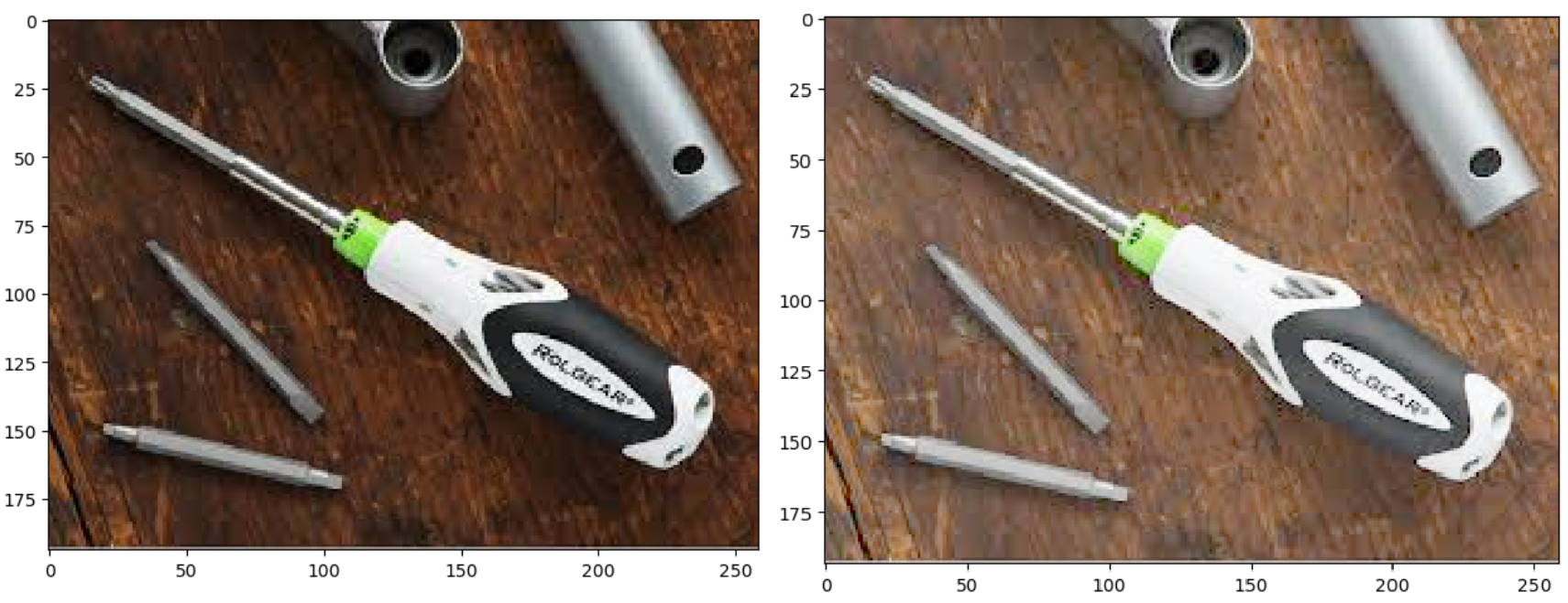
(a) Original image (b) By applying Gamma correction

Figure 1: Graphical representation of preprocessing task

PROPOSED METHODOLOGY

This section discusses the overall proposed methodology in detail. Section 3.1 discusses the idea of the preprocessing task, section 3.2 elaborates on the BPSO-based feature selection approach, section 3.3 highlights the objective function of the BPSO method, and finally, section 3.4 overviews the ensemble-based feature section approach, which is used here for the classification task. Figure 2 shows the graphical diagram of the proposed method.
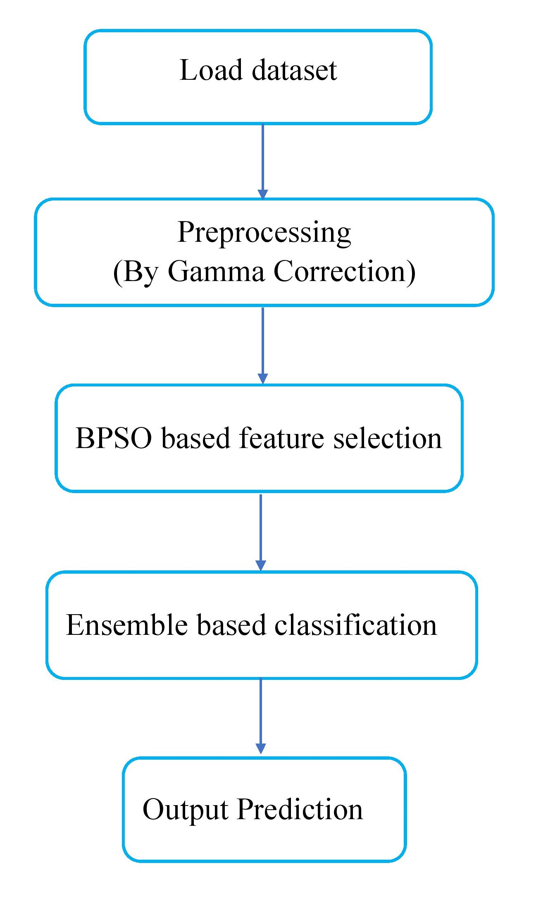
Figure 2: Diagrammatic representation of the proposed methodology

Preprocessing

Preprocessing is the word for actions on images that are performed at the most fundamental level; both the input and output are intensity images. In this case, the Gamma correction was applied as a preprocessing task for our suggested technique. Gamma correction, a nonlinear adjustment, is applied to every pixel value. Gamma correction is responsible for changing the image’s saturation by using nonlinear algorithms to the pixels of the input image. It’s crucial to keep the gamma value constant; it shouldn’t be too high or too low. Figure 1 shows the graphical diagram of a gamma corrected image in the MTC dataset.

BPSO based feature selection

One type of EC employed in the many optimization issues created by [14] is PSO. Swarm intelligence, or the schooling behavior of fish and birds swarming, served as the basis for this program. The number of particles that are potential solutions to the optimization problem is contained in the PSO method. The location vector and velocity vector of length $n,$where $n$ is the dimension of the search space, together define each particle in the search space. For the $i^{th}$particle in the search space having the position vector [$P_{i}^{1},P_{i}^{2},P_{i}^{3},…,P_{i}^{n}$] and velocity vector [$c_{i}^{1},c_{i}^{2},c_{i}^{3},…,c_{i}^{n}$] respectively. During the process of optimization, the position and velocity of the particle is being updated by the following equations,

$c_{i}^{t+1}=c_{i}^{t}+ϵ_{1}.R_{1}.\left(Pbest_{i}-P_{i}^{t}\right)+ϵ_{2}.R_{2}\left(Gbest-P_{i}^{t}\right)$ (1)

${ P}_{i}^{t+1}=P_{i}^{t}+c_{i}^{t+1}$ (2)

Where, $Pbest_{i}$ is the best position of the $i^{th}$particle and $Gbest$ is the best position with respect to all particles in the whole swarm. $R_{1}$ and $R_{2}$ are the two random numbers that are uniformly distributed over $\left(0,1\right)$. $ϵ_{1}$ and $ϵ_{2}$ are the social and cognitive parameters.
To enhance the PSO algorithm's performance, an inertia weight [14] has been introduced, here the modified equation is,
$c_{i}^{t+1}=w.c_{i}^{t}+ϵ_{1}.R_{1}.\left(Pbest_{i}-P_{i}^{t}\right)+ϵ_{2}.R_{2}.\left(Gbest-P_{i}^{t}\right)$ (3)

In Binary PSO (BPSO) [7] the newly transformed position is calculated via sigmoid function,

$sig\left(c_{i}^{t}\right)=\frac{1}{1+e^{c_{i}^{t}}}$ (4)

If ${ x}_{i}^{t}$ is greater than $rand<sig\left(c_{i}^{t}\right)$ then it will be 1 else it is 0

Objective function

An essential element in optimization problems is the objective function. The contribution of each variable to solving the problem optimally is measured by the objective function. Classification accuracy measures how well the proposed FS performs classifying and is used as an objective function. It looks for the most discriminative spectral features with higher accuracy. The objective function of the suggested FS technique could be stated as follows; Maximize accuracy: Cross-validation evaluates a model’s performance. It shows how the model would act with a different dataset, such as an uncharted or actual situation. Mathematically it can be stated as follows;
$£=\frac{p+q}{p+q+r+s}$ (5)

Where p, r, q, and s are the true positive, false positive, true negative, and false negative, respectively. $£$ is the value of the objective function. Our objective is to maximize the accuracy for our proposed method.

Ensemble classification
In ML and data science, ensemble-based classification has emerged as a promising technique for boosting the accuracy and robustness of classification models. Instead of using a single classifier, ensemble techniques utilize the knowledge of numerous classifiers to provide more accurate predictions. The predictions of various classifiers are merged to produce a final classification result in ensemble-based classification. The fundamental idea behind ensemble techniques is that combining the outcomes from numerous classifiers decreases individual classifiers’ shortcomings and flaws, resulting in more accurate and reliable predictions. Voting-based ensemble classification, an ensemble approach in which several classifiers are combined by using a voting mechanism to obtain the final classification decision, is the ensemble method we used in our work. Combining predictions from different classifiers and choosing the class with the most support is the basic idea. Support vector machines, decision trees, neural networks, and other classification methods can all be employed with voting-based ensemble classification. Each classifier should have a variety of biases, strengths, and error sources for it to perform well. It offers the advantages of increased accuracy, noise, outlier resistance, and more effective generalization. Furthermore, by allowing the dominant class to control the voting process, vote-based ensembles can address the issues caused by class imbalance.

RESULTS WITH DISCUSSIONS

Dataset Description
We have used the Mechanical Tools Classification (MTC) [5] dataset taken from the Kaggle website. This dataset contains images of tools like Gasoline Can, Hammers, Pebbles, Pliers, Ropes, Screw Drivers, Toolboxes, Wrenches, etc. Figure 3 shows the images of various tools for the MTC dataset. This dataset contains images of Gasoline Can 246, Hammers 1826, Pebbles 629, Pliers 397, Ropes 335, Screw Driver 1969, Toolbox 482, and Wrench 1643, respectively.

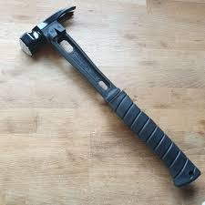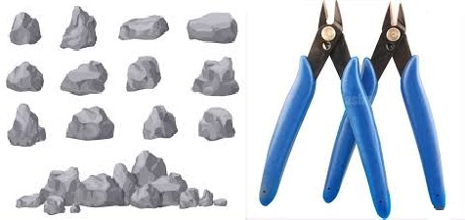
(a) Gasoline Can (b) Hammer (c) Pebbles (d) Pliers
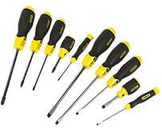
(e) Ropes (f) Screw Driver (g) Toolbox (h) Wrench

Figure 3: Various images of tools in the MTC dataset

Performance measures

Performance metrics are used in research to evaluate and measure the efficacy or efficiency of a model, algorithm, or system. The following performance metrics have been employed ;

- Accuracy (ACC) : It is a statistic used to evaluate an ML model’s efficacy. It shows what proportion of the dataset’s total instances (positive or negative) were accurately classified as instances. Mathematically it can be written as;
$$ACC=\frac{p+q}{p+q+r+s}$$

- Precision (PN) : The ratio of correctly classified positive samples to all positively classified samples (whether rightly or wrongly) is used to calculate it. The precision estimates how precisely a sample is classified as positive or negative by the model. Mathematically it can be written as;
$$PN=\frac{p}{p+r}$$

- Recall (RL) : It is determined by dividing the total number of positive samples by the proportion of positive samples correctly identified as positive. The recall measures a model’s ability to recognize positive samples. The recall rises as more positive samples are discovered. Mathematically it can be written as;
$$RL=\frac{p}{p+s}$$

- F1-Score (F1) : It assesses how well a model performs in binary classification tasks. The proportion of true positives among all projected positives is calculated by recall, whereas the proportion of true positives among all observed positives is determined by precision. Together, these two calculations form the harmonic mean. Mathematically it can be written as;
$$F1=2*\left(\frac{PN*RL}{PN+RL}\right)$$

- Geometric Mean (GM) : The GM of P N and RL normalizes TP to the GM of Predicted Positives and Real Positives, and its information value equates to the Arithmetic Mean of the Information represented by P N and RL. Mathematically it can be written as;

$$GM=\sqrt{PN*RL}$$

Experiments performed

One of the most popular strategies for handling an unbalanced dataset is resampling the data. There are essentially two approaches for doing this: undersampling and oversampling. In general, oversampling techniques are preferred to undersampling ones. We routinely omit data pieces that could have important information when we undersample. SMOTE is an oversampling technique in which made-up samples are created for the minority class. By using this approach, the overfitting problem caused by random oversampling is mitigated. In this study, we have dealt with this issue using the SMOTE method. Here, the complete experiment has been divided into the following sections;

- Experiment I : In this experiment, we have calculated the performance of the dataset against various basic classifiers. Table 1 shows the experimental results of the MTC dataset via various basic classifiers. Here the SVM(RBF) achieves the highest PN, ACC, F1, and GM values of 0.4497, 0.4436, 0.3311, and 0.4466, respectively. The highest RL value achieved by kNN is 0.3494. Here the kNN achieves the second highest PN, RL, F1, and GM values of 0.3593, 0.3785, 0.3199, and 0.3688, respectively. The second highest RL value achieved by NB is 0.3064.

Table 1 : Performance of Kaggle MTC image dataset using different standard ML classifiers
Classifier | PN | RL | ACC | F1 | GM
NB | 0.2312 | 0.3064 | 0.1541 | 0.1661 | 0.1887
SGD | 0.2349 | 0.2010 | 0.3240 | 0.1836 | 0.2759
RF | 0.1642 | 0.1709 | 0.3373 | 0.1243 | 0.2354
k-NN | 0.3593 | 0.3494 | 0.3785 | 0.3199 | 0.3688
MLP | 0.0357 | 0.1250 | 0.2855 | 0.0555 | 0.1009
k-Means | 0.0029 | 0.0702 | 0.0159 | 0.0056 | 0.0068
DT | 0.1289 | 0.1602 | 0.3161 | 0.1254 | 0.2019
LR | 0.3009 | 0.2752 | 0.3785 | 0.2738 | 0.3375
SVM(Linear) | 0.2859 | 0.2841 | 0.3360 | 0.2786 | 0.3099
SVM(RBF) | 0.4497 | 0.3184 | 0.4436 | 0.3311 | 0.4466

Table 2 : Performance of Kaggle MTC image dataset using SMOTE approach by different standard ML
Classifier | PN | RL | ACC | F1 | GM
NB | 0.2592 | 0.2485 | 0.2551 | 0.1880 | 0.2571
SGD | 0.6211 | 0.4881 | 0.4881 | 0.5128 | 0.5505
RF | 0.1921 | 0.2613 | 0.2640 | 0.1802 | 0.2252
k-NN | 0.6211 | 0.5952 | 0.6022 | 0.5864 | 0.6115
MLP | 0.0136 | 0.1250 | 0.1091 | 0.0246 | 0.0386
k-Means | 0.0132 | 0.0545 | 0.0660 | 0.0213 | 0.0296
DT | 0.1184 | 0.2153 | 0.2119 | 0.1372 | 0.1584
LR | 0.4221 | 0.4238 | 0.4270 | 0.4210 | 0.4246
SVM(Linear) | 0.5821 | 0.5758 | 0.5793 | 0.5777 | 0.5807
SVM(RBF) | 0.6199 | 0.6003 | 0.6022 | 0.5990 | 0.6110

Table 3 : Performance of Kaggle MTC image dataset using the BPSO based feature selection via basic classifiers and the ensemble approach
Classifier | PN | RL | ACC | F1 | GM
NB | 0.4811 | 0.4011 | 0.5011 | 0.4375 | 0.4393
SGD | 0.7544 | 0.6522 | 0.6751 | 0.6996 | 0.7014
RF | 0.4011 | 0.4511 | 0.4240 | 0.4246 | 0.4254
k-NN | 0.7567 | 0.6831 | 0.7511 | 0.7180 | 0.7190
MLP | 0.4163 | 0.4871 | 0.4633 | 0.4489 | 0.4503
k-Means | 0.2111 | 0.2389 | 0.1876 | 0.2241 | 0.2246
DT | 0.3321 | 0.3012 | 0.3721 | 0.3159 | 0.3163
RF | 0.6122 | 0.6523 | 0.6811 | 0.6316 | 0.6319
SVM(Linear) | 0.7345 | 0.6544 | 0.7545 | 0.6921 | 0.6933
SVM(RBF) | 0.7762 | 0.7431 | 0.7649 | 0.7593 | 0.7595
Proposed Methodology | 0.8278 | 0.8031 | 0.8231 | 0.8153 | 0.8154

- Experiment II : In this experiment, we have calculated the performance of the dataset against various basic classifiers using the SMOTE technique. Table 2 shows the experimental results of the MTC dataset via various basic classifiers by applying SMOTE technique. Here the SVM(RBF) achieves the highest RL, F1, and ACC values of 0.6003, 0.6022, and 0.5990, respectively. The highest PN and GM value achieved by kNN is 0.6211 and 0.6115, respectively. Here the SVM(RBF) achieves the second highest PN and GM values of 0.6199 and.6110, respectively. Also, the second highest RL and F1 value achieved by kNN is 0.5952 and 0.5864, respectively. SVM(Linear) gets the second highest value of 0.5793.

- Experiment III : In this experiment, we calculated the dataset’s performance by applying the BPSO based feature selection approach. We have used the basic classifiers and the ensemble-based classification approach for the classification task. Table 3 shows the experimental results of the MTC dataset by applying BPSO based feature selection approach. We have used the basic classifiers and the ensemble-based classification approach for the classification task. Here the proposed method achieves the highest PN, RL, RL, F1, and GM values of 0.8278, 0.8031, 0.8231, 0.8153, and 0.8154, respectively. Also, the SVM(RBF) achieves the second highest PN, RL, RL, F1, and GM values of 0.7762, 0.7431, 0.7649, 0.7593, and 0.7595, respectively.

CONCLUSION

The use of machine tools is essential for the manufacturing sector. By adopting machine tools, manufacturers can lower costs, boost production, and enhance quality. Nowadays, large and small-scale industries give their order online for mechanical tool products. Various images of the different products have been shown online on different websites, and the companies place their orders on that websites. In this work, for MTC, we have proposed a hybrid framework based on FS with ensemble based classification. We have used the BPSO based approach for the FS task. Then the resultant features have been fed in the ensemble based classification approach. To handle the class imbalance problem, we have also used the SMOTE technique. Here we also have used the gamma correction technique for the preprocessing task.

REFERENCES

- Benker M, Kleinwort R, Z¨ah MF (2019) Estimating remaining useful life of machine tool ball screws via probabilistic classification. In: 2019 IEEE International Conference on Prognostics and Health Management (ICPHM), pp 1–7, DOI 10.1109/ICPHM.2019.8819445.
- Das A, Namtirtha A, Dutta A (2023) L´evy–cauchy arithmetic optimization algorithm combined with rough k-means for image segmentation. Applied Soft Computing 140:110268, DOI https://doi.org/10. 1016/j.asoc.2023.110268.
- Ding S, Zhang S, Yang C (2023) Machine tool fault classification diagnosis based on audio parameters. Results in Engineering 19:101308, DOI https://doi.org/10.1016/j.rineng.2023.101308.
- Fayad R (2010) Tool monitoring for drilling process applying enhanced neural networks. In: 2010 The 2nd International Conference on Computer and Automation Engineering (ICCAE), vol 3, pp 200–204, DOI 10.1109/ICCAE.2010.5452063.
- Hossain S, Komol J, Raidah MM (2020) Mechanical tools classification dataset. URL https://www. kaggle.com/dsv/1609481
- Jiang X, Zhang Z, Wang Q, Meng P, Dai M, Wen H (2022) Visual inspection system for cnc turning tool wear based on transfer learning. In: 2022 28th International Conference on Mechatronics and Machine Vision in Practice (M2VIP), pp 1–6, DOI 10.1109/M2VIP55626.2022.10041057.
- Kennedy J, Eberhart RC (1997) A discrete binary version of the particle swarm algorithm. In: 1997 IEEE International Conference on Systems, Man, and Cybernetics. Computational Cybernetics and Simulation, vol 5, pp 4104–4108 vol.5, DOI 10.1109/ICSMC.1997.637339.
- Luo J, Ser W, Liu A, Yap P, Liedberg B, Rayatpisheh S (2021) Microorganism image classification with circle-based multi-region binarization and mutual-information-based feature selection. Biomedical Engineering Advances 2:100020, DOI https://doi.org/10.1016/j.bea.2021.100020.
- Mart´ınez-Arellano G, Terrazas G, Ratchev S (2019) Tool wear classification using time series imaging and deep learning. The International Journal of Advanced Manufacturing Technology 104:3647–3662.
- Mekhmoukh A, Mokrani K (2015) Improved fuzzy c-means based particle swarm optimization (pso) initialization and outlier rejection with level set methods for mr brain image segmentation. Computer Methods and Programs in Biomedicine 122(2):266–281, DOI https://doi.org/10.1016/j.cmpb.2015.08. 001.
- Sallam NM, Saleh AI, Arafat Ali H, Abdelsalam MM (2023) An efficient egwo algorithm as feature selection for b-all diagnoses and its subtypes classification using peripheral blood smear images. Alexandria Engineering Journal 68:39–66, DOI https://doi.org/10.1016/j.aej.2023.01.004.
- Sellami A, Farah M, Dalla Mura M (2023) Shcnet: A semi-supervised hypergraph convolutional networks based on relevant feature selection for hyperspectral image classification. Pattern Recognition Letters 165:98–106, DOI https://doi.org/10.1016/j.patrec.2022.12.004.
- Shang C, Barnes D (2013) Fuzzy-rough feature selection aided support vector machines for mars image classification. Computer Vision and Image Understanding 117(3):202–213, DOI https://doi.org/10. 1016/j.cviu.2012.12.002.
- Shi Y, Eberhart R (1998) A modified particle swarm optimizer. In: 1998 IEEE International Conference on Evolutionary Computation Proceedings. IEEE World Congress on Computational Intelligence (Cat. No.98TH8360), pp 69–73, DOI 10.1109/ICEC.1998.699146
- Zhang H, Peng Q (2022) Pso and k-means-based semantic segmentation toward agricultural products. Future Generation Computer Systems 126:82–87, DOI https://doi.org/10.1016/j.future.2021.06.059.
- Zhang H, Peng Q (2022) Pso and k-means-based semantic segmentation toward agricultural products. Future Generation Computer Systems 126:82–87, DOI https://doi.org/10.1016/j.future.2021.06.059
- Zhou X, Gao X, Wang J, Yu H, Wang Z, Chi Z (2017) Eye tracking data guided feature selection for image classification. Pattern Recognition 63:56–70, DOI https://doi.org/10.1016/j.patcog.2016.09.007.

