The Intra-Aortic Balloon Pump (IABP): Mechanisms, Applications, and
Clinical Considerations
Mr. EISHAN ALTAF BHAT,
Lecturer, Department Of Cardiac Technology,
School of Allied Health Sciences, AarupadaiVeedu Campus, Paiyanoor,
Vinayaka Mission’s Research Foundation- DU.
bhatteeshu16@gmail.com

ABSTRACT
In the twenty-first century, there are several mechanical options for the support of a failing heart. One of the oldest methods is intra-aortic balloon pump (IABP), also known as “counterpulsation.” Despite the proliferation of other options, IABP remains the most common assist device for several reasons: it is minimally invasive, does not require extracorporeal handling of blood, causes minimal haemolysis, and can be inserted in multiple settings (catheterization lab, operating room, intensive care unit, etc.) by both surgeons and interventional cardiologists. This chapter will review the indications for IABP counterpulsation, describe the physiologic mechanisms supporting its use, describe the technique of insertion as well as potential complications, and finally describe the outcomes reported by clinical trials.

INTRODUCTION
The Intra-Aortic Balloon Pump (IABP) is a mechanical circulatory support device that has been utilized for several decades to augment cardiac function in critically ill patients. It serves as a temporary tool to improve coronary perfusion and reduce cardiac workload in various clinical scenarios. The cardiovascular system is an imperative system in the human body, with the heart being a key organ for proper function. It allows for blood, oxygen, and nutrients to be delivered to different parts of the body [1]. The heart needs a specific amount of oxygen, so that it can continue to function properly (myocardial oxygen demand) and it also has a maximum amount of oxygen that can be provided by the blood (myocardial oxygen supply)
[2]. If the heart does not have an accurate supply and demand balance, then it would be considered weak and in need of assistance. One suggestion physicians make for patients with a heart condition, such as heart failure, is the use of an intra-aortic balloon pump (IABP)
[3].The IABP is a long and thin balloon that is able to control the blood flow through the aorta. The device attempts to balance out the supply and demand of blood and oxygen needed for the heart. To understand how the device works, it is necessary to gain knowledge on the fundamentals of hemodynamics and where the IABP will be incorporated. As Figure shows;
the blood flow through the heart begins with deoxygenated blood flowing into the right atrium (1), then the tricuspid valve opens and releases blood into the right ventricle (2), where it will then flow through the pulmonary valve and into the lungs where it will become oxygenated. The blood then flows into the left atrium and the mitral valve will open, allowing blood to flow

into the left ventricle (3). The heart then pumps the blood through the aortic valve and into the aorta, to bring oxygenated blood to different parts of the body (4). The IABP joins this circulation in the aorta and takes a mechanical circulatory support approach to treat cardiac diseases. This chapter aims to provide a comprehensive overview of the mechanisms, applications, and clinical considerations related to IABP therapy.

MECHANISM OF ACTION
The IABP operates on the principle of counterpulsation, where a balloon is synchronized with the cardiac cycle to assist the heart's pumping action. During diastole, the balloon inflates, reducing aortic pressure and enhancing coronary perfusion. This inflation also leads to an increase in diastolic pressure, which helps improve myocardial oxygen supply. As systole begins, the balloon deflates rapidly, lowering resistance in the aorta and reducing afterload. This assists the heart in pumping blood more efficiently and decreasing myocardial workload.

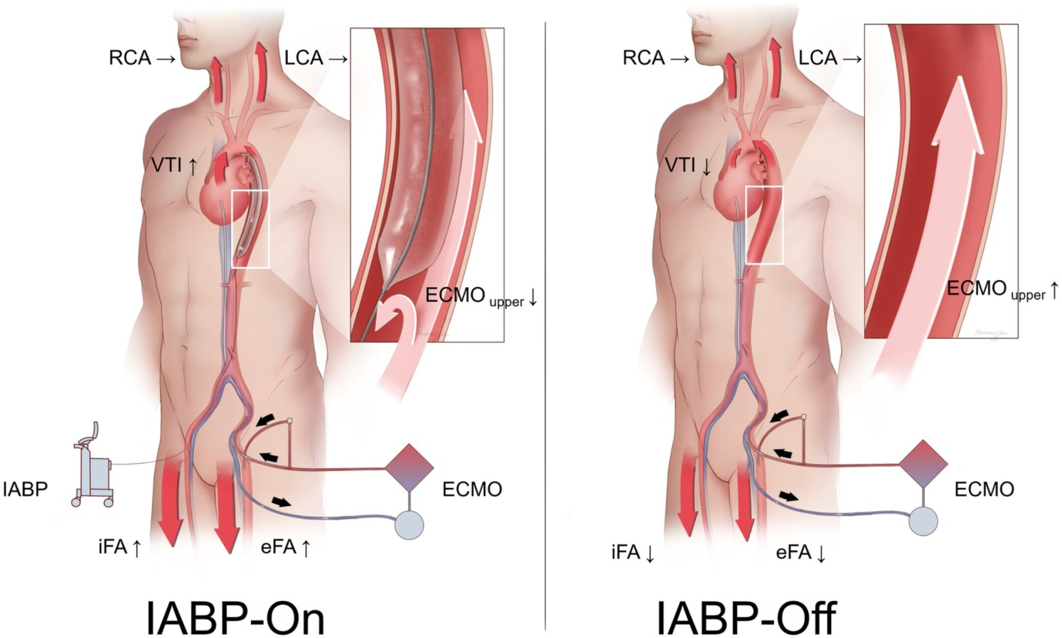

INDICATIONS FOR IABP
- Cardiogenic Shock: In cases of severe myocardial infarction, myocarditis, or acute heart failure, the IABP can provide temporary hemodynamic support until the underlying cause is addressed.
- High-Risk Cardiac Procedures: IABP can stabilize patients undergoing high-risk coronary interventions or cardiac surgeries.
- Unstable Angina: For patients with refractory angina, IABP therapy can improve oxygen supply and alleviate symptoms.
- Bridge to Recovery or Transplant: IABP can serve as a bridge for patients awaiting heart transplantation or those with reversible cardiac dysfunction.
- Weaning from Cardiopulmonary Bypass: Post-cardiopulmonary bypass, IABP support can assist the heart in regaining normal function.

INSERTION AND MONITORING
IABP insertion involves the placement of a catheter with an inflatable balloon tip into the aorta, typically via the femoral artery. Proper positioning is confirmed through radiography or fluoroscopy. Hemodynamic monitoring, including arterial pressure, ECG, and continuous waveform analysis, guides the timing of balloon inflation and deflation, ensuring synchronization with the cardiac cycle.

CLINICAL CONSIDERATIONS
- Patient Selection: Appropriate patient selection is crucial. IABP is most effective in conditions with reversible cardiac dysfunction, and careful evaluation of the underlying etiology is necessary.
- Timing: Early initiation of IABP therapy in cardiogenic shock can impact patient outcomes. Timely intervention improves coronary perfusion and prevents further deterioration.
- Complications: Potential complications include limb ischemia, bleeding, infection, and vascular injury. Regular assessment and vigilant monitoring are essential.
- Weaning and Removal: Gradual weaning off IABP is necessary to assess the heart's ability to function independently. Abrupt removal can lead to hemodynamic instability.
- Alternative Therapies: While IABP has been a cornerstone in circulatory support, newer devices like ventricular assist devices (VADs) and extracorporeal membrane oxygenation (ECMO) offer more robust support for advanced heart failure patients.

CONTRAINDICATIONS OF IABP

Absolute contraindications  • Aortic regurgitation  • Aortic aneurysm  • Aortic dissection  • Severe sepsis  • Uncontrolled coagulopathy  Relative contraindications  • Atherosclerosis and arterial tortuosity  • Left ventricular outflow tract obstruction  • Contraindications to anticoagulation | Common complications  Mild limb ischaemia - 2.9%  Balloon leak - 1.0%  Major limb ischaemia - 0.9%  Haemorrhage - 0.8%  Leg amputation due to ischaemia - 0.1%  Rare complications  Atheromatous cholesterol emboli  Aortic or arterial dissection  Cerebrovascular accident  Thrombocytopenia  Haemolysis  Helium embolis

CONCLUSION
The Intra-Aortic Balloon Pump remains a valuable tool in the management of acute cardiac conditions, offering a temporary means of circulatory support. Understanding its mechanisms of action, indications, insertion techniques, monitoring protocols, and potential complications is essential for healthcare professionals involved in the care of critically ill cardiac patients. As technology advances, the role of IABP continues to evolve in conjunction with other advanced mechanical circulatory support options.

REFERENCES
1.https://www.mdpi.com/2571-841X/2/3/19

2.https://www.researchgate.net/publication/324930401_Intra-aortic_Balloon_Pump

3.https://derangedphysiology.com/main/required-reading/cardiothoracic-intensive-care/Chapter%206.3.7/contraindications-and-complications-iabp

4.https://www.webmd.com/heart-disease/iabp-balloon-pump

5.https://link.springer.com/article/10.1007/s11897-020-00480-0

6.https://cardiothoracicsurgery.biomedcentral.com/articles/10.1186/s13019-016-0513-0

7.Textbook of Clinical Application of Intra-Aortic Balloon Pump, 3rd Edition

8.Textbook of Hemodynamic Monitoring and Therapy (Chapter-32 Intra-aortic Balloon Pump)

9.Textbook of Care of patients connected to IABP

10.Textbook of Fast facts for cardiac surgery

