A Bibliometric Analysis of Marital rape as a Human Right Aspect
Authors
Ms. Sanmati Rathore Dr Raja Roy Choudhury
Lecturer, Department of Law, Prestige Institute Director, Department of Law, Prestige Institute of Management and
of Management and Research, Research
Indore, India Indore, India
sanmati.rathore@gmail.com director_law@pimrindore.ac.in

ABSTRACT
The present study is based on bibliometric analysis on research publications which accentuates primarily upon human rights of married women against marital rape. The core objective of this study is to ascertain the research work conducted on marital rape in human rights framework. The data for conducting this research has been procured from Scopus database with use of VOS viewer software. The studies which are published from year 2000 till 2020 are being pursued for this research paper. This study consists of total of 65 documents of different categories including articles, papers reviews etc. The analysis and presentation of data has been done with the use of charts, graphs, and tables. It can be deduced from the study that marital rape as an aspect of human right is an under researched area which eventually showcase the divergence of penal laws regarding this crime as well. It is suggested that human rights bodies and institutions should promote and sponsor research in this field so as to enhance awareness and bring attention of people over this peculiar issue.
Key word- Bibliometric Analysis; Marital Rape; Human Rights; Scopus; VosViewer

- INTRODUCTION

The crime of rape is the one on which people frown upon and is highly disregarded. The word ‘rape’ owes its origin to a Latin word i.e., ‘rapere’ which means ‘to seize’. It means “ravishment of women against own will or without her consent obtained by force, fear or fraud or the carnal knowledge of women by force against her will”. Conceptually, rape can be defined as “any sexual intimacy forced on one person by another.” (Medea Andra and Thompson Kathleen, 1974) Levine in his study defined rape as “culturally disvalued use of coercion by a male to achieve the submission of a female to sexual intercourse.” (Levine R.A, 1956) The criminal justice system abates recognizing forceful sexual intercourse between legally wedded couple as rape (Cronan Sheila, 1969) indicates that the concept of consent doesn’t hold any relevance when the offender is husband of the women.

The present study is an attempt to analyse the publications on marital rape conjoining it with human rights aspect from 2000 to 2020. There is less academic attention on the marital rape in spite of being considered as an act of human rights violation. This study examines total of 65 documents which could be retrieved in the given time frame with the help of graphical interpretation. This study examines various areas like keywords occurrence, article distribution pattern, publication growth, citation analysis, author/university affiliation, research domain, and publication distribution as per countries.

- STATEMENT OF PROBLEM

It is well acknowledged and recognized fact in human rights regime that any sort of violence against women puts question upon women’s Fundamental Human Rights. The act of marital rape put various rights under jeopardy like right to life and dignity, right against torture, right to security etc. Marital rape denotes the inhuman and degrading treatment of women (Barbara C Alexander, 1999). Lack of research and legislations on this heinous act worldwide showcases the ignorance of legal scholars and legislators towards rights of married women. The marital rape is still not illegal in various nations due to the deep rooted stigma where women is considered to have given irrevocable consent to sex post marriage. Due to such prolonged stigma several women and communities do not even consider marital rape as a “real rape” (Jeffords & Dull, 1982; Kilpatrick, Best, Saunders & Veronen, 1988; Shotland & Goodstein, 1992; Sullivan & Mosher)
Due to societal pressure and psychological set up, women are tend to remain silent even when she experiences sexual violence from her husband in order to maintain hers and her family’s reputation. Thus marriage in a way gives right to husband to exploit her wife sexually where her consent is considered immaterial. In absence of legal safeguards in all such complexities these crimes are unrestricted and leave women with no choice than to continue to suffer.

- OBJECTIVES OF THE STUDY:

The following objectives are intended to achieve through this study-
- To study the article distribution pattern and publication growth over the years.
- To plot the most occurred keywords with regard to subject of this study
- To locate the various domain of research on the current study.
- To discover university/institute affiliation, the authors and journals contributing in the field of marital rape considering it as a human right.
- To undertake citation analysis of the published documents.
- To scrutinize the countries contributing most in the research and publication

- LITERATURE REVIEW
Carrasco Mercedes et al (2007) through this study analysed publications for a period of 2000-2005 in scientific journals focusing on the men abusing their female partners. It could be derived from this literature that even those studies which focuses on the curative side also lacks to address the efficiency of programs aimed at abusers. Moreover, no related studies have been found in public health journals. The authors, therefore, pointed categorically that such lack of scientific study is one of the prominent reason impeding effective policy-making.
Jorden.,C.E (2009) did a review whereby he explored the unique challenges associated with the field of gendered violence. The author proposed creation of transdisciplinary science for the this field since addressing VAW appropriately through academy alone with only minor adjustments cannot bring the desired results.
Wathen, CN., et al (2013) laid stress on the need to enhance decision making regarding health care through evidences derived from research. The authors’ presented KT (Knowledge translation) case study focusing on area of health care screening for Intimate Partner Violence.
Taiwo Aderonke Idowu (2020) Conducted a bibliometric study Gender-based Violence (GBV) Research Productivity in South Africa for a period of 2009- 2018, which revealed severe shortfall on Gender Based Violence researches.
Majumdar Navaneeta (2021) highlighted through the bibliometric study that in the last decade of 2011-2020, there has been substantial increment of 238% in the publications related to gender equality.

- RESEARCH METHODOLOGY
- Source of Information
The analysis has been done through the help of Scopus Database which was developed in year 2004 by Elsevier. It is a peer reviewed database which includes wide variety of documents in its purview including, articles, conference papers, editorials and so forth. The research work of different domain is covered through this data base including, medicine, social sciences, psychology, arts and humanities etc. Scopus provides the tool for analysing the data in visual representations like chart, graph etc.

- Study Design
The bibliometric analysis approach has been adopted to conduct the present research work. The data has been extracted for 20 years from 2000 to 2020 in order to analyse the trends of research on the subject of the current study in recent years.

- Search Strategy
In order to retrieve the desired results it is crucial that appropriate keywords are being used. To minimise the false positive report, few constraints are applied in the present study. The keywords at the date range which was set to obtain the results are depicted in Table No 1. For conducting this study, only the documents and journals of English language were taken into considerations. Scopus Database fetched total of 65 documents from year 2000 to 2021 with the use of keywords mentioned in Table 1. All publication in the subject matter of marital rape in association with human rights has been selected. For network and density visualization of map Vosviewer has been used as tool and for Charts and graphs, analysis of the Scopus Database has been utilized.

- PRESENTATION AND ANALYSIS OF DATA

Key Word | Search within | Date Range | Exclusions
Marital Rape and Human Rights | Article Title, Abstracts, Keywords | 2000-2021 | None
Table 1: Search strategy to obtain relevant documents

- Typology of Documents and Publication Trends
There are varied types of documents included in those 65 documents which are retrieved from year 2001 to 2020 on marital rape and human rights. These different types of documents comprises of Articles, Conference Paper, Reviews, Book Chapter, Book, Editorial, Letter, Note.
Figure 1 and Table 2 given below depicts the details of different composition of documents and it can be observed that the larger share of documents is occupied by Articles (43) followed by Conference Papers (7) and Reviews (6). Other documents comprising of editorials, books, books chapter etc. finds a smaller share in total publication
The publication of documents during 2001 to 2020 kept on fluctuating on the present topic. Year 2002 and 2003 accounts for zero publications and publications were at peak in year 2015. However, there has been substantial decline of number publications in year 2016 but these are gradually increasing from year 2019 till present as represented in Figure 2 and Table 3.
Figure 1: Document by Type
Source: http://www.scopus.com (accessed on 6th June, 2021)
Types of Documents | No of Documents | % (N= 65 )
Articles | 43 | 66.2
Conference Paper | 7 | 10.8
Review | 6 | 9.2
Book Chapter | 5 | 7.7
Book | 1 | 1.5
Editorial | 1 | 1.5
Letter | 1 | 1.5
Note | 1 | 1.5
Total | 65 | -
Table 2: Documents types and number of documents
Source: http://www.scopus.com (accessed on 6th June, 2021)
Figure 2: Yearly Publication Trend of Documents
Source: http://www.scopus.com (accessed on 6th June, 2021)

Year | No of Publication | Year | No of Publication
2001 | 3 | 2011 | 5
2002 | 0 | 2012 | 4
2003 | 0 | 2013 | 3
2004 | 2 | 2014 | 5
2005 | 2 | 2015 | 13
2006 | 2 | 2016 | 1
2007 | 1 | 2017 | 4
2008 | 1 | 2018 | 3
2009 | 2 | 2019 | 3
2010 | 4 | 2020 | 6
Total |  |  | 65

Table 3: Yearly Trends of Publication
Source: http://www.scopus.com (accessed on 6th June, 2021)

Analysis of Most Recurringly used Keywords
The intention of the researcher regarding the undertake study is showcased priliminary through the appropritate use of keyword. The accurate blend of keywords helps in targeting the research areas significant for the study. The final results of the study higly depends on the right selection of keywords in the beginning. Table 4 below showcases the distribution of the keywords classified in different clusters. First twenty keywords along with there occurance has been represented through Table 5. It can be seen here that the keywords “human” , “Marital Rape” or “Women’s Rights” occur more than “human rights”. The most common and frequently used keywords are visualised in the map (Figure 3).
Cluster | Total No of Items | Colour | Keywords
1 | 32 | Red | Abortion, induced, acquired immune deficiency, Africa, Africa south of Sahara article, child, crime, critical, cultural anthropology, demographic, developing countries, developing country, economic factors, economic, education, evaluation studies, government, HIV infections, human immunodeficiency virus infection, human relation, human rights, human rights women, interpersonal relations, law, marital status, politics, social psychology, socio economic factors, socio economic, war, women, women’s rights
2 | 29 | Green | Adolescents, Adult, alcohol consumption, controlled study, Cross-sectional studies, cross-sectional study, depression, educational status, epidemiology, female, humans, major clinical study, male, marriage, middle aged, partner violence, pregnancy, prevalence, psychological aspect, psychology, questionnaire, reproductive rights, risk factor, risk factors, spouse, spouse abuse, victim, violence, young adult
3 | 22 | Blue | Abortion, attitude, child sexual abuse, domestic violence, gender identity, human, India, legal aspect, marital rape, mental health, priority journal, rape, religion, review, sexual abuse, sexual assault, sexual behaviour, sexual crime, sexual violence, sexuality, social aspect, united states.
Table 4: Keywords Distribution

Table 5: First twenty Keywords and Occurrences
Source: http://www.scopus.com (accessed on 6th June, 2021)
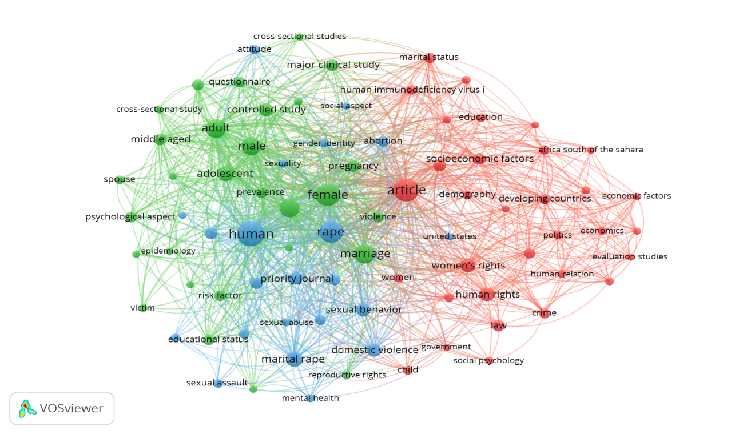
Figure 3: Network Visualisation of Most Frequently used keywords
Type of Analysis: Co-Occurance
Unit of Analysis: All Keywords
Counting method: Full Counting

- Subject Areas
Figure 4 and Table 6 dipicts the compartmentalisation of different subject areas as resarch domain. It is lucid from the figure and table as well that the domain in which maximum research could be traced in the field of maital rape and human rights is ‘Medicine’ which occupies total of 43.6% of area accounting for 41 documents out of 65. This is followed by social sciences occupying 29.8% of area follwed by Psychology with 10.6. Arts and Humanties, Pharmacology, and Nursing have contibuted 5.3%, 4.3%, and 2.1% respectively. The remaining contibution has been from the domians sch as Biochemistry, Genetics and Molecular Biology, Environmental science, Immunology and Microbiology and lastly Neuroscience. It can be notices that marital rape is not given due and appropriate attention in light of human rights as well as law in general.

Subject Area | No of Documents
Medicine | 41
Social Sciences | 28
Psychology | 10
Arts and Humanties | 5
Pharmacology, Toxicology and Pharmaceutics | 4
Nursing | 2
Biochemistry, Genetics and Molecular Biology | 1
Environmental science | 1
Immunology and Microbiology | 1
Neuroscience | 1
Table 6: Subject area and documents
Source- http://www.scopus.com (accessed on 8th June 2021)
Figure 4: Subject area of extracted publications
Source: http://www.scopus.com (accessed on 8th June 2021)
- Geographical Analysis of Most Attentive Publishers
Through the representation made by Table 7 and Figure 5, it could be analysed that United states has contributed most publications out of total retrieved documents. With the higest number of published documents i.e., 19, US tops the list of most active country which is then followed by India having 5 documents in its account. Further, contribution of 4 docmunets each is made by Australia, Canada, Nigeria Spain and United Kingdom. Brazil, Ethiopia and Sweden each contribute 3 document from year 2000 till 2020.

COUNTRY | NO OF DOCUMENT
United States | 19
India | 5
Australia | 4
Canada | 4
Nigeria | 4
Spain | 4
United Kindom | 4
Brazil | 3
Ethiopia | 3
Sweden | 3
Table 7: Top 10 most active countries

Figure 5: Top 10 most active countries
Source: http://www.scopus.com (accessed on 8th June 2021)

- Citation Analysis

Citations are one factor determining influence of a research (Tsay, 2009). The impact which a research has can be determined by the extent to which that study has been of use to other scholars researching on the area (Shadbolt et al., 2006). The motive behind citations is to signify that a publication has used the information and contents of various other published documents as well. Therefore, the total count of citations used in a research works as a determining factor regarding the influence which research has made (Lutz Bornmannl, 2008).
The total of 65 documents has been retrieved from the Scopus database, out of which 40 documents met the citation threshold. The minimum number of citation applied for analysis purpose here is 5. Figure 6 represents the density visualization consisting of total 37 clusters, where each cluster consist of one author except Cluster 1 and Cluster 2 having 3 and 2 authors respectively.

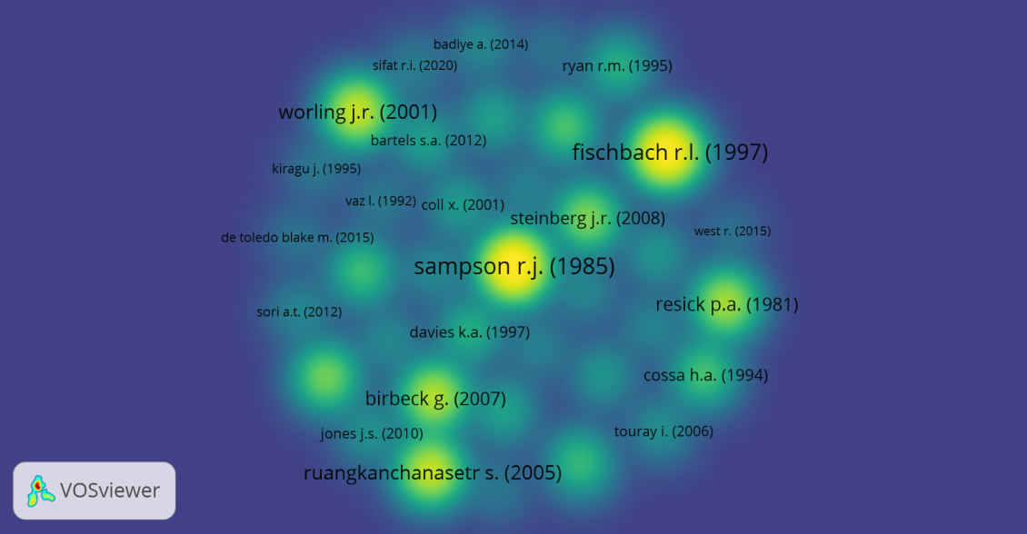

Figure 6: Density Visualization: Citation Anlaysis
Unit of Analysis: Document
Counting method: Full Counting
Minimum number of Citation: 5
- Author and Affiliation Statistics
The contibution of top ten authors in publication related to marital rape and human rights is dipicted through Figure 7. While analysing affiliation statistics it can be drawn from Figure 8 that Sweden based university, i.e., Uppsala University had contibuted most in research work in the field conerning marital rape. Following which the other univerisities or institutions making contibution includes Women for women’s Human Rights (Istanbul), Emory University (Atlanta), University of Ibadan (Nigeria) etc.

Figure 7: Most Contributing authors
Source- http://www.scopus.com (accessed on 8th June 2021)

Figure 8: Affiliation Statistics
Source- http://www.scopus.com (accessed on 8th June 2021)

- Document by source
The total documents which has been retrieved are published in 50 different journals out of which the most active journal is ‘Ajil Unbound’ having published 5 documents on the subject of current study. The next journal is line contributing in publication includes ‘Aggression and Violent behaviour’ and ‘BMC Pubic Health’ having 3 and 2 documents respectively. The top 5 journals having contribution in publication are dipicted below in figure 9.
Figure 9: Source Statistics
Source- http://www.scopus.com (accessed on 8th June 2021)

- IMPLICATIONS OF THE PRESENT STUDY
This study was undertaken to analyse the trends of research in the area of marital rape linking it with human rights aspects .The research work on present topic of study have been undertaken by researchers around the globe. However, it can be identified that although there are number of works conducted on marital rape and human rights independently but less coverage has been given to them together. The present research work therefore prompts more scholarly attention on marital rape and human rights together as a subject of research.
The bottom level keywords in Table 5 of this present bibliometric study conducted on marital rape and human rights are- human rights, pregnancy, sexual behaviour and risk factor. This implies that existence of huge research gap which is consequently providing the critical and unexplored space to the analysts and reserchers worldwide to focus on these identified gaps. Not only these domains have scope of research but there is need of these areas to be investigated and worked upon.
United States and India are working at a quick pace in this research domain contributing 24 documents out of total of 65 retrieved document between 2000-2020. The sensitivity of United State towards marital rape and protection of human rights of women can be lucidly observed through there legislative framework that penalises this act. India, on the contrary, being a country where marital rape is still an exception and not an illegal act provides the Indian researchers with an opportunity to look into the intricacies which have been overlooked in the past.
- LIMITATIONS OF THE STUDY
For conducting this study, data has been extracted and explored from Scopus Data Base through a combination of relevant keywords for analysis purpose. It is necessary to consider that data accumulated for bibliometric analysis is not static and keeps on changing. The statistics keeps on fluctuating regarding number of citations, articles etc due to frequent data revision in Scopus. Also, the study is limited in its scope since only the documents which are in English language are undertaken for analysis of data.

- CONCLUSION
The bibliometric analysis by associating marital rape with human rights revealed that sufficienct coverage has not been given in this field of research. Marital rape is a recognized act which is detrimental to Human Rights of women and failure by states to inculcate laws in there national laws dipicts ignorance of Human Rights Law. Such prolonged non-consideration of women’s rights continue to thwart her dignity. Therefore, more research work is to be undertaken to ascertain and determine the possible causes and the ways through which fundamental human rights of women can be safeguarded. The central problem which relates to ignorance of relevancy of women’s consent for sexual intercourse in marital relationship has to be studied as a part of her basic and fundamental human right.

REFRENCES
- Barbara C Alexander (1999), “Convention Against Torture: A Viable Alternative Legal Remedy for domestic violence Victims”, American University International Law Review Vol 15, 895, retrieved from https://digitalcommons.wcl.american.edu/cgi/viewcontent.cgi?referer=https://www.google.com/&httpsredir=1&article=1277&context=auilr (accessed on 29 May 2021)
- Carrasco Mercedes et al (2007) “What Do We Know About Men Who abuse Their female Partner? A Systematic Review”, Pan American Journal of Public Health 22(1), 55-63, retrieved from https://scielosp.org/article/rpsp/2007.v22n1/55-63/es/ (accessed on 02 June 2021)
- Cronan Sheila, “Marriage”, THE FEMINIST, 213-221(1969) https://pages.uoregon.edu/eherman/teaching/texts/Cronan%20Marriage.pdf
- Jeffords C.R, & Dull, R. T, (1982) , “Demographic Variation In Attitudes Towards Marital Rape Immunity”, 44(3) JOURNAL OF MARRIAGE AND FAMILY, 755-762 retrieved from https://www.jstor.org/stable/351597 (accessed on 01 June 2021)
- Jorden.,C.E (2009), (2009), “Advancing The Study Of Violence Against Women: Evolving Research Agendas Into Science”, Violence Against Women, 15, 393-419, retrieved from https://doi.org/10.1177/1077801208330692 (accessed on 02 June 2021)
- Kilpatrick D.G, Best C.L, Saunders B.E and Veronen L.J, (1988) “Rape in Marriage and Dating Relationships: How Bad is it for Mental Health? Human Sexual Aggression: Current Perspectives”, 528 ANNALS OF NEW YORK ACADEMY OF SCIENCES, 335-344 retrieved from https://psycnet.apa.org/record/1991-18728-001 (accessed on 05 June 2021)
- Levine R.A (1956), “Gussi Sex Offenses: A Study in Social Control, American Anthropologist” 969 , retrieved from https://anthrosource.onlinelibrary.wiley.com/doi/abs/10.1525/aa.1959.61.6.02a00050 (accessed on 29 May, 2021)
- Majumdar Navaneeta et al (2021), “Measuring the Global Research Output and Visualization on Gender Equality: A Bibliometric Analysis” Library Philosophy and Practice (e-journal), 5803, retrieved from https://digitalcommons.unl.edu/libphilprac/5803/ (accessed on 14 July 2021)
- Medea Andra and Thompson Kathleen (1974), “Against Rape”, Farrar, Straus And Giroux, Vol 12.
- Shotland, RL, & Goodstein L (1992), “Sexual Precedence reduces the perceived legitimacy of sexual refusal: An examination of attributions concerning date rape and consensual sex”, Personality And Social Psychology Bulletin, 18(6), 141-149 retrieved from https://journals.sagepub.com/doi/10.1177/0146167292186012 (accessed on 05 June 2021)
- Sullivan J.P and Mosher D.L, (1990), “Acceptance of Guided imagery of Marital Rape as a function of a Macho Personality”, 5(4 )Violence And Victims, 275-286 https://pubmed.ncbi.nlm.nih.gov/2098091/ (accessed on 01 June 2021)
- Taiwo Aderonke Idowu Mrs (2020) "A Decade of Gender-based Violence (GBV) Research Productivity in South Africa 2009-2018", Library Philosophy and Practice (e-journal). 3844, retrieved from https://digitalcommons.unl.edu/libphilprac/3844/ (accessed on 01 June 2021)
- Tsay, M. Y. (2009) “Citation analysis of Ted Nelson’s works and his influence on hypertext concept” Scientometrics, 79(3), 451-472. https://doi.org/10.1007/s11192-008-1641-7 (accessed on 01 June 2021)
- Wathen, CN., et al (2013), “Exploring The Uptake And Framing Of Research Evidence On Universal Screening For Intimate Partner Violence Against Women: A Knowledge Translation Case Study”, Health Research Policy and Systems 11(1),13, retrieved from https://health-policy-systems.biomedcentral.com/articles/10.1186/1478-4505-11-13 (accessed on 03 June 2021)

