Analysis of Unsteady MHD Boundary Layer Flow of Nanofluid Over a Linear and Non-Linear Stretching Sheet

**Abstract:**

In the present study, the analysis of nanofluids was considered and analysed between two stretching sheets linear and non-linear, with the impact of thermal radiation and magnetic field analysis. Buongiorno's model is incorporated to study the combined effects of thermophoresis (*Nt*) and Brownian motion (*Nb*). The coupled non-linear transformed equations are solved numerically by shooting technique with built-in MATLAB bvp4c package. The obtained results are depicted through graphs and analysed numerically through the table.

**Keywords:** Magnetohydrodynamics, Unsteady, Buongiorno’s model; linear and non-linear stretching sheet.

**Introduction:**

The Stagnation Point of the fluid is the point where the local velocity is void. In General, the stagnation points in the flow field form at the surface point of the objects, wherever the fluid is brought to rest by any substance. Hiemenz [1] was the first to examine the flow of a stagnation point in a plane. He examined the stagnation flow problem over a stationary plate and used likeness transformations to convert the Navier–Stokes equations into non-linear Ordinary Differential Equations (ODEs). Many researchers have spread the concept to consider various importance of the stagnation point flows with this importance and its plenty of practical applications, the stagnation point flow attracted many researchers.

There are numerous applications related to industries and engineering like melt-spinning, hot rolling, extrusion, manufacture of fibreglass, plastic, and the production of rubber sheets. Crane [2] originated the study of flow over a stretching sheet. In this problem, he solved a steady 2D flow over a linearly stretching plate analytically. after that, Wang [3] improved the idea of Crane from a 2D to a 3D case. Suali et al. [4] concluded the impact of suction and injection on stagnation point flow through stretching/shrinking sheets and concluded that the mass suction causes the improvement of the range of dual solutions while the reverse trend is noticed for mass injection. Also, some recent investigations related to stagnation point flow stretching surface have been discussed [5]. The 2-dimensional boundary layer flow of fluid along a stretching surface was started with Crane [6] with this point, the flow analysis of nanofluid over a heated stretching sheet with the influence of unsteady free stream condition and radiation is analysed by Das et al. [7]. The hydromagnetic boundary layer flow of a nanofluid over a stretching sheet with Newtonian heating and dissipation effects is investigated by Khader et al. [8]. The hydromagnetic flow of a radiative nanofluid over a stretching sheet is analysed by Devi et al. [9] who concluded that the stretching parameter enhances the nanofluid temperature. Awad et al. [10] studied the unsteady Oldroyd-B Nanofluid flow over a stretching sheet. They found that the larger value of the fluid relaxation parameter is indicative that the Oldroyd-B nanofluid is stretched.

**2.2 FLOW ANALYSIS AND MATHEMATICAL FORMULATION**

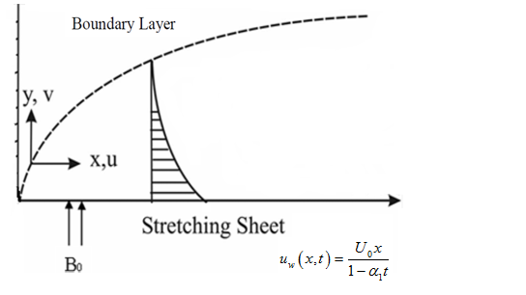 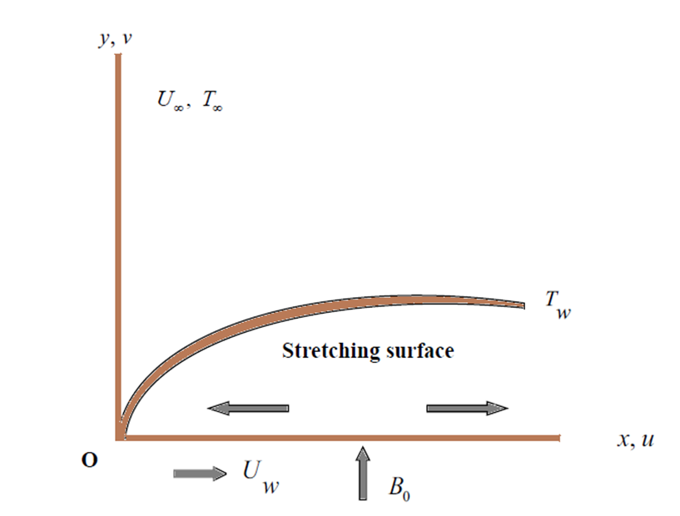

**Fig.** Physical model and co-ordinate system of linear and non-linear stretching sheet

**CONTINUITY EQUATION**

, (1)

**MOMENTUM CONSERVATION EQUATION**

, (2)

**ENERGY CONSERVATION EQUATION**

, (3)

, (4)

**MASS CONSERVATION EQUATION**

. (5)

The associated appropriate boundary conditions are

**Linear**

 (6)

**Non-Linear**

 (7)

By suitable transformations, we obtain the following ordinary differential equations.

**Linear:**

, (8)

, (9)

. (10)

**Non-Linear:**

 (11)

 (12)

 (13)

The pertinent dimensionless boundary conditions are.

**Linear**

 (14)

**Non-Linear**

 (15)

**METHOD OF SOLUTION**

The coupled non-linear ordinary differential equations, with the related boundary conditions cannot be solved through analytic method. Hence the solutions are obtained numerically with the support of bvp problem solver with MATLAB bvp4c package. This tool basically incorporates the shooting technique. Hence, the mesh choice and error mechanism are equipped by the residual of continuous solution. The approval was fixed to 10−7. In this problem, the decision of, guarantees that every numerical solution approach to an accurate asymptotic value.

**RESULTS AND DISCUSSION**



Impact of Magnetic Field in temperature profile between Linear and Non-Linear Stretching Sheet

  Impact of thermophoresis and Brownian motion parameter in temperature profile

**References**

[1] K.K. Hiemenz, Die Grenzschicht an einem in den gleichformingen Flussigkeitsstrom eingetauchten graden Kreiszylinder, Dingl Polytech Journal, 326 (1911) 321–324.

# [2] L.J Crane, Flow past a stretching plate. Zeitschrift für angewandte Mathematik und Physik, 21 (1970) 645–647.

[3] C.W. Wang, The three-dimensional flow due to a stretching flat surface, Physics of Fluids, 27 (1984)1915–1917.

[4] M. Suali, N.M.A. Nik Long and N.M. Ariffin, Unsteady stagnation point flow and heat transfer over a stretching/shrinking sheet with suction or injection, Journal of Applied Mathematics, 2012 (2012) 1-12.

[5] Y. Zhong and T. Fang, Unsteady stagnation point flow over a plate moving along the direction of flow impingement, International Journal Heat and Mass Transfer, 54 (2011) 3103-3108

[7] K. Das, P. R. Duari and P. K. Kundu, Nanofluid flow over an unsteady stretching surface in presence of thermal radiation, Alexandria Engineering Journal, 53 (2014)737–745.

[8] M.M. Khader and A. M. Megahed, Numerical solution for boundary layer flow due to a nonlinearly stretching sheet with variable thickness and slip velocity, The European Physics Journal Plus, 128:100 (2013).

[9] S. P. Anjali Devi and M. Prakash, Thermal radiation effects on hydromagnetic flow over a slendering stretching sheet, Journal of the Brazilian Society of Mechanical Science and Engineering, 38 (2016) 423–431.

# [10] A. G. Awad, S.M.S. Ahamed, and M. Khumalo, The Effect of Thermophoresis on Unsteady Oldroyd-B Nanofluid Flow over Stretching Surface, PloS One, 10(8), 2015