A Comprehensive Review on Deep Learning Techniques used in Diagnosing Retinal Diseases on Fundus Images

Author’s VIJAYA MADHAVI V¹ Author’s Dr. P. LALITHA SURYA KUMARI^{2*}

¹Research Scholar, Department of CSE, Koneru Lakshmaiah Education Foundation, Hyderabad, Telangana, India.
Email: madhavikrishnat@klh.edu.in

₂Professor, Department of CSE, Koneru Lakshmaiah Education Foundation, Hyderabad, Telangana, India

Email:vlalithanagesh@gmail.com

Abstract: Due to the exponential growth of the computing infrastructure, there has been an unheard increase in the deployment of computer vision, deep learning in recent years. This was true for fundus image processing: effective AI models were created employing a range of visual markers extracted from eye image data to identify various retinal diseases. The detection of five important eye diseases—diabetic retinopathy, glaucoma, age-related macular degeneration, cataract, and retinopathy of prematurity—has been made possible in recent years by the use of a variety of deep learning techniques. This article is structured along a pipeline for implementing deep learning, providing a detailed overview of different approaches to each of the five aforementioned retinal diseases, followed by an introduction to commonly used datasets, metrics, image preprocessing techniques, and basic models for deep learning. The article concludes by listing the eight main study areas that are now being studied in the area of diagnosing retinal diseases, outlining their primary difficulties and potential future prospects for the research community at large.

Keyterms:- Glaucoma • Retinal Fundus Images •Computer Vision • Deep Learning •
Detection• Medical Image Analysis •
I.INTRODUCTION
Numerous imaging modalities have been developed over the years to examine the human eye, but fundus imaging is becoming more popular due to its non-invasive and inexpensive properties. In fundus photography, a monocular camera is used to record the fundus or its projection onto a two-dimensional plane. 2D fundus scans can be used to identify various ocular structures, biomarkers, and abnormalities (Figure 1). Identification of retinal disease is greatly facilitated by many of these visual indicators. Microaneurysms (MAs), which resemble small red dots, usually develop as a result of narrowing of capillaries and lack of oxygen. A complete loss of supply due to certain arteriolar occlusions (SE) results in soft white patches called ointments. If a retinal artery ruptures due to pressure build-up within the arteriole, it may bleed and appear as a dark red spot. Hard exudate (HE), a hard, yellow, waxy substance, results from protein and fat leaking out of defective blood vessel walls. We investigate the presence of these lesions in combination with other retinal biomarkers. B. The macula, fovea, optic disc, and blood vessels provide important insights and help in diagnosis of some of the most important retinal diseases.
In densely populated countries like India, there is a serious shortage of qualified ophthalmologists capable of such a tedious task[1].
The most common eye diseases that can lead to blindness if not properly treated include diabetic retinopathy (DR), glaucoma, age-related macular degeneration (AMD), diabetic macular edema (DME), retinopathy of prematurity (ROP) and cataracts. Such retinal diseases usually require specialist care and comprehensive screening techniques [2]. 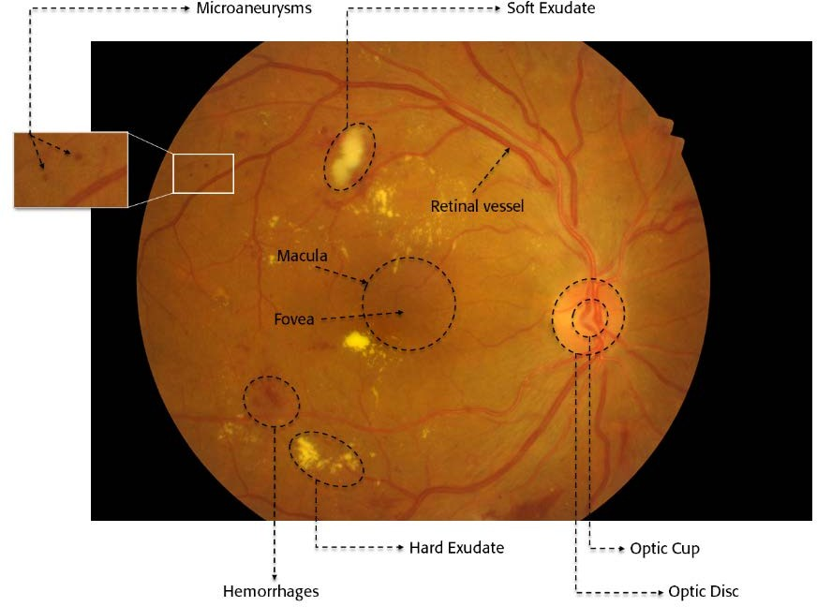
Fig1: Fundus Image
Classification and segmentation tasks are the two main types of DL tasks used in the diagnosis of retinal diseases. The task of direct classification of input photos into multiple illness categories is referred to as the classification task. Similar to this, segmenting is important for biomarkers and significant lesions from a patient's fundus image can offer a wealth of information on the nature and classification of retinal illnesses. For such purposes, numerous DL architectures have been created and evaluated, as is extensively illustrated in [3].
Digital processors have grown exponentially recently, data-driven technologies have made AI-based medical screening systems increasingly common. These systems provide workable and affordable options for the automatic identification of retinal illnesses. In particular, fundus image analysis has shown tremendous growth and promise in computer vision, deep learning techniques. [4].
In addition, this article uses a DL process pipeline approach to diagnose retinal diseases and provides an overview of current research on the diagnosis of five major eye diseases.
Diabetic retinopathy, glaucoma, age-related macular degeneration, cataract, retinopathy of prematurity. This is in contrast to recently published reviews [5]–[9] on this subject.
In addition, it fully describes all datasets that are available for the aforementioned illnesses together with ground truth descriptions.
It includes an extensive literature review of DL implementations for five major retinal diseases and tabulates their comparative performance. In addition, we discuss the various research directions currently available in this field. We provide knowledge about widely used image preprocessing methods, evaluation methods, and commonly used DL backbone approaches for the diagnosis of retinal diseases.
II.DATASETS AND EVALUATION METRICS
Fundus photography is a method of acquiring a three-dimensional fundus image of the retina in two dimensions using reflected light projected onto the image plane. Commonly used fundus image dataset for DL-based diagnosis of retinal diseases. The dataset is used for disease diagnosis and the results are color coded. All records are presented in one table for ease of understanding and comparative analysis.
III.PREPROCESSING TECHNIQUES
Fundus images are typically preprocessed before training to enhance learning and create meaningful predictive models. A learning step is performed to compensate for noise caused by different types of imaging devices used with different lighting settings during image capture. As shown in Figure 2, many important biomarkers and lesions may go undetected due to the complexity of the retinal structure and poor image quality. Preprocessing techniques are also used to enhance the features of the fundus image and remove unwanted noise before running the DL model. Table 2 lists some of the commonly used preprocessing methods for diagnosing retinal disease from color fundus images.

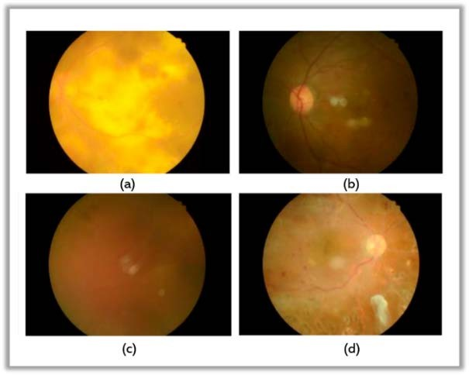
Fig:- Retinal Fundus Images
Fundus Image Preprocessing Technique | Description
CLAHE(Contrast Enhancement) | Constrast limited adaptive histogram equalization is a widely used technique especially in fundus images.
Colour Space Transformation | Green channel extraction from fundus images is well known for providing high-contrast images with rich visual information.
Noise Removal | Many denoising algorithms such as Gaussian filter,median filter and non-local means denoising are used to remove unwanted noise.
Cropping and Extracting Region of Interest | Cropping is done to extract a precise region of interest from the entire fundus image. For example, to study the size of the optic disc, only this portion of the image is cropped and used as her ROI for model training, reducing unnecessary learning effort.
Augmentation | Augmenting techniques such as image rotation, rescaling, mirroring and transformation are used to balance the image dataset.

Table2: Commonly used Preprocessing techniques for Image Enhancement
IV.DEEP LEARNING TECHNIQUES
Deep learning (DL), based on artificial neural networks, is a subclass of artificial intelligence techniques (learning methods inspired by the biological structure of the human brain). Potential and intrinsic relationships of input data are automatically learned through the mathematical representation of the DL process. Unlike common machine learning (ML) techniques, deep learning (DL) techniques extract meaningful features directly from data without relying on manually created features. This makes DL eligible for medical image analysis because it can automatically learn features from complex visual data. In this section, we describe the design of several commonly used basic models, especially for classification and segmentation tasks in the diagnosis of retinal diseases.
V.MODELS OF CLASSIFICATION
A. CONVOLUTIONAL NEURAL NETWORKS(CNN)
CNN (Convolution Neural Network) architecture is one of the most commonly used DL designs for effective multi-layer training [10]. The overall structure of CNN is shown in Figure 3. A CNN consists of three main parts.Convolutional layers, pooling layers, fully connected layers. The training process consists of two steps. The first stage is called the "forward stage", where the input image is rendered with the correct weights and distortions at each level. The expected output is then used to compute the loss function by comparing it to the ground truth values. His second stage, called the "backward stage", uses a loss function to compute the gradient of each parameter. Parameters are set and changed for subsequent transfers. 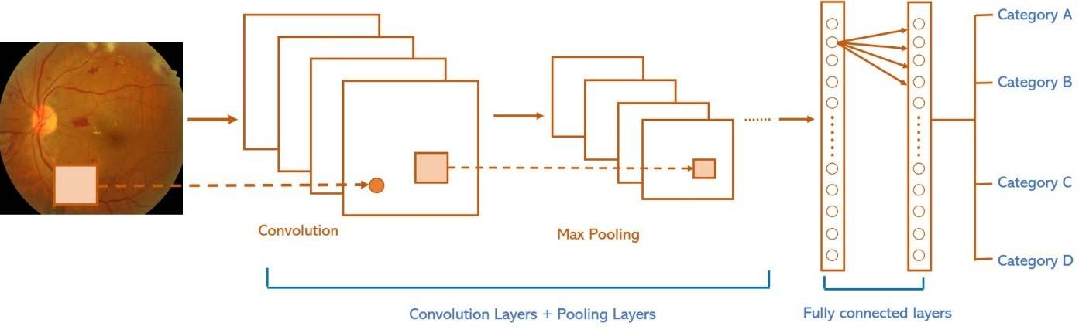
Figure 3: CNN Architecture
B. VGGNET
VGG Network is yet another backbone network that is frequently utilised to classify retinal disorders (VGGNet). In 2014 [11], Karen Simonyan and Andrew Zisserman made this suggestion. The architecture of a VGGNet is seen in Figure 4. The VGG acronym stands for Visual Geometry Group(VGG), which starting with VGG-16 through VGG-19 produced numerous versions of Convolution network for various image categorization applications. Researching the depth of CNN affects the precision of picture classification was the initial motivation for the creation of VGG. In order to improve the depth of network without using so many parameters, a tiny kernel is employed in all levels of the model.
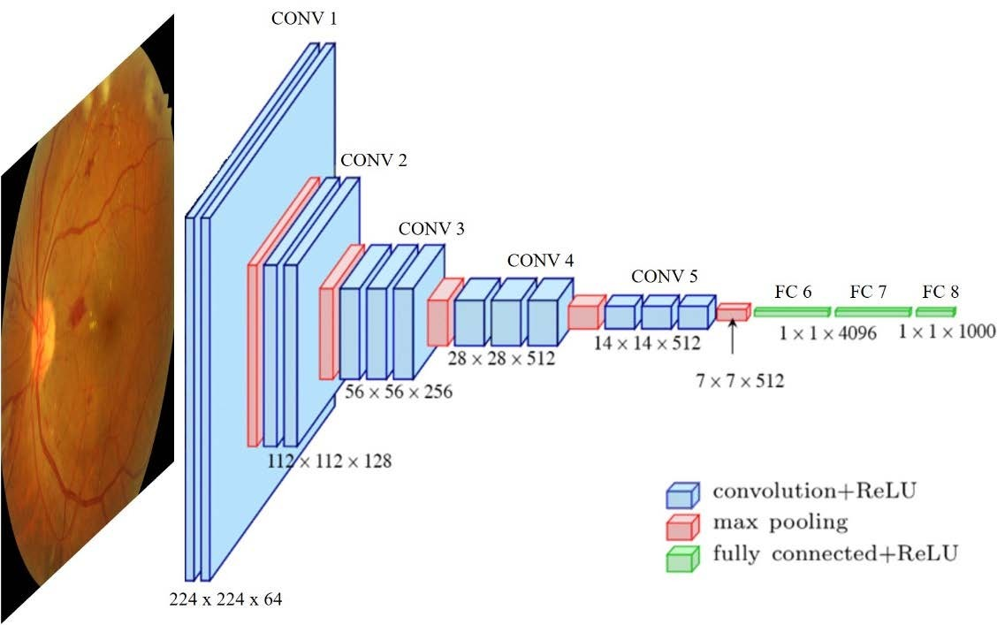

Figure4: VGGNET
C.RESNET
The 152 layers that make up the residual network (ResNet) [12] are created by stacking individual residual blocks shown in Fig. 5(a) and (b). These residual blocks consist of two convolutional layers (3 3). The number of filters is doubled periodically and a step size of 2 is used for spatial down sampling. After each convolutional layer, this network uses stack normalization and specific hopping connections. These deep models take activations from one layer and pass them directly to another layer, so hop connections are used to optimize them. This makes it possible to train deep networks without encountering the vanishing gradient problem. ResNet has a fully connected layer that outputs 1000 classes to reduce the number of parameters.
-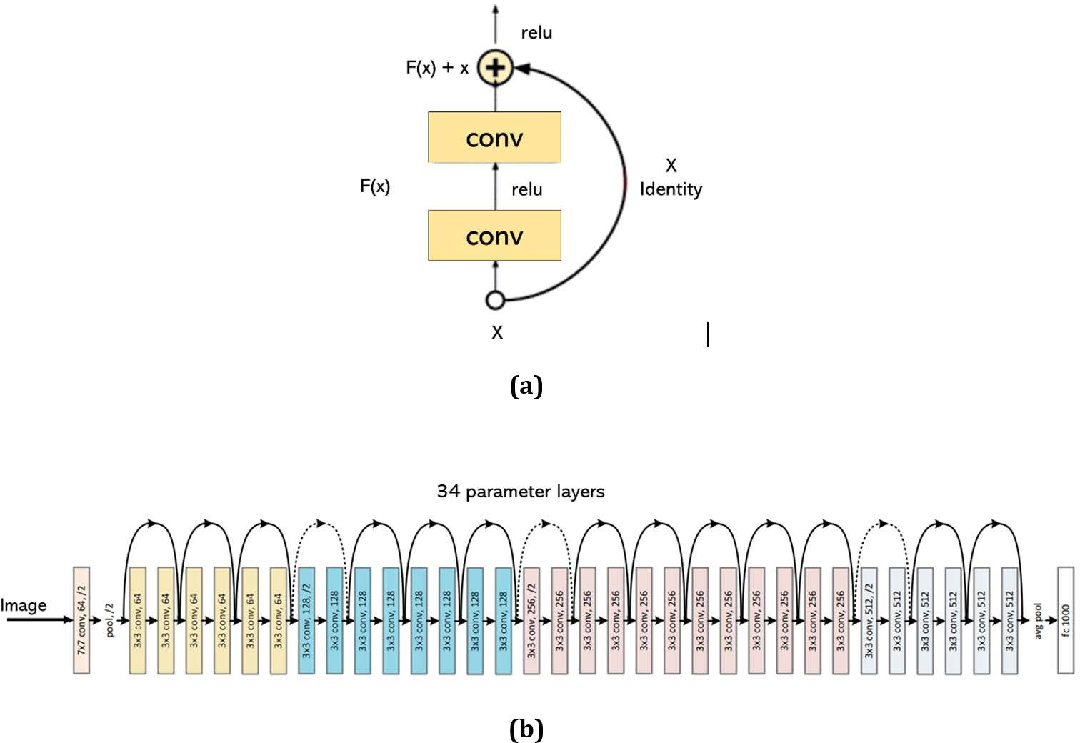
Figure5: a) Residual Block b) Architecture of ResNet

D.BACKBONE MODELS FOR SEGMENTATION IN FUNDUS IMAGES
- FULLY CONVOLUTION NETWORKS (FCNs)
A modified CNN network was proposed by Long et al. [13] by substituting up sampling layers for fully linked layers (Figure 6). The initial layers' extracted features are up-sampled to the input image's size. In comparison to CNN, a fully convolution network is more suitable for segmentation tasks because to its ability to execute dense pixel-wise prediction.
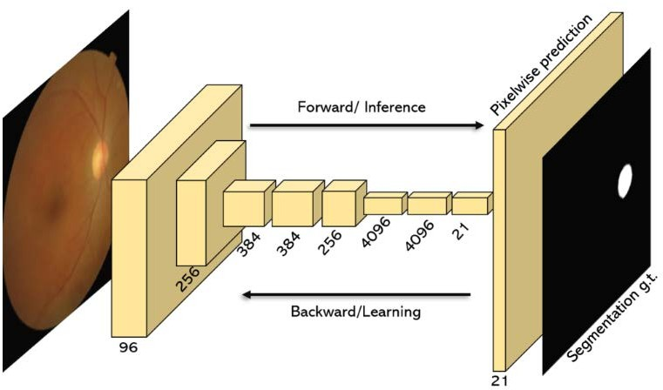
Figure 6: FCN Architecture

2)U-NET
A network with symmetrical encoder and decoder structures and multiple-hop connections from the encoding path to the decoding path was proposed by Ronneberger et al. Presented. [14], shown in Fig. 7. The encoder is responsible for extracting features from the input image, while the decoder reconstructs the image for the final output. Hop configuration enables the network to generate better predictions by directly connecting low-level feature maps from the encoder to the decoder.

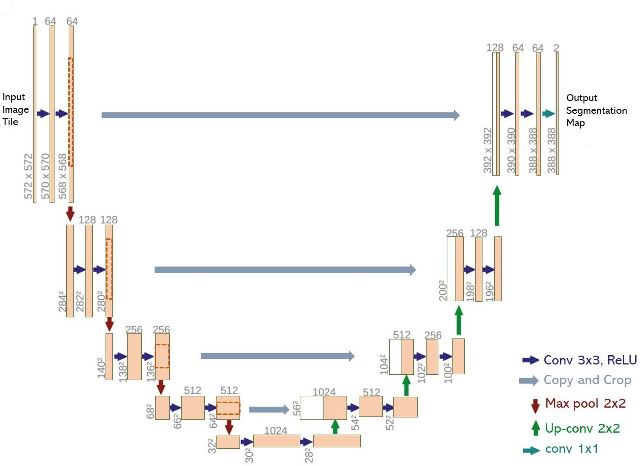

Figure7: U-Net Architecture

VI.DEEP LEARNING RETINAL DISEASE DIAGNOSIS PROCESS

- DIAGNOSIS DIABETIC RETINOPATHY
One of the most common retinal diseases leading to blindness is diabetic retinopathy. One-third of diabetics suffer from this problem [15]. According to research, around 93 million people worldwide are affected by DR [16]. Any person with diabetes can get DR, which leads to the destruction of retinal blood vessels. These numbers are expected to increase further, given the rapidly increasing number of people with diabetes worldwide [17]. The severity of DR has been classified by the International Clinical Diabetic Retinopathy Scale (ICDRS) into five categories: Class 0 for no DR, Class 1 for mild DR, Class 2 for moderate DR, Class 3 for severe DR, and Class 4 for proliferative DR. Many DL models have been implemented to create a reliable DR diagnostic model from fundus images.

- GLAUCOMA DIAGNOSIS
Another important factor contributing to permanent blindness worldwide is glaucoma [18]. The researchers are focused on creating multiple DL models for diagnosing glaucoma from fundus images, as they have done for many other retinal diseases. The following section describes recent progress in this direction. By extracting OD, OC and retinal nerve fiber layer (RNFL) features, Xu et al. [19] created a DL framework for glaucoma diagnosis using a relatively small number of training samples. Pre-diagnostic classification is based on common fundus images (global attributes) in frames. In the next step, segmentation of the above biomarkers is performed and ISNT and MCDR scores are calculated. All segmentation data were used to perform final diagnostics. The cup-to-disk ratio (CDR) was determined by Shanmugam et al. Already used. [20] Detect glaucoma on fundus images. Their approach mainly focuses on accurate segmentation of OC and OD performed via improved U-Net. By incorporating adaptive convolution into the framework, we use fewer filters and less computational effort than traditional U-Net. Glaucoma images were separated from healthy images using a random forest classifier using morphometric attributes obtained from the segmentation results. In another study, Wang et al. [21] used a transfer learning strategy for model training and glaucoma classification using VGG-16 and Alex Net. They have created two sets of ONH photos that have been compiled from multiple publicly available sources. The dataset has been augmented using various data augmentation techniques. B. Random scaling, cropping, rotation and flipping.
Nayak et al. [22] developed a network using a biological phenomenon-based trait optimization technique, the so-called real-coding genetic algorithm, to overcome problems such as overfitting and the need for large datasets (RCGA). After the improved features are obtained using this method, different classifiers are used to identify glaucoma-based images. I got the best results when using the RCGA algorithm and his SVM classifier. To test and train the model, see Li et al. [23] developed a CNN ResNet architecture with 101 layers and a total of 26,585 images. By implementing skip connections between layers throughout the training phase, we were able to avoid the vanishing gradient problem. A CNN-based technique was developed by Hemelings et al. developed. [24], combined active his learning techniques and transfer learning for accurate diagnosis of glaucoma.
According to Juneja et al. [25], the images were mapped to a CNN-based model after undergoing specific preprocessing methods such as image cropping, enlargement and denoising (76 layers deep). They used an "additional layer" in each block that combined the previous block's output with the next block's output to compensate for the missing data. A glaucoma diagnostic pipeline that can be used offline on mobile devices has been published by Martins et al. Created. [26]. They mainly used his U-shaped model (OD and OC segmentation) to generate favorable morphological features that are exploited by another classification network (He based on MobileNet-V2 as backbone).
Glaucoma classification was adapted from Bajwa et al. carried out. [27] In two steps. Region using CNN (RCNN) is used in the initial stages of OD extraction and localization. It also features a semi-automatic ground truth generation component to generate ground truth including OD positions for training RCNN. The second stage uses the ROI image (created after OD extraction) for classification and consists of 4 convolutional layers and 3 fully connected layers. A network of two tasks was developed by Kim et al. I suggested. [28] uses different CNNs for glaucoma classification and “gradient-weighted class activation mapping” to identify the most suspicious glaucoma regions within a given fundus image. The ResNet 152-M model gave the most promising results among the other CNN variants.
Classification of Glaucoma by Bajwa et al. [29] It was held in two parts. OD extraction and localization is done in an early step using "Regions using CNN" (RCNN). It also features a semi-automatic ground truth building component for building ground truth using OD locations for training RCNNs. The second stage consists of 4 convolutional layers and 3 fully connected layers and uses his ROI images (generated after OD extraction) for classification. Kim et al. [30] proposed a two-task network that uses different CNNs for glaucoma classification in addition to “gradient-weighted class activation mapping” to identify the most probable glaucoma regions within a given fundus image. Among the various CNN iterations, the ResNet 152-M model provided the most promising results.
A 201-layer dense network was reported by his Ovreiu et al. I suggested. [31] to improve the performance of glaucoma classification. Layers of this network are built from the input of the previous layer. In another study, Saravanan et al. [32] presented an autoencoder architecture for glaucoma diagnosis and AVP detection. They paid special attention to reducing classification errors by implementing multimodal learning. The effectiveness of his three pre-trained CNN-based models for early detection of glaucoma was reviewed by Shoukat et al. compared. [33]. The RIM-ONE, G1020, and REFUGE datasets were used to run the tests. For the G1020 dataset, pretrained EfficientNet-B7 gave the best results. Islam et al. used a private dataset of 643 fundus photographs to study. [34] Performance of various DL models such as DenseNet, MobileNet, EfficientNet and GoogleNet.
Ovreiu et al. [31], he proposed a 201-layer dense network to improve the effectiveness of glaucoma classification. Inputs from previous layers are used to build the layers of this network. In another study, Saravanan et al. [32] demonstrated an autoencoder architecture for glaucoma diagnosis and his AVP identification. They put particular emphasis on reducing classification errors by incorporating multimodal learning. Shukat et al. [33] examined the effectiveness of his three pre-trained CNN-based models for early detection of glaucoma. Testing was performed using the RIM-ONE, G1020 and REFUGE datasets. The pre-trained EfficientNet-B7 showed the best performance on the G1020 dataset. The performance of techniques by various authors is defined in Table [3].

References | Dataset | ACC | SE | SP | AUC | F1
[19] | Private-Tongren |  | 0.961 | 0.939 | 0.981
[20] | DRIONS-DB,HRF | 0.943 | 0.907 | 0.979 | 0.991
[21] | Private |  | 0.940 | 0.860
[22] | Private-Kasthurba Medical College,Manipal | 0.980 | 0.974 | 0.988 |  | 0.983
[23] | Private | 0.953 | 0.96 | 0.939 | 0.944
[24] | Private |  | 0.980 | 0.910 | 0.995
[25] | DRISHTI-GS,RIM-ONE | 0.870 | 0.85 |  | 0.93
[26] | Origa,Drishti,iChalenge,RIM-ONE,RIGA | 0.870 | 0.85 |  | 0.93
[27] | ORIGA,HRF,OCF&CFI |  | 0.717 |  | 0.874
[28] | SamsungMedical Centre,Soeul | 0.96 | 0.95 |  | 0.99 | 0.97
[33] | G1020 | 0.992 | 0.98 | 0.97
[34] | G1020 | 0.98 | 0.951 | 0.94
Table3:Glaucoma Diagnosis Performance Comparision
1)OC/OD SEGMENTATION
Optic disc (OD) and optic disc are two other important retinal indices used to diagnose glaucoma (OC). The vertical cup diameter and vertical disk diameter are used to calculate the cup-to-disk ratio. Therefore, correct OD/OC segmentation is essential for glaucoma diagnosis and much research has been done in this area. In addition to experimental results, his recent work on DL-based OD/OC segmentation is discussed in the next section.
C) AMD DIAGNOSIS
One of the main causes of blindness in the senior population is age-related macular degeneration (AMD) [35]. AMD typically damages the retina's macular area. According to a study, there would be 288 million AMD sufferers worldwide by the year 2040, up from an estimated 196 million people in 2020 [36]. In the section that follows, we go over various DL-based approaches used recently for automatic diagnosis of AMD. In order to distinguish between neovascular AMD (NAMD) and (PCV), Chou et al. [37] combined a fundus image-based DL model with biomarkers obtained from optical coherence tomography (OCT) using a stacking technique. Multiple Correspondence Analysis (MCA), a brand-new technique, was developed to transform OCT biomarkers into continuous main components. Fundus pictures were trained and validated using EfficientNet-B3. For precise predictions on new input photos, the ensemble stacking technique produces the optimal combination from the aforementioned two paths. Yan et al. [38] presented framework to predict late AMD progression by using modified Deep CNN. Apart from the fundus images, their model also consider genotypes for improving accuracy. Chou et al. [37] used the stacking strategy to integrate a fundus image-based DL model with biomarkers collected from optical coherence tomography (OCT) in order to differentiate between neovascular AMD (NAMD) and polypoidal choroidal vasculopathy (PCV). OCT biomarkers were converted into continuous major components using a novel technique called Multiple Correspondence Analysis (MCA). EfficientNet-B3 was used to train and validate fundus images. The ensemble stacking method creates the ideal mix from the aforementioned two approaches to exact predictions on new input images. Using a modified Deep CNN, Yan et al. [38] proposed a methodology for forecasting the evolution of late AMD. Their model takes genotypes into account in addition to fundus photos to increase accuracy.
To classify AMD and PCV, Xu et al. [39] proposed a dual-deep CNN model using pairs of fundus and OCT images. To take advantage of transfer learning, weights from ResNet-50 were first applied to two independent models taking inputs separately from fundus and OCT images. The weights were refined with new data and then transferred to the appropriate convolutional block. Finally, an FC layer was created to classify input pairs into Wet AMD, Dry AMD, PCV, and nAMD categories. Another study based on drusen segmentation for AMD detection was published by Pham et al. Published. [40] attempted to address the problem of data imbalance, as the number of non-druze pixels was significantly higher than the number of dreuze pixels. Use of images in various modalities.
Xu et al. [39] proposed a dual-deep CNN model to classify AMD and PCV using pairs of fundus and OCT images. Weights from ResNet-50 were first applied to two different models containing inputs from fundus and OCT images separately to take advantage of transfer learning. The weights were refined using new inputs and assigned to the appropriate convolutional blocks. Finally, the input pairs were classified into Wet AMD, Dry AMD, PCV, and nAMD categories and FC layers were constructed. Pham et al. [40] published another study using drusen segmentation for AMD detection.
D) CATARACT DIAGNOSIS
If a retinal disease is identified and treated promptly, cataract is one of a major retinal disease, can cause irreversible vision loss [41]. According to a recent study, cataracts are responsible for roughly 33.6 million cases of blindness, or 45% of all occurrences of blindness worldwide [42]. There have recently been numerous attempts to automatically detect cataracts from fundus images. Below is a discussion of recent advancements in this area and a comparison of the performance of several DL models.
The activation and loss functions for CNN-based architectures are published by Junayed et al. Changed. [43] Reduce training parameters and computational load when training a model for cataract detection. Additionally, he evaluated the recognition accuracy of the three alternative models using 3, 4, or 5 CNN blocks, depending on the model. The 4-block model gave the best results without overfitting. By combining CNN and recurrent neural networks, Imran et al. [44] proposed a cataract classification model (severe, moderate, mild, normal) (RNN). Each fundus image from the dataset was divided into 12 patches after preprocessing, and each patch was processed for feature extraction by pretrained CNN models (GoogleNet, AlexNet, VGGNet, and ResNet).
E) ROP DIAGNOSIS
Infants' fundus vasculature is most impacted by the retinal illness known as retinal retinopathy of prematurity (ROP). Children who have this illness may experience serious outcomes like retinal detachment and total blindness due to neo-vascularization. Identification of an early symptom known as well as disease-causing morphological abnormalities to preterm infants' retinal blood vessels is crucial for prompt treatment
Ramachandran et al. introduced a framework to detect an infant's ROP by detecting additional diseases from fundus images. [45]. This network, in a semi-supervised approach, creates bounding boxes around twisted vessels and identifies the presence of disease in retinal images by the number of these frames. This is achieved by using a fully convolutional neural network to detect twisted vessels affected by the YOLO architecture. The model is first trained using the manually labeled images to create bounding box images (pseudo-labeled images) and then retrained using both the manually labeled and pseudo-labeled images. The model is then used for ROP prediction. Establish a system of ROP diagnosis and supported medical follow-up care.
VI RESEARCH DIRECTIONS
As it was covered in previous sections, testing and assessing different network topologies for the diagnosis of retinal diseases has advanced impressively using DL approaches. Future research has a lot of potential and uncharted territory, nevertheless.
Weekly supervised Learning Models:
Although many fundus image data sets are publicly available, the availability of annotated fundus images is rather limited compared to natural image data sets such as ImageNet, which contains approximately 14 million images. The available fundus datasets are also diverse with respect to their ground truth labelling. While other techniques such as image synthesis that can generate artificial fundus images are also being researched in parallel, researchers can explore weakly supervised learning models for training the original fundus images with different ground truth labels. Robust model performance for diagnosing retinal diseases can be achieved by weakly supervised training techniques, even on partially or imprecisely labeled datasets.
Fundus Image Synthesis
The recent popularity of generative adversarial networks (GANs) has shown the potential to generate synthetic fundus images that can be used to augment training datasets. This effectively eliminates the lack of high-quality data and improves predictive performance. Recent studies have demonstrated the synthesis of images for DR, glaucoma, and AMD, but the field is still relatively new and leaves much room for future research.
Light Weight Network Design
The majority DL models created for diagnosing retinal diseases work well but use up a lot of computational resources. Implementing such models on portable edge devices faces this significant obstacle. The creation of new, lightweight models to cut down on computing requirements while retaining performance is another open research area in this area.
Improving Generalization
We found that the performance of the DL models varies due to different image acquisition settings for each dataset, with certain models succeeding on some datasets while failing on others. By exploring alternative domain matching approaches, researchers can focus on improving the model's performance for generalization. The underlying goal of these methods is to reduce the distribution gap between the source and target data domains. Existing reconciliation techniques include moment matching, which minimizes distribution differences at the feature space level, and adversarial learning, which reconciles source and target domains. Considering the difficulty of creating retinal fundus images, the field of domain matching offers many potential opportunities for researchers to improve model generalization.

Implementing Federated Learning
Most hospitals and other research institutions are reluctant to share fundus photographs with others due to various privacy restrictions. This further exacerbates the data scarcity problem, restricting model training to only publicly available datasets and inaccessible training on the extensive and diverse private fundus data available in hospitals. Techniques such as federated learning allow you to train models locally using private data. The learned weights are applied to the global model.
Multiple Disease Diagnosis
Simultaneous detection of many retinal diseases by DL is another interesting research area. Helps doctors identify patients with multiple retinal diseases. In this area, studies such as "simultaneous diagnosis of DME and DR" and "simultaneous diagnosis of AMD, DR and glaucoma" have already been conducted, but research has not progressed sufficiently.
Smart phone based Retinal Disease Diagnosis
The most recent research in this field uses fundus images obtained by high-resolution fundus examinations. Researchers have plenty of room to create models that can learn from fundus photographs taken with smartphones. This will help establish a method for remotely examining the eye.
Generating Evidence Maps
One of the major issues with DL implementations for retinal disease detection is getting buy-in from medical experts for AI-based models. Few studies have been conducted to increase the predictability of outcomes. A solution to this problem is to create an evidence map for the prediction of the DL model and display or highlight the key fundus image regions that the deep network relied on for the final decision. Although certain methods have advanced in this area recently, there is still much to be learned about how to improve the accuracy of these evidence maps. For example, since DR diagnosis relies on the detection of a large number of lesions and markers on fundus images, it is possible to provide high-quality evidence maps with accurate lesion segmentation and simultaneous DR grading.
VII.CONCLUSION
Given the disproportionate numbers of patients and healthcare workers, automated eye disease detection solutions are urgently needed. In terms of medical image analysis, color fundus imaging, which expresses a wide range of eye-related diseases in image format, has greatly expanded the research area. Various DL models have been used and tested for automated disease diagnosis. Using advanced image processing techniques, we can now extract salient features from a given fundus image. Today, it is possible to diagnose diseases at an early stage from lesions such as microaneurysms, effusions, and bleeding. These make up a much smaller number of pixels in the fundus image. This review provided a process-based approach for understanding state-of-the-art DL techniques in the diagnostic process of ocular disease.
A compilation of all publicly available fundus image datasets is provided with ground truth descriptions, as the performance of the DL model is highly dependent on the training dataset. A number of databases such as IDRiD, Messidor and DRIVE have been found to provide excellent fundus photographs taken in controlled environments. For other datasets, models trained on those datasets may not perform well. On the other hand, photos taken in different environmental conditions can be found in databases such as Kaggle and Eye-PACS.
These may not be effective, but simulating real-world conditions can guide the behavior of your model in useful directions. A collection of balanced datasets can be used to develop robust models for clinical use.
Most of the studies show that image preprocessing techniques such as contrast enhancement, color space conversion, image magnification, and filtering can be used to improve the ability of DL models to extract disease-related features during the training phase.
A recently published study developed a solution for disease diagnosis using different skeletal models. Networks such as Basic CNN, VGG, ResNet, and Inception are used for classification tasks, while networks such as U-Net, FCN, Mask RCNN, and Seg-Net are used for segmentation tasks. These backbone models were typically used only as a basis for research. Other learning paradigms, such as group learning, transfer learning, multitask learning, and active learning, were also explored to improve model performance and provide accurate diagnostics. Diabetic retinopathy is one of the retinal diseases receiving the most research and clinical attention. In addition to disease classification, the current core research on DR focuses on creating interpretable heatmaps.
The retinal diseases covered in this review are of great importance because delayed treatment can lead to complete vision loss. Interest in using DL for diagnosis of retinal diseases has increased significantly in recent years. In some cases, the DL model's performance outperformed the pro's. The future of efficient and successful patient care remains highly uncertain as DL systems need to be further developed and integrated into clinical practice.
REFERENCES
- D. Chawla and A. Deorari, ‘‘Retinopathy of prematurity prevention, screening and treatment programmes: Progress in India,’’ in Seminars in Perinatology, vol. 43. Amsterdam, The Netherlands: Elsevier, 2019, pp. 344–347.

- M. M. Fraz, P. Remagnino, A. Hoppe, B. Uyyanonvara, A. R. Rudnicka,
C. G. Owen, and S. A. Barman, ‘‘Blood vessel segmentation methodolo- gies in retinal images—A survey,’’ Comput. Methods Programs Biomed., vol. 108, no. 1, pp. 407–433, Oct. 2012.
- Y. Guo, Y. Liu, A. Oerlemans, S. Lao, S. Wu, and M. S. Lew, ‘‘Deep learning for visual understanding: A review,’’ Neurocomputing, vol. 187, pp. 27–48, Apr. 2016.
- M. D. Abràmoff, M. K. Garvin, and M. Sonka, ‘‘Retinal imaging and image analysis,’’ IEEE Rev. Biomed. Eng., vol. 3, pp. 169–208, 2010.
- S. Sengupta, A. Singh, H.A. Leopold, T. Gulati,and V. Lakshminarayanan, ‘‘Ophthalmic diagnosis using deep learning with fundus images—A critical review,’’ ArtifIntell. Med., vol. 102, Jan. 2020, Art. no. 101758.
- M. Badar, M. Haris, and A. Fatima, ‘‘Application of deep learning for retinal image analysis: A review,’’ Comput. Sci. Rev., vol. 35, Feb. 2020, Art. no. 100203
- T. Li, W. Bo, C. Hu, H. Kang, H. Liu, K. Wang, and H. Fu, ‘‘Applications of deep learning in fundus images: A review,’’ Med. Image Anal., vol. 69, Apr. 2021, Art. no. 101971.

- W. L. Alyoubi, M. F. Abulkhair, and W. M. Shalash, ‘‘Diabetic retinopa- thy fundus image classification and lesions localization system using deep learning,’’ Sensors, vol. 21, no. 11, p. 3704, May 2021.
- D. Mirzania, A. C. Thompson, and K. W. Muir, ‘‘Applications of deep learning in detection of glaucoma: A systematic review,’’ Eur. J. Oph- thalmol., vol. 31, no. 4, pp. 1618–1642, Jul. 2021.
- Y. LeCun, L. Bottou, Y. Bengio, and P. Haffner, ‘‘Gradient-based learn- ing applied to document recognition,’’ Proc. IEEE, vol. 86, no. 11, pp. 2278–2324, Nov. 1998.
- K. Simonyan and A. Zisserman, ‘‘Very deep convolutional networks for large-scale imagerecognition,’’2014,arXiv:1409.1556.[Online].Available: https://doi.org/10.48550/arXiv.1409.1556, doi: 10.48550/arXiv.1409.1556.
- K. He, X. Zhang, S. Ren, and J. Sun, ‘‘Deep residual learning for image recognition,’’ in Proc. IEEE Conf. Comput. Vis. Pattern Recognit. (CVPR), Jun. 2016, pp. 770–778.
- J. Long, E. Shelhamer, and T. Darrell, ‘‘Fully convolutional networks for semantic segmentation,’’ in Proc. IEEE Conf. Comput. Vis. Pattern Recognit. (CVPR), Jun. 2015, pp. 3431–3440.
- O. Ronneberger, P. Fischer, and T. Brox, ‘‘U-Net: Convolutional networks for biomedical image segmentation,’’ in Proc. Int. Conf. Med. Image Comput. Comput.-Assist. Intervent. Cham, Switzerland: Springer, 2015, pp. 234–241.
- J. Jenkins, M. V. Joglekar, A. A. Hardikar, A. C. Keech, D. N. O’Neal, and A. S. Januszewski, ‘‘Biomarkers in diabetic retinopathy,’’ Rev. Dia- betic Stud., vol. 12, nos. 1–2, p. 159, 2015.
- J. W. Yau, S. L. Rogers, R. Kawasaki, E. L. Lamoureux, J. W. Kowalski, T. Bek, S.-J. Chen, J. M. Dekker, A. Fletcher, and J. Grauslund, ‘‘Global prevalence and major risk factors of diabetic retinopathy,’’ Diabetes Care, vol. 35, no. 3, pp. 556–564, 2012.
- W. Yang, J. Lu, J. Weng, W. Jia, L. Ji, J. Xiao, Z. Shan, J. Liu, H. Tian, and Q. Ji, ‘‘Prevalence of diabetes among men and women in China,’’ New England J. Med., vol. 362, no. 12, pp. 1090–1101, 2010.
- R. R. A. Bourne, G. A. Stevens, R. A. White, J. L. Smith, S. R. Flaxman,H. Price, J. B. Jonas, J. Keeffe, J. Leasher, K. Naidoo, K. Pesudovs, S. Resnikoff, and H. R. Taylor, ‘‘Causes of vision loss worldwide, 1990– 2010: A systematic analysis,’’ Lancet Global Health, vol. 1, no. 6, pp. e339–e349, Dec. 2013.
- Y. Xu, M. Hu, H. Liu, H. Yang, H. Wang, S. Lu, T. Liang, X. Li, M. Xu,L. Li, H. Li, X. Ji, Z. Wang, L. Li, R. N. Weinreb, and N. Wang, ‘‘A hier- archical deep learning approach with transparency and interpretability based on small samples for glaucoma diagnosis,’’ NPJ Digit. Med., vol. 4, no. 1, pp. 1–11, Dec. 2021.
- S. P., R. J., and P. R., ‘‘An automatic recognition of glaucoma in fundus images using deep learning and random forest classifier,’’ Appl. Soft Comput., vol. 109, Sep. 2021, Art. no. 107512.
- P. Wang, M. Yuan, Y. He, and J. Sun, ‘‘3D augmented fundus images for identifying glaucoma via transferred convolutional neural networks,’’ Int. Ophthalmol., vol. 41, no. 6, pp. 2065–2072, Jun. 2021.
- D. R. Nayak, D. Das, B. Majhi, S. V. Bhandary, and U. R. Acharya, ‘‘ECNet: An evolutionary convolutional network for automated glaucoma detection using fundus images,’’ Biomed. Signal Process. Control, vol. 67, May 2021, Art. no. 102559.
- F. Li, L. Yan, Y. Wang, J. Shi, H. Chen, X. Zhang, M. Jiang, Z. Wu, and K. Zhou, ‘‘Deep learning-based automated detection of glaucomatous optic neuropathy on color fundus photographs,’’ Graefe’s Arch. Clin. Experim. Ophthalmol., vol. 258, no. 4, pp. 851–867, Apr. 2020.
- R. Hemelings, B. Elen, J. Barbosa-Breda, S. Lemmens, M. Meire,S. Pourjavan, E. Vandewalle, S. Van De Veire, M. B. Blaschko, P. De Boever, and I. Stalmans, ‘‘Accurate prediction of glaucoma from colour fundus images with a convolutional neural network that relies on active and transfer learning,’’ Acta Ophthalmol., vol. 98, no. 1, pp. e94–e100, Feb. 2020.
- M. Juneja, N. Thakur, S. Thakur, A. Uniyal, A. Wani, and P. Jindal, ‘‘GC- NET for classification of glaucoma in the retinal fundus image,’’ Mach. Vis. Appl., vol. 31, no. 5, pp. 1–18, Jul. 2020.
- J. Martins, J. S. Cardoso, and F. Soares, ‘‘Offline computer-aided diag- nosis for glaucoma detection using fundus images targeted at mobile devices,’’ Comput. Methods Programs Biomed., vol. 192, Aug. 2020, Art. no. 105341.
- H. Liu, L. Li, I. M. Wormstone, C. Qiao, C. Zhang, P. Liu, S. Li, H. Wang, D. Mou, and R. Pang, ‘‘Development and validation of a deep learning system to detect glaucomatous optic neuropathy using fundus photographs,’’ JAMA Ophthalmol., vol. 137, no. 12, pp. 1353–1360, 2019.
- M. N. Bajwa, M. I. Malik, S. A. Siddiqui, A. Dengel, F. Shafait,W. Neumeier, and S. Ahmed, ‘‘Two-stage framework for optic disc local- ization and glaucoma classification in retinal fundus images using deep learning,’’ BMC Med. Informat. Decis. Making, vol. 19, no. 1, pp. 1–16, Dec. 2019.
- M. Kim, J. C. Han, S. H. Hyun, O. Janssens, S. Van Hoecke, C. Kee, and W. De Neve, ‘‘Medinoid: Computer-aided diagnosis and localization of glaucoma using deep learning,’’ Appl. Sci., vol. 9, no. 15, p. 3064, Jul. 2019.
- L. K. Singh, H. Garg, and M. Khanna, ‘‘Deep learning system applica- bility for rapid glaucoma prediction from fundus images across various data sets,’’ Evolving Syst., pp. 1–30, Feb. 2022. [Online]. Available: https://doi.org/10.1007/s12530-022-09426-4, doi: 10.1007/s12530-022- 09426-4.
- S. Ovreiu, E.-A. Paraschiv, and E. Ovreiu, ‘‘Deep learning & digital fundus images: Glaucoma detection using DenseNet,’’ in Proc. 13th Int. Conf. Electron., Comput. Artif. Intell. (ECAI), Jul. 2021, pp. 1–4.
- V. Saravanan, R. D. J. Samuel, S. Krishnamoorthy, and A. Manickam, ‘‘Deep learning assisted convolutional auto-encoders framework for glaucoma detection and anterior visual pathway recognition from reti- nal fundus images,’’ J. Ambient Intell. Humanized Comput., pp. 1–11, Jan. 2022. [Online]. Available: https://doi.org/10.1007/s12652-021- 02928-0, doi: 10.1007/s12652-021-02928-0.

- A. Shoukat, S. Akbar, S. A. E. Hassan, A. Rehman, and N. Ayesha, ‘‘An automated deep learning approach to diagnose glaucoma using retinal fundus images,’’ in Proc. Int. Conf. Frontiers Inf. Technol. (FIT), Dec. 2021, pp. 120–125.

- M. Tanvir Islam, S. T. Mashfu, A. Faisal, S. Chowdhury Siam, I. Tahmid Naheen, and R. Khan, ‘‘Deep learning-based glaucoma detection with cropped optic cup and disc and blood vessel segmentation,’’ IEEE Access, vol. 10, pp. 2828–2841, 2022.

- A. Shoukat, S. Akbar, and K. Safdar, ‘‘A deep learning-based automatic method for early detection of the glaucoma using fundus images,’’ in Proc. Int. Conf. Innov. Comput. (ICIC), Nov. 2021, pp. 1–6.

- Q. Yan, D. E. Weeks, H. Xin, A. Swaroop, E. Y. Chew, H. Huang, Y. Ding, and W. Chen, ‘‘Deep-learning-based prediction of late age- related macular degeneration progression,’’ Nature Mach. Intell., vol. 2, no. 2, pp. 141–150, Feb. 2020.

- Z. Xu, W. Wang, J. Yang, J. Zhao, D. Ding, F. He, D. Chen, Z. Yang, X. Li, W. Yu, and Y. Chen, ‘‘Automated diagnoses of age-related macular degeneration and polypoidal choroidal vasculopathy using bi-modal deep convolutional neural networks,’’ Brit. J. Ophthalmol., vol. 105, no. 4, pp. 561–566, Apr. 2021.

- Q. T. M. Pham, S. Ahn, S. J. Song, and J. Shin, ‘‘Automatic drusen segmentation for age-related macular degeneration in fundus images using deep learning,’’ Electronics, vol. 9, no. 10, p. 1617, Oct. 2020.

- R. Isaacs, J. Ram, and D. Apple, ‘‘Cataract blindness in the developing world: Is there a solution?’’ J. Agromedicine, vol. 9, no. 2, pp. 207–220, 2004.

- S. Pawar, ‘‘Causes of blindness and vision impairment in 2020 and trends over 30 years, and prevalence of avoidable blindness in relation to VISION 2020: The right to sight: An analysis for the global burden of disease study,’’ SSRN Electron. J., vol. 9, no. 2, pp. e144–e160, 2021.

- M. S. Junayed, M. B. Islam, A. Sadeghzadeh, and S. Rahman, ‘‘Cataract- Net: An automated cataract detection system using deep learning for fundus images,’’ IEEE Access, vol. 9, pp. 128799–128808, 2021.

- Imran, J. Li, Y. Pei, F. Akhtar, T. Mahmood, and L. Zhang, ‘‘Fun-dus image-based cataract classification using a hybrid convolutional and recurrent neural network,’’ Vis. Comput., vol. 37, no. 8, pp. 2407–2417, Aug. 2021.

- S. Ramachandran, P. Niyas, A. Vinekar, and R. John, ‘‘A deep learn- ing framework for the detection of plus disease in retinal fundus images of preterm infants,’’ Biocybernetics Biomed. Eng., vol. 41, no. 2, pp. 362–375, Apr. 2021.

