Innovative Approaches of Nanotechnology in response to Recombinant DNA Technology
Parul Saini¹, Sonali Rao¹, Vinay Kumar¹ and Rajiv Dutta^{1, 2} *
¹ School of Biological Engineering and Sciences, Shobhit University, Gangoh, Saharanpur, UP-247341, India
² Department of Biotechnology, School of Biological Engineering and Life Sciences, Shobhit Institute of Engineering and Technology (Deemed-to-be-University), Meerut,UP-250110, India.
*Corresponding Author Email ID: director.sbt@gmail.com (ORCID: 0000-0003-3411-6530)

Abstract
Nanotechnology and recombinant DNA technology have rapidly evolved in recent years, offering a plethora of applications across various fields. The integration of these two disciplines has led to the development of innovative approaches that hold great promise for numerous biomedical, Industrial and Environmental applications. This comprehensive book chapter deals with the latest advancements in the field of recombinant DNA technology and nanotechnology. This chapter explore the cutting-edge techniques, methodologies, and applications that have emerged at the intersection of these two fields. From targeted drug delivery and gene therapy to sustainable energy production and environmental remediation.
Introduction
In the realm of modern science and technology, the convergence of various disciplines has led to groundbreaking innovations. One such promising intersection is between nanotechnology and recombinant DNA technology (Cooke, P. 2008). Both of these fields have individually revolutionized their respective domains, and their combination holds immense potential for applications in biotechnology. This chapter explores the synergistic possibilities arising from the integration of nanotechnology and recombinant DNA technology, highlighting their individual significance and the enhanced capabilities they offer when combined. The convergence of nanotechnology and recombinant DNA technology has ushered in a new era of innovation in various fields, including medicine, biotechnology, agriculture, and environmental science (Figure-1). Due to the unique physicochemical properties of nanoparticles, have emerged as versatile tools in response to the demands of recombinant DNA technology (Yao, J., et. al. 2014). This synergy has paved the way for groundbreaking approaches, offering novel solutions to challenges in genetic engineering, gene therapy, drug delivery, diagnostics, and beyond.
Agriculture
Biotechnology
+
Nanotechnology
Nanobiorobotics
Bionanotechnology
Nanobiotechnolgy
Nanobiology
Biomemetics
Nanobiomedicine
Nanobiostructurs

Figure 1: Application of Nanobiotechnology
Recombinant DNA technology, commonly referred to as genetic engineering, involves the manipulation of genetic material to create genetically modified organisms (GMOs), produce recombinant proteins, or modify the genetic code for therapeutic purposes (Zhang, et. al. 2016). This technology has revolutionized numerous industries by enabling the design and modification of genetic material with unprecedented precision.
On the other hand, nanoparticles are ultra-small particles, typically with dimensions in the nanometer range (1-100 nanometers). They can be composed of various materials, including metals, polymers, lipids, and ceramics, each imparting distinct properties to the nanoparticles (Peponi, et. al. 2014). These nanoscale materials exhibit unique behaviors, such as size-dependent optical, electronic, and catalytic properties, high surface area-to-volume ratios and the ability to traverse biological barriers. These attributes make nanoparticles/nanotechnology as ideal candidates for enhancing and expanding the capabilities of recombinant DNA technology (Pal, et al. 2019).
This chapter, will explore some of the innovative approaches that nanoparticles bring to the realm of recombinant DNA technology. These approaches encompass a wide range of applications, from improving the efficiency of gene editing techniques like CRISPR-Cas9 to enabling targeted drug delivery systems and enhancing the sensitivity of diagnostic assays (Lino, et. al. 2018). By harnessing the synergies between nanoparticles and recombinant DNA technology, scientists and researchers are poised to overcome longstanding challenges and open new frontiers in the fields of biotechnology, medicine, and nanotechnology.
This chapter explore into the utilization of nanotechnology for gene delivery, CRISPR-Cas9 delivery, DNA sequencing, gene therapy, and more. We will also explore the potential ethical and safety considerations that arise with the convergence of these powerful technologies, underscoring the need for responsible innovation in this burgeoning field (Bandara, et. al. 2021). The subsequent sections will provide an in-depth analysis of each of these innovative approaches, shedding light on their significance, challenges, and future prospects.
As the synergy between nanotechnology and recombinant DNA technology continues to evolve, it holds the promise of transforming the way we address fundamental biological questions, treat genetic disorders, combat diseases and develop sustainable agricultural practices (Glick, et. al. 2022). This exploration will serve as a roadmap for understanding the dynamic landscape of innovation at the intersection of nanotechnology and genetic engineering, highlighting the potential to reshape the future of science and technology (Ferrari, et. al. 2015). The amalgamation of nanotechnology and recombinant DNA technology has ushered in a transformative era of scientific and technological advancement. Nanoparticles, characterized by their minuscule size and remarkable properties, have emerged as pivotal tools in the realm of genetic manipulation and molecular biology (Hull, et. al. 2018). This confluence of disciplines has given rise to ingenious approaches that promise groundbreaking solutions to complex challenges in genetic engineering, healthcare, diagnostics, and numerous other domains.
Recombinant DNA technology, commonly known as genetic engineering, enables scientists to manipulate genetic material with remarkable precision. It serves as the cornerstone of biotechnological advancements, enabling the creation of genetically modified organisms (GMOs), the production of therapeutic proteins, recombinant vaccines and the targeted modification of genetic codes for therapeutic purposes (Knott, et. al. 2018). This technology has catalyzed revolutionary changes across industries, from agriculture to medicine.
In parallel, nanoparticles, with their nanoscale dimensions and diverse composition possibilities, have brought forth a myriad of opportunities. These nanosized materials exhibit distinctive properties, including size-dependent behavior, a high surface area-to-volume ratio, and the ability to interact with biological systems on a molecular level (Xu, et. al. 2021). Such attributes have positioned nanoparticles as invaluable assets in the toolbox of recombinant DNA technology.
In this discourse, we embark on a journey to explore the innovative approaches enabled by nanoparticles in response to the demands of recombinant DNA technology. These approaches encompass a vast spectrum of applications, ranging from the enhancement of gene editing techniques like CRISPR-Cas9 to the facilitation of targeted drug delivery systems and the amplification of sensitivity in diagnostic assays (Dodgson, et. al. 2018). The interplay between nanoparticles and genetic engineering stands as a beacon of hope for addressing long-standing challenges and forging novel pathways in the realms of biotechnology, medicine, and beyond.
Our exploration will delve into the role of nanoparticles in gene delivery, CRISPR-Cas9-mediated gene editing, DNA sequencing, gene therapy, and other areas of significance (Carroll, et. al. 2015). Furthermore, we will touch upon the ethical and safety considerations that arise in the midst of this burgeoning synergy, emphasizing the need for responsible innovation.
As the dynamic synergy between nanoparticles and recombinant DNA technology continues to evolve, it holds the potential to redefine the boundaries of scientific inquiry, reshape medical interventions, combat genetic disorders, and revolutionize agricultural practices (Sabatier, et. al. 2012). This exploration serves as a compass for navigating the ever-evolving landscape of innovation where nanotechnology meets genetic engineering, offering glimpses into a future where the frontiers of science and technology converge to address some of humanity's most pressing challenges.
Nanoparticles in Biotechnology
Nanotechnology, the manipulation of matter at the nanometer scale, has opened up new avenues in biotechnology (Contera, et. al. 2020). Nanoparticles, particles with dimensions ranging from 1 to 100 nanometers, exhibit unique physicochemical properties due to their small size (Joudeh, et. al. 2022). These properties differ from those of bulk materials, enabling nanoparticles to interact with biological systems in novel ways. The application of nanoparticles in biotechnology ranges from targeted drug delivery and imaging to biosensing and tissue engineering (Harish, et. al. 2022. Their high surface area-to-volume ratio and tunable surface properties allow for precise interactions with biomolecules and cells, making them valuable tools in biomedicine.
Recombinant DNA Technology and its Applications
Recombinant DNA technology, also known as genetic engineering, involves the manipulation of DNA sequences to create novel genetic combinations (Glick, et. al. 2022). This technology has transformed various sectors, including medicine, agriculture, and industrial biotechnology. By inserting, modifying, or deleting specific genes, scientists can produce organisms with desired traits or synthesize valuable proteins. Insulin production using recombinant DNA technology, for example, has revolution sized diabetes treatment. Additionally, genetically modified crops can exhibit enhanced resistance to pests or improved nutritional content, addressing global food security challenges (Kavhiza, et. al. 2022).
Intersection of Nanoparticles and Recombinant DNA Technology
The integration of nanoparticles and recombinant DNA technology presents a compelling arena for innovation (Singh, et. al. 2018). Researchers are exploring ways to combine the unique attributes of nanoparticles with the precision of genetic manipulation to develop novel tools and techniques. This convergence has the potential to significantly enhance targeted drug delivery systems (Das, K. P. 2023). By functionalizing nanoparticles with specific ligands, such as antibodies, and incorporating genetic modifications for controlled release, scientists can create intelligent drug delivery vehicles that target the specific cells, increasing therapeutic efficacy, efficiency and affinity and minimizing the side effects.
Moreover, the use of nanoparticles in gene delivery has the potential to overcome limitations of traditional viral vectors (Zu, et. al. 2021). Nanoparticles can be engineered to encapsulate and protect DNA fragments, aiding their safe delivery into target cells. This approach holds promise for gene therapy, where defective genes can be replaced or corrected within a patient's cells (Naldini, L. 2015). Additionally, the incorporation of nanoparticles into biosensors can improve the sensitivity and accuracy of gene detection assays, enabling earlier disease diagnosis and monitoring.
In summary, the convergence of nanoparticles and recombinant DNA technology represents a frontier of exploration in biotechnology and nanobiotechnology. Their combination offers innovative solutions for drug delivery, gene therapy, diagnostics, and more. As research in these fields advances, the collaborative potential of nanoparticles and recombinant DNA technology is likely to reshape the landscape of biotechnology, ultimately leading to improved healthcare, sustainable agriculture, and enhanced bio manufacturing (National Academies of Sciences).
Innovative Approaches
The fusion of nanoparticles with recombinant DNA technology has given rise to innovative approaches that hold significant promise across various domains of biotechnology (López-Sagaseta, et. al. 2016). Here, we investigate into five specific areas where this convergence has led to transformative advancements.
DNA-Functionalized Nanoparticles for Targeted Drug Delivery
DNA-functionalized nanoparticles offer a new dimension to targeted drug delivery (Nicolson, et.al. 2020). By integrating recombinant DNA technology, nanoparticles can be coated with DNA strands designed to interact with specific cellular receptors and increasing the precision of targeted drug delivery (Figure: 2) (Mitchell, et. al. 2021). Moreover, these DNA-functionalized nanoparticles can be engineered to release drugs on particular target site by changing. The cues, like pH changes or enzymatic activity, thereby optimizing therapeutic effects and minimizing the side effects.
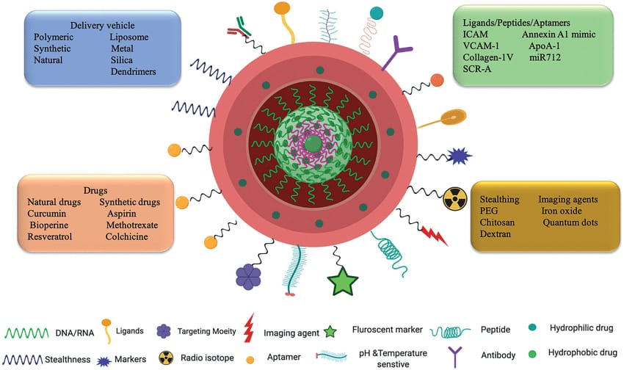

Figure 2: DNA-Functionalized Nanoparticles for Targeted Drug Delivery (Pillai, et. al. 2021).

Nanoparticle-Mediated Gene Delivery Systems
The combination of nanoparticles and recombinant DNA technology has revolutionized gene delivery. Non-viral vectors, such as nanoparticles, offer safer alternatives to viral vectors for introducing therapeutic genes into cells (Figure: 3) (Jayant, et. al. 2016). Researchers can engineer nanoparticles to carry genetic material and protect it from degradation, allowing for efficient gene transfer (Demirer, et. al. 2019). This approach has vast implications for gene therapy, where defective genes can be replaced or corrected within a patient’s cells to treat genetic disorders ( Zhang, B. 2021).

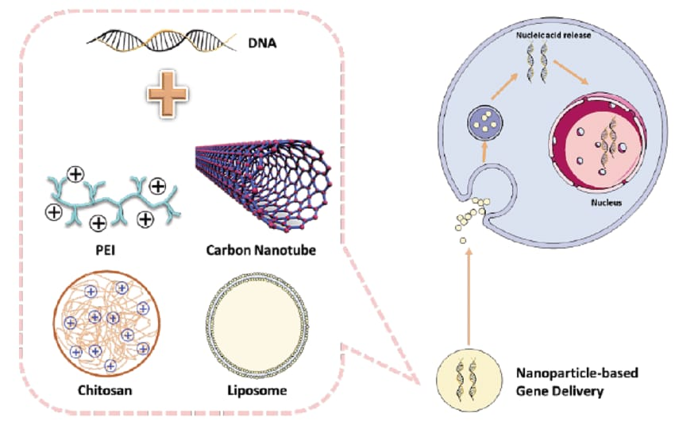
Figure 3: Nanoparticle-Mediated Gene Delivery Systems (Shen, et. al. 2019).

Nanoparticle-Based Biosensors and Diagnostics
The integration of nanoparticles and recombinant DNA technology has led to the development of highly sensitive biosensors and diagnostics (SadAbadi, et. al. 2013).Nanoparticles can be functionalized with DNA probes that selectively bind to specific target sequences, enabling the detection of genetic mutations or pathogens. This approach enhances the accuracy and speed of diagnostic tests, enabling early disease detection and personalized medicine (Awotunde, et. al. 2022).
Nanoparticles for Enhanced Vaccine Delivery
Nanoparticles have shown promise in enhancing vaccine delivery and efficacy (Rodgers, et. al. 2018). By incorporating recombinant DNA technology, nanoparticles can be engineered to display specific antigens or immunostimulatory molecules, mimicking the properties of pathogens. Moreover, nanoparticles can enable controlled and sustained antigen release, reducing the need for frequent vaccinations and enhancing patient compliance.
Bioconjugation Strategies for Functional Nanoparticles
Bioconjugation, the process of linking biological molecules to nanoparticles, has been refined through recombinant DNA technology (Lutz, et.al. 2008). By genetically engineering proteins or peptides that possess specific binding affinities, nanoparticles can be functionalized with high precision (Zhang, et. al. 2018). This bioconjugation enables the creation of multifunctional nanoparticles with capabilities such as targeted drug delivery, imaging, and cell-specific targeting (Veiseh, et. al. 2010).
In conclusion, the intersection of nanoparticles and recombinant DNA technology has given rise to innovative approaches across various domains of biotechnology (Hu, et. al. 2019). These approaches are transforming drug delivery, gene therapy, diagnostics, vaccine development, and the creation of functional nanoparticles (Parveen, et. al. 2017). As research progresses, these innovative strategies hold the potential to address critical challenges in healthcare, agriculture, and other sectors, ultimately improving the quality of human life.
Emerging Applications
The integration of nanoparticles with recombinant DNA technology continues to unveil emerging applications with the potential to reshape various fields (Xiong, et. al. 2018). Here, we explore four burgeoning areas where this synergy is paving the way for transformative innovations.
Nanoparticles in Gene Editing Techniques (CRISPR-Cas9)
Nanoparticles are being explored as delivery vehicles for gene editing tools like CRISPR-Cas9 (Tang, et. al. 2021). By encapsulating the CRISPR components within nanoparticles, researchers aim to enhance the precision and efficiency of gene editing (Figure: 4). This approach offers several advantages, including targeted delivery to specific cell types or tissues, protection of CRISPR components from degradation, and reduced off-target effects (Chen, et. al. 2020).The combination of nanoparticles and CRISPR technology holds immense potential for treating genetic disorders and advancing personalized medicine.
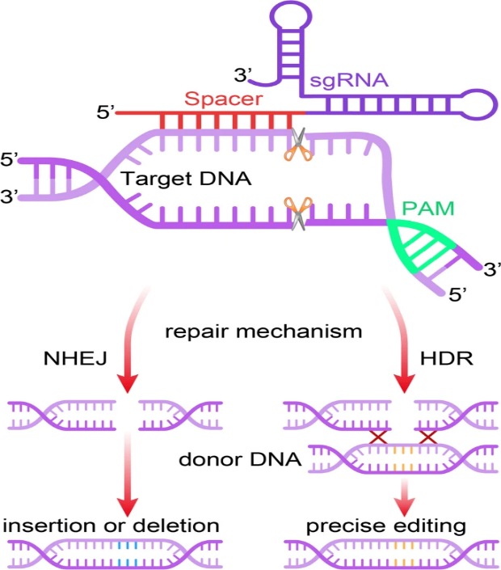
Figure 4: Nanoparticles in Gene Editing Techniques (CRISPR-Cas9) (Zhang, et. al. 2021)
Nanoparticles for Tissue Engineering and Regenerative Medicine
In tissue engineering and regenerative medicine, nanoparticles can play a pivotal role in promoting tissue growth and repair (Subbiah, et. al. 2019). Nanoparticles can be loaded with growth factors, genetic material, or other bioactive molecules to enhance cell proliferation and differentiation (Wang, et. al. 2021). By incorporating recombinant DNA technology, these nanoparticles can be engineered to release specific signals or factors that guide tissue regeneration. This convergence offers innovative solutions for healing injuries, regenerating damaged organs, and creating functional tissue constructs (Matai, et. al. 2020).
Nanoparticles in Agricultural Biotechnology
The integration of nanoparticles and recombinant DNA technology is extending its impact to agricultural biotechnology (Glick, et. al. 2022). Nanoparticles can be designed to deliver nutrients, pesticides, or genetic material to crops in a targeted and controlled manner (Figure: 5). By incorporating recombinant DNA technology, scientists can engineer nanoparticles to carry genes that confer resistance to pests, tolerance to environmental stresses, or improved nutritional content ( Moeller, et. al. 2008). These advancements have the potential to address challenges in sustainable agriculture and food security.
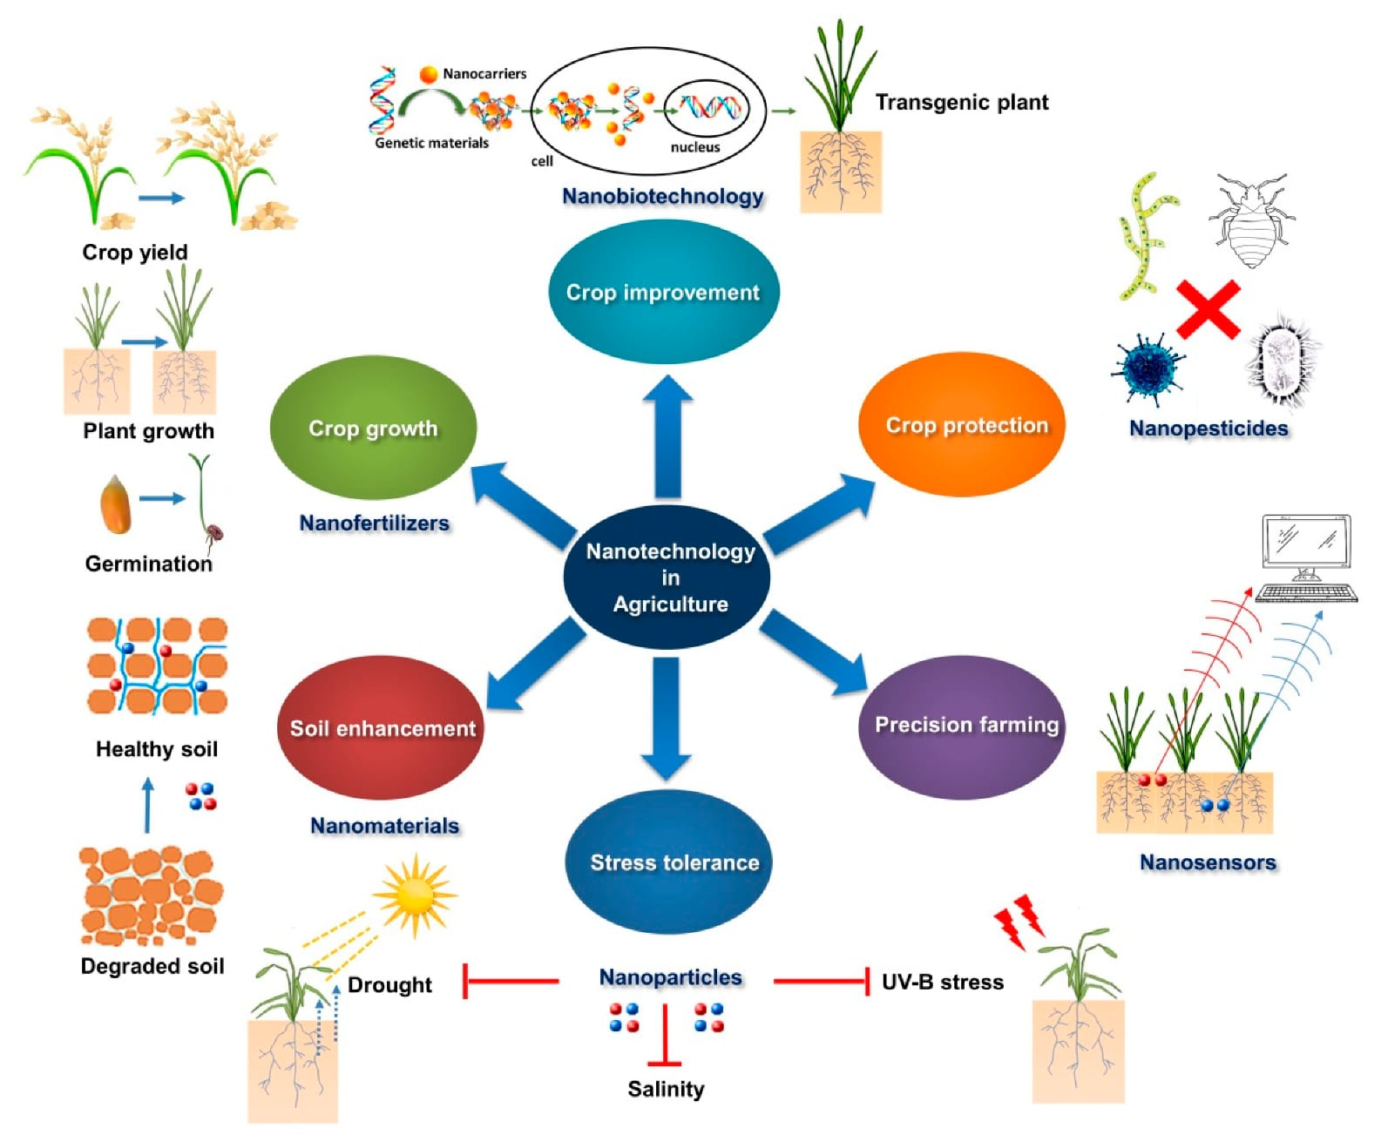
Figure 5: Nanoparticles in Agricultural Biotechnology (Shang, et. al. 2019)
Nanoparticle-Mediated Environmental Remediation
The intersection of nanoparticles and recombinant DNA technology has implications for environmental remediation. Nanoparticles can be functionalized with enzymes or DNA sequences that break down pollutants or degrade contaminants in soil, water, or air (Khin, et. al. 2012). This approach enables efficient and targeted environmental cleanup, addressing issues such as water pollution, soil degradation, and air quality (Figure: 6). By leveraging the capabilities of nanoparticles and recombinant DNA technology, scientists are pioneering eco-friendly solutions for mitigating the impact of human activities on the environment ( Rafeeq, et. al. 2023).

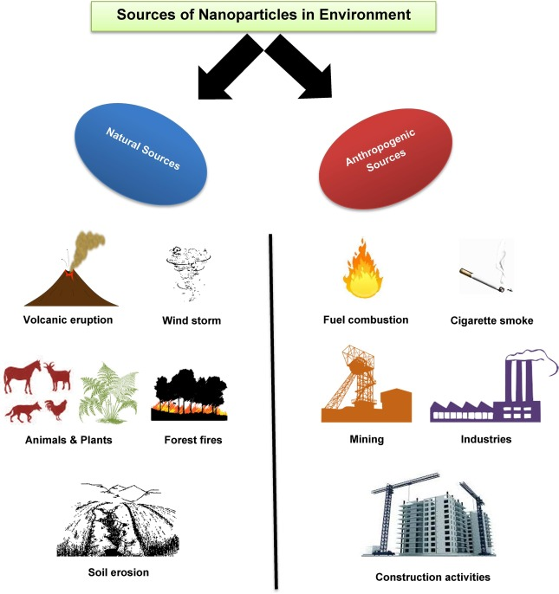
Figure 6: Nanoparticle-Mediated Environmental Remediation (Das, et. al. 2022).
In summary, the emerging applications resulting from the synergy between nanoparticles and recombinant DNA technology hold tremendous potential for diverse fields (Anjum, et. al. 2021). From gene editing to regenerative medicine, agricultural biotechnology, and environmental remediation, this convergence is driving innovations that tackle some of society's most pressing challenges. As researchers continue to explore these frontiers, the combined power of nanoparticles and recombinant DNA technology is likely to catalyze breakthroughs with far-reaching impacts (Ahmar, et. al. 2021).
Challenges and Future Directions
While the integration of nanoparticles and recombinant DNA technology holds great promise, there are several challenges and considerations that must be addressed to fully harness their potential (Wang, et. al. 2022). Here, we examine key challenges and discuss possible future directions for these innovative approaches.
Safety and Toxicity Considerations
One of the foremost challenges is ensuring the safety of nanoparticles used in biotechnological applications (Neme, et. al. 2021). Nanoparticles, due to their unique properties, can interact with biological systems in ways that may have unforeseen consequences. It is crucial to thoroughly investigate the toxicity, immunogenicity, and long-term effects of nanoparticles in vivo. Developing standardized methods for evaluating the safety profile of nanoparticles and establishing guidelines for safe usage are essential steps toward responsible application (Hofmann-Amtenbrink, et. al. 2015).
Regulatory and Ethical Concerns
As nanoparticles integrated with recombinant DNA technology advance toward clinical and commercial use, regulatory agencies face the challenge of developing appropriate guidelines for their approval and monitoring (Ragelle, et. al. 2017). Ethical considerations surrounding gene editing, especially in germline cells, require careful deliberation to balance the potential benefits with the risks and unintended consequences. Balancing innovation with ethical and regulatory frameworks is vital for responsible advancement (Nordberg, et. al. 2018).
Scalability and Production Challenges
Scalability and cost-effectiveness are significant challenges in translating nanoparticle-recombinant DNA technologies from the laboratory to real-world applications (Chattopadhyay, et. al. 2023). Developing efficient methods for producing large quantities of functionalized nanoparticles and ensuring batch-to-batch consistency are essential. Addressing these challenges will facilitate the widespread adoption of these technologies across various sectors (Choi, C. 2009).
Prospects for Personalized Nanomedicine
The convergence of nanoparticles and recombinant DNA technology offers exciting prospects for personalized nanomedicine (Iverson, e. al. 2008).The ability to tailor nanoparticles to individual genetic profiles can enhance treatment efficacy and minimize adverse effects. However, realizing the potential of personalized nanomedicine requires advances in genomic profiling, bioinformatics, and data integration. As these technologies continue to progress, the vision of precise and personalized medical interventions becomes more achievable (Weston, et. al. 2004).
Future Directions:
- Multidisciplinary Collaboration: Collaboration between researchers from diverse fields, including materials science, biotechnology, medicine, and ethics, is crucial to address the multifaceted challenges posed by nanoparticles and recombinant DNA technology( Sandler, and R. 2009).
- Advanced Characterization Techniques: Developing advanced techniques for characterizing nanoparticles at the molecular level can provide insights into their interactions with biological systems, aiding in the design of safer and more effective nanoparticles (Mu, et. al. 2014).
- In Silico Approaches: Computational modeling and simulations can help predict the behavior of nanoparticles and guide their design, facilitating efficient experimentation and reducing trial-and-error efforts (Wang, et. al. 2017).
- Biomimetic Design: Drawing inspiration from natural systems can lead to the development of nanoparticles with enhanced biocompatibility and targeted delivery capabilities (Calzoni, et. al. (2019).
- Long-Term Safety Studies: Conducting rigorous long-term safety studies in animal models and eventually in human subjects is essential to gain a comprehensive understanding of the potential risks associated with nanoparticle-based interventions (Bogart, et. al. 2014).
- Public Engagement and Education: Fostering public awareness and engagement in discussions about the applications, benefits, and potential risks of nanoparticles and recombinant DNA technology is important for shaping responsible development and adoption (Stilgoe, et. al. 2020).
While the integration of nanoparticles and recombinant DNA technology offers transformative potential, addressing safety concerns, navigating regulatory landscapes, and advancing production methods are critical for realizing their benefits (Hull, et. al. 2018). By collaborating across disciplines, investing in research, and upholding ethical considerations, we can chart a course toward a future where these innovative approaches contribute to advancements in biotechnology, medicine, and beyond (Duderstadt, J. J. (2007).
Conclusion
This book chapter, have embarked on a comprehensive exploration of the dynamic intersection between recombinant DNA technology and nanoparticles. By delving into the cutting-edge research and applications within this interdisciplinary realm, we have unveiled the potential for transformative impacts across a multitude of industries and sectors. The convergence of these two fields has unveiled a realm of possibilities that could reshape biotechnology, medicine, agriculture, environmental remediation, and beyond.
Throughout this chapter, we have underscored the significance of addressing the challenges that accompany these promising advancements. From the imperative of safety assessments and toxicity evaluations to the complex terrain of ethical considerations and regulatory frameworks, we have illuminated the importance of responsible progress. By diligently navigating these challenges, we can fully harness the potential of this convergence to drive innovation and benefit society at large.
This chapter conclude the threshold of a new era in biotechnological advancement. The synergy between recombinant DNA technology and nanoparticles not only showcases the possibilities of human ingenuity but also underscores the need for thoughtful reflection and responsible stewardship. By fostering collaboration, embracing multidisciplinary perspectives, and upholding the highest standards of research and ethics, we can unlock the full potential of this convergence and embark on a journey of discovery and innovation that holds promise for the betterment of our world in the years to come.
Reference
- Cooke, P. (2008). Regional innovation systems, clean technology & Jacobian cluster‐platform policies. Regional Science Policy & Practice, 1(1), 23-45.
- Yao, J., Yang, M., & Duan, Y. (2014). Chemistry, biology, and medicine of fluorescent nanomaterials and related systems: new insights into biosensing, bioimaging, genomics, diagnostics, and therapy. Chemical reviews, 114(12), 6130-6178.
- Zhang, C., Wohlhueter, R., & Zhang, H. (2016). Genetically modified foods: A critical review of their promise and problems. Food Science and Human Wellness, 5(3), 116-123.
- Peponi, L., Puglia, D., Torre, L., Valentini, L., & Kenny, J. M. (2014). Processing of nanostructured polymers and advanced polymeric based nanocomposites. Materials Science and Engineering: R: Reports, 85, 1-46.
- Pal, G., Rai, P., & Pandey, A. (2019). Green synthesis of nanoparticles: A greener approach for a cleaner future. In Green synthesis, characterization and applications of nanoparticles (pp. 1-26). Elsevier.
- Lino, C. A., Harper, J. C., Carney, J. P., & Timlin, J. A. (2018). Delivering CRISPR: a review of the challenges and approaches. Drug delivery, 25(1), 1234-1257.
- Bandara, R. A., Chen, Z. R., & Hu, J. (2021). Potential of helper-dependent Adenoviral vectors in CRISPR-cas9-mediated lung gene therapy. Cell & Bioscience, 11, 1-9.
- Glick, B. R., & Patten, C. L. (2022). Molecular biotechnology: principles and applications of recombinant DNA. John Wiley & Sons.
- Ferrari, A. C., Bonaccorso, F., Fal'Ko, V., Novoselov, K. S., Roche, S., Bøggild, P., & Kinaret, J. (2015). Science and technology roadmap for graphene, related two-dimensional crystals, and hybrid systems. Nanoscale, 7(11), 4598-4810.
- Hull, M., & Bowman, D. (Eds.). (2018). Nanotechnology environmental health and safety: risks, regulation, and management. William Andrew.
- Knott, G. J., & Doudna, J. A. (2018). CRISPR-Cas guides the future of genetic engineering. Science, 361(6405), 866-869.
- Xu, W., He, W., Du, Z., Zhu, L., Huang, K., Lu, Y., & Luo, Y. (2021). Functional nucleic acid nanomaterials: development, properties, and applications. Angewandte Chemie International Edition, 60(13), 6890-6918.
- Dodgson, M., & Gann, D. (2018). Innovation: A very short introduction. Oxford University Press.
- Carroll, D., & Charo, R. A. (2015). The societal opportunities and challenges of genome editing. Genome biology, 16, 1-9.
- Sabatier, V., Craig-Kennard, A., & Mangematin, V. (2012). When technological discontinuities and disruptive business models challenge dominant industry logics: Insights from the drugs industry. Technological Forecasting and Social Change, 79(5), 949-962.
- Contera, S., Bernardino de la Serna, J., & Tetley, T. D. (2020). Biotechnology, nanotechnology and medicine. Emerging Topics in Life Sciences, 4(6), 551-554.
- Joudeh, N., & Linke, D. (2022). Nanoparticle classification, physicochemical properties, characterization, and applications: a comprehensive review for biologists. Journal of Nanobiotechnology, 20(1), 262.
- Harish, V., Tewari, D., Gaur, M., Yadav, A. B., Swaroop, S., Bechelany, M., & Barhoum, A. (2022). Review on nanoparticles and nanostructured materials: Bioimaging, biosensing, drug delivery, tissue engineering, antimicrobial, and agro-food applications. Nanomaterials, 12(3), 457.
- Glick, B. R., & Patten, C. L. (2022). Molecular biotechnology: principles and applications of recombinant DNA. John Wiley & Sons.
- Kavhiza, N. J., Zargar, M., Prikhodko, S. I., Pakina, E. N., Murtazova, K. M. S., & Nakhaev, M. R. (2022). Improving crop productivity and ensuring food security through the adoption of genetically modified crops in sub-Saharan Africa. Agronomy, 12(2), 439.
- Singh, N., & Herzer, S. (2018). Downstream processing technologies/capturing and final purification: Opportunities for innovation, change, and improvement. A review of downstream processing developments in protein purification. New bioprocessing strategies: development and manufacturing of recombinant antibodies and proteins, 115-178.
- Das, K. P. (2023). Nanoparticles and convergence of artificial intelligence for targeted drug delivery for cancer therapy: Current progress and challenges. Frontiers in Medical Technology, 4, 1067144.
- Zu, H., & Gao, D. (2021). Non-viral vectors in gene therapy: Recent development, challenges, and prospects. The AAPS journal, 23(4), 78.
- Naldini, L. (2015). Gene therapy returns to centre stage. Nature, 526(7573), 351-360.
- National Academies of Sciences, Engineering, and Medicine. (2020). Safeguarding the bioeconomy. National Academies Press.
- López-Sagaseta, J., Malito, E., Rappuoli, R., & Bottomley, M. J. (2016). Self-assembling protein nanoparticles in the design of vaccines. Computational and structural biotechnology journal, 14, 58-68.
- Nicolson, F., Ali, A., Kircher, M. F., & Pal, S. (2020). DNA nanostructures and DNA‐functionalized nanoparticles for cancer theranostics. Advanced Science, 7(23), 2001669.
- Mitchell, M. J., Billingsley, M. M., Haley, R. M., Wechsler, M. E., Peppas, N. A., & Langer, R. (2021). Engineering precision nanoparticles for drug delivery. Nature reviews drug discovery, 20(2), 101-124.
- Pillai, S. C., Borah, A., Jacob, E. M., & Kumar, D. S. (2021). Nanotechnological approach to delivering nutraceuticals as promising drug candidates for the treatment of atherosclerosis. Drug Delivery, 28(1), 550-568.
- Jayant, R. D., Sosa, D., Kaushik, A., Atluri, V., Vashist, A., Tomitaka, A., & Nair, M. (2016). Current status of non-viral gene therapy for CNS disorders. Expert opinion on drug delivery, 13(10), 1433-1445.
- Demirer, G. S., Zhang, H., Matos, J. L., Goh, N. S., Cunningham, F. J., Sung, Y., ... & Landry, M. P. (2019). High aspect ratio nanomaterials enable delivery of functional genetic material without DNA integration in mature plants. Nature nanotechnology, 14(5), 456-464.
- Zhang, B. (2021). CRISPR/Cas gene therapy. Journal of Cellular Physiology, 236(4), 2459-2481.
- Shen, H., Huang, X., Min, J., Le, S., Wang, Q., Wang, X., & Xiao, J. (2019). Nanoparticle delivery systems for DNA/RNA and their potential applications in nanomedicine. Current topics in medicinal chemistry, 19(27), 2507-2523.
- SadAbadi, H., Badilescu, S., Packirisamy, M., & Wüthrich, R. (2013). Integration of gold nanoparticles in PDMS microfluidics for lab-on-a-chip plasmonic biosensing of growth hormones. Biosensors and Bioelectronics, 44, 77-84.
- Rodgers, A. M., Cordeiro, A. S., Kissenpfennig, A., & Donnelly, R. F. (2018). Microneedle arrays for vaccine delivery: the possibilities, challenges and use of nanoparticles as a combinatorial approach for enhanced vaccine immunogenicity. Expert Opinion on Drug Delivery, 15(9), 851-867.
- Sapsford, K. E., Algar, W. R., Berti, L., Gemmill, K. B., Casey, B. J., Oh, E., ... & Medintz, I. L. (2013). Functionalizing nanoparticles with biological molecules: developing chemistries that facilitate nanotechnology. Chemical reviews, 113(3), 1904-2074.
- Lutz, J. F., & Börner, H. G. (2008). Modern trends in polymer bioconjugates design. Progress in Polymer Science, 33(1), 1-39.
- Zhang, P., Zhang, L., Qin, Z., Hua, S., Guo, Z., Chu, C., & Liu, G. (2018). Genetically engineered liposome‐like nanovesicles as active targeted transport platform. Advanced Materials, 30(7), 1705350.
- Veiseh, O., Gunn, J. W., & Zhang, M. (2010). Design and fabrication of magnetic nanoparticles for targeted drug delivery and imaging. Advanced drug delivery reviews, 62(3), 284-304.
- Hu, Y., & Niemeyer, C. M. (2019). From DNA nanotechnology to material systems engineering. Advanced Materials, 31(26), 1806294.
- Parveen, S., Misra, R., & Sahoo, S. K. (2017). Nanoparticles: a boon to drug delivery, therapeutics, diagnostics and imaging. Nanomedicine in cancer, 47-98.
- Xiong, R., Grant, A. M., Ma, R., Zhang, S., & Tsukruk, V. V. (2018). Naturally-derived biopolymer nanocomposites: Interfacial design, properties and emerging applications. Materials Science and Engineering: R: Reports, 125, 1-41.
- Tang, H., Zhao, X., & Jiang, X. (2021). Synthetic multi-layer nanoparticles for CRISPR-Cas9 genome editing. Advanced Drug Delivery Reviews, 168, 55-78.
- Chen, F., Alphonse, M., & Liu, Q. (2020). Strategies for nonviral nanoparticle‐based delivery of CRISPR/Cas9 therapeutics. Wiley Interdisciplinary Reviews: Nanomedicine and Nanobiotechnology, 12(3), e1609.
- Zhang, H., Qin, C., An, C., Zheng, X., Wen, S., Chen, W., & Wu, Y. (2021). Application of the CRISPR/Cas9-based gene editing technique in basic research, diagnosis, and therapy of cancer. Molecular Cancer, 20, 1-22.
- Subbiah, R., & Guldberg, R. E. (2019). Materials science and design principles of growth factor delivery systems in tissue engineering and regenerative medicine. Advanced healthcare materials, 8(1), 1801000.
- Wang, N., Fuh, J. Y. H., Dheen, S. T., & Senthil Kumar, A. (2021). Functions and applications of metallic and metallic oxide nanoparticles in orthopedic implants and scaffolds. Journal of Biomedical Materials Research Part B: Applied Biomaterials, 109(2), 160-179.
- Matai, I., Kaur, G., Seyedsalehi, A., McClinton, A., & Laurencin, C. T. (2020). Progress in 3D bioprinting technology for tissue/organ regenerative engineering. Biomaterials, 226, 119536.
- Glick, B. R., & Patten, C. L. (2022). Molecular biotechnology: principles and applications of recombinant DNA. John Wiley & Sons.
- Shang, Y., Hasan, M. K., Ahammed, G. J., Li, M., Yin, H., & Zhou, J. (2019). Applications of nanotechnology in plant growth and crop protection: a review. Molecules, 24(14), 2558.
- Moeller, L., & Wang, K. (2008). Engineering with precision: tools for the new generation of transgenic crops. Bioscience, 58(5), 391-401.
- Khin, M. M., Nair, A. S., Babu, V. J., Murugan, R., & Ramakrishna, S. (2012). A review on nanomaterials for environmental remediation. Energy & Environmental Science, 5(8), 8075-8109.
- Rafeeq, H., Afsheen, N., Rafique, S., Arshad, A., Intisar, M., Hussain, A., & Iqbal, H. M. (2023). Genetically engineered microorganisms for environmental remediation. Chemosphere, 310, 136751.
- Das, P. K., Mohanty, C., Purohit, G. K., Mishra, S., & Palo, S. (2022). Nanoparticle assisted environmental remediation: Applications, toxicological implications and recommendations for a sustainable environment. Environmental Nanotechnology, Monitoring & Management, 18, 100679.
- Anjum, S., Ishaque, S., Fatima, H., Farooq, W., Hano, C., Abbasi, B. H., & Anjum, I. (2021). Emerging applications of nanotechnology in healthcare systems: Grand challenges and perspectives. Pharmaceuticals, 14(8), 707.
- Ahmar, S., Mahmood, T., Fiaz, S., Mora-Poblete, F., Shafique, M. S., Chattha, M. S., & Jung, K. H. (2021). Advantage of nanotechnology-based genome editing system and its application in crop improvement. Frontiers in Plant Science, 12, 663849.
- Wang, J., Drelich, A. J., Hopkins, C. M., Mecozzi, S., Li, L., Kwon, G., & Hong, S. (2022). Gold nanoparticles in virus detection: Recent advances and potential considerations for SARS‐CoV‐2 testing development. Wiley Interdisciplinary Reviews: Nanomedicine and sNanobiotechnology, 14(1), e1754.
- Neme, K., Nafady, A., Uddin, S., & Tola, Y. B. (2021). Application of nanotechnology in agriculture, postharvest loss reduction and food processing: Food security implication and challenges. Heliyon, 7(12).
- Hofmann-Amtenbrink, M., Grainger, D. W., & Hofmann, H. (2015). Nanoparticles in medicine: Current challenges facing inorganic nanoparticle toxicity assessments and standardizations. Nanomedicine: Nanotechnology, Biology and Medicine, 11(7), 1689-1694.
- Ragelle, H., Danhier, F., Préat, V., Langer, R., & Anderson, D. G. (2017). Nanoparticle-based drug delivery systems: a commercial and regulatory outlook as the field matures. Expert opinion on drug delivery, 14(7), 851-864.
- Nordberg, A., Minssen, T., Holm, S., Horst, M., Mortensen, K., & Møller, B. L. (2018). Cutting edges and weaving threads in the gene editing (Я) evolution: reconciling scientific progress with legal, ethical, and social concerns. Journal of Law and the Biosciences, 5(1), 35-83.
- Chattopadhyay, A., Jailani, A. A. K., & Mandal, B. (2023). Exigency of Plant-Based Vaccine against COVID-19 Emergence as Pandemic Preparedness. Vaccines, 11(8), 1347.
- Choi, C. (2009). Removing market barriers to green development: principles and action projects to promote widespread adoption of green development practices. Journal of Sustainable Real Estate, 1(1), 107-138.
- Iverson, N., Plourde, N., Chnari, E., Nackman, G. B., & Moghe, P. V. (2008). Convergence of nanotechnology and cardiovascular medicine: progress and emerging prospects. BioDrugs, 22, 1-10.
- Weston, A. D., & Hood, L. (2004). Systems biology, proteomics, and the future of health care: toward predictive, preventative, and personalized medicine. Journal of proteome research, 3(2), 179-196.
- Sandler, R. (2009). Nanotechnology: the social and ethical issues.
- Mu, Q., Jiang, G., Chen, L., Zhou, H., Fourches, D., Tropsha, A., & Yan, B. (2014). Chemical basis of interactions between engineered nanoparticles and biological systems. Chemical reviews, 114(15), 7740-7781.
- Wang, W., Sedykh, A., Sun, H., Zhao, L., Russo, D. P., Zhou, H., & Zhu, H. (2017). Predicting nano–bio interactions by integrating nanoparticle libraries and quantitative nanostructure activity relationship modeling. ACS nano, 11(12), 12641-12649.
- Calzoni, E., Cesaretti, A., Polchi, A., Di Michele, A., Tancini, B., & Emiliani, C. (2019). Biocompatible polymer nanoparticles for drug delivery applications in cancer and neurodegenerative disorder therapies. Journal of functional biomaterials, 10(1), 4.
- Bogart, L. K., Pourroy, G., Murphy, C. J., Puntes, V., Pellegrino, T., Rosenblum, D., & Lévy, R. (2014). Nanoparticles for imaging, sensing, and therapeutic intervention. ACS nano, 8(4), 3107-3122.
- Stilgoe, J., Owen, R., & Macnaghten, P. (2020). Developing a framework for responsible innovation. In The Ethics of Nanotechnology, Geoengineering, and Clean Energy (pp. 347-359). Routledge.
- Hull, M., & Bowman, D. (Eds.). (2018). Nanotechnology environmental health and safety: risks, regulation, and management. William Andrew.
- Duderstadt, J. J. (2007). Engineering for a changing road, a roadmap to the future of engineering practice, research, and education.

