STRATEGIC MANAGEMENT PROJECT
- NAME :DURGA SAWANT
- SUBMITTED BY :DURGA SAWANT
- ROLL NO :BMS02145
- YEAR OF SUBMISSION :2023

CERTIFICATE

This is to certify that Durga Sawant student of SEM 5 “BMS202145” has successfully completed their Strategic Management Project on “Industry Organisational Analysis”under the guidance of “Miss Ashiwini Mhatre Ma’am.

Miss Ashiwini Mhatre

INDEX
- CHAPTER 1: Introduction and Research Methodology

- CHAPTER 2: Objectives

- CHAPTER 3: Review of Literature.

- CHAPTER 4:Industry Profile

- CHAPTER 5:Company Profile

- CHAPTER 6:Product Profile

- CHAPTER 7:Market Competitors

- CHAPTER 8:Data Analysis and Interpretation

- CHAPTER 9:Problems faced by organisation

- CHAPTER 10:Strategies

- CHAPTER 11: Conclusion

- CHAPTER 12: Recommendations.

- CHAPTER 13: Annexure

Title: Industry and Company Analysis of Sula Vineyards: Unveiling the Success of India's Wine Industry Leader

Abstract
This project presents business and marketing analysis of Sura Vineyards, a well-known player in the Indian wine industry. India's wine industry has experienced significant growth in recent years and Sura Vineyards has emerged as a leader in this emerging sector.
The first part of the review focuses on the overall wine industry in India and explores the historical development, current trends and future growth of this industry. Explore key concepts such as government regulations, consumer preferences, and distribution to understand business opportunities and challenges.
Part Two covers detailed company analysis of Sula Vineyards. Explain the company's history, mission, and business goals. Analysis of Sula Vineyards' financial performance, including revenue, profitability and key financial ratios, to assess the health and profitability of the company. Additionally, the project evaluates Sula Vineyards' market positioning, competitive advantage, and the unique selling points that have contributed to its success.
Furthermore, the project examines Sula Vineyards' supply chain management, production process, and quality control practices, emphasizing their commitment to sustainability and environmental responsibility. The company's marketing and branding strategies are also scrutinized to understand how they have captured and retained a significant market share in the Indian wine industry.
Moreover, the project analyzes the management team and corporate governance practices at Sula Vineyards to assess their leadership and decision-making capabilities, which play a crucial role in the company's sustained growth and success.
The findings of this industry and company analysis aim to shed light on the factors that have contributed to Sula Vineyards' ascendancy as a market leader in India's wine industry. By understanding the industry dynamics and the successful strategies adopted by Sula Vineyards, this study provides valuable insights for other players in the wine sector and offers a framework for strategic decision-making in the rapidly evolving Indian wine market.

CHAPTER 1: INTRODUCTION AND RESEARCH METHODOLOGY
SECTOR : Agriculture,Plantations and other Rural Sectors.
The agriculture sector forms the backbone of many nations, providing sustenance and livelihoods to millions. It involves cultivating crops, rearing livestock, and harnessing nature's bounty to produce food, fiber, and raw materials. Agriculture is not only a means of survival but also an essential part of cultural heritage and identity, passed down through generations.In the heart of rural landscapes, the agricultural sector thrives, playing a pivotal role in shaping the socioeconomic fabric of communities. The rural economy covers all aspects of rural life, from agriculture and agribusiness to rural areas, education and healthcare. It loves tradition, embraces simplicity and celebrates unity, creating a strong fabric that enriches the country's diversity.
In this agricultural wonderland, Sula Vineyards is a beacon of transformation. Founded by visionaries with a passion for viticulture, Sula Vineyards has become a leading force in the Indian wine industry. Set in the picturesque countryside, Sura Vineyards has not only replicated the Indian ethos of wine but has also had a positive impact on rural areas.
The amazing story of Sula Vineyards shows the power of commercial agriculture in supporting rural communities. Vineyards are spread across the country, supporting local farmers and creating employment and skills development projects. By integrating modern farming practices with traditional knowledge, Sula Vineyards has breathed new life into rural regions.
Through sustainable agriculture and community engagement, Sula Vineyards has become an embodiment of how the agriculture sector and rural development can work hand in hand. By fostering a harmonious relationship between the land, the people, and the industry, Sula Vineyards has proven that prosperity can blossom in the heart of rural landscapes.
As we embark on this exploration of the agriculture sector and rural development, let us draw inspiration from Sula Vineyards' remarkable journey.

INTRODUCTION
Nestled amidst the picturesque landscape of Nashik, India's wine country, Sula Vineyards stands as a beacon of excellence in the world of winemaking. Since its establishment in 1997, Sula has emerged as a pioneer in the Indian wine industry, producing a stunning array of world-class wines that have garnered international acclaim.
Our story began with the vision of Mr. Rajeev Samant, who saw the untapped potential of Nashik's soil and climate for grape cultivation. Guided by his passion for wine and a commitment to quality, he embarked on a journey to create wines that would not only redefine the Indian viticulture scene but also resonate with wine connoisseurs worldwide.
Nurtured by the gentle tropical breeze and blessed with abundant sunlight, our vineyards span across acres of lush greenery, creating an idyllic setting for grapevines to flourish. We cultivate a diverse range of grape varieties, carefully selected to suit the region's terroir, allowing us to craft wines that reflect the unique characteristics of Nashik's land.
At Sula, winemaking is an art form, meticulously blending tradition and innovation to produce wines that are both elegant and distinctive. Our team of talented winemakers and sommeliers pour their skills and passion into each bottle, so each sip tells a story of craftsmanship and excellence.
Whether you're a wine lover or just starting your journey into the world of winemaking, Sula Vineyards has something for every taste. From crisp and refreshing whites to rich and smooth reds, all our wines capture the essence of the country and the passion of our team. But Sula is more than a winery; It is an experience. As you wander through our vineyards, attend wine tastings and dine on delicious meals in our fine restaurants, you will be immersed in the soundtrack of flavors, aromas and sensitivities that make Sula Vineyards a truly unforgettable experience.
It is India's number one producer of premium wines and one of India's three largest international wine and spirits brands (operated through its subsidiary Sula Selections). We are proud to lead the Indian wine revolution and are committed to creating and delivering a unique product and customer experience with every bottle! Our vineyards are located in Maharashtra and Karnataka. We are the pioneers of wine tourism in India, with luxury vineyards (Place of Sula and Beyond of Sula) and a tasting room in Nashik, just a 3-hour drive from Mumbai. We are a proud partner in sustainable grape growing, winemaking and viticulture and are committed to the growth and development of our village farmers, communities and the environment. Sula also imports and exports international wines and spirits such as Le Grand Noir, Torres, Trapiche, Hardy's, Beluga Vodka and more! We are committed to creating an environment built on the values ​​of competition, innovation, responsibility, integrity and excellence and look forward to leading the Indian wine industry. Trading to higher levels!

- Website: https://sulavineyards.com/
- Industries: Beverage Manufacturing
- Company size : 501-1,000 employees
- Headquarters: Mumbai, Maharashtra
- Type: Privately Held
- Founded: 1999
- Specialties: Wines and Spirits, Wine Tourism, and Hospitality

RAJEEV SAMANT
(Promotor,MD,CEO)

Research Objectives:
1) To complete the market analysis of Sula Vineyards products and their performance in local and international markets. This may involve examining sales data, consumer preferences, and competitor analysis.
2) To understand the preferences, buying behavior, and perception of consumers towards Sula Vineyards' wines. This could include conducting surveys, interviews, or focus groups with wine enthusiasts and consumers.
3)To assess the impact of Sula Vineyards on the local tourism industry, including the number of visitors, revenue generated, and the influence on the overall tourism landscape of the region.
4)To evaluate the quality and characteristics of Sula Vineyards' wines through sensory analysis, comparing them with other wines in the market or against industry standards.
5) To study and assess the sustainable practices adopted by Sula Vineyards in their winemaking process, including environmentally friendly initiatives and social responsibility programs.
6)To measure the brand perception and awareness of Sula Vineyards among consumers and stakeholders, and identify areas for improvement.
7)To analyze the visitor experience at Sula Vineyards, including factors influencing satisfaction, suggestions for improvement, and the overall impact on customer loyalty.
8) To recommend growth strategies for Sula Vineyards, such as entering new markets, introducing new products, or enhancing distribution channels.
9) To evaluate the effectiveness of Sula Vineyards' wine education programs, if any, in creating awareness and promoting wine culture among consumers.
10) To understand how external factors, such as government policies, climate change, or economic conditions, may affect Sula Vineyards' business and operations.

- CHAPTER 2: REVIEW OF LITERATURE

A Competitive Study of Wine Tourism Destination in India:

- MAHARASHTRA EMERGING DESTINATION:
Maharashtra was the first state to establish India's first international standard winery in 1980s. The landmass under cultivation is 7000 acres, with an annual grape cultivation of 15 lakh metric tonnes. In 2008, Maharashtra's market reached a high of 1.5 million cases, including approximately 250,000 imported wines. National wine consumption and production declined from 2008 to 2011. A growth of 20% to 25% is expected over the next five years. Nashik has emerged as the hub of wine tourism activities in the state (Arora, 2013). Special interest tourism is one of the most crucial stages in the evolution of tourism, as it has given the leisure viewpoint a whole new dimension. Wine tourism, a subset of food and beverage tourism, has piqued the interest of travelers seeking unique vacation experiences, including both wine aficionados and novices.Maharashtra is justifiably regarded as India's pioneer in the field of wine tourism and vineyard tourism. Although wine tourism in India is still in its infancy compared to its foreign equivalents, it is emerging as a kind of special interest tourism on anational level. Wine tourism in Maharashtra, like its parent business, the wine industry, is progressively progressing towards a growth stage in the product lifecycle. Wineries in Maharashtra are gradually realizing the benefits of incorporating wine tourism into their main wine business and are now willing to venture into wine tourism. Nashik region in Maharashtra, which is justifiably known as India's "wine bowl," is a natural home for all of the state's wine tourism activities. Despite the reality that Nashik has originated as the state's wine tourism area, with some of the state's most prominent vineyards including Sula, Soma, York, Zampa-Grover, and Charosa, Pune and Sholapur also compete with their own wineries, Four Seasons and Fratelli. Other important districts, such as Ahmednagar and Sangli, have a great chance of it becoming wine tourism destinations.

- Mukund Padmanabhan (2010) in his article talks about What do Indians like to drink,What do we really know?

The problem is not merely that we don’t have anything remotely close to a proper survey on Indian wine drinking habits. Also, the wine produced in India is not diverse enough to throw much light on consumer preferences. Yes, domestic production accounts for a little over 6 lakh cases, something like 75 per cent of the total wine consumed in the country. But despite the increase in the number of varietals, the consumer is pretty starved of choice when drinking wine produced in India. Red wine is mainly Cabernet Sauvignon, Shiraz or a blend of the two. Most whites in the market are either Chenin or Sauvignon Blanc. There is a preference for reds over whites. Sixty five per cent of the wine he imports are reds. Younger people consume a lot of wine. Over 50 per cent are within the 25 to 35 age bracket and possibly another 25 per cent between 35 and 45.In retail sales, there is a marked preference for new world wines — from countries such as Australia, Chile and South Africa. It’s possible that consumers see better value in them.

- Manu Vipin (2011) in his article Raising a toast to Indian wine:
says that Upwardly mobile Indians are taking to wine drinking. Thanks to the availability of quality Indian and international brands and a high disposable income. The wine connoisseurs say Indian wine has come of age. It is a new industry and there is mass production because of the subsidy allotted by the government. There are a lot of wine floating in Maharashtra, Bangalore, Delhi and Kolkata. But it is yet to trickle down to smaller cities. So wine has a great scope in Indian market to grow.

- Mansukhani (2011) in his article Cheers to new Indian wine:
Over the past few years, Indians have been steadily increasing their consumption of wine. So much so that until the recent global economic meltdown, the rate of growth of the country’s wine market made wine exporters from countries such as France, Italy and Australia giddy thinking about the number of cases they could drop at Indian ports. But despite the hype surrounding the wine market, the choice of local wines has been limited to a quartet of French varieties grown largely in Nashik.

- Anumeha Chaturvedi (2017) from economic times writes in her article:
in that Sonal Holland Wine Academy commissioned Drshti Strategic Research Services conducted the first-ever comprehensive survey of the urban Indian wine consumer. According to survey results, Consumers’ understanding of wine is limited; however, awareness and consumption are positively related. Other than colour, there is very little involvement with other wine styles; names of regions and grape varieties remain underdeveloped cues. This points out to the nascence of the wine market in India, and the scope for educating and involving the consumer. Price remains the most important choice cue for consumers. Women represent an increasingly important market segment for the wine industry. Indian women view wine as a classy, empowering, healthy beverage of their family members or the society at. Women are purchasing wine as often as men across all occasions.

- CHAPTER 4: INDUSTRY PROFILE:

- THE INDIAN WINE INDUSTRY: Overview

THE INDIAN WINE INDUSTRY: Overview
Wine refers to an alcoholic beverage made with the fermented juice of grapes. It consists of additional condiments, such as potassium sorbate, water, aromatics, potassium metabisulfite, acids, alcohol, tannins, and sugar, to inhibit enzymatic browning. Wine is rich in antioxidants that are beneficial in treating a common cold, lowering bad cholesterol, regulating blood sugar levels, reducing the risk of cancer, and protecting against cell damage. It is widely consumed directly or used in cooking applications to intensify the flavor and aroma of finished dishes. Commonly available in still, fortified, sparkling, and vermouth forms, small amounts of alcohol may prevent heart disease and diseases such as atherosclerosis, heart disease, heart attack, failure, and stroke.
The Indian wine market is estimated to have a CAGR of 30.92% between 2022 and 2027. The market size is expected to increase from US$ 688.16 million. In 2017, the market size was 68.8 million US dollars.
This India Wine Market detailed report includes market segmentation by brand (domestic and foreign) and product (red wine, fortified wine, white wine and sparkling wine). It also includes an in-depth analysis of factors, trends and challenges.
The wine industry in India is growing thanks to online retailers and specialty stores that offer consumers a wide range of choices and easy online shopping. Powerful online distribution and service providers like WineWell and LiquorKart are driving online sales. This expansion creates opportunities for sellers to market to customers without geographic restrictions, increase efficiency, and offer customized products. The evolving sales landscape can enable sellers to create online strategies and eliminate intermediaries, thus achieving competitive prices and increasing profitability. Factors such as increasing disposable income, changing drinking habits, awareness of alcohol as a sophisticated beverage, growth in the bar industry and tourism have contributed to the growth of this business. The Indian wine industry is expected to continue its upward trend and become a major player in the global market.
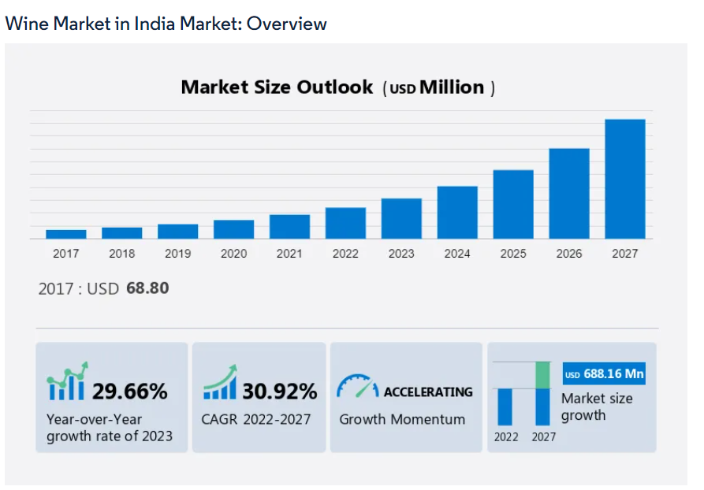

- India Wine Market Trends:
Widespread usage in the food and beverage (F&B) industry across the country creates a positive market outlook. Wine is widely used to decorate products and show off their richness. In addition, the increase in demand for products among young consumers due to the emergence of social networks in restaurants and bars is also positive for the growth of the business. Additionally, the introduction of organic wine, which prohibits the use of chemicals during harvest and preparation, also contributes to the growth of the industry. Growers who use this sustainable approach can enjoy many health and environmental benefits, including higher levels of antioxidants, better heart health, easier liver functioning, and lower carbon monoxide. Meanwhile, the increasing demand for gluten-free alcoholic beverages due to public health awareness and the increasing incidence of celiac disease are also driving the growth of the market. Additionally, the increasing demand for high-end wines made with premium ingredients and the launch of new strong wines are having a positive impact on the growth of the market. Other factors such as increasing spending power of consumers, improving lifestyle and convenience of products on e-commerce platforms are also supporting the growth of the business.

- CHAPTER 5:COMPANY PROFILE: OVERVIEW
Sula Vineyards Limited is a public company incorporated on 26 February 2003. It is classified as a public limited company and is located in Mumbai, Maharashtra. Its registered capital is INR 20.21 Cr and its fully paid-up capital is INR 16.88 Cr.
Sula Vineyards Limited's net income from operations in the financial year ended March 31, 2022 ranged between INR 100 - INR 500. EBITDA VS. There was an increase of 95.40% compared to the previous year. At the same time, book value increased by 26.65%.
Description: The company's field of activity includes the production of wine, brandy and brandy spirits.
Products and services: Wine, Brandy and Brandy Spirits.
Category: Producer
Current status of Sula Vineyards Limited - Active.
According to our records, the last reported General Meeting of Shareholders (Annual General Meeting) of Sula Vineyards Limited was held on 23 June 2023.
Sula Vineyards Limited has seven directors - Alok Sureshchandra Vajpeyi, Rajeev Samant and others.
The Corporate Identification Number (CIN) of Sula Vineyards Limited is L15549MH2003PLC139352. Sula Vineyards Limited has its registered office at 901, Solaris One, NS Phadke Marg Andheri (E) Andheri East t, Mumbai, Maharashtra.
Managers
The company has 7 managers and 2 faculty members. The current longest-serving Chairman is Rajeev Samant on 26 February 2003. Rajeev Samant has been on the Board of Directors for over 20 years. The most recently appointed director is Riyaaz Nasruddin Amlani, who was appointed on 19 April 2023.
Alok Sureshchandra Vajpeyi has the highest shareholding among other directors with a total of 15 companies. The company has connections with 43 companies in total through its managers.

- FINANCIALS:
Operating Revenue : INR 100 cr - 500 cr
EBITDA : 95.40 %
Networth : 26.65 %
Debt/Equity Ratio : 0.52
Return on Equity :11.77 %
Total Assets : 0.91 %
Fixed Assets : 8.01 %
Current Assets : -4.01 %
Current Liabilities : -14.63 %
Trade Receivables : -19.56
Trade Payables :16.48 %
Current Ratio :1.20

- COMPANY NETWORK:
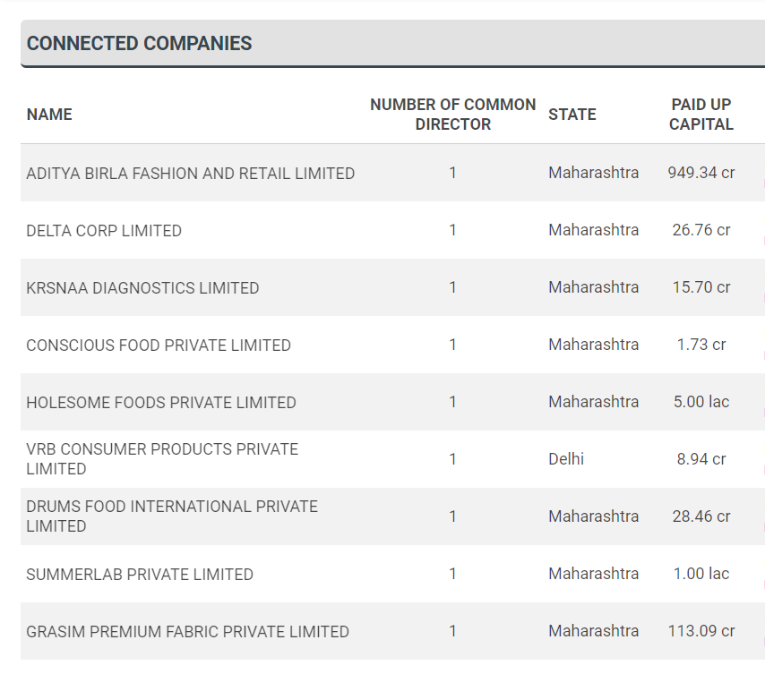

- CONNECTED INDUSTRY NETWORKS:
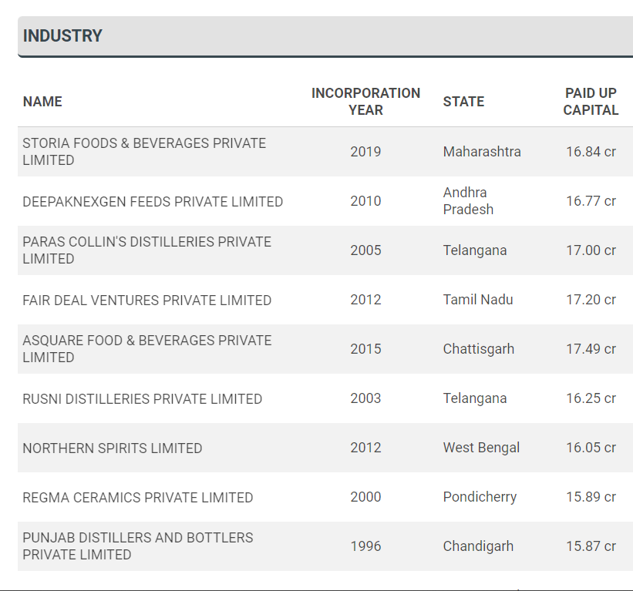
- DIRECTORS
The company has 7 directors and 2 reported key management personnel.

The longest serving director currently on board is Rajeev Samant who was appointed on 26 February, 2003. Rajeev Samant has been on the board for more than 20 years. The most recently appointed director is Riyaaz Nasruddin Amlani, who was appointed on 19 April, 2023.
Alok Sureshchandra Vajpeyi has the largest number of other directorships with a seat at a total of 15 companies. In total, the company is connected to 43 other companies through its directors.

- PRODUCT PROFILE

The product profile of Sula Vineyards typically includes a wide range of wines catering to various tastes and preferences. Some of their popular wine products include:

Sula Dindori Reserve Shiraz: A premium red wine made from the Shiraz grape variety, grown in the Dindori region of Nashik.

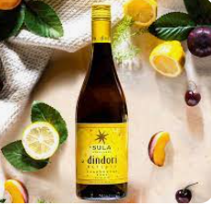

Sula Sauvignon Blanc: A refreshing white wine made from Sauvignon Blanc grapes, known for its tropical and citrusy flavors.
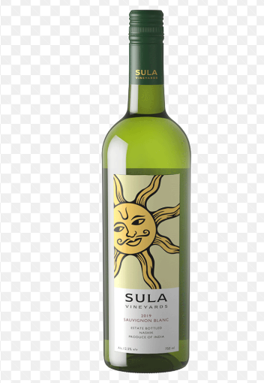

Sula Chenin Blanc: A light and crisp white wine made from the Chenin Blanc grape variety, offering fruity and floral notes.
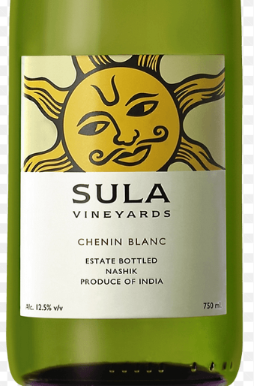

Sula Zinfandel: A fruity red wine made from the Zinfandel grape, often known for its jammy characteristics.
Sula Brut: A sparkling wine, perfect for celebrations and special occasions.

Sula Seco Rosé: A dry rosé wine, ideal for those who prefer a pink-hued, light-bodied wine.
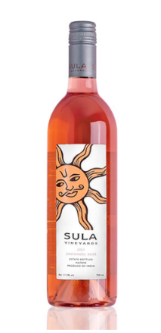
Apart from these, Sula Vineyards may offer other wine varietals and blends as part of their seasonal releases or special collections.

Additionally, Sula Vineyards has expanded its offerings beyond wines and has introduced products like grape seed oil, grape juice, and grape-based alcoholic beverages like Sula's Grape Seed Oil and Sula Grape Vinegar.

- TOP MARKET COMPETITORS:

The top competitors of Sula Vineyards include Grover Zampa, RIO Fizzy Wine, Reveilo, Rhythm Winery and Natures Bounty. Sula Vineyards has 26 active competitors.
Here is a list of the top 10 competitors of Sula Vineyards, ranked by Tracxn score:
Grover Zampa - Mumbai based, 1988 founded, Series C company.
RIO Fizzy Wine - Mumbai based, 2017 founded, Unfunded company.
Reveilo - Mumbai based, 2002 founded, Seed company.
Rhythm Winery - Pune based, 2011 founded, Unfunded company.
Natures Bounty - Delhi based, 2006 founded, Funding Raised company.
Four Seasons - Bengaluru based, 2006 founded, Acquired company.
Beringer - Napa based, 1875 founded, Public company.
Charosa Vineyards - Mumbai based, 2013 founded, Acquired company.
Big Banyan Wines - Bengaluru based, 2007 founded, Unfunded company.
RockClimber - Mumbai based, 2021 founded, Seed company.

- VISION,MISSION STATEMENT & OBJECTIVES OF SULA VINEYARDS:

VISION STATEMENT:
Sula Vineyard's Vision Statement is its strategic plan for the future - Sula Vineyards' future goals and defines goals , Inc. The Sula Vineyards Vision Statement is a document that defines Sula Vineyards' goals to support its strategy, management and overall decision-making process.

MISION STATEMENT:
Sula Vineyard's mission statement is a public document that explains Sula Vineyard's values ​​and strategic goals. Sula Vineyards' mission statement also explains the organization's purpose in life and the services and products it provides. Additionally, the mission statement outlines Sula Vineyards' operational goals, the company's methods of achieving these goals, its target customers, and the areas in which the company operates.
OBJECTIVES:
Organizational objectives for Sula Vineyards are the short to medium term targets and goals that the organization sets to achieve the bigger strategic goals set for the long term. The organizational objectives are important in shaping resource allocation within Sula Vineyards as well as in determining the policies, schedules and processes that are implemented in Sula Vineyards.

- DATA ANALYSIS & INTERPRETATION:
Based on the survey collected through the questionnaire from 32 respondents, following is the Data Analysis and its interpretation:
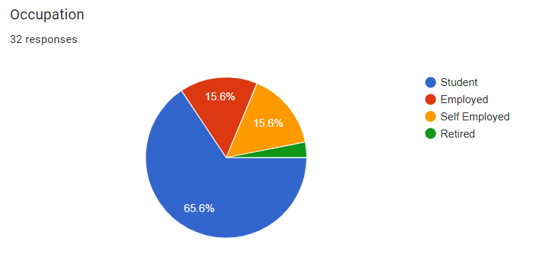

Above is the occupation of the respondents and 65.6% of the respondents belong to the students background, while the others are employed,self employed and Retired.

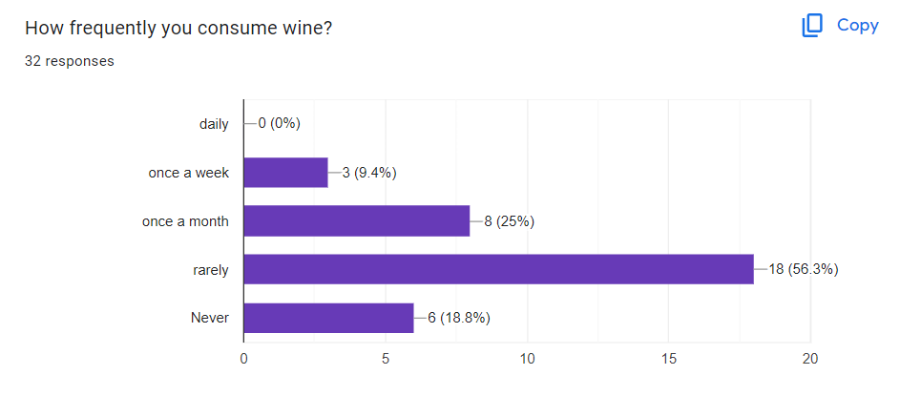
Most of the respondents i.e (56.3%) rarely consume wines.
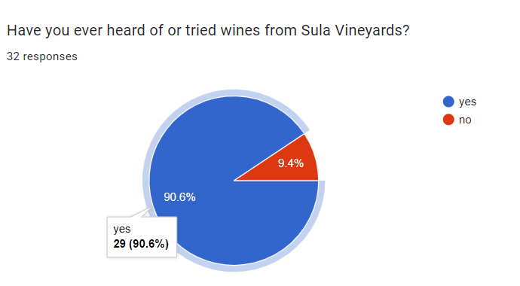

Yes, 90.6% of the respondents had tried the wines of Sula Vineyards.

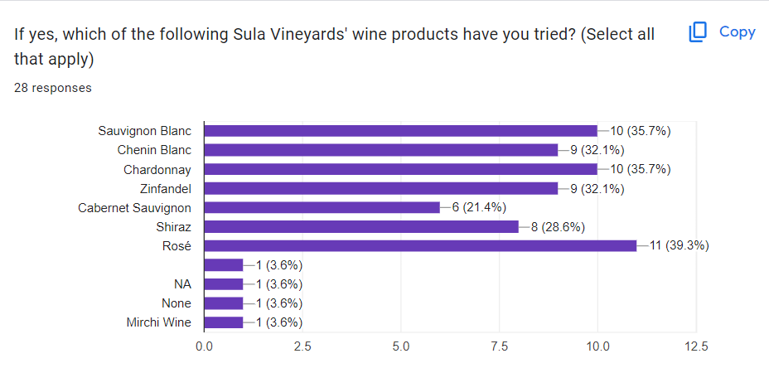

Most of the respondents had tried majority of every wines but the highest wine product % is of 39.3% which is of Rose Wines.

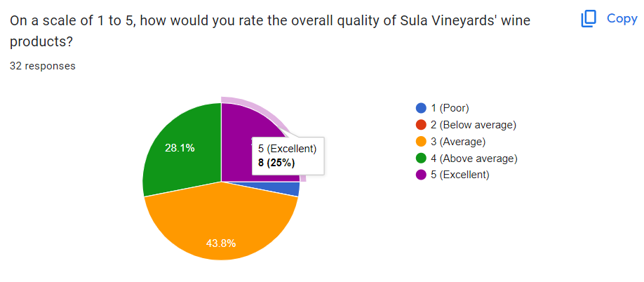

43.8% of the respondents rated the average quality of wine products.

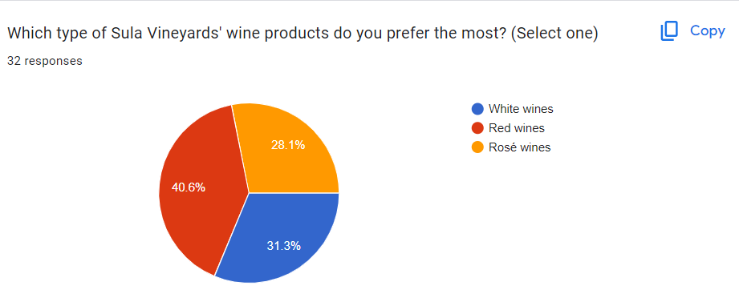

40.6% of the respondents prefer the red wines products.

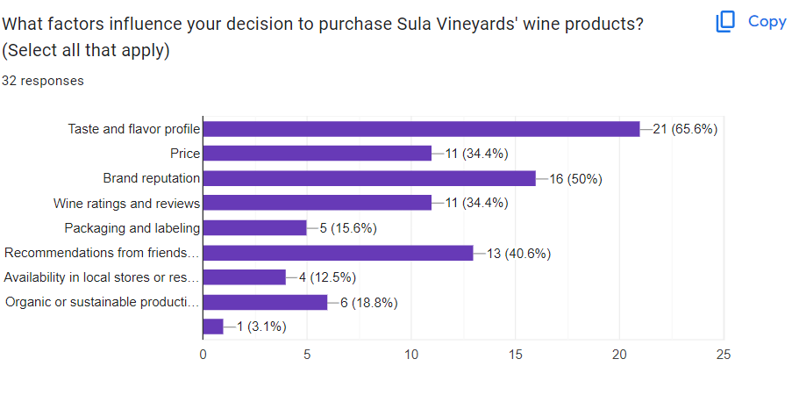
Most of the respondents i.e(65.6%) preferred to the taste and flavour profile of the wine products,while the other respondents also prefer price,brand reputation,and recommendations from the friends/experts.

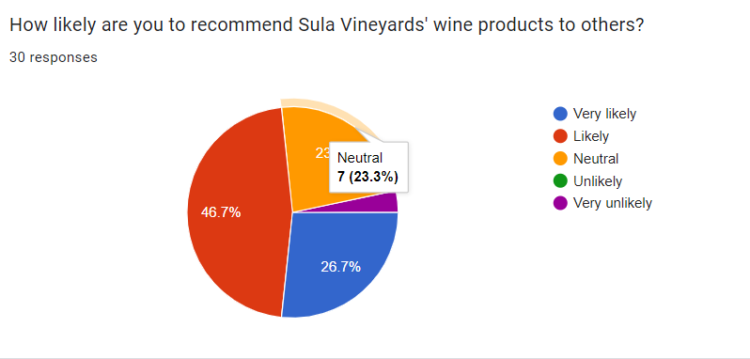

46.7% of the respondents would recommended as wine products to others.
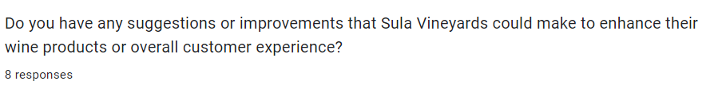

8 respondents said that they are best in their own way, and they don’t need to get improvements among them .

- PROBLEMS FACED BY THE SULA VINEYARDS:

Climate and Weather: Weather conditions can greatly impact grape cultivation and the quality of the harvest. Extreme temperatures, hailstorms, excessive rain, or drought can all have adverse effects on grapevines and the final wine product.

Pests and Diseases: Grapevines are susceptible to various pests and diseases, which can affect the vineyard's health and yield. Controlling pests and diseases requires constant monitoring and preventive measures to avoid significant losses.

Market Competition: The wine industry is highly competitive, with numerous wineries vying for market share. Sula Vineyards faces competition from both domestic and international wine producers, making it essential to continuously innovate and maintain a strong market presence.

Distribution and Retail: Ensuring the distribution of Sula wines to various markets and maintaining good retail relationships can be challenging. Securing shelf space in stores and managing distribution networks effectively is crucial for reaching a broader consumer base.

Quality Control: Maintaining consistent quality across different wine vintages is essential for brand reputation. Sula Vineyards must invest in quality control measures and winemaking techniques to ensure that each bottle meets customer expectations.

Regulatory and Legal Challenges: The wine industry is subject to various regulations and legal requirements concerning labeling, distribution, taxes, and more. Complying with these regulations can be complex and time-consuming.

Environmental Concerns: Sustainable and environmentally responsible practices are becoming increasingly important for wineries. Addressing issues like water usage, waste management, and carbon emissions are vital for long-term sustainability.

Tourism and Hospitality: Sula Vineyards is known for its tourism and hospitality offerings. However, maintaining a high standard of service, managing visitor traffic, and providing unique experiences can be demanding.

Capital Intensive: Establishing and maintaining a vineyard requires significant initial investment, as well as ongoing expenses for maintenance and expansion. Access to capital and managing finances effectively is crucial for the vineyard's growth and success.

Global Economic Factors: Changes in the global economy can impact the wine industry, affecting factors like export/import duties, currency exchange rates, and consumer spending patterns.

- OVER COMING STRATEGIES
Product Diversification: Expanding the range of wines offered by introducing new varietals or blends can attract a wider customer base and cater to different preferences. Additionally, branching out into related products like wine-related accessories or even non-alcoholic grape-based products can increase revenue streams.

Quality Focus: Maintaining and improving the quality of their wines is crucial. Consistently producing high-quality wines will help build a loyal customer base and enhance their brand reputation.

Market Expansion: Sula Vineyards can explore opportunities to expand their presence in both domestic and international markets. Entering new markets can lead to increased sales and brand recognition.

Winery Experience: Enhancing the winery experience for visitors can attract more tourists and wine enthusiasts. This can be achieved through guided tours, wine tastings, on-site restaurants, and events.

Sustainable Practices: Emphasizing sustainable and eco-friendly practices in their winemaking process can appeal to environmentally conscious consumers and create a positive brand image.

Digital Marketing and E-commerce: Leveraging digital marketing channels and establishing a robust e-commerce platform can help reach a broader audience and boost direct sales.
Collaborations and Partnerships: Collaborating with restaurants, hotels, and other hospitality businesses can help expand the distribution network and reach new customers.
Investing in Research and Development: Continuously investing in R&D can lead to innovations in winemaking techniques, grape cultivation, and product development.
Customer Engagement: Fostering strong relationships with customers through loyalty programs, social media engagement, and personalized offers can enhance customer retention.
Adaptation to Market Trends: Staying up-to-date with current market trends and consumer preferences will help Sula Vineyards remain relevant and competitive.
Employee Training and Development: Investing in employee training and development can lead to a skilled and motivated workforce, contributing to the overall success of the company.
• STRATEGIC ANALYSIS OF SULA VINEYARDS COMPANY:
Since most of the models of management at the Sula Vineyards Company propose a linear format in decision making, responding to the issues raised by the customers often take a longer time than is expected by the clients.
Thus, the company should change the linear approach to a more insightful customer support system. In order to be more competitive, the Sula Vineyards Company should introduce more products and offer free samples and discounts to its clients.
Within the wine production industry in the India, the business magnitude of the Sula Vineyards Company is wide and well organized into different stores and has a strong presence in most of the stores and regions across India. The company has an extensive partnership network and very many products that will support its sustainability goals (Birdsall and Johnston, 2010).
The company has stratified its target market into upper and lower economic end segments. The Sula Vineyards’ wine products are further classified into premium and ordinary in order to maximise the returns from customers from different social and economic backgrounds.
Despite the relatively crowded market, Sula Vineyards has designed and integrated reliable and efficient distribution platform to ensure that they remain the most reliable provider of wine products across the regions of Indian and its neighbouring countries.The performance of the Sula Vineyards Company within the expansive wine production industry in India is highly dependent on the buyer-power in terms of their purchases of the wines. For instance, the numerous products and quality assurance strategies have ensured that the business is geared towards maximising its returns.Through competitive pricing, strategic expansion, and planned diversification, the Sula Vineyards Company has managed to establish a strong market niche in India despite the rivalry. Now the company has responded with customer support and similar products. With the market turning in its favor, Sula Vineyards has a huge opportunity for expansion. For example, its innovative approach to solve customer problems cost-effectively and easily through similar integration is a guarantee of rapid expansion into new market niches.
The company divided its target market into high-end and low-end market segments. Sula Vineyards' wines are premium and regularly distributed to ensure quality returns to customers from different cultures and industries.
Despite the crowded market, Sura Vineyards has built and consolidated a reliable and profitable business to ensure it remains a trusted brand mostly in India and neighboring regions. Sura Vineyards' success in the Indian wine market largely depends on the purchasing power of wine buyers. For example, many products and good security strategies that will enable the business to get the best returns.
Through competitive pricing, business expansion and diversification, Sula Vineyards has achieved a strong market presence in India despite competition. Now the company has responded to the customer's support and installation of good products.
Sula Üzüm Bağları A.Ş. There is huge opportunity for expansion as the industry pivots to its advantage. For example, its innovative approach to solving customer value and convenience problems through similar integration is a guarantee of rapid expansion into new market areas
• Conclusion:
Sula Grape Orchard is located in Nashik, India wine lovers and travelers It is the best place for. With its rich history, beautiful scenery and award-winning wines, Sula Vineyards has left its mark on the world of wine production and agritourism. The vineyard's commitment to sustainable practices and responsible winemaking has earned it local and international recognition. Sulla is committed to producing quality wine in its vineyard and collaborating with other winemakers, demonstrating their commitment to supporting the Indian wine industry. Additionally, Sura Vineyards has contributed to the growth of wine tourism in India, enabling international tourists to experience the beauty of the Nashik wine region. They carefully plan tours, wine tastings and a variety of cultural events to create an unforgettable and immersive experience for all guests.
In conclusion, Sura Vineyards is a shining example of success in the Indian wine industry. With its commitment to quality, sustainability and promoting wine culture, Sura has not only elevated the status of Indian wine but also presented a unique atmosphere in the minds of wine lovers and travelers worldwide. Whether you are a wine lover or a lover of beautiful vineyards, visiting Sula Vineyards is an unforgettable and rewarding experience.

• Recommendations:

Thanks to its comprehensive distribution system, Sula Vineyards has the opportunity to expand its business beyond its current operations. In particular, the company has the ability to enter foreign markets such as China, Singapore and even South Korea.
Since wine production can be effectively managed from a single platform, the company should consider expanding its business to all countries in Asia. Central point (Parente, 2006).
When implementing their strategic plans, companies need to change their approach to understanding rather than the current understanding. Companies also need to work with financial aid providers to obtain sufficient funding to support the five-year expansion plan. Companies can also market their products and human resources to ensure efficient production and distribution (Roberts, 2005). Additionally, companies need to implement traditional marketing as Indians know how to use products that can be easily associated with their culture (Cheverton, 2004).
Sula Vineyards Company can organize annual meetings/events and invite plans and existing customers to enhance the company's reputation. When it comes to personal selling, Sula Vineyards may send trained sales personnel to attend meetings and presentations to finance and develop business plans. Wine has always been made in India. However, as the Indian wine/viticulture industry was introduced to wine, it became a part of their culture and society. There are probably only two main generations of drinkers in India today, and they are rich.
The main reason for this is that the new wine culture is only a part of India's diversity since westernization (Parente, 2006). Therefore, rebranding Sura Vineyards' wine products to suit the Indian drinking culture will give the company a high profile in the Indian wine/viticulture industry.
- ANNEXURE:

How frequently you consume wine?
*
Have you ever heard of or tried wines from Sula Vineyards?
*
If yes, which of the following Sula Vineyards' wine products have you tried? (Select all that apply)
Other…
On a scale of 1 to 5, how would you rate the overall quality of Sula Vineyards' wine products?
*
Which type of Sula Vineyards' wine products do you prefer the most? (Select one)
*
What factors influence your decision to purchase Sula Vineyards' wine products? (Select all that apply)
*
Other…
How likely are you to recommend Sula Vineyards' wine products to others?

Do you have any suggestions or improvements that Sula Vineyards could make to enhance their wine products or overall customer experience?
Long-answer text

