Bioreactors - A critical review on construction, considerations and applications

Dr Palukurty Mary Anupama
Head, Asst.Prof.,
Department of Biochemistry
St. Joseph’s College for Women(A)
Visakhapatnam
AP., India

Abstract

Bioreactors play a crucial role in the fermentation industry, enabling the controlled growth of microorganisms, plant cells or animal cells to produce various products like enzymes, antibiotics, biofuels, secondary metabolites, vaccines etc. They provide aseptic condition and also the optimal conditions for growth and metabolic activity of organisms Made from glass, metal or fibre, they help in bioconversions or transformations and even bioremediations. Various types of bioreactors are developed to cater the needs of the industry. Some examples include- Stirred tank bioreactors, membrane bioreactors, fluidized bed bioreactors, photobioreactors etc. Their sizes depend upon the scale of production. Effective bioreactors are the once which automatically regulate the conditions of production or transformation and result in good turnover. Many of them are equipped with specialized devices that allow adequate mass transfer, heat transfer, free flow of media and supporting ports. This chapter discusses various types of bioreactors, their design, modification if any and applications at large.

Key words- Bioreactors, fermenters, Stirred tank bioreactors, Air lift bioreactors, Membrane bioreactors, Packed bed bioreactors, Photobioreactors, Fluidized bed bioreactors, perfusion bioreactors

Author correspondence
Dr P. Mary Anupama
Email- drmaryanupama@gmail.com
Mobile- 9885808345

INTRODUCTION

Bioreactors are devices or systems designed to facilitate the controlled growth, maintenance, and manipulation of biological systems, such as microorganisms, plant cells, or animal cells, in a controlled environment (1-3). They are essential tools in bioprocess engineering for applications ranging from microbial fermentation to cell culture and biopharmaceutical production (4-7). These may be referred to as engineered devices that are designed to provide optimal conditions for growth and metabolic activity of organisms (8). Raw materials provided to the organisms range from inorganic to organic compounds to complex materials. The end products of the conversions range from Baker’s yeast, Single cell protein to primary and secondary metabolites (9). The sizes of bioreactors can vary widely based on the specific application, from laboratory-scale reactors with volumes of a few millilitres to large industrial-scale reactors with volumes of several thousand Liters or more (1,3,6,10, 11). During the design of these bioreactors several aspects of biotechnological processes must be given attention which include- reaction rate, cell growth, process stability, physical conditions to be maintained etc (12). An overview of the following types of bioreactors will be presented in this chapter.

1. Stirred tank bioreactors
2. Air lift bioreactors
3. Packed bed bioreactors
4. Membrane Bioreactors
5. Fluidized bed Bioreactors
6. Photobioreactors
7. Perfusion Bioreactors

1. Stirred Tank Bioreactors:
Stirred tank bioreactors, also known as stirred tank reactors (STRs) or simply bioreactors, are widely used in the fermentation industry for the cultivation of microorganisms. They consist of a cylindrical vessel equipped with an agitator or impeller that stirs the culture medium to ensure uniform mixing of nutrients, gases, and microorganisms (2). Stirred tank bioreactors are versatile and can accommodate various microbial cultures, making them a staple in bioprocessing (13).

Components of Stirred Tank Bioreactors (figure 1):

a. Vessel: The main cylindrical vessel holds the culture medium and microorganisms. It is typically made of stainless steel or other biocompatible materials. The choice of material for bioreactor vessel construction is critical to ensure compatibility with the process, maintain sterility, and provide optimal conditions for cell growth and bioprocessing.
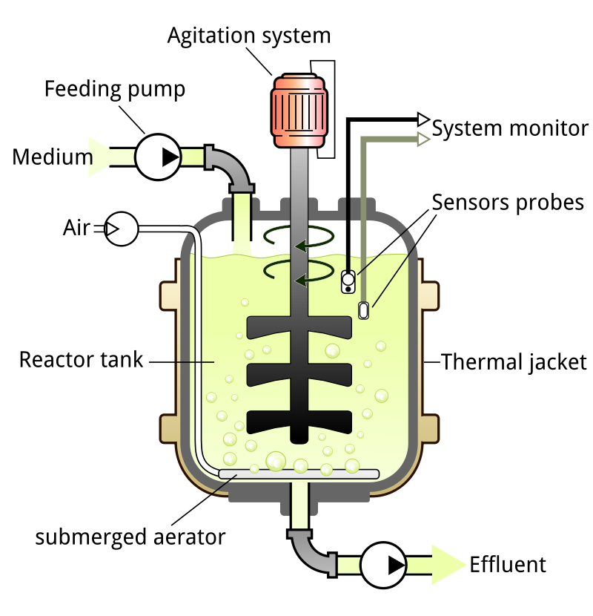
(Source- By GYassineMrabetTalk - Own work, CC BY-SA 3.0, https://commons.wikimedia.org/w/index.php?curid=8301774)

i. Stainless Steel vessels: Stainless steel (typically 316L or 316Ti) is a common material for industrial-scale bioreactor vessels due to its corrosion resistance and durability. It is also suitable for high-temperature and high-pressure applications (14).

ii. Glass: Borosilicate glass is used in laboratory-scale bioreactors due to its transparency, allowing visual monitoring of cultures. These are suitable for applications that require non-reactive, inert surfaces (15).

iii. Plastic and Polymer Materials: Polycarbonate, polyethylene, polypropylene, and other plastics are used for disposable and single-use bioreactor vessels. These materials offer flexibility, easy disposal, and reduced risk of cross-contamination (16).

iv. Single-Use Materials: Biocompatible polymers, such as polyethylene, are used for disposable bioreactor bags and liners. They eliminate the need for cleaning and sterilization between batches (17).

v. Ceramic Materials: Alumina, zirconia, and other ceramics are used in specialized applications requiring high-temperature resistance and corrosion resistance (18).

b. Agitation System: An agitator or impeller is used to mix the culture medium, ensuring uniform distribution of nutrients and gases. Impellers can have various designs, such as Rushton, Smith, or pitched-blade impellers. Impellers are crucial components of bioreactors that provide mixing and aeration for optimal cell growth and bioprocess performance. These are of various types (Figure 2):
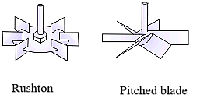
Figure 2- Few Impellers used in Bioreactors

i. Rushton Turbine Impeller: These are the classic impeller designs with radial blades. They provide efficient mixing and aeration and are suitable for various applications, including cell culture and microbial fermentation (19).

ii. Pitched Blade Impeller: The blades are pitched at an angle to improve vertical mixing and gas-liquid dispersion. These are used in applications requiring gentle agitation and aeration (20).

iii. Doughnut Impeller: The impeller is of toroidal shape with an annular gap. It enables gentle mixing with reduced shear stress, suitable for shear-sensitive cultures (21).

iv. High-Efficiency Impeller (HE-3): These are designed to provide enhanced mixing and gas dispersion and are suitable for high-density microbial fermentations (22).

v. Smith Turbine Impeller: They have flat blades with a backward-curved leading edge and are used for high-viscosity and non-Newtonian fluids (22).

c. Aeration System: An aeration system provides oxygen to the microorganisms. It usually involves sparging air or other gases into the culture medium.
The aeration system in bioreactors is essential for providing oxygen to cells and promoting efficient mixing of the culture medium. Sparging is done which involves introducing air or gas into the culture medium to provide oxygen and facilitate mixing. Common sparging methods include porous diffusers, fine-bubble spargers, and ring spargers (23). Aeration systems influence the mass transfer of gases (e.g., oxygen and carbon dioxide) between the gas phase and the liquid phase. Mass transfer coefficients are important for optimizing oxygen delivery to cells (24). Aeration system design must account for scale-up effects, ensuring consistent oxygen delivery across different bioreactor sizes (25).
Few more parameters to be considered in aeration are the rate of aeration and bubble size and distribution. Aeration rate and oxygen concentration should match the oxygen demand and uptake rate of the cells to avoid oxygen limitation (26). The size and distribution of bubbles generated by the aeration system affect mass transfer efficiency and shear stress on cells (27).

d. Cooling and Heating System: Temperature control is crucial for maintaining optimal growth conditions. Cooling/heating jackets or coils are used to regulate the temperature. Cooling and heating systems are crucial components of bioreactors that help maintain optimal temperature conditions for cell growth and bioprocessing.

i) Jacket and Cooling system: A jacket surrounding the bioreactor vessel is filled with a temperature-controlled fluid (e.g., water or glycol) to transfer heat. This is used for maintaining a constant temperature in bioreactor contents (28).

ii) External Heat Exchangers: Heat exchangers connected to the bioreactor circulate temperature-controlled fluids to control the temperature of the bioreactor contents. They are used for precise temperature control and in cases where direct heating/cooling is not suitable (29).

iii) Direct Heating and Cooling Plates: Heating and cooling plates are directly attached to the bioreactor vessel for efficient heat transfer. They provide rapid temperature changes and precise control (30).

iv) Thermal Jackets: Insulated jackets surrounding the bioreactor vessel help to maintain temperature by reducing heat exchange with the environment. They are often used in conjunction with other temperature control methods (31).

v. Cooling Coils and Immersion Heaters: Cooling coils or immersion heaters placed inside the bioreactor vessel directly affect the temperature of the culture medium. This system is used for small-scale systems and specific applications (32).

e. pH and Dissolved Oxygen Probes: Sensors monitor pH and dissolved oxygen levels in the culture medium, allowing for real-time adjustments. pH and dissolved oxygen (DO) are critical parameters to monitor and control in bioreactors to ensure optimal conditions for cell growth and bioprocessing.

i. pH Measurement: pH sensors, such as glass electrodes, are used to measure the acidity or alkalinity of the culture medium. pH control is crucial for maintaining optimal enzyme activity and cell growth (33).

ii. Dissolved Oxygen Measurement: DO sensors, such as polarographic or optical sensors, measure the concentration of oxygen dissolved in the culture medium. Monitoring DO is essential for preventing oxygen limitation and optimizing aerobic processes (34).

iii. Online Monitoring Systems and control strategies: Advanced bioreactor systems incorporate online sensors for continuous pH and DO monitoring, allowing real-time adjustments (35). Feedback control systems adjust pH and DO levels using automated dosing of acid/alkali and oxygen. Proportional-Integral-Derivative (PID) control loops are often used for pH and DO control (36). Regular calibration and maintenance of pH and DO sensors are essential for accurate measurements.

f. Foam Control: Foam can form during fermentation due to the vigorous mixing. Foam control systems prevent excessive foam from escaping the bioreactor. Foam control systems are essential in bioreactors to prevent excessive foam formation, which can lead to cell damage, loss of product, and contamination. Antifoam agents are added to the culture medium to reduce surface tension and suppress foam formation. Common antifoam agents include silicones, polyethylene glycols (PEGs), and fatty acids (37). Foam sensors detect the level of foam in the bioreactor, triggering the addition of antifoam agents. Controllers automate the addition of antifoam based on sensor inputs (38). Feedback control systems adjust the addition of antifoam agents based on real-time foam measurements. Strategies adopted can include on/off control, proportional control, or advanced control algorithms (39). In few Bioreactors mechanical foam breakers or foam knockers are devices that physically break down foam bubbles. They can be integrated into bioreactors to mitigate foam accumulation (40). Foam behaviour can vary with bioreactor scale, necessitating adjustments in foam control strategies.

g. Sampling Ports: Ports allow for the sampling of culture medium without disrupting the fermentation process. Sample ports in bioreactors are openings designed to allow the extraction of samples from the culture for monitoring and analysis. They are essential for assessing parameters such as cell density, metabolite concentrations, and pH during bioprocesses. The purpose of sample ports facilitate the collection of culture samples without the need to open the bioreactor, minimizing the risk of contamination. Samples can be taken for various analyses, including cell viability, growth kinetics, and product concentration (41). They can be designed as septum-sealed ports or quick-connect ports. Proper placement of ports ensures representative sampling and minimal disturbance to the culture (42). They should be designed and positioned to maintain sterility and prevent contamination. Proper sealing and aseptic techniques are crucial (43). Advances in technology allow for online monitoring and sampling without the need for manual sampling ports. The frequency of sampling and the depth of analysis impact the accuracy of process understanding and optimization (44).

h. Inlet and Outlet Ports: Ports for introducing fresh medium and removing spent medium, respectively. Inlet and outlet ports in bioreactors are essential for introducing and removing substances to and from the bioreactor. Inlet ports are used to introduce fresh culture media, nutrients, gases, and other substances into the bioreactor. Proper design and placement ensure even distribution and minimal disturbance to the culture (45). Outlet ports allow the removal of waste products, biomass, and harvested products from the bioreactor. Design considerations of these ports include preventing cell sedimentation and maintaining sterility (46). Some outlet ports are dedicated to sampling for monitoring and analysis purposes. Proper sampling techniques and representative sampling are crucial for accurate process understanding. During scale up, during Inlet and outlet port design one should consider scale-up effects to ensure consistent fluid dynamics and process performance (47). Proper sealing and aseptic techniques are crucial in designing and usage of these ports.

g. Applications of stirred tank bioreactors: Stirred tank bioreactors are extensively used in Pharmaceutical and Biopharmaceutical productions for the production of antibiotics, enzymes, proteins, and other bioactive compounds in the pharmaceutical industry (48,49).They are utilized to cultivate microorganisms for high-yield production of enzymes used in various industrial processes(50,51). These bioreactors are used in the production of various food and beverage industries for the preparation of fermented foods, beverages, and food additives (52,53). Stirred tank bioreactors are employed in the production of biofuels such as ethanol and biodiesel (54,55). These are also utilized in wastewater treatment and bioremediation processes (56, 57).

2. Airlift bioreactors:
Constructing airlift bioreactors involves specific engineering knowledge and considerations. These can be used for the production processing involving free or immobilized, cell or enzymes. Inside the reactor the fluid id divided into two components, the riser and the downcomer by riser tube (58). The components of these bioreactors are discussed below (figure 3).
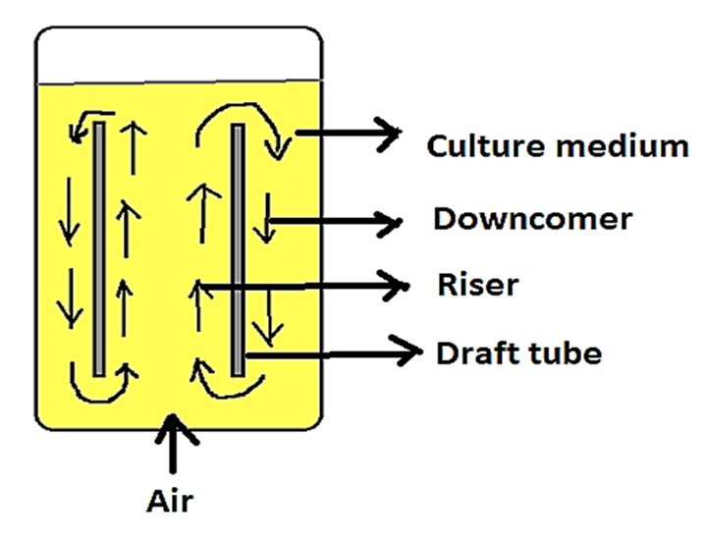

Figure 3: Airlift Bioreactor
Components of Airlift Bioreactors:

a. Riser and Downcomer Functionality: The riser is the vertical column in which gas bubbles rise, creating upward liquid flow. The downcomer is a vertical or inclined pipe that allows the liquid to flow back from the top to the bottom of the reactor, completing the circulation loop (59).

b. Gas-Liquid Mass Transfer and circulation enhancement: The riser is where gas bubbles are introduced into the liquid phase, promoting gas-liquid interaction and mass transfer. The downcomer allows the liquid to flow back, ensuring continuous circulation and contact with the gas phase (60). Their configuration and design influence the circulation pattern, affecting mixing and overall reactor performance (61) and have an impact on overall hydrodynamics and mixing behaviour of the bioreactor. While scaling up the dimensions and design of riser and downcomer has to be considered as they affect the flow pattern and mass transfer.

c. Gas Supply: Compressed air or other gases are introduced into the riser to create gas bubbles that drive the fluid circulation. Gas supply in airlift bioreactors is critical for providing the necessary oxygen for aerobic cultures and promoting mixing. Typically, air or other oxygen-rich gases are supplied to create the circulation of liquid in the bioreactor. Some considerations of air supply include:

i. Air Supply and oxygen enrichment: Compressed air is commonly used as the gas supply in airlift bioreactors. Air bubbles introduced at the bottom of the riser section provide buoyancy, driving the upward flow of liquid (62). For oxygen-demanding cultures, oxygen-enriched gases (e.g., pure oxygen or oxygen-nitrogen mixtures) can be supplied. Oxygen enrichment enhances oxygen transfer rates and biomass productivity (1).

ii. Gas Sparger Design: Proper sparger design is crucial for efficient gas-liquid mass transfer in airlift bioreactors (figure 4). Sparger type and location impact bubble size and distribution (63). The sparger is the component that disperses gas into the culture medium. It is usually located at the bottom of the riser. Sparger design is a critical aspect of airlift bioreactors as it directly affects gas-liquid mass transfer, mixing efficiency, and overall reactor performance. Various sparger types are used in airlift bioreactors, including porous diffusers, frits, and orifices, and each type has different bubble size characteristics and gas distribution patterns (64). The location of the sparger influences the flow patterns and mixing efficiency in the reactor. It also affects the circulation of liquid between the riser and downcomer (66).

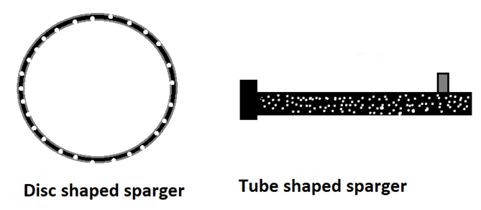
Figure 4: Spargers used in Bioreactors
iii. Gas Flow Rate Control: Gas flow rates need to be controlled to match the oxygen demand of the culture and prevent excessive foaming. Mass flow controllers or rotameters are commonly used for gas flow rate control (65). Gas supply rates would be adjusted carefully during scale-up

iv. Bubble Size and Distribution: Sparger design impacts bubble size distribution, which influences gas-liquid mass transfer. Smaller bubbles generally lead to higher mass transfer rates (67). When large reactor are used they require multiple spargers.

v. Computational Fluid Dynamics (CFD) Modelling: CFD simulations can help optimize sparger design by predicting flow patterns and mass transfer performance in internal lood airlift reactors with low-pressure porous plate spargers (68).

d. Impellers or Baffles: Some airlift bioreactors incorporate impellers or baffles to enhance mixing and circulation. Baffles are commonly used in airlift bioreactors to improve mixing, enhance circulation, and promote better gas-liquid mass transfer. They help break the symmetry of the reactor and create swirling flow patterns, leading to improved mixing and circulation of liquid. Contribute to enhanced circulation contributes to better mass transfer and more uniform conditions (69). They help prevent short-circuiting, where liquid flows directly from the riser to the downcomer without proper mixing which can reduce mass transfer efficiency. Baffles promote better gas-liquid interaction, leading to increased gas-liquid mass transfer rates and enhance oxygen availability for aerobic cultures (70). Their placement, shape, angles, and positions can influence fluid dynamics and hence they are to be optimized during scale up (71).

e. Cooling/Heating System: Temperature control is essential for maintaining optimal growth conditions. Cooling or heating systems may be integrated to regulate the temperature.

f. pH and Dissolved Oxygen Sensors: Sensors are used to monitor pH and dissolved oxygen levels, enabling real-time adjustments.

Applications of Airlift Bioreactors: Airlift bioreactors are a type of bioreactor used for various applications in biotechnology and industrial processes. They offer advantages such as efficient mixing, high mass transfer rates, and relatively simple design.

a. Microalgae Cultivation for Biofuel Production: Airlift bioreactors have been used to cultivate microalgae for biofuel production due to their efficient mixing and aeration capabilities. Microalgae can be grown in these bioreactors to produce lipids that can be converted into biodiesel (72).

b. Wastewater Treatment: Airlift bioreactors are applied in the treatment of various types of wastewaters, including industrial and municipal wastewaters. They provide an environment for the growth of microorganisms that can biodegrade pollutants. This application is often referred to as the Up flow Anaerobic Sludge Blanket (UASB) process (73).

c. Fermentation and Enzyme Production: Airlift bioreactors are employed for microbial fermentation and the production of enzymes and other bioproducts. The efficient mixing and oxygen transfer in these bioreactors can improve yields (74).

d. Anaerobic Digestion for Biogas Production: Airlift bioreactors are utilized in anaerobic digestion processes to produce biogas from organic materials. The anaerobic digestion of biomass in these bioreactors generates methane-rich biogas (75).

3. Packed bed bioreactors: These bioreactors consists of a bed of packing material which is made up of glass, natural materials, glass etc. These are available in various sizes and shaped and allow fluids to flow through. Cell or enzymes are immobilized on to these materials and used for productions or enzymatic conversions. The nutrients or substrate is fed from the bottom of these bioreactors in a controlled way adjusting flow rate and retention time in these reactors. The packed bed compartment can be located either external or within the reservoir of the medium

Components of Packed Bed Bioreactors:
a. Support Matrix: The solid support matrix, often in the form of beads or fibres, provides a substrate for microbial attachment and growth. In packed bed reactors, support matrices are used to provide structural support to the packed bed of solid catalyst or adsorbent particles. These matrices help distribute flow evenly, maintain bed integrity, and enhance mass transfer. The purpose of support matrix is to help prevent particle settling, channelling, and attrition within the packed bed. They ensure uniform flow distribution and enhance overall reactor efficiency (77). Support matrices can be of various materials, such as ceramics, metals, and polymers, depending on the specific process requirements. They are available in various geometries, such as rings, saddles, and spheres (78).
Support matrices influence the hydrodynamics of the packed bed, affecting pressure drop and mass transfer. They can promote mixing and reduce dead zones (79). Support matrices can enhance mass transfer by creating additional surface area for reactants to interact with the catalyst. They can improve reactant distribution within the bed (80).

b. Packed Column: The support matrix is packed into a column or reactor vessel, creating a bed through which the liquid medium flows.

c. Inlet and Outlet Ports: Ports for introducing the medium and removing the effluent after passing through the packed bed.

d. Permeable Membrane (Optional): In some cases, a permeable membrane might be used to contain the support matrix and prevent it from escaping while allowing liquid flow.
Permeable membranes can be used in conjunction with packed bed reactors to facilitate separation and mass transfer processes. Membrane-integrated packed bed reactors offer advantages such as enhanced selectivity, improved product recovery, and efficient utilization of catalysts. Permeable membranes can be incorporated within packed bed reactors to separate components from the reaction mixture as they enable continuous separation and reaction processes (81). Various types of permeable membranes can be employed, including polymeric membranes, ceramic membranes, and composite membranes. The choice of membrane material depends on the process requirements (82). These allow certain components to pass through and also improve separation efficiency in packed bed reactors (83). Scale-up of membrane-integrated packed bed reactors requires careful engineering to maintain performance and efficiency.

e. Few considerations while working with packed bed bioreactors:
i. The choice of support matrix depends on the application and the specific microorganisms being cultured and hence has to be done carefully.
ii. Proper flow distribution and avoidance of channelling (preferential flow paths) within the packed bed are crucial for efficient mass transfer.
iii. Efficient nutrient and oxygen transfer to microorganisms within the packed bed is essential for optimal growth. In packed bed bioreactors, nutrient and oxygen supply is essential for supporting microbial growth and ensuring efficient bioprocesses. Nutrient supply methods used include continuous feeding, intermittent feeding, and substrate gradients (84). As oxygen supply is very crucial for aerobic processed appropriate oxygen supply methods include sparging, mixing, and using oxygen-permeable membranes are used (85, 86). Large scale reactors require modified feeding of nutrients and oxygenation strategies.
iv. Proper control and monitoring of nutrient and oxygen supply are crucial for optimizing bioreactor performance. Online sensors and feedback control systems can help maintain optimal conditions.

f. Scale-Up: Scaling up packed bed bioreactors requires careful consideration of factors such as pressure drop, mass transfer limitations, and heat transfer. Hydrodynamic conditions affect mass transfer, mixing, and pressure drop in packed beds. Maintaining similar flow patterns and residence times is crucial for efficient scale-up (71). As the reactor size increases, pressure drop across the packed bed can increase. Hence proper design and packing materials selection mitigate excessive pressure drop (87).- Mass transfer limitations can change at larger scales due to changes in geometry and flow characteristics hence adjustments in design are to be done to maintain effective mass transfer (88). Temperature control becomes more challenging at larger scales due to heat generation and dissipation. Therefore adequate cooling and heating systems are important for maintaining optimal conditions (89). Larger reactors may require more sophisticated control systems and online monitoring to ensure stable and reproducible operations.

Applications of Packed bed Bioreactors:
Packed bed bioreactors have a range of industrial applications due to their ability to support high-density microbial growth and efficient mass transfer. They are used for the production of enzymes used in various industries, such as food, textiles, and biofuels (90, 91).Packed bed bioreactors are employed in wastewater treatment for the removal of pollutants and organic compounds (92,93) . They are used in the production of biopolymers and bioplastics with applications in various industries, including packaging (94,95). They are used for the conversion of gases (such as methane) by microbial processes (96) and for the production of biogas from organic waste (97).

4. Membrane Bioreactors: These are combinations of membrane processes like microfiltration for the treatment of waste water and in the activated sludge process. These bioreactors are widely used for the treatment of Industrial and municipal waste waters. These are of two configurations- the submerged membrane bioreactor (figure 5) and the side stream membrane bioreactor.

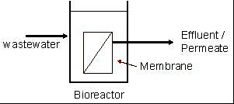
Figure 5: Submerged membrane Bioreactor

Types of Membrane Bioreactors: Membrane bioreactors (MBRs) come in various configurations which are as follows (106-108):
a. Submerged Membrane Bioreactor (SMBR): Membranes are submerged directly in the mixed liquor, with the filtration occurring outside the bioreactor. They are suitable for various wastewater treatment applications.
b. External Membrane Bioreactor (EMBR): The membrane modules are located outside the bioreactor, and the mixed liquor is pumped through the membranes for filtration. These are used for situations where fouling control is critical.
c. Anaerobic Membrane Bioreactor (AnMBR): Combines anaerobic digestion with membrane separation. They are used in wastewater treatment for biogas production and nutrient removal.
d. Hybrid Membrane Bioreactor (HMBR): They combine MBR technology with other treatment processes, such as activated sludge or advanced oxidation. They enable enhanced treatment efficiency and removal of specific contaminants.
e. Anaerobic-Anoxic-Oxic Membrane Bioreactor (A2O-MBR): Integrates anaerobic, anoxic, and aerobic treatment stages with membrane filtration. These are suitable for simultaneous removal of organic matter, nitrogen, and phosphorus.

Components of Membrane Bioreactors:

a. Bioreactor Tank: The main tank holds the mixed liquor, which is the mixture of microorganisms, organic matter, and treated water.

b. Membrane Module: The membrane module consists of permeable membranes that separate the treated water from the mixed liquor. Membrane materials include microfiltration (MF), ultrafiltration (UF), nanofiltration (NF), and reverse osmosis (RO) membranes. Membrane bioreactors (MBRs) combine biological treatment with membrane separation, providing efficient wastewater treatment and solid-liquid separation (figure 6).
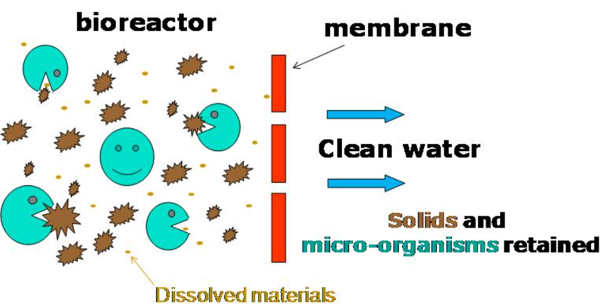
Figure.6 Schematic description of MBR process
(Source- https://en.wikipedia.org/wiki/File:MBR_Schematic.jpg)

Various membrane module configurations are used in MBR systems.
i. Hollow Fiber Membrane Modules: These are commonly used in MBRs due to their high surface area-to-volume ratio. They can be submerged in the bioreactor or placed outside in a side-stream configuration (98).

ii. Flat Sheet Membrane Modules: Flat sheet membranes can be arranged in a plate-and-frame configuration. Plate-and-frame modules provide easy access for maintenance and cleaning (70)

iii. Spiral-Wound Membrane Modules: These are used for high-flow applications and are commonly associated with reverse osmosis membranes. These modules are often used in conjunction with MBRs for advanced treatment (99).

iv. Tubular Membrane Modules: These consists of long tubes where membranes are installed. These modules are less common in MBRs but may be used for specialized applications (100).

v. Hybrid Membrane Modules: Hybrid modules combine different types of membranes or configurations for enhanced performance. These modules are designed to address specific challenges, such as fouling or high solids content (101).

c. Aeration System: Aeration systems in membrane bioreactors (MBRs) play a crucial role in supplying oxygen to support microbial growth and enhance membrane fouling control. Modes of aeration used include diffused aeration, coarse bubble aeration, and microbubble aeration. Microbubble aeration is often preferred for its enhanced oxygen transfer efficiency and reduced membrane fouling (102). Fine bubble aeration systems when used they can create smaller bubbles, which enhance mass transfer and oxygen utilization. And contribute to efficient oxygen transfer (103).

d. Membrane Module Integration: Aeration systems need to be integrated within the membrane modules to ensure uniform oxygen distribution. Bubble size and distribution impact fouling control (98).

e. Membrane Fouling Control: Proper aeration helps control membrane fouling by preventing excessive deposition of solids on the membrane surface. Adequate aeration maintains shear forces that prevent fouling (101).

f. Pump and Filtration System: A pump system draws the mixed liquor through the membrane module, and the filtration system separates the treated water from the biomass.

g. Permeate Collection: The treated water, known as permeate, is collected and removed from the system.

h. Sludge Discharge: Excess biomass, known as sludge, is removed from the bioreactor to prevent excessive accumulation. This is a crucial aspect of membrane bioreactors (MBRs) to maintain proper solids retention time, prevent excessive accumulation of biomass, and ensure efficient operation. Various methods are used for sludge discharge in MBRs, including intermittent or continuous withdrawal, gravity settling, and hydraulic backwashing. Proper sludge discharge prevents sludge buildup and membrane fouling (104). Sludge discharge frequency and duration should be optimized based on reactor size, solids concentration, and process requirements.

Consideration in Membrane Bioreactors (105):

1. Membrane Selection: The choice of membrane material and pore size depends on the desired separation efficiency and the characteristics of the wastewater.

2. Hydraulic Retention Time (HRT): The HRT determines how long the mixed liquor stays in the bioreactor, affecting treatment efficiency.

3. Aeration Rate: Proper aeration is necessary to maintain the biomass concentration and ensure effective treatment.

4. Fouling Control: Membrane fouling, the accumulation of solids on the membrane surface, must be managed to maintain system performance.

Applications of Membrane Bioreactors: MBRs have diverse applications in various fields due to their ability to combine biological treatment with membrane separation. They are widely used for municipal and industrial wastewater treatment, offering enhanced effluent quality and smaller footprint compared to conventional treatment methods (98). MBRs can be used for water reclamation and desalination, producing high-quality water for various non-potable and portable applications (109). They are used in bioconversion processes for the production of bioproducts, enzymes, and biofuels from various feedstocks (110). MBRs are used in the food and beverage industry for wastewater treatment and the recovery of valuable byproducts (111). These reactors are also employed for the removal of pharmaceuticals and personal care products from wastewater, contributing to environmental protection (112).

5. Fluidized Bed Bioreactors: These reactors are like packed bed reactors, packed with bed of smaller size particles. These reactors overcame the disadvantage of packed bed reactor in that, the problem of clogging, high liquid pressure drop, channelling and bed compactions are prevented. They allow use of high concentration of biocatalyst along with no limitations to free cell count (113). Constructing fluidized bed bioreactors involves specific engineering knowledge and considerations (figure 7).

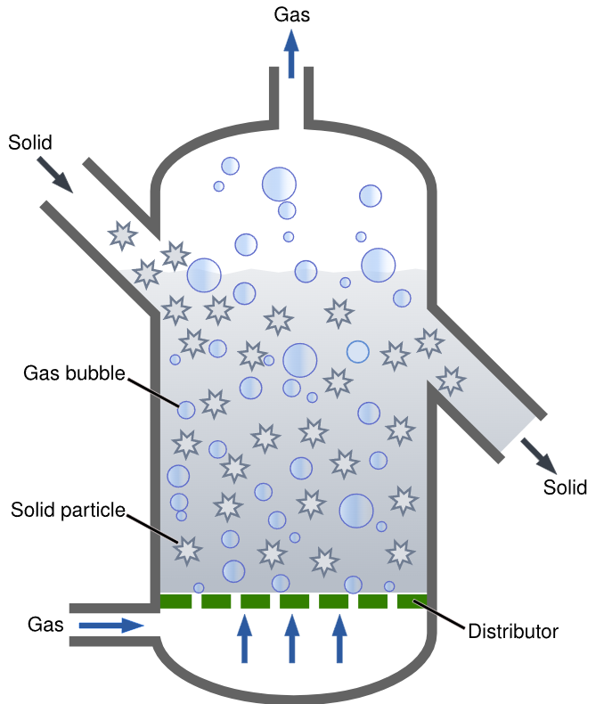

(Source- https://en.wikipedia.org/wiki/File:Fluidized_Bed_Reactor_Graphic.svg)
Figure 7: Fluidized bed Bioreactor

Components of Fluidized Bed Bioreactors (114-116):

a. Reactor Vessel: The main vessel holds the solid particles (support matrix) and the liquid medium containing microorganisms.

b. Gas Distribution System: An arrangement to introduce gases (usually air) from the bottom of the reactor to create fluidization of solid particles.

c. Support Matrix: Solid particles or carrier materials provide a surface for microbial attachment and growth.

d. Aeration System: Aeration provides oxygen and mixing within the reactor, facilitating mass transfer and microbial activity.

e. Pump and Filtration System (Optional): If needed, a system to recirculate the liquid medium through the reactor and filter the effluent.

Most of the aspects were dealt in detail in packed bed reactors

Applications of Fluidized bed bioreactors: Fluidized bed bioreactors find applications in various fields due to their efficient mixing, enhanced mass transfer, and ability to handle a wide range of materials. They are used for the treatment of industrial and municipal wastewater, offering efficient removal of pollutants and nutrients (117,118). They are
employed for the bioremediation of contaminated soils, sediments, and water bodies (119). Fluidized bed bioreactors are utilized for the production of biohydrogen through anaerobic fermentation processes (120). They are employed in biorefinery processes to convert biomass into valuable products like biofuels and biochemicals (121). Fluidized bed bioreactors are used for coating or encapsulating particles, such as pharmaceuticals or agricultural inputs (122).

Variations in Fluidized bed reactors (77, 123-125) :

a. Bubbling Fluidized Bed Reactor: In this configuration, solid particles are fluidized by upward-flowing gas bubbles. Gas and solid particles are in intimate contact, allowing for efficient heat and mass transfer.

b. Circulating Fluidized Bed Reactor: Solid particles are entrained in a fast-moving stream of gas, creating a circulating loop of solids between the riser and downcomer sections. They are often used in processes like combustion and gasification.

c. Spouted Bed Reactor: It features a central gas injection that creates a high-velocity gas jet, causing the solids to circulate in an annular region and is used for mixing, heat transfer, and chemical reactions.

d. Jet-Fluidized Bed Reactor: In this configuration, gas jets are introduced from the bottom, creating localized fluidization zones. It is useful for exothermic reactions and heat-sensitive materials.

e. Internally Circulating Fluidized Bed Reactor: It combines features of bubbling and circulating fluidized bed reactors. It provides better contact between solids and gas, suitable for endothermic reactions.
.
6. Photobioreactors:
Photobioreactors are specialized bioreactors designed for the cultivation of photosynthetic microorganisms, such as microalgae and cyanobacteria, under controlled light conditions. These bioreactors provide optimal light exposure, temperature, and nutrient supply to enhance the growth and productivity of these organisms for various applications including biofuel production, biomass generation, and environmental remediation.

Components of Photobioreactors ( Figure 8 )
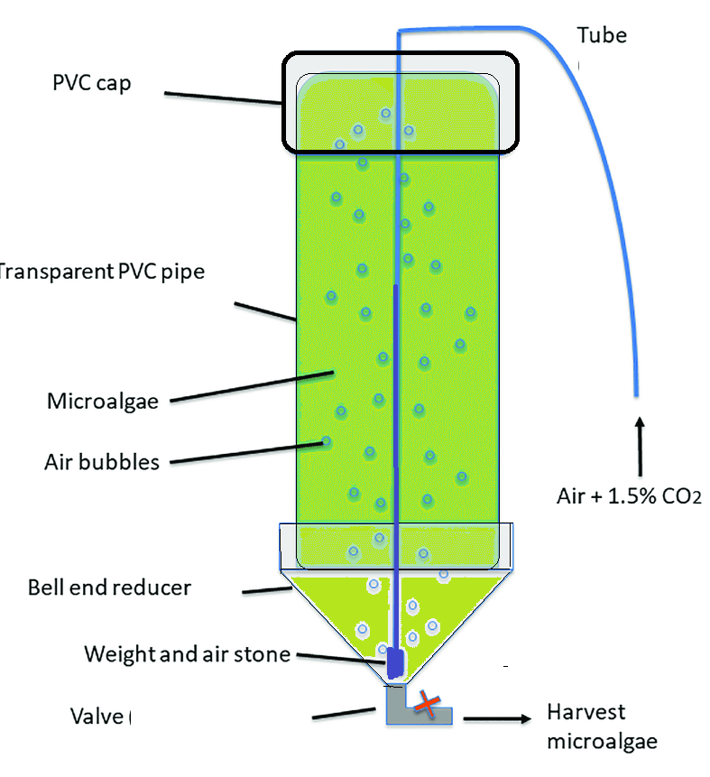
Figure 8- Basic construction of Bioreactor

a. Light Source and Light Distribution System: The light source provides the necessary energy for photosynthesis. In outdoor systems, sunlight is used, while indoor systems may employ artificial light sources such as LEDs. The light distribution system ensures even light exposure throughout the culture to prevent shading effects and promote uniform growth (126).

b. Cultivation Vessel: The cultivation vessel holds the microalgal culture and is usually transparent to allow light penetration. It can come in various shapes, including tubular, flat-panel, or bubble column designs (127).

c. Mixing and Aeration System: Mixing ensures uniform distribution of nutrients and prevents sedimentation of cells. Aeration provides the necessary carbon dioxide and oxygen exchange for photosynthesis and respiration (128).

d. Temperature Control System: Microalgal growth is temperature-sensitive. A temperature control system maintains the desired temperature range for optimal growth and prevents temperature fluctuations (129).

e. Nutrient Supply and Monitoring System: Nutrients like nitrogen and phosphorus are essential for microalgal growth. The nutrient supply system delivers these nutrients in appropriate concentrations, and monitoring systems ensure that nutrient levels remain within optimal ranges.

f. pH Control System: Maintaining a proper pH level is crucial for microalgal growth and biochemical reactions. pH control systems help regulate the pH by adding acids or bases as needed (131).

g. Harvesting System: When the microalgal biomass reaches the desired concentration, a harvesting system is used to separate the cells from the culture medium. Various methods, such as centrifugation, filtration, and flocculation, can be employed.

Types of Photobioreactors:

a. Tubular Photobioreactors: Tubular photobioreactors consist of long transparent tubes where the photosynthetic microorganisms are circulated (figure 9). They can be arranged in a horizontal or vertical configuration. Light is typically provided using natural sunlight or artificial light sources. Tubular photobioreactors are often used for large-scale cultivation due to their scalability (126).
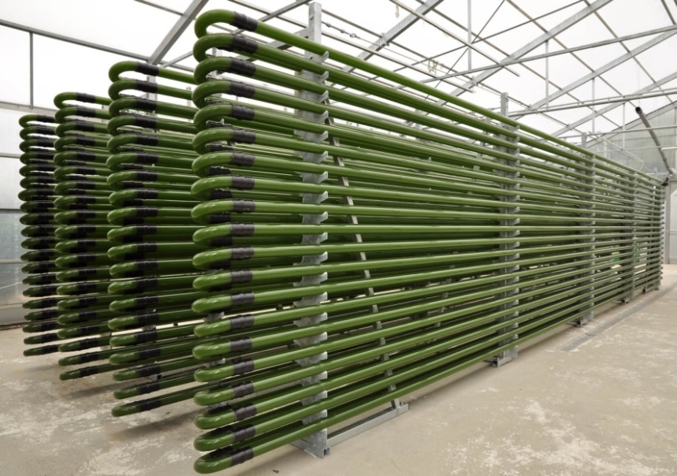
Figure 9: Tubular Photobioreactors
(Source- By IGV Biotech - Own work, CC BY-SA 3.0, https://commons.wikimedia.org/w/index.php?curid=25767679)

b. Flat-Panel Photobioreactors: Flat-panel photobioreactors consist of transparent panels illuminated by sunlight or artificial light (Figure 10). They are suitable for both laboratory and small-scale outdoor cultivation. These bioreactors offer precise control over light intensity and can be stacked to increase cultivation capacity (127).
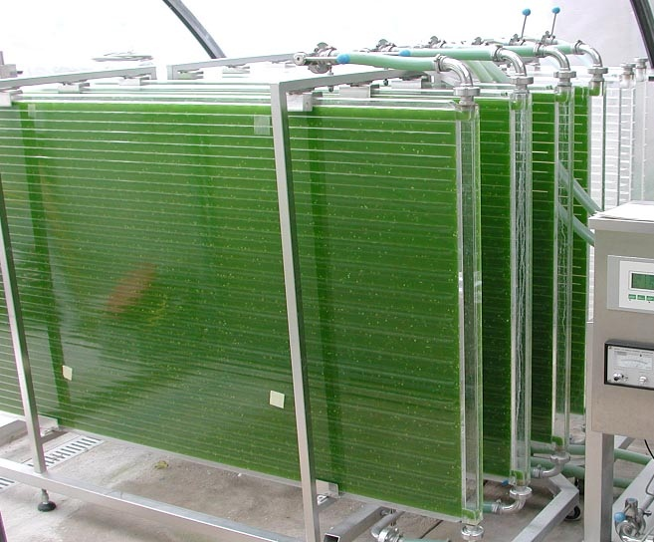
Figure 10- Flat Panel Bioreactor
(Source- By IGV Biotech - Own work, CC BY-SA 3.0, https://commons.wikimedia.org/w/index.php?curid=25767678)

c. Bubble Column Photobioreactors: Bubble column photobioreactors consist of a vertical column in which microalgae are suspended by rising air bubbles. The bubbles provide mixing, aeration, and light exposure. They are suitable for photosynthetic organisms that can tolerate mechanical stress caused by bubbling (128).

d. Bag Photobioreactors: These use plastic bags or transparent containers to hold the microalgal culture. They are easy to set up and suitable for small-scale applications or research purposes. Bag photobioreactors offer a cost-effective way to grow microalgae (132).

e. Panel Photobioreactors: The bioreactors consist of flat panels that are continuously rotated to ensure uniform light exposure on both sides of the panels. This design helps maximize light utilization and biomass productivity (133).

Applications of Photobioreactors: Photobioreactors have a wide range of applications due to their ability to cultivate photosynthetic microorganisms efficiently. They are used to cultivate microalgae and cyanobacteria for the production of biofuels like biodiesel, bioethanol, and biogas (134). Photobioreactors are used to produce microalgae rich in nutrients, antioxidants, and omega-3 fatty acids for nutraceuticals and functional foods (135, 136). They find their application cultivate microorganisms for the production of pharmaceuticals, enzymes, and other bioproducts (126). Photobioreactors can be used to capture carbon dioxide emissions and treat wastewater by utilizing microalgae's ability to remove nutrients (137). Photobioreactors integrated into building frontages can contribute to indoor air quality and reduce carbon dioxide emissions (138).

7. Perfusion Bioreactors: Perfusion bioreactors, also known as continuous-flow bioreactors, are systems in which fresh culture medium is constantly supplied to the bioreactor while spent medium is simultaneously removed. This setup allows for the continuous growth of cells or microorganisms, making them particularly useful for applications that require stable and prolonged cultivation. Important features of these Bioreactors include:

a. Continuous Nutrient Supply: Perfusion bioreactors provide a constant supply of nutrients to the growing cells, maintaining optimal nutrient levels and preventing nutrient depletion. This feature is crucial for the sustained growth of cells over extended periods (139).

b. Provide Stable Environment: By continuously removing waste products and maintaining a consistent environment, perfusion bioreactors offer a more stable culture environment compared to batch systems. This stability can lead to improved cell growth and product yields (140).

c. Higher Cell Densities: The continuous removal of inhibitory metabolites allows cells to be cultured at higher densities without reaching toxic levels. This is particularly valuable for applications that require high cell densities, such as the production of therapeutic proteins (141).

d. Reduced Metabolic Variability: Continuous cultivation minimizes the fluctuations in metabolite concentrations that are commonly observed in batch cultures. This can lead to more consistent and predictable production of metabolites or bioproducts (142).

e. Long-Term Experiments and enhanced productivity: Perfusion bioreactors are suitable for long-term experiments, such as studies involving slow-growing or sensitive cells, as they can be maintained in a controlled environment for extended periods (143).

f. Enhanced Productivity: The continuous nature of perfusion bioreactors enables higher productivity for cells or organisms that require specific growth conditions. This is especially relevant in industries such as pharmaceuticals and biomanufacturing (144).

Components of Perfusion Bioreactors (figure 11):
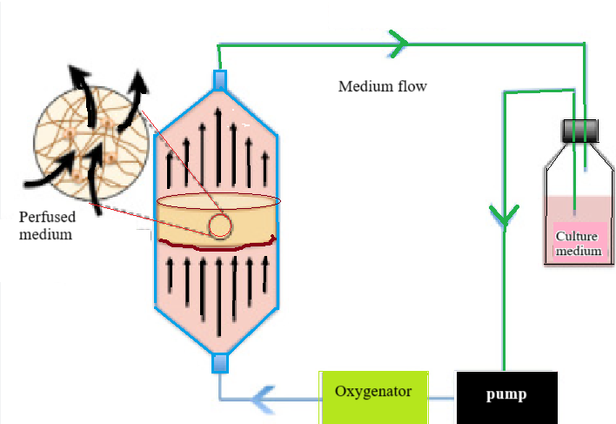
Figure 11: Perfusion system representation

The following are the components of Perfusion Bioreactors (145, 146 ):

a. Culture Chamber: The main vessel where cells or microorganisms are cultured and media is continuously circulated.
b. Media Delivery System: Pumps and tubing are used to deliver fresh media into the culture chamber at a controlled rate.
c. Cell Retention System: Devices such as filters, membranes, or screens retain cells within the culture chamber while allowing media exchange.
d. Waste Removal System: Used media and waste products are removed from the culture chamber and collected for further processing.
e. Sensors and Control System: Sensors monitor key parameters like pH, dissolved oxygen, and cell density, while the control system regulates media flow and other conditions.

Considerations in perfusion systems (147):
a. Cell Retention: Choosing an appropriate cell retention system is essential to prevent cell washout while ensuring efficient media exchange.
b. Media Composition: The composition of the media needs to be carefully controlled to provide optimal nutrients and maintain cell viability.
c. Scaling Up: Scaling up perfusion bioreactors requires considerations for maintaining uniform media distribution and controlling shear forces.

Applications of Perfusion Bioreactors based on their construction: Perfusion bioreactors come in various variations to suit different cell types, applications, and process requirements.
a. Tangential Flow Filtration (TFF) Perfusion Bioreactors: These utilizes a membrane filter to separate cells from the culture medium, allowing continuous media exchange while retaining cells. They are commonly used in the biopharmaceutical industry for monoclonal antibody production (148).

b. Hollow Fiber Perfusion Bioreactors: Cells are cultured within hollow fiber membranes, allowing continuous perfusion of media on one side and waste removal on the other. These are suitable for high-density cell culture and bioproduction (149).
c. Microcarrier-Based Perfusion Bioreactors: Cells are attached to microcarriers, which are continuously circulated in a culture vessel. These are used for scalable production of adherent cells and stem cells (150).

d. Single-Use Perfusion Bioreactors: Utilizes disposable components to minimize the risk of cross-contamination and simplify cleaning. These are gaining popularity in biopharmaceutical manufacturing (151).

e. Dual-Perfusion Bioreactors: They utilizes two separate perfusion loops for medium delivery and waste removal, allowing enhanced control over nutrient supply and waste removal (152).

Applications of Perfusion bioreactors in general: Perfusion bioreactors find applications in various fields due to their ability to provide continuous and controlled cell culture conditions. They are widely used for the production of therapeutic proteins, monoclonal antibodies, and other biopharmaceuticals (35). They are used to expand and differentiate stem cells for regenerative medicine (153) and tissue engineering for transplantation and regenerative medicine (154). Perfusion bioreactors are used for large-scale expansion of cells for cell-based therapies and immunotherapy (155).

Conclusion:
Bioreactors are the vessels which are being used since several years for the production of many important biomolecules of medicinal and industrial importance. The production of high- value products has gained its important with the design of bioreactors that are carefully engineered to suit the need of the cells or enzymes being used, their nutritional requirement, oxygen and pH requirements etc. Today Bioreactors are integrated and automated that enable continuous monitoring of the process of production, conversion or transformation. Their scale varied from few milli liters to gallons and each component of it is carefully fabricated to contribute to better production formation. They are being used for microbial, plant and animal cell in various research labs. One has to choose the appropriate bioreactor that suits the needs of the reaction or the cell for conversion to take place.

REFERENCES

1. Doran, P. M. (2012). Bioprocess Engineering Principles. Academic Press.
2. Blanch, H. W., & Clark, D. S. (1997). Biochemical Engineering. CRC Press.
3. Lee, S. Y., & Papoutsakis, E. T. (1987). Culture of animal cells in mechanically stirred reactors. Biotechnology and Bioengineering, 30(5), 729-746.
4. Chisti, Y. (2001). Recombinant protein production by insect cells in culture. Chemical Engineering Research and Design, 79(6), 639-653.
5. Konstantinov, K. B., & Cooney, C. L. (2015). White Paper on Continuous Bioprocessing. Journal of Pharmaceutical Sciences, 104(3), 813-820.
6. Haug, W., & Katinger, H. (1982). Hollow-fiber bioreactors: A novel approach for continuous hybridoma cultivation. Biotechnology and Bioengineering, 24(5), 1091-1104.
7. Hammond, T. G., Hammond, J. M., & Lee, C. S. (1998). Cultivation of functional liver cells within 3-dimensional cellular structures. In Vitro Cellular & Developmental Biology-Animal, 34(2), 120-126.
8. Development of mathematical model, biotechnology and biomedical engineering, bioreactor modelling & simulation lab, IUPAC, Compendium of Chemical Terminology, Blackwell Scientific Publications, Oxford, UK, 2nd ed.
9. Jagriti Singh, Nirmala Kaushik and Soumitra Biswas (2014). Bioreactors- Technology & Design Analysis. The Scitech Journal, Vol.01 (6), June, 1-10. E journal ISSN No- 2348-2311.
10. Konstantinov, K. B., & Cooney, C. L. (2015). White Paper on Continuous Bioprocessing. Journal of Pharmaceutical Sciences, 104(3), 813-820.
11. Lacki, K. M., Hicks, R. M., & Burcham, G. J. (2001). A survey of bioreactor scale-up and manufacturing. Pharmaceutical Technology, 25(12), 48-60.
12. Chen H-C, Hu Y-C. (2006), Bioreactors for tissue engineering, Biotechnology Letters, vol. 28(18), 1415–1423.
13. Stanbury, P. F., Whitaker, A., & Hall, S. J. (2017). Principles of Fermentation Technology. Butterworth-Heinemann.
14. Hassan, A. M., & Wahid, M. A. (2018). Stainless steel for bioengineering applications: Properties, processing, and performance. In Stainless Steel: Microstructure, Mechanical Properties and Methods of Application (39-59). IntechOpen.
15. Zhang, T., Sun, J., Fu, Q., Wang, Y., & Li, F. (2020). A glass-based microfluidic bioreactor for high-density cell culture and cell-based assay. Journal of Micromechanics and Microengineering, Vol.30(6), 065012.
16. Birnbaum, S., Ellenberg, J., Arimura, S., Beig, J., Gerisch, G., & Oster, G. (1995). Self-organization of actin filament orientation in the dendritic-nucleation/array-treadmilling model. Proceedings of the National Academy of Sciences, 92(18), 8159-8163.
17. Boukouvala, F., Ganetsos, G., & Konstantinidis, S. T. (2013). Disposable bioreactors: Trends and advances. Biotechnology Advances, 31(1), 267-279.
18. Thébault, M., Clouet, E., Drouet, C., & Lefebvre, L. P. (2020). New insights on advanced ceramics for bone surgery from a multimodal characterization at micro and nanoscales. Journal of the European Ceramic Society, 40(5), 1604-1613.
19. Rushton, J. H., Costich, E. W., & Everett, A. (1950). Power characteristics of mixing impellers. Chemical Engineering Progress, 46(8), 395-404.
20. Kim, M. G., Kim, S. D., & Kim, J. Y. (2002). Hydrodynamics of a pitched-blade turbine impeller in a stirred tank reactor. Chemical Engineering Science, 57(17), 3651-3658.
21. Chisti, M. Y., & Moo-Young, M. (1981). Effects of impeller design on fluid circulation and oxygen transfer in a vessel stirred with multiple-impellers. Biotechnology and Bioengineering, 23(11), 2457-2477.
22. Nienow, A. W., Rielly, C. D., & Millat, T. (2005). Axial flow impellers for the fermentation and cell culture industries. Chemical Engineering Research and Design, 83(6), 662-673.
23. Kargi, F., & Shuler, M. L. (1981). Effect of sparger design on bubble column performance. Biotechnology and Bioengineering, 23(1), 95-110.
24. Dhinakarraj, G., & Giri, A. V. (2019). Gas–liquid mass transfer in bioreactors. Bioprocess and Biosystems Engineering, 42(11), 1787-1805.
25. Ahmed, S. U., Ogunnaike, B. A., & Zhang, H. (2019). Modeling and control of bioreactors: scale-up/scale-down considerations. Journal of Process Control, 75, 67-86.
26. Lee, G. M., Jang, Y. S., & Park, J. H. (2001). Kinetics of cell growth and monoclonal antibody production during perfusion culture of hybridoma cells. Enzyme and Microbial Technology, 28(3-4), 290-297.
27. Merchuk, J. C., & Oldshue, J. Y. (1970). Oxygen transfer to animal cell cultures. Science, 170(3965), 447-449.
28. Croughan, M. S., Hamel, J. F., Wang, D. I., & Yelton, D. E. (1986). Strategies for temperature control during the production of monoclonal antibodies with a continuous stirred tank reactor. Biotechnology and Bioengineering, 28(8), 1138-1144.
29. Zeng, A. P., & Deckwer, W. D. (1992). High cell density cultivation of Ralstonia eutropha in a trickle-bed reactor. Biotechnology and Bioengineering, 39(11), 1335-1342
30. Molina, E. F., & Gutiérrez-Antonio, C. (2017). Design and operation of a bench-scale bioreactor for the optimization of fermentative hydrogen production using Clostridium sp. Revista Mexicana de Ingeniería Química, 16(3), 1089-1103.
31. Fidalgo, J. P., Viamonte, A., Teixeira, J. A., & Vicente, A. A. (2013). Impact of different bioreactor systems on yeast extract production by Kluyveromyces marxianus. Biochemical Engineering Journal, 70, 154-161.
32. Han, Y., & Lee, S. Y. (2002). The effect of TCA cycle intermediates as cryoprotectants on cell growth and trehalose production in Escherichia coli. Applied Microbiology and Biotechnology, 58(4), 432-435.
33. Kinsella, J. E., & Hwang, D. H. (1976). Enzyme activity and the regulation of lipid metabolism in animals. Advances in Lipid Research, 14, 1-53.
34. Bruns, T., Engasser, J. M., & Glazyrina, J. (2001). Characterization of oxygen consumption rates of animal cells using a respiration activity monitoring system. Biotechnology and Bioengineering, 75(2), 161-168.
35. Borys, M. C., Linzer, D. I., Papoutsakis, E. T., & Sinskey, A. J. (1990). Culture medium effects on antibody production in the perfusion mammalian cell culture bioreactor. Biotechnology and Bioengineering, 35(6), 595-603.
36. van Gulik, W. M., & Heijnen, J. J. (1995). A metabolic network stoichiometry and kinetics of growth and xanthan gum production by Xanthomonas campestris. Applied Microbiology and Biotechnology, 43(6), 833-850.
37. Koller, K. P., Fasl, H., Ettmayer, P., & Katinger, H. (1992). Application of antifoam agents to animal cell culture. Cytotechnology, 8(1), 89-100.
38. Neubauer, P., Junne, S., Thiele, B., Knorr, A., & Buck, H. (2003). Dispersed bubble size in a stirred tank reactor and its dependence on the impeller type. Chemical Engineering Science, 58(6), 1241-1250.
39. García-Ochoa, F., Gómez, E., & Monroy-Arreola, G. (2010). Comparative study of oxygen mass transfer coefficients in a bubble column using different techniques. Industrial & Engineering Chemistry Research, 49(3), 1321-1330.
40. Lutz, S., Recke, P., Urlacher, V. B., Peyraud, R., Thull, R., Wray, V., ... & Bilitewski, U. (2008). Isolation and identification of a second set of flavobacterial Gluconolactonases belonging to the metallo-β-lactamase/β-lactamase homologous protein family. Journal of Molecular Catalysis B: Enzymatic, 54(1-2), 62-68.
41. Rao, G., & Webb, C. (2002). Analysis and control of bioprocesses. In Biochemical Engineering (pp. 51-87). Marcel Dekker.
42. Li, C. W., Chen, C. H., & Liao, M. H. (2009). On-line estimation of viable cell concentration and viability in perfusion culture based on off-gas analysis. Journal of Biotechnology, 144(4), 304-313.
43. Desmond, R., Cordonnier-Pratt, M. M., & Pratt, L. H. (2001). Aseptic techniques in a modern cell culture facility. Current Protocols in Immunology, Appendix 3A
44. Mazumdar, J., & Shimizu, K. (2011). Analysis of cell death by cell density and cell viability during fed-batch cultures of hybridoma cells. Bioprocess and Biosystems Engineering, 34(4), 389-399.
45. Kensy, F., & Zang, E. (2004). The feeding strategy for high cell density cultivation. In High Cell Density Culture of Recombinant Organisms (pp. 75-95). Springer.
46. Wittmann, C., Heinzle, E., & Westerhoff, H. V. (2013). Metabolic network analysis of Corynebacterium glutamicum. In Corynebacterium glutamicum (pp. 257-285). Springer.
47. Diaz-Ramirez, I. J., Hendrikse, L., & Meyer, J. J. (2016). Scale-up of a wood-degrading fungal culture: Transitioning from shake flasks to stirred tank reactors. Biotechnology Progress, 32(2), 491-500.
48. Nielsen, J., & Villadsen, J. (1994). Bioreaction Engineering Principles. Springer.
49. Bailey, J. E., & Ollis, D. F. (1986). Biochemical Engineering Fundamentals. McGraw-Hill.
50. Pandey, A., Soccol, C. R., & Mitchell, D. (2000). New developments in solid state fermentation: I-bioprocesses and products. Process Biochemistry, 35(10), 1153-1169.
51 Adinarayana, K., Ellaiah, P., & Prasad, D. S. (2003). Response surface optimization of the critical medium components for the production of alkaline protease by a newly isolated Bacillus sp. Journal of Pharmacy and Pharmaceutical Sciences, 6(1), 33-38.
52. Tamang, J. P., & Kailasapathy, K. (2010). Fermented Foods and Beverages of the World. CRC Press.
53. Charles, D. J., & Harrison, K. L. (1992). The volatile flavor constituents of dragon fruit (Hylocereus undatus). Journal of Agricultural and Food Chemistry, 40(6), 1108-1110.
54. Lee, J., & Koo, B. W. (1996). Ethanol fermentation using immobilized yeast cells on lignocellulosic materials. Biotechnology Letters, 18(5), 557-560.
55. Mannan, A. A., Liu, D., Zhang, F., O’Shea, J. P., & Ruan, R. (2008). Biodiesel production from algae. Renewable and Sustainable Energy Reviews, 14(2), 1307-1317.
56. Sayadi, S. (1999). Microbial lipases: Inducement, isolation, and production. Enzyme and Microbial Technology, 24(3-4), 235-251.
57. Murugesan, K., & Kim, Y. M. (2013). Biological treatment of phenolic compounds and cyanide contained in coal gasification wastewater by a consortium of Rhodococcus sp. Water, Air, & Soil Pollution, 224(5), 1-13.
58. Veera, U. P., and Joshi, J. B (1999)., "Measurement of Gas Hold-up Profiles by Gamma Ray Tomography: Effect of Sparger Design and Height of Dispersion in Bubble Columns,"
Chemical Engineering Research & Design, 77 (A4), 303-317.
59. Molina, E. F., & Gutiérrez-Antonio, C. (2017). Design and operation of a bench-scale bioreactor for the optimization of fermentative hydrogen production using Clostridium sp. Revista Mexicana de Ingeniería Química, 16(3), 1089-1103.
60. Ghosh, S. B., & Dey, P. K. (2010). Hydrodynamics and gas holdup in external loop airlift reactors with different downcomer configurations. Chemical Engineering Journal, 163(1-2), 159-166.
61. Vijayaraghavan, G., Nair, R. R., Udupa, N., Prabhu, R. K., & Bhargava, S. (1999). Design and operation of a plate column airlift bioreactor for the production of L-asparaginase. Biochemical Engineering Journal, 3(3), 235-242.
62. Chisti, Y. (1989). Airlift reactors: Characteristics, applications, and design considerations. Chemical Engineering Communications, 79(6), 433-477.
63. Gao, H. J., Ye, M., & Lu, W. B. (2015). Performance characteristics of airlift loop bioreactors: Experiments and simulations. Industrial & Engineering Chemistry Research, 54(1), 262-272.
64. Hosseini, S. M., & Ghaemi, A. (2019) Mass transfer correlation in two-phase airlift reactors using different sparger configurations. Journal of Chemical Engineering of Japan, 52(3), 200-207.
65. Chandel, A. K., & Bhagat, S. (2019). Scale-up studies for microbial fermentation. In Microbial Biotechnology (pp. 215-230). Springer.
66. Fayolle, F., Fournier, Y., & Leuliet, J. C. (1990). Hydrodynamics and mass transfer in a co-current two-phase flow bubble column with an external loop. Chemical Engineering Science, 45(10), 3107-3116.
67. Liu, L., & Wong, K. Y. (2005). Study of fluid dynamics and mass transfer in airlift loop bioreactor. Chemical Engineering Journal, 106(1), 33-40.
68. Tie, D., Huang, H., Lin, Y., & Ye, Z. (2021). Hydrodynamic and mass transfer characteristics in an internal loop airlift reactor with a low pressure porous plate sparger: A CFD study. Chemical Engineering Science, 229, 116153.
69. Chisti, Y. (1989). Airlift reactors: Characteristics, applications, and design considerations. Chemical Engineering Communications, 79(6), 433-477.
70. Tchobanoglous, G., & Burton, F. L. (1991). Wastewater engineering: treatment, disposal, and reuse. McGraw-Hill.
71. Al-Fuad, N. A., & Aroua, M. K. (2005). Hydrodynamics and gas holdup in an external-loop airlift reactor with different configurations of draft tube and baffles. Chemical Engineering and Processing: Process Intensification, 44(5), 517-524.
72. Chen, Y., Zhang, W., & Zhang, L. (2013). Algal biofuels: challenges and opportunities. BioMed Research International, 2013. doi: 10.1155/2013/Article ID 572671.
73. Lettinga, G., van Velsen, A. F. M., Hobma, S. W., de Zeeuw, W., & Klapwijk, A. (1980). Use of the upflow sludge blanket (USB) reactor concept for biological wastewater treatment, especially for anaerobic treatment. Biotechnology and Bioengineering, 22(4), 699-734. doi: 10.1002/bit.260220402.
74. Pandey, A., Soccol, C. R., Nigam, P., & Soccol, V. T. (2000). Biotechnological potential of agro-industrial residues. I: sugarcane bagasse. Bioresource Technology, 74(1), 69-80. doi: 10.1016/S0960-8524(99)00142-X.
75. Chernicharo, C. A. L. (2007). Anaerobic reactors. Biological Wastewater Treatment Series, Volume 4. IWA Publishing.
76. Wang G, Zhang W, Freedman D, Eppstein L, Kadouri A., (1992). Animal cell technology, developments, process and products., In: Spier RE, Griffiths G, MacDonald D, editors. Continuous production of monoclonal antibodies in Celli Gen packed bed reactor using Fibracel carrier, Oxford: Butterworth-Heinemann; 460–4 (b).
77. Kunii, D., & Levenspiel, O. (1991). Fluidization Engineering. Butterworth-Heinemann.
78. Kolaczkowski, S. T., Dronzek, M. A., & Snow, L. A. (1998). Enhanced particle collection in trickle-bed reactors using grooved tube support media. Chemical Engineering Journal, 69(2), 135-145.
79. Balakotaiah, V., & Stewart, W. E. (1993). Flow in porous media: Applications to biological systems. Reviews in Chemical Engineering, 9(2), 107-183
80. Schramm, J., & Barth, J. (1990). Mass transfer and chemical reaction in packed beds containing immobilized enzymes. Biotechnology and Bioengineering, 35(8), 732-740.
81. Sirkar, K. K., & Cohen, Y. (1990). Combined reaction and separation: Integrating membranes into chemical processing. AIChE Journal, 36(5), 672-682.
82. Cussler, E. L. (2009). Diffusion: Mass Transfer in Fluid Systems (3rd ed.). Cambridge University Press.
83. Kang, G. D., & Cao, Y. M. (2010). Membrane separation processes. Chemical and Biochemical Engineering Quarterly, 24(3), 265-279.
84. Zeng, A. P., & Deckwer, W. D. (1994). Impact of substrate gradients on microbial growth in a packed-bed reactor: theory and experimental validation. Biotechnology and Bioengineering, 43(12), 1153-1161.
85. Chisti, Y. (2001). Airlift reactors: Recent developments. Journal of Chemical Technology & Biotechnology, 76(9), 929-932.
86. Li, K., & Zhang, L. (2010). Oxygen supply strategies for the large scale culture of oxygen transfer limited cells. Biochemical Engineering Journal, 52(2-3), 187-193.
87. Shah, Y. T., & Mishra, I. M. (2005). Factors affecting pressure drop in packed columns: A review. Chemical Engineering Research and Design, 83(7), 787-810.
88. Srinivasan, R., & Ramkrishna, D. (1981). Scaling of Fixed-Bed Adsorption Columns: Mass Transfer Effects. AIChE Journal, 27(6), 1003-1012.
89. Fernandez, A., & Chisti, Y. (2010). Scale-up and design of bioreactors: Inocula preservation. Biochemical Engineering Journal, 48(3), 349-354.
90. Manivasagan, P., Sivasankar, P., Venkatesan, J., & Sivakumar, K. (2014). Production, purification and engineering applications of laccase from Pseudomonas sp. Journal of Genetic Engineering and Biotechnology, 12(1), 51-59.
91. Gupta, S. C., Singh, R. P., & Tiwari, A. (2013). Bio-catalysis of non-food feedstocks to fatty acid alkyl esters for biodiesel: an overview. Bioresource Technology, 128, 575-583.
92. Kulkarni, S. J., & Parikh, P. K. (1998). Treatment of distillery wastewater using an upflow anaerobic fixed bed reactor. Bioresource Technology, 66(3), 195-198.
93. Kargi, F., & Dinçer, A. R. (2000). Wastewater treatment using fixed-bed bioreactors. Process Biochemistry, 35(12), 1273-1286.
94. Mohanty, A. K., Misra, M., & Hinrichsen, G. (2000). Biofibres, biodegradable polymers and biocomposites: An overview. Macromolecular Materials and Engineering, 276(1), 1-24.
95. Gajanan, S. R., & Sudhir, K. A. (2018). Polyhydroxyalkanoates (PHAs) and their copolymers: potential for various biomedical applications. Journal of Chemical Technology & Biotechnology, 93(5), 1210-1224.
96. Lykidis, A., Chen, C. L., Tringe, S. G., McHardy, A. C., Copeland, A., Kyrpides, N. C., & Hugenholtz, P. (2011). Multiple syntrophic interactions in a terephthalate-degrading methanogenic consortium. ISME Journal, 5(8), 122-130.
97. Nkemka, V. N., Murto, M., & Björnsson, L. (2013). Anaerobic digestion of source-sorted organic municipal solid waste. Bioresource Technology, 127, 346-352.
98. Judd, S. (2011). The MBR Book: Principles and Applications of Membrane Bioreactors in Water and Wastewater Treatment. Elsevier.
99. Chen, H., & Hu, J. (2011). Membrane fouling in a submerged membrane bioreactor: Differences in relative abundance of bacterial species in a whole-genome sequencing study. Environmental Science & Technology, 45(18), 7971-7978.
100. Drioli, E., & Giorno, L. (2010). Comprehensive Membrane Science and Engineering. Elsevier.
101. Le-Clech, P., Chen, V., & Fane, T. A. G. (2006). Fouling in membrane bioreactors used in wastewater treatment. Journal of Membrane Science, 284(1-2), 17-53.
102. Jiang, J., & Lloyd, D. R. (2012). A novel micro-bubble generator for ultrafine bubble generation using a porous tube. Chemical Engineering Journal, 183, 325-331.
103. Habermacher, J., & Pronk, W. (2005).** Performance of fine-pore diffusers in activated sludge systems. Water Science and Technology, 51(10), 127-134.
104. Hosseini Koupaie, E., Haghighat, F., & Giesy, J. P. (2016). Membrane bioreactor: Membrane fouling and studies on controlling strategies. Bioresource Technology, 216, 696-713.
105. Judd, S. (2008). The MBR Book: Principles and Applications of Membrane Bioreactors for Water and Wastewater Treatment. Elsevier.
106. Di Bella, G., Torregrossa, M., Viviani, G., Raffa, M., & Viviani, D. (2017).** Comparative evaluation of a full-scale submerged and an external membrane bioreactor for municipal wastewater treatment. Water, 9(4), 232.

107. El-Hadj, S. A., Morgenroth, E., & Derlon, N. (2017). The roles of detachment and aeration on the performance of aerobic granular sludge in a membrane bioreactor. Water Research, 124, 259-271.
108. Huang, X., De Wever, H., Tack, P., Van Nieuwenhuijzen, A. F., & Van Der Bruggen, B. (2013).** A review on membrane fouling in anaerobic membrane bioreactors for wastewater treatment. Bioresource Technology, 127, 343-355.
109. Kimura, K., Matsuo, T., Watanabe, Y., Kobayashi, T., & Yamaguchi, T. (2019). Long-term operation of MBRs for advanced wastewater treatment and reuse: A review. Chemical Engineering Journal, 366, 608-625.
110. Kim, Y. M., Murthy, G. S., & Dorgan, J. R. (2015). Continuous production of butanol by Clostridium pasteurianum in a two-stage open-column membrane bioreactor system. Biotechnology Progress, 31(2), 540-550.
111. Abdolali, A., Ngo, H. H., Guo, W., Zhou, J. L., Zhang, J., Liang, S., & Chen, M. (2014). A mini-review on membrane fouling. Bioresource Technology, 185, 383-388.
112. Kang, S., & Sung, W. (2020). Pharmaceuticals and personal care products (PPCPs) removal in a hybrid anaerobic-aerobic membrane bioreactor. Chemosphere, 242, 125166.
113. Gibilaro L.G, 2001. Fluidization - Dynamics: The formulation and applications of a predictive theory for the fluidized state, Butterworth Heinemann eds.
114. Schwuger, M. J., & Tramper, J. (Eds.). (1992). Bioreaction Engineering: Modelling and Control. Springer Science & Business Media.
115. Nigam, P. S. (2019). Bioreactors: Analysis and Design (3rd ed.). Elsevier.
116. ElMekawy, A., Hegab, H. M., & Pant, D. (2016). The role of support matrix on microbial fuel cells and other types of bioelectrochemical systems. Bioresource Technology, 215, 306-318.
117. Zheng, X., Sun, G., & Chen, H. (2015). Nutrient removal from wastewater using fluidized bed bioreactors: A review. Environmental Science and Pollution Research, 22(5), 3399-3415.
118. Gao, X., Zhang, D., Wang, S., & Cheng, S. (2014). Fluidized bed bioreactors for nitrate removal from wastewater: A review. Bioresource Technology, 171, 136-143.
119. Sammoura, F., & Suidan, M. (1999). Microbial degradation of chlorinated organics using fluidized bed bioreactors. Water Research, 33(5), 1111-1122.
120. Kapdan, I. K., & Kargi, F. (2006). Biohydrogen production from waste materials. Enzyme and Microbial Technology, 38(5), 569-582.
121. Wei, W., Wu, S., Xia, A., & Zhao, X. (2017). Biochemical conversion processes of lignocellulosic biomass to fuels and chemicals - A review. Bioresource Technology, 215, 296-303.
122. Heskins, M., & Guillet, J. E. (1968). Solution properties of poly(N-isopropylacrylamide). Journal of Macromolecular Science: Part A - Chemistry, 2(8), 1441-1455.
123. Basu, P. (2013). Combustion and Gasification in Fluidized Beds. CRC Press.
124. Grace, J. R., Matsen, J. M., & Wei, J. (2003). Fluidization. Springer Science & Business Media.
125. Yerushalmi, J., & Lapidot, A. (1990). Spouted beds: a review. Chemical Engineering Science, 45(5), 1241-1254.
126. Richmond, A. (2004). Handbook of microalgal culture: biotechnology and applied phycology. John Wiley & Sons.
127. Ugwu, C. U., Aoyagi, H., & Uchiyama, H. (2008). Photobioreactors for mass cultivation of algae. Bioresource Technology, 99(10), 4021-4028.
128. García-Malea, M. C., Sánchez, S., & Fernández-Sevilla, J. M. (2014). Photobioreactors for the production of microalgae and cyanobacteria. Bioresource Technology, 169, 487-501.
129. Rawat, I., Kumar, R. R., Mutanda, T., & Bux, F. (2013). Biodiesel from microalgae: a critical evaluation from laboratory to large scale production. Applied Energy, 103, 444-467.
130. Converti, A., Casazza, A. A., Ortiz, E. Y., Perego, P., & Del Borghi, M. (2009). Effect of temperature and nitrogen concentration on the growth and lipid content of Nannochloropsis oculata and Chlorella vulgaris for biodiesel production. Chemical Engineering and Processing: Process Intensification, 48(6), 1146-1151.
131. Borowitzka, M. A. (1999). Commercial production of microalgae: ponds, tanks, tubes and fermenters. Journal of Biotechnology, 70(1-3), 313-321.
132. Markou, G., & Nerantzis, E. (2013). Microalgae for high-value compounds and biofuels production: a review with focus on cultivation under stress conditions. Biotechnology Advances, 31(8), 1532-1542.
133. Chen, C. Y., & Durbin, E. G. (1994). Effects of mixing on cell growth and oil production in a high cell density Chlorella vulgaris culture using an external-loop airlift-type photobioreactor. Biotechnology and Bioengineering, 44(8), 952-960.
134. Chisti, Y. (2007). Biodiesel from microalgae. Biotechnology Advances, 25(3), 294-306.
- Hu, Q., Sommerfeld, M., Jarvis, E., Ghirardi, M., Posewitz, M., Seibert, M., & Darzins, A. (2008). Microalgal triacylglycerols as feedstocks for biofuel production: perspectives and advances. The Plant Journal, 54(4), 621-639.
135. Becker, E. W. (2004). Micro-algae as a source of protein. Biotechnology Advances, 25(2), 207-210.
136. Spolaore, P., Joannis-Cassan, C., Duran, E., & Isambert, A. (2006). Commercial applications of microalgae. Journal of Bioscience and Bioengineering, 101(2), 87-96.
137. De Mooij, T., De Vrieze, J., Wery, N., Janssen, M., Ibanez, A. B., & Muylaert, K. (2016). Carbon dioxide removal from air by cultivation of microalgae in a membrane‐‐aerated photobioreactor. Journal of Chemical Technology & Biotechnology, 91(7), 1999-2009.
138. Sælen, H., Alme, M., & Solli, C. (2016). Algae biofacades for buildings—Pilot study of biofacade prototype cultivation, productivity, and biomass energy calculations. Journal of Applied Phycology, 28(1), 599-613.
139. Flickinger, M. C., & Drew, S. W. (1999). Encyclopedia of Bioprocess Technology: Fermentation, Biocatalysis, and Bioseparation. John Wiley & Sons.
140. Chisti, Y. (2001). Hydrodynamic damage to animal cells. Critical Reviews in Biotechnology, 21(2), 67-110
141. Butler, M. (2005). Animal cell cultures: recent achievements and perspectives in the production of biopharmaceuticals. Applied Microbiology and Biotechnology, 68(3), 283-291.
142. Walsh, G. (2018). Biopharmaceuticals: Approval Trends in 2017. BioProcess International, 16(1), 10-17.
143. Farmer, M. A., & Sundberg, D. K. (2000). Bioreactor design for tissue engineering. Annals of the New York Academy of Sciences, 875(1), 399-414.
144. Goudar, C. T., & Marx, K. A. (1998). A distributed parameter model for the evaluation of continuous perfusion in bioreactors. Chemical Engineering Science, 53(16), 2839-2847.
145. Zhang, H., Wang, D. I., & Zhang, W. (2010). Advances in perfusion bioreactors for producing therapeutic cells. Biotechnology Advances, 28(5), 385-392.
146. Wang, Y. C., & Simpson, D. M. (2018). Strategies for controlling perfusion bioreactors in the production of therapeutic cells. Biotechnology and Bioengineering, 115(12), 2846-2860.
147. Merten, O. W. (2010). Advances in cell culture: anchorage dependence. Philosophical Transactions of the Royal Society B: Biological Sciences, 366(1565), 2238-2246.
148. Sawant, R., Gupta, R., & Gerngross, T. U. (2015). An Overview of Upstream and Downstream Processing of Biopharmaceuticals. In Bioprocessing of Plant In Vitro Systems (pp. 143-155). Springer.
149. Kaully, T., & Kaufman-Francis, K. (2018). Hollow Fiber Perfusion Bioreactors. In Perfusion Bioreactors (pp. 1-13). Humana Press.
150. Olmer, R., Lange, A., Selzer, S., Kasper, C., & Haverich, A. (2012). Microcarrier-based expansion process for hMSCs with a GMP compliant animal component-free medium. Stem Cell Research, 8(2), 312-323.
151. Warikoo, V., Godawat, R., Brower, K., Jain, S., Cummings, D., Simons, E., ... & Konstantinov, K. (2012). Integrated continuous production of recombinant therapeutic proteins. Biotechnology and Bioengineering, 109(12), 3018-3029.
152. Ziehr, H., Besser, H., & Rasch, D. (2019).** Two-Compartment Bioreactor System for Perfusion Cultivation. In Microbial Systems Biology (pp. 203-213). Humana, New York, NY.
153. Hass, R., & Kasper, C. (2011). Böhringer: “Receptor” by Fluorescence? Der Klinikarzt, 40(1/2), 60.
154. Grayson, W. L., Frohlich, M., Yeager, K., Bhumiratana, S., Chan, M. E., Cannizzaro, C., ... & Vunjak‐Novakovic, G. (2010). Engineering anatomically shaped human bone grafts. Proceedings of the National Academy of Sciences, 107(8), 3299-3304.
155. Leyva‐Gómez, G., Lozano‐Mendoza, J. R., Gutiérrez‐Granados, S., Jiménez‐Hernández, J. A., & Gutiérrez‐Padilla, J. A. (2021). Bioreactor design for large‐scale expansion of natural killer cells. Biotechnology Progress, 37(2), e3109.

