Environmental Impact Assessment Report
Safeguard Policies for Environment
With
Environmental Checklist, Management and Monitoring Plan
EIA/ IEE for BRO – Kurkuti – Ghamsali – Niti Roads, Uttarakhand State

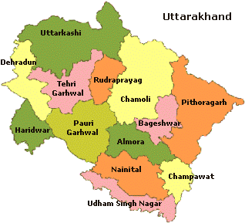
BRO: Border Road Organization,
November – 2019
TABLE OF CONTENTS

Sr. No. | Description of Item | Page Nos.
CHAPTER – 1: ENVIRONMENTAL IMPACT ASSESSMENT AND EMP FOR UTTARAKHAND STATE
1. | INTRODUCTION AND BACKGROUND OF THE PROJECT | 08
2. | BACKGROUND – Scope and Study | 23
3. | PROJECT DESCRIPTION AND ALIGNMENT | 32
4. | OBJECTIVEOF CONSULTANCY SERVICES | 46
5. | PROPOSED APPROACH AND METHODOLOGY: Eco – Friendly OR Environmental Friendly Road Construction Methods and Materials | 49
6. | ENVIRONMENTAL INDEX OR FEATURES OF THE PROJECT | 51
7. | DEMOGRAPHIC INFRASTRUCTURE INDEX OF THE PROJECT DISTRICT/ STATE | 53
8. | ENVIRONMENTAL CHECKLIST | 76
9. | STATUTORY CLEARANCES REQUIRED | 77
10. | ENVIRONMENTAL IMPACT ASSESSMENT OF THE PROJECT | 85
11. | BASELINE ENVIRONMENTAL INDEX AND STATUS | 85
12. | AIR, WATER AND NOISE LEVEL | 93
13. | INSTITUTIONAL REQUIREMENTS AND ENVIRONMENTAL MONITORING PLANS | 114
14. | Principal Component Analysis (PCA) Indicators | 116
15. | ENVIRONMENTAL MANAGEMENT PLAN (EMP) for Kurkuti – Ghamsali – Niti Road in the State of Uttarakhand | 135
16. | CONCLUSIONS AND BUDGET | 146
17. | CONCLUSIONS AND RECOMONDATIONS | 149

Sr. No. | LIST OF TABLES | Page Nos.
CHAPTER – 1: ENVIRONMENTAL IMPACT ASSESSMENT AND EMP FOR UTTARAKHAND STATE
Table 1: | The Route Plan of Kurkuti – Ghamsali – Niti. | 17
Table 2: | Noteworthy and Remarkable Facts on Uttarakhand State. | 17
Table 3: | Average Temperature for the Year in Uttarakhand. | 30
Table 4: | Extra Widening/ Improvement and Land Acquisition Index. | 32
Table 5: | Ghamsali Village Population and Literacy Rate. | 34
Table 6: | Demographics of Rewal Chak Kurkuti Village with Population and Literacy Rate. | 34
Table 7: | Niti Village Population and Literacy Rate. | 35
Table 8: | Joshimath Tehsil Population Rate. | 36
Table 9: | Divisions and Districts in Uttarakhand (Uttaranchal). | 37
Table 10: | The Inventory of Kurkuti – Ghamsali – Niti Project Road. | 45
Table 11: | Economy of Uttarakhand at a Glance. | 52
Table 12: | Homogeneous Section based on Traffic Volume Tehsil/ District Wise Villages. | 53
Table 13: | Existing – Proposed Chainage Wise Villages. | 53
Table 14: | Uttarakhand Facts and Special Effects. | 54
Table 15: | Yearly Increase in Population Rate of Uttarakhand State, 2014 to 2019. | 56
Table 16: | Conversation/ Speaking Percentage Languages in Uttarakhand State, 2011 (Uttaranchal). | 56
Table 17: | Religious Conviction Percentage in Uttarakhand State, 2011 (Uttaranchal). | 57
Table 18: | List of Villages with Length. | 75
Table 19: | Rapid Environmental Assessment Checklist. | 76
Table 20: | Required Statutory (EIA/ S) Clearances. | 77
Table 21: | Pavement Crust Thickness for Widening and New Construction. | 79
Table 22: | Chainage References of Village Community/ Town (Kurkuti – Ghamsali – Niti Road). | 79
Table 23: | Chainage of References Village/ Township (Kurkuti – Ghamsali – Niti Road). | 79
Table 24: | Details of Existing DESIGN PARAMETERS for Proposed Structures. | 80
Table 25: | Hilly OR Mountainous Terrain All Most Stretch/ Normal/ Rolling Gradient. | 81
Table 26: | Details of Reserved Forest with Existing and Design Chainage. | 83
Table 27 (a): | Crust/ Pavement Composition Kurkuti – Ghamsali – Niti Road. | 83
Table 27 (b): | Soil Classification Kurkuti – Ghamsali – Niti Road. | 83
Table 27 (c): | Bridge and Proposed Culverts. | 84
Table 28: | Classified Different Average Daily Traffic (ADT) Surveys and Dates of Commencement Locations. | 84
Table 29 (a): | Design of Proposed Better Crust Thickness for Ridge Pavement Composition. | 85
Table 29 (b): | Design of Proposed Flush Cause Ways/ Hume Pipe Culvert for Cross Drainage Works. | 85
Table 30: | AAQ Monitoring Result of Project Road. | 93
Table 31: | National Ambient Noise Standards. | 94
Table 32: | Equivalent Noise Level Data. | 94
Table 33: | CPCB Best Use Classification for Surface Water Bodies. | 95
Table 34 (a): | Ground Water and Surface Water Quality along the Project Road. | 95
Table 34 (b): | Ground Water and Surface Water Quality along the Project Road. | 96
Table 35: | Potential Environmental Impacts. | 104
Table 36: | Impacts during Design Phase. | 110
Table 37: | Environmental Management Plan during Construction Period. | 110
Table 38: | Environmental Management during Operation Phase. | 111
Table 39: | Institutional Responsibility of Remedial Measures. | 114
Table 40: | Principal Component Analysis as Significant Indicators of Remedial Measures. | 116
Table 41: | Environmental Management Plan (EMP). | 135
Table 42: | Environmental Mitigation and Monitoring Requirements. | 146
Table 43 (a): | Details of Kurkuti – Ghamsali – Niti Road. | 147
Table 43 (b): | Tentative Cost of Kurkuti – Ghamsali – Niti Road. | 149
Table 44 (a): | Focus Group Discussion Public Consultation. | 150
Table 44 (b): | Positive Impacts. | 150
Table 44 (c): | Negative Impacts. | 151
Table 44 (d): | Public Consultation and Focus Group Discussions in Kurkuti – Ghamsali – Niti Road. | 152

Sr. No. | LIST OF FIGURES | Page Nos.
CHAPTER – 1: ENVIRONMENTAL IMPACT ASSESSMENT AND EMP FOR UTTARAKHAND STATE
Figure 1 (a): | Uttarakhand States’ Birds, Animals and Cumulative Impact Assessment (CIA) Supporting Wealthy and Rich Diversity OR Species. | 12
Figure 1 (b): | Traditional Uttarakhand States’ Food Culture and Cumulative Impact Assessment (CIA) Supporting Wealthy and Rich Assortment OR Collection. | 13
Figure 1 (c): | Mountain Ranges, Meandering Rivers and Miles of Forests Supporting Wealthy and Rich Biodiversity. | 14
Figure 1 (d): | Mountain Ranges, Meandering Rivers and Miles of Forests Supporting Wealthy and Rich Biodiversity. | 15
Figure 1 (e): | Mountain Ranges, Meandering Rivers and Miles of Forests Supporting Wealthy and Rich Biodiversity. | 16
Figure 2: | Detailed Project Description Process (Schematic Diagram OR Flowchart Showing Project Layouts and Concluding Components). | 25
Figure 3: | Index Map Showing Projected Road. | 26
Figure 4: | The Tentative Prototype – Paradigm – Digital Sample/ Example of Digital Terrain Model (DTM)/ DEM Generation of Geo – Tiff – Format of Kurkuti to Ghamsali to Niti Road, Village (17.565 Km) Projected New Road at Kurkuti Latitude of 30.7116° (North) and Longitude of 79.8381° (East); Niti Latitude of 30.7776° (North) and Longitude of 79.8412° (East). Vetting/ Geology and Slope Stability are observed by IIT Delhi/ Roorkee Team Experts. (Package – I) | 29
Figure 5: | Project Alignment of Kurkuti – Ghamsali – Niti Road. | 33
Figure 6: | Demographic Map of Rewal Chak Kurkuti Village. | 35
Figure 7: | Approved Project Alignment of Kurkuti – Ghamsali – Niti Road Projected as per Inception Report by Environmental Team Experts. | 46
Figure 8: | Project Execution Objectives and Decision Making Work – Life Cycle. | 48
Figure 9: | Methodological Perspective Over – View of Road Date Base Construction Photographs. | 50
Figure 10: | Lipukekh Pass – Indo – China Border and Shri Laxmi Narayan Temple in Legship. | 55
Figure 11: | Joshimath Tample is among the most Famous Religious Place for Pilgrims. | 58
Figure 12: | Traditional Tample Festivals of Uttarakhand State. | 60
Figure 13: | Uttarakhand’s Traditional Food – based Dishes like Kafuli/ Kapaa, Phaanu, Baadi, Chainsoo, Rus/ Thhatwani, Dubuk/ Dubke, Jhangore ki Kheer, Sisunaak Saag and Chudkaani. | 72
Figure 14: | Buddha Temple Dehradun, Clement Town Places to Visit… Le monastère de Mindrolling Uttarakhand. | 73
Figure 15: | Technical Universities Campus in Pauri, Dehradun and Uttarakhand. | 74
Figure 16: | Prototype – Paradigm of Land Use Pattern of Existing Road. | 81
Figure 17 (a): | Daily Variations of Traffic Volume at Kurkuti (Chainage 00+000) to Niti (Chainage 18+530) on Projected Road. | 82
Figure 17 (b): | Catalogue for Pavement with Bituminous Surface with CTSB, CTB and SAMI – Effective CBR 10% (Plate – 22). | 83
Figure 18: | Three Columns of Sustainability Development – Environmental, Economic and Social. | 93
Figure 19: | Increase in Levels of Pollutant – Emissions – Impact on Future Generated Aspects/ Prospects from Various Sources. | 100
Figure 20: | Noise Levels Impact Must Not Exceed the Permissible Limits in Sensitive Zones along Road Side. | 101
Figure 21: | Mitigatory Measures Plans Generated; Initialized and Finalized to Avoid Contamination Impact on Water Resources and Quality. | 102
Figure 22: | Plan Mitigatory Measures to Avoid Soil Contamination Impact on Agricultural Land and Other Sensitive Zones in Environmental/ Natural/ Ecological Vicinity/ Area/ Site. | 104
Figure 23 (a): | Mitigation Enhancement as per Alignment Design Phase to Reduce Tree Cutting and Compensatory Plantation Relevance. | 106
Figure 23 (b): | Anticipated Refined Enhancement Measures of Road Design Phase as per Alignment to Reduce Tree Cutting and Compensatory Plantation Relevance for ZERO Pollution Level. | 107
Figure 23 (c): | Recommended Refined Enhancement Measures of Road Design Phase as per Alignment to Reduce Tree Cutting and Compensatory Plantation Relevance for ZERO Pollution Level. | 108
Figure 23 (d): | Road Designing Phase as per Alignment to Reduce Tree Cutting and Compensatory Plantation Relevance for ZERO Pollution Level. | 109
Figure 24: | Process of Pyrolysis in Solid and Waste Water Treatment. | 112
Figure 25: | Solid Waste Handling Pyrolysis Technique. | 113
Figure 26: | Sewage Treatment Process (STP) of Wastewater Layout. | 114
Figure 27 (a): | TCS: TYPICAL CROSS SECTION FOR 2 – LANE CARRIAGEWAY.  TYPICAL CROSS SECTION – I | 119
Figure 27 (b): | TYPICAL CROSS SECTION: FOR 2 – LANE CARRIAGEWAY.  TYPICAL CROSS SECTION – II | 119
Figure 27 (c): | TYPICAL CROSS SECTION: FOR 2 – LANE CARRIAGEWAY.  TYPICAL CROSS SECTION – III | 120
Figure 27 (d): | TYPICAL CROSS SECTION: FOR 2 – LANE CARRIAGEWAY.  TYPICAL CROSS SECTION – IV | 120
Figure 27 (e): | TYPICAL CROSS SECTION: FOR 2 – LANE CARRIAGEWAY.  TYPICAL CROSS SECTION – V | 121
Figure 27 (f): | TYPICAL CROSS SECTION: FOR 2 – LANE CARRIAGEWAY.  TYPICAL CROSS SECTION – VI | 121
Figure 27 (g): | TYPICAL CROSS SECTION: FOR 2 – LANE CARRIAGEWAY.  TYPICAL CROSS SECTION – VII | 122
Figure 27 (h): | TYPICAL CROSS SECTION: FOR 2 – LANE CARRIAGEWAY.  TYPICAL CROSS SECTION – VIII | 122
Figure 27 (i): | TYPICAL CROSS SECTION: FOR 2 – LANE CARRIAGEWAY.  TYPICAL CROSS SECTION – IX | 123
Figure 28: | BOTHER... SAFEGUARD; PROTECT; CONSERVE AND PRESERVE OUR PLANET EARTH’S NATURAL – MOTHER... (ECO – NATURAL – GREEN – ENVIRONMENT)...!!! | 123
Figure 29 (a): | Overview of the Environment and Social Framework. | 131
Figure 29 (b): | Core Principles of the Environmental and Social Framework. | 132
Figure 29 (c): | The Environmental Objectives; Application Scope; Policy Approach of the Environmental and Social Framework. | 133
Figure 29 (d): | The Policy Requirements; Roles and Responsibilities of the Environment and Social Framework. | 134
ABBREVIATIONS AND ACRONYMS

AADT | Annual Average Daily Traffic |  | MOEF | Ministry of Environment and Forests
AC | Asphaltic Concrete |  | MORT & H | Ministry of Road Transport & Highways
ADT | Average Daily Traffic |  | BRO | Border Road Organisation
BBD | Benkelman Beam Deflection |  | MSA | Million Standard Axles
BC | Bituminous Concrete |  | MSL | Mean Sea Level
BM | Bituminous Macadam |  | NH | National Highway
BOQ | Bill of Quantities |  | NMT | Non – Motorized Traffic
BOT | Build Operate Transfer |  | NPV | Net Present Value
BSNL | Bharat Sanchar Nigam Limited |  | NSDP | Net State Domestic Product
BT | Bituminous Track |  | NTPC | National Thermal Power Corporation
CBR | California Bearing Ratio |  | O&M | Operation & Maintenance
CD | Cross Drainage |  | O – D | Origin Destination
CGWB | Central Ground Water Board |  | OFC | Optical Fiber Cable
CMSA | Cumulative Million Standard Axles |  | OMC | Optimum Moisture Content
COI | Corridorof Impact |  | PCC | Plain Cement Concrete
CRRI | Central Road Research Institute (India) |  | PCU | Passenger Car Unit
CVPD | CommercialVehiclePerDay |  | PIU | Project Implementation Unit
DBFOT | Design, Build, Finance, Operate & Transfer |  | PPM | Parts Per Million
DBM | Dense Bituminous Macadam |  | PPP | Public Private Partnership
DLC | Dry Lean Concrete |  | PPR | Preliminary Project Report
DTM | Digital Terrain Model |  | PQ | Pre – Qualification
EA | Environmental Assessment |  | PQC | Pavement Quality Control
EASL | Equivalent Standard Axle Load |  | PWD | Public Works Department
EIA | Environment Impact Assessment |  | QAP | Quality Assurance Plan
EIRR | Economic Internal Rate of Return |  | QC | Quality Control
FFR | Final Feasibility Report |  | R&R | Resettlement and Rehabilitation
FIRR | Financial Internal Rateof Return |  | RAP | Resettlement Action Plans
GAD | General Arrangement Drawing |  | RCC | Reinforced Cement Concrete
GDP | Gross Domestic Product |  | RHS | Right Hand Side
GOI | Government of India |  | RL | Reduced Level
GPS | Global Positioning System |  | ROB/ RUB | Road Over Bridge/ Road Under Bridge
GSB | Granular Sub – Base |  | ROW | Right of Way
GTS | Geodetic Triangulation Survey |  | Rs. | Rupees
Ha | Hectare |  | SH | State Highway
HDM–4 | Highway Design & Maintenance Model (Series – 4) |  | SIA | Social Impact Assessment
HDMQ | Highway Designand Maintenance Model with Congestion Analysis |  | Sq. Km. | SquareKiloMeters
HFL | High Flood Level |  | TBM | Temporary Bench Mark
IRC | Indian Road Congress |  | Temp | Temperature
IRR | Internal Rate of Return |  | TOR | Terms of Reference
Km | Kilometre |  | TRL | Transportation Research Laboratory
KMPH | Kilometre Per Hour |  | UG | Under Ground
LA | Land Acquisition |  | VDF | Vehicles Damage Factor
LT/ HT | Low Tension/ High Tension Electric Lines |  | Veh. | Vehicles
m | Meters |  | VGF | Viability Gap Funding
MDR | Major District Road |  | WB | World Bank
mm | Millimetre |  | WBM | Water Bound Macadam
Dia. | Dia Meters |  | WMM | Wet Mix Macadam
EPC | Engineering, Procurement, and Construction |  | PPE | Personal Protective Equipment
PPR | Peste – des Petits Ruminants |  | GAD | General Administration Department
LMI | Labour Market Information |  | MSE | Mean Squared Error
SARA | Saturates, Aromatics, Resins and Asphaltenes |  | ACZ | Agro – Climatic Zone
PET | Poly – Ethylene Tere – phthalate |  | SEDP | Sustainable Environmental Development Practices
FRC | Fibre Reinforced Concrete |  | PCM | Public Consultation Method
PCM | Public Consultation Meeting |  | FGD | Focus Group Discussion
UTC | Universal Time Coordinated |  | GPS | Global Positioning System
DEM | Digital Elevation Model |  | DTM | Digital Terrain Model
FCW | Flush Cause Way |  | CRRI | Central Road Research Institute
CVPD | Commercial Vehicles Per Day |  | ATTC | Advanced Technical Training Centre
CCCT | Centre for Computers and Communication Technology |  | CRPF | Central Reserve Police Force
NWL | Normal Water Level |  | TAR | Tibet Autonomous Region
CCP | CIVIL CONSTRUCTION PRACTICES |  | NSSDA | National Standard for Spatial Data Accuracy
GSD | Ground Sample Distance |  | DGPS | Differential Global Positioning System
NRSC | National Remote Sensing Centre |  | GIS | Geographical Information System
DEM | Digital Elevation Model |  | RL | Reduced Level

This is a Draft Chapter on Environmental and Social Management Framework (ESMF) for the proposed Enhancing Land, Air, Water, Noise and Road Construction Resource Efficiency (ELAWNRCRE) Project with financial assistance from the BRO/ ITBP/ CPWD/ PWD/ MPRDC/ MSRDC/ ADB/ NDB OR World Bank etc. This is hereby disclosed with a view to soliciting comments/ suggestions on or before December 2019. In this regard, please send your comments/ suggestions by email to h.g@rediffmail.com or by WhatsApp Number 09329213257 to Dr. Harish Kumar Gupta, Environment Expert, L. N. M. Infra Projects Pvt. Ltd., Bhopal (M.P.).

Chapter – 1: ENVIRONMENTAL IMPACT ASSESSMENT AND EMP FOR UTTARAKHAND STATE

1. INTRODUCTION AND BACKGROUND OF THE PROJECT

Uttarakhand formerly known as Uttaranchal is a state in the Northern part of India. It is often referred to as the “Devabhumi” (literally “Land of the Gods”) due to a large number of Hindu temples and pilgrimage centres found throughout the state. Uttarakhand is known for the natural environment of the Himalayas, the Bhabhar and the Terai. On 9th November 2000, Uttarakhand became the 27th state of the Republic of India, being carved from the Himalayan districts of Uttar Pradesh. It borders Tibet Autonomous Region of China to the North; the Sudurpashchim Pradesh of Nepal to the East; the Indian states of Uttar Pradesh to the South and Himachal Pradesh to the west and North – West. The state is divided into two divisions, Garhwal and Kumaon, with a total of 13 districts. The interim capital of Uttarakhand is Dehradun, the largest city of the state, which is a railhead and the High Court of the state is located in Nainital.

Archaeological evidence supports the existence of humans in the region since prehistoric times. The region formed a part of the Uttara Kuru Kingdom during the Vedic age of Ancient India. Among the first major dynasties of Kumaon were the Kunindas in the 2nd century BCE who practised an early form of Shaivism. Ashokan edicts at Kalsi show the early presence of Buddhism in this region. During the medieval period, the region was consolidated under the Kumaon Kingdom and Garhwal Kingdom. In 1816, most of modern Uttarakhand was ceded to the British as part of the Treaty of Sugauli. Although the erstwhile hill kingdoms of Garhwal and Kumaon were traditional rivals, the proximity of different neighboring ethnic groups and the inseparable and complementary nature of their geography, economy, culture, language, and traditions created strong bonds between the two regions which further strengthened during the Uttarakhand movement for statehood in the 1990s.

The natives of the state are generally called Uttarakhandi, or more specifically either Garhwali or Kumaoni by their region of origin. According to the 2011 Census of India, Uttarakhand has a population of 10,086,292, making it the 20th most populous state in India.

Etymology

Uttarakhand's name is derived from the Sanskrit words uttara (उत्तर) meaning “North”, and khanda (खण्ड) meaning “Land”, altogether simply meaning “Northern Land”. The name finds mention in early Hindu scriptures as the combined region of “Kedarkhand” (present day Garhwal) and “Manaskhand” (present day Kumaon). Uttarakhand was also the ancient “Puranic” (पौराणिक) term for the central stretch of the Indian Himalayas.

However, the region was given the name Uttaranchal by the Bharatiya Janata Party led central government and Uttrakhand state government when they started a new round of state reorganization in 1998. Chosen for its allegedly less separatist connotations, the name change generated enormous controversy among many activists for a separate state who saw it as a political act. The name Uttarakhand remained popular in the region, even while Uttaranchal was promulgated through official usage.

In August 2006, Union Cabinet of India assented to the demands of the Uttaranchal Legislative Assembly and leading members of the Uttarakhand statehood movement to rename Uttaranchal state as Uttarakhand. Legislation to that effect was passed by the Uttaranchal Legislative Assembly in October 2006, and the Union Cabinet brought in the bill in the winter session of Parliament. The bill was passed by Parliament and signed into law by then President A. P. J. Abdul Kalam in December 2006, and since January 1st, 2007 the state has been known as Uttarakhand.

History

History of Uttarakhand and Uttarakhand Movement: Ancient rock paintings, rock shelters, paleolithic stone tools (hundreds of thousands of years old), and megaliths provide evidence that the mountains of the region have been inhabited since prehistoric times. There are also archaeological remains which show the existence of early Vedic (c. 1500 BCE) practices in the area. The Pauravas, Nandas, Mauryans, Kushanas, Kunindas, Guptas, Gurjara – Pratihara, Katyuris, Raikas, Palas, Karkotas, Chands, Parmars or Panwars, and the British have ruled Uttarakhand in turns.

It is believed that the sage Vyasa scripted the Hindu epic Mahabharata in the state. Among the first major dynasties of Garhwal and Kumaon were the Kunindas in the 2nd century BCE who practised an early form of Shaivism and traded salt with Western Tibet. It is evident from the Ashokan edict at Kalsi in Western Garhwal that Buddhism made inroads in this region. Folk Hindu shamanic practices deviating from Hindu orthodoxy also persisted here. However, Garhwal and Kumaon were restored to nominal Vedic Hindu rule due to the travels of Shankaracharya and the arrival of migrants from the plains.

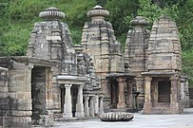

Katarmal Sun Temple constructed by the Katyuri Kings in the 9th century CE.

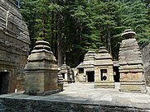

Jageshwar Temples are a group of over 100 Hindu Temples dated between 7th and 12th century.

Between the 4th and 14th centuries, the Katyuri dynasty dominated lands of varying extent from the Katyur Valley (Modern – Day Baijnath) in Kumaon. The historically significant temples at Jageshwar are believed to have been built by the Katyuris and later remodelled by the Chands. Other peoples of the Tibeto –Burman Group known as Kirata are thought to have settled in the Northern highlands as well as in pockets throughout the region, and are believed to be ancestors of the modern day Bhotiya, Raji, Buksa, and Tharu people.

Princely Flag of Kingdom of Garhwal

By the medieval period, the region was consolidated under the “Garhwal Kingdom” in the West and the Kumaon Kingdom in the East. During this period, learning and new forms of Painting (the Pahari School of Art) developed. Modern – day Garhwal was like wise unified under the rule of Parmars who, along with many Brahmins and Rajputs, also arrived from the plains. In 1791, the expanding Gorkha Empire of Nepal overran Almora, the seat of the Kumaon Kingdom. It was annexed to Kingdom of Nepal by Amar Singh Thapa. In 1803, the Garhwal Kingdom also fell to the Gurkhas. After the Anglo – Nepalese War, this region was ceded to the British as part of the Treaty of Sugauli. The Garhwal Kingdom was then re – establishedfrom a smaller region in Tehri.

Uttarakhand as a Part of the United Province, 1903

After India attained independence from the British, the Garhwal Kingdom was merged into the state of Uttar Pradesh, where Uttarakhand composed the Garhwal and Kumaon Divisions. Until 1998, Uttarakhand was the name most commonly used to refer to the region, as various political groups, including the “Uttarakhand Kranti Dal” (Uttarakhand Revolutionary Party), began agitating for separate statehood under its banner. Although the erstwhile hill kingdoms of Garhwal and Kumaon were traditional rivals the inseparable and complementary nature of their geography, economy, culture, language, and traditions created strong bonds between the two regions. These bonds formed the basis of the new political identity of Uttarakhand, which gained significant momentum in 1994, when demand for separate statehood achieved almost unanimous acceptance among both the local populace and national political parties.

The most notable incident during this period was the Rampur Tiraha Firing Case on the night of 1st October 1994, which led to a public uproar. On 24th September 1998, the Uttar Pradesh Legislative Assembly and Uttar Pradesh Legislative Council passed the Uttar Pradesh Reorganisation Bill, which began the process of forming a new state. Two years later the Parliament of Indiapassed the Uttar Pradesh Reorganisation Act, 2000 and thus, on 9th November 2000, Uttarakhand became the 27th state of the Republic of India.

“माटू हमरू, पाणी हमरू, हमरा ही छन यी बौण भी... पितरों न लगाई बौण, हमुनही त बचौण भी।
Soil ours, water ours, ours are these forests. Our forefathers raised them; it's we who must protect them.
— Old Chipko Song (Garhwali Language)”

Uttarakhand is also well known for the mass agitation of the 1970s that led to the formation of the Chipko Environmental Movement and other Social Movements. Though primarily a livelihood movement rather than a forest conservation movement, it went on to become a rallying point for many future environmentalists, environmental protests, and movements the world over and created a precedent for non – violent protest. It stirred up the existing civil society in India, which began to address the issues of tribal and marginalized people. So much so that, a quarter of a century later, India Today mentioned the people behind the “Forest Satyagraha” of the Chipko Movement as amongst “100 People Who Shaped India”. One of Chipko's most salient features was the mass participation of female villagers. Both female and male activists played pivotal roles in the movement. “Gaura Devi was the main activist who started this movement other participants was Chandi Prasad Bhatt, Sunderlal Bahuguna, and Ghanshyam Raturi, the Popular Chipko Poet”.

The consultancy services for carrying out preparation of Initial Environmental Examination (IEE)/ Detailed Project Report (DPR) and bid documents. In order to fulfil the traffic needs and road safety requirement, Border Road Organisation (BRO) has appointed the M/s HIGHWAY ENGINEERING Consultant BHOPAL (MP), for Survey, Investigation and Preparation of Detailed Project Report for improvement of Road and Bridges etc. for construction of High Altitude Hill Roads to Border Road Organization under Phase – I in the state of Uttarakhand using Satellite Imagery and Geographical Information System (GIS). The report brings out the project background, mobilization and staffing, approach and methodology relating to surveys/ investigations and detailed design. A broad conceptualization of the project essentially based on study of available data/ reports and a detailed reconnaissance survey has been provided. “Uttarakhand BRO – 21 BRTF (123 – RCC) Division Suraitota, has been entrusted preparation of Initial Environmental Examination (IEE) of Kurkuti – Ghamsali – Niti from 00.000 Km to 20.000 Km (20.00 Kms) from CL – 9 to NHDL Specification in 21 – BRTF area under PROJECT – Shivalik in Uttarakhand”.Through Consultancy Services As Specified By MORT & H and Provisions of IRC – SP – 19 for Improvement/ Development of Road Kurkuti – Ghamsali – Niti from 00.000 Km to 20.000 Km (20.00 Kms) area under Project Shivalik Uttarakhand State, the assignment for Letter No. 80260/ Consultancy/ KGN/ 48/ E8 Dated July 2018. The report also makes proposals on issues requiring discussions with the Border Road Organisation (BRO) by Ministry of Home Affairs, Department of Border Management, and Government of India and decisions necessary for detailing of the project.

The report covers the following major aspects and prospects are as discussed below one by one:

Project Background;

Mobilization and Progress;

Project Appreciation and Conceptualization;

Proposed Approach and Methodology;

Alignment Deciding Criteria andSignificant Factors

Connectivity to Indo – Tibetan Border Police (ITBP) Posts Authorities of 11th and 13th Battalion, Raised on 24th October 1962, under the Central Reserve Police Force (CRPF) Act;

Stable Side of Hilly Areas;

Avoiding of S – Bends to the Extent Possible;

Gradient Limits;

Availability of Road Construction Materials;

Minimum Number of Cross Drainage Structures;

Connectivity to Intermediate Village, If Any;

Avoiding Acquisition of Private Land;

Keeping the Alignment 25 – 30 m above Normal Water Level (NWL) of River, If Any;

The consultancy services for the same have included design of best possible alignment and pavement composition, culverts and other structures in addition to analysis of costs, determining project feasibility and Initial Environmental Examination (IEE) Report for the Project Kurkuti – Ghamsali – Niti Road Starts from Kurkuti Road and Terminates at Niti Road in the Uttarakhand State.

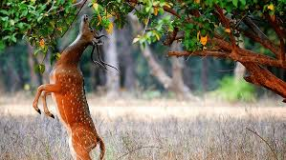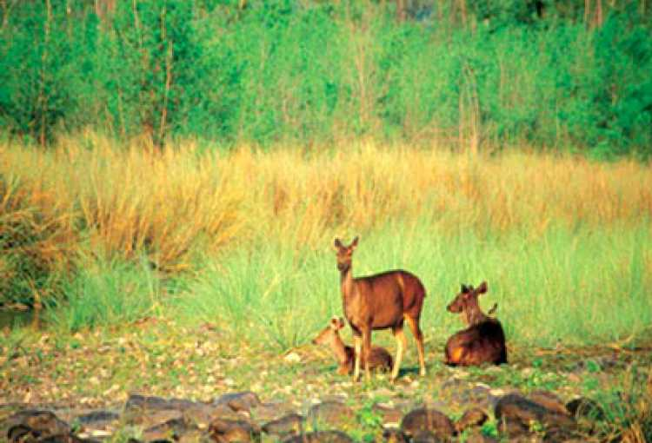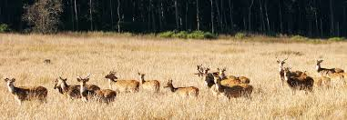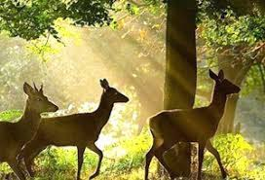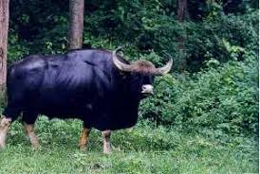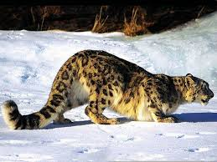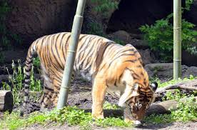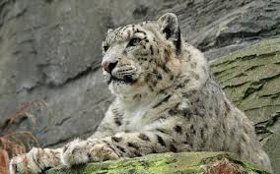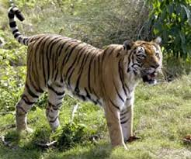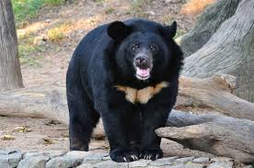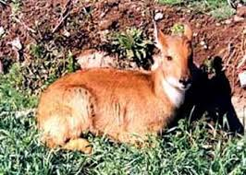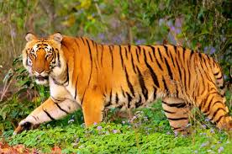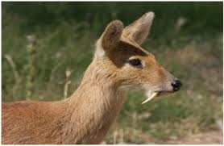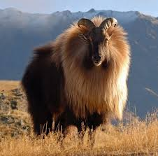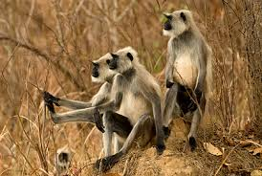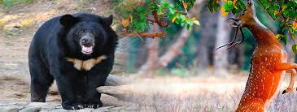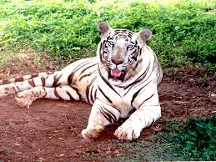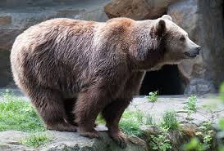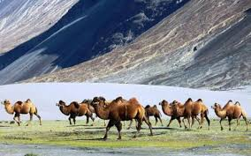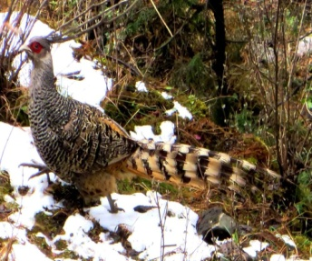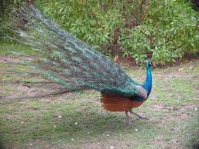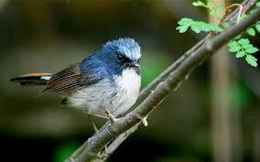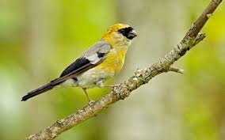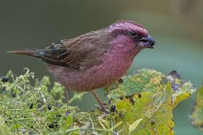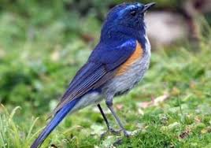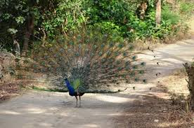

Figure 1 (a): Uttarakhand States’ Birds, Animals and Cumulative Impact Assessment (CIA) Supporting Wealthy and Rich Diversity OR Species.
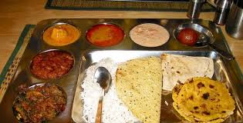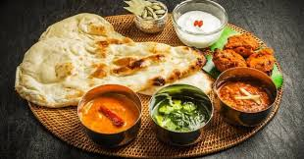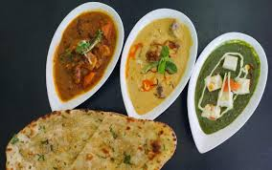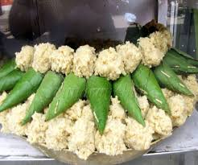

Figure 1 (b): Traditional Uttarakhand States’ Food Culture and Cumulative Impact Assessment (CIA) Supporting Wealthy and Rich Assortment OR Collection.
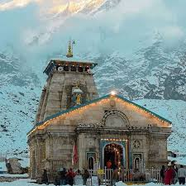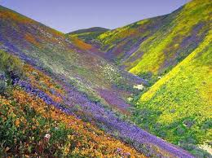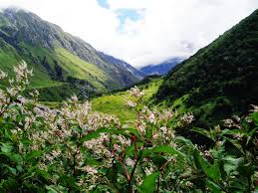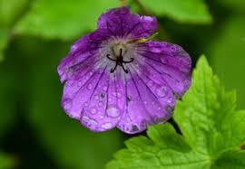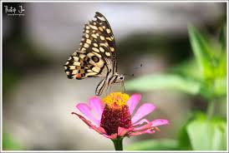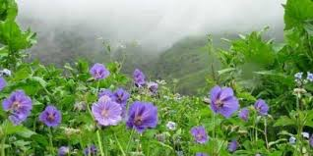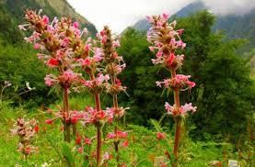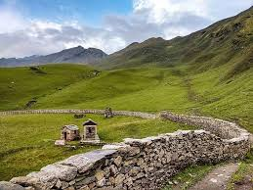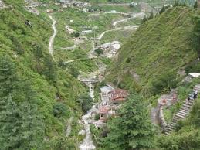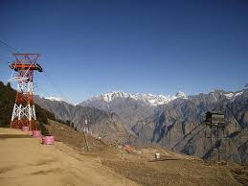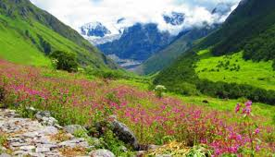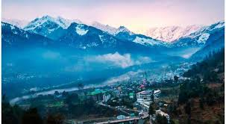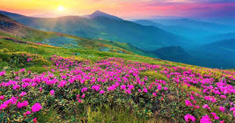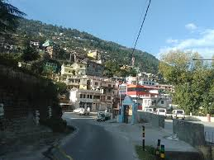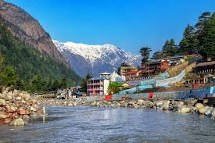

Figure 1 (c): Mountain Ranges, Meandering Rivers and Miles of Forests Supporting Wealthy and Rich Biodiversity.
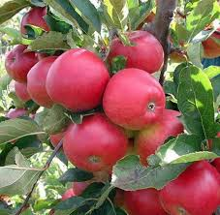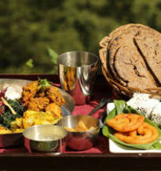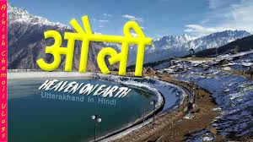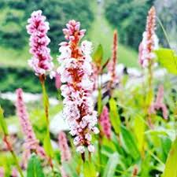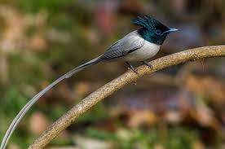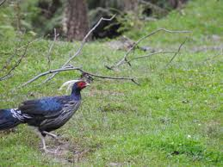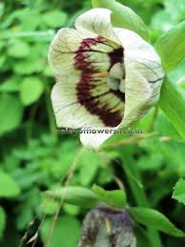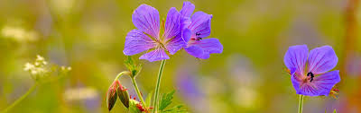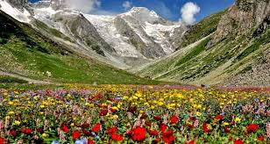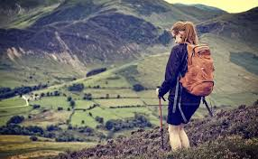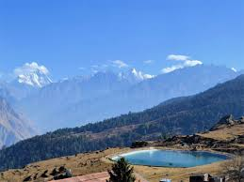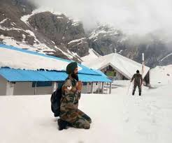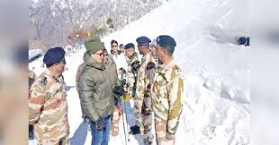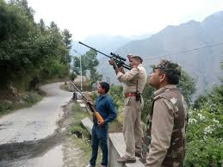

Figure 1 (d): Mountain Ranges, Meandering Rivers and Miles of Forests Supporting Wealthy and Rich Biodiversity.
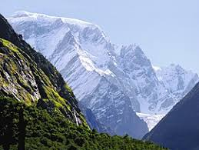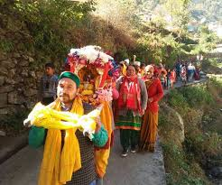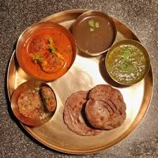
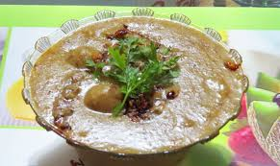
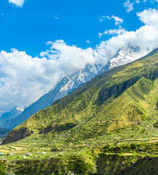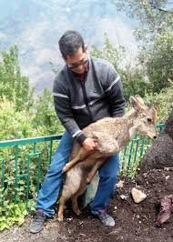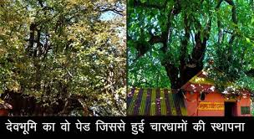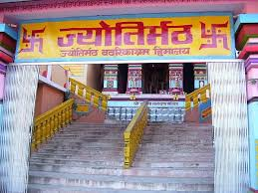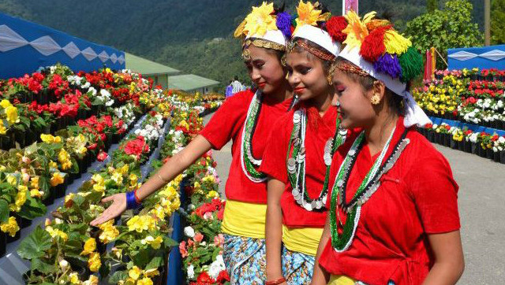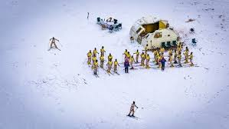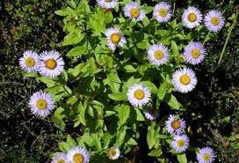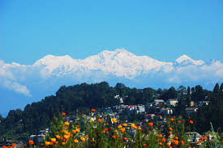

Figure 1 (e): Mountain Ranges, Meandering Rivers and Miles of Forests Supporting Wealthy and Rich Biodiversity.

Most of the areas being hilly, summers in Uttarakhand State are soothing as the temperature hardly crosses 30°C (about 86°F), whereas the summers are exceedingly hot with temperatures crossing the 40°C mark and considerable humidity. Winters can be chilly with temperatures going below 5°C at times. The climate in the Northern part of Uttarakhand is typically Himalayan. This mountain range itself exerts an appreciable extent of influence on monsoon and rainfall patterns. Within the Himalayas, climate differs depending on altitude and position. Climate ranges from subtropical in the southern foothills, averaging summer temperatures of about 30°C (about 86°F) and winter temperatures of about 18°C (about 64°F). Warm temperate conditions prevail in the Middle Himalayan valleys, with summer temperatures usually hovering about the mark of 25°C (about 77°F) and cooler winters. It lies between Latitude 30.0668° N and Longitude 79.0193° E. Located in the North – Eastern part of the country, Uttarakhand is surrounded by West Bengal on its South and shares international borders with Bhutan on its South – East, Nepal on its West and the Tibet Autonomous Region (TAR) of China on its North – East and it is often referred to as the “Smart and Beautiful – Heritage of Himalayas”. The beautiful mountains, the deep valleys and the biodiversity make Uttarakhand a favourite spot for tourists like Mountain Ranges, Meandering Rivers and Miles of Forests Supporting Wealthy and Rich Biodiversity in Uttarakhand State as shown above in Figures 1 (a), (b), (c), (d) and (e). The Initial Environmental Examination (IEE) Report for improvement of “Uttarakhand BRO – 21 BRTF (123 – RCC) Division Suraitota, has been entrusted preparation of Initial Environmental Examination (IEE) of Kurkuti – Ghamsali – Niti Road from 00.000 Km to 20.000 Km (20.00 Kms) from CL – 9 to NHDL Specification in 21 – BRTF area under PROJECT – Shivalik in Uttarakhand”. The Projected Road Kurkuti – Ghamsali – Niti Starts at Kurkuti and Terminates at Niti. The Project Assignment/ Task for Letter No. 80260/ Consultancy/ KGN/ 48/ E8 Dated July 2018. The design length of proposed alignment is 191.00 Km. and the route plan of Kurkuti – Ghamsali – Niti Road is given in Table 1.

Table 1: The Route Plan of Kurkuti – Ghamsali – Niti Road.

Road Direction and Route Plan

Place Name |  | Distance | Approximate Time for Journey | Mode of Vehicle
From | To
Kurkuti | Niti | 17.56 Km. | 04.25 Hrs | By Road with 4 Wheeler Drive
Total |  | 17.56 Km.

Physiographic Index

Uttarakhand is the second – smallest Indian state and is geographically located at Latitude 30.0668° N and Longitude 79.0193° E. Landlocked in the Himalayan range, the state is bordered by Tibet on its North – East, Nepal on its west, Bhutan on its South – East and West Bengal on its South. The residents of Uttarakhand experience two kinds of climate. The Northern part of the state experiences tundra type of climate, whereas, the Southern part observes sub – tropical climatic conditions. Because of the tundra type of climate, the Northern part of the state remains covered with snow for almost 4 months in a year, when the night temperature goes below the level of 0°C. The weather condition of the state is mainly divided into 5 seasons, which are depicted below:

- Spring;
- Summer;
- Autumn;
- Monsoon;
- Winter.

Uttarakhandis subdivided into following units as Noteworthy and Remarkable Facts on Uttarakhand State are shown in the Table 2 with worth mentioning and incredibleIndex of Uttarakhand State.

Table 2: Noteworthy and Remarkable Facts on Uttarakhand State.

Facts on Uttarakhand State
Official Website | https://www.euttaranchal.com and https://uk.gov.in/ andhttps://uktech.ac.in/
Date of Formation | Uttarakhand formerly known as Uttaranchal is a state in the Northern part of India. On 9th November 2000, Uttarakhand became the 27th State of the Republic of India, being carved from the Himalayan Districts of Uttaranchal. The region formed a part of the Uttara Kuru Kingdom during the Vedic age of Ancient India.
Area | 53,483 Km²
Density | The population density of the state is 189 People/ Km² having a 2001 – 2011 decadal growth rate of 18.81%.
Total Population (2012 and 2019) | 1.01 crores OR 10.3932 Million Approximately.
Males Population (2011) | 5,137,773
Females Population (2011) | 4,948,519
Number of District | 13
Capital | Dehradun
Rivers | Alaknanda River, Ganges River, Pindar River, Assan Barrage, Gaula River, Pushpawati River, Bhilangna River, Kosi River and Ramganga River. In some parts of Uttarakhand, rivers like Ganga, Tons, Yamuna, and Kali are famous for offering a wide variety of water sports.
Forests and National Park | Six National Parks in Uttarakhand for Your Next Getaway. Jim Corbett National Park, Rajaji National Park, Valley of Flowers National Park, Nanda Devi National Park, Gangotri National Park, Govind Pashu Vihar National Park and Sanctuary.
Languages | Garhwali or Kumaoni depending on their place of origin.
Neighbours State | Himachal Pradesh, Haryana, Uttar Pradesh.
State Animal | “Alpine Musk Deer” (Official Moschus chrysogaster).  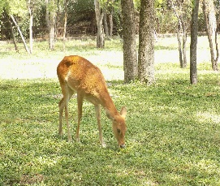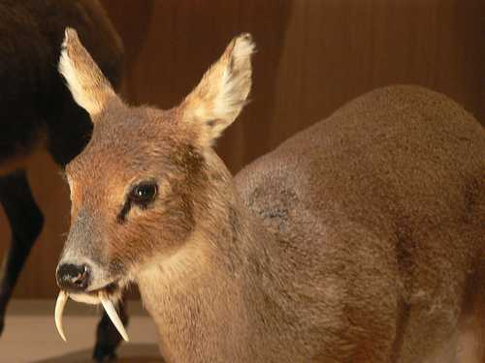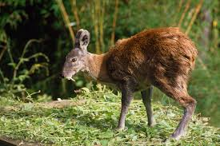
State Bird | “Himalayan Monal Pheasant” (Official Lophophorus impejanus).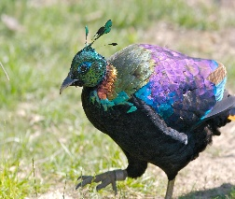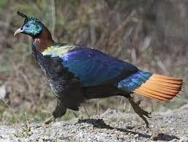
State Tree | “Burans” (Official Rhododendron arboreum).  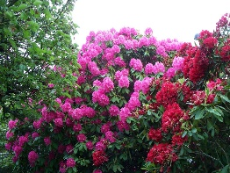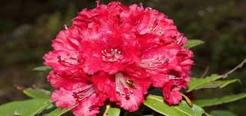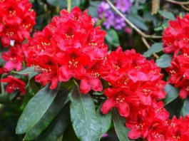
State Flower | “Brahm Kamal” (Official Saussurea obvallata).  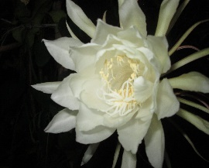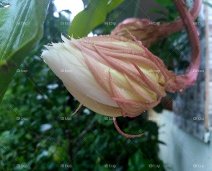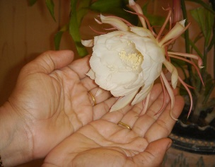
State Fish | To Protect the Endangered “Mahaseer” Fish, Uttarakhand.  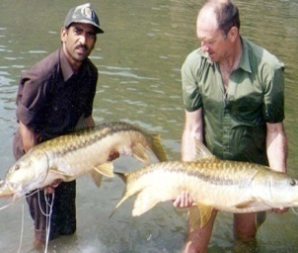
Net State Domestic Product (2011 – 12 To 2015 – 16) | 1,62,168 (Rs. Crore)
Literacy Rate (2011) | 78.82%
Females per 1,000 Males {Sex Ratio Females (Rural)} | 963 {1000}
Assembly Constituency | General Seats 54, SC Seats 14, ST Seats 2. Total Seats 70.
Parliamentary Constituency | The Lok Sabha (meaning “House of the People”) is the lower house of the Parliament of India. Uttarakhand state elects 5 members and they are directly elected by the state electorates of Uttarakhand. Members are elected for five years. The numbers of seats, allocated to the state/ union territory are determined by the population of the state/ union territory.

Waterfalls

Combined with the snow capped peaks of Uttarakhand, and the lush green forests that lead you to amazing trekking memories, Waterfalls in Uttarakhand rejuvenate your mind, body and soul like no other. Whether it is about bathing in the medicinal natural ponds at the edge of these waterfalls, or simply admires their beauty on a day trip, the undeniable serenity of these falls adds more to your ordinary day.

If you’re one of those people for whom only thinking about such places sparks joy, then scroll down to know what awaits you at these falls to plan a perfect outing …!!! Uttarakhandis primarily a land of sky scraping mountains/ hills and the lush green vegetation on the mountain sides presents an Eye – Soothing View and this sight is made more panoramic by the waterfalls in Uttarakhand. Mostly perennial in nature, waterfalls abound in Uttarakhand, especially in the Northern region. The local inhabitants of Uttarakhand consider some of the waterfalls to be sacred place. The waterfalls of Uttarakhand are ideal sites for setting trekking base camps, since they fall from high altitudes and are perennial in nature; these waterfalls are also conducive for setting up hydro power projects. Witness the beauty of Uttarakhand and indulge in spiritual pilgrimages, adventure sports, and treks. Visit Nainital, Rishikesh, Haridwar, Auli, Jim Corbett, and more. The important waterfalls in Uttarakhand are:

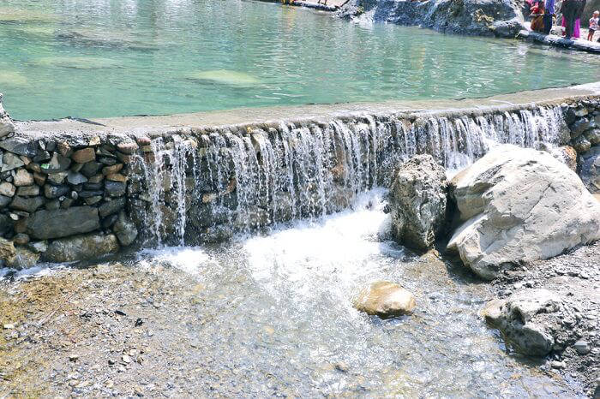

- Kempty Waterfalls: Located a few kilometers off Mussoorie, Kempty falls is a serene waterfall that is a must visit for all the tourists visiting the nearby hill station. Falling from a height of 1,364 Metres above sea level, these falls are an amazing site to admire. Nature’s beautiful creation like this one is a perfect spot for a day trip or a picnic with your loved ones and stay till the evening time to revive your senses with a fresh cool breeze that flows around this region. So, when are you planning to visit one of the Top Waterfalls in Uttarakhand …?

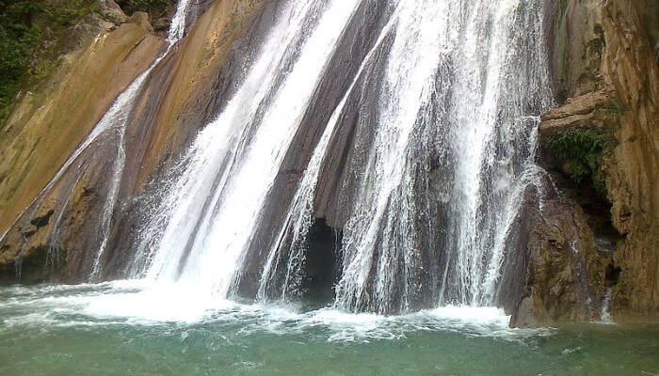

- Bhatta Waterfalls: Earlier a lesser known place, this charming waterfall in Mussoorie has gained popularity in recent years and is surely not to be missed while you’re planning a trip to Mussoorie. You can easily reach this place via bus or a car in the Bhatta village and have a fun outing with your folks ..!!! A rather steep fall, that comes directly from the hills above, hitting the rocks around, people belonging to different age groups visit this place to bath and enjoy the serenity of this place.

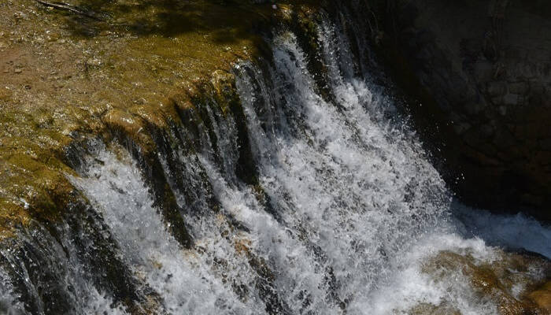

- Corbett Waterfalls: With a mere distance of 25 Kms from Ramnagar, you can easily reach Corbett falls in Uttarakhand for a day trip. The dense teak wood forest adds more to the charm of this place and a melodious chirping of the birds in this region will make you stay for a bit longer. You can either stay overnight and set a camp near these waterfalls or just have a picnic meal with your favourite travel folks. This is surely amongst the most Famous Waterfalls in Uttarakhand that you ought to visit …!!!

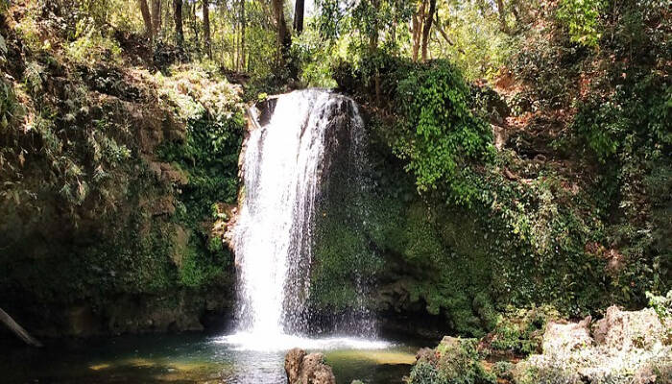

- Vasudhara Waterfalls: With a close proximity to Badrinath, Vasudhara falls make an amazing spot to witness spectacular views around and soak in the tranquility that accompanies this environment. Dropping from a height of 400 Feet and 122 Metres above sea level. Even though it is said that the true beauty of this place can only be admired by those who are guilt free, it is always a good idea to visit waterfalls to revive your senses.

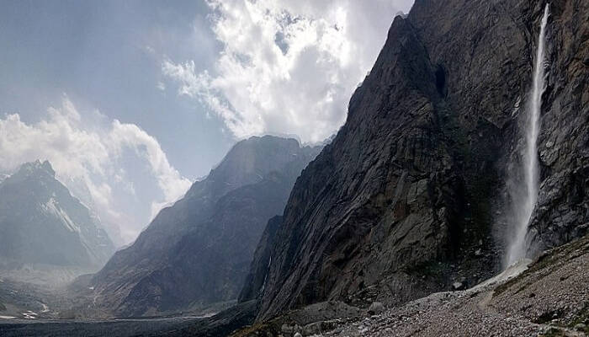

- Neer Garh Waterfalls: You can easily reach Neer Garh waterfall from Rishikesh Railway Station, as it is only at a distance of 9 Km. Amongst the most popular places to visit in Rishikesh, this waterfall is known for having a fun trek abode. If you’re not in the mood to exercise, then surely a dip in the cool waters of this place will be perfect for you. There are also two bridges on this waterfall and the colourful butterflies found here add more beauty to this place.

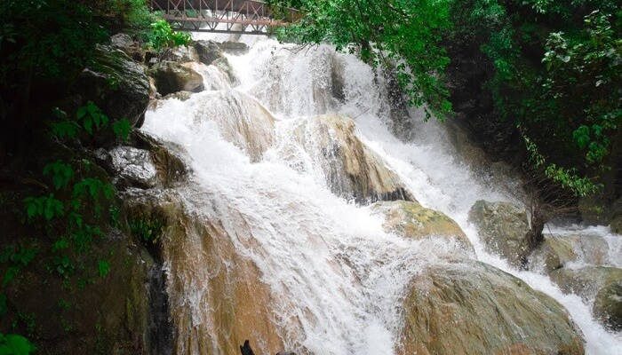

- Birthi Waterfalls: Covering a mere 14 Km distance from Tejam will let you experience the splendid site of Birthi Falls in Pithoragarh district of Uttarakhand. Approximately 400 Feet above sea level, the rolling water splashes on the shore with an unparalleled gorgeous view that is more than enough to make your day. You can even choose to trek to this place and have an exciting outing with your pals (friends) at this site for sure …!!!

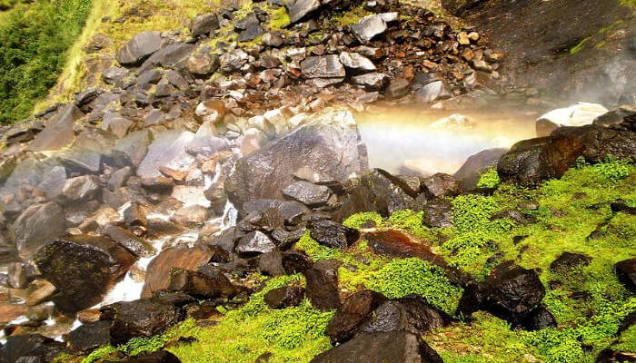

- Tiger Waterfalls: Falling from a height of 50 Metres, the renowned Tiger falls offer a relaxing bath in the pond below. You can easily access this place via a short trek of 1 Km after a drive on Chakrata – Lakhamandal route. An alternative route involving the scenic views of the forests in Chakrata via a 5 Km trek can also lead you to this place. Be careful of the narrow and rough roads that are used to reach this place and they’re only suitable for SUV Cars.

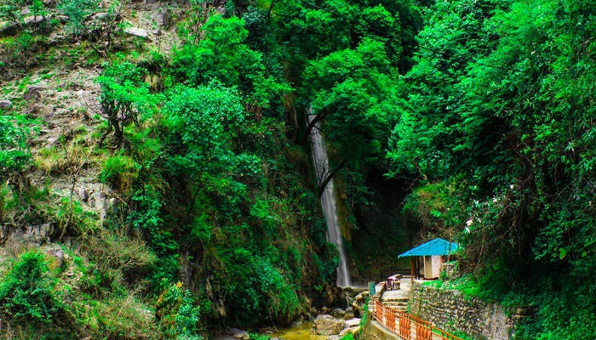

- Sahastradhara Waterfalls: Here as per with numerous caves around, we wouldn’t be surprised if Sahastradhara falls turns out to be your favourite waterfall in Uttarakhand. The sulphur content of this waterfall is said to have medicinal properties, which is why you can see many locals as well as tourists bathing in these falls. The best time to visit this place is the rainy season, when the falls have more water and the relatively greener region in the surrounding add to the charm of this place. You surely cannot miss out on the Best Waterfall in Uttarakhand on your next vacay …!!!

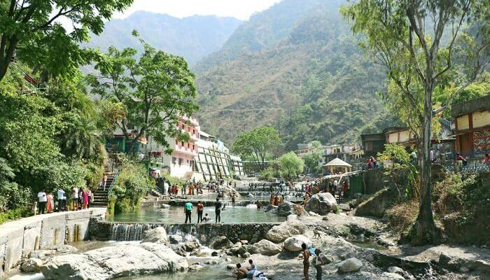

2. BACKGROUND – Scope and Study

The construction of high altitude hilly/ mountainous roads to Indo – China Border road under phase – II in the state of Uttarakhand has been entrusted to Border Road Organisation (BRO) by Ministry of Home Affairs, Department of Border Management, and Government of India. The work is of National importance having strategic in nature from Border security aspect. The consultancy work for Preparation of Detailed Project Report has been awarded to M/s HIGHWAY ENGINEERING Consultant BHOPAL (MP). The Border Road Organisation (BRO) has been entrusted with theassignment of Consultancy Services for preparation of Detailed Project Report of National Highways/ State Roads (approved as National Highway) in many States for up gradation to Two/ Four Lanes with paved shoulder configuration. BRO now invites proposal from Technical Consultants for carrying out detailed project report for proper structuring and implementation of projects on Engineering, Procurement, and Construction (EPC)/ Public Private Partnership (PPP) mode on Kurkuti – Ghamsali – Niti Roadin the North Uttarakhand State. In order to fulfill the traffic needs and road safety requirement, BRO has appointed the M/s HIGHWAY ENGINEERING Consultant BHOPAL (MP) as consultants to Providing Consultancy Services for Preparation of Detailed Project Report of Kurkuti – Ghamsali – Niti Road for Managementand Construction of High Altitude Hill Roads to Indo – China Border Road under Part – 1 in the State of Uttarakhand, Package No.: 00, using Satellite Imagery/ Global Positioning System.

The Ministry of Home Affairs (MHA), Govt. of India has decided to take up the development of High Altitude Hill Roads to Indo – China Border. The Border Road Organisation (BRO) has been entrusted with the construction of High Altitude Hill Roads to Indo – China Border road in the State of Uttarakhand. This project section is from Kurkuti – Ghamsali – Nitiin the State of Uttarakhand and the Total Length of Proposed Road is 17.56 Km. The Coordinates of Project roads at Starting Point, Kurkuti are Latitude of 21.3199° (North) and Longitude of 82.5646° (East). Coordinates at the End Point, Niti are Latitude of 30.7776° (North) and Longitude of 79.8412° (East). Length provide by ITBP for the road is 20.00 Km., whereas the designed length is 17.56 Km.

The project study consists of preparation of the following as shown in Figure 2:

Stage 1 – Inception Report and Quality Assurance Plan;
Stage 2 – Reconnaissance/ Investigation/ Servey Report;
Stage 3 – LA and Clearances I – Report;
Stage 4 – Detailed Project Report (DPR);
Stage 5 – Technical Schedules;
Stage 6 – LA and Clearances II – Report.

Figure 2: Detailed Project Description Process (Schematic Diagram OR Flowchart Showing Project Layouts and Concluding Components).

Consultancy Services for preparation of feasibility study and detailed project report of INITIAL ENVIRONMENTAL EXAMINATION (IEE) assessED – controlled… areas like super communication expressway...!!!

Operations and Maintenances

CS/ CC/ Bituminous Road Construction
Clearing Sites/ Places/ Areas
Standards/ Policies/ Essential Environmental Clearances

Road/ Bridge Construction Network/ Activities
Construction of Roads/ Bridges and Pertinent/ Applicable Structures

FINAL PLANS/ DPR
Project Planning’s (Alternative Considerations)
Sanction from BRO and State/ Local/ Regional Government Agencies
Leveling/ Laying Foundation on Coat
Preliminary Engineering Applications
(Preferred Plans/ Locations/ IEE REPORT)
Route Inspection/ Innovations and Inventory
Project Development Concepts/ Baselines

