Precision Health: Exploring Biosensors in Hypertension Management

AUTHORS

Dr.Sushrut Ingawale (MD, DNB)
Former Assistant Professor,
Department of Medicine,
Seth GSMC and KEM Hospital, Mumbai, India
sushrutingawale2012@kem.edu

Dr.Nandhini Iyer (MBBS)
Intern,
Grant Government Medical College and Sir J.J Group of Hospitals,
Mumbai, India
nandhini.iyer1998@gmail.com

I. ABSTRACT
Hypertension (HTN), a global health concern, poses challenges in its early identification. Its detection can be facilitated through blood pressure measurement at home or in healthcare facilities and managed effectively with economical pharmaceutical interventions. Timely recognition and the initiation of intervention play pivotal roles in curtailing HTN-related complications and fatalities. Enhancing hypertension management and treatment efficacy, home-based serial blood pressure (BP) monitoring surpasses sporadic clinic measurements. Hence, continual surveillance of cardiovascular health metrics is imperative. Consequently, diverse advancements in biosensor technology have garnered significant attention due to their inherent merits of simplicity, portability, and continuous non-invasive monitoring capabilities. Wearable sensors, such as health trackers, smartphone-integrated biosensors, and implantable devices, are gaining traction. Emerging technologies for wearable BP monitoring hold promise for seamless and unobtrusive at-home BP tracking throughout the day, bolstering hypertension awareness across broader demographics. This chapter expounds on biosensor mechanisms, elucidates the principles underpinning photoplethysmography (PPG), pulse wave velocity (PWV), pulse transit time (PTT), and pulse arrival time (PAT). Furthermore, it accentuates diverse modalities of biosensor utilization and navigates the ethical dimensions entwined with artificial intelligence. In summation, this chapter furnishes a comprehensive overview of healthcare progress and patient management achieved by harnessing technological breakthroughs to govern hypertension.

II. INTRODUCTION

Hypertension, abbreviated as HTN, poses a global health challenge due to challenges associated with its early identification. Over the past thirty years, there has been a notable increase in the prevalence of hypertension among adults aged 30-79, escalating from 650 million to 1.28 billion individuals [1]. These findings stem from a comprehensive worldwide analysis of hypertension trends in terms of occurrence, diagnosis, treatment, and management, conducted collaboratively by the World Health Organization (WHO) and Imperial College London. Astonishingly, more than fifty percent of these cases were undiagnosed [1, 2]. Hypertension significantly amplifies the risk of various cardiovascular, neurological, and renal ailments, including heart attacks, strokes, and chronic kidney diseases, thus ranking high among the leading global causes of fatality and illness. This underscores its role in premature demise and lethal complications. Thankfully, detecting hypertension can be relatively straightforward through blood pressure measurements either at home or in healthcare facilities, and it can be effectively controlled with affordable medications [1, 3, 4]. Detecting the condition early and promptly commencing treatment are pivotal measures in curtailing complications and fatalities associated with HTN. In contemporary clinical practice, the oscillometric method has gained widespread acceptance for blood pressure measurement, largely supplanting the traditional auscultatory approach.

We need to weigh many practicalities while measuring BP to ensure that the measurement accurately reflects the BP of the patient at that moment [5]. Conventional techniques for measuring hypertension are condition- and operator-dependent. Ambulatory monitoring was introduced to overcome the issues arising from manual methods. Ambulatory blood pressure monitoring (ABPM) is done with a portable oscillometer, the cuff of which fits around the upper arm and inflates at timely intervals while the person continues his or her daily activities. However,it requires the arm to be static during cuff inflation, which interferes with sleep and other activities [4]. 24-hour ambulatory blood pressure monitoring can help to diagnose “masked hypertension”, “whitecoat hypertension”, “labile hypertension”, “postural hypertension”, and “nocturnal hypertension,” as categorized in Figure (1) below, thus guiding decisions about treatment. The pressure also varies with the location of the measurement and body position [4,5].
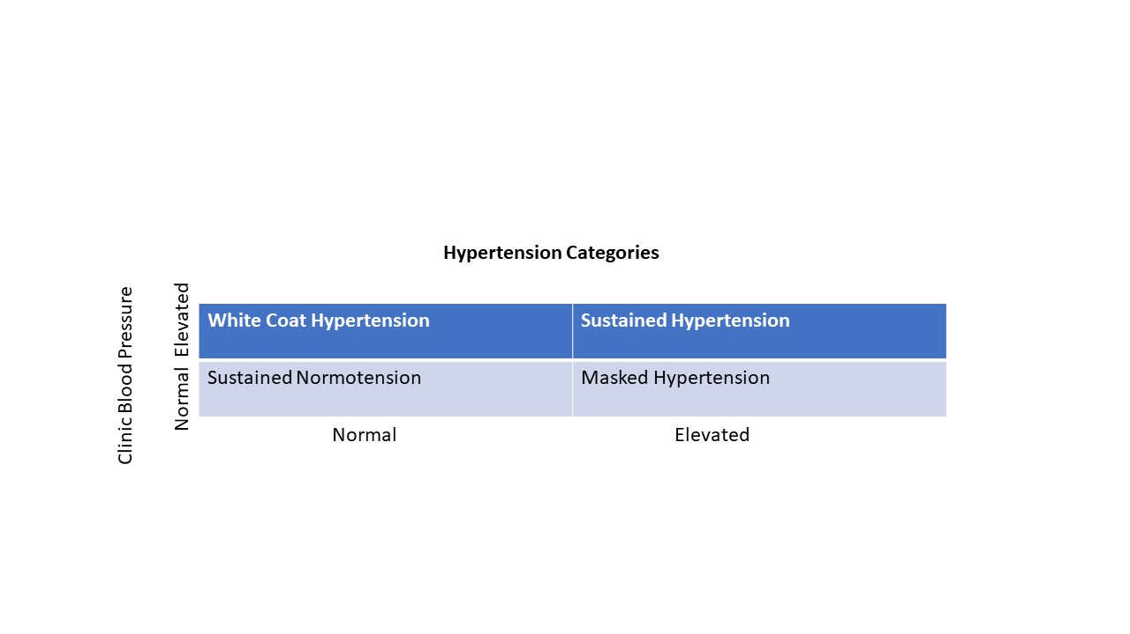
Figure 1 : Categories of Hypertension

As stated by the World Health Organization (WHO), the leading cause of global mortality is cardiovascular disease [6]. Unhealthy lifestyle choices, elevated cholesterol levels, and hypertension are contributing factors to the increased risk of cardiovascular issues. Hence, the timely identification of these conditions holds the potential to diminish the risk of cardiovascular-related deaths. Among the prime risk factors, hypertension stands out, as it can be anticipated through blood pressure assessment. A range of methods, both invasive and non-invasive, exist for measuring blood pressure.

In critical care units or major surgical settings, invasive techniques are typically applied, necessitating the expertise of a trained professional. Conversely, the non-invasive approach is widely favored for its convenience. Most of these non-invasive methods offer accurate blood pressure measurements with minimal discomfort for patients [6]. Consistently measuring blood pressure at home has been shown to enhance hypertension control and treatment efficacy compared to infrequent clinic-based measurements alone [7]. Consequently, maintaining a continuous watch over cardiovascular health parameters is imperative. This has sparked considerable interest in the development of biosensors leveraging technological advancements, known for their simplicity, portability, and ability to provide uninterrupted, non-invasive monitoring.

Wearable sensors, exemplified by health tracking devices, are experiencing a surge in popularity. Innovative technologies for wearable blood pressure monitoring hold the potential to enable easy and inconspicuous monitoring at home and throughout the day. These advancements play a significant role in increasing hypertension awareness across a broader segment of the population. To be on par with conventional blood pressure cuff devices, these innovations must offer convenience and comparable accuracy [6, 8].

Over the past two decades, machine learning systems have progressively gained prominence in healthcare, primarily for patient monitoring and disease diagnosis. Digital health fitness trackers, fitness watches, and smartphone applications designed for health monitoring have captured attention, particularly due to their health tracking benefits and integration of physiological sensors with artificial intelligence. These sensors are largely affordable, portable, user-friendly, and support continuous monitoring. Photoplethysmography (PPG) and Electrocardiography (ECG) are two promising techniques with the potential to significantly impact cardiovascular health tracking.

This chapter spotlights recent advancements in hypertension biosensors, delving into photoplethysmography, pulse-transit time, and their roles in estimating blood pressure. The discussion extends to various modes of biosensor application and the ethical implications of artificial intelligence. Overall, the chapter offers a comprehensive view of healthcare progress and patient management through the adept utilization of technological breakthroughs to control hypertension.

III. BIOSENSORS FOR HYPERTENSION MONITORING

Biosensors encompass analytical tools that transform biological responses into electrical signals. They gauge the levels of biological markers or chemical reactions by generating signals that correspond to the concentration of an analyte within those reactions. Ideally, biosensors should exhibit exceptional specificity and remain unaffected by physical factors like pH and temperature. They ought to possess sensitivity, stability, reproducibility, and the capacity to detect particular analytes even when present in minute concentrations. This property is referred to as linearity, denoting a substantial signal alteration in response to minimal shifts in analyte concentration [4, 9]. In the realm of blood pressure (BP) measurement, biosensors fall into two categories: those reliant on cuffs and those without cuffs. Non-cuff devices, which provide continuous and non-invasive BP measurements, have garnered considerable interest. These compact, cost-effective, and comfortable devices are not only used for BP monitoring but also extend to tracking other vital signs such as oxygen saturation, body temperature, and respiratory rate [4, 10].

- Different principles and mechanisms of Biosensors:

- Electrochemical Biosensors: These consist of electrodes that translate chemical signals into electrical signals.
- Visual Biosensors: These particular biosensors, often referred to as optical biosensors, identify alterations in light characteristics, encompassing transmittance, reflectance, and fluorescence. These changes arise from the interaction between an analyte and a receptor. Photoplethysmography (PPG) constitutes a technique for quantifying the light absorbed or reflected by blood vessels within living tissue. The degree of absorption or reflection correlates with the quantity of blood present in the optical pathway. Consequently, the signal is sensitive to fluctuations in blood volume, determined through a photoelectric method, rather than solely responding to blood pressure. Wearable devices can incorporate PPG sensors to facilitate blood pressure monitoring [2, 4, 11]. Figure (2) demonstrates the reflective and transmittive types of biosensors with the differences in the position of the photodetector and the light source.
- Calorimetric Biosensors: These biosensors measure the heat released or absorbed by the reaction.

Figure (2) demonstrates the reflective and transmittive types of biosensors with the differences in the position of the photodetector and the light source

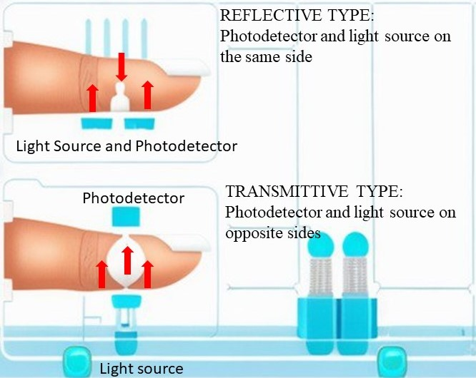
Figure 2: Representation of reflective type and transmittive type (PPG sensor and light source)
[4]-Aggarwal H, Jain D, Pahuja T. Biosensors in Hypertension. In 2021. p. 152–62.

(B) Photoplethysmography (PPG)

Utilizing photoplethysmography (PPG) signals for blood pressure assessment has emerged as a promising and user-friendly approach. PPG involves quantifying the light absorbed or reflected by blood vessels within living tissue. The extent of this absorption or reflection is contingent upon the volume of blood present in the optical path. Notably, the PPG signal reacts to shifts in blood volume rather than the pressure within blood vessels. This comprehensive signal spans both systolic and diastolic periods, encompassing hemodynamics and peripheral microcirculation systems. Thus, it serves as an external indicator of physiological processes like heart rate, blood pressure, cardiac output, and microcirculatory blood flow.

The convenience and affordability of PPG make it a valuable technique, with its principles lending themselves to the creation of wearable, non-cuff blood pressure monitoring devices. In essence, PPG offers a cost-effective and accessible technology applicable to a wide range of cardiovascular monitoring aspects. These include measuring blood oxygen saturation, heart rate, blood pressure, cardiac output, respiration rate, arterial aging, endothelial function, microvascular blood flow, and autonomic function (4, 11). Recent advancements in remote photoplethysmography (rPPG) algorithms have paved the way for novel methods of contactless blood pressure measurement.

PPG Signal Processing:
Wearable biosensors comprise a light-emitting diode (LED) transmitter that emits or reflects infrared light to capture the PPG signal. This signal arrives in its unprocessed and corrupted state, necessitating preprocessing steps like normalization, denoising, or filtration, often employing median and notch filters. Once refined, the resulting high-quality signal remains untainted, encompassing the distinct systolic and diastolic phases separated by a dicrotic notch. This pristine signal serves as the basis for extracting valuable characteristics such as peak-to-peak interval, systolic peak amplitude, crest time, pulse area, and stiffness index.

The systolic peak, defined by the amplitude of the PPG waveform, proves pivotal in calculating heart rate. This amplitude reveals insights into the pulsatile alterations within blood volume. Crest time quantifies the duration from the PPG wave's base to its zenith. Additionally, the 'stiffness index' serves as an indicator of arterial stiffness, computed while considering the individual's height and weight. These parameters form the foundation of various time-domain processing techniques like peak detection and transition point calculation. Figure 3 illustrates the pulse waveform of a photoplethysmogram (PPG).
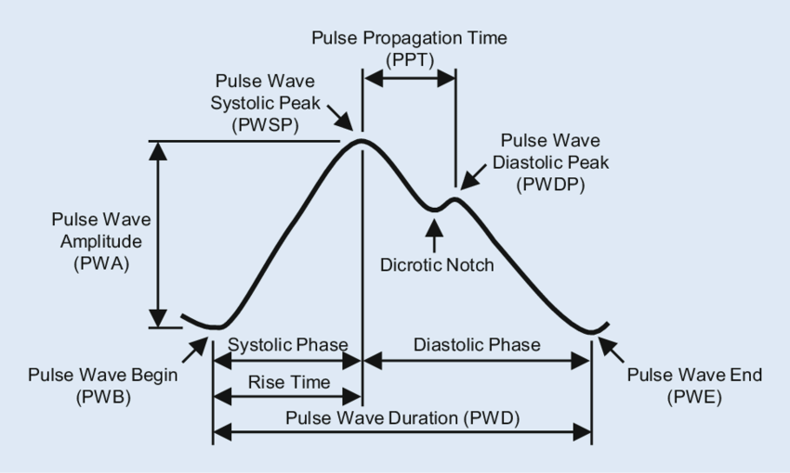
Figure 3 : Description of pulse wave form of photoplethysmogram (PPG)
[12]-Fischer C, Glos M, Penzel T, Fietze I. Extended algorithm for real-time pulse waveform segmentation and artifact detection in photoplethysmograms. Somnologie. 2017 May 17;21:1–11.

(C) Some Important Terms to Understand the mechanics of Biosensors: [13]

Pulse Wave Velocity (PWV): PWV is the speed at which the pressure wave propagates through arteries. Typically, PWV is calculated by gauging the Pulse Transit Time (PTT).

Pulse Transit Time (PTT): PTT measures the duration it takes for the pressure wave to travel from a starting point to a distant point within the arterial system, all within a single cardiac cycle. The underlying principle hinges on the fact that arterial elasticity is linked to blood pressure (BP), subsequently influencing PWV. This leads to the possibility of estimating BP via PTT or PWV measurements. However, the precise relationship between BP and PTT varies individually, contingent upon the unique physical characteristics of each person's blood vessels. To establish a rough approximation of this relationship, it's necessary to carry out a calibration process involving multiple reference BP measurements for each individual.

Pulse Arrival Time (PAT): PAT encompasses not only the targeted PTT but also a pre-ejection period (PEP). PAT has demonstrated a significant correlation with BP, particularly systolic BP.
Figure 4 showcases the visualization of Pulse Transit Time (PTT), Pulse Arrival Time (PAT), and Pre-Ejection Period (PET).
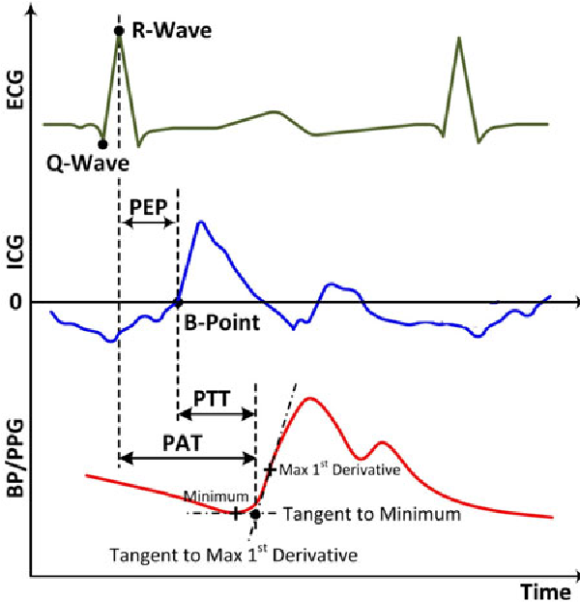
Figure 4: Demonstrating Pulse transit time (PTT), Pulse Arrival Time (PAT), and Pre-Ejection period (PET)
[14]-Mukkamala R, Hahn JO, Inan OT, Mestha LK, Kim CS, Toreyin H, et al. Toward Ubiquitous Blood Pressure Monitoring via Pulse Transit Time: Theory and Practice. IEEE Trans Biomed Eng. 2015 Aug;62(8):1879–901.

(D) Pulse transit time-based methods:
Pulse transit time (PTT) refers to the duration it takes for the pressure wave to traverse between two points within the arterial system during a single cardiac cycle. Conventionally, the heart is taken as the starting point, with the index finger serving as the destination. PTT proves valuable in approximating the speed of the pressure wave, which is termed as Pulse Wave Velocity (PWV). This velocity is contingent on the inflexibility and resistance of the vessel wall. Elevated blood pressure (HTN) can contribute to arterial media thickening, leading to heightened wall tension. Measurements of PTT and PWV can provide estimates of blood pressure (BP).

Calculating PTT often involves integrating Photoplethysmography (PPG) with other cardiovascular signals like the Electrocardiogram (ECG), ballistocardiogram (BCG), and phonocardiogram (PCG). PTT denotes the temporal distance between a distinct point in one signal and a specific point within the PPG waveform.

(E) PPG combined with Electrocardiogram (ECG):
To determine the pulse transit time, two essential components are required: an electrocardiogram and a photoplethysmogram. Within the electrocardiogram (ECG) signal, the peak R wave aligns with the ventricles' contraction and the blood's propulsion through the arteries. This R wave serves as the designated starting point for pulse transit time measurement. Conversely, in the photoplethysmogram (PPG) signal, the peak marks the conclusion of the PTT measurement. Thus, the temporal disparity between these two peaks defines the pulse transit time.

Blood pressure estimation involves the application of fluid dynamic principles. This approach is notably advantageous for patients confined to bed. However, its viability for ambulatory monitoring is restricted due to the need for separate devices and multiple sensors (requiring 3 ECG electrodes and a PPG finger optical sensor), which is not practical for routine daily use.

Another approach involves measuring the pulse arrival time (PAT), computed as the temporal gap between the ECG's R wave and the systolic peak within the PPG waveform. PAT is subsequently used to derive the pulse transit time (PTT), with the formula PAT = PTT + PET (pre-ejection time). PET denotes the interval between the electrical depolarization of the left ventricle and the mechanical ventricular ejection. Further research is underway in this domain, particularly to establish PTT using multiple PPG signals [4, 15]. Some studies have explored alternative vital signs, like the phonocardiogram (PCG) or ballistocardiogram (BCG), as proximal timing references to derive the PTT index instead of the PAT index.

(F) WEARABLE BIOSENSORS:
Wearable biosensors have gained popularity with the advent of technology for health monitoring. These devices measure BP while the person is performing routine daily activities without causing any disturbance. The detection of elevated blood pressure can help detect a missed dose of an antihypertensive. Some devices utilize an alarm system that gets triggered by a change in blood pressure and reminds patients about their missed dose. These devices can also be useful in emergency departments to screen for elevated blood pressure. Lastly, with the advent of telehealth, physicians can monitor the data from their patients’ devices, thus serving as a boon for cardiovascular monitoring.

- Smartwatches and Fitness Trackers:
Smartwatches offer a convenient, non-intrusive, and cuff-free approach to blood pressure assessment. This methodology is founded on a watch-based system, akin to fitness trackers such as FitBit or the Apple Watch. The technique relies on utilizing pulse-transit time (PTT) to derive blood pressure readings. When the user positions the watch's face on their sternum for approximately 15 seconds, the watch's accelerometer captures thoracic vibrations and notes the proximal timing of blood ejection from the left ventricle into the aorta. Meanwhile, optical sensors on the watch, which gauge the blood volume pulse or photoplethysmogram (PPG), track the distal timing – the duration taken for the pulse wave to reach the wrist. The temporal delay between these proximal and distal times yields the pulse transit time (PTT), which is then matched with individual-specific parameters furnished during the initial calibration to estimate blood pressure levels. This technique's advantage lies in its absence of cuffs and non-invasive nature, enabling episodic blood pressure measurement by placing the watch on the chest when needed. However, it should be noted that this method doesn't enable continuous monitoring due to its user-dependent measurement point [4, 8].

- Blood pressure monitoring patches and multimodal sensors:
A flexible, stretchable, and integrated wearable sensor has been developed to enable the monitoring of blood pressure, heart rate, and levels of various substances such as glucose, lactate, caffeine, and alcohol. This comprehensive self-monitoring tool utilizes ultrasonic transducers for blood pressure (BP) and heart rate (HR) monitoring, while electrochemical sensors are employed to measure biomarker levels. By thoughtfully selecting materials, designing, and fabricating, researchers collaborating with Semipionatto et al. have created both rigid and flexible sensor components, specifically incorporating piezoelectric lead zirconate titanate (PZT) ultrasound transducers and polymer composites. These components are integrated into a single conformal wearable sensor that exhibits robust mechanical resilience without signal interference. This innovative device facilitates real-time tracking of diverse parameters related to cardiovascular health and enables simultaneous sampling of interstitial fluid and sweat biofluids. The wearable patch emits ultrasonic pulses, capturing echoes from arteries and simultaneously stimulating sweat and extracting interstitial fluid via iontophoresis. This permits the concurrent measurement of heart rate, blood pressure, and other biomarkers in the extracted fluid. The wearable patch employs a stretchable substrate, ensuring high flexibility, conformity, and stretchability.
The blood pressure sensing component consists of an array of eight piezoelectric transducers, optimally positioned over the carotid artery to capture accurate ultrasonic signals. These transducers emit ultrasound pulses that generate echoes from both the anterior and posterior walls of the artery. On the chemical sensing front, the process involves applying an IP current from a positive terminal (anode) to a negative terminal (cathode). This facilitates the electro-repulsive delivery of a sweat-stimulating molecule (P+, such as pilocarpine or nitrate). After pilocarpine delivery, the sensor collects and quantifies stimulated sweat containing biomarkers like lactate, caffeine, and alcohol on its right side. This device holds particular promise for critically ill patients who necessitate continuous monitoring of glucose, lactate, and blood pressure. The integration of acoustic and electrochemical sensing in a single wearable patch offers insights into the body's responses to daily activities and could potentially predict early signs of physiological irregularities. Importantly, this non-invasive, comfortable wearable device stands to provide valuable information while minimizing discomfort for the wearer [16].
(c) ECG monitoring devices:
Sagirova et al. conducted a study [17] introducing CardioQVARK, a smartphone case that integrates a single-channel ECG monitor and a photoplethysmography (PPG) monitor to estimate blood pressure. Their research aimed to establish the correlation between traditional blood pressure readings using a standard sphygmomanometer and the outcomes obtained from a portable ECG monitor combined with PPG for pulse wave registration among individuals with arterial hypertension. This device simultaneously captures ECG and PPG data, with a linked smartphone application collecting pertinent information like gender, height, weight, associated risk factors, and ICD-10 codes. The accumulated parameters are then transmitted to a server. This server contains built-in algorithms designed to compute heart rate, heart rhythm, PQRST interval, pulse wave type, extrasystole count, vascular stiffness, oxygen saturation (Spo2), and breathing cycles per minute. Leveraging the combined ECG and PPG results, the server estimates blood pressure values. The pulse wave and cardiac cycle are automatically cross-referenced with quality standards for assessment. Inadequate quality recordings are eliminated. Following this, the parameters are marked and calculated, forming the basis for systolic and diastolic blood pressure estimations.

Bland-Altman analysis revealed a robust correlation between the cuff-less smartphone-case-based blood pressure device and traditional cuff-based sphygmomanometer readings, particularly in systolic and diastolic blood pressure values. The emergence of innovative technologies like this one, enabling remote and cuff-less blood pressure monitoring, holds the potential to enhance blood pressure management, ultimately leading to reduced morbidity and mortality rates among individuals dealing with hypertension.

Advantages:
1. Simplifies and facilitates BP monitoring using a non-invasive, cuff-less method
2. Does not require regular checks, calibrations, or the size of cuff, making it easy for patients with obesity
3. Increased efficacy of home-based BP monitoring allows telemetric transmission of results and eases interventions such as medication titration.
4. Easy-to-use smart phone-based applications allow widespread application.

Limitations:
1. The value of BP depends on the quality of PPG; therefore, further studies are needed on the effect of noise, etc., to determine the accuracy of the reading.
2. The BP measure was compared to a non-invasive method; therefore, no comparison with the gold standard invasive method was made.

(d) Biosensors in the Phone:
Mobile phones can be used as a tool for BP monitoring. Both Android and Apple phones have mobile applications that work on the basis of an oscillometric mechanism for blood pressure measurement. The individual presses his or her finger against the rear camera of the phone. Pulsatile blood volume oscillations within the artery are measured via PPG and a transducer embedded in the phone. The amplitude of these oscillations is used to compute the blood pressure.
Smartphone devices can also measure blood pressure using photoplethysmography (PPG) and vascular transit time (VTT). The cameras on the smartphone help in determining the proximal time taken by the PPG signal from the individual’s finger.The distal point is derived from the heart sounds collected by the microphone of the device. The VTT between these two points is calculated to estimate BP [4].
Smartphone applications like Instant Blood Pressure and Wello are a few among many others easily available on the Play Store and App Store to the majority of the population. These apps use the principle of wave propagation to estimate blood pressure.

(e) Eyeglasses:
Eyeglasses incorporating photoplethysmography (PPG) sensors are equipped to capture the pulse waveform. These sensors are strategically positioned: at the nose bridge, detecting pulsations from the angular artery; on the side of the head, capturing temporal artery pulsations; and behind the ear, gauging occipital artery pulsations. This arrangement enables blood pressure measurement by calculating the time difference between pulse occurrences in different arteries, constituting the pulse transit time. However, it's crucial to note that this device lacks validation within a clinical setting.

(G) SUBCUTANEOUS IMPLANTABLE BIOSENSORS FOR HYPERTENSION MONITORING:
An implantable system, characterized by its minimal invasiveness, utilizes pulse transit time for blood pressure assessment. The pulse wave is discerned through a photoplethysmographic (PPG) signal, directly acquired with exceptional quality from subcutaneous muscle tissue. Simultaneously, electrocardiograms (ECG) are captured from the same tissue using flexible implantable electrodes. A flat optoelectronic pulse oximeter, measuring 20mm x 6mm, operates in reflection mode to detect the PPG signal. Both the sensor and ECG electrodes can be implanted with a small incision into the skin, thus facilitating convenient, long-term blood pressure monitoring and alleviating the burden of the disease.

(H) ULTRASOUND BASED BLOOD FLOW MEASUREMENT :
Ultrasonic transducers are flexible devices to measure blood flow. They can display information on the local position, and the simplicity of handling ultrasound transducers allows measurement over major vasculature not easily accessible by conventional cuff or other non-invasive cuffless methods. In a pilot study done by Meusel et al. [18] , ultrasonic BP measurement was shown to be an adequate and accurate alternative to continuous hemodynamic monitoring.

Table 1: Comparative table listing the advantages and limitations of some biosensors
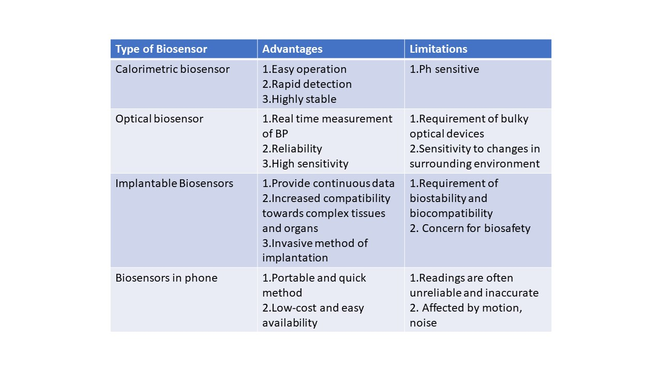

IV. UTILIZATION AND PROSPECTS OF MACHINE LEARNING IN HYPERTENSION STUDIES

Artificial Intelligence (AI) has emerged as a valuable tool for hypertension-focused clinicians. Machine learning encompasses methodologies and algorithms for predictive modeling, with the central objective of generating optimal linear or non-linear predictions. It also encompasses techniques for unsupervised learning. Machine learning is gradually leaving its imprint on clinical research and practice in multifaceted ways. One avenue involves enhancing clinical decision-making by drawing insights from extensive datasets, identifying associated patterns, and aiding in effective decision-making. Additionally, it enables epidemiologists and researchers to explore disease occurrence patterns and attain a comprehensive understanding of contributing factors. Consequently, this empowers community health organizations and clinicians to propose preventive measures for better condition management and improved control.

Wearable sensors and smartphone applications offer a means of tracking patient behavior, facilitating remote, real-time data monitoring and early identification of potential risks. For high-risk individuals, this capability allows physicians to gauge medication adherence and compliance with clinical recommendations. It opens doors to personalized interventions tailored to address the intricate requirements of each individual. Furthermore, data from these devices can fuel further clinical investigations. In totality, the influence of machine learning and AI on healthcare advancement is profound [19].

Progress in Biosensor Technologies:
Recent technological strides have endowed biosensors with significant potential for enhancing home blood pressure monitoring. They have contributed to the enhancement of medication adherence, functioning as diagnostic tools for kidney diseases, end-stage renal conditions, chronic kidney disease (CKD) care, and post-kidney transplant patient management [20].

V. ETHICAL CONSIDERATIONS

Every technological advancement in science comes with some legal and ethical implications. Some of the main ethical issues to be considered with the use of biosensors in healthcare are consent and autonomy. The use of applications with personal health information about individuals and their usage for research and clinical advancement may be pointed out as an invasion of privacy. There is also a right reserved for every patient, with a “right to know” and a “right not to know”. Due to continuous remote real-time monitoring with the help of smartphones,somewhere the patient loses the autonomy to make decisions about not wanting to know some particular aspects of his or her health. Numerous ethical aspects can be debated, and certain regulations would definitely be needed to validate these concerns.

VI. CONCLUSION

With the widespread use of portable and wearable health devices, continuous and timely monitoring of blood pressure has become a possibility. The principle of photoplethysmography has been used independently or in combination with an ECG to estimate blood pressure. The availability of mobile applications on Android and Apple devices that measure BP by simply pressing a finger against the rear camera of the phone has helped guide healthcare professionals in identifying fluctuations in the patterns of an individual’s BP and also helped remind a person of their missed dose of medication with the help of alarms. In the larger picture, this has helped prevent the complications of hypertension, thereby contributing to the prolonging of lifespan through the reduction of mortality from cardiovascular disease. However, there are various ethical concerns that need to be addressed with respect to the use of artificial intelligence in healthcare.

VII. REFERENCES

[1] More than 700 million people with untreated hypertension [Internet]. [cited 2023 Jul 14]. Available from: https://www.who.int/news/item/25-08-2021-more-than-700-million-people-with-untreated-hypertension
[2] García‐Rubio DL, de la Mora MB, Cerecedo D, Saniger Blesa JM, Villagrán‐Muniz M. An optical-based biosensor of the epithelial sodium channel as a tool for diagnosing hypertension. Biosens Bioelectron. 2020 Jun 1;157:112151.
[3] Franco C, Sciatti E, Favero G, Bonomini F, Vizzardi E, Rezzani R. Essential Hypertension and Oxidative Stress: Novel Future Perspectives. Int J Mol Sci. 2022 Nov 21;23(22):14489.
[4]Aggarwal H, Jain D, Pahuja T. Biosensors in Hypertension. In 2021. p. 152–62.
[5] Alpert BS, Quinn D, Gallick D. Oscillometric blood pressure: a review for clinicians. J Am Soc Hypertens. 2014 Dec 1;8(12):930–8.
[6] Maqsood S, Xu S, Tran S, Garg S, Springer M, Karunanithi M, et al. A survey: From shallow to deep machine learning approaches for blood pressure estimation using biosensors. Expert Syst Appl. 2022 Jul 1;197:116788.
[7] Agarwal R, Bills JE, Hecht TJW, Light RP. Role of Home Blood Pressure Monitoring in Overcoming Therapeutic Inertia and Improving Hypertension Control. Hypertension. 2011 Jan;57(1):29–38.
[8] CAREK AM, CONANT J, JOSHI A, KANG H, INAN OT. SeismoWatch: Wearable Cuffless Blood Pressure Monitoring Using Pulse Transit Time. Proc ACM Interact Mob Wearable Ubiquitous Technol. 2017 Sep;1(3):40.
[9] Metkar SK, Girigoswami K. Diagnostic biosensors in medicine – A review. Biocatal Agric Biotechnol. 2019 Jan 1;17:271–83.
[10] Wieringa FP, Broers NJH, Kooman JP, Van Der Sande FM, Van Hoof C. Wearable sensors: can they benefit patients with chronic kidney disease? Expert Rev Med Devices. 2017 Jul 3;14(7):505–19.
[11] Elgendi M, Fletcher R, Liang Y, Howard N, Lovell NH, Abbott D, et al. The use of photoplethysmography for assessing hypertension. Npj Digit Med. 2019 Jun 26;2(1):1–11.
[12] Fischer C, Glos M, Penzel T, Fietze I. Extended algorithm for real-time pulse waveform segmentation and artifact detection in photoplethysmograms. Somnologie. 2017 May 17;21:1–11.
[13] Esmaili A, Kachuee M, Shabany M. Nonlinear Cuffless Blood Pressure Estimation of Healthy Subjects Using Pulse Transit Time and Arrival Time. IEEE Trans Instrum Meas. 2017 Sep 12;PP:1–10.
[14] Mukkamala R, Hahn JO, Inan OT, Mestha LK, Kim CS, Toreyin H, et al. Toward Ubiquitous Blood Pressure Monitoring via Pulse Transit Time: Theory and Practice. IEEE Trans Biomed Eng. 2015 Aug;62(8):1879–901.
[15] Omari T, Bereksi-Reguig F. A new approach for blood pressure estimation based on phonocardiogram. Biomed Eng Lett. 2019 Jun 7;9(3):395–406.
[16] Sempionatto JR, Lin M, Yin L, De la paz E, Pei K, Sonsa-ard T, et al. An epidermal patch for the simultaneous monitoring of haemodynamic and metabolic biomarkers. Nat Biomed Eng. 2021 Jul;5(7):737–48.
[17] Sagirova Z, Kuznetsova N, Gogiberidze N, Gognieva D, Suvorov A, Chomakhidze P, et al. Cuffless Blood Pressure Measurement Using a Smartphone-Case Based ECG Monitor with Photoplethysmography in Hypertensive Patients. Sensors. 2021 May 19;21(10):3525.
[18] Meusel M, Wegerich P, Bode B, Stawschenko E, Kusche-Vihrog K, Hellbrück H, et al. Measurement of Blood Pressure by Ultrasound—The Applicability of Devices, Algorithms and a View in Local Hemodynamics. Diagnostics. 2021 Dec 2;11(12):2255.
[19] Amaratunga D, Cabrera J, Sargsyan D, Kostis JB, Zinonos S, Kostis WJ. Uses and opportunities for machine learning in hypertension research. Int J Cardiol Hypertens. 2020 Mar 19;5:100027.
[20] Park SH, Zhang Y, Rogers JA, Gallon L. Recent advances of biosensors for hypertension and nephrology. Curr Opin Nephrol Hypertens. 2019 Jul;28(4):390.

