SMART CAR PARKING SYSTEM

Yuvasri M
Department of Electronics and Communication Engineering,
Karpagam Institute of Technology,
Coimbatore, Tamil Nadu, India.

Mythili Priya R
Department of Electronics and Communication Engineering,
Karpagam Institute of Technology,
Coimbatore, Tamil Nadu,India.
Poornima K
Department of Electronics and Communication Engineering,
Karpagam Institute of Technology,
Coimbatore,TamilNadu,India.

Palanivelavan R
Department of Electronics and Communication Engineering,
Karpagam Institute of Technology,
Coimbatore, Tamil Nadu,India.

S. Pragadeswaran*
Department of Electronics and Communication Engineering,
Karpagam Institute of Technology,
Coimbatore, Tamil Nadu, India.
praga1994@gmail.com

ABSTRACT

Automated parking guidance systems help drivers detect whether a parking spot is occupied or vacant, which can save the driver unnecessary search time to find an available spot. Both drivers and cities benefit from these parking guidance systems because these systems can reduce traffic congestion caused by drivers looking for parking spaces. When a parking spot is vacant in a garage or parking lot, the guidance systems can also maximize the revenue of a paid parking area by alerting drivers about the open spot. One way to detect whether a parking spot is empty or occupied is through contactless ultrasonic technology, as it is reliable in harsh outdoor environments. Gates to garages can also employ ultrasonic technology to make the ticketing process fully automated. Efficient and smart way to automate the management of the parking system that allocates an efficient parking space using internet of things technology. The IoT provides wireless access to the system and the user can keep a track of the availability of the parking area. With an increase in the population of vehicles in metropolitan cities, road congestion is the major problem that is being faced. The aim of this paper is to resolve this issue. The user usually wastes his time and efforts in search of the availability of the free space in a specified parking area. The parking information is sent to the user via notification. Thus, the waiting time for the user in search of parking space is minimised. RFID technology is being used to avoid car theft. The Internet of things (IoT) has the ability to transfer data through networks without involving human interactions. IoT allows users to use affordable wireless technology and also helps the user to transfer the data into the cloud. IoT helps the user to maintain

Keyword: RFID, Arduino, GSM Module, IR Sensor, cloud database

I. INTRODUCTION
The Internet of things (IoT) has the ability to transfer data through networks without involving human interactions. IoT allows users to use affordable wireless technology and also helps the user to transfer the data into the cloud. IoT helps the user to maintain transparency. The idea of IoT started with the identity of things for connecting various devices. These devices can be controlled or monitored through computers over the internet. IoT contains two prominent words “Internet” and “Things”, where Internet is a vast network for connecting servers with devices . The Internet enables the information to be sent, received or even communicate with the devices. The parking problem causes air pollution and traffic congestion . In today’s scenario, parking space is hard to search in a day to day life for the people. According to the recent survey, there will be a rapid increase in the vehicle’s population of over 1.6 billion around 2035 . Around one million barrels of the world's oil is being burnt everyday . Thus, a smart parking system is the key solution to reduce the waste stage of the fuel. The solution for the problems that are being raised. Smart parking can be a solution to minimise user’s time and efficiency as well as the overall cost of the fuel burnt in search of the parking space. In this, the data is collected from the sensor and through analysing and processing, the output is obtained.
This data gets transmitted in the devices which extracts the relevant information and sends it to the Arduino device which gives the command instruction for the data to the particular devices simultaneously. Arduino sends the signal to the servo motor along with a GSM module which further gives instructions and notification to the user. When the user enters the parking area, the RFID card allotted to the registered user is scanned by the reader module thus ensuring the security of the user identity. This enables the user to get the information of the available parking space as well as SMS notification to the registered user’s mobile number. It consists of three parts where the first part is the parking area which includes Arduino devices along with IR Sensor. The user interacts with the parking area with the help of these devices. The second section of the paper includes the cloud web services which act as a mediator between the user and the car parking area. The cloud is updated according to the availability of parking areas. The cloud service is administered by the admin but it can also be viewed by the user to check the availability. The third section of the paper is the user side. The user gets notified for the availability via SMS through the GSM module. The user interacts with the cloud as well as the parking area. The user gets the notification when the parking availability is full which saves the time for the user.

II. LITERATURE SURVEY

The existing parking systems simply gather the available information of vacant parking lots using various sensor networks, and update the data to direct drivers. But the problem lies here, this system will not be able to direct the drivers to their respective parking slots. Blind searching is a common way by which drivers look out for vacant spaces when there is no availability of parking information. The drivers keep searching for empty parking spaces within a close distance to their end location.
The drivers will not stop looking around until they find an empty space and keep extending the searching area. To Tackle The Problem Of “many-vehicles-chase-single-slot”, the way of sharing the information about the parking slots is modified. The designers intentionally decrease the number of available slots while publishing the information, they act as buffer slots. When there are many vehicles wanting to park in a limited amount of available space, this system will have some extra spaces reserved in order to avoid a conflict. But it is a difficult task to estimate the number of the buffer spaces required. If the reserved space is too small, then we cannot overcome the problem of “many-vehicles-chase-single-slot”. If the buffer is too large, then parking space cannot be utilized effectively.
Walking distance and Traffic volume are two performance metrics that address these issues. In order to address these challenges few systems have been already proposed such as Reservation Performance where the system continuously retrieves and stores data about the performance metrics, it also includes the status of parking slot(occupied or vacant), reservation time, exact parking location and also about driver’s identity. As soon as the reserved space is occupied by a vehicle, the system should automatically verify the driver’s identity in order to block that slot. Iris-net has proposed a system which uses cameras, microphones and motion detectors.
These sensors are used to detect the availability of vacant parking spaces. It also acquires real time information about vacant parking slots through their web applications. But the problem is that it generates a huge amount of data. One of the main limitations of this system is high energy consumption and it also suffers from technical aspects [3]. The E-parking system makes use of the latest technologies to merge the reservation of parking slots and the payment systems.
A driver can utilize this system to get information about the availability of vacant parking spaces, to reserve a parking space at his desired location and also to make the payment when leaving [4].The above system can be accessed through a smartphone, or through the web. But still there is a requirement of conventional detectors to detect the status of the parking slot. Automated parking systems make a way for an efficient use of a limited number of parking spaces.

III. PROPOSED SYSTEM

It consists of three sections: the first section is the parking area which includes Arduino devices along with sensors. The user interacts with the parking area with the help of these devices. The user cannot enter the parking area without the help of an RFID card. The second section contains the cloud-based web services which act as a mediator between the user and parking area. The cloud is updated depending upon the availability of the parking area. The admin administers the cloud services and it can also be viewed by the user for checking the availability. The third section is the user side. The user gets notification on the basis of the availability via SMS through GSM module.

IV. HARDWARE AND DESCRIPTION
The three main hardware components used are GMS module, RFID card, and IR sensors. A user is allowed inside a parking space only if the user has a RFID card. RFID card contains the information of the registered user. As the car enters the parking slot, the reader module scans the registered user’s RFID tag. The data is sent to the ardunio for checking the availability of the car parking and simultaneously, the user is notified through SMS about the status of the parking area. The GSM module sends the message according to the availability. IR sensor sends the signals according to the presence of the vehicle.
COMPONENTS:
IR SENSOR:
An infrared sensor is basically an electronic device which is used to detect the presence of objects. Infrared light is emitted by this device. If this device does not detect any IR light reflected back that means there is no object present. If the light is detected by the sensor there is an object present.
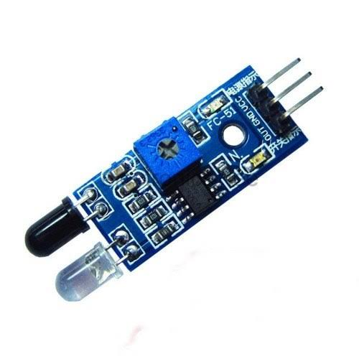
Figure1.IR Sensor

RFID TAGS:
RFID tags are made up of integrated circuit (IC), an antenna, and a substrate. It is an identification badge or credit card that transfers its contents about an object to the reader module. RFID tag transfers data about an object through radio waves. When RFID tags are attached to devices they can also be used for tracking.
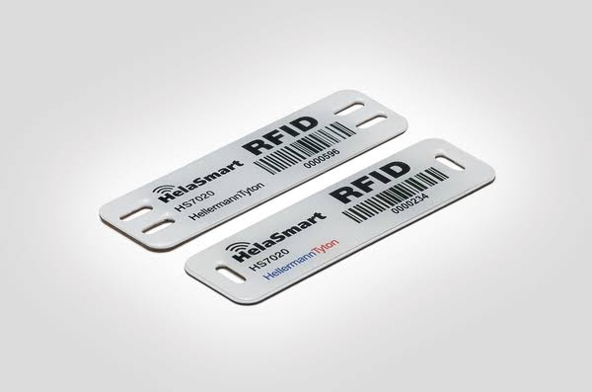
Figure 2.RFID tags

GSM module:
The GSM module is a circuit which is used to setup communication between mobile phones and microcontroller. It is used to send SMS, MMS and voice messages through mobile network. GPRS extension in GSM allows high data transmission. GSM uses time division multiple access approach for transmission.
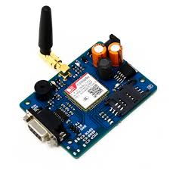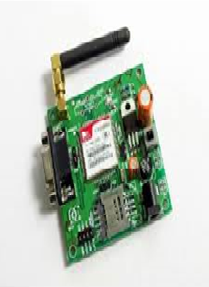
Figure 3.GSM module

V. SOFTWARE AND DESCRIPTION

APP DEVELOPMENT:
An app is developed which is supported on android, windows and IOS. This app enables the users to register and book slots in advance. Another advantage is that the users can pay through their linked wallets in the app.
WEBSITE:
Similar to the application , the users are authenticated and allowed to book through the website also. The programming languages that are used to build the website are PHP, JS, Bootstrap, Jquery and HTML.

VI.METHODOLOGY
Every parking slot in the given mall is identified with a unique id(Parking id).The User registers using either the app/website which prompts him to enter the Username and Password. Once he is registered he is given a unique Customer id. This id is used every time he wants to book a parking slot. To book a parking slot he initially needs to select a destination of his choice. The available number of parking slots in that place will be displayed. One constraint we consider is that the user is allowed to book only when he is within 30 minutes from his arrival time.
Case 1:
For parking in public areas:
Parking spaces in public areas are considered registered to this system. Even people who are having unused parking space/garage can register to this system. This will be beneficial during peak hours. If the parking slots are available at the specified time at the desired location, the user is allocated a slot. This slot has a unique id (Parking id) associated with it which notifies the user where he has to exactly park his vehicle. He would receive a confirmation receipt regarding his parking status.
Case 2:
For parking inside malls:
If the parking slots are available at the specified time in that mall, the user is allocated a particular slot. This slot has a unique id (Parking id) associated with it which notifies the user of the slot where he has to park. He would receive a confirmation receipt regarding his parking status.
a) User didn’t arrive at the specified time If the time slot is opened and if the user hasn’t cancelled, whether he arrives at the specified time or at a later time, he will be charged the same amount. The amount deducted is based upon the duration of the slot booked by him.
b) Cancelled before the time slot opens The slot is released into the pool of available slots and the amount will not get deducted from the user’s account.
c) Cancelled after the time slot opens. The slot gets released into the available pool but a small amount (cancellation charges) gets deducted from the user’s account.

Flow Chart:

Start

|
[User Arrives at Parking Lot]

|
Is a Parking Spot Available?

|
Reserve Parking Spot (Optional)

|
Notify User and Provide Directions

|
User Parks Vehicle

|
Is Vehicle Detected in Spot?

|
Yes

|
Update Parking Availability Status

|

User Leaves Parking Lot

|
End

VI. RESULTS

The demand of smart parking system is increasing significantly. This allows user to involve real time access of the availability of the parking space. The existing system in today’s world doesn’t contains the facilities of parking reservation and parking slot availability checker.
The existing system was a vision-based monitoring system which estimates the number of the parking slots available in the area by counting the number of incoming and outgoing cars which consume a lot of time and effort. The next existing system was sensor-based system which uses ultrasonic sound waves for detecting the presence of vehicles and then two-tier parking came into existence which used the concept of parking cars one above another. The result of the paper is to make the parking area connected with the world as well as reduce time and can be cost effective for the user. The result of this paper is to reduce car theft. This paper reduces overall fuel energy of the vehicle which is consumed in the search of the car.

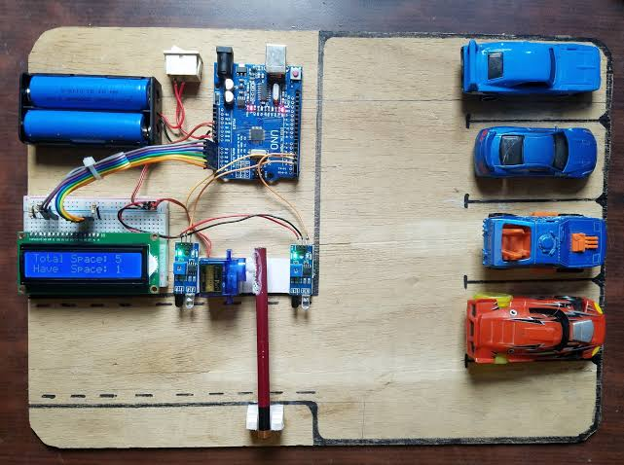

Figure 4. PROPOSED MODEL

VII. CONCLUSION AND FUTURE WORK
The concepts of smart cities have always been a dream. There have been advancements made from the past couple years to make a smart city dream into reality. The advancement of internet of things and cloud technologies has given rise to the new possibilities in terms of smart cities. Smart parking facilities have always been the core of constructing smart cities. The system provides a real time process and information of the parking slots.
This paper enhances the performance of saving users time to locate an appropriate parking space. It helps to resolve the growing problem of traffic congestion. As for the future work the users can book a parking space from a remote location .GPS(Global Positioning system), reservation facilities and license plate scanner can be included in the future.

REFERENCES
- Abhirup Khanna, R. A. (2016). IoT based Smart Parking System. International Conference on Internet of Things and Applications (IOTA) (p. 5). Pune: IEEE.
- Rachapol Lookmuang, K. N. (2018). Smart Parking Using IoT Technology . IEEE , 6.
- O. Orrie, B. S. (2015). A Wireless Smart Parking System. IECON (p. 5). Yokohama: IEEE.
- Khaoula Hassoune, W. D. (2016). Smart parking Systems:A Survey . IEEE .
- Wael Alsafery, B. A. (2018). Smart Car Parking System Solution for the Internet of Things in Smart Cities. IEEE .
- IrisNet: Internet -scale Resource-Intensive Sensor Network Service, http://www.intel-iris.net
- Kumar, Rakesh, Naveen K. Chilamkurti, and Ben Soh. "A comparative study of different sensors for smart car park management." In Intelligent Pervasive Computing, 2007. IPC. The 2007 International Conference on, pp. 499-502. IEEE, 2007.
- HappyMinds: SMARTPARKINGhttp://www.happiestminds.com

