TRENDS AND PATTERN OF AGRICULTURE PRODUCTIVITY IN INDIA: AN INTER-STATE STUDY

Imran Ali Baig
Department of Economics & IB
School of Business Studies Sharda University
Email Id: ialibaig043@gmail.com; Imran.baig@sharda.ac.in

1. Introduction

Agricultural development is one of the most powerful tools to eradicate extreme poverty, increase the income of the rural people, improve the standard of living of agriculture labour, boost shared prosperity and feed a projected 9.7 billion people by 2050 (FAO, 2019). Growth in the agriculture sector is more effective in raising rural incomes among the poorest as compared to other sectors of the economy. Agriculture plays a significant role in economic growth and development in several ways explained by the renowned economist (Johnston & Mellor 1961; Ranis & fie 1961). Agriculture productivity contributes to economic development, growth and national income in three significant ways. Johnston & Mellor (1961) stated that the agriculture sector in developing countries contributes mainly through five interlinkages, which include the transfer of surplus labour to the non-agriculture sector, providing the foods for the domestic consumption, provision of the market for industrial production, savings usage for the investment in the non-agriculture sector; and use of earnings obtained from agriculture export to finance the import of goods (Baig et al., 2021). The neoclassical growth model explained that economic growth is always accompanied by improved productivity and sustainable growth in the agriculture sector. These studies establish the link between the agricultural and industrial sectors, which can be seen from the development of processing of agricultural products for the industrial sector (Souza, 2014; Mondal, 2014; Olmstead & Rhode, 2007). In the case of developed countries, a thriving agricultural sector is a prerequisite for the development of the industrial and service sector in the future (Briones & Felipe, 2013). However, agriculture is the engine of economic growth in developing countries (Awokuse & Xie, 2015).
In the least developing nations, majority of the population lives in the rural regions and solely depends on the agriculture sector and its allied activities for their well-being. In the least developed countries and southern Asian countries, nearly 65.5 per cent of the population lives in rural areas. Approximately the same proportion works primarily in the agriculture sector and its allied activities (FA0 2019). According to Gollin, developing countries are poor, where most of the population lives in rural areas. Therefore, approximately 70 per cent of poor people live in a rural region in the world. In his seminal two-sector economic model (Lewis, 1954), he characterizes the agricultural or subsistence sector as labour abundant and the industrial sector as labour scarce. He discusses how labour migrates from the subsistence sector to the industrial sector. Humphries & Knowles (2010) establishes a direct positive association of transfer of labour with economic growth. The non-agriculture sectors, directly and indirectly depend on agriculture growth and productivity.
Productivity in agriculture is more petite than industrial production, which might be due to poorly managed agriculture firms. The performance of agriculture productivity is very poor due to the low level of rural infrastructure and the adverse impact of climate change. Beyond productivity and agriculture’s role as a productive sector, there are other reasons to focus on agriculture as a sector that has an essential impact on economic growth. One crucial issue is the sector's central role in providing food for the people of the Nation. Due to low agriculture productivity, relatively low trade and low income, they likely face high food costs relative to income in the developing countries. The household survey indicates that more than 50 per cent of income spend on food consumption almost necessarily imply deep poverty, closely related to low agricultural productivity and output (Gollin, 2010). Agriculture productivity is of immense importance to meet the demand of food consumption and improve the well-being of agriculture labours and workers in developing countries.
This chapter explores the trends and pattern of agricultural productivity in India during 1990-2020. First section of this chapter deals with the importance of agricultural development, second section reveals status of India’s agriculture sector to global economic growth, third section illustrates trends of agricultural productivity and growth and forth section deal with conclusion.

2. Status of India’s agriculture sector to Global Economic Growth
Food grain production has been increasing since 1991, and the highest production level was reached 2849 lakh tonnes in 2017-18. India is one of the top food grain crop producers, including wheat, rice, and pulses. India is the second-largest contributor in the share of agriculture value-added after China, followed by Indonesia, Pakistan, and Japan in the world (Graph 1). During 2015-19 India’s position in agriculture valued-added remains the same in the world. In terms of rice and wheat production, India is the second-largest producer after china in the world. Nevertheless, India has not come under the top twenty Asian countries in cereals yields.
Graph 1: Comparison of agriculture value added with other countries (billion USD)
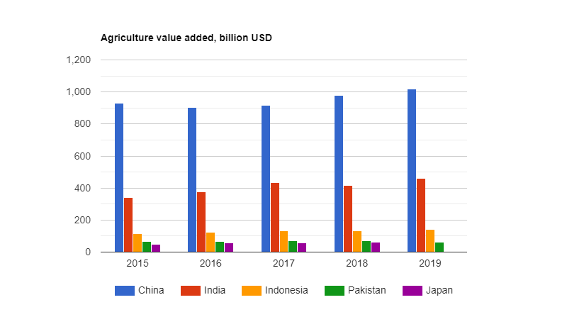
Sources: Calculated by the Author
Trends of cereal productivity in China, India, Bangladesh, Sri Lanka, and Pakistan from 1990-2018 are demonstrated in Graph 2. From the graph, we can infers that over the period of time, the cereal productivity of India has been lower than China, Bangladesh and Sri Lanka. However, India is the seventh-largest country in the world which more than 55 per cent of the land used for the agriculture sector and nearly 2.2 per cent share in the world agriculture land (FA0, 2020).
Graph 2: Trends of cereal yield (kg per hectare) in different countries.
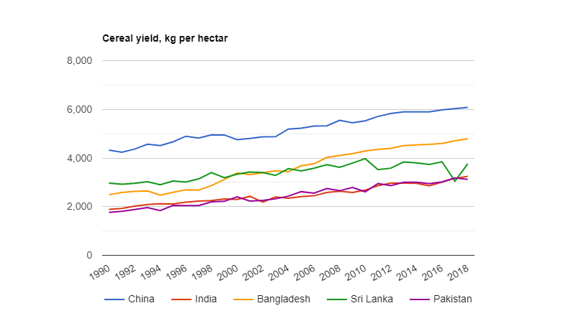
Sources: Calculated by the Author
Therefore, evidence indicates that India's agriculture sector performance has not been satisfactory in the world.

3. Trends of Agricultural Productivity and Growth
Despite the declining contribution of the agriculture sector in economic growth (Graph 3), it continues as a primary sector of improving the economy as it stays the first source of employment and a key driver of economic development and poverty reduction. The agriculture sector has overcome stagnation in food grain productivity and production in India. In comparing pre and post-economic reform, over a couple of decades, the overall performance of the agriculture sector on a sustainable basis has been much more modest.
Graph 3: Value added in the agricultural sector as present of GDP
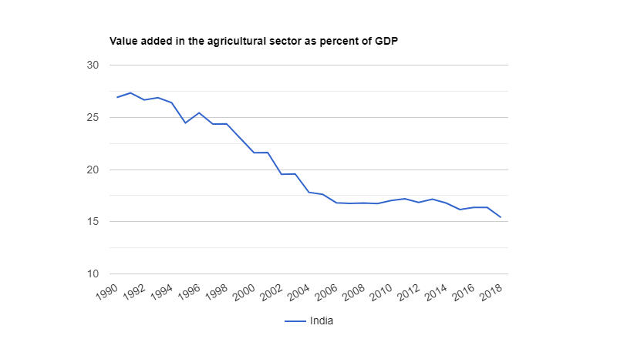
Sources: World Bank, 2019
To better understand the performance of the agriculture sector, there is a need to examine trends of the productivity and production trends at the national and state level. Trends of agricultural productivity of India are presented in Graph 4. Graph 4 present the trend of food grain production, and it indicated the food grain yield increases from 1380 kilogram/hectare (kg/ha) in 1991 to 1734 (kg/ha) in 2002. Due to the drought, food grain yield declined to 1535 (kg/ha) in 2002-2003 but again increased to 1727 (kg/ha) in 2003-2004.
Sources: Calculated by the Author
However, graph 3.3 depicts food grain productivity growth rate during 1991-2017 has sharply declined and reached up to approximately negative 11 per cent in 2002, while the production of food grain has increased sharply in 2003-2004. The annual growth rate rose 12.50 per cent which is the highest growth rate till now. In the absolute term, overall yield increased from 1380 (kg/ha) in 1991 to 2299 (kg/ha) in 2019, but in terms of annual aggregate term, food grain production has increased approximately by 2 per cent (Table 4).

Sources: Calculated by the Author
Statistics reveal that the aggregate annual growth of food grain productivity has approximately 2 per cent. The table also indicates that 12.5 per cent was the highest risen annual growth rate in 2003 while negative 11.5 per cent the highest declining annual growth rate in 2002, which might be due to the occurrence of drought in India.
Similarly, let us considered Graph 3.4, which shows the trend of food grain production. Production of food grain had increased from 1764 lakh tonne in 1991 to 2098 lakh tonne in 2000. During the same period, agriculture production had increased by approximately 19 per cent. In the 2002-03 period, the production has sharply gone down from 1968 Lakh tonne to 1745 Lakh tonne due to drought occurrence, but again in the next year production has increased up to 2132 lakh tonne in 2003-04. In the tenth plan, the annual average of food grain production was 2022 lakh tonne, lower than the average annual ninth plan. However, the annual average food grain production was 2374 lakh in eleventh and 2600 lakh tonne in twelve plans. Overall, food grain production had increased from 1764 lakh tonnes in 1991 to 2849 lakh tonnes in 2019.
Sources: Calculated by the Author
Graph 3.5 shows that aggregate production has grown at an average annual growth rate of 2.01 per cent from 1991 to 2019. During 1991-2000, the average annual growth rate of production was 2.07 per cent which is greater than the 2000-10 period but lower than 3.13 per cent during the 2010-2019 period. Drought was the main reason to decline production in 2002-03. The most recent recovery period (2004-05 to 2011-12) shows a marked return to growth of about 3.37 per cent per annum. The overall increase in the value of the output of the crop sector remains modest at about 3 per cent. Notwithstanding, the performance of food grain production has much higher in 2010-19, which is far better than the last two decades.
Sources: Calculated by the Author
Since the 1990s the annual growth rate of food grain production has been about 3 per cent, but the agriculture growth rate remains below the total GDP growth rate. Moreover, per-capita agricultural output has seen a steady rise, while the share of agriculture in the Gross Domestic Product (GDP) gradually has been falling. The rise in per-capita agricultural production is reducing pressure on meeting the demand of food and nutrition supply, hence ensuring the Nation's food security. However, growth in agricultural output is characterized by fluctuations, i.e. each high-growth period is followed by a phase of low development. This repeated pattern has reflected itself in annual growth rates of about 3 per cent in the Tenth Five-Year Plan, which increased to 4 per cent in the Eleventh Five-Year Plan. The most crucial crop segment and sub-sectors are subject to severe adverse shocks like floods and drought, which leads to severe agriculture crises. Indian agriculture has been considered a gamble of nature, i.e. the monsoon, which resulted in the low return rate of public capital formation in the agriculture sector (Planning Commission, 2014).
3.1 Trends of productivity of major crops in India
Trends of major food grain crops are reported in graph 3.6. It can be said that all these crops contributed a large share in the production of food grain. Firstly, Let us considered rice productivity; India is the second-largest producing country of rice over an area of about 430 lakh ha and produces around 1250 lakh tonnes of rice with yield level remaining low at around 2.65 t/ha, contributed over 43 per cent of food grain production to the nation.
Sources: Calculated by the Author
The most significant increase has been recorded in wheat yield which is increases from 2281 kg/ha in 1990 to 3507 kg/ha in 2019 while the productivity of rice increased from 1740 kg/ha from 2659 kg/ha during 1991-2019.
A consistent increase in the rice yield was noted since 1991. The increasing Indian population is reflected by the growing rice demand across the country and production and consumption volumes. Along with other food grains, rice is the essential part of an Indian meal, 60 per cent of the population consume rice crop at least once a day across the states of India. India was the most prominent global rice producer in terms of the area harvested. Despite the cultivation of wheat and other products, rice was the most consumed agricultural product and had the highest market value in 2016 (FAO, 2018).
Wheat is the major staple food crop after rice in India. The crop has been under cultivation in about 30 million hectares to produce the all-time highest output of 99.70 million tonnes of wheat with a record average productivity of 3371 kg/ha (Graph 3.7). Having a significant share in consumption of food basket with a 36% share in the total food grains produced from India and ensuring not only food security but also nutrition security. The wheat is extensively procured by the government and distributed to a majority of the population through public distribution system (PDS). Wheat yield rises from 2281 kg/ha to 3507 kg/ha over the period 1991-2019, which increased approximately 50 per cent, despite the fact that the area under crop is much lesser than rice crop. The most disappointing performance of pulse, the productivity has risen from 578 kg/ha in 1990 to 806 kg/ha in 2019 while the performance of coarse cereal is far better than other food grain crop.

3.2 Trends of Agriculture Growth Rate
The agriculture sector has remained the dominant sector of the Indian economy, contributed 17.15 per cent share in GDP (CSO, 2018), and despite the share of employment declined from 63.2 per cent in 1991-92 to 42.9 per cent in 2018-19 (World Bank, 2019). However, more than 50 per cent of the population depends on agriculture activities for livelihood and well-being.

Sources: Calculated by the Author
Graph 3.7 presents the annual growth rate of agriculture production and economic growth trends from 1961 to 2019. To better understand the scenario of agriculture growth, the whole period has been categorized into pre-economic and post-economic reform.
During the pre-economic reform period, the agriculture sector was not stable due to the drought situation in the whole country, and Indian agriculture was mainly dependent on the monsoon. Thus negative aggregate annual growth, i.e. -0.47 seen from 1960 to 1966. In comparison, the aggregate annual growth rate of the agriculture sector was 3.3 due to the adoption of the green revolution in some parts of the country, mainly Punjab, Haryana and Western Uttar Pradesh. The introduction of the green revolution in the mid-1960s resulted in the improved performance of significant crop production, particularly wheat and rice. The growth rate of rice production increases from 2.2 per cent to 3.3 per cent from 1967-80 to 1980-90. Overall, the performance of agriculture production slightly declines from 3.3 per cent in 1966-80 to 3.02 per cent 1980-90 (Graph 3.7). In comparison, the overall economic growth performance is far much better than the performance of agriculture production during 1961-1990.

Sources: Calculated by the Author
During the Post-economic reform period, per-capita agricultural output has seen a steady rise, while the share of agriculture in the Gross Domestic Product (GDP) has been falling. The performance of the agriculture sector fell from 3.02 per cent in the 1980s to 2.63 per cent in 1990 and stood at 2.84 per cent till 2000. To deeply understand the trend of the agriculture sector, categorize the Post economic reform period into two periods, i.e. 1990-2000 and post-national agriculture policy.
Agriculture production has risen at the annual aggregate of 2.88 per cent during 1961-2019. While in 2000, government launched the National Agriculture policy and during this era, the performance of the agriculture sector has far much better than over the period 1990-2000. Still, the growth of the agriculture sector was much below than the target of 4 per cent. During 1991-2019 agriculture production has risen at an annual growth rate of 3.14 per cent. Whereas economic growth has increased by 3.34 per cent. The decline of agriculture growth can be attributed to a reduction in public investment, low level of technology, shrinking farm size and unbalanced use of agricultural inputs.

Conclusion:
The aim of this chapter is to explain the trends and patterns of agricultural development along with its importance in India since economic reform. Since economic reform agricultural productivity has consistently gone down resulting low level of infrastructure and a lack of modernization in the agricultural sector. Despite the fact that the agricultural sector is one of the leading sectors in the Indian economy.
India is one of the top food grain crop producers, including wheat, rice, and pulses. India is the second-largest contributor in the share of agriculture value-added after China, followed by Indonesia, Pakistan, and Japan in the world. Overall yield increased from 1380 (kg/ha) in 1991 to 2299 (kg/ha) in 2019, but in terms of annual aggregate term, food grain production has increased approximately by 2 per cent. Similarly, food grain production had increased from 1764 lakh tonnes in 1991 to 2849 lakh tonnes in 2019. During 1991-2019 agriculture production has risen at an annual growth rate of 3.14 per cent. Whereas economic growth has increased by 3.34 per cent. The decline of agriculture growth can be attributed to a reduction in public investment, low level of technology, shrinking farm size and unbalanced use of agricultural inputs.
To increase the overall performance of agricultural sector, government should frame the environmental policy to curb the climate change problems, and on the other hand side micro irrigation program to offset the problem of deficiency of rainfall or uneven distribution of rainfall. Moreover, policy maker and academician should aware the farmers regarding the optimum quantity of fertilizer and pesticide used for farming because they do not know how much quantity of fertilizer and which pesticide is beneficial to cure the plant diseases. In this order agricultural production could be increased by 20-25 per cent.

References:
Awokuse, T. O., & Xie, R. (2015). Does agriculture really matter for economic growth in Developing countries ? 63, 77–99. https://doi.org/10.1111/cjag.12038
Briones, R., & Felipe, J. (2013). Agriculture and structural transformation in developing Asia: Review and outlook. In ADB Economics Working Paper Series (Vol. 363). https://doi.org/10.2139/ssrn.2321525
De Souza J. P, (2014). Growth complementarity between agriculture and industry : Evidence from a panel of developing countries.
Government of India (2006). Agricultural Statistics at a Glance 2015. Ministry of Agriculture, New Delhi
Government of India (2011a). Census Report, 2011, Office of the Registrar General and Census Commission, India.
Government of India (2011b). Faster, sustainable and more inclusive growth: An approach to the 12th Five Year Plan (Draft). Planning Commission, New Delhi.
Government of India (2015). Agricultural Statistics at a Glance 2015. Ministry of Agriculture, New Delhi
Government of India (2016). Economic Survey 2015-16, Economic Division, Department of Economic Affairs, Ministry of Finance, Government of India, Oxford University Press, New Delhi.
Humphries H & Knowles S, (2010). Does agriculture contribute to economic growth ? Some empirical evidence Does agriculture contribute to economic growth ? Some empirical e v idence. 6846. https://doi.org/10.1080/000368498325471
Johnston B. F & Mellor, J. W. (1961). The role of agriculture in economic development. The American Economic Review, 51(4), 566-593.
Mondal D, (2014). Agricultural productivity and industrialization: A reformulation. Discussion Paper.
Olmstead A. L & Rhode P W, (2007) Conceptual issues for the comparative study of agricultural development. Agriculture and Economic Development in Europe Since, June, 27–51. https://doi.org/10.4324/9780203928776
Ranis, G., & Fei, J. C. (1961). A theory of economic development. The American economic review, 533-565.

