Empowerment of Women through Self-Help Groups: A Comprehensive Study in Sundarbans, West Bengal
Dr. Rinki Mishra, Dr. Masuma Mehata
ªAssistant Professor in Parul University, Vadodara
^{b} Associate Professor, St. Kabir Institute of Professional Studies, Ahmedabad

Abstract
The SHG is the subject of the investigation in three different ways. It begins by evaluating the members of the SHG's economic and social circumstances. Then, it attempts to study the SHG's structure and operation and looks at the degree to which women are empowered at various levels (viz Economic, Social, Political and Health). This study discovered that the SHG member's living circumstances are significantly improved by the loans obtained and the money made via income-generating activities. The women's participation in the organisation has improved their financial literacy, created a bank account in their names, met and interacted with other members of society, participated in social and political events, and provided them access to various resources. According to the studies, rural women who joined SHGs experienced economic growth, social empowerment, and personal growth regarding knowledge and decision-making abilities.
Key words: Microfinance, Self-Help Groups (SHG), Women empowerment,
Self- Help Groups in India
The rural poor are given access to microfinance, which offers financial services such deposits, payments, loans, and insurance as well as assistance in starting small businesses. The purpose of financial assistance is to give the rural poor access to funding in order to help them launch and grow businesses that will enable them to escape poverty. It supports the financially vulnerable individuals in accessing services and financial support in order to improve their level of living and income. Self Help Groups (SHGs) are voluntary organisations created by the impoverished to collect small amounts of money on a regular basis and lend the small amounts of money inside the group. The bank credit follows once the group has enough money to manage the group. Microfinance has advanced as a crucial programme for providing direction to the society's abandoned groups, particularly the poor, rural, and depressed women. The major goal is to show how easily poverty can be eradicated if those who are economically disadvantaged are given access to financial assistance. As a result, the provision of loans becomes an essential tool in the socioeconomic development of rural impoverished people.
Origin of Self Help Groups (SHGs) In India
The "Swarnjayanti Gram Swarojgar Yojana" (SGSY) was created in April 1999 as a consequence of widespread agreement over the necessity for revising the Integrated Rural Development Programme (IRDP). This effort focused on creating SHGs for the rurally underprivileged, skill development, capacity building, technology, lending links, infrastructure, product creation, and promotion.
SHG is a concept created by Mr. Mohammed Yunus, who established the Grameen Bank of Bangladesh in 1975. In India, NABARD introduced it between 1986 and 1987. However, it became effective after SHGs were linked up with banks in 1991–1992. In order to provide impoverished women with banking resources, NABARD created the Pilot Project for Microcredit in 1991–1992, partnering SHGs and financial institutions. Banks have been instructed by RBI to aggressively take part in this SHG linkage scheme. In India, there are three models for connecting SHGs and banks.
Model I
Banks themselves designed and publicised the SHGs. Large amounts of credit were directly offered to the SHG by the bank. Using the standards that the group's members established, the SHG awards credit to its members. The assisting Bank is given financial support by NABARD.
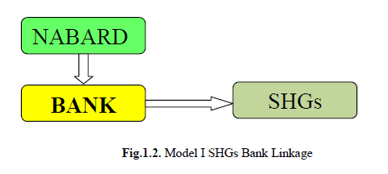
Model II
In Model II, the SHGs were created and promoted by the DRDA under the direction of the Block Development Officer (BDO) or an NGO. The SHGs are referred directly to the bank for financing by the BDO or NGO. Bank may extend credit to an individual member or to the entire group. Here, the supporting organisation aids the SHGs and the Banks by keeping track of the SHGs, providing members with training, and assessing the loan payback situation.
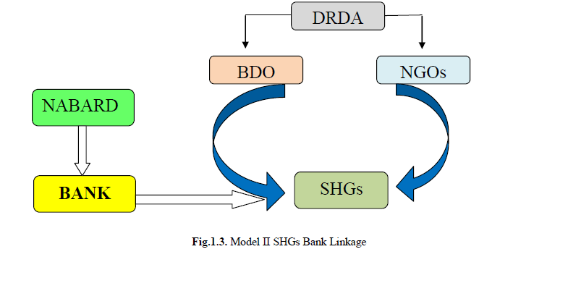
Model III
NGOs created and arranged the groups and suggested linking them to the bank. Banks provided the money to NGOS so that they could support SHGs financially or vice versa. NGOs are responsible for the SHGs' operation, training, and activity monitoring.

Statement of the Problem
Women are the ones who suffer from poverty the most since they must balance the "means and ends" of the household and frequently skip meals so that the rest of the family can take use of the limited resources. These women face social and economic prejudice, and getting credit is difficult for them. Millions of Indian women are subsistence farmers, and social change won't have much of an impact on them unless they are given economic freedom.
The global agenda for socio-economic and political development processes is increasingly placing women at the forefront. Despite the significant gap between the agenda, policies, and practises, planners, and implementation systems are continually focused on their contribution. Women's development is more important because the development indicators for women, such as health, education, nutrition, and decision-making, have so far made poor progress.
The majority of developmental programmes now shift their emphasis from an individual to a group approach. People form SHGs when they are helped by one another to solve common issues. These groups can address a variety of issues, including microcredit and alcoholism.
The term "Self Help Group" refers to a group of rural women who have got together to organise themselves into a group in order to end their own poverty and have a stable source of income.
Giving rural women microcredit will help them launch their businesses. In terms of rural microcredit, regional rural banks, cooperative banks, and commercial banks are unsuccessful. Due to the low status of their means of subsistence and low levels of literacy, many rural poor women are unwilling to contact banks or financing organisations and lack the necessary fortitude.
Research Gap
A survey of the literature revealed that the majority of research concentrated on the SHG members' credit lending, spending, and savings habits. In the studied area, there has been relatively little research on the structure and operation of SHGs, particularly on overall empowerments such economic, social, psychological, political, and health aspects. The goal of the current study is to measure the degree of women's empowerment at various levels.

Objectives of the Study
- To determine the socioeconomic status and standard of life of the women who participate in SHGs.
- To assess how well SHGs are structured and operating in relation to the members' income, spending, and savings habits.
- To evaluate the effect of the loan received and the members of the women SHGs' repayment status.
- To highlight the degree of the women SHG members' empowerment at all levels (economic, social, psychological, political, and health).
Need and Scope of the Study
SHGs are currently recognised on a worldwide scale as a tool to empower women in both social and economic spheres. Women's entire growth will be aided when socioeconomic empowerment is reached. Women's living standards in society will be determined by their economic empowerment. It promotes gender equality and elevates the position of women in the household. So, using SHG to create income-generating possibilities results in long-term empowerment. Additionally, women's participation in various community initiatives and societal activities boosts their self-esteem, which in turn widens their circle of social connections. Even SHGs place a strong emphasis on the psychological growth of women and promote holistic development. Thus, the current study focuses on the socioeconomic environment, SHG structure, and women's empowerment through SHGs at various levels.

Reason for Joining SHG
The source of motivation and the reason for joining SHG are different. Despite the fact that the government has launched a number of rural development initiatives aimed at the advancement of women in rural families, SHG enrolment is significantly higher than that of other initiatives. Therefore, the reason or foundation for joining a SHG will support rural people's expectations of development programmes.

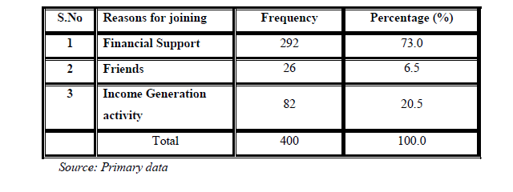
According to the analysis of the aforementioned table, 73% of the members stated that they joined SHG in order to save money. The remaining members stated that they were able to obtain money at lower rates of interest through SHG, and that it served as a source of income that allowed them to meet the bare minimum requirements of their families.
Empowerment of Women through SHG
For many developing nations, including India, the goal of empowering women has been long-stated. Women gradually develop their sense of self-worth and confidence. Rural women are less powerful and don't have a voice outside of the home. They are denied their fundamental rights and excluded from society's mainstream. SHG is a tool for rural women's empowerment. SHG gives women a chance to integrate into society on a regular basis. When a woman joins a SHG, she first learns how to speak up in front of the group, learns how to budget, and develops financial stability. The economic stability boosts women's self-esteem. This section focuses on how women are empowered economically after joining the SHG, how they use their loan money, how they save and spend it, how they use support networks, how they participate in training programmes and social activities, how their roles in the family are changing, how their children are developing academically, and other topics.
Economic Empowerment
SHG aims to empower rural women and fight poverty. The research focuses on the total empowerment of women. The economic emancipation of women is explained in this section. The SHGs are run by BDO and give women financial security and independence, particularly in order to break their dependency on moneylenders. As a result, the economic empowerment of women is investigated by analysing their saving and spending habits, asset development, loan repayment, and participation in and performance of income production programmes. Following their participation in the SHG, women's economic development is carefully evaluated, and the improvement and change in their economic standing is also quantified using percentage analysis as shown in the following tables.
Social Empowerment
Access to knowledge, information, and the acquisition of skills to function in society are all examples of social empowerment. At the individual, group, and community levels, social empowerment is measured. For people, it manifests as knowledge expansion, skill adoption in response to demand, personality development, and the growth of self-confidence to meet obstacles. The evaluation of empowerment at the group level is based on participation, making the proper decision on the issue, speaking in public, meeting with government representatives for social issues, for the community, and organising community development and social developmental programmes.
Cross Tabulation Analysis
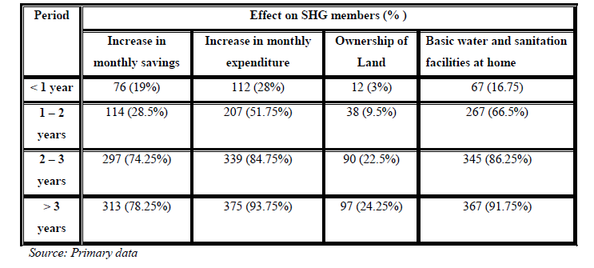
Table 4.43 shows the length of time women have been involved in SHGs and how it has affected their living level. The impact may be observed in the growth in monthly savings, expenditure, ownership of land, and growth in basic facilities as the members' time with the SHG has expanded. It is very obvious that once women join SHGs and begin to save there, they develop a savings habit that lasts year after year, increases their savings, and is reflected in their spending patterns. The influence may be observed in the supply of basic amenities at home and property ownership. As savings rise, expenditures expand as well.
Chi-Square Analysis
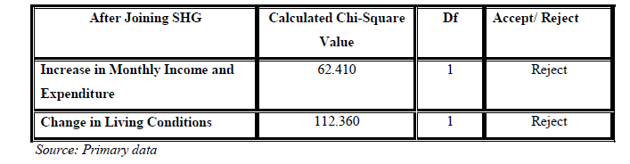
Chi Square analysis was used to analyse the effect of SHG on respondents' living conditions and validate the null hypothesis. The results show that after joining the group, members' monthly income and expenses significantly increased, which had an impact on the SHG members' living conditions. Table 4.44 illustratively demonstrates that the null hypothesis is rejected and that the SHG members' living conditions significantly improved. After joining the SHG, the members' living situations have been significantly impacted by the rise in monthly revenue and expenses.
FINDINGS, SUGGESTIONS
- The requirement for SHG participation in raising awareness of various issues was closely tied to the educational background. It was clear that 65.2% of the respondents had completed sixth through tenth grades and kept complete records in SHGs.
- Despite the fact that SHGs were created to foster self-employment, the members were nevertheless rather inactive in developing a source of income for their families, content with their day jobs and the help provided by SHGs in times of need thanks to their savings. The need for construction of sanitary latrines has been realized among the members and the government has also provided loan for it.
- After becoming a member of a SHG, a certain sum (between 100 and 200 rupees) is automatically put into their account each month. In addition, they frequently had to borrow money from lenders at exorbitant rates of interest, which over time led to the destruction of both them and their families owing to debt. The members stated that having a regular savings habit through SHG has given them the assurance and support to live much more contentedly every day.
- Through the distribution, it became clear that the officials had a crucial part to play in explaining SHG to the rural poor and the prospects it offers. In addition, the BDO door-to-door method has touched all of their communities.The dependency on money lenders, on the whole, has come down (28%) among the group members. It can be expected that within a few years, with the complete establishment of SHG all over the country, the poor rural women will be fully liberated from the clutches of the money lenders.
- The women who participate in SHG firmly concur that their engagement has given them more self-confidence, improved decision-making skills, and the ability to establish a sense of self as a SHG member, which has given them psychological strength.
- As a result of their involvement in SHG, they have improved their public speaking skills and acquired knowledge of banking operations. Additionally, the respondents concur that SHG has given them the skills and self-assurance to assume leadership roles and train others in doing so, but on the other hand, almost one-fourth of them are not even able to speak in public or plan any social programmes or events for the betterment of the community.

Conclusion
In examining the economic empowerment of SHG Women, it has been discovered that SHG Women's participation in economic activities such as saving and spending, maintaining thrift, financial transactions, documentation, asset creation, and income generation has increased due to their involvement in SHG. Similar to this, taking part in protests, awareness campaigns, and social gatherings has helped social empowerment. Along with being more influential in family decisions and having a stronger voice in the home, children's education has boosted their psychological empowerment. Additionally, some degree of political empowerment has resulted through involvement in political campaigns and political party support for group advancement. Additionally, group-level gatherings that pushed women out of their comfort zones and allowed them to talk about their health-related issues and stress with other attendees while also clearing up any questions they had about women's health and hygiene, sexual health, and family planning techniques led to health empowerment. Overall, SHG in the study region developed women and empowered women at all levels (economic, social, psychological, political, and health) in order to help the nation reach its objective of sustainable development.

REFERENCES
- Abhaskumar Jha (2004), “Lending to the Poor: Designs for Credit”, Economic and Political Weekly 25, 8- 9.
- Ackerly, B. (1995), Testing the tools of Development: Credit programmes loan involvement and Women’s Empowerment, World Development, 26(3), 56-68.
- Ahuja, Rajeev and Indranil De. (2009), “Poverty Reduction through Self-Employment Programme in India: Interstate Performance”, The IUP Journal of Governance and Public Policy, IUP Publications, (3-4), pp.62-76.
- Bakshi, S. and Varma, R.V. (2001), “Empowering Women through Self Help Groups: A Case Study”, Conference Paper: Kerala Forest Research Institute, pp. 238-240.
- Baruah, Prasenjit Bujar, (2012), “Impact of Microfinance on Poverty: A Study of Twenty Selfhelp Groups in Nalbari District, Assam”, Journal of Rural Development, 31 (2), pp. 223-234.
- Bennett, Lynn. (2002), Using Empowerment and Social Inclusion for Pro-poor Growth: A Theory of Social Change. “Working Draft of Background Paper for the Social Development Strategy Paper. World Bank”.
- Chandra (2000), “Women and Empowerment”, Indian Journal of Public Administration, 42(3) 12-16.
- Chiranjeevulu T. (2003) Empowering Women through Self-Help Groups- Experiences in Experiment.
- Dhanalakshmi, U and Rajini, K (2013): A Review of Literature: Women Empowerment Through Self-Help Groups (SHGs). International Journal of Research in Commerce and Management 10, 29-35.
- Empowering Women: A Study of Rural Assam. Social Change and Development 11, 90-98.
- Gautam Vir (2008) “Status of Women in Rural India and their role in rural development”, Abhijeet Publications.
- Jaya S. Anand (2002), ‘Self-Help Groups in Empowering Women: Case Study of Selected SHGs and NHGs’, Kerala Research Programme on Local Level Development, Centre for Development Studies.
- Karkar (1995), “Empowering Women through Self Help Groups – Experiences in Experiment”, Kurukshetra.
- Mofidul Islam & Jayanta Krishna Sarmah, (2014) Impact of Self Help Groups in Murugan K.R. and Dharmalingam B. (2000), “Self Help Groups- New Women’ Movement in TamilNadu”, Social Welfare, 47(5), 9-12.
- Nayar K.R. and Kyobutungi C. (2005), Community participation in health: A qualitative study of women’s self-help groups in Kerala state, India. Journal of Health and Development 1, 91-101.
- Purushotham, P. (2009) “Institutional Credit for Rural Livelihoods (A Study of SGSY in the Regions of High Poverty), National Institute of Rural Development.
- Raghavan .V.P., (2009) “Micro-Credit and Empowerment: a study of Kudumbashree projects in Kerala, India”, Journal of Rural Development 28, 451 – 467.
- Syed Hashemi, Sidney Schuler, and Ann Riley (1996), "Rural Credit Programs and Women's Empowerment in Bangladesh," World Development 24, 635-653.
- Tanmoyee Banerjee, (2009), Economic Impact of Self-Help Groups - A Case Study, Journal of Rural Development 28, 451 – 467.
- Yadappanavar A.V.(2008) Credit Support to Women Entrepreneurs under SGSY, Gyan Publishing House.

