Artificial Intelligence Based Medical Sensors for Health Care

Ms.N.Kavitha
Assistant Professor, Department of EIE
Hindusthan College of Engineering and Technology
Coimbatore, India
kavitha.eie@hicet.ac.in

Dr.P.Moniya
Assistant Professor, Department of EIE
Hindusthan College of Engineering and Technology
Coimbatore, India
moniya.eie@hicet.ac.in

Ms.P.Palaniyammal
Assistant Professor, Department of ECE
Study World College of Engineering
Coimbatore, India
moniya.eie@hicet.ac.in

ABSTRACT
The traditional medical order has been disrupted by the older age populace and the presence of communicable disorders, greatly raising the strain on health maintenance as well as unfavorably disturbing the conservative system. Artificial intelligence (AI)-based medical sensors offer novel perspectives on how to gather information for modern medicine to track changes in the environment and people's health. The position of AI-equipped health detecting sensors for off-body illness, adjoining-body observing, sickness forecast, and medical verdict sustain systems is briefly reviewed in this paper, along with the ongoing difficulties and possible solutions for moving from concept to implementation. Development in the integration of clinical sensors as well as AI coding are anticipated to open the door to near the beginning recognition and medical verdict sustain as well as increase the accuracy and effectiveness of medical diagnosis in the very near future.

Keywords—Artificial Intelligence;Sensors;Machine Learning Algorithms;Clinical decision support sytem

INTRODUCTION

Life span and quality of lives have been substantially enhanced in recent years due to advancements in biomedical science and micromachining technologies. Modern medical testing still struggles with reactive, preventive, and untimely issues exactly obstruct efficient and dependable at-once observing, interpretation, and medicaments. Presently, the most widely used techniques for keeping track of an individual's health continues to rely on medical surveillance and self-reported survey questions for the diagnosis and classification of diseases. A 30% decrease in misdiagnosed costs could be made in the global healthcare budget. In order to accurately anticipate and identify infection in its premature phase, earlier than indication manifest, with dependable along with economical instantaneous examining techniques, it is necessary known the present era inhabitants and COVID-2019 global epidemic. The focus of medical testing must become more proactive and individualized.
Due to the tremendous workload placed on doctors who must care for many patients as well as their propensity to put off patient diagnosis and treatment, clinical observation is ineffective. On the other hand, the self-reported questionnaires necessitate a high level of patient focus, concentration, and current psychological condition. People with impairments, infants, and the elderly are prominent examples of these restrictions. These issues result in a significantly increased likelihood of misdiagnosis, which negatively affects patients' health and financial burden in addition to degrading the doctor-patient relationship. Statistics show that one in seven diagnoses are incorrect globally, which has an impact on about one million people annually. Taking care of misdiagnosis might release 30% of the overall budget for global healthcare.
The amalgamation of medicinal sensors and artificial intelligence (AI) has paying attention a extensive choice of interest. Medicinal sensors, are categorized as off-body detection and near-body observing, transform biological factors into easily measured signals like electricity and light. In order to increase the efficiency and accuracy of illness diagnosis, off-body observation is mostly carried out by means of medicinal fluid sensors, gas sensors and picturing equipment to observe bodily liquid (blood, saliva, urine, etc.), exhaled breath, and medical images. The use of wearable devices placed directly on various body parts of the skin to quickly gather vital data regarding the wearer's health opens up novel prospect for telemedicine and continuous observing. There are many application scenarios, such as illness, movement, and cerebral condition observing, due to the features of permanence, simply persistent, and multi-indicator.
AI algorithms have advanced significantly in their ability to increase the effectiveness and precision of medical sensors' diagnosis and therapy. Support vector machines (SVM), principle component analyses (PCA), decision trees (DT), long short-term memories (LSTM), artificial neural networks (ANN), recurrent neural networks (RNN), and convolutional neural networks (CNN) are examples of common techniques at the moment. There may be greater potential for proactive, contemporary, and personalized medicine as a result of the massive amount of data that sensing gadgets collect and AI algorithms analyze. Typically, the structure of medical data is relatively complex, it is developing quickly, and it is rich. In order to examine the inner structure of the deep of medicinal big statistics, recognize patterns of illness circumstances, and get around the general access restrictions to local datasets, machine learning (ML) methods can pool medicinal datasets from zillions of patients, including diagnostic profiles, imaging registers, and wearable evidence. The most recent developments in AI for medical analysis from three angles, including CDSS, disease prediction, near-body monitoring, and off-body detection as depicted in Figure 1
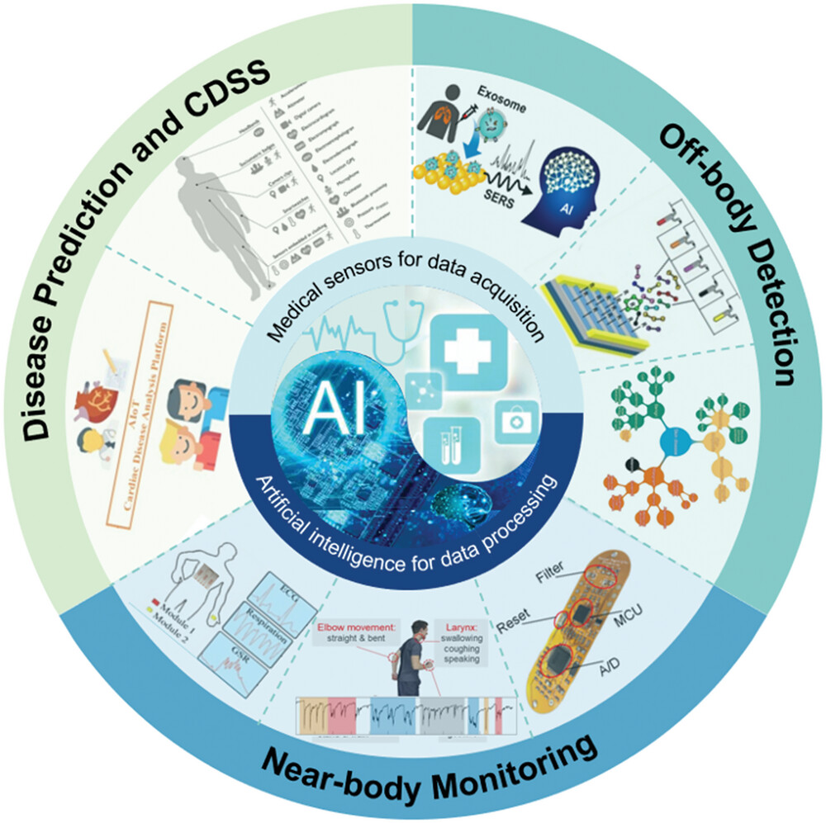
Figure 1: Theoretical Illustration of the Amalgamation of Medicinal Sensors and AI Codes

ARTIFICIAL INTELLIGENCE IN HEALTH CARE

Off Body Detection through Fluid Sensor
Body liquids, such as blood, saliva, and urine, include few biochemical indicators that can be found in fluid sensors that aid assess an individual's wellbeing. These indicators include proteins, nucleic acid-based biomarkers, lipid metabolites, and extra minor particles. However, some of challenges that modern medical sensors confront include interference from unrelated chemicals, short sample quantities, and dilution of biomarkers. Combining medicinal fluid sensors with an AI algorithm can successfully prevent these issues.In orders to diagnose early-stage lung cancer; Shin et al. used Surface-Enhanced Raman Spectroscopy (SERS) based on deep learning. They extracted exosomes from human plasma models and then gathered SERS indications using a plate coated in gold Nano Particles (GNP). Then, without learning insufficient human data, they used deep learning to investigate the characteristics of plasma exosomes and determine their similarity. The possible of deep learning-based SERS methods for lung cancer identification as a routine prescreening tool is demonstrated by the supervised prototype trained with SERS signals, which effectively categorized the exosome data into binary clusters and forecast lung cancer patients and healthy controls with exactness of 95% and 90.7%, respectively. However, the examination of biomarkers found in blood extracts is intrusive and necessitates lengthy pre-processing procedures. Microfluidic devices are prominent in clinical diagnostics because they may deliver comprehensive health information with little sample requirements and have advantages of miniaturization, high throughput, and automation.

Detection through Image
When diagnosing a clinical ailment, imaging examination is frequently utilized to find alterations in the structure and blood flow of pathogenic tissues. With probabilistic and statistical methodologies, AI has been used on datasets of various sizes in the imaging industry. Radiologists can make diagnoses as accurately as feasible to cut down on diagnostic time and expense with the use of imaging feature processing and machine learning (ML)-based categorization or forecast. Furthermore, it enables radiologists to focus on areas of interest to detect cancer that might otherwise go unreported. In order to forecast the likelihood of developing lung cancer, Ardila et al. devised a deep learning method that analyzed a patient's recent and old computed tomography volumes. To find 3D cancer candidate regions, they built a 3D CNN model and trained a CNN region-of-interest (ROI) model. They ultimately created a cancer hazard forecast model based on this to provide a case-level malignancy score. The model performs at the cutting edge for 6716 cases from the National Lung Cancer Screening Trial, 94.4% of the zone below the arc (AUC), which is comparable to a separate authentication sample of 1139 cases. The model outperforms all six radiologists in terms of accurateness, constancy, and adoption development for lung cancer screening without the use of prior computed tomography imaging, with absolute reductions of 11% in false positives and 5% in false negatives. Images are a favorable detection approach for the presently widespread COVID-19 in addition to cancer diagnosis.

Near Body Disease Monitoring
The ability to instantaneously screen several physiological indications and biomarkers for illness observing is a major advantage of skin-based wearable technology. One of the most prevalent chronic diseases is diabetes, which requires regular monitoring of the patient's blood glucose levels. Based on functionalized CVD graphene, Lee et al. combined observing and treatment into a single wearable device. The electrochemical activity, sensitivity, and selectivity of the biochemical sensors were improved for the detection of human sweat biomarkers using the solid-state Ag/AgCl counter electrodes. A heating element could be activated to facilitate feedback dosing when a high glucose concentration was detected. The monitoring and therapeutic device was then created using a thin polyimide (PI) substrate, which facilitates integration and industrialization. The two loadable medications might achieve, respectively, gradual suppression and quick regulation of blood glucose levels. The innovative combined solution offers significant improvements in stress- and pain-free diabetes care. Levodopa (L-dopa) levels in sweat can be used for Parkinson's disease medication dose observing in addition to diabetes diagnosis. In the framework of a stress monitoring system, Riera et al. combined electromyography (EMG) and electroencephalography (EEG) to produce the analyzed data. Information on emotional states that are most closely related to stress was extracted using EEG. The monitoring system's resilience was increased using EMG. The classification rate may be effectively increased using the data fusion method from 79% to 91.7%, which is a fantastic result for a real-time system. Though models for monitoring mental state have come a long way, there has not been much progress made in the improvement of AI that can explain psychological wellbeing issues.

Mental Status Observing
Observing and assessing psychological health are challenging tasks. One potential approach to the monitoring and recognition issue is the use of wearable technology to moment-by-moment measure an individual's everyday activities. When AI is used, it is possible to intervene in patients' mental states in a timely manner to prevent disasters.ML, a subset of AI, has significant advantages in the merging of data from several biosensors and in the interpretation of that data. According to Zeng et al., epidermal electronics systems (EES) that use machine learning (ML) algorithms to categorize and forecast mental fatigue levels can simultaneously monitor numerous physiological signs. The EES comprises of dual units: the first unit is attached to the chest for the purpose of monitoring the ECG and breathing level, and the second unit is attached to one palm for the purpose of perceiving galvanic skin response. Then, three different types of machine learning (ML) algorithms (SVM, KNN, and DT) gathered features from the induced signals and created a predictive model to identify the level of weariness. The accuracy of the forecast can reach up to 89% and is based on six different physiological variables. The growth of epidermal multifunctional sensors can be advanced with the use of this technology, which is reasonably easy to construct. Generalized anxiety disorder is a more severe ailment than mental tiredness and is considerably more difficult to monitor and assess.

AI ASSISTED DESIGN OF BIOSENSORS

Electro-physiological and electrochemical signs from the body are measured by wearable biosensors. ECG, EMG, and Electro-Dermal Activity (EDA) are examples of electrical accomplishments originating from different biological procedures in the body that can be removed from diagnostic devices or wearable sensors and offer important evidence about one's wellbeing situations. The physiological signals can be analyzed to extract time and frequency domain properties using techniques including major component study, discrete cosine transforms, auto-regressive methods, and wavelet transformations. In the real world, wearable sensors like smartphones or smart watches can be used to passively collect medical signal data. Gel electrodes positioned on the body have been the conventional method of signal acquisition. Recent developments in construction and electronics have enabled the combination of bio-sensing electrodes in additional procedures such as eyeglasses, VR head-mounted displays, and fabrics in addition to the practice of conventional wearables like smart watches and fitness trackers.

Electrochemical Biosensor
These are a common variety of biosensor. Ni and Kokot examined the use of conventional chemometrics in combination with EC biosensors in 2008.The application of cutting-edge ML techniques in modern EC biosensors, however, is still in its infancy. Although a wide range of signals can be described by the very complex theoretical foundations of electrochemistry, EC biosensors are not very repeatable or reliable in actualmodel detection. Numerous interferants may be present in real samples throughout an extensive range of ionic strength, temperature, pH, and other factors. The electrode or modified electrode used in EC biosensors entangles over time, which is additional factor. Consequently, complex signals that are knowingly connected with the sort and amount of analytes cannot be learned by one-dimensional data study. The possible for integrating ML with EC biosensors to investigate how ML may be used to increase sensor accurateness and consistency in actual sample measurements is highlighted by this.

SERS and other Spectra based Biosensors
Anintricate matrix can be employed to obtain inherent fingerprint data about an analyte using surface enhanced Raman spectroscopy (SERS).One of the utmost promising analytical techniques for quick, label-free, on-site, and nondestructive detection is SERS sensing. Though, the spectra of numerous analytes and the substantial in the matrix are similar or overlay. Physically distinguishing them is problematic or unbearable. Confidently, the usage of ML will significantly upsurge SERS's efficacy. For ML approaches to work, the improvement factor of the SERS substrate must be uniform because big data set variance increases prediction variance, which restricts the approaches to semi quantitative or quantitative analysis. With medium or big data sets, CNN steadily shows advanced forecast correctness than additional ML methods. As a result, CNN is currently the utmost widely employed for spectral analysis. For the purpose of identifying oligonucleotide (OND) damage on a gold grating substrate, a CNN-assisted SERS biosensor was created. Different operators used a portable spectrometer to gather the SERS spectra of OND deprived of first optimizing the test settings (such as the best placement on the substrate, the strongest laser, the length of the acquisition, and manual baseline correction). A novel method of feature removal known as binary stochastic filtering (BSF) was included in their CNN structure. In order to pinpoint significant regions in the original spectrum, BSF would assess the relevance of each item that was entered. The suggested SERS-CNN approach can locate extremely minute DNA damage that is rarely detectable by current methods. Their findings demonstrated that the OND damage categorization was up to 98% accurate, with a self-assurance level of greater than 95%.

Fluorometric and Colorimetric Biosensors
Noteworthy consideration has been produced by the automatic ordering of colors and their intensity from these biosensing photos. One kind of fluorometric biosensor is the digital polymerase chain reaction (dPCR). As colorimetric biosensors, we also comprise lateral flow assay (LFA), paper-based vertical flow assay (VFA), and other colorimetric strips. A promising method for diagnosing genes is fluorescence imaging-based dPCR. For the dPCR to be employed in the actual application, it must be conceivable to identify the positive reaction chamber in the fluorescent image precisely and rapidly. The study of the photos has made use of predictable methods such threshold segmentation, numerical clustering, and grid placement. Threshold segmentation is the utmost widely used image processing technique. In all analysis, the threshold segmentation's settings must be attuned. Furthermore, it is limited to the analysis of photos with uneven brightness brought either by subpar camera imaging or uneven lighting. In the real challenging atmosphere, the circulation of light intensity is not ever even. A low accuracy of the positive reaction chamber recognition may outcome from this situation.
A vertical flow assay (VFA)-based colorimetric sensor motorized by deep learning was described for C-Reactive Protein (CRP) detection. The deep learning technique was employed to enhance the configuration of immune reaction spots and forecast the attentiveness of CRP. The CNN-aided colorimetric sensor can deliver the outcome fast and elude the practice of hefty instruments.

Biosensors in Microfluidic Bioassay
A quick diagnosis of a disease can be made with the use of blood cell counting. There have been several reports of ML-based microfluidic cytometers. For a lens-free blood cell including system that integrates a microfluidic channel and a corresponding metal oxide semiconductor (CMOS) image sensor, extreme learning machine based super-resolution (ELMSR) and CNN based super-resolution (CNNSR) were tested. Four times the cellular firmness was amplified, and compared to the ELMSR, CNNSR displayed a 9.5% higher quality.
The quartz crystal microbalance (QCM)-based biosensor is one kind of attractive detecting method which is gravimetrically sensitive and can sense analyte at sub-nanogram resolution. The SVM grouping/regression algorithm was smeared to discriminate/quantify trypsin and plasmin based on frequency shift data generated by QCM. Multi-biosensor synchronous measurement is vital for hands-on applications. Mixture of detecting data from numerous biosensors straightly influences application enactment. Wearable biosensors have increased amazing attention owed to their enormous possible in noninvasive observing of human physiology by diverse biological fluid.

MACHINE LEARNING ALGORITHMS IN DISEASE FORECAST

In general, the collecting and processing of complex biological signals for disease prediction can be done using an amalgamation of medical sensors and ML algorithms. The ML algorithms employed in this scenario are typically supervised. In supervised learning, predictions are made using sample inputs from well-known classes. The fixed, in advance-provided data used to develop the models has the similar statistical characteristics as the actual data employed in the models. Regression-based ML algorithms, SVM, and CNN are a few examples of ML techniques that are frequently utilized in clinical management and disease prediction.
A continuous output variable can be predicted using one or more variables via regression-based ML models by fitting a linear or nonlinear function. Its main applications are in time series modeling and the identification of causal links between variables. To incorporate physiological and/or laboratory parameters for early clinical deterioration prediction, Zhai et al. developed a logistic regression algorithm depends on the Electronic Health Record. The approach outperforms published models by achieving 84.9% sensitivity, 85.9% specificity, and 91.2% of the AUC. Regression-based models provide a straightforward and intuitive method for classifying and predicting medical data by considering correlations based on familiar statistical concepts, but they also call for more exacting presumptions.
As a supervised machine learning code, SVM can split assorted class issues hooked on a few binary problems in order to address the "multi classification" and "one-to-one predictive" challenges.SVM builds single or a collection of hyper planes in high-dimensional spaces to partition the input dataset into candidate classes. The margin distance, which is the separation among the support vectors as well as the hyperplane divider line, reveals the precision of the classification outcomes. SVM offers a desirable solution for problems like categorizing patient symptoms based on clinical data.
Depends on the amalgamation of features, Sun et al. developed SVM for the forecast of severe/critical COVID-19 cases. As of March 12, 2020, 336 patients affected with COVID-19 in Shanghai were split into training and test datasets for this investigation. To find clinical indications linked to harsh or serious symptoms and create a forecast model, 220 clinical and laboratory interpretation or reports were also gathered. A total of 36 clinical markers, such as thyroxine, immune-related cells, age, and others, were found. In the guidance and test datasets, correspondingly, the optimum combinations of attributes achieve 99.96% and 97.57% of the area under the receiving operating curve (AUROC). The study shows that SVM is reliable and efficient in illness forecast, with high possible for early detection of severe/critical cases and resource conservation.

ARTIFICIAL INTELLIGENCE IN MEDICAL VERDICT SUPPORT SYSTEM

Healthcare contributors are looking for quicker and less expensive techniques to provide medical care. The standard hospital-based healthcare system prioritizes diagnosis above therapy. These days, the emphasis is turning to a big data-based, individual-centered healthcare system that emphasizes early risk factor detection, premature diagnosis, and early preventative treatment. On the one hand, AI algorithms have the capacity to combine in-depth investigation with potent predictive abilities, offering quick disease forecasts for outlook data through extensive processing of medical data and model training. On the other side, CDSS supports decision-makers and healthcare systems in their efforts to enhance their access to information, insights, and settings. To accomplish the goals, a CDSS paired with AI, for instance, can take into consideration person heterogeneity in atmosphere, way of life, and genetic make-up. In a real-world setting, the tool's use will advance health assessments' capacity to identify and anticipate diseases, separate disease subcategories and hereditary traits, and keep track of disease development and therapeutic procedures.

Table 1: AI in disease prediction and medical assessment support systems

Sensor Types | Software/Hardware | Algorithm | Application
Textile based Sweat Sensor | Chem Office Software | ANN | Forecast of stress for wellbeing evaluation
Surface EMG and inertia sensor | MATLAB | Support Vector Regression | Quantitative assessment of muscle spasticity
Wearable ECG patch sensor | IoT Hardware | CNN | Prediction of cardiac disease
Photoplethysmography Sensor | Tensorflow | CNN | Recognition of human activity
Clinical indicators  (GSH,Protein,etc.) | R Platform | SVM | Critical symptom of  COVID 19

CONCLUSION

The healthcare industry is transforming from sensitive, hasty, and anticipatory healthcare to pro-active healthcare as a result of the growth of AI-enabled medicinal sensors. Different physical and biochemical markers can be employed for diagnosis and clinical decision-making with the use of AI and sensing technologies. detection of diseases continuously and non-invasively using a comprehensive set of novel tools, allowing for both inpatient and remote patient monitoring in a choice of ways.AI algorithms combined with medical sensors have generated a lot of interest recently and have made major advancements. However, only a small number of novel discoveries are completely utilized in clinical applications and are commercialized. To enhance the market and medicinal worth of biosensors, challenges must be solved.AI-enabled medicinal sensors will inert present numerous novel potentials in wellbeing observing, illness detection, and forecast despite difficulties in commercialization and practical use. With the mutual hard work of researchers from around the globe, it is anticipated that the use of medicinal sensors and AI codes will create a novel stage for extra accurate and efficient medical decision-making in the future, with the possible to enhance almost every feature of healthcare administration.

REFERENCES

- S. A. Basit, R. Qureshi, S. Musleh, R. Guler, M. S. Rahman, K. H. 1077 Biswas, and T. Alam, “Covid-19base v3: Update of the knowledgebase 1078 for drugs and biomedical entities linked to covid-19,” Frontiers in 1079 Public Health, vol. 11, 2023.
- L. Zhang, J. Wang, S. Wang, L. Wang, M. Wu, J. Mater. Chem. C 2022, 10, 4327.
- R. Qureshi, M. Zhu, and H. Yan, “Visualization of protein-druginteractions for the analysis of drug resistance in lung cancer,” IEEE Journal of Biomedical and Health Informatics, vol. 25, no. 5, pp. 1839– 1190 1848, 2020.
- H. Haick and N. Tang, “Artificial intelligence in medical sensors for clinical decisions,” ACS nano, vol. 15, no. 3, pp. 3557–3567, 2021.
- I. Dayan, H. R. Roth, A. Zhong, A. Harouni, A. Gentili, A. Z. Abidin,A. Liu, A. B. Costa, B. J. Wood, C.-S. Tsai, et al., “Federated learningfor predicting clinical outcomes in patients with covid-19,” Naturemedicine, vol. 27, no. 10, pp. 1735–1743, 2021.
- S. B. Junaid, A. A. Imam, M. Abdulkarim, Y. A. Surakat, A. O. Balo gun, G. Kumar, A. N. Shuaibu, A. Garba, Y. Sahalu, A. Mohammed, et al., “Recent advances in artificial intelligence and wearable sensors in healthcare delivery,” Applied Sciences, vol. 12, no. 20, p. 10271,2022.
- R. Qureshi, S. A. Basit, J. A. Shamsi, X. Fan, M. Nawaz, H. Yan, and T. Alam, “Machine learning based personalized drug response 1 prediction for lung cancer patients,” Scientific Reports, vol. 12, no. 1, p.18935, 2022.
- P. Rajan Jeyaraj and E. R. S. Nadar, “Smart-monitor: patient monitoring system for iot-based healthcare system using deep learning,” IETE Journal of Research, vol. 68, no. 2, pp. 1435–1442, 2022.
- O. Sadak, F. Sadak, O. Yildirim, N. Iverson, R. Qureshi, M. Talo, C. P.Ooi, U. R. Acharya, S. Gunasekaran, and T. Alam, “Electrochemical biosensing and deep learning-based approaches in the diagnosis of covid-19: A review,” IEEE Access, 2022.
- W. Ahmad, H. Ali, Z. Shah, and S. Azmat, “A new generative 1374 adversarial network for medical images super resolution,” Scientific 1375 Reports, vol. 12, no. 1, p. 9533, 2022.
- H. Shin, S. Oh, S. Hong, M. Kang, D. Kang, Y.-g. Ji, B. H. Choi, K.-W. Kang, H. Jeong, Y. Park, S. Hong, H. K. Kim, Y. Choi, ACS Nano 2020, 14, 5435.
- D. Ardila, A. P. Kiraly, S. Bharadwaj, B. Choi, J. J. Reicher, L. Peng, D. Tse, M. Etemadi, W. Ye, G. Corrado, D. P. Naidich, S. Shetty, Nat. Med. 2019, 25, 954.
- C. T. Arsene, R. Hankins, and H. Yin, “Deep learning models for denoising ecg signals,” in 2019 27th European Signal Processing Conference (EUSIPCO), pp. 1–5, IEEE, 2019.
- P. Kumari, L. Mathew, and P. Syal, “Increasing trend of wearablesand multimodal interface for human activity monitoring: A review,” Biosensors and Bioelectronics, vol. 90, pp. 298–307, 2017.
- H. Lee, T. K. Choi, Y. B. Lee, H. R. Cho, R. Ghaffari, L. Wang, H. J. Choi, T. D. Chung, N. Lu, T. Hyeon, S. H. Choi, D.-H. Kim, Nat. Nanotechnol. 2016, 11, 566.

