Requirement analysis using artificial intelligence in software engineering
R.D.Budake¹, S.D.Bhoite²
¹Assistant Professor, Department of Computer Science, K.H. College, Gargoti, India
²Associate Professor, CSIBER, India

Abstract: Application software is all about logic, problem-solving and, creativity. It is based on user requirements. Requirements are bridge between end-user and the software development team. Planning, data collection, analysis, design, programming, testing, implementation, and maintenance processes are a few of the procedures used in software development. During the software development process, planning and requirement analysis carry a significant level of risks. A problem that begins during the requirement analysis phase of the SDLC will persist throughout the entire life cycle of the software, making it a crucial phase of the SDLC. When automated technologies are used in the requirement analysis process, then it reduces the cost and duration of software development. Natural Language Processing (NLP) helps to identify problems in user requirements. Software requirements are classified and identified using supervised classification methods like SVM, K-Nearest Neighbour, and Naive Bayes Algorithm in combination with text vectorization techniques like BoW and TF-IDF. The main purpose of this chapter is to identify user requirement problems during requirement analysis and provide AI techniques to overcome these problems.
Keywords: AI, ML, NLP, Python, SDLC

Introduction:
Virtually every facet of business is being transformed by artificial intelligence, and this trend is also present in the software development industry. Due to inadequate requirements, the majority of software development companies deal with issues with rework and project defects. NLP produces a more readable, unique, and visually appealing output of the user's requirement.Use NLP rules to extract syntactical and semantic meaning from the input document. NLP is the task of processing written forms of languages and making a computer understand them. NLP transforms unstructured input into structured data, which is helpful when constructing SRS documents. Entity Relationship Diagrams (ERDs) are created from end-user requirements by utilizing NLP to extract entities, their characteristics, types, and relationships [1]. In this work, researchers break down the process of building a machine-learning model into some steps. 1. Understand and identify the data: A machine learning model built on training data, and then applying model to make accurate predictions from new data. 2. Collect and prepare data: In data preparation tasks include data collection, cleansing, Aggregation, Labelling, and Transformation among others. 3. Determine the model’s features and train the model: It requires Model Technique Selection, Training, Hyperparameter Setting, Validation, Development and Testing, Algorithm Selection, and Model Optimization. 4. Evaluate model performance: It includes performance matric and final determination.
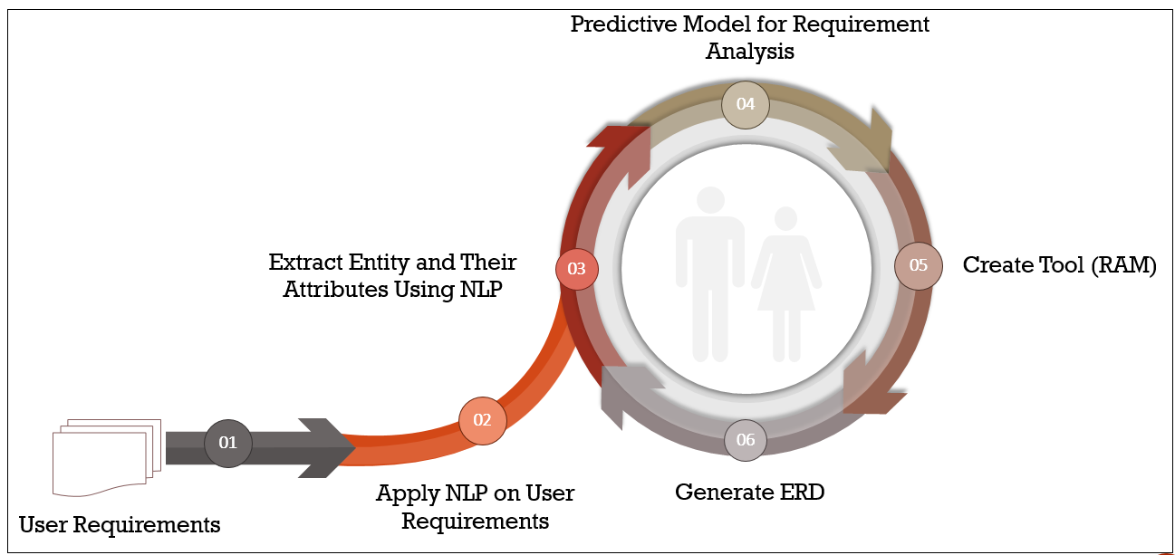
Fig.1.Life Cycle of Predictive Model for Requirment Analysis
Finally, researchers collect entities and attributes to generate diagrams such as ERDs.
Literature Review:
AI presently depends on artificial structures and is primarily concerned with replication, although automation of software engineering processes has a key advantage: when utilized appropriately, AI technologies enable human developers to expand their creative potential [2]. During their research, Yalla and Sharma used Natural Language Processing (NLP) to automate the requirement and analysis phases of the Software Development Life Cycle (SDLC). In the Requirement Analysis phase, plain text is employed, and this plain text is used as input for the NLP. They asserted that machine translation could translate textual artifacts into several languages. Textual information, or any other sort of information understood by both computers and people, must be mechanized. These authors provide a wide range of software engineering and natural language processing issues, as well as an integrated strategy that combines computer science and software engineering [3]. Each word in a phrase is assigned an abbreviation via the Part Of Speech (POS) method. To apply many possible analyses to the results, chunking and parsing are utilized. Following that, we use the Grammar Parsing procedure to assign a syntactic analysis to a string of words that builds a parsing tree. The complete study shows that the information collected from the parsing tree results in the E.R. diagram in the end [4].Natural Language Processing (NLP) was used by Btoush and Hammad to extract E.R. components from natural language requirements. Natural language documents serve as the source of information for creating the E.R. data model. This method demonstrates how natural language processing techniques based on syntactic heuristics principles, such as tokenization, POS tagging, chunking, and parsing, may be used to extract composite attributes, cardinalities, weak attributes, and so on. [5]. Patil et al. discovered that machine learning approaches such as Naive Bayes, Support Vector Machines, Decision Trees, Random Forest, and deep learning techniques contributed positively to practically all phases of natural language processing. The accuracy indicates whether or not the machine understands natural language. Finally, they determined that the application of Machine Learning in Natural Language Processing had a significant favorable impact. [6].Lilleberg et al. focused on support vector machines and word2vec for text classification to analyze the TF-IDF without stop words and TF-IDF with stop words. Word2vec brings extra semantic features that help in text classification [7]. Zijad, K. &Walid, M. applied a Support Vector Machine and lexical features for classifying requirements as functional (FR) and non-functional (NFR) in the dataset [8]. Nagarhalli, T. P. et al. suggested that the use of machine learning techniques like the Naïve Bayes, Support Vector Machines, Decision Trees, Random Forest, and deep learning techniques made a positive contribution in almost all these stages of natural language processing. The accuracy shows that natural language understanding by the machine or not. Finally, they conclude that the use of Machine Learning in Natural Language Processing has had a very positive Impact [9]. Arshad Ahmad et al. presented to recognize or identify and categorize or classify the type of machine learning algorithms or techniques used for identifying software requirements on the Stack Overﬂow platform [10]. Mohd et al. proposed a combination of text mining and machine learning and the dataset is derived from Malaysian industrial SRS documents using nine classification algorithms. The machine learning community develops these algorithms to detect which algorithm best suits the ambiguous software requirement specification [11].Gokhan et al. suggested extracting quality attributes from non-functional requirements from plain text using Support Vector Machines and classifying quality attributes from raw text [12].
Design and development of a system using NLP and ML:
There are several uses for information extraction. The endeavor to extract structured data from end-user requirements during the requirement analysis phase of software development is a particularly relevant topic of the current study.
In this paper, researchers pass the user requirement to NLP in the form of the text of the document. NLP has several phases to reach target representation. Following are the steps for generating entities and their attributes using NLP.

Step 1. Input sentence to the NLP
Fig.2.Program for Token Identifier.
Step 2. Parse the sentence
Fig.3.Program for Parsing the Sentence
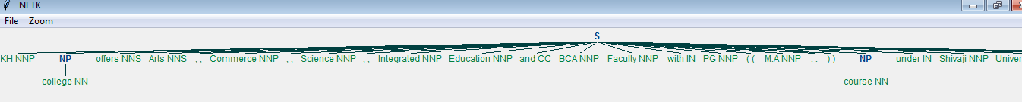
Fig.4.Output of Parsing the Sentence

Step 3: Input the sentences using Spacy
Fig.5.Program for Token Identifier using SpaCy
Step 4: Display the structure of the sentence using Displacy
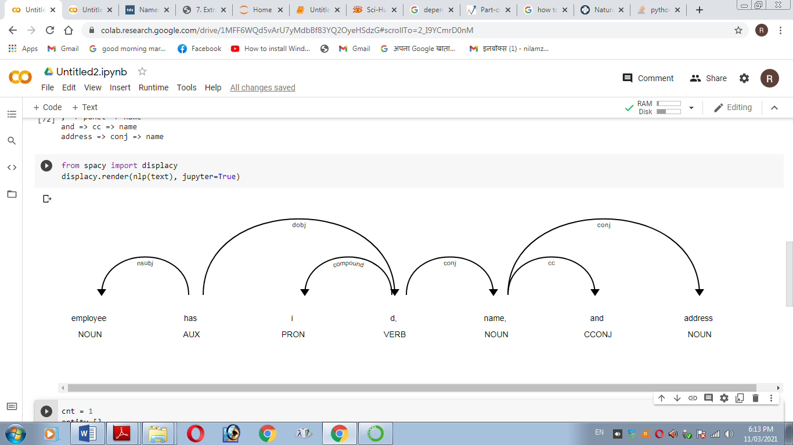
Fig. 6. Named Entity Recognition Using Displacy
Step 5: Collect Entities and their attributes using NLP
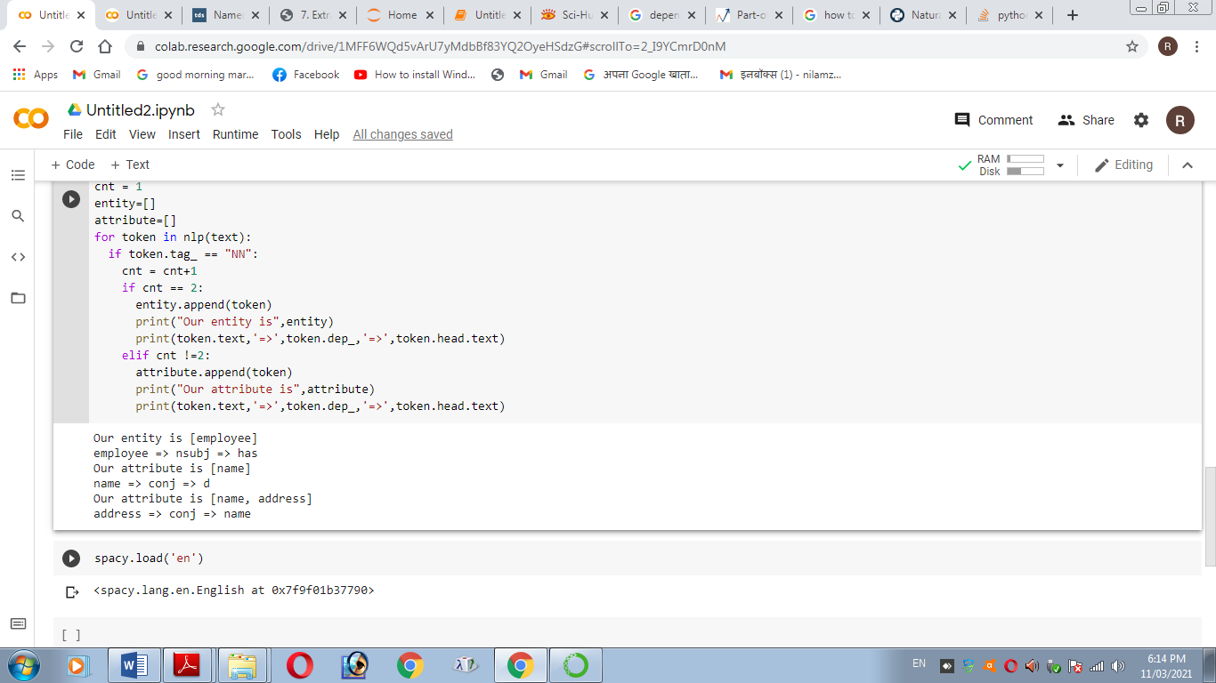
Fig. 7. Output of Entity and their Attributes
Step 6: Building a machine-learning model
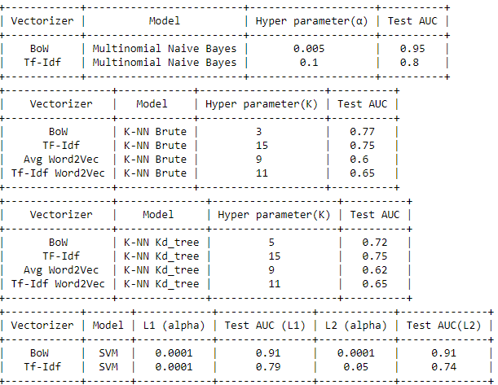
Fig. 8. The Accuracy of the Above Models with Their Parameters
Step 7: Deploy and test the mode
This step display automatically identifies and classifies functional and non-functional requirements as well as subclasses after deploying a machine-learning model on an unbalanced dataset.
Fig. 9.Output of Entity with Functional or Nonfunctional Requirement
Step 8: Genetate ER- Diagram
Fig. 10. Fetch Data from MySQL and Save to CSV
Fig. 11. Fetch data from SQLite
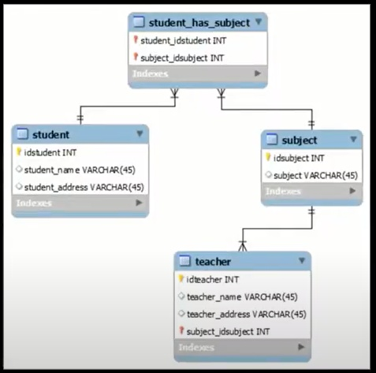
Fig.12.Display ERD
Result and Discussion:
The requirement analysis phase of the SDLC necessitates additional effort due to the collection of requirements, verification, and traceability. A combination of survey, interview, and questionnaire techniques is intended to collect high-quality stakeholder requirements written down in English and distributed to other stakeholders. SpaCy and dislacy are applied to extracted requirements, resulting in a more readable, unique, and visually appealing output of user requirements (sentence-wise) that allows you to visualize a dependency parse or named entities. It is useful in identifying areas of ambiguity in our extracted specifications. Using the spaCy and NLTK libraries of natural language processing, we can extract entities and their attributes from our extracted requirements. It is preferable to use the spaCy and NLTK libraries of Natural Language Processing to analyze requirements. When you use the AutoNormalize library in Python, it automatically detects and normalizes relationships in the dataset. To improve Natural Language Processing text by utilizing advanced algorithms such as k-Nearest Neighbor (K-NN), Naive Bayes (NB), and Support Vector Machine (SVM), as well as text vectorization techniques such as Bag of Words (BOW) and Term Frequency-Inverse Document (TF-IDF), Featurization & Machine Learning Models, ROC and AUC curves, Bi-Grams, and n-Grams in Python. It is useful for identifying and categorizing Functional Requirements (F.R.s), Non-Functional Requirements (NFRs), and their sub-classes in software development. In addition, the use of Natural Language Processing and Machine learning to generate ERD.
Conclusion:
A requirement analysis phase is more effective when supported by automated tools that ensure that the cost and time of software development are kept to a minimum. Applying NLP to user requirements and extracting entitieses and their attribute is fantastic. Apply spacy and displacy to a user requirement to make the output (phrase by sentence) more understandable, and and distinctive, and to visualise a dependency parsing or named entities.AI helps for classifying and identifying functional and non-functional requirements. It also assists in generating of ER-Diagram. This study aims to identify problems with requirements during the requirement analysis and provide NLP & ML techniques to overcome these problems as quickly as possible.

References:
- R.D.Budake, S.D.Bhoite, “Extract Entity and Attributes from User Requirement by Applying on Natural Language Processing (NLP) Model”, STM Journal Recent Trends in Programming Language, Vol.8, ISSN: 2455-1821, 2021.
- R.D.Budake, S.D.Bhoite, “Risk Analysis in Software Development Based on Artificial Intilligence (A.I.): Modern Approach”, MuktShabd Journal, ISSN: 2347-3150, UGC Care Group-I Journal, Vol.IX, June 2020.
- Yalla, P., & Sharma, N. (2015). Integrating Natural Language Processing and Software Engineering. International Journal of Software Engineering and Its Applications, 9(11), 127–136. https://doi.org/10.14257/ijseia.2015.9.11.12
- Habib, M. (2019). On the Automated Entity-Relationship and Schema Design by Natural Language Processing. The International Journal of Engineering and Science, 8(11), 42–48.
- Btoush, E., &Hammad, M. (2015). Generating E.R. Diagrams from Requirement Specifications Based On Natural Language Processing. International Journal of Database Theory and Application, 8(2), 61–70.
- Patil, B. P., Kharade, K. G., &Kamat, R. K. (2020). Investigation on Data Security Threats & Solutions. International Journal of Innovative Science and Research Technology, 5(1), 79–83.
- Lilleberg, J., Yun, Z., &Yanging, Z. (2015). Support Vector Machines and Word2vec for Text Classification with Semantic Features. IEEE 14th International Conference on Cognitive Informatics & Cognitive Computing (ICCI*CC). doi:10.1109/icci-cc.2015.7259377.
- Zijad, K., &Walid, M. (2017). Utomatically Classifying Functional and Non-functional Requirements Using Supervised Machine Learning. IEEE 25th International Requirements Engineering Conference (RE), 490–495. https://doi.org/10.1109/RE.2017.8
- Nagarhalli, T. P., Vaze, V., &Rana, N. K. (2021). Impact of Machine Learning in Natural Language Processing: A Review. 2021 Third International Conference on Intelligent Communication Technologies and Virtual Mobile Networks (ICICV). doi:10.1109/icicv50876.2021.9388380
- Arshad Ahmad, Chong Feng, Muzammil Khan, Asif Khan, AyazUllah, Shah Nazir, and Adnan Tahir, Article 2020. "A Systematic Literature Review on Using Machine Learning Algorithms for Software Requirements Identification on Stack Overflow". Hindawi Security and Communication Networks Volume 2020, Article
- MohdHafeez Osman and MohdFirdausZaharin, (2018). "Ambiguous Software Requirement Specification Detection: An Automated Approach". 2018 ACM/IEEE 5th International Workshop on Requirements Engineering and Testing.
- GokhanGokyer,Semih Cetin, CevatSener, Meltem T. Yondem, 2008. "Non-functional Requirements to Architectural Concerns: ML and NLP at Crossroads". The Third International Conference on Software Engineering Advances.978-0-7695-3372-8/08 $25.00 © 2008 IEEE.

